|  |
| --- |
| NHS Digital |
| Guide to the MediPi Patient Observation Screen |
| V1.2 |

|  |
| --- |
| Richard Robinson  29/06/2017 |

Contents

MediPi Clinical Web Interface 2

OVPN Connection 2

Login Procedure 2

MediPi Clinical Caseload View 2

Patient Status Indicator 3

MediPi Clinician Caseload Dashboard Status Flowchart 3

MediPi Patient Details View 5

Patient Demographic Details 5

Measurement Data-points 5

Latest Measurement Panel 5

Thresholds 6

## MediPi Clinical Web Interface

The MediPi Patient Observation Screen gives clinicians:

1. A view on the full caseload using a tiled dashboard interface, showing a status for each patient
2. A graphical view on the full history of each individual patient’s measurements
3. The ability to set thresholds per patient, per measurement

### OVPN Connection

For security reasons MediPi Patient Observation Webpage will only work when there is a connection to the OpenVPN service.

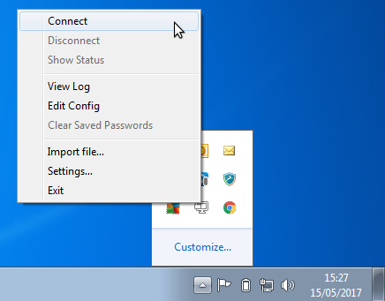

### Login Procedure

MediPi Patient Observation Screen has been tested using Chrome web browser. It does work with Internet Explorer, but has not been thoroughly tested on this browser. The guide has been written assuming the use of Chrome.

Open Chrome web browser and input <https://192.168.128.14:11980/login> into the address bar and hit enter.

Upon accessing the MediPi Patient Observation Screen, users will be presented with simple Username and Password login screen. The users should use their provided details to login.

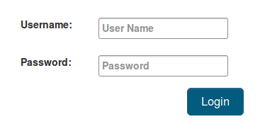

### MediPi Clinical Caseload View

Upon successful login the user will be presented with a tiled dashboard style interface for each patient from their clinical cohort.

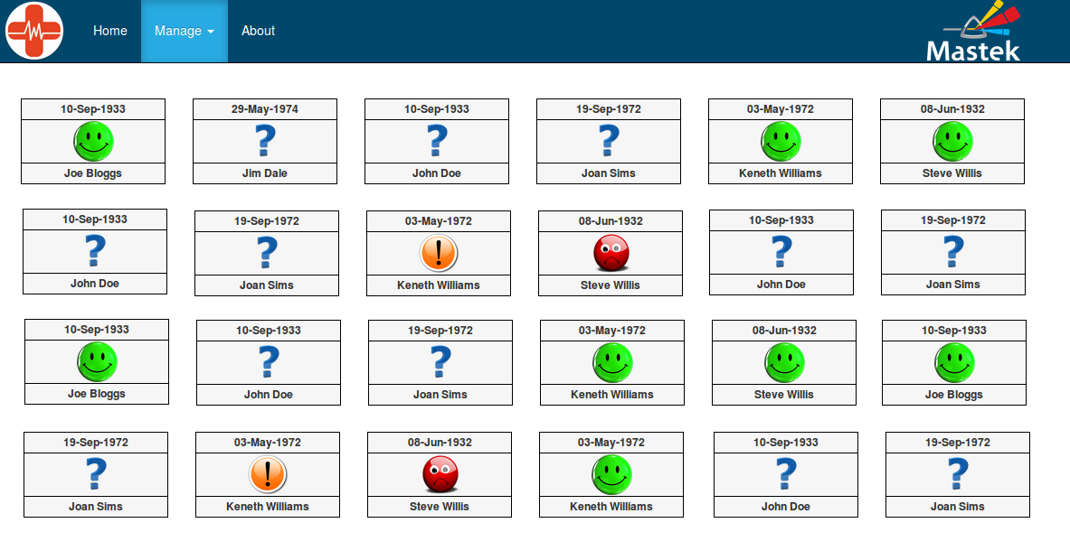 Each patient tile contains:

1. Name (First name, Last name)
2. Date of Birth
3. Patient Status Indicator

### Patient Status Indicator

The Patient Status Indicator is calculated upon the highest severity submission from the patient in this scheduled period as described in the flow chart below. The statuses of all the patients are reset at the start of each scheduled period. For example, if the patients in this cohort are required to submit measurements once-a-day after 12 midnight, then at 12 midnight the patient statuses would reset and would all show “?” as no data would have been submitted in this schedule yet. Subsequently as patients submit their measurements during the morning they will affect the Patient Status Indicator as below.

### MediPi Clinician Caseload Dashboard Status Flowchart

This flow chart shows how the software makes the decision as to what overall status a patient icon has.

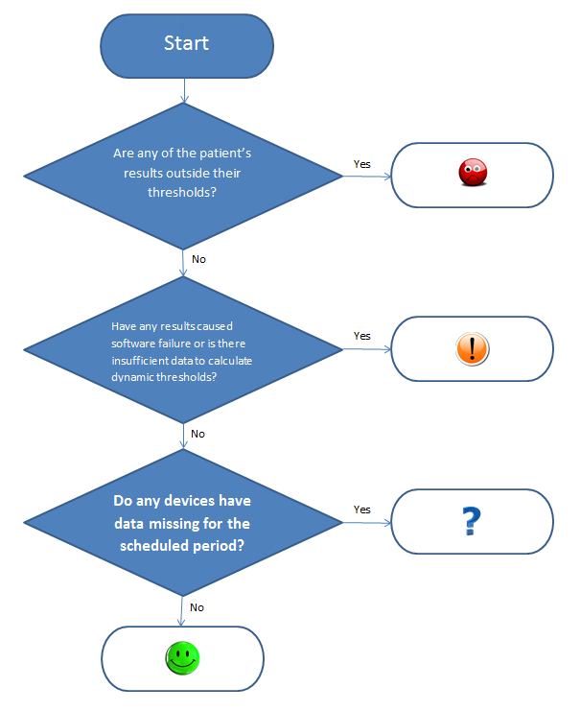

## MediPi Patient Details View

In order to review a patient’s detailed measurements and history, a patient’s icon can be clicked to open the MediPi Patient Details View. This view allows all current and historical measurements to be viewed graphically against a timeline and also allows clinicians to modify threshold values per patient, per measurement type.

### Patient Demographic Details

The patient’s demographic details are displayed at the top of the Patient Details View page

### Measurement Data-points

Beneath the Demographic details, each Measurement type is displayed with a line chart or bar graph against time. Note: Questionnaire results are plotted using a bar graph as their outcome is binary. However, for the Questionnaire chart, whilst time is still plotted against the x-axis it must be noted that this is not plotted proportionately. The time axis for all other graphs is linear and proportional.

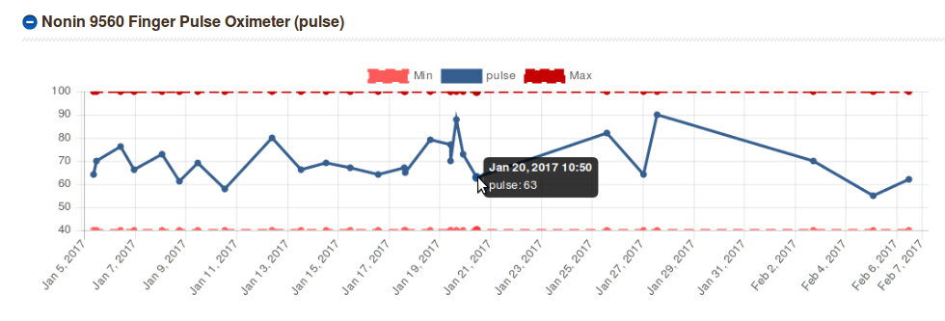

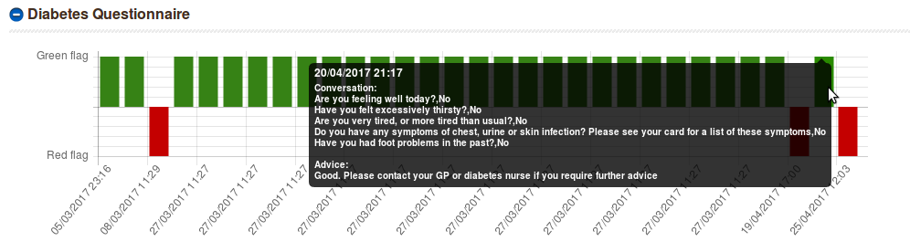

Each measurement type has a graphical representation of the historical and current data. Individual data points can be inspected by hovering the mouse over the data-point, whereby the measurement detail and timestamp are displayed. Hovering the mouse over the Questionnaire chart shows a full list of questions asked of the patient on the MediPi Patient Device and answers given by the patient

### Latest Measurement Panel

This panel shows details of the last measurement submitted for a measurement type, the status of that measurement against any thresholds set and allows those thresholds to be modified.

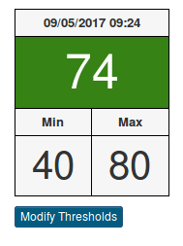

Time at which the latest measurement was taken

Current Minimum and Maximum threshold

Status of the latest measurement against thresholds

The colour-coded status in the panel is represented by:

**Green** – the latest measurement that has been submitted is within the thresholds set by the clinician

**Red** – the latest measurement that has been submitted is outside the thresholds set by the clinician

**Yellow** – Can’t calculate: the latest measurement has been submitted was not able to be tested against the thresholds due to an internal error.

In order to change the thresholds click on “Modify Thresholds” button, enter new values and confirm the change. When applied a message appears at the top of the MediPi Patient Details View Screen. Note: When thresholds are changed the existing threshold dotted line will not move on the graph as the change refers only to measurements made in the future. When the next measurement is submitted by the patient the threshold lines will reflect the change. Warning: The graph is automatically sized by the data it is representing. Please take care to only set realistic thresholds as they affect the sizing of the graph

### Thresholds

There are currently 2 main types of threshold:

1. **Simple high/low thresholds** – These are set and measurements when submitted by the patient are tested against them – they are inclusive so measurement which lie on the boundary are said to be within threshold.

Weight thresholds should be calculated by:

High threshold: Dry Weight (patient weight without any water retention) **plus** the additional buffer weight (expected day-to-day fluctuations in weight)

Low threshold: Dry Weight (patient weight without any water retention) **minus** the additional buffer weight (expected day-to-day fluctuations in weight)

1. **Red/Green Flag Questionnaire Thresholds** – when a questionnaire is submitted the overall outcome (determined by how the patient answered the questions) is ascertained and the status of the measurement type is directly related to the flag i.e. Red flag = outside threshold, Green Flag = within threshold.