Dear MediPi User,

We’d like to express our thanks for your participation in the MediPi Pilot.

MediPi is an exciting and innovative project which NHS Digital is delivering in partnership with Hertfordshire Community NHS Trust. The project is looking to make remote patient monitoring affordable and inform and empower patients to self-manage their conditions.

Self-management has been shown to improve patient experience, with patients reporting benefits in terms of greater confidence, reduced anxiety and increased physical functioning.

Furthermore, self-management programmes have been shown to reduce unplanned hospital admissions for certain conditions and to improve adherence to treatment and medication.

The MediPi device gives patients and clinicians the flexibility to take measurements without the need for appointments or home visits. It also and allows clinicians to remotely access these measurements.

Once you’re familiar with MediPi, it typically takes about 5 minutes to take and transmit your readings.

Never has it been more important to maximise the value for taxpayers’ money and, through advances in technology, improve the care the NHS gives its patients. The number of people with multiple long-term conditions is predicted to rise by a third over the next ten years and as healthcare providers we need to devise affordable, creative ways to care for those extra patients.

The security and protection of patient data is paramount and MediPi uses the same security model used by NHS systems.

MediPi has been rigorously tested, but the only way we can prove the concept and test the technology is through patient participation. Your help is vital and fundamentally important to our pilot and we are very grateful that you have agreed to help us in this endeavour.

The MediPi Team at NHS Digital

1. Turn on the MediPi Patient Device. Find a mains power socket and insert the MediPi Patient Unit Power supply (This must be within 1.5M /5 feet of where it is to be used).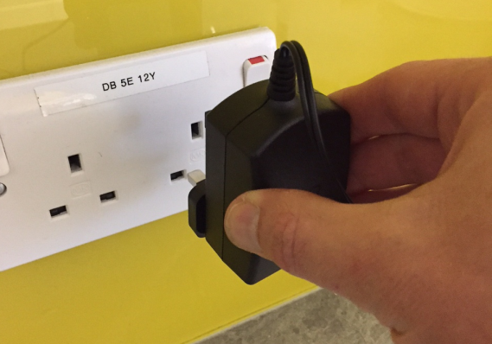
2. Unwrap the cable and carefully insert the other end into the MediPi Patient Unit, ensuring the white panel on the MediPi Patient Device and white side of the plug match.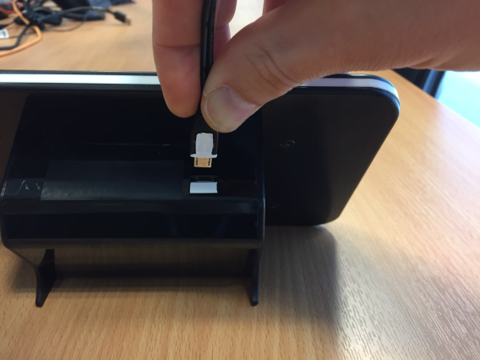
3. The MediPi Patient Unit will boot up showing various images on its screen (a rainbow square, scrolling writing) and after approximately 30 seconds it will display the MediPi Login screen.

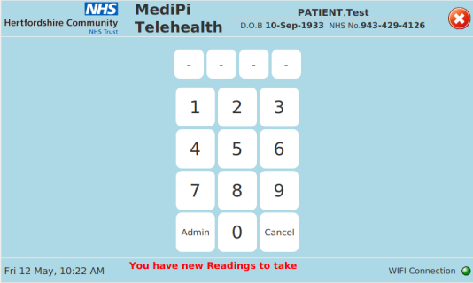

Initially the device may report that it has not synchronised its clock or that the WIFI connection is down – this is expected at start-up and the messages should quickly disappear. If they persist after a further 30 seconds please refer to the troubleshooting guide.

1. Enter your MediPi PIN and the MediPi Dashboard view will be displayed. The MediPi Patient Unit will lock itself after 15 minutes of inactivity, requiring your PIN to be re-entered.
2. MediPi Dashboard: This shows the Readings tile. This tile will indicate to you every day when you have readings to take and will guide you through the process of taking each of the measurements in turn and transmitting them to the clinician.

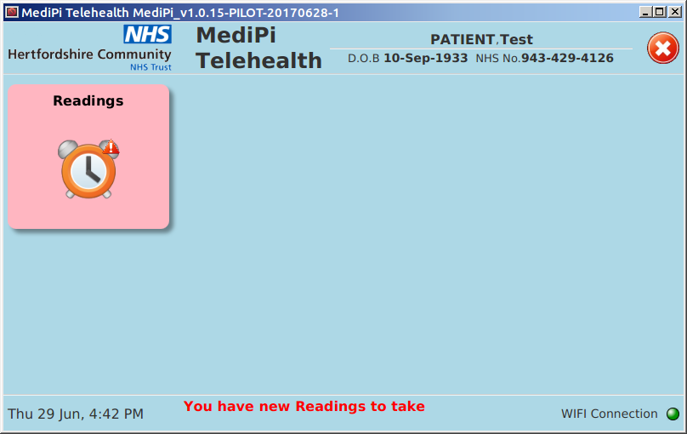

1. The Readings Tile

When you are required to take measurements, the readings tile will be coloured red and the scrolling alert banner at the bottom of the screen will remind you:



Tap the Readings tile and you will be shown a summary of your Readings schedule and history over the previous week. You are required to take all the measurements in the Readings schedule every day or as directed by your clinician.

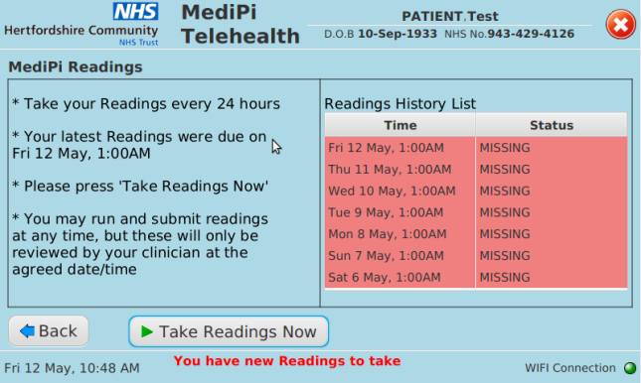

1. Press “Take Readings Now” button to start the process of taking your daily readings. You will be guided to take measurements using each of the physiological devices. Each physiological device has its own on-screen help guide which can be scrolled left and right which will tell you exactly how to take the measurements for each device – These are printed in the appendix (Appendix - User Checklist for the MediPi User Device). **Please follow these instructions carefully.**
2. Press the Next button after the completion of each device measurement. (The devices and measurements you will be asked to take may not be exactly the same as those displayed below, but will have been determined individually for you by your clinician). The “Next” button will proceed through the measurements to be taken and the “Back” button will reverse through the screens.

The last screen in the sequence will be the transmitter screen which will show you a summary of all the measurements you have taken and will allow you to transmit the measurements to your clinician using the “Transmit” button. If you have not taken measurements for one of the devices then you will be reminded (although you can still send the measurements in any case).

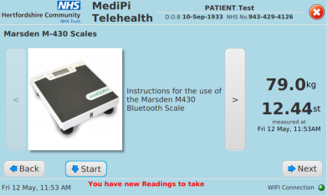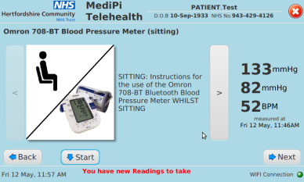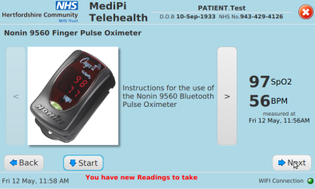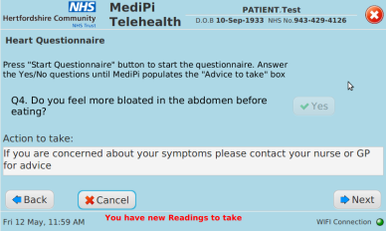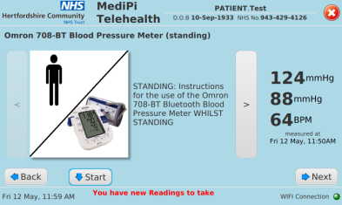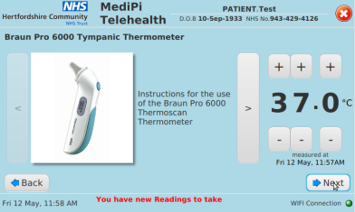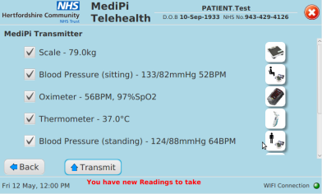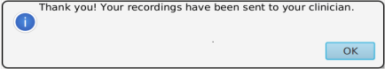 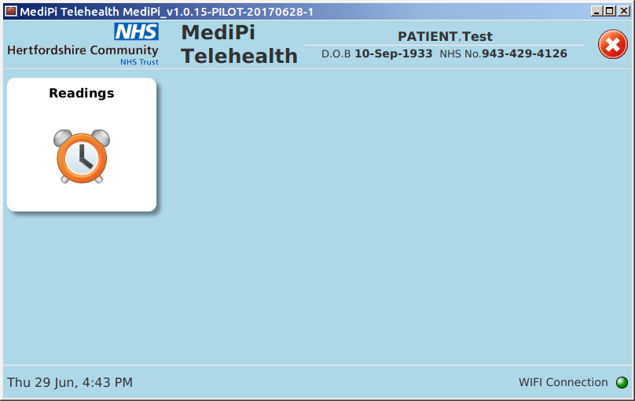

Once you have seen the message:



then the process is complete. Congratulations!

Note that the alert at the bottom of the screen has now disappeared and the Readings tile is no longer shaded red.

1. Switch the MediPi Patient Unit off**. It is very important to switch the patient unit off correctly:** Press the red cross at the top left-hand corner and a confirmation message will appear



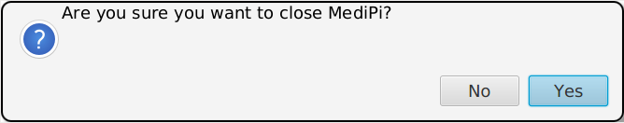

You can now unplug the device. **Please do not unplug the device without closing it down in this way as this can damage the MediPi Patient Unit**.

## Troubleshooting Guide

1. If the WIFI Connection light flashes red then MediPi Patient Device is unable to connect to your home WIFI. 

* Leave it 30 seconds to see if it finds the connection (sometimes the connection can reset)
* Check that the home WIFI router is switched on and in range
* If the above doesn’t fix it try turning the MediPi device off then on again and retry

If the WIFI is not connected the device will not allow any readings to be sent to the clinician.

1. The lower banner on the screen shows that the clock needs to sync



* Leave it 30 seconds to see if it synchronises its clock (It will be trying to synchronise its clock from an internet server which can take some time)
* Check that the home WIFI router is switched on and in range
* If the above doesn’t fix it try turning the MediPi device off then on again and retry

The MediPi Patient device MUST synchronise its clock with a reliable time-source over the internet. Until it does then no measurements can be taken or sent to the clinician.

1. If any of the physiological devices fail to transfer their data to the MediPi Patient Device:

* Read the on-screen information and picture help guide and retry
* If the above doesn’t fix it try turning the MediPi device off then on again and retry

1. Any other problem: please write down in as much detail as possible:
   * The actions you performed prior to the problem
   * Exactly what happened when the problem occurred
   * The error messages that were displayed if any
   * If the problem happened again when you repeated the actions (preferably after the device was restarted)

and report these to your clinician

### Device Specific Troubleshooting:

Marsden Scales. If the scales take a weight measurement but do not beep (and no measurement appears on the MediPi Patient Device) then check that there is an arrow against the Bluetooth symbol  and that there is a flashing arrow against ‘Hold’

