|  |
| --- |
| NHS Digital |
| **MediPi Patient Unit Administration Mode Guide – Clinician’s Guide** |
| V1.2 |

|  |
| --- |
| Richard Robinson  16/08/2017 |

Contents

Change Log 1

Glossary 1

Initial Configuration 1

Step-by-Step Guide to Configuring the MediPi Patient Unit 2

1. Power on Device 2

2. Open MediPi Patient Unit in Administration Mode 3

3. Log onto the Wi-Fi Access Point (Connect to WI-FI) 5

4. Power down the MediPi Patient Device 7

Device Synchronisation 7

1. Omron 708-BT Blood Pressure Meter 7

2. Nonin 9650 Finger Pulse Oximeter 8

# Change Log

|  |  |  |
| --- | --- | --- |
| Date | Author | Change |
| 16.08.2017 | R.Robinson | Addition of synchronisation process for BP and Pulse Oximeter |
|  |  |  |

# Glossary

MediPi Patient Unit: This is the touchscreen Raspberry Pi based device in a black enclosure

Power Supply Unit: This is the adaptor which plugs into a domestic power supply terminating in a micro USB plug.

Physiological Device: any of the devices which measure physiological state i.e. Pulse Oximeter, Scales, Blood Pressure Cuff and Tympanic Thermometer

## Initial Configuration

It is expected that the HCT technical team will have configured the hardware and software before the units are given to the Clinicians.

The HCT Medical Devices Manager will be expected to update the following on the MediPi Patient Unit:

1. Pair each of the Bluetooth physiological devices with the MediPi Patient software
2. Input the MAC address(es) of the Bluetooth physiological devices on MediPi Patient software where necessary
3. Set Time on the Bluetooth physiological devices that require it
4. Update the patient forename, surname, NHS number and date of birth
5. Create appropriate schedules on the devices for that specific patient

The clinicians will be expected to update the following on the MediPi Patient Unit:

1. Connect the MediPi Patient Unit to the patient’s home WIFI network

Note: Actions 4 and 5 above will need to be carried out in concert between the Technical and Clinical teams and could be performed by either.

It will be necessary to inform NHS Digital of all **new patients** before the hardware is distributed so that the Concentrator and Clinical Databases can be updated to allow data to be sent and patients to be added to the relevant patient groups. NHS Digital will require:

* Patient forename and last name
* Patient NHS Number
* Patient Date of Birth
* Identifying details of the MediPi Patient Unit to be used

*Exact details and lead times for this process to be agreed

# Step-by-Step Guide to Configuring the MediPi Patient Unit

## Power on Device

Turn on the MediPi Patient Device. Find a mains power socket and insert the MediPi Patient Unit Power supply (This must be within 1.5M /5 feet of where it is to be used).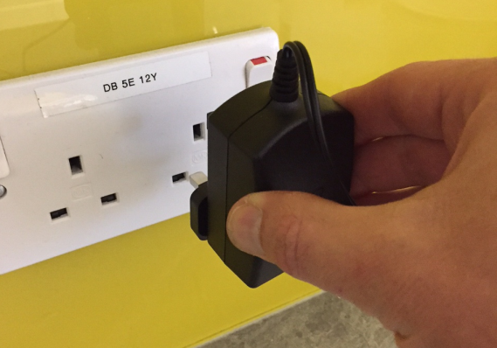

Unwrap the cable and carefully insert the other end into the MediPi Patient Unit, ensuring the white panel on the MediPi Patient Device and white side of the plug match.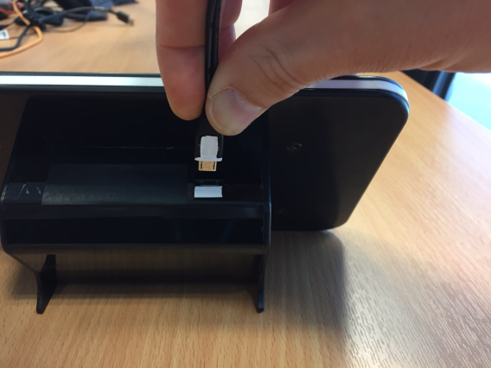

The MediPi Patient Unit will boot up showing various images on its screen (a rainbow square, scrolling writing) and after ~30 seconds will display the MediPi Login screen.

## Open MediPi Patient Unit in Administration Mode

This mode allows authorised users to maintain: Wi-Fi access, Bluetooth pairing of physiological devices, maintenance of the patient demographic details and the MediPi Readings Schedule.

Press the button on the MediPi Patient Authorisation screen to open a 10 digit passcode login. Carefully input the 10 digit admin passcode, making sure that an asterisk appears in the display for each number pressed. Passcodes will be supplied by NHS Digital technical department.

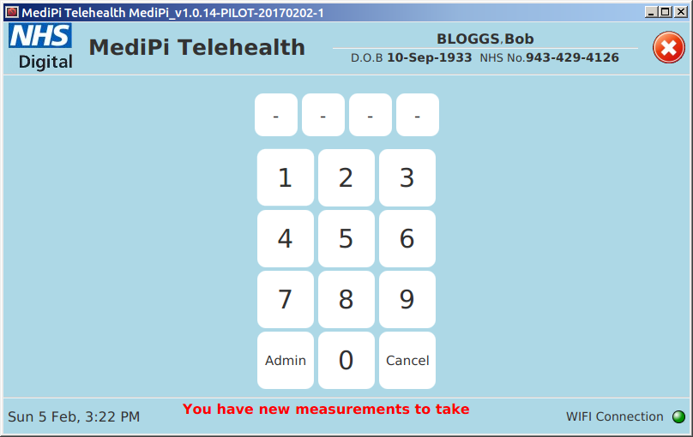 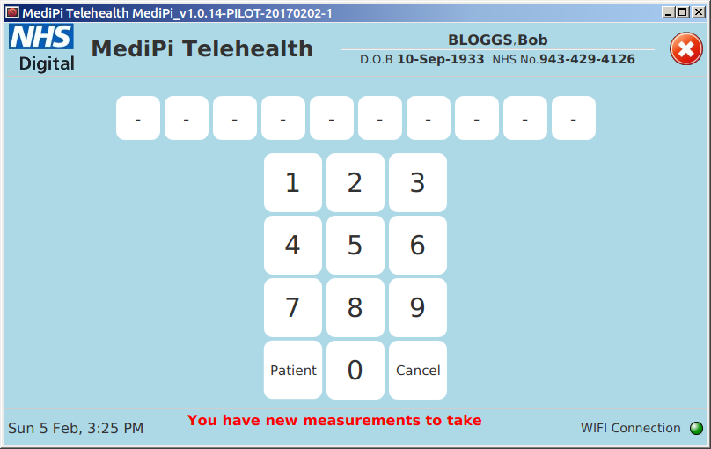 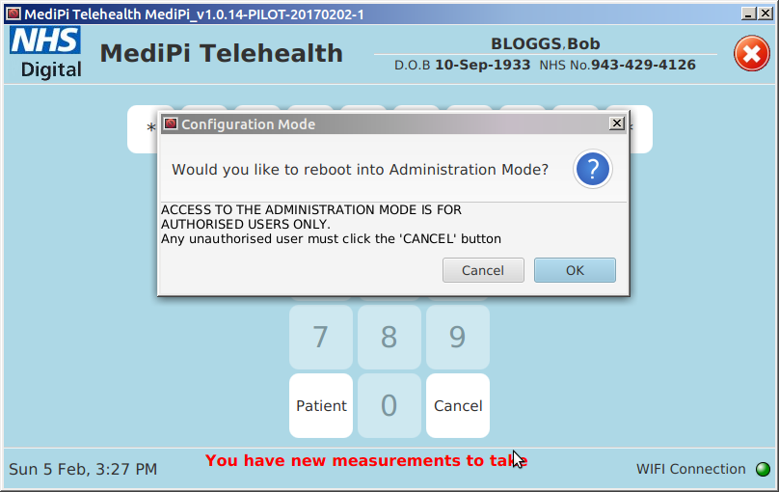

**Very Important**: This mode allows access to the underlying operating system and would give malicious users the ability to subvert the software or its access to the Virtual Private Network (VPN). As such, **it is imperative that the access code is kept secret and only used by authorised users**. The 10 digit administration code is a universal code which will be the same for all the MediPi Patient devices.

On accepting the login request, the MediPi Patient unit will reboot to a Windows-style desktop. This may take some time (~30 seconds) during which the screen may look black, after which the display will show a desktop with an on-screen keyboard. The keyboard can be exited using the ‘X’ in the top right hand corner and can be opened again using the shortcut on the taskbar.

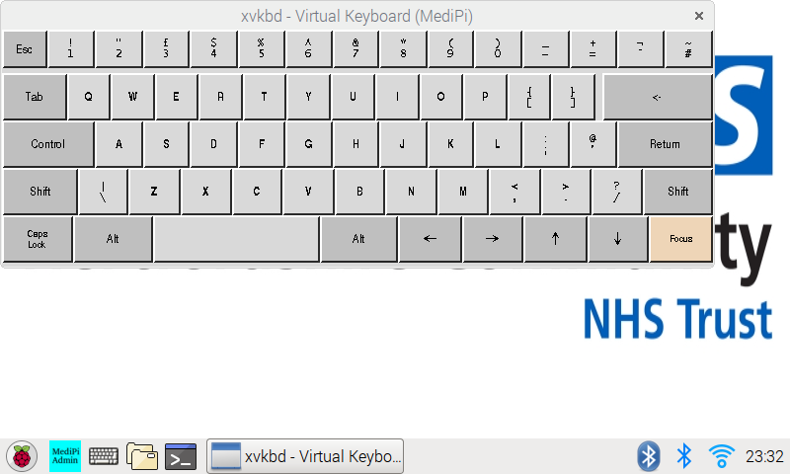

## Log onto the Wi-Fi Access Point (Connect to WI-FI)

This is done using the Raspberry Pi operating system’s standard wizard.

First obtain the Wi-Fi password and the network name (sometimes known as the SSID) from the patient’s wireless router:

* + - *On the* ***BT Home Hub*** *you'll find the network name (SSID) and wireless key (password) on the Hub settings card on the back. There's also a label with this information underneath the Hub.*

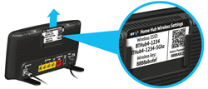

* + - *On the* ***Sky Hub*** *the same information is displayed on the back:*

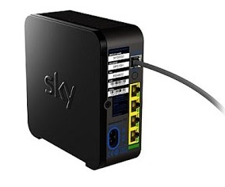

* + - *On the* ***TalkTalk Hub*** *the same information is on the back:*

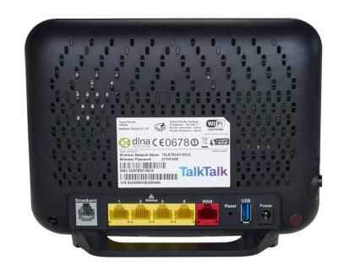

* + - *On the* ***Virgin Hub****, the information is underneath the router:*

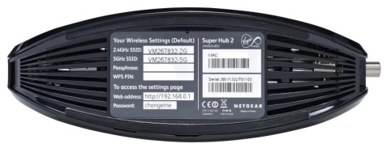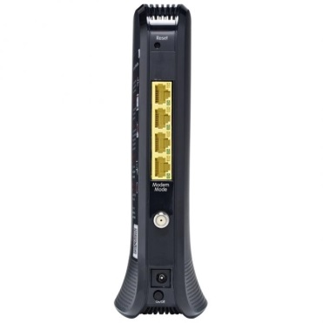

* + - *On the* ***Plusnet*** *router, the information is on the back:*

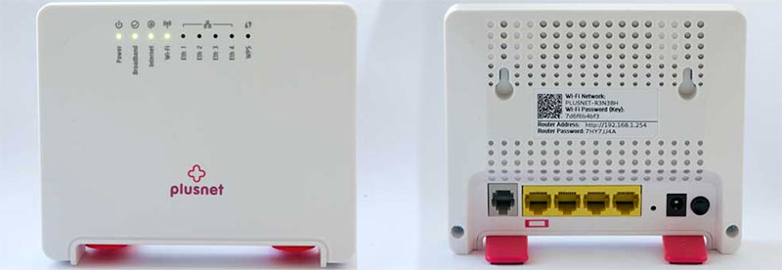

1. Click on the network icon on the MediPi Patient Unit’s desktop taskbar:

It will almost certainly look like but may look like  or 



1. And select the patient’s network name (or SSID) from the list e.g. BTHub4-XXXX (it may take a short while for the access point to appear in the list after tapping on it)
2. Then, using the on-screen keyboard, input the wireless network’s password exactly (including upper and lower case letters) into the following box:



1. After this has been successfully accepted the network icon should first flash then show a steady connection icon:



## Power down the MediPi Patient Device

**It is important to power down the MediPi Patient Device properly**. Press the raspberry button on the taskbar:  and select “Shutdown..” from the menu then press the Shutdown button. It is our experience that if you wish to reboot the MediPi Patient Device, it is quicker to use Shutdown and unplug and plug the power adaptor in rather than use the Reboot button.

# Device Synchronisation

During the course of normal operation, if the MediPi Patient Device detects that the physiological devices internal clock is not sufficiently synchronised, it will ask that the physiological device is synchronised and will display a guide to do so. (Additionally synchronisation can proactively be started using the appropriate button in the MediPi Administration Mode).

### Omron 708-BT Blood Pressure Meter

To set the time on the device press “Update Time” on the MediPi Screen then carefully follow the words and picture instructions displayed: (taken from the Omron guide)

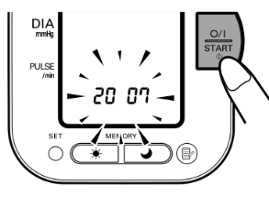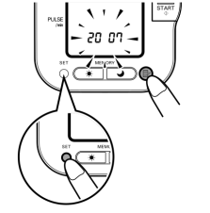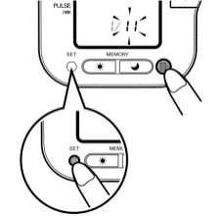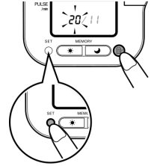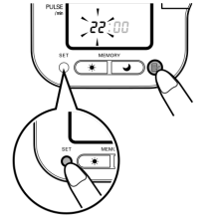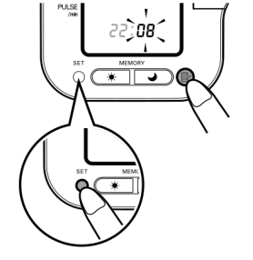

111

711

611

511

411

211

1. Use MediPi's clock as the timesource for setting the device clock – BUT SET THE BP DEVICE CLOCK TO BE 1 MINUTE BEHIND THE MEDIPI PATIENT DEVICE TIME (MediPi patient device will reject any readings which are in the future, but will tolerate some backwards drift – the initial setup is that the BP device time can be up to 1 hour behind the MediPi Patient device). Make sure the Omron device is OFF, then press and hold the "SET" button until the year digits flash on the display. Alternatively, if the unit is turned on for the first time after inserting batteries, the year digits (2007) will flash on the display.

2. Press the MEMORY button to advance the digits one at a time. Notes: The range for the year setting is 2007 to 2030. If the year reaches 2030, it will return to 2007. If you hold down the MEMORY button, the digits will advance rapidly.3. Press the SET button to confirm the setting when the desired number appears on the display. The year is set and the month digits flash on the display.4. Repeat steps 2 and 3 to set the month. The month is set and the day digits flash on the display.5. Repeat steps 2 and 3 to set the day. The day is set and the hour digits flash on the display.6. Repeat steps 2 and 3 to set the hour. The hour is set and the minutes digits flash on the display.7. Repeat steps 2 and 3 to set the minutes. The minutes settings is set. The unit automatically turns itself off after the minute setting has been set. To adjust the date and time, press the SET button while the unit is in standby mode.

### 2. Nonin 9650 Finger Pulse Oximeter

To set the time on the device press “Update Time” on the MediPi Screen then carefully follow the words and picture instructions displayed:

