|  |
| --- |
| NHS Digital |
| MediPi Patient Unit Administration Mode Guide – HCT Technical Team |
| V1.1 |

|  |
| --- |
| Richard Robinson  16/08/2017 |

Contents

Change Log 1

Glossary 2

Background Considerations 2

Initial Configuration 2

‘Swap-out’ of Physiological Devices 3

Swap-out MediPi Patient Units 3

Step-by-Step Guide to Configuring the MediPi Patient Unit 4

1. Power on Device 4

2. Open MediPi Patient Unit in Administration Mode 4

3. Log onto the Wi-Fi Access Point (Connect to WI-FI) 6

4. Pair/UnPair Bluetooth Physiological Devices (including the Bluetooth Keyboard) 7

5. Open the MediPi Admin Interface 8

6. Update the Patient Demographic Settings 9

7. Update the Bluetooth Settings 9

8. Set the Time on the Physiological Devices 10

Marsden M430 scales 11

Braun Pro 6000 Tympanic Thermometer 11

Omron 708-BT Blood Pressure Meter 11

Nonin 9650 Finger Pulse Oximeter 12

Bluetooth Device Requirement Table 12

9. Adjust the MediPi Patient Schedule 12

10. Power down the MediPi Patient Device 13

# Change Log

|  |  |  |
| --- | --- | --- |
| Date | Author | Change |
| 16.08.2017 | R.Robinson | Update the suggestion for what time to use for the BP device internal clock |
|  |  |  |

# Glossary

MediPi Patient Unit: This is the touchscreen Raspberry Pi based device in a black enclosure

MediPi Patient software: The software which runs on the MediPi Patient Device

Power Supply Unit: This is the adaptor which plugs into a domestic power supply terminating in a micro usb plug.

Physiological Device: any of the devices which measure physiological state i.e. Pulse Oximeter, Scales, Blood Pressure Cuff, Tympanic Thermometer

Digital Certificates: These provide the security encryption and signatures for data in transit and at rest. There are 2 on the MediPi Patient Device: a patient certificate and a device certificate. The device certificate is tied and is specific to the Raspberry Pi hardware board on which it runs. The patient certificate pseudo-identifies the patient using the device.

# Background Considerations

MediPi Patient software has a number of elements which can be edited and changed by authorised users through its settings panel. This guide is intended to be thorough with a bit of background as to why certain actions are being taken. It may be appropriate in time to produce a cutdown version but once followed a few times will become straightforward.

## Initial Configuration

It is expected that the HCT technical team will have configured the hardware and software before the units are given to the clinicians.

The technical team will be expected to update the following on the MediPi Patient Unit:

1. Pair each of the Bluetooth physiological devices with the MediPi Patient software
2. Input the MAC address(es) of the Bluetooth physiological devices on MediPi Patient software where necessary
3. Set Time on the Bluetooth physiological devices that require it
4. Update the patient forename, surname, NHS number and date of birth
5. Create appropriate schedules on the devices for that specific patient

The clinicians will be expected to update the following on the MediPi Patient Unit:

1. Connect the MediPi Patient Unit to the patient’s home WIFI network

Note: Actions 4 and 5 above will need to be carried out in concert between the Technical and Clinical teams and could be performed by either.

It will be necessary to inform NHS Digital of all **new patients** before the hardware is distributed so that the Concentrator and Clinical Databases can be updated to allow data to be sent and patients to be added to the relevant patient groups. NHS Digital will require:

* Patient forename and last name
* Patient NHS Number
* Patient Date of Birth
* Identifying details of the MediPi Patient Unit to be used

*Exact details and lead times for this process to be agreed

## ‘Swap-out’ of Physiological Devices

If, during the course of use, a physiological device breaks then the ‘swap-out’ procedure can be performed in the home by the clinician or at HCT base by the Technical Team (The second option may require an interruption of service to the patient). It requires the following updates to the MediPi Patient Unit:

1. Unpairing the existing Bluetooth physiological device
2. Pairing the new Bluetooth physiological device
3. If the broken device is a Nonin 9560 Finger Pulse Oximeter or the Marsden Scales, then the MAC address of the new physiological device will need to be updated using the MediPi Admin Software.
4. Setting Time on the physiological device using the MediPi Admin software. This necessary for the Omron Blood Pressure Cuff (a manual process of setting the time on the device) and for the Nonin 9560 Finger Pulse Oximeter (an automated process where the MediPi software synchronises the time)

No changes to the MediPi Concentrator or Clinical databases is necessary when a physiological device is swapped.

## Swap-out MediPi Patient Units

When the MediPi Patient Unit requires swapping, there are 2 options. Either:

1. Take the unit and all Bluetooth physiological devices and replace them with a new MediPi Patient Unit with new Bluetooth physiological devices pre-paired and configured
2. Replace the MediPi Patient Unit and re-pair and configure the existing Bluetooth physiological devices to it.

Additionally, there are 2 options for swapping out the MediPi Patient Unit:

1. A new unit is used which would have new digital certificates. The advantage is that it can be swapped out very easily and given back to the patient immediately, but because the patient will now have a new identity on the database, the observed outcome for clinicians will be that the patient will now have a second, new patient icon on the clinical front end web page and all subsequent measurements taken will be sent to the new identity.
2. A new unit is used and the old certificates are manually copied to the new unit and reconfigured. The big advantage is that from the clinician’s point of view the patient’s identity does not change on the clinical front end. However the disadvantage is that initially at least a representative from NHS Digital will have to remotely login to the new MediPi Patient Device and transfer certs and reconfigure it. This won’t take very long to do but is a manual process which will need some co-ordination. My preference is for this second option.

The following hardware failures can be changed at HCT base without requiring any changes to the configuration of the Patient Unit or to the Concentrator or Clinical databases:

* Broken plastic enclosure
* Broken screen
* Faulty power supply (could be swapped in the home if it can be identified)

# Step-by-Step Guide to Configuring the MediPi Patient Unit

## Power on Device

Plug in MediPi Patient Unit using the mains adaptor and wait for the unit to display the MediPi Login screen

## Open MediPi Patient Unit in Administration Mode

This mode allows authorised users to maintain: Wi-Fi access, Bluetooth pairing of physiological devices, maintenance of the patient demographic details and the MediPi Readings Schedule.

Press the button on the MediPi Patient Authorisation screen to open a 10 digit passcode login. Carefully input the 10 digit admin passcode, making sure that an asterisk appears in the display for each number pressed. Passcodes will be supplied by NHS Digital technical department.

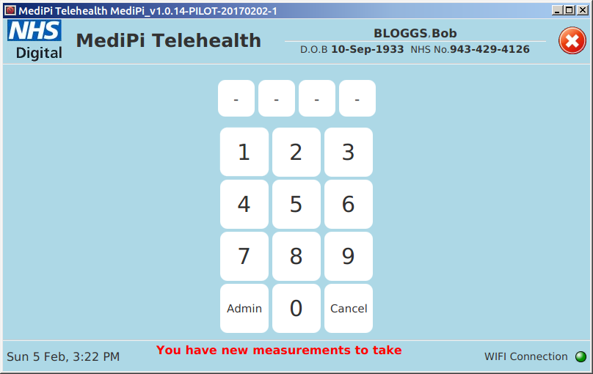 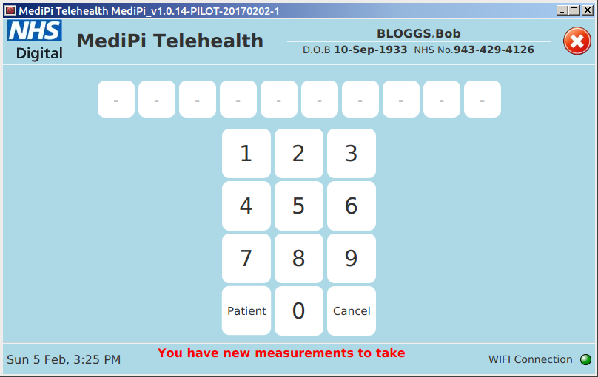 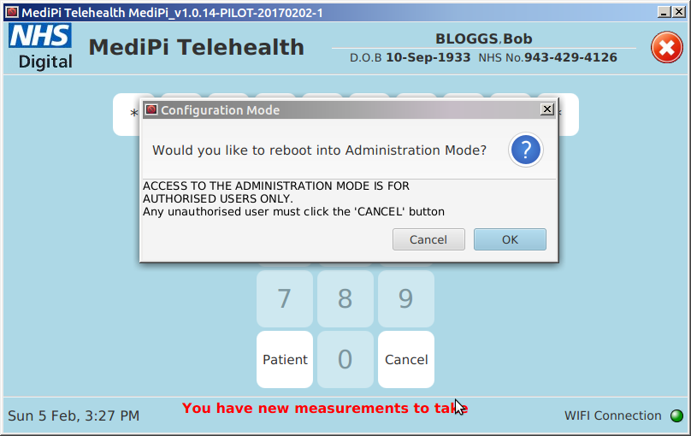

**Very Important**: This mode allows access to the underlying operating system and would give malicious users the ability to subvert the software or its access to the Virtual Private Network (VPN). As such, it is imperative that the access code is kept secret and only used by authorised users. The 10 digit administration code is a universal code which will be the same for all the MediPi Patient devices.

On accepting the login request, the MediPi Patient unit will reboot to a Windows-style desktop. This may take some time (~30 seconds) during which the screen may look black, after which the display will show a desktop with an on-screen keyboard.

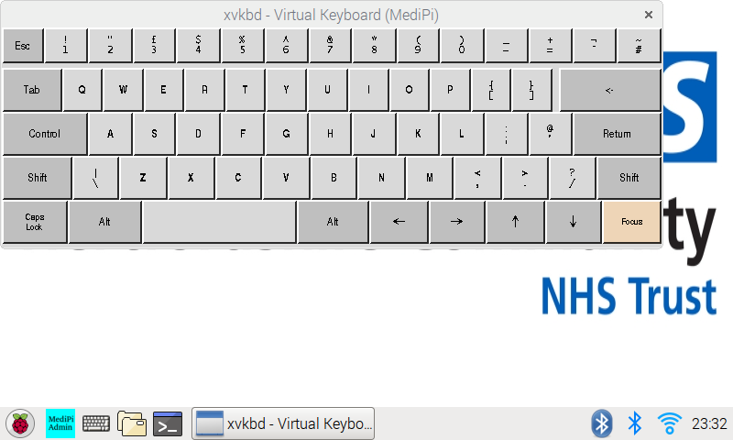

All necessary actions for the configuration of the MediPi Patient Device *can* be performed using the on screen keyboard, however this would become frustrating and so we would suggest using a Bluetooth enabled keyboard (we have included one in the shipment of the first 10 MediPi Devices). See below for Bluetooth pairing instructions which is necessary for the operation of the keyboard. The on-screen keyboard can be closed using the ‘X’ in the upper right hand corner of its window. Note that in accordance with the configuration of the MediPi Patient Device when tested against Class B Electromagnetic Conformance, it was necessary to disable all the USB ports and so a standard USB keyboard can no longer be used (The apertures for the USB ports have also been covered).

## Log onto the Wi-Fi Access Point (Connect to WI-FI)

This is done using the Raspberry Pi operating system’s standard wizard. The internet access that this step creates is necessary for time synchronisation later.

1. First obtain the Wi-Fi password and the network name (sometimes known as the SSID) from the patient’s wireless router e.g. BT Home Hub 4:

*On the Hub 4 you'll find the network name (SSID) and wireless key (password) on the Hub settings card on the back. There's also a label with this information underneath the Hub.*

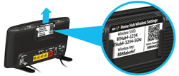

On the Sky Hub the same information is displayed on the back:

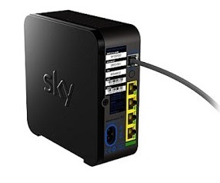

1. Click on the network icon on the MediPi Patient Unit’s desktop taskbar:

It may look like or  or 



1. And select the patient’s network name (or SSID) from the list e.g. BTHub4-XXXX (it may take a short while for the access point to appear in the list)
2. Then input the wireless network’s password exactly (including upper and lower case letters) into the following box:



1. After this has been successfully accepted the network icon should first flash then show a steady connection icon:



## Pair/UnPair Bluetooth Physiological Devices (including the Bluetooth Keyboard)

1. Click on the Bluetooth icon on the desktop taskbar: 
2. View the dropdown menu of Bluetooth options and paired devices:
3. If there are Bluetooth devices which are being swapped out then remove their pairings from this menu using “Remove Device…”
4. Select “Add Device…” and start the physiological device into paring mode (Be patient for the devices to appear, it can sometimes take 30-60 seconds) :
   * Nonin 9650 Pulse Oximeter (from the Nonin Guide):
     + To be discoverable, the 9560 must be powered on with a finger inserted. The 9560 will be discoverable for 90 seconds once a finger is inserted. The 9560 will provide a friendly name starting with “Nonin_Medical_Inc._” and followed by a six digit number, referred to as the PIN. The PIN is etched on the side of battery door and is the same as the last six digits of the serial number. To complete the pairing process the Bluetooth PIN must be provided.
   * Marsden M430 Scales

These should become discoverable when switched on. Make sure that Bluetooth is enabled (This is indicated on the LCD screen of the Marsden scales). If Bluetooth needs enabling (from the Marsden Guide):

* + - Press the TARE key for three seconds. The display will show ‘set.’
    - Press the BMI/HOLD key until the display shows ‘bluet.’
    - Press the TARE/+ key to enter Bluetooth setting mode.
    - Press the BMI/HOLD key to toggle between ‘on’ (enable) and ‘off’ (disable).
    - Press TARE/+ to confirm the setting.
    - Press the BMI/HOLD key twice, and then TARE/+ to return to normal weighing mode.
  + Omron 708-BT Blood Pressure (from the guide):
    - If the Omron LCD screen is blank then press one of the arrow keys to switch the device on then press and hold the Bluetooth upload button for more than 3 seconds. The pairing display appears on the Omron LCD screen.

1. Performing the pairing procedure

* The discoverable devices will appear on the Bluetooth pairing menu. Be patient for the devices to appear, it can sometimes take 30-60 seconds. Select the desired device from the Bluetooth menu and click “Pair”:

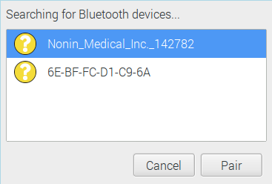

* The Marsden Scales and the Omron Blood Pressure cuff will pair without any further input but the Nonin Pulse oximeter requires a password (which is printed on the side of the device itself and also as part of the device name):

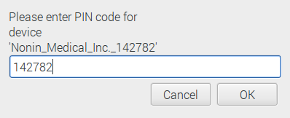

* Upon successful pairing the following message will be displayed – press OK:

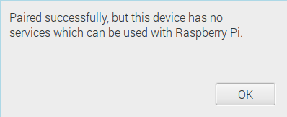

Disregard the advice here about the device not having any services – this just means that the Raspbian OS has no native services for these devices which is expected. The important thing is that it has paired successfully.

## Open the MediPi Admin Interface

Find the MediPi Admin shortcut button on the taskbar and press it: 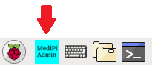

This will open up a special instance of MediPi Patient Software. Press on the Administration Mode button which will open the dashboard which has only one Settings dashboard item. Press this to open the Settings interface

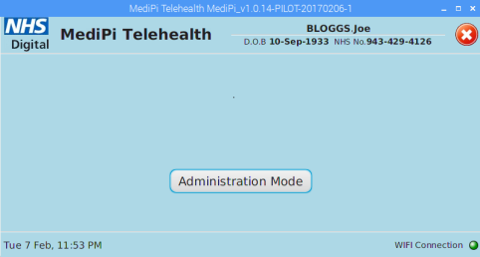

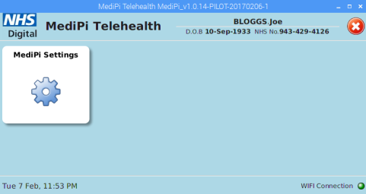

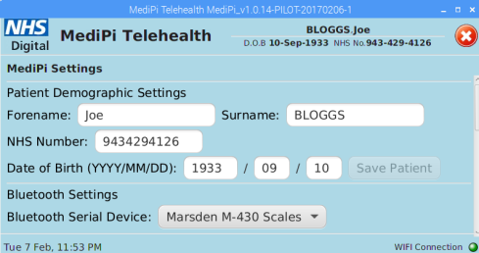

## Update the Patient Demographic Settings

The patient demographic settings allow the update of the patient details which are displayed at the top of every screen of the MediPi Patient software. Input the required information and press “Save Patient” button. Dates and NHS Number are validated. Note: If you close the MediPi Admin software without clicking Save Patient the changes will be lost and not be saved.

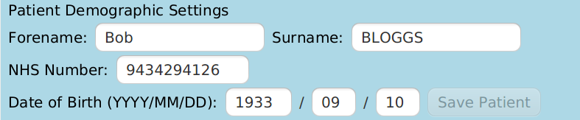

## Update the Bluetooth Settings

MediPi requires MAC addresses for certain Bluetooth devices. Only devices which require this information will be displayed in the Bluetooth Serial Device dropdown box (these are the Marsden Scales and the Nonin Pulse Oximeter). Choose the appropriate device from the dropdown list and input its MAC address. The MAC address is in the format XX-XX-XX-XX-XX-XX.

* Nonin Pulse Oximeter MAC Address is embossed on the side of the device.
* Marsden Scales MAC Address is not printed on the device itself but can be found by pressing on the other Bluetooth taskbar icon , choosing Devices from the dropdown menu which opens up a screen showing details of all the paired devices including the MAC address. The Marsden MAC address is displayed here.

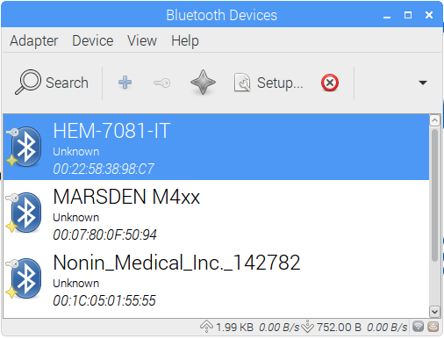

(It might be a good idea for the HCT Technical Team to save this MAC Address and print it on the device as part of their labelling as it will mean in the future that it can be found more easily.)

The MAC address can be input with or without the hyphens. After inputting ***each*** MAC address click “Save BT Serial MAC” button in turn, before inputting any other device’s MAC address . Note: If you close the MediPi Admin software or change to a different MAC address using the dropdown box without clicking Save BT Serial MAC, then the changes will be lost and not be saved.



## Set the Time on the Physiological Devices

It is vitally important that MediPi can rely on the accuracy of the timestamps from the devices and on the time of the MediPi Patient unit itself. The MediPi Patient Unit sets its time from a dedicated time server automatically and will not allow any data to be taken until it has successfully made this synchronisation.

It is required that, for physiological devices which can store historic readings, the time is set correctly on the physiological device itself. Only the devices which need synchronisation appear in the MediPi Admin Settings screen:

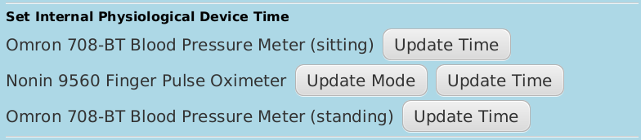

### Marsden M430 scales

The Marsden scales can only transmit its data in real time and even though time can be set on the device itself MediPi opts to use its own timestamp so no synchronisation is necessary.

### Braun Pro 6000 Tympanic Thermometer

As the input from this device is a manual process the timestamp comes from the MediPi Patient unit and no synchronisation is necessary.

### Omron 708-BT Blood Pressure Meter

To set the time on the device press “Update Time” on the MediPi Screen then carefully follow the words and picture instructions displayed: (taken from the Omron guide)

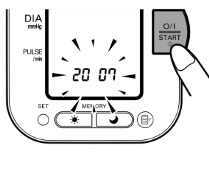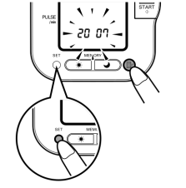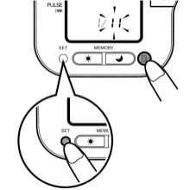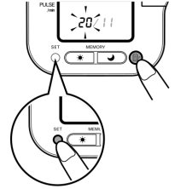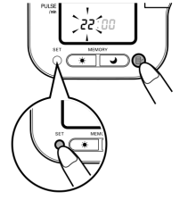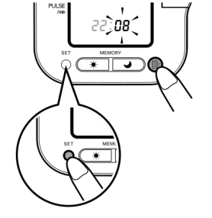

111

711

611

511

411

211

1. Use MediPi's clock as the timesource for setting the device clock – BUT SET THE BP DEVICE CLOCK TO BE 1 MINUTE BEHIND THE MEDIPI PATIENT DEVICE TIME (MediPi patient device will reject any readings which are in the future, but will tolerate some backwards drift – the initial setup is that the BP device time can be up to 1 hour behind the MediPi Patient device). Make sure the Omron device is OFF, then press and hold the "SET" button until the year digits flash on the display. Alternatively, if the unit is turned on for the first time after inserting batteries, the year digits (2007) will flash on the display.

2. Press the MEMORY button to advance the digits one at a time. Notes: The range for the year setting is 2007 to 2030. If the year reaches 2030, it will return to 2007. If you hold down the MEMORY button, the digits will advance rapidly.3. Press the SET button to confirm the setting when the desired number appears on the display. The year is set and the month digits flash on the display.4. Repeat steps 2 and 3 to set the month. The month is set and the day digits flash on the display.5. Repeat steps 2 and 3 to set the day. The day is set and the hour digits flash on the display.6. Repeat steps 2 and 3 to set the hour. The hour is set and the minutes digits flash on the display.7. Repeat steps 2 and 3 to set the minutes. The minutes settings is set. The unit automatically turns itself off after the minute setting has been set. To adjust the date and time, press the SET button while the unit is in standby mode.

### Nonin 9650 Finger Pulse Oximeter

To set the time on the device press “Update Time” on the MediPi Screen then carefully follow the words and picture instructions displayed:

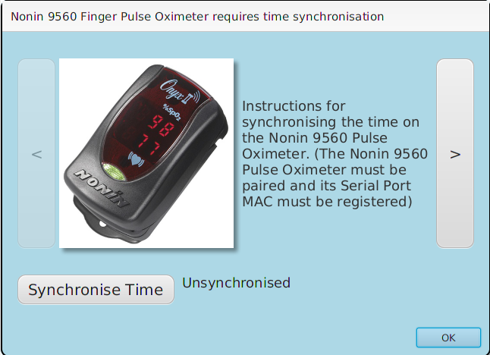

### Bluetooth Device Requirement Table

|  |  |  |  |
| --- | --- | --- | --- |
| Physiological Device | Bluetooth pairing required | Bluetooth MAC address required | Internal clock requires setting |
| Marsden M430 Scales | Y | Y | N |
| Omron 708 BT Blood Pressure Cuff | Y | N | Y |
| Nonin 9560 Pulse Oximeter | Y | Y | Y |
| Braun Pro 6000 Tympanic Thermometer | N | N | N |

## Adjust the MediPi Patient Schedule

The MediPi Schedule reminds the patient to take their readings every scheduled period and combines the process of taking each individual reading and the transmission of the data into one simple procedure. New Readings Schedules can be defined and created using this screen.

Each device (physiological and the questionnaire screen) is listed and is available for selection or deselection in the new schedule (The transmitter is selected by default and cannot be deselected as it is necessary for the transmission of the data to the clinicians).

Select/deselect these checkboxes as directed by the clinicians for each patient.

“Scheduled Initialisation Time”: This is the time at which the first schedule of a series is due to start. Along with the “Schedule Repeat Time”, it is used to calculate all subsequent schedule start times. A valid date and time for the Schedule Initialisation Time must be input and can be set to start in the past or the future but not before the a pre-existing schedule’s initialisation time. The Repeat time is measured in minutes (N.B. 24 hours = 1440 minutes). **The default “Schedule Initialisation Time” and the “Schedule Repeat Time” are set to start overnight and repeat every 24 hours – there should be no need to change this value.**

When all the relevant information has been entered, click on “Save new Schedule” button. Note: If you close the MediPi Admin software without clicking “Save new Schedule” the changes will be lost and not be saved.

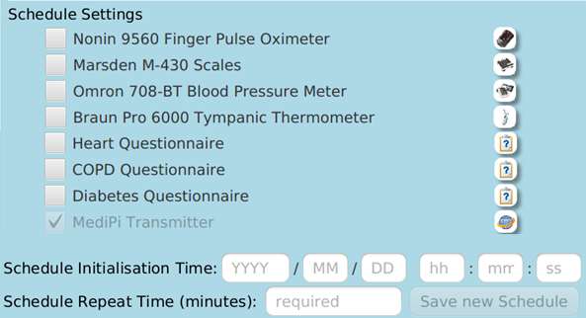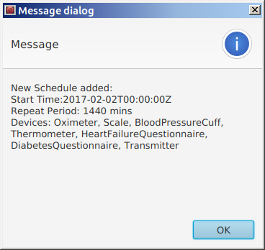

## Power down the MediPi Patient Device

It is important to power down the MediPi Patient Device properly. Press the raspberry button on the taskbar:  and select “Shutdown..” from the menu then press the Shutdown button. It is our experience that if you wish to reboot the MediPi Patient Device, it is quicker to use Shutdown and unplug and plug the power adaptor in rather than use the Reboot button.