Masterarbeit: IK_RL MVP – Three-Axis Dilemma
Masterarbeit
Master of Science im Studiengang Maschinenbau/Produktentwicklung
an der Fakultät für Anlagen-, Energie- und Maschinensysteme
der Technischen Hochschule Köln
Projektteilnehmer: Vanya Aziz
Matrikel-Nr.: 11136876
Adresse: Deutz-Kalker-Str. 118
50679 Köln
vaziz@th-koeln.de
Professor: Prof. Dr. Anja Richert
Betreuer: Dario Luipers, M.Sc.

Köln, 05.02.2020

Letzte Änderung: 15.02.2021

Inhalt
Masterarbeit: IK_RL MVP – Three-Axis Dilemma I
Inhalt 2
1. Problem: The output of the PPO agent diverges [Max., Max., Min] 3
1.1 Observations 3
1.2 Potential Solutions 3 Axes 4
1.2.1 Standard Configuration 4
1.2.2 Solutions 5

Problem: The output of the PPO agent diverges [Max., Max., Min]

Observations
i) As expected, the divergence speed is highly dependent on the learning rate
ii) AI algorithms for continuous action spaces are not dimensioned for multiple
action outputs. This is especially true for actor-critic algorithms. The network
head will have always two output heads:
1. One Parameter for the mean value
2. One Parameter for the standard deviation
Action is selected according to the Gaussian probability distribution.
iii) No counter measures help to contain the action range in a defined interval.
Measures only help temporarily, and even then the actions space must be defined
very liberally as to prevent getting stuck on them from the very beginning.
iv) Interesting behavior: Even with one action output, as is recommended for PPO,
if the learning rate is too high, the action selection will always be the boundaries!
v) The max. IK points as for now are 2. The agent will never be rewarded for the
self._contact_with_force. It is better to reward it when the object is between the
fingers.

Potential Solutions 3 Axes

Standard Configuration
- Partial Solutions:
Solution_13: Punishment of the crash is multiplied by the max. allowable
trajectory points.
Solution_14: Reduction of the trajectory. Based on Iterations_Conclusions
Section 2
Solution_15: Not punished for depleting trajectory points without reaching
its objective
Solution_28: Change termination coditions in the for- and while loop
GENERAL: Liberal Action Space
- Configuraiton:
a) Network Architecture: [200,200]
b) Controlled Axis: 3
c) self._max_IK_points: 2
d) Action Space: [-5, -5, -5] [5, 5, 5]
i) gamma = 0.99
ii) n_steps = 2
iii) entropy_coef = 0.01
iv) learning_rate = 5e-4
v) vf_coef = 0.5
vi) max_grad_norm = 0.5
vii) lam = 0.95
viii) n_minibatches = 1
ix) noptepochs = 4
c) cliprange = 0.2

Solutions
1) Solution 1
Punish the agent whenever it selects the boundaries and terminate the episode.
- Configuraiton:
a) Network Architecture: [150,150]
b) Controlled Axis: 3
c) self._max_IK_points: 2
d) Action Space: [-2, -2, -2] [2, 2, 2]
i) gamma = 0.99
ii) n_steps = 2
iii) entropy_coef = 0.01
iv) learning_rate = 5e-4
v) vf_coef = 0.5
vi) max_grad_norm = 0.5
vii) lam = 0.95
viii) n_minibatches = 1
ix) noptepochs = 4
c) cliprange = 0.2
- Result Training; Time to reach plateuing in reward (START: 23:14;END: 00:05 )
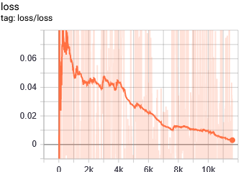
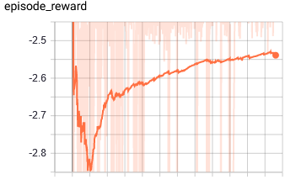

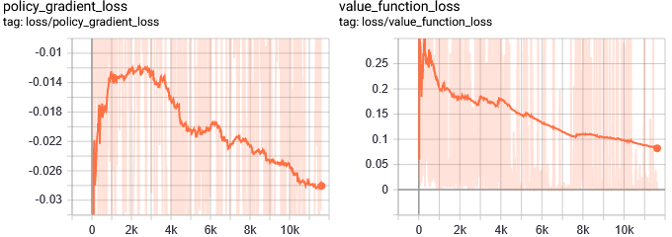

- Notes:
- It gets punished by self._max_IK_points + 1in case of boundary selection
Selection of boundaries significantly reduced.
- Converges to the "crash" value.
- Possible improvements:
- Subtract the punishment for the crash by each IK point execution that didn’t
crash in order to exterminate the "suicide" behavior.
2) Based on 1)
Exterminate episode termination tendency by reducing the punishment of the crash
dependent on the previously executed crash-free targets.
reward -= (self._max_IK_points – self._previously_crashless)
- Configuraiton:
a) Network Architecture: [150,150]
b) Controlled Axis: 3
c) self._max_IK_points: 2
d) Action Space: [-2, -2, -2] [2, 2, 2]
i) gamma = 0.99
ii) n_steps = 2
iii) entropy_coef = 0.01
iv) learning_rate = 5e-4
v) vf_coef = 0.5
vi) max_grad_norm = 0.5
vii) lam = 0.95
viii) n_minibatches = 1
ix) noptepochs = 4
c) cliprange = 0.2
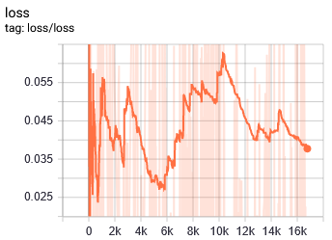
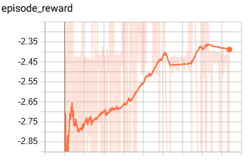
- Result Training; min.; START: 01:00;END: 02:18

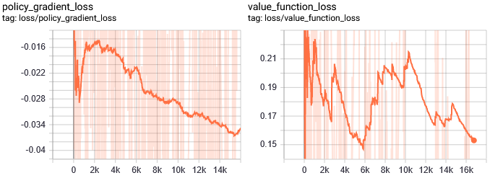

- Notes:
- Temporarily reaches a much higher average reward of approximately -0.98.
- Plateaus prematurely.
- Boundaries are not selected!
- Doesn't seem to be sensitive toward the position of the object

3) Based on 1)
Do not punish for crash; do not terminate episode if crashed. Solution 2) in this case
can be omitted.
Terminates, if the boundaries are selected!
- Configuraiton:
a) Network Architecture: [150,150]
b) Controlled Axis: 3
c) self._max_IK_points: 2
d) Action Space: [-2, -2, -2] [2, 2, 2]
i) gamma = 0.99
ii) n_steps = 2
iii) entropy_coef = 0.01
iv) learning_rate = 5e-4
v) vf_coef = 0.5
vi) max_grad_norm = 0.5
vii) lam = 0.95
viii) n_minibatches = 1
ix) noptepochs = 4
c) cliprange = 0.2
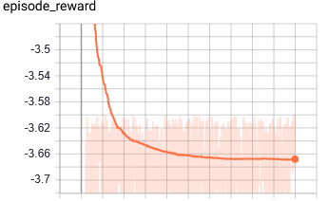
- Result Training; min.; START: 14:41;END: 15:01
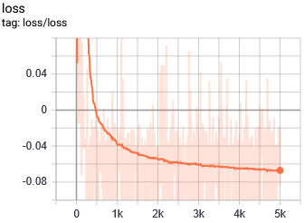

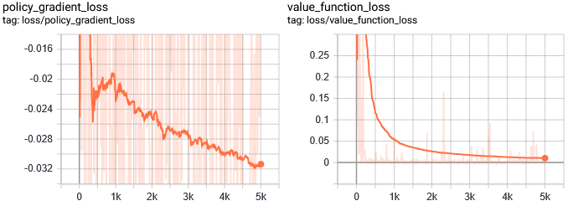

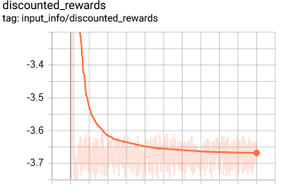

- Notes:
- In the beginning, the rewards are around -0.6x, actions selected have realistic
values. After the first updates it very quickly converges to the worst reward by
always picking the boundary values
Why?

4) Based on 1) + 3)
- Do not punish for crash; do not terminate episode if crashed
- Punish the agent whenever it selects the boundaries and terminate the episode.
- Configuraiton:
a) Network Architecture: [150,150]
b) Controlled Axis: 3
c) self._max_IK_points: 2
d) Action Space: [-2, -2, -2] [2, 2, 2]
i) gamma = 0.99
ii) n_steps = 2
iii) entropy_coef = 0.01
iv) learning_rate = 5e-4
v) vf_coef = 0.5
vi) max_grad_norm = 0.5
vii) lam = 0.95
viii) n_minibatches = 1
ix) noptepochs = 4
c) cliprange = 0.2
- Results after training; START: 15:12 ; END: 15:26
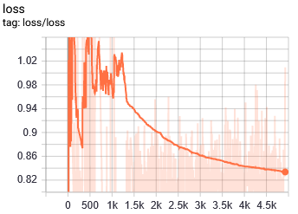
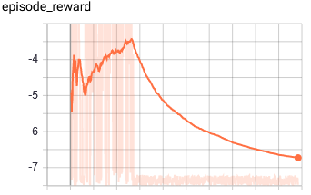

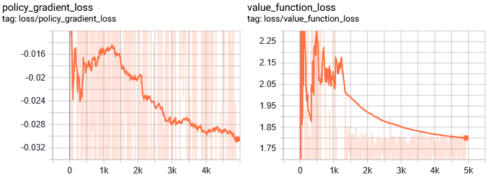

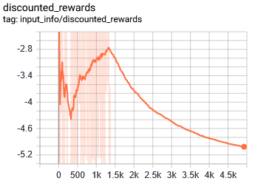

- Notes:
- For future tests: Do you have to terminate the episode after crashing? Isn't
punishment enough?
- Even reaches a positive value of 0.8 before the model breaks!
- Breaking point: Where value loss drops sudddenly.

5) Solution 5 – Extension by Propertiy of 2)
- Do not terminate after crash, just punish!
- Do not terminate after boundary selection, just punish
- Just terminate the IK process in case of a crash
- Do NOT terminate the IK process based on the selection of the boundary values. Boundary. values must lead to crash in order to stop the IK execution
- Configuraiton:
a) Network Architecture: [150,150]
b) Controlled Axis: 3
c) self._max_IK_points: 2
d) Action Space: [-2, -2, -2] [2, 2, 2]
e) Reward Dist. Norm: No
i) gamma = 0.99
ii) n_steps = 2
iii) entropy_coef = 0.01
iv) learning_rate = 5e-4
v) vf_coef = 0.5
vi) max_grad_norm = 0.5
vii) lam = 0.95
viii) n_minibatches = 1
ix) noptepochs = 4
c) cliprange = 0.2
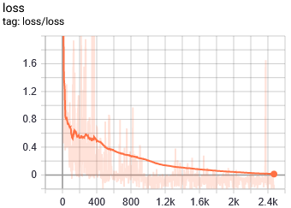
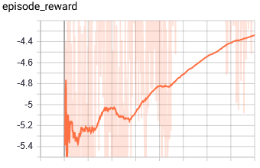
- Results; START: 18:16;END: 18:27

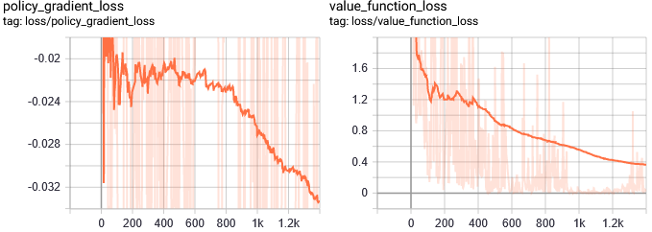

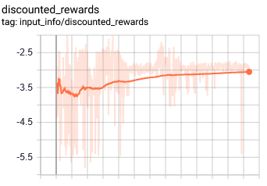

- Notes:
- Actions approach the limtis!
- Very bad run

6) Solution 6
- ONLY reward -= (self._max_IK_points – self._previously_crashless); no
punishment for selecting the boundary!
- Configuraiton:
a) Network Architecture: [150,150]
b) Controlled Axis: 3
c) self._max_IK_points: 2
d) Action Space: [-2, -2, -2] [2, 2, 2]
i) gamma = 0.99
ii) n_steps = 2
iii) entropy_coef = 0.01
iv) learning_rate = 5e-4
v) vf_coef = 0.5
vi) max_grad_norm = 0.5
vii) lam = 0.95
viii) n_minibatches = 1
ix) noptepochs = 4
c) cliprange = 0.2
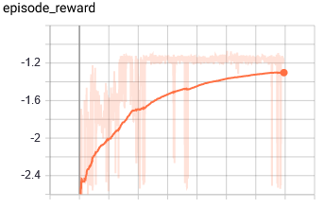
- Results; START: 21:24;END:XX:XX
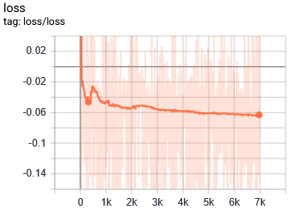

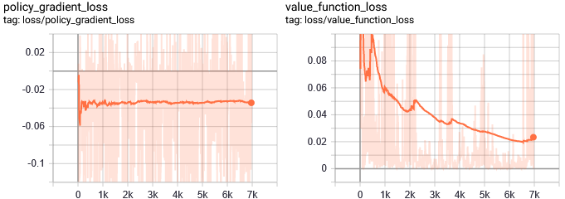

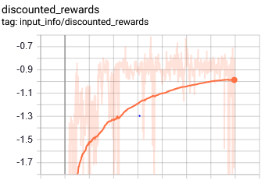
- Notes:
- Converges to the limits; usually [Max., Max., Max.] with low rewar around
-0.6x

7) Based on solution 6
- Eliminate any positions that can cause the final position of the EE not to be the same as the action ouput. This happens mostly, when very large values axis are selected.
- Configuration:
a) Network Architecture: [150,150]
b) Controlled Axis: 3
c) self._max_IK_points: 2
d) Action Space: [0.25, -0.4, 0.55] [0.55, 0.8, 0.9]
i) gamma = 0.99
ii) n_steps = 2
iii) entropy_coef = 0.01
iv) learning_rate = 5e-4
v) vf_coef = 0.5
vi) max_grad_norm = 0.5
vii) lam = 0.95
viii) n_minibatches = 1
ix) noptepochs = 4
c) cliprange = 0.2
- Results; START: 12:06 ; END:
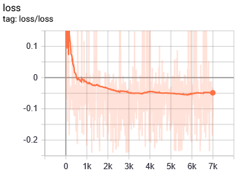
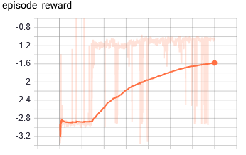

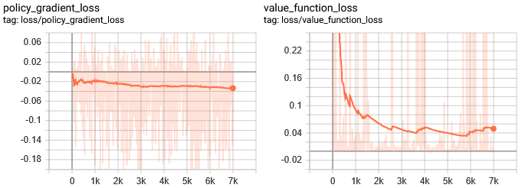

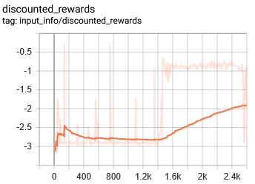

- Notes:
- Actions are always [0.55 0.8 0.9 ]; [Max., Max., Max.]

8) Solution 2; different configuration
Exterminate episode termination tendency by reducing the punishment of the crash
dependent on the previously executed crash-free targets.
reward -= (self._max_IK_points – self._previously_crashless)
- Configuraiton:
a) Network Architecture: [150,150]
b) Controlled Axis: 3
c) self._max_IK_points: 2
d) Action Space: [0.25, -0.4, 0.55] [0.55, 0.8, 0.9]
i) gamma = 0.99
ii) n_steps = 2
iii) entropy_coef = 0.01
iv) learning_rate = 5e-4
v) vf_coef = 0.5
vi) max_grad_norm = 0.5
vii) lam = 0.95
viii) n_minibatches = 1
ix) noptepochs = 4
c) cliprange = 0.2
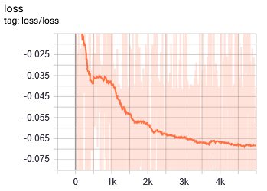
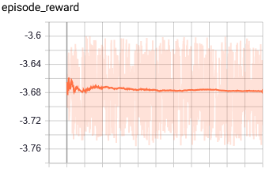
- Results: START: 14:15;END: 14:35

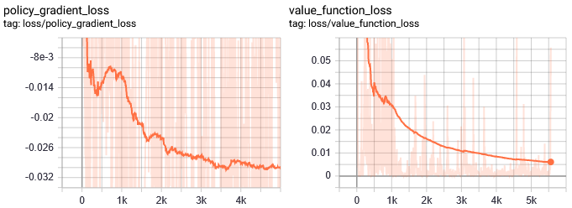

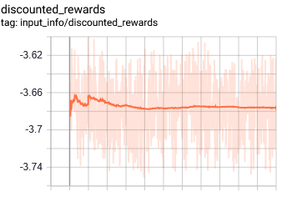

- Notes:
- Very quickly the action selection converges to [0.25, -0.4, 0.55] (min,min,min)

9) Based on 2)
- With reward normalization:
Distance reward, Crash reward, Boundary selection reward
- Action Space in the recommended interval of -1 and 1
- Configuraiton:
a) Network Architecture: [150,150]
b) Controlled Axis: 3
c) self._max_IK_points: 2
d) Action Space: [-1, -1, -1] [1, 1, 1]
i) gamma = 0.99
ii) n_steps = 2
iii) entropy_coef = 0.01
iv) learning_rate = 5e-4
v) vf_coef = 0.5
vi) max_grad_norm = 0.5
vii) lam = 0.95
viii) n_minibatches = 1
ix) noptepochs = 4
c) cliprange = 0.2
- Result; START:16:06; END: 16:06
- Non-sense behavior.

- Notes:
- Action selection converegs to [-1, 1, -1] in the 20 first steps.
- After a while tires [1, 1, -1]
- After yet another time interval it tries [-1, -1, -1]
- The [1, -1, -1]

10) 9) with different actionspace
- Crash punishment is -0.95, boundary punishment is -1
a) Network Architecture: [150,150]
b) Controlled Axis: 3
c) self._max_IK_points: 2
d) Action Space: [-2, -2, -2] [2, 2, 2]
i) gamma = 0.99
ii) n_steps = 2
iii) entropy_coef = 0.01
iv) learning_rate = 5e-4
v) vf_coef = 0.5
vi) max_grad_norm = 0.5
vii) lam = 0.95
viii) n_minibatches = 1
ix) noptepochs = 4
c) cliprange = 0.2
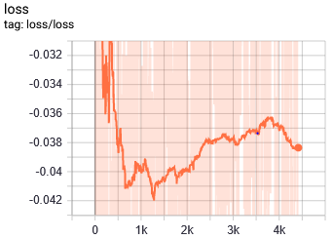
- Result; START:17:21; END: 17:41
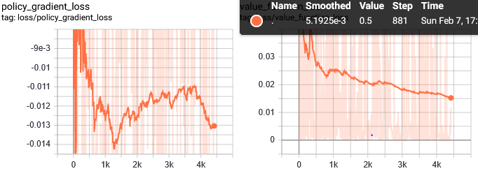
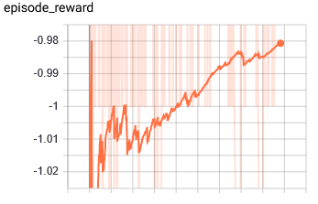

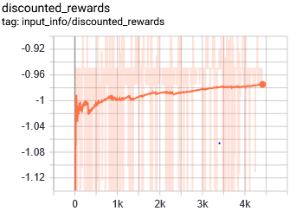

- Notes:

11) Based on 10) with normalized reward
- Do not terminate episode, if boundary values are selected; punish only
- Configuraiton:
a) Network Architecture: [150,150]
b) Controlled Axis: 3
c) self._max_IK_points: 2
d) Action Space: [-2, -2, -2] [2, 2, 2]
i) gamma = 0.99
ii) n_steps = 2
iii) entropy_coef = 0.01
iv) learning_rate = 5e-4
v) vf_coef = 0.5
vi) max_grad_norm = 0.5
vii) lam = 0.95
viii) n_minibatches = 1
ix) noptepochs = 4
c) cliprange = 0.2
- Results: START:20:45;END:21:05

Mistake: Due to the nature of the reward design, the negative reward at the end of the
episode is higher when the agent does not crash in the first step.
Soultions: Relative Reward depending on the current distance between the
EE and goal and that distance in the previous step.

12) Based on 11), but the mistake of the higher punishment in case of not crahsing
is fixed by relative rewards. Termination if boundary is selected.
Now it only gets a overall more reward in case of surviving IK-point=1 when it
diverges in the first run and crashes in the second.
Restructutring the architecture:
- Reward Calulations are isolated in a method, i.e., all distance calulations
- The point is to calculate the difference in distance before and after the
action execution
- Episode termination when reaching the goal is omitted for now.
- Configuraiton:
a) Network Architecture: [150,150]
b) Controlled Axis: 3
c) self._max_IK_points: 2
d) Action Space: [-2, -2, -2] [2, 2, 2]
i) gamma = 0.99
ii) n_steps = 2
iii) entropy_coef = 0.01
iv) learning_rate = 5e-4
v) vf_coef = 0.5
vi) max_grad_norm = 0.5
vii) lam = 0.95
viii) n_minibatches = 1
ix) noptepochs = 4
c) cliprange = 0.2
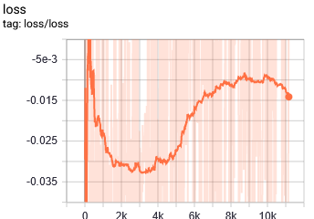
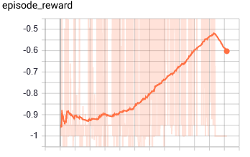
- Results: START: 15:06;END: 16:00

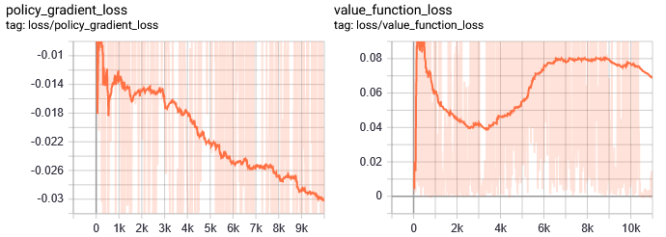

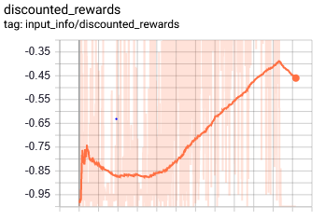

- Notes:
- Best run until now with three axes.
- At the breaking point after episode 10K:
It tries to reach a "good" EE pos, but the actions that lead to this good position are
the limits!
Action:
[2, 2, 2,]
Reached position:
(0.5838464688618944, 0.8872927706460313, 1.00259819545266)
Theoretically a good position
We see, because selecting the limits leads to undefined behaviour,
selecting them can sometimes lead to a "good" position. But it still gets
highly negative reward. This breaks the policy
Solution: Prevent the endeffector to go beyond its reach without limiting
the action boundaries.
OR: Do not punish for selection of boundary. Punish. based on dist. only.
- Observations when running he model:
- In the first step it often learns to position itself approximately above the
object, reducing its z-value.
But it always goes up after that because it previously experienced crashes
in the lower z-ranges!
13) 12) with different action space; see if conservative action space works in this
version. To prevent out-of-reach undefined behavior with a.s. limitation.
- Because now it is much more probable that a limit interval is selected and that
the limit isn’t inherently bad, the boundary selection punishment must be activated
- Configuraiton:
a) Network Architecture: [150,150]
b) Controlled Axis: 3
c) self._max_IK_points: 2
d) Action Space: [0.25, -0.5, 0.55] [0.7, 0.8, 1]
i) gamma = 0.99
ii) n_steps = 2
iii) entropy_coef = 0.01
iv) learning_rate = 5e-4
v) vf_coef = 0.5
vi) max_grad_norm = 0.5
vii) lam = 0.95
viii) n_minibatches = 1
ix) noptepochs = 4
c) cliprange = 0.2
- Results; START: 16:29; END: 17:00
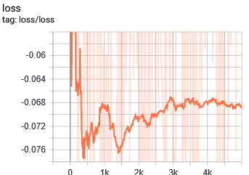
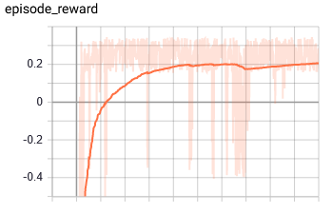
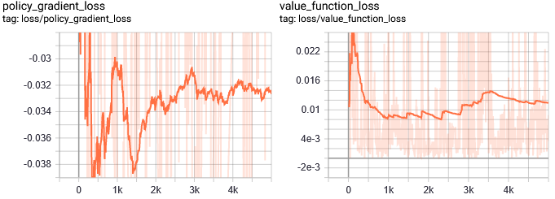
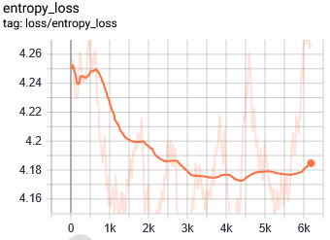
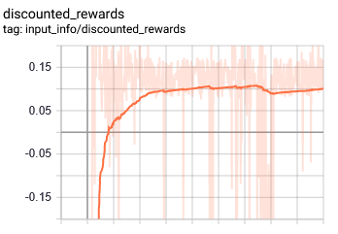

- Notes:
- It get stuck in the limits, even though the observation space and reward values are
all normalized.
- Eventually the network architecture in this configuration always leads to high
activation due to the many parameters.
Solution: Kernel initialization?
- Might reduce the cliprange to eliminate hugh updates. (oscillation between
min. and max.)

14) Solution 13 + smaller cliprange.
- Configuraiton:
a) Network Architecture: [150,150]
b) Controlled Axis: 3
c) self._max_IK_points: 2
d) Action Space: [0.25, -0.5, 0.55] [0.7, 0.8, 1]
i) gamma = 0.99
ii) n_steps = 2
iii) entropy_coef = 0.01
iv) learning_rate = 5e-4
v) vf_coef = 0.5
vi) max_grad_norm = 0.5
vii) lam = 0.95
viii) n_minibatches = 1
ix) noptepochs = 4
c) cliprange = 0.1
- Results: START: 17:21;END: 17:37
- Same as 13)
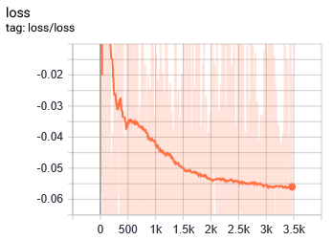
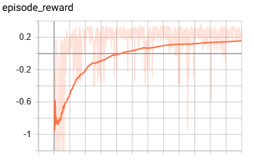
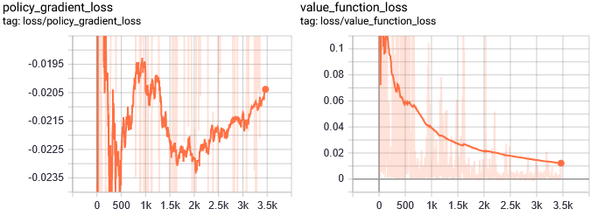

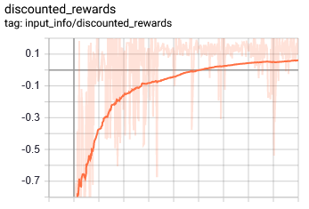

- Notes:
- Same as 13); No effect observed.

15) 12), but do not punish for the action boundary selection and do not terminate. Pun
-ishment based only on distance.
- Configuration:
a) Network Architecture: [150,150]
b) Controlled Axis: 3
c) self._max_IK_points: 2
d) Action Space: [-2, -2, -2] [2, 2, 2]
i) gamma = 0.99
ii) n_steps = 2
iii) entropy_coef = 0.01
iv) learning_rate = 5e-4
v) vf_coef = 0.5
vi) max_grad_norm = 0.5
vii) lam = 0.95
viii) n_minibatches = 1
ix) noptepochs = 4
c) cliprange = 0.2
- Results: START:XXXXX;END:XXXX
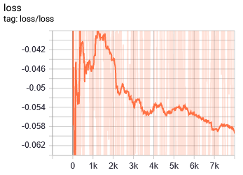
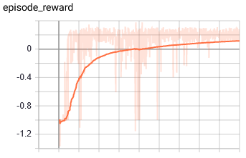
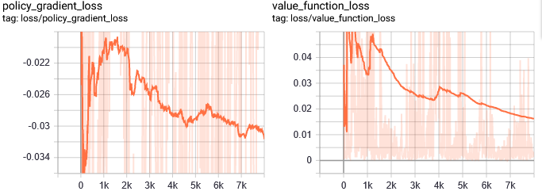

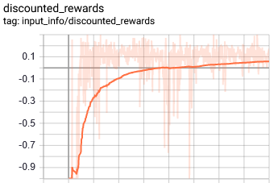

- Notes:
- Actions converge to [2, 2, 2]
- First step:
[2. 2. 2.]
(0.5838464688618944, 0.8872927706460313, 1.00259819545266
The reward is_:0.2287179340912756
- Second step:
[2. 2. 2.]
(0.6428589974070759, 0.8346729725383953, 1.0056234193489753)
The reward is_:0.02781085108229675

16) Based on 12), with different horizon and minibatch numbers
a) Network Architecture: [150,150]
b) Controlled Axis: 3
c) self._max_IK_points: 2
d) Action Space: [-2, -2, -2] [2, 2, 2]
i) gamma = 0.99
ii) n_steps = 20
iii) entropy_coef = 0.01
iv) learning_rate = 5e-4
v) vf_coef = 0.5
vi) max_grad_norm = 0.5
vii) lam = 0.95
viii) n_minibatches = 4
ix) noptepochs = 4
c) cliprange = 0.2
- Results of first training session: START: 22:33;END:01:45
Much more stable learning process, although it plateus eventually
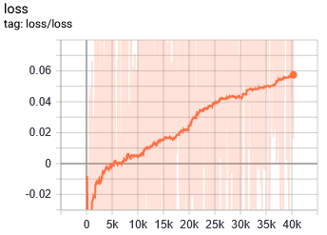
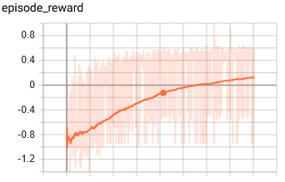

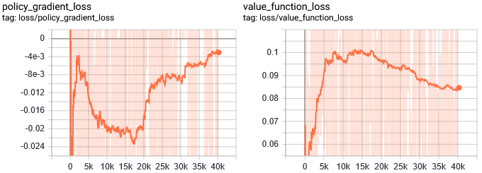

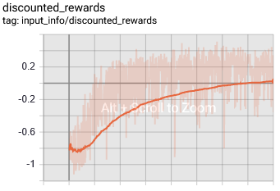

- Notes:
- The position of the goal is still not considered very important. The agent is not
sensitive towards it at all. Overfitting
Significantly change the objects position (50/50 right/left tray)
Or communicate the distance to it.

17) Test – Environment
- To test if one action, normalized reward, observation and action still leads to
the selection of an interval boundary
- Reduce agent output to one dimension with boundary [-1, 1]
- Map the output to x-, y- and z-coordinates.
- Make sure, that there are no "jumps", i.e., similar outputs must lead to points
in the same neighbourhood.
- Since the reward accumulation is always positive in
- The agent is not punished, when boundaries are selected!
- Configuration
a) Network Architecture: [150,150]
b) Controlled Axis: 3
c) self._max_IK_points: 2
d) Action Space: [-1, 1]
i) gamma = 0.99
ii) n_steps = 20
iii) entropy_coef = 0.01
iv) learning_rate = 5e-4
v) vf_coef = 0.5
vi) max_grad_norm = 0.5
vii) lam = 0.95
viii) n_minibatches = 4
ix) noptepochs = 4
c) cliprange = 0.2
- Results: START: 16:00; END: 16:55
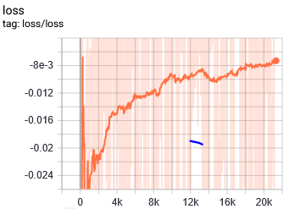
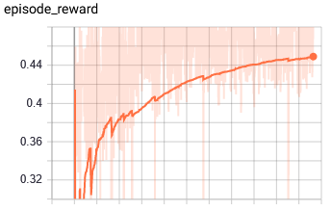

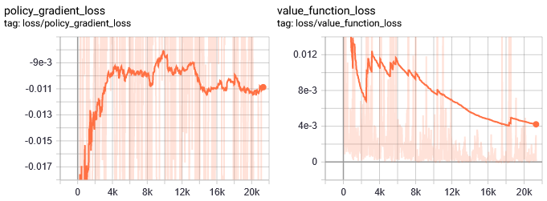
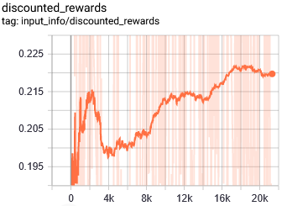
- Notes:
- In the beginning it picks the interval boundaries over proportiionally, but shortly
after this behavior diminishes.
- It has a clear tendency towards actions [-0.2, 0] and [0, 0.2], of which both
give a very high reward, on the average 9/20 compared to the other intervalls

18) Identical to 17), but with a much higher learning rate, lower gamma
- Since the test environment is very simple, convergence will be tested with
higher learning rate.
- For this simple example, it is better if the agent seeks the immediate reward.
- Configuration
a) Network Architecture: [150,150]
b) Controlled Axis: 3
c) self._max_IK_points: 2
d) Action Space: [-1, 1]
i) gamma = 0.2762516677
ii) n_steps = 20
iii) entropy_coef = 0.01
iv) learning_rate = 5e-2
v) vf_coef = 0.5
vi) max_grad_norm = 0.5
vii) lam = 0.95
viii) n_minibatches = 4
ix) noptepochs = 4
c) cliprange = 0.2
- Results: START: 23:02; END: 23:37
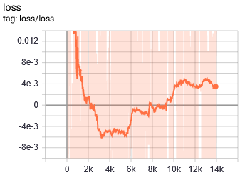
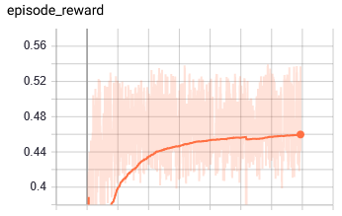
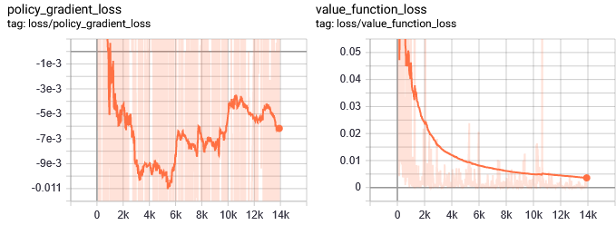

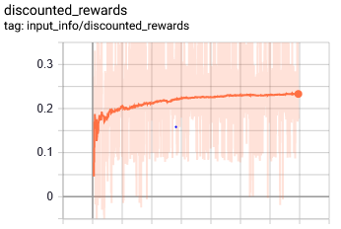

- Notes:
- Does not work with LR = 0.05
- LR = 0.005:
- Seems to learn for a bit, after 8 minutes it diverges to boundary
selection!
- Converges only with LR = 0.00015. After 30 minutes it learns to select the correct
action on approximately 80% of the time.

19) Like 16), that is based on 12)
- Trays + object closer to robot by reducing x by 0.14mm. Object lesser dev. (10mm)
Small change in orn was necessary to for correct alignment.
- Gamma only slightly reduced to 0.95 to have good comparison basis
- Configuraiton:
a) Network Architecture: [150,150]
b) Controlled Axis: 3
c) self._max_IK_points: 2
d) Action Space: [-2, -2, -2] [2, 2, 2]
i) gamma = 0.95
ii) n_steps = 20
iii) entropy_coef = 0.01
iv) learning_rate = 5e-4
v) vf_coef = 0.5
vi) max_grad_norm = 0.5
vii) lam = 0.95
viii) n_minibatches = 4
ix) noptepochs = 4
c) cliprange = 0.2
- Results: START:15:08; END: 20:50

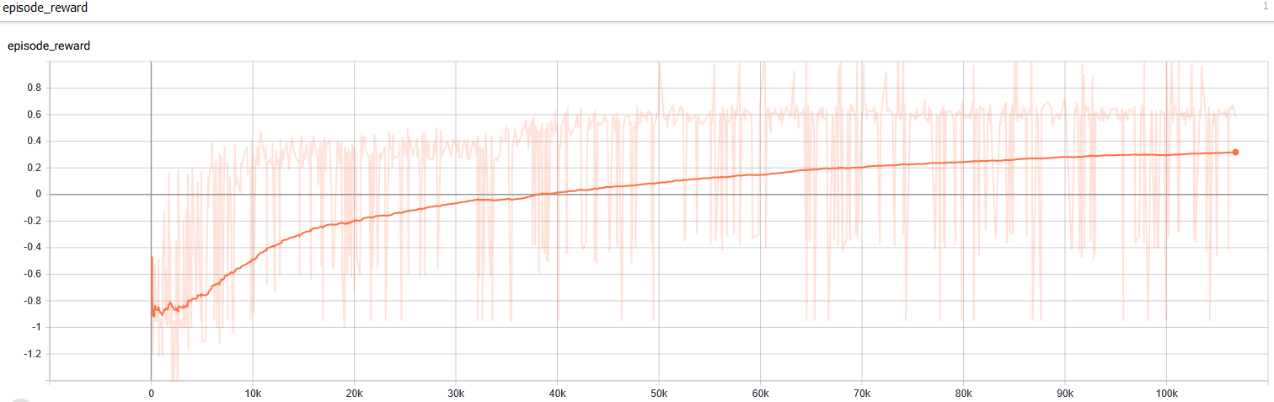

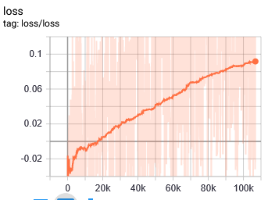

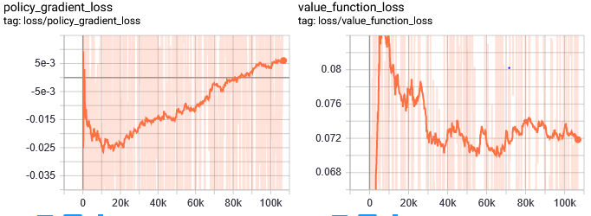

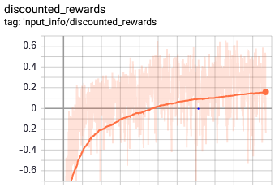

- Notes:
- Best run yet
- After a while the selected positions are always in the possible robot range so
that action = EE-pos after execution.
- After a while the agent learns to be more sensitive towards the object position,
but it still remains in the proximity of where it originally spawns even when the
object is thrown far away (although it tries to follow it, but in very small steps)

20) Like 19, but the object is spawned in the other tray half of the time.
- Configuraiton:
a) Network Architecture: [150,150]
b) Controlled Axis: 3
c) self._max_IK_points: 2
d) Action Space: [-2, -2, -2] [2, 2, 2]
i) gamma = 0.95
ii) n_steps = 20
iii) entropy_coef = 0.01
iv) learning_rate = 5e-4
v) vf_coef = 0.5
vi) max_grad_norm = 0.5
vii) lam = 0.95
viii) n_minibatches = 4
ix) noptepochs = 4
c) cliprange = 0.2
- Results: START: 23:46; END: 02:30

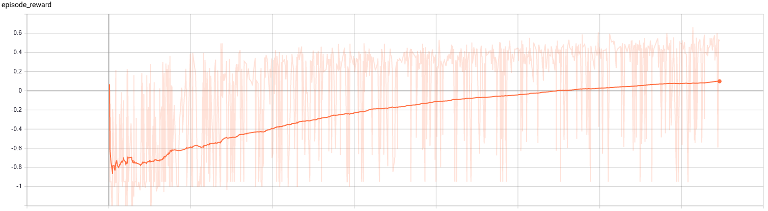

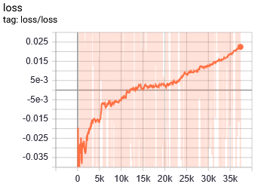

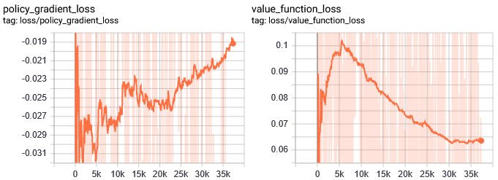
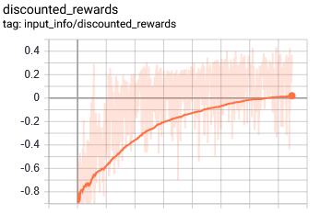
- Notes:
- Seems to reach a higher value earlier then 19). Could be the lesser distance from
EE to goal and from geal to target_pos.

21) Significantly increase the time to converge with utilization of multiple CPU cores.
Based on 19)
- Configuraiton:
a) Network Architecture: [150,150]
b) Controlled Axis: 3
c) self._max_IK_points: 2
d) Action Space: [-2, -2, -2] [2, 2, 2]
i) gamma = 0.95
ii) n_steps = 20
iii) entropy_coef = 0.01
iv) learning_rate = 5e-4
v) vf_coef = 0.5
vi) max_grad_norm = 0.5
vii) lam = 0.95
viii) n_minibatches = 4
ix) noptepochs = 4
c) cliprange = 0.2
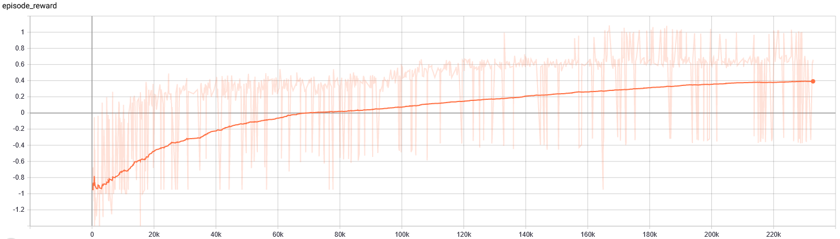
- Results: START: 13:46 END: 19:30

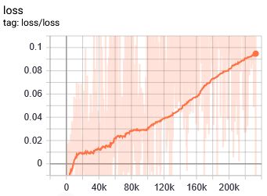

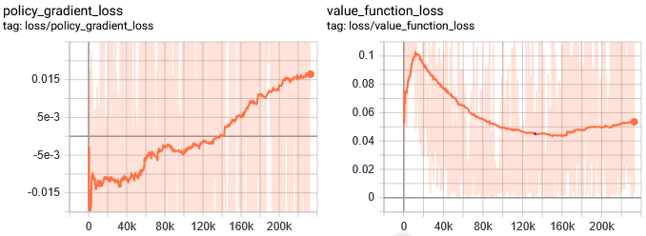
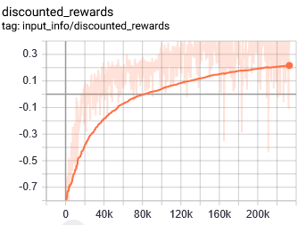

- Notes:
- All cores were utilized, but the horizon was not changed. leading to a much more
stable learning process at the same convergence speed.
- It seems that around episode 180K it reaches an even higher reward then solution
19)

22) The output is constrained to [-1, 1] and mapped to $R^{3}$. Everything else is based
on 21), which is the multiprocess version of 19)
- Configuraiton:
a) Network Architecture: [150,150]
b) Controlled Axis: 3
c) self._max_IK_points: 2
d) Action Space: [-1, 1]
i) gamma = 0.95
ii) n_steps = 20
iii) entropy_coef = 0.01
iv) learning_rate = 5e-4
v) vf_coef = 0.5
vi) max_grad_norm = 0.5
vii) lam = 0.95
viii) n_minibatches = 4
ix) noptepochs = 4
c) cliprange = 0.2
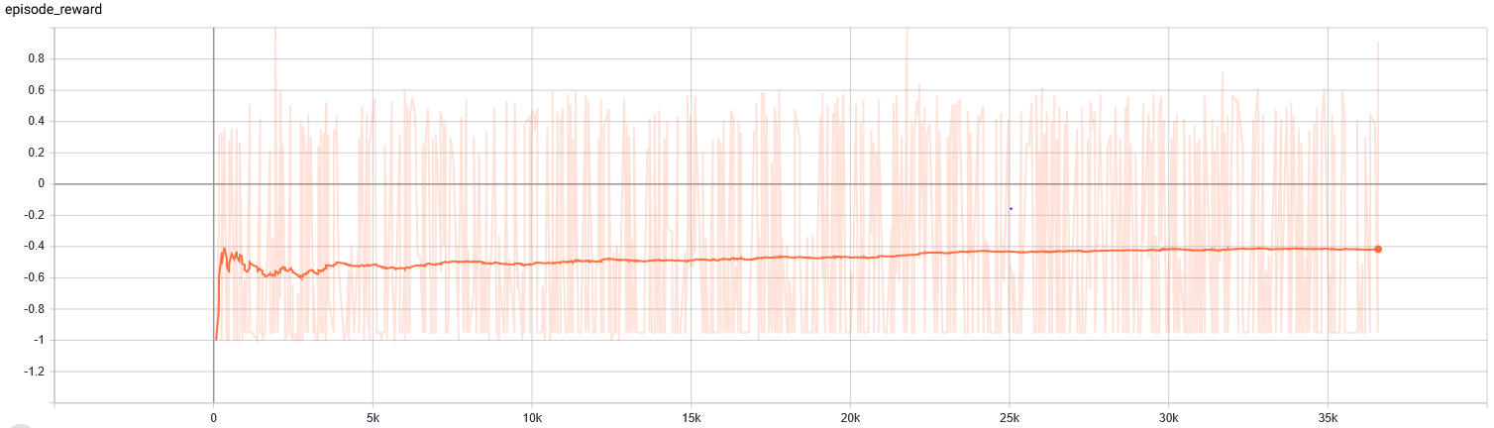
- Results; START: 12:47; END: 13:30

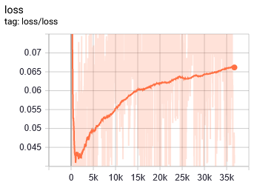

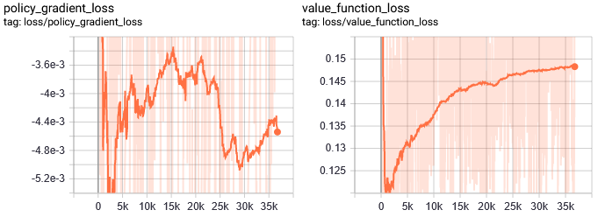
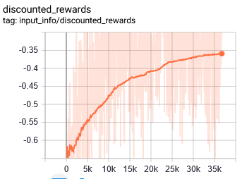

- Notes:
- Bad Run
- Unlike in solution 21), the episode reward does not gradually go up in the first 20K
episodes. It is highly noisy and the reward flattens around 30K.
Solutions:
i) Reduce the learning rate to the value of environment._step_size, that
way the agent can perform smaller updates that are necessary to
select the exact output, since a difference as small as 2.368096997253008e-05 corresponds to one centimeter.

23) Repeat 22) with learning rate = environment._step_size
- Change the grip reward to ray intersection reward
- Configuraiton:
a) Network Architecture: [150,150]
b) Controlled Axis: 3
c) self._max_IK_points: 2
d) Action Space: [-1, 1]
i) gamma = 0.95
ii) n_steps = 20
iii) entropy_coef = 0.01
iv) learning_rate = environment._step_size
v) vf_coef = 0.5
vi) max_grad_norm = 0.5
vii) lam = 0.95
viii) n_minibatches = 4
ix) noptepochs = 4
c) cliprange = 0.2
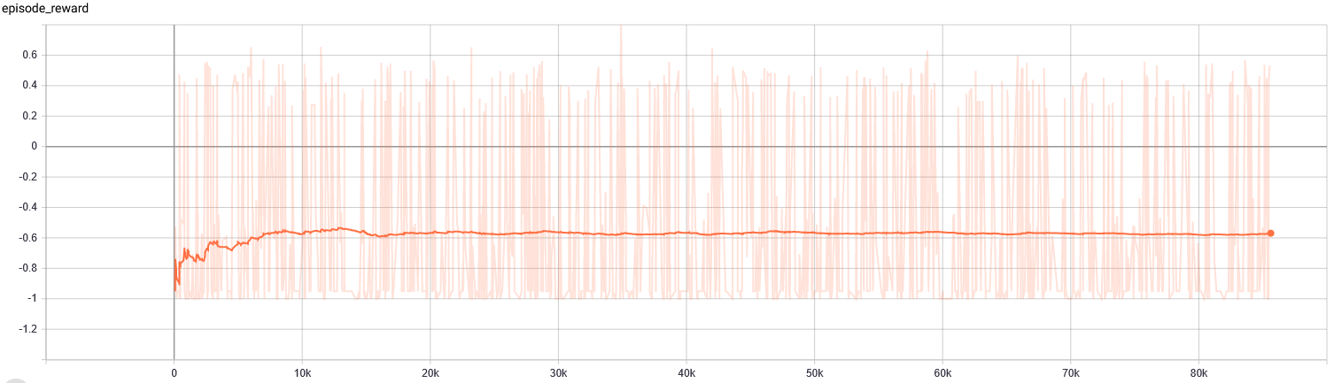
- Results: START: 15:38 ; END: 18:00

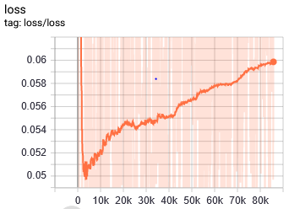

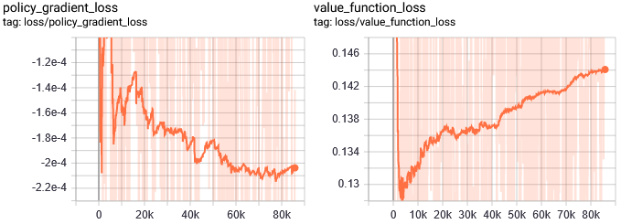
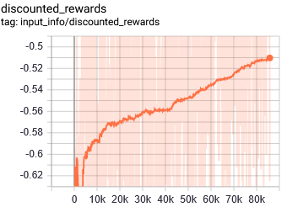
- Notes:
- Bad run
- Like 22), the reward does not converge despite the much lower learning rate.

24) Based on 22) and 23), but with a HIGHER learning rate.
- Configuraiton:
a) Network Architecture: [150,150]
b) Controlled Axis: 3
c) self._max_IK_points: 2
d) Action Space: [-1, 1]
i) gamma = 0.95
ii) n_steps = 20
iii) entropy_coef = 0.01
iv) learning_rate = 5e-3
v) vf_coef = 0.5
vi) max_grad_norm = 0.5
vii) lam = 0.95
viii) n_minibatches = 4
ix) noptepochs = 4
c) cliprange = 0.2
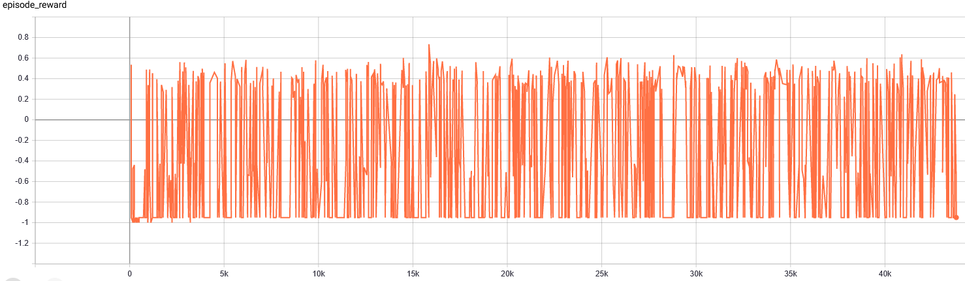
- Results: START: 18:53 ; END: 19:53

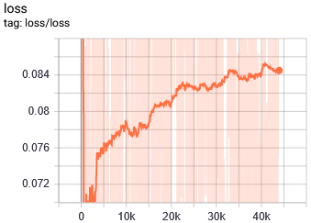

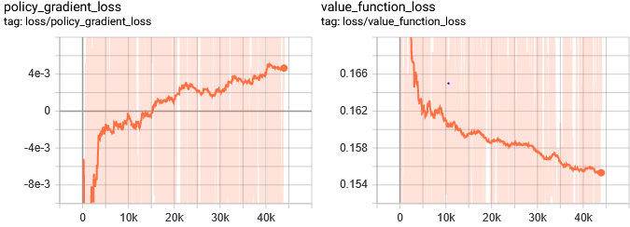

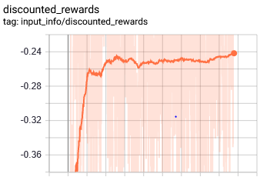
- Notes:
- Bad run
- Still doesn’t converge even with the much higher learning rate.

25) Based on 22), but the action space is higher in hopes to facilitate the selection of
the correct action.
- Configuraiton:
a) Network Architecture: [150,150]
b) Controlled Axis: 3
c) self._max_IK_points: 2
d) Action Space: [-100, 100]
i) gamma = 0.95
ii) n_steps = 20
iii) entropy_coef = 0.01
iv) learning_rate = 5e-4
v) vf_coef = 0.5
vi) max_grad_norm = 0.5
vii) lam = 0.95
viii) n_minibatches = 4
ix) noptepochs = 4
c) cliprange = 0.2
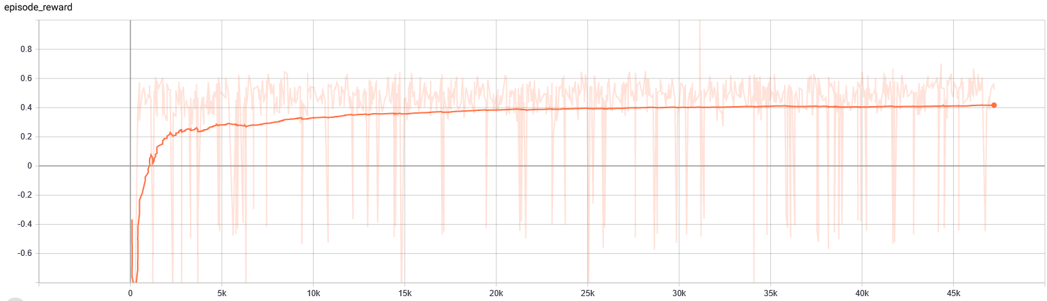
- Results: START: XX:XX; END: XX:XX, convergeces after approx. 10 minutes.

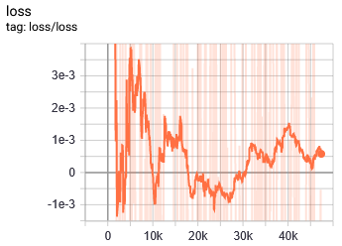

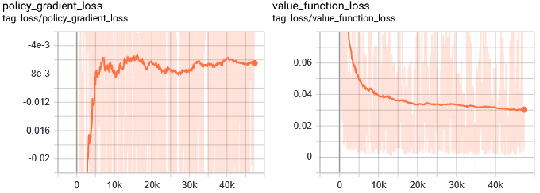
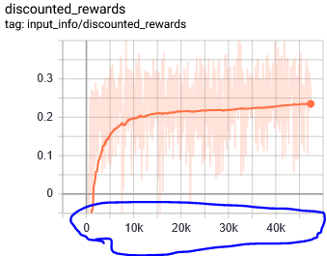
- Notes:
- Converges extremely quicky, after 20K, the max. reward for gripless and without
crashing is reached! This translates to maybe 15 minutes of training.
But it can be observed that it doesn’t seem to be very successful with picking it.
Higher resolution? Test with gradually going down to object with max. z – step.
- NOTE: Downward Spikes are less in magnitutde, although they appear to be more
frequent.
- Value loss looks very bad.

26) Based on 25)
- The object spawns in the other tray half of the time
- The target_pos is in the other tray, if the object spawns in the right tray. The
shift in y of the object is equal to the change in y of the target_pos.
- The Box must be extended to the right tray (dynamically).
- Configuraiton:
a) Network Architecture: [150,150]
b) Controlled Axis: 3
c) self._max_IK_points: 2
d) Action Space: [-100, 100]
i) gamma = 0.95
ii) n_steps = 20
iii) entropy_coef = 0.01
iv) learning_rate = 5e-4
v) vf_coef = 0.5
vi) max_grad_norm = 0.5
vii) lam = 0.95
viii) n_minibatches = 4
ix) noptepochs = 4
c) cliprange = 0.2
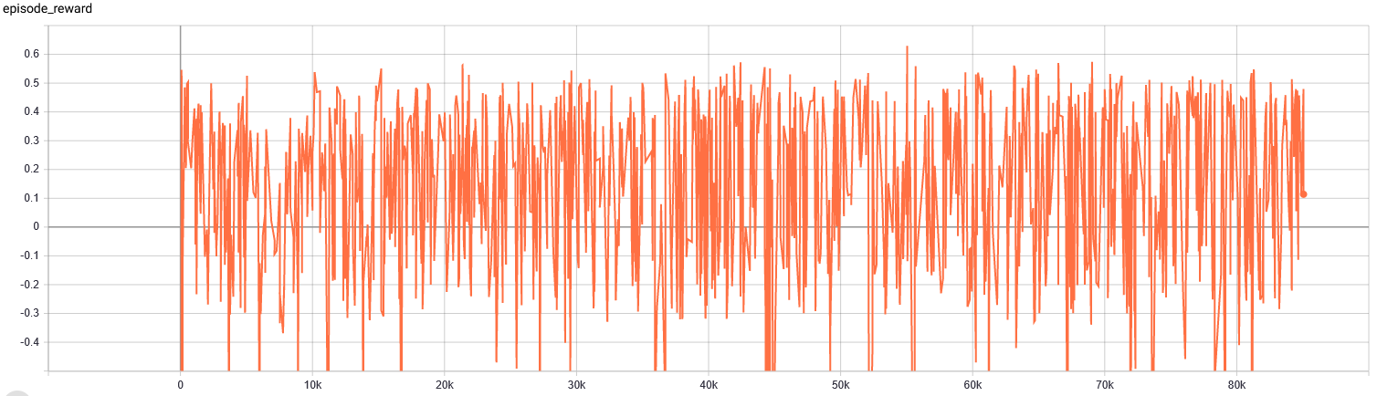
- Results: START: 17:23; END: 19:11

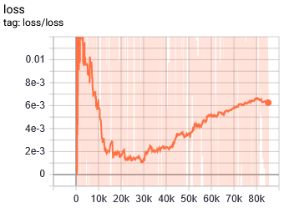
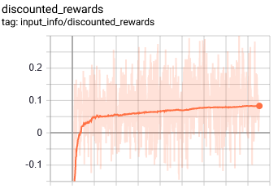

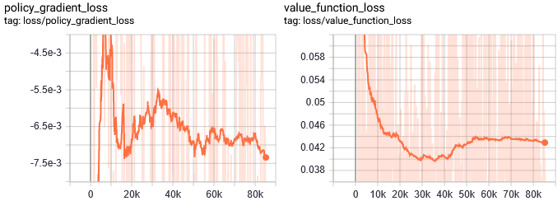

- Notes:
- It does not converge at all. BAD RUN!
Probably it’s the extended y-value; try to reduce the learning rate by 60%.
- Value Loss looks very bad

27) Like 26), but with a learning rate of 1.5e-5
- Configuraiton:
a) Network Architecture: [150,150]
b) Controlled Axis: 3
c) self._max_IK_points: 2
d) Action Space: [-100, 100]
i) gamma = 0.95
ii) n_steps = 20
iii) entropy_coef = 0.01
iv) learning_rate = 1.5e-4
v) vf_coef = 0.5
vi) max_grad_norm = 0.5
vii) lam = 0.95
viii) n_minibatches = 4
ix) noptepochs = 4
c) cliprange = 0.2
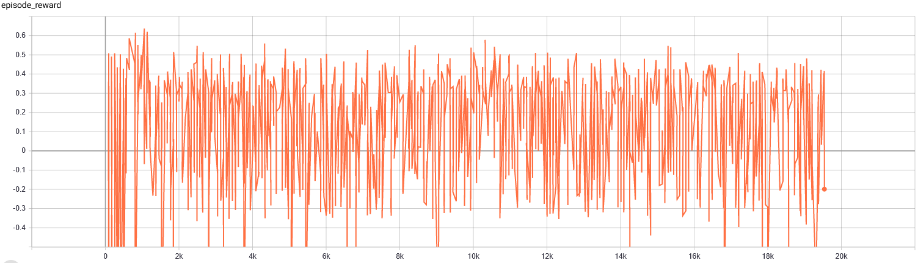
- Results: START: 20:42; END: 21:08

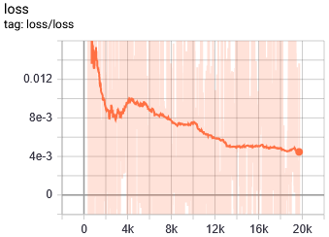

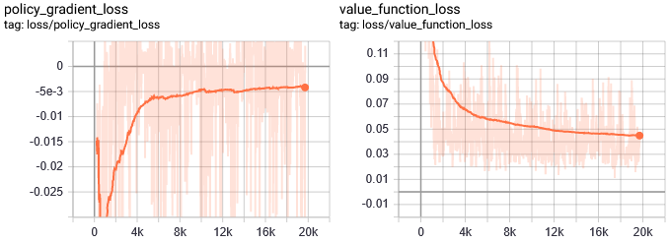
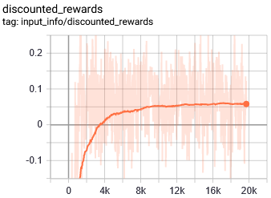
- Notes:
- There is no evidence of convergence. BAD RUN.
- As can be seen in the value loss, this solution does not improve at all

28) Like 26), but with a more realistic action space.
- Configuraiton:
a) Network Architecture: [150,150]
b) Controlled Axis: 3
c) self._max_IK_points: 2
d) Action Space: [-5, 5]
i) gamma = 0.95
ii) n_steps = 20
iii) entropy_coef = 0.01
iv) learning_rate = 5e-4
v) vf_coef = 0.5
vi) max_grad_norm = 0.5
vii) lam = 0.95
viii) n_minibatches = 4
ix) noptepochs = 4
c) cliprange = 0.2
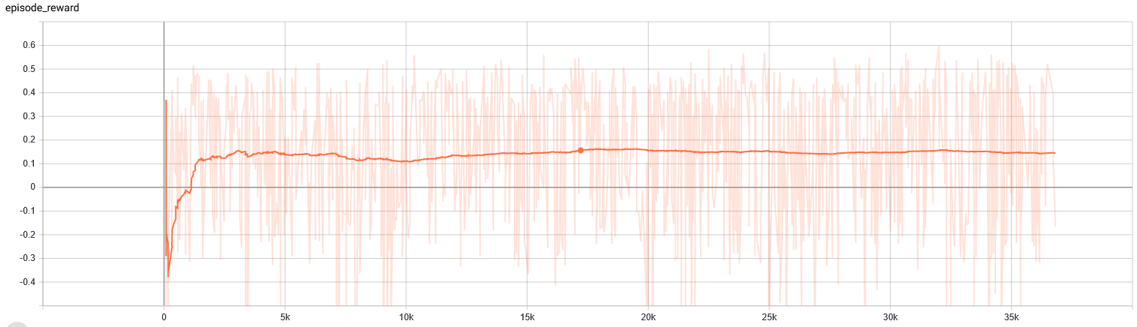
- Results: START: 10:22; END: 11:05

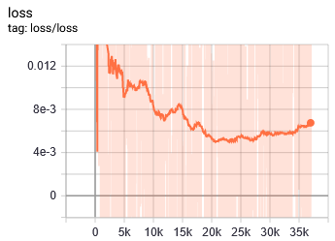
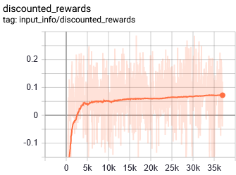
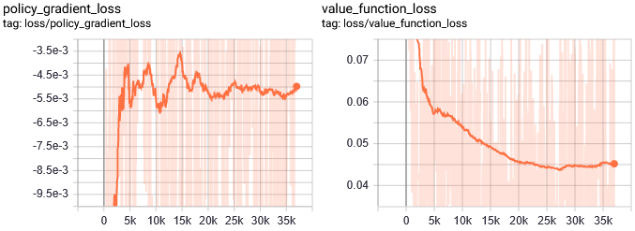

- Notes:
- Does not converge. BAD RUN
- The solution to the R1 prolem might be the significant reduction of the clip ratio, so
that the updates within the range [-Boundary, Boundary] are very small. They need
to be small because a difference of 1e-2 can or even 1e-3 can drastically affect the
position of the EE
i) Clip Ratio Reduction
ii) In General: Whatever forces the output head to change the mean and the
standard deviation in very small increments.

29) Based on 21)
- The object spawns in the other tray 50% of the time
- If this is the case, pos_target is shifted in the same amount in positive y-direction
as the object is shifted in the negative y-direction.
- Configuraiton:
a) Network Architecture: [150,150]
b) Controlled Axis: 3
c) self._max_IK_points: 2
d) Action Space: [-2, -2, -2] [2, 2, 2]
i) gamma = 0.95
ii) n_steps = 20
iii) entropy_coef = 0.01
iv) learning_rate = 5e-4
v) vf_coef = 0.5
vi) max_grad_norm = 0.5
vii) lam = 0.95
viii) n_minibatches = 4
ix) noptepochs = 4
c) cliprange = 0.2
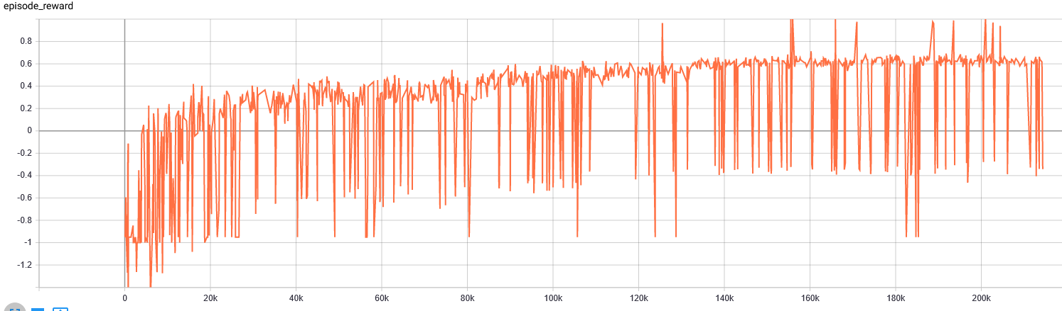
- Results: START: 18:05;END: 23:25

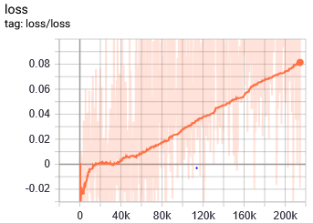

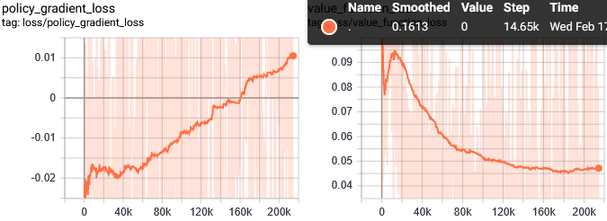

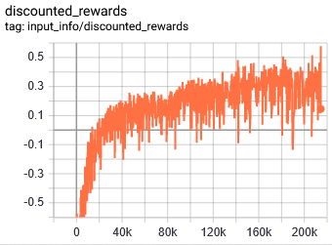
30) Based on 21).
- IK points are increased to 4!
Horizon and the minibatch size are doubled as well to retain proportionality.
- Learning rate is halved, since the training occurs over night and there is plenty
of time.
- Configuraiton:
a) Network Architecture: [150,150]
b) Controlled Axis: 3
c) self._max_IK_points: 4
d) Action Space: [-2, -2, -2] [2, 2, 2]
i) gamma = 0.95
ii) n_steps = 40
iii) entropy_coef = 0.01
iv) learning_rate = 2.5e-4
v) vf_coef = 0.5
vi) max_grad_norm = 0.5
vii) lam = 0.95
viii) n_minibatches = 8
ix) noptepochs = 4
c) cliprange = 0.2
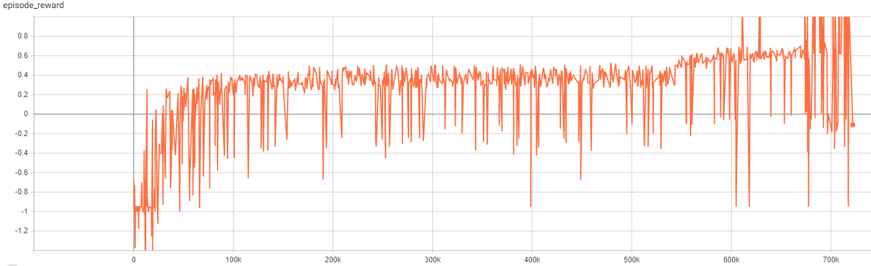
- Results: START: 17.02.2021, 00:24 ; END: 15:10

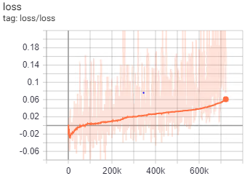

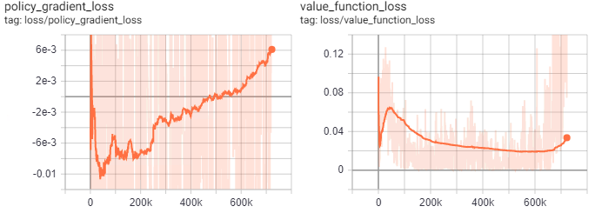
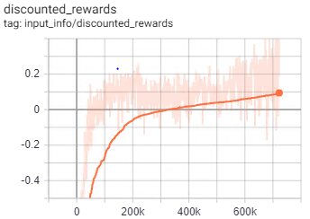

- Notes:
- The agent exhibits a much more generalized behavior: It not only picks the object,
although that does not occur often, but it also moves toward the target position
without having it hardcoded.
- When it realized that picking the object is "good", it often crashes and the learning
process becomes very volatile.

