Masterarbeit: Hyperparameter Tuning
Masterarbeit
Master of Science im Studiengang Maschinenbau/Produktentwicklung
an der Fakultät für Anlagen-, Energie- und Maschinensysteme
der Technischen Hochschule Köln
Projektteilnehmer: Vanya Aziz
Matrikel-Nr.: 11136876
Adresse: Deutz-Kalker-Str. 118
50679 Köln
vaziz@th-koeln.de
Professor: Prof. Dr. Anja Richert
Betreuer: Dario Luipers, M.Sc.

Köln, 01.02.2021

Letzte Änderung: 01.02.2021

Inhalt
Masterarbeit: Hyperparameter Tuning I
Inhalt 2
1. Original Configuration – Solution 28 2

Original Configuration – Solution 28

1. The punishment for the crash is multiplied by the number of max. allowable IK-points,
so the discounted sum of the reward when the agent does not crash is still smaller
then the punishment in case of a crash
2. Reduced the memory trajectory to the number of max. allowable IK-points. Other
agent parameters remain unchanged.
3. Trained with self._max_IK_points = 2, but with only one action output to test the PPO-algorithms performance for one output Action bound: [-5, 5]
4. Terminating condition: self._current_points >= self._max_IK_points, so that the agent can define a trajectory with two points. (Restored to old condition)
5. Termination condition within the while- and for-loops in method step() changed
to if self._contact_with_env:
6. Network architecture: [150, 150]
Training parameters:
i) gamma = 0.99
ii) n_steps = 2
iii) entropy_coef = 0.01
iv) learning_rate = 5e-4
v) vf_coef = 0.5
vi) max_grad_norm = 0.5
vii) lam = 0.95
viii) n_minibatches = 1
ix) cliprange_vf= None
ix) noptepochs = 4
c) cliprange = 0.2
- Best possibe slution for the action [AGENT_X , self._goal_pos[1], 0.9]:
For 50 Episodes: -0.5173544785723742
- Agent average reward for last 50 episodes: -0.60 (SEE TENSORBAORD CHART)
Average reward for normal control with
np.array(reward_liste).mean() for reward_liste[-50:] is :
- 0.5173544785723742
Policy entropy reduces over time, assumes negative value

Tuning of the Original Configuration

Iteration 1
- Controlled axis: x
- Network Architecture: [100, 100]
- Max. IK points: 2
- Action Space and bound: [-5, 5]
- Training Parameters:
i) gamma = 0.99
ii) n_steps = 2
iii) entropy_coef = 0.01
iv) learning_rate = 5e-4
v) vf_coef = 0.5
vi) max_grad_norm = 0.5
vii) lam = 0.95
viii) n_minibatches = 1
ix) cliprange_vf= None
ix) noptepochs = 4
c) cliprange = 0.2

- Summary of the training after 20 min. of training.
Start: 14:32
End: 14:52
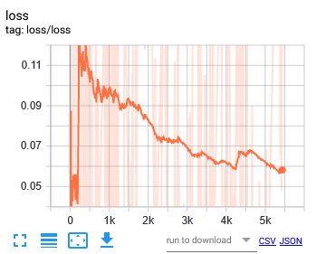
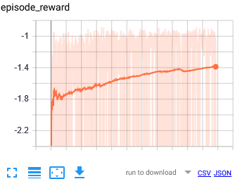

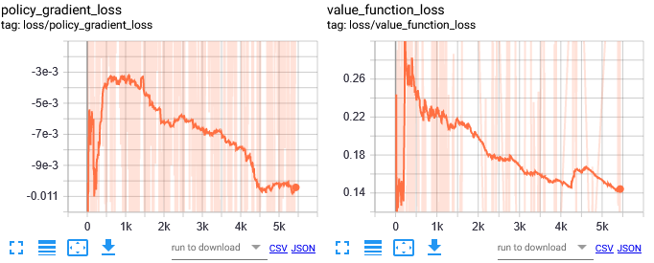

- Notes:
-

Iteration 2
- Controlled axis: x
- Network Architecture: [150, 150]
- Max. IK points: 2
- Action Space and bound: [-5, 5]
- Training Parameters:
i) gamma = 0.99
ii) n_steps = 2
iii) entropy_coef = 0.01
iv) learning_rate = 50e-4
v) vf_coef = 0.5
vi) max_grad_norm = 0.5
vii) lam = 0.95
viii) n_minibatches = 1
ix) cliprange_vf= None
ix) noptepochs = 4
c) cliprange = 0.2

- Summary of the training after 20 min. of training.
Start: 15:09
End: 15:29
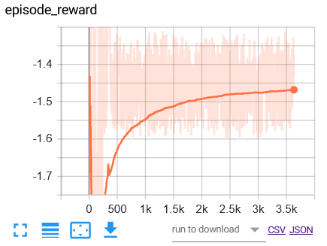
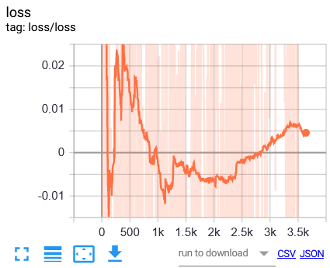

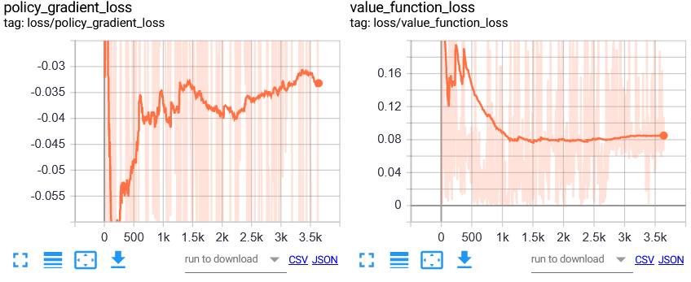

- Notes:
- Converges to local minimum. Action at the end of the training is always 5.0 (interval
limit max.)
- General Loss is not decreasing continuously!
- A good point to continue training with reduced learning rate is @ update
1100.

Iteration 3
- Controlled axis: x
- Network Architecture: [150, 150]
- Max. IK points: 2
- Action Space and bound: [0.25, 1]
- Training Parameters:
i) gamma = 0.99
ii) n_steps = 2
iii) entropy_coef = 0.01
iv) learning_rate = 50e-4
v) vf_coef = 0.5
vi) max_grad_norm = 0.5
vii) lam = 0.95
viii) n_minibatches = 1
ix) cliprange_vf= None
ix) noptepochs = 4
c) cliprange = 0.2

- Summary of the training after 20 min. of training.
Start: 15:43
End: 16:03

Iteration 4
- Controlled axis: x
- Network Architecture: [150, 150]
- Max. IK points: 2
- Action Space and bound: [0.25, 1]
- Training Parameters:
i) gamma = 0.99
ii) n_steps = 2
iii) entropy_coef = 0.01
iv) learning_rate = 5e-4
v) vf_coef = 0.5
vi) max_grad_norm = 0.5
vii) lam = 0.95
viii) n_minibatches = 1
ix) cliprange_vf= None
ix) noptepochs = 4
c) cliprange = 0.2

- Summary of the training after 20 min. of training.
Start: d
End: d

See rest in the summary "Hyperparameter_Tuning_Summary"

