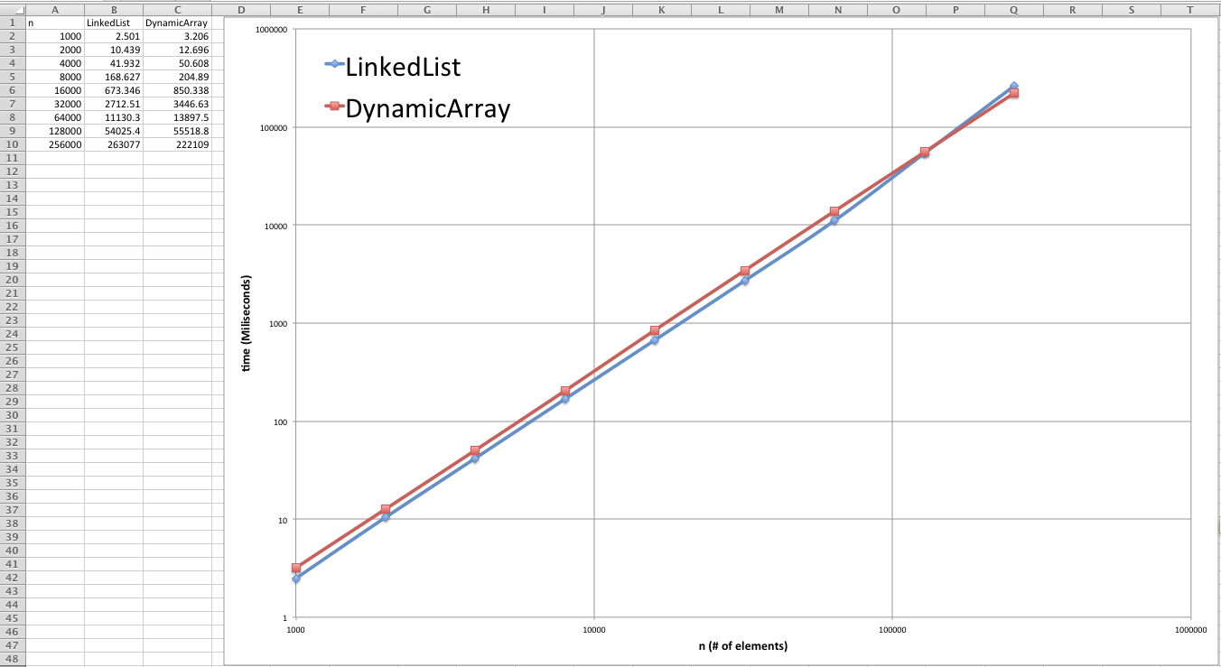

**Which of the implementations is the fastest?**

It looks like the linked List implementation is faster until 64000 elements. After that, the Dynamic Array is faster.

**Would you expect anything to change if the loop performed removeBag instead of contains? If so, what?**

From simple runs I made, I think the Dynamic Array it would be faster. But the linked List would be the same time.