In Sakai go to the Assignments or Assignments2 page.

Select the, “Download All” button.

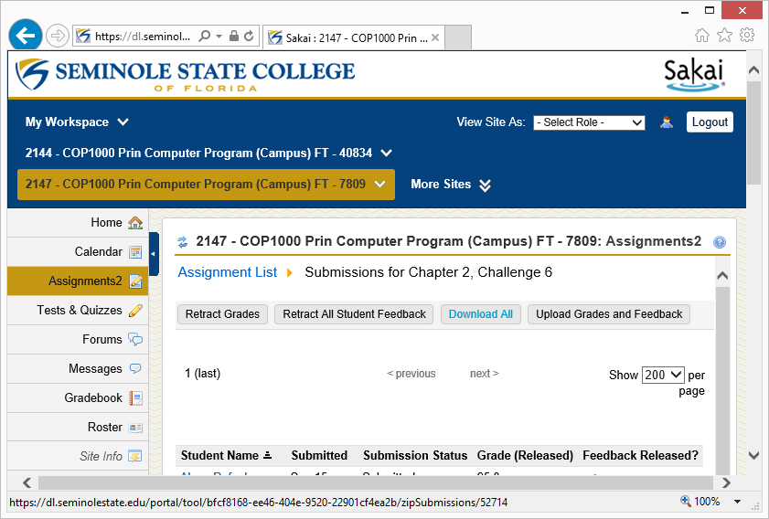

Select, “Save As”.

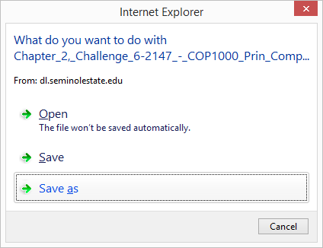

Navigate to the directory where you want to save the zip file and select, “Save”.

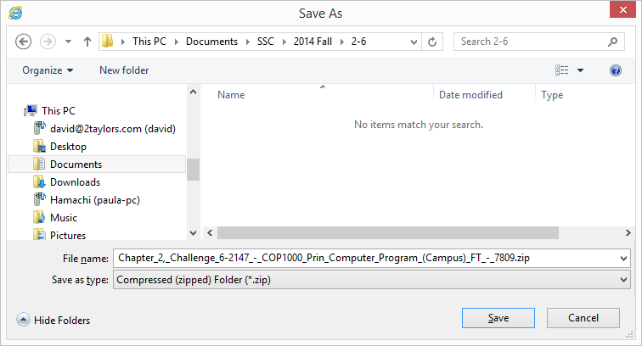

To install the StudentUnzip program go to:<http://cop1000.com/cop1000/downloads/studentunzip/publish.htm>

The first time you see this form you will need to select the, “Install” button. If you ever go back to this page you only need to select, “Launch”.

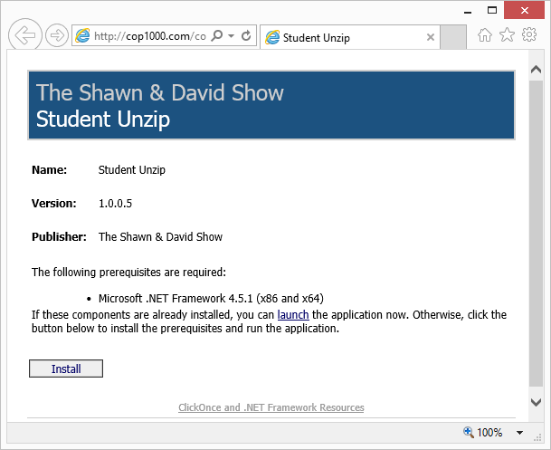

**NOTE:** The default path from Sakai is so long it will not always allow the files within the zip file to unzip all of its contained files. For this reason we have provided a place for you to enter a substitute directory name called an alias. For this example I’ve used, “StudentFiles”. If you don’t provide one we have provided the default directory name of, “MyZip”. You can always rename it to whatever you choose.

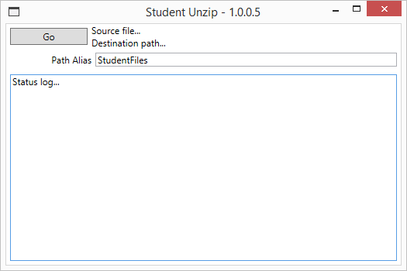Select, “Go”.

The, “Go” button will prompt you for the directory where you stored the zip file downloaded from Sakai; the, “Source file…”.

Select the source file and then, “Open”,

or just double-click the name of the source file.

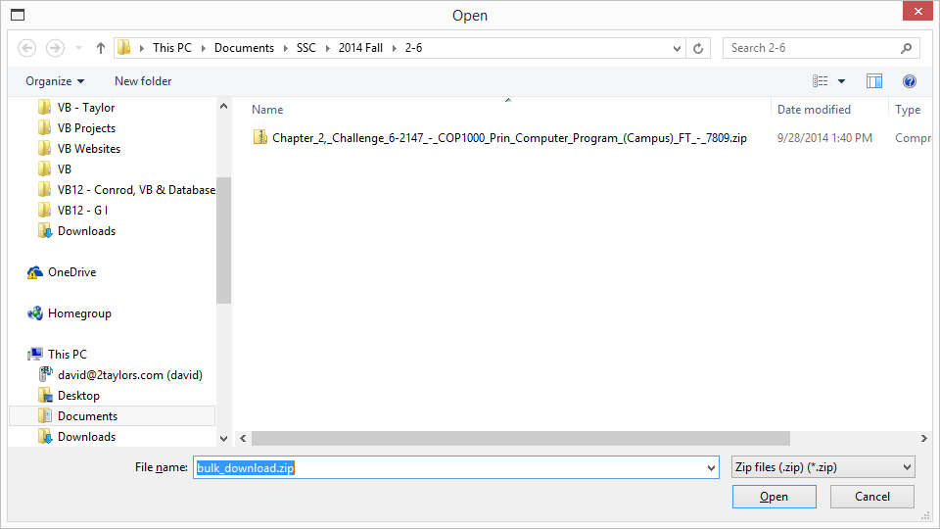

Then it will prompt you for the, “Destination path…”.

**NOTE:** The directory selected for the, “Destination path…” must be empty so you do not inadvertently merge with or overwrite existing files.

Next you will select the folder where you want the files to be unzipped.

Once you have selected the directory pick, “OK”.