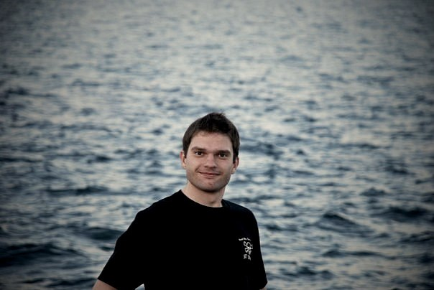 | Summary  BADIUL Valentine S.  Date Birth: 1987  Address of residence: Kiev  Marital status: married (no children)  Phone: 096-172-6-999  Skype: ur5fesur5fes  Website: http://valentin.in.ua  Mail: ur5fes@ya.ru  Hobby: swimming

Goal
Obtaining positions, a programmer in a stable company with the purpose to
professional growth and development.

MORE information

Product skills

Skills | Experience, years
PHP 4 , PHP 5 ,  Zend framework, Codeigniter framework, Simfony framework  ZendDeveloperTool,  PHPDoc,  FirePHP,  design pattern, SOLID… | 6
MySQL ,  Oracle sql,  PostgresSQL | 5
Memcached, neo4j, Redis
(CAP, ACID)
JavaScript ( Jquery, AJAX) | 6
HTML ,  XML ,  html5 ,  CSS ,  Bootstrap ( front-end framework ) | 6
Apache , Nginx & PHP-FPM on Ubuntu | 6
Mac OS , Windows OS,  Linux OS,( Ubuntu , Linux Terminal ) | 14
GIT, SVN | 3
Delphi7,  C ++ Builder, WinAPI | 2
Objective-C ( Xcode 4.1 ) | Less year
- Development of User-Friendly Web interface and KISS (keep it simple stupid)
- Knowledge of principles and stages of SEO. (google analytics )
- Connection of the site to the payment system Visa / MasterCard
- Knowledge and experience in working with online services
(Google,Facebook etc)
- Experience with web on Mobile (advantage to HTML 5)
- Knowledge of basic software development methodologies:
Scrum, Waterfall, Kanban
- The ability to transfer knowledge, monitor performance, to motivate employees.
Knowledge of Foreign Languages
Technical English.
German - reading , translating with dictionary.
Fluent in Russian and Ukrainian languages.

Personal Quality
Responsible, focus on results, social, punctual, friendly,
creative, loyal, self-organized,
presentable appearance, fast learner,
innovator, decent, non smoker,
healthy life style.

Education

2009 -2011 | National Kiev University of T. Shevchenko (Ukraine)  Master Degree , Faculty of Radiophysics and Physical electronics.  http://valentin.in.ua/diplom/
2005-2009 | National Kiev University of T. Shevchenko (Ukraine)  Wardengroup Bachelor Department of Quantum is pleased physics.  http://valentin.in.ua/diplom/
2007-2009 | Attended 2 years programs at the Military institute of T. Shevchenko  Rank : Lieutenant , troop commander

Experience of

2006-2011 | Ltd. "Morkomtrans" Technical director
2011-2012 | Freelancer
2012 - 2013 | Centre sovereign land cadastre of Ukraine
2013 - ... | Freelancer

Brief description of commercial projects in which I took part, with a description of my role and the technology used.

Technical director
Functions and Responsibilities:
- Management Group developers
Web - projects (mostly online auctions) in as Technical leader
(Recruitment, training, preparation of job descriptions, setting and monitoring tasks);
-The creation and development of IT - Infrastructure;
-Ensure the stable operation of IT infrastructure;
-Provision of IT security (policy-backup and data recovery, virus protection, control the use of Internet resources);
- Responsibility for technical implementation project
which to match "Challenges Business " on each of stages development the project;
- Control of Developers: quality standardization and speed;
- Operational adjustment code and introduction urgent changes;
in project (Understanding Logic all Parts project)
- Participation in development concept product.
Achievements:
-Development of software for Automatic measurement volt-ampere characteristics on on Motherboard expansion PCI-9112 (ADLINK);
-A software provision in algorithm on C ++ language which can map expansion for Synchronization with external devices.
Software provision can measure Voltage and current in mode Real time with opportunity conservation Data in Microsoft Office Excel or opportunity conservation Data nA Web server in base MySQL;
-Created software provision for PC with to of exchange data Interfaces for COM and LPT;
-A algorithm for Search on Online PHP,
created e library. Created search-robot which enters all data in base Data SQL. Ability Automatic Authorization and registration;
- A Software for Mac OS Lion 10.7.1 , iPhone 4.3 iPad 4.3 in srere Xcode 4.1.
- And Software written to work with bank payment systems.

Social network ( high load )
Technology
PHP5 Zend framework,
MySQL (Master-Slave, partitioning),
NoSQL Local Storage,
jquery,
backbonejs,
OpenLayers.Map,
CSS (bootstrap , SCSS),
HTML,
Netbeans+android sdk, Sublime text, Wrkbench, SVN.

This project is designed for relaxation.
People can communicate with friends, share photos, publish text works …

B2B project

This is a B2B project is intended to account for the money. Implemented on the Zend framework .
Principle of operation.
each employee has a password and username (Zend ACL). Once an employee goes on a mission done acc record from SQL.
Upon return, the employee makes a record of what money is spent …
after which he was in a bank account is charged a certain sum ....
Technology , PHP5 Zend framework , Doctrine
MySQL , jquery , CSS, HTML
Apache , ubuntu , software development environment NetBeans, UbuntuOS
(high load php)

The project has been implemented using the MVC pattern.
MySQL number of tables used by about 100.
The maximum amount of myisam table was about 1 GB
front-end using jquery
The project used technology php curl to work with the Google API
( high load )

California (freelance)
This project is designed for relaxation.
a kind of analogue of YouTube with the only difference that the management is not a computer and a television.
Technology
PHP5 Zend framework, MySQL, Jquery, CSS, HTML5
Nginx + Apache, Ubuntu
I was responsible for the full realization (backend). (Except for the video processing in C ++)
Also been implemented Exchange for sale buy gold, silver ... (Has been implemented as a demonstration, test, training project)
Technology
PHP5, MySQL, Jquery, CSS, HTML5
Apache, (high load php)

Centre sovereign land cadastre of Ukraine

B2B Highload project is designed to control the land.
Technology
PHP5 Zend framework, MySQL, postgresql, Oracle, XSLT, CSS, HTML5, Jquery
Nginx + Apache, Ubuntu
Position
"Провідний інженер - програміст відділу розробки програмного забезпечення департаменту программного та технічного забезпечення Державного земельного кадастру Державного підприемства "
Duties support already implemented project, refactoring, completion of new features.
The implementation of an entirely new software.
Basically interface implementation for the generation and exchange files with
"Міністерство юстиції України" by WEB resource.

Certificates
http://valentin.in.ua/diplom/certificates.tar.gz
Example code
http://valentin.in.ua/diplom/example-code/index.tar.gz

Recommendations

