Geometric Transformations

Submitted as a

Project in
Computer Graphics
for
Semester V

For partial completion of
B-Tech in Computer Science & Engineering

By:
Vaibhav Bajpai (0509713060)
Yadvendra (0509710121)

Under the guidance of

Sir. Anand Srivastava
Department of Computer Science & Engineering
Galgotias College of Engineering Technology
Greater Noida

Overview

A transformation in elementary terms is any of a variety of different functions from geometry, such as rotations, reflections and translations. These can be carried out in Euclidean space, particularly in dimensions 2 and 3.

Transformations:

- Geometric Transformations
- Coordinate Transformations

Geometric Transformations:

- Translation
- Rotation
- Scaling
- Reflection
- Shear

Feasibility Study

The project uses an arbitarily drawn triangle as a sample polygon to which successive geometric transformations are applied.

Transformations Supported:

- Translation

- Reflection

- Scaling

Technologies:

- Language: C++
Compiler: GCC(g++)

- Graphic Library: SDL(Simple Direct Media Layer)

- Supported O/S: Linux, Windows, OSX

Key Features

- 32-bit C++ Compiler

The project uses GCC instead of 16-bit Turbo C++ compiler extending the address
space of the project beyond 16KiB to support high resolution as 800x600 to display
polygons and preventing stack overflows in case of flood-fill subroutines that
extensively use recursion to fill the areas.

- Cross-Platform Graphic Library

The project uses SDL(Simple Direct Media Layer) instead of graphics.h to
implement low level pixel operations to allow the project to be easily ported across
different platforms

Simple Direct Media Layer

- Simple DirectMedia Layer is a cross-platform multimedia library designed to provide low level access to audio, keyboard, mouse, joystick, 3D hardware via OpenGL, and 2D video frame buffer.

- SDL supports Linux, Windows, Windows CE, BeOS, MacOS, Mac OS X, FreeBSD, NetBSD, OpenBSD, BSD/OS, Solaris, IRIX, and QNX

- SDL is written in C, but works with C++ natively . SDL is distributed under GNU LGPL version 2.
.

Screenshots
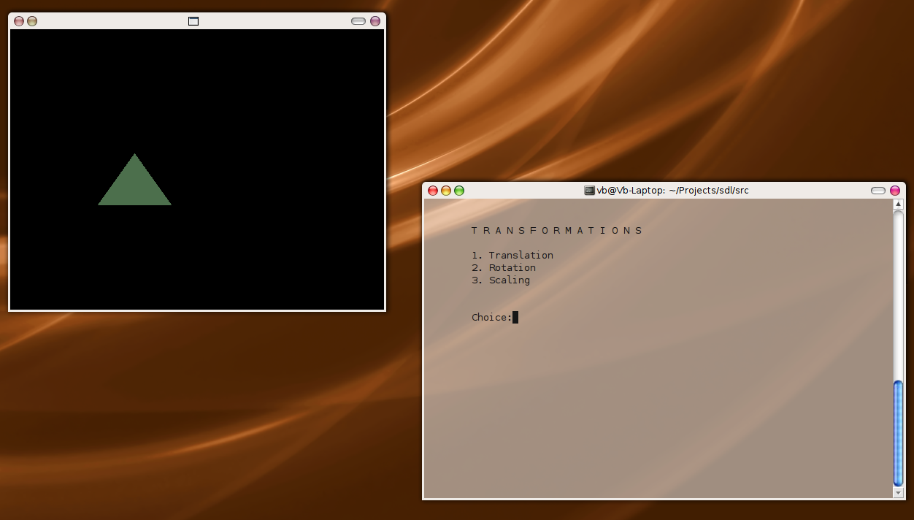

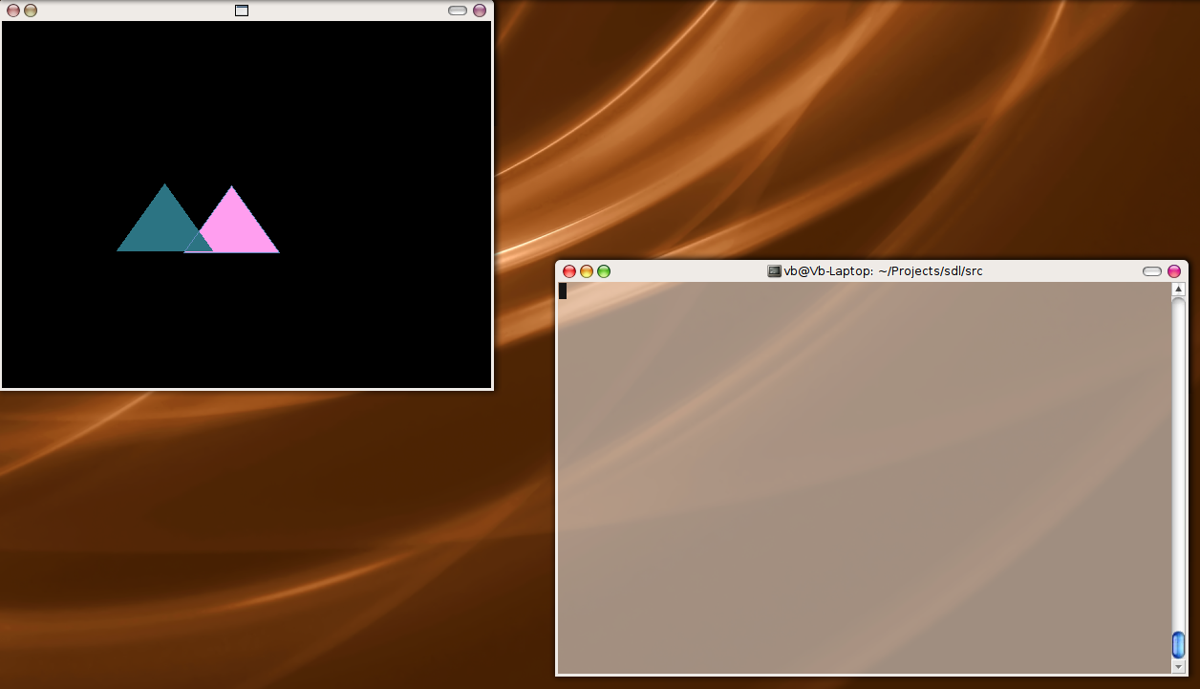

Screenshots

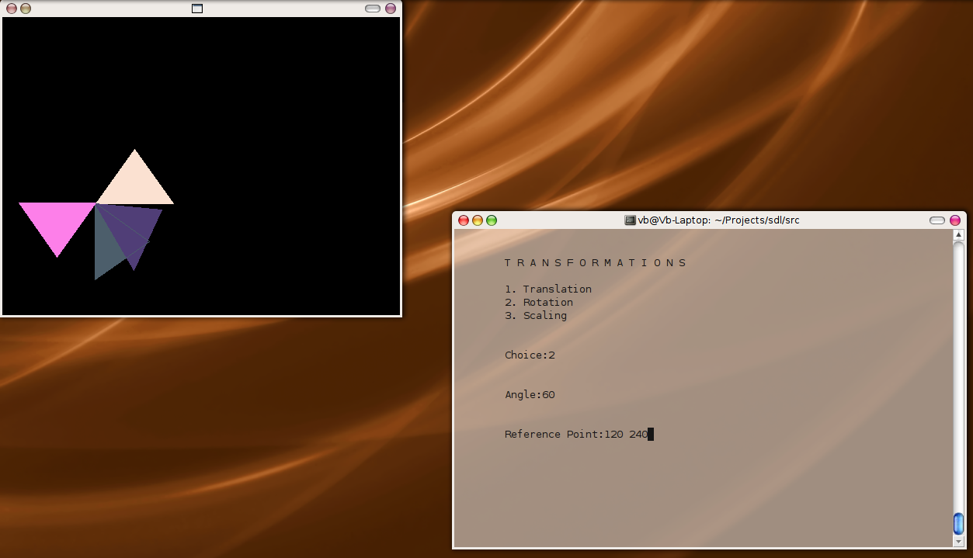

Source Code

#include “SDL/SDL.h”
#include <iostream>
#include <cmath>
#include <ctime>
#define round(x) (int)((x)+0.5)
#define PI 3.14159265
using namespace std;
SDL_Surface* pSurface;

typedef float Matrix3x3[3][3];
Matrix3x3 Matrix;

enum
{
SCREENWIDTH = 512,
SCREENHEIGHT = 384,
SCREENBPP = 0,
SCREENFLAGS = SDL_ANYFORMAT
} ;

struct Point
{
int xco;
int yco;
};

class Transformation
{

public:

static void Init()
{
SetIdentity(Matrix);
}

static void SetIdentity(Matrix3x3 m)
{
for(int i=0;i<3;i++)
for(int j=0;j<3;j++)
m[i][j] = (i==j);
}

static void PreMultiply(Matrix3x3 a, Matrix3x3 b)
{
Matrix3x3 tmp;

for(int r=0;r<3;r++)
for(int c=0;c<3;c++)
tmp[r][c] = a[r][0]*b[0][c] + a[r][1] *b[1][c] + a[r][2] *b[2][c];

for(int r=0; r<3; r++)
for(int c=0;c<3;c++)
b[r][c] = tmp[r][c];
}

static void Translate(int tx, int ty)
{
Matrix3x3 m;

SetIdentity(m);

m[0][2] = tx;
m[1][2] = ty;

PreMultiply(m,Matrix);
}

static void Rotate(float a, Point p)
{
Matrix3x3 m;

SetIdentity(m);

a = a * PI / 180;

m[0][0] = cosf(a);
m[0][1] = -sinf(a);
m[0][2] = p.xco * (1- cosf(a)) + p.yco * sinf(a);
m[1][0] = sinf(a);
m[1][1] = cosf(a);
m[1][2] = p.yco * (1 - cosf(a)) - p.xco * sinf(a);

PreMultiply(m,Matrix);
}

static void Scale(float sx, float sy, Point p)
{
Matrix3x3 m;

SetIdentity(m);

m[0][0] = sx;
m[0][2] = (1-sx) * p.xco;
m[1][1] = sy;
m[1][2] = (1-sy) * p.yco;

PreMultiply(m,Matrix);
}

static void TransformPoints(const int num, Point *P)
{
float tmp;

for(int k = 0; k<num; k++)
{
tmp = Matrix[0][0] * P[k].xco + Matrix[0][1] * P[k].yco + Matrix[0][2];

P[k].yco = Matrix[1][0]*P[k].xco + Matrix[1][1]*P[k].yco + Matrix[1][2];

P[k].xco = (int)tmp;
}
}
};

class Start
{
public:

static const int num=4;

static Point P[4];

static void Menu()
{

system("clear");

SDL_Flip(pSurface);

cout<<"\n\n\tT R A N S F O R M A T I O N S \n\n";

int ch;

Transformation::Init();

cout << "\t1. Translation\n";
cout << "\t2. Rotation\n";
cout << "\t3. Scaling\n";

cout << "\n\n\tChoice:";

cin>>ch;

switch(ch)
{
case 1:
int tx,ty;

cout<<"\n\n\tTranslation Distances:";
cin>>tx>>ty;

Transformation::Translate(tx,ty);

break;

case 2:
Point p1;
float angle;

cout<<"\n\n\tAngle:";
cin>>angle;

cout<<"\n\n\tReference Point:";
cin>>p1.xco>>p1.yco;

Transformation::Rotate(angle, p1);

break;

case 3:
float sx,sy;
Point p2;

cout<<"\n\n\tScaling Factors:";
cin>>sx>>sy;

cout<<"\n\n\tReference Point:";
cin>>p2.xco>>p2.yco;

Transformation::Scale(sx,sy,p2);

}

}

static void Draw()
{
srand((unsigned int)time(NULL));

SDL_Color color ;
color.r = rand ( ) % 256 ;
color.g = rand ( ) % 256 ;
color.b = rand ( ) % 256 ;

PolygonDraw(num,P,color);

int xc = (P[0].xco + P[1].xco + P[2].xco)/3;
int yc = (P[0].yco + P[1].yco + P[2].yco)/3;

PolygonFill(xc,yc,color);
}

static void PolygonDraw(int n, Point points[],SDL_Color color)
{
if(n>=2)
{
for(int count=0;count<n-1;count++)
lineDDA(&points[count],&points[count+1],color);
}
}

static void PolygonFill(int xc,int yc, SDL_Color color)
{
SDL_Color color1 ; // Black
color1.r = 0 ;
color1.g = 0 ;
color1.b = 0 ;

FloodFill(xc,yc,color,color1);
}

static void lineDDA( struct Point * p1, struct Point *p2, SDL_Color color)
{
int dx,dy,steps,k;
float xinc,yinc,x,y;

dx=p2->xco - p1->xco;
dy=p2->yco - p1->yco;

if(abs(dx) > abs(dy))
steps=abs(dx);
else
steps=abs(dy);

xinc=(float)dx/(float)steps;
yinc=(float)dy/(float)steps;
x=p1->xco;
y=p1->yco;

SetPixel(pSurface,round(x),round(y),color);

for(k=0;k<steps;k++)
{
x+=xinc;
y+=yinc;
SetPixel(pSurface,round(x),round(y),color);
}
}

static void FloodFill(int x, int y, SDL_Color fill, SDL_Color oldcolor)
{
SDL_Color current = GetPixel(pSurface,x,y);

if(CompareColor(current,oldcolor))
{
SetPixel(pSurface,x,y,fill);
FloodFill(x+1,y,fill,oldcolor);
FloodFill(x-1,y,fill,oldcolor);
FloodFill(x,y+1,fill,oldcolor);
FloodFill(x,y-1,fill,oldcolor);
}
}
static bool CompareColor(SDL_Color c1, SDL_Color c2)
{
if(c1.r == c2.r && c1.g == c2.g && c1.b == c2.b)
return true;
else
return false;
}

static void SetPixel ( SDL_Surface* pSurface , int x , int y , SDL_Color color )
{
//convert color
Uint32 col = SDL_MapRGB ( pSurface->format , color.r , color.g , color.b ) ;

//determine position
char* pPosition = ( char* ) pSurface->pixels ;

//offset by y
pPosition += ( pSurface->pitch * y ) ;

//offset by x
pPosition += ( pSurface->format->BytesPerPixel * x ) ;

//copy pixel data
memcpy ( pPosition , &col , pSurface->format->BytesPerPixel ) ;
}

static SDL_Color GetPixel ( SDL_Surface* pSurface , int x , int y )
{
SDL_Color color ;
Uint32 col = 0 ;

//determine position
char* pPosition = ( char* ) pSurface->pixels ;

//offset by y
pPosition += ( pSurface->pitch * y ) ;

//offset by x
pPosition += ( pSurface->format->BytesPerPixel * x ) ;

//copy pixel data
memcpy ( &col , pPosition , pSurface->format->BytesPerPixel ) ;

//convert color
SDL_GetRGB ( col , pSurface->format , &color.r , &color.g , &color.b ) ;
return ( color ) ;
}

};

class SDLInit
{
public:

static void Init()
{
//initialize systems
SDL_Init ( SDL_INIT_VIDEO ) ;

//set our at exit function
atexit ( SDL_Quit ) ;

//create a window
pSurface = SDL_SetVideoMode ( SCREENWIDTH , SCREENHEIGHT ,
SCREENBPP , SCREENFLAGS ) ;

//declare event variable
SDL_Event event ;

//message pump
for ( ; ; )
{
//look for an event
if ( SDL_PollEvent ( &event ) )
{
//an event was found
if ( event.type == SDL_QUIT ) break ;
}

Start::Draw();

Start::Menu();

Transformation::TransformPoints(Start::num,Start::P);

Start::Draw();

}//end of message pump

//done
}

};

Point Start::P[4] = {{120,240}, {220,240} , {170,170}, {120,240}};

int main()
{
SDLInit::Init();
return ( 0 ) ;
}

