* **Jabber: Instant Messenger**

Submitted as a

**Mini Project**

For

**Semester VI**

For the partial completion of

B. Tech in Computer Science and Engineering

By

**Vaibhav Bajpai, Rahul Burman, Ritika Wadhwa**

Under the guidance of

**Mr. Anand Srivastava**

Department of Computer Science and Engineering

Galgotias College of Engineering and Technology

**Protocol Overview**

**Jabber:** An open, secure technology for instant messaging. It is a friendly community of end users and developers who value freedom of communication. It is a decentralized network of IM services in which your messages are not monitored by a big company like AOL, Microsoft, or Yahoo. You can even run your own server!

**Features:**

* A Completely Open System and Standards.
* Open, XML based Technology.
* Interoperability with other IM systems
* Simple Protocols.
* Simplifying the responsibilities of clients whenever possible.
* Control over the system.

**XMPP:** eXtensible Messaging and Presence Protocol (XMPP) (formerly known as Jabber) is an open, XML-inspired protocol for near real time, extensible instant messaging (IM) and presence information (a.k.a. buddy lists). The protocol is built to be extensible and other features such as Voice over IP and file transfer signaling have been added.

**Project Overview**

**Technologies Used:**

**Language**: J2SE 6.0, XML

**API:** SAX, Collections Framework, Swing

**Protocol:** Jabber

**Project Implementation**

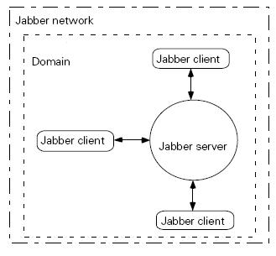

**A minimal jabber network with a single domain managed by a jabber server and one or more clients**

**Server Architecture**

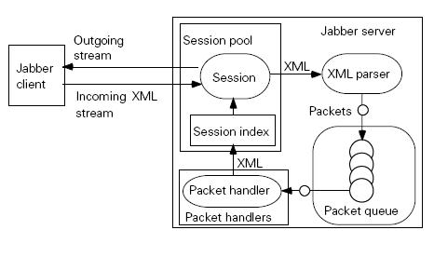

**Client Architecture**

