Student:Balanescu Victor

**Group:30234**

Table of Contents

1. Requirements Analysis 3

1.1 Assignment Specification 3

1.2 Functional Requirements 3

1.3 Non-functional Requirements 3

2. Use-Case Model 3

3. System Architectural Design 3

4. UML Sequence Diagrams 3

5. Class Design 3

6. Data Model 3

7. System Testing 3

8. Bibliography 3

1. Requirements Analysis

# Assignment Specification

Tema pregatita este o aplicatie utila pentru realizarea operatiilor de catre o companii producatoare de mobile. Aplicatia permite cu usurinta vizualizarea, prelucrarea, adaugarea si stergerea de informatii referitoare la comenzi si produsele disponibile, precum si vizualizarea acestora.

# Functional Requirements

*Ca si functionalitate, aplicatia este utilizabila doar de angajatii companiei, deci e nevoie de un system de Login pentru angajatii companiei. Vor exista 2 tipuri de conturi: Admin si User. Adminul poate poate crea noi conturi si vizualiza informatii despre activitatea userilori. Pentru modul user, odata inregistrat, aplicati va prelucra datele introduce de el si in functie de optiunea dorita aceasta va realize una din urmatoarele operatii:*

*Produse*

*-vizualizarea produselor si informatiilor referitoare la acestea*

*-adaugarea de produse*

*-stergerea de produse*

*-editarea informatiilor despre produse*

*Comenzi*

*-vizualizarea produselor si informatiilor referitoare la acestea*

*-adaugarea de comenzi*

*-stergerea de comenzi*

*-editarea informatiilor despre comenzi*

# Non-functional Requirements

*Se cere implementarea si testarea metodelor, pentru realizarea operatiilor. Aplicatia va fi dezvoltata in limbajul C#.NET, iar informatiile vor fi stocate in baza de date MySQL.*

2. Use-Case Model

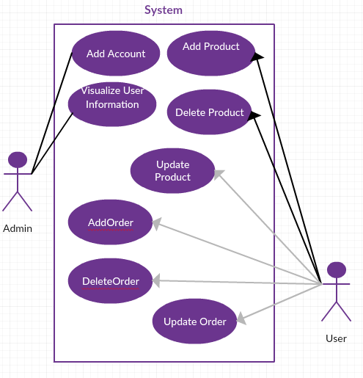 1`

*[Create the use-case diagrams and provide one use-case description (according to the format below).*

*Use-Case description format:*

*Use case: <use case goal>*

*Level: <one of: summary level, user-goal level, sub-function>*

*Primary actor: <a role name for the actor who initiates the use case>*

*Main success scenario: <the steps of the main success scenario from trigger to goal delivery>*

*Extensions: <alternate scenarios of success or failure>*

*]*

3. System Architectural Design

**3.1 Architectural Pattern Description**

*[Describe briefly the used architectural patterns.]*

**3.2 Diagrams**

*[Create the system’s conceptual architecture; use architectural patterns and describe how they are applied. Create package, component and deployment diagrams]*

4. UML Sequence Diagrams

*[Create a sequence diagram for a relevant scenario.]*

5. Class Design

**5.1 Design Patterns Description**

*[Describe briefly the used design patterns.]*

**5.2 UML Class Diagram**

*[Create the UML Class Diagram and highlight and motivate how the design patterns are used.]*

6. Data Model

*[Present the data models used in the system’s implementation.]*

7. System Testing

*[Present the used testing strategies (unit testing, integration testing, validation testing) and testing methods (data-flow, partitioning, boundary analysis, etc.).]*

8. Bibliography