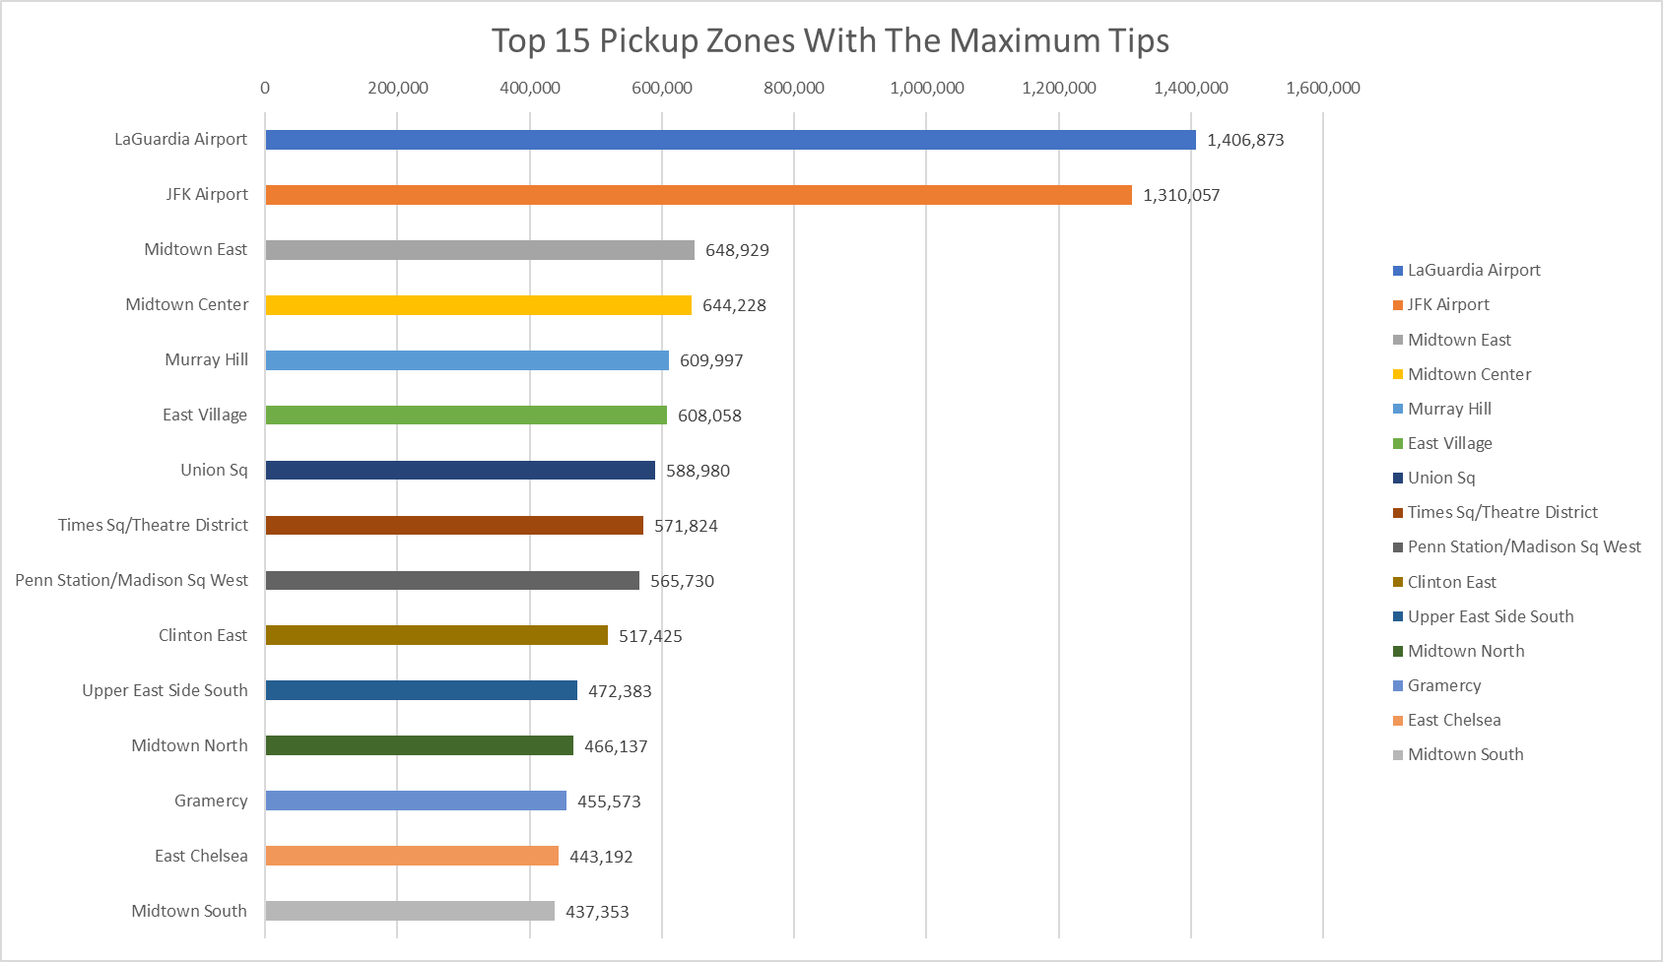

|  |  |  |  |  |
| --- | --- | --- | --- | --- |
| **Pickup Zone** | **Ridecount** | **sum_tip_amount** | **tripduration_minutes** | **tips_perminute_cents** |
| Newark Airport | 659 | 6,185 | 2,996 | 206 |
| Dyker Heights | 90 | 893 | 1,107 | 81 |
| Marble Hill | 101 | 494 | 968 | 51 |
| Queens Village | 100 | 659 | 1,411 | 47 |
| Sunset Park East | 174 | 699 | 2,286 | 31 |
| Belmont | 55 | 209 | 759 | 28 |
| Randalls Island | 710 | 3,416 | 12,731 | 27 |
| Whitestone | 79 | 274 | 1,101 | 25 |
| East Flatbush/Farragut | 149 | 471 | 2,106 | 22 |
| Riverdale/North Riverdale/Fieldston | 103 | 298 | 1,392 | 21 |
| Schuylerville/Edgewater Park | 77 | 216 | 1,094 | 20 |
| Rosedale | 50 | 193 | 998 | 19 |
| Kew Gardens | 721 | 1,881 | 9,964 | 19 |
| Bellerose | 119 | 251 | 1,347 | 19 |

