1. **Go to _icons.cshtml.**
2. **Define Correct Permission**

@if (LIB.Tools.Security.Authentication.GetCurrentUser().HasAtLeastOnePermission((long)LIB.BusinessObjects.BasePermissionenum.VenueAdmin))

{

}

1. **Add Icon**

Example 1: FROM

<a href="@LIB.Tools.Utils.URLHelper.GetUrl("DocControl/Venue")" target="_blank" class="dashboard-ico dashboard-ico-reports">

<div class="outer-ico">

<div class="inner-ico">

<div class="dashboard-icon">

@Html.Raw(MedCore.Helpers.T.Str("AddVenue", "DashBoard", "Add <br/> Venue"))

</div>

</div>

</div>

</a>

DocControl – built in controller for Form process.

MedCore.Helpers.T.Str (string alias, string ResourceFile, string defaultvalue="") – translates strings from res files.

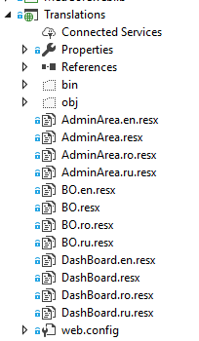

Example 1: REPORT

<a href="@LIB.Tools.Utils.URLHelper.GetUrl("Report/VenueList")" target="_blank" class="dashboard-ico dashboard-ico-paginasectia">

<div class="outer-ico">

<div class="inner-ico">

<div class="dashboard-icon">

@Html.Raw(MedCore.Helpers.T.Str("ReportLits", "DashBoard", "Report <br/> Venues"))

</div>

</div>

</div>

</a>

Report – built in controller for Report process.