General

Contents

1. Short Description 2

2. Attachments 4

*DashBoard* 4

*Form & Dynamic List & Dynamic Form* 5

*Report List* 7

3. Naming Convention 8

# 1. Short Description

*Dashboard* is the main page of the web site, which is unique for each user. Here will be located the following content:

* *Pie Chart* (a pie diagram, that will display the definite objects and those statistic)
* *Icons* (links to various pages)
* *List* (list of data, displayed in a table)

For realization of these components, it is necessary to create a class of the dashboard, to implement the methods, which help to make the list and pie chart, create the db procedures for them, create the view for dashboard and add the required icons.

The *icons* represents paths to the following parts of the project:

* *Form* (page to fill up the fields of an object)
* *Report List* (the list of all objects)
* *SMI* (admin area item)
* *Control* *Panel* (admin area item)

The *form* represent a page where is situated the form. It is consisted of fields of a certain entity, filling it will be created an entry in the database.

As well it is possible to add to the form a *dynamic list* of objects assigned to this object. This kind of list is used in forms to add objects from other classes to this class (will be created a new class and table to be store the relations between them).

Also we are able to add a *popup form.* It is useful when we want to add some more information from another entity to the main in the form (like the dynamic form, but in a separate window)

The *report list* is composed of the list of data, enclosed in a table, and several filters used do search data by definite criteria. The elaboration of this part of the project consists of projecting the class and the procedure. The view is common for all reports. It is generated automatically.

The*SMI* represents the admin area panel, in which only the administrator is able to make changes. Here admin is able to add roles, permissions, users, pages and other.

The *Control* *Panel* alsorepresents the admin area panel, in which only the administrator is able to make changes. But the deference is that here the admin can add entry in the database without using form.

# 2. Attachments

## *DashBoard*

## *Form & Dynamic List & Dynamic Form*

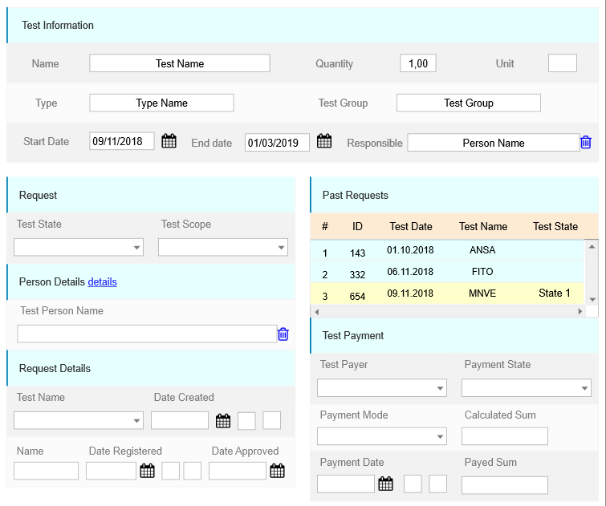

*Dynamic List*

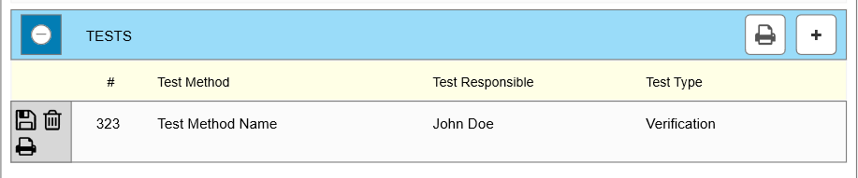

*Dynamic Form*

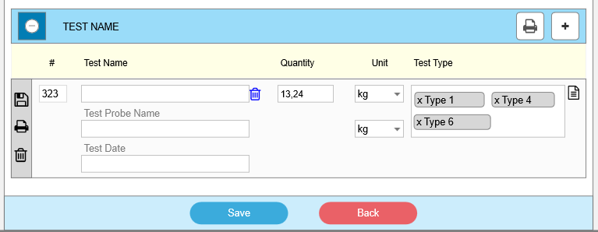

## *Popup Form*

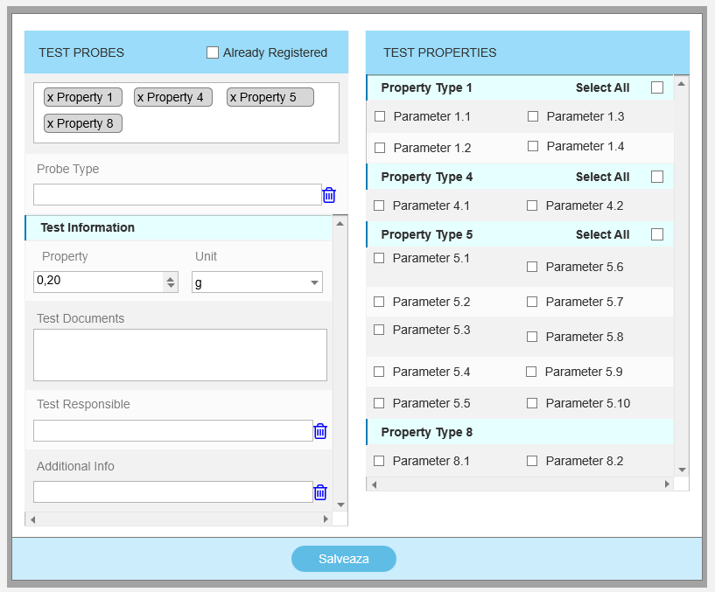

## *Report List*

## *Control Panel*

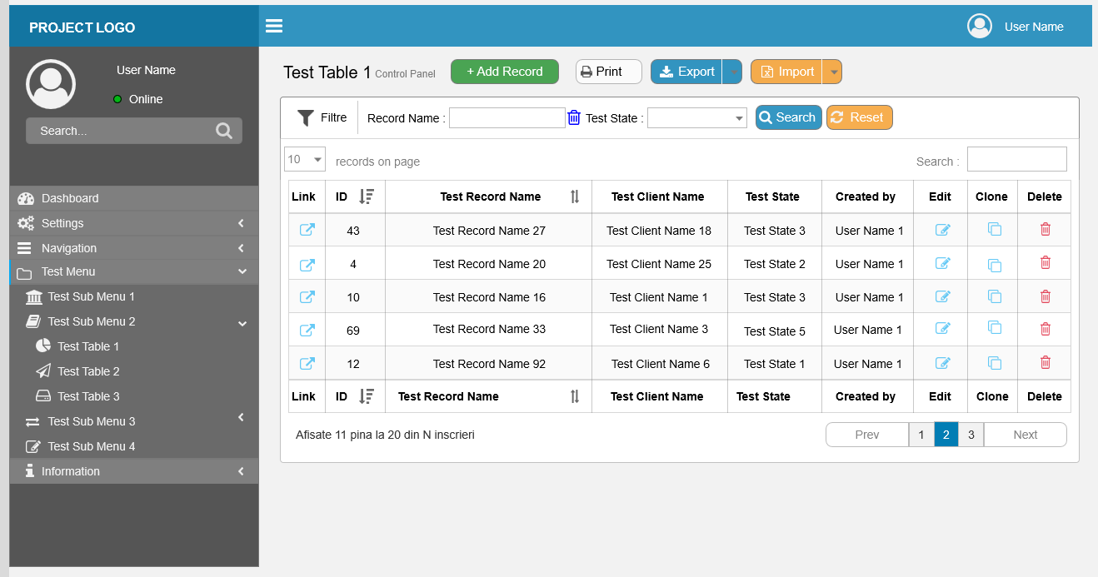

# 3. Naming Convention

For C# class names and corresponding table names are used only English singular terminology in Camel Case (<https://ru.wikipedia.org/wiki/CamelCase>). The same approach is used for properties and table columns.

For example, if it is required in Report to add a Student state field with name StudentState. Should be used following names:

Class file: **StudentList**.cs

Class name: **StudentState**

View file: **StudentList**.sql

string Name

Class name should be the same like View name.