Git Update and Push

First some terminology:

* Pull – take the updates from remote repository.
* Sync – get all updates from remote (data, branches, etc…)
* Update – update your local copy(in case of sync you can grab updates from remote but not update your local copy)
* Commit – send your changes to local repository
* Push – send changes from local repository to remote repository

In general lines there are several GIT restrictions that should be always taken into account:

* You cannot pull in case when you can not committed changes
* You cannot push if there are remote changes, that are not pulled
* You cannot switch branch in case when you have uncommitted changes

Please use this concept for each update.

1. Commit your changes.

Team Explorer -> Home -> changes

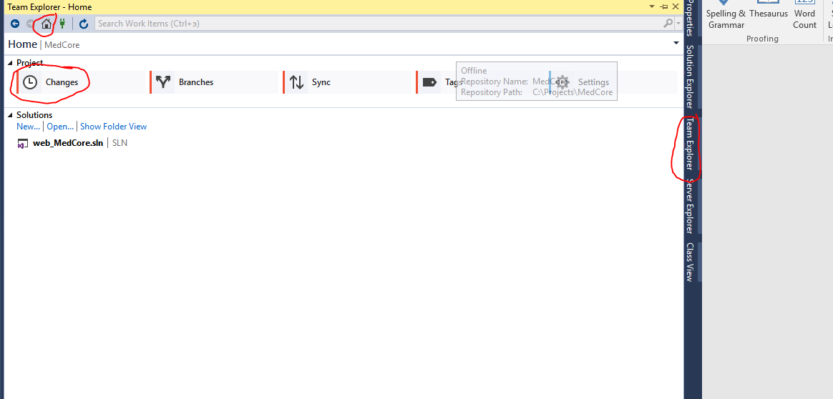

Comment is required and it will be good to add bug number for this commet

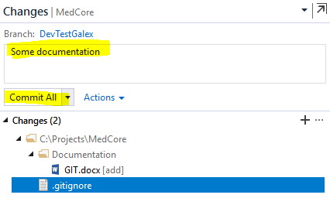

1. Go to Sync

Team Explorer -> Home -> Sync

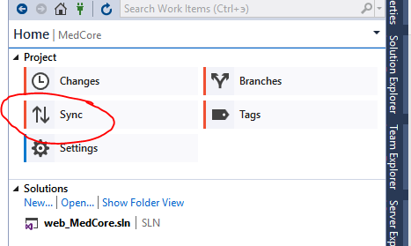

1. Pull changes

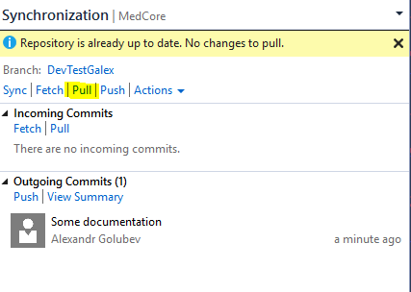

1. In case of conflicts resolve these conflicts first.
2. Push your changes

