SOFTWARE REQUIREMENTS
SPECIFICATION
Eyewear Shop Management System
(ESMS)
Complete Milestone 1 Document
Version 1.0 - Final Draft
Business Name | Lensora Optical
Prepared by | Lê Văn Bảo
Course | SWP391 - Software Development Project
Software Type | Web Application
Primary Market | Vietnam
Date | 20 July 2026
Software Requirements Specification and Preliminary Design

Document Control
Field | Value
Document Title | Eyewear Shop Management System - Complete SRS and Preliminary Design
Document Version | Draft v1.0
Document Status | Final Draft for Milestone 1
Prepared By | Lê Văn Bảo
Business Context | Lensora Optical - fictional eyewear retail chain with three branches in Hanoi
Included Content | Chapter 1 - Project Overview; Chapter 2 - Actors and Use Cases
Planned Submission Date | 30 July 2026

Revision History
Version | 1.0 | Description | Author
0.1 | 20 July 2026 | Initial project scope and business context drafted. | Lê Văn Bảo
1.0 | 20 July 2026 | Chapter 1 and Chapter 2 consolidated into the first SRS draft. | Lê Văn Bảo

Document Note
This is a working SRS draft. Later chapters will add user stories, acceptance criteria, business rules, non-functional requirements, architecture, MongoDB design, API overview, wireframes, test planning, and AI usage logs.

Table of Contents
CHAPTER 1 - PROJECT OVERVIEW
1.1 Project Information
1.2 Business Background
1.3 Business Problem Statement
1.4 Project Purpose
1.5 Project Objectives
1.6 Project Scope
1.7 Out of Scope
1.8 Project Success Criteria
1.9 Primary Workflows
CHAPTER 2 - ACTORS AND USE CASES
2.1 Actor Overview
2.2 Actor Descriptions
2.3 External Actors and Services
2.4 Use Case Catalog
2.5 Primary Use Case Specifications
2.6 Important Use Case Relationships
2.7 Simplified Use Case Diagram
CHAPTER 3 - USER STORIES AND ACCEPTANCE CRITERIA
CHAPTER 4 - FUNCTIONAL REQUIREMENTS AND BUSINESS RULES
CHAPTER 5 - NON-FUNCTIONAL REQUIREMENTS, CONSTRAINTS, ASSUMPTIONS, AND GLOSSARY
CHAPTER 6 - SYSTEM ARCHITECTURE AND TECHNOLOGY DESIGN
CHAPTER 7 - DATABASE DESIGN
CHAPTER 8 - WORKFLOW AND STATE DESIGN
CHAPTER 9 - API SPECIFICATION OVERVIEW
CHAPTER 10 - USER INTERFACE AND EXPERIENCE DESIGN
CHAPTER 11 - TESTING AND QUALITY ASSURANCE
CHAPTER 12 - PROJECT PLAN, RISKS, AND MILESTONE DELIVERABLES
APPENDIX A - AI ASSISTANCE LOG
APPENDIX B - REQUIREMENT TRACEABILITY MATRIX
APPENDIX C - INITIAL DEMONSTRATION DATA

CHAPTER 1 - PROJECT OVERVIEW
This chapter defines the business context, problems, purpose, objectives, boundaries, and success criteria of the Eyewear Shop Management System.

1.1 Project Information
Item | Information
Project Name | Eyewear Shop Management System
Project Abbreviation | ESMS
Business Name | Lensora Optical
Software Type | Web Application
Business Model | A fictional eyewear retail chain with three branches in Hanoi, Vietnam
Branches | Cau Giay, Dong Da, and Ha Dong
Target Users | Customers, Sales Staff, Prescription Staff, Branch Managers, and Super Administrator
Primary Market | Vietnam
Development Model | Iterative and incremental development
Repository Name | eyewear-shop-management-system

1.1.1 Project Description
The Eyewear Shop Management System, abbreviated as ESMS, is a web-based platform developed for Lensora Optical, a fictional eyewear retail chain operating three branches in Hanoi, Vietnam.
The system combines an online eyewear shopping platform with internal business management functions. It allows customers to browse eyewear products, configure prescription glasses, submit prescriptions, book eye examination appointments, place orders, make payments, select delivery methods, and track order progress.
ESMS also supports employees in managing products, prescriptions, branch inventory, appointments, customer consultations, payments, shipping, returns, and order fulfillment. Administrators can manage the overall system and monitor business performance through centralized dashboards and reports.

1.1.2 Branch Structure
Lensora Optical operates three fictional branches in Hanoi. Each branch maintains its own inventory, staff assignments, appointment schedules, and order-processing workload.
Branch | Location | Prescription Staff | Sales Staff | Eye Examination Service
Lensora Optical - Cau Giay | Cau Giay District, Hanoi | 2 | 3 | Available daily
Lensora Optical - Dong Da | Dong Da District, Hanoi | 2 | 3 | Available daily
Lensora Optical - Ha Dong | Ha Dong District, Hanoi | 2 | 3 | Available daily

Eye examination services operate from 9:00 AM to 9:00 PM every day. Each appointment has a default duration of 30 minutes. Prescription Staff have individual work schedules and break periods rather than a fixed branch-wide break time.

1.2 Business Background
Lensora Optical provides prescription glasses, sunglasses, fashion eyewear, optical frames, lenses, eye examination appointments, and after-sales services.
The business serves a broad customer base, including:
- Students who need affordable prescription glasses or blue-light filtering glasses.
- Office workers who spend significant time using computers.
- Customers with nearsightedness, farsightedness, or astigmatism.
- Customers purchasing sunglasses and fashion eyewear.
- Parents purchasing eyewear for family members.
Lensora Optical currently has a basic website that mainly introduces products and branch information. However, most online sales activities are still conducted through disconnected communication channels such as Facebook, Zalo, phone calls, and direct messages.
Each branch maintains its inventory using separate spreadsheet files. Prescription information may be stored as paper documents, uploaded images, or chat messages. Eye examination appointments are arranged manually, and customers must contact employees to confirm available time slots.
Because these activities are managed through separate tools, Lensora Optical does not have a centralized platform for managing customers, products, prescriptions, appointments, inventory, orders, and business reports.

1.3 Business Problem Statement
Lensora Optical is experiencing operational difficulties because its business data and processes are distributed across multiple independent tools.

1.3.1 Manual and Fragmented Order Processing
Most online orders are received through Facebook, Zalo, and phone calls. Sales Staff must manually record customer information, selected products, lens requirements, prescription details, payment methods, and delivery addresses. This process increases processing time and creates a high risk of missing, duplicated, or incorrectly entered order information.

1.3.2 Unsynchronized Inventory Across Branches
Each branch manages product inventory using separate spreadsheet files. Inventory changes may not be updated immediately after a product is sold, reserved, returned, or adjusted. As a result, employees may provide customers with incorrect availability information, and multiple customers may attempt to purchase the same remaining product.

1.3.3 Inconsistent Prescription Management
Prescription information is stored in different formats, including paper documents, images, spreadsheets, and chat messages. Employees may have difficulty retrieving previous prescriptions, identifying the correct prescription for an order, or determining whether a prescription has been reviewed. Manual entry also increases the risk of incorrect eye parameters being recorded.

1.3.4 Inefficient Appointment Scheduling
Eye examination appointments are currently scheduled through phone calls and messaging applications. Employees must manually check schedules before confirming an appointment. This process can create duplicated time slots, scheduling conflicts, uneven employee workloads, and delayed customer responses.

1.3.5 Limited Customer Self-Service
Customers lack a centralized platform for configuring prescription glasses, submitting or reusing prescriptions, booking eye examinations, making online payments, selecting delivery or branch pickup, tracking orders, reviewing appointment history, communicating with staff, and submitting return or refund requests.

1.3.6 Scattered Customer Communication
Customer conversations are distributed across multiple platforms. Employees may not have access to the complete conversation history when another employee continues supporting the customer. Important information such as product preferences, prescription updates, order problems, and appointment changes may be overlooked.

1.3.7 Lack of Centralized Reports and Dashboards
Managers cannot monitor inventory, orders, prescriptions, appointments, payments, revenue, and product performance in real time. Reports must be manually created by combining data from different branches and spreadsheet files, making reporting slow, inconsistent, and difficult to verify.

1.3.8 High Risk of Human Error and Data Duplication
Manual data entry and disconnected records can create duplicate customer profiles, incorrect inventory quantities, missing prescription information, and inconsistent order statuses. These problems negatively affect operational efficiency, customer satisfaction, and business scalability.

1.4 Project Purpose
The purpose of ESMS is to develop a centralized web-based platform that integrates Lensora Optical’s online sales activities and internal management processes.
The system will replace fragmented manual workflows with standardized digital processes for product management, prescription verification, branch inventory, appointment scheduling, ordering, payment, shipping, customer support, and reporting.
ESMS is expected to improve data consistency, reduce manual workload, increase order-processing accuracy, and provide customers with a more convenient online-to-offline eyewear shopping experience.

1.5 Project Objectives

OBJ-01 - Provide an Online Eyewear Shopping Platform
Allow customers to browse, search, filter, and view prescription glasses, sunglasses, fashion eyewear, frames, lenses, and related options.

OBJ-02 - Support Eyewear Configuration
Allow customers to select a frame variant, lens type, lens options, prescription, quantity, and fulfillment branch before adding a configured eyewear product to the cart.

OBJ-03 - Digitize Prescription Management
Allow customers to manually enter prescription information, upload a prescription image, or reuse a saved prescription. Prescription Staff can review, verify, request updates, or reject invalid submissions.

OBJ-04 - Centralize Branch Inventory
Maintain separate stock quantities for each product variant at each branch and support availability checking, temporary reservation, stock deduction, stock release, and transaction history.

OBJ-05 - Improve Order Processing
Provide a standardized workflow for regular and prescription eyewear orders, including item-level processing statuses and an overall order status.

OBJ-06 - Support Multiple Payment Methods
Support Cash on Delivery and VNPAY Sandbox. Prescription eyewear paid through VNPAY becomes payable only after all required prescriptions have been verified.

OBJ-07 - Support Delivery and Branch Pickup
Allow customers to select home delivery or branch pickup. For home delivery, the system recommends a fulfillment branch using inventory availability, shipping cost, delivery time, stock level, and branch workload.

OBJ-08 - Automate Appointment Scheduling
Allow customers to choose a branch, date, and time slot. The system automatically assigns an available Prescription Staff member according to branch assignment, schedule conflicts, and workload.

OBJ-09 - Improve Customer Communication
Provide real-time communication with Sales Staff, in-app notifications, email notifications, FAQ responses, and AI-assisted chatbot functionality.

OBJ-10 - Provide Management Dashboards
Allow administrators to monitor orders, sales, inventory, prescriptions, appointments, payments, product performance, and branch activities.

OBJ-11 - Improve the Shopping Experience
Provide face-shape recommendations and virtual try-on through uploaded images and live-camera input as advanced features.

OBJ-12 - Reduce Operational Errors
Reduce duplicated data, incorrect inventory records, missing prescription information, scheduling conflicts, delayed order updates, and manual reporting effort.

1.6 Project Scope

1.6.1 Core MVP Scope
The Core MVP contains the functions that must be completed before planned and advanced features.
Authentication and Authorization
- Customer registration using email and password.
- Email verification and password reset using OTP.
- Login, logout, JWT Access Token, and Refresh Token.
- Role-based access control and temporary account lock after repeated failed login attempts.
- Admin creation and management of staff accounts.
User, Family Profile, and Branch Management
- Customer profile and delivery-address management.
- Reusable family profiles for appointments, prescriptions, and prescription orders.
- Branch information management.
- Assignment of Sales Staff and Prescription Staff to branches.
Product Management
- Frame, frame variant, lens, lens option, brand, and category management.
- Product image management through Cloudinary.
- Product searching, filtering, sorting, and pagination.
Inventory Management
- Separate inventory for each branch.
- Available and reserved inventory quantities.
- Inventory reservation during checkout and release when payment expires or an order is cancelled.
- Inventory transaction history and prevention of overselling through atomic updates and MongoDB transactions.
Cart Management
- Guest cart stored in localStorage and authenticated cart stored in MongoDB.
- Automatic cart merging after login.
- Cart items containing complete eyewear configurations.
- Backend recalculation of prices and inventory before checkout.
Prescription Management
- Manual entry, document upload, and reuse of saved prescriptions.
- Prescription review by assigned Prescription Staff.
- Statuses including draft, pending_review, verified, needs_update, rejected, and expired.
- Review notes, history, 12-month default validity, and protection against guessing missing professional information.
Checkout and Order Management
- Checkout for regular and prescription eyewear.
- One fulfillment branch for the entire order.
- Home delivery and branch pickup.
- Cash on Delivery and mixed orders containing regular and prescription items.
- Item-level processing status, overall order status, history, and stage-based cancellation.
Basic Dashboard
- Total orders, orders by status, and revenue summary.
- Low-stock products and pending prescriptions.
- Basic branch inventory and appointment information.

1.6.2 Planned Feature Scope
- VNPAY Sandbox payment.
- GHN shipping fee calculation, shipment creation, and tracking.
- Fulfillment-branch recommendation during checkout.
- Eye examination appointment scheduling and automatic staff assignment.
- Real-time chat using Socket.IO.
- In-app, real-time, and email notifications.
- Promotion and voucher management.
- Verified-purchase product reviews.
- Return and refund request management.
- Configurable cancellation-processing fees.
- Shipping, address, payment, and AI provider abstractions.

1.6.3 Advanced Feature Scope
- FAQ-based chatbot and AI-assisted chatbot with interchangeable providers.
- Automatic face-shape analysis and frame recommendations.
- Virtual try-on using uploaded images.
- Live-camera virtual try-on.
- Optional prescription OCR assistance that never replaces staff verification.

1.7 Out of Scope
- Online medical diagnosis or automated prescription approval without Prescription Staff review.
- An online eye examination performed entirely through the website.
- Hospital or clinic management and electronic medical records.
- Insurance claim processing.
- Supplier and purchase-order management.
- Central warehouse and inter-branch stock transfer.
- Multi-vendor marketplace functionality.
- International payment and international shipping.
- Automatic VNPAY refund processing.
- Same-day express delivery.
- Native Android or iOS applications.
- Integration with physical eye-testing equipment.
- Advanced accounting and tax management.
- Loyalty points and membership-tier management.

1.8 Project Success Criteria
1. Customers can complete a prescription-eyewear order through the website.
2. Prescription Staff can review and verify customer prescriptions.
3. Sales Staff can process an eligible order through the required fulfillment stages.
4. Inventory is managed separately for each branch.
5. The system prevents unavailable products from being sold beyond available stock.
6. Customers can track prescription, appointment, and order statuses.
7. The system enforces permissions for all user roles and administrative levels.
8. Administrators can monitor essential business information through dashboards.
9. Core APIs are documented using Swagger/OpenAPI and can be demonstrated through Postman.
10. The three primary workflows operate successfully from beginning to end.

1.9 Primary Workflows

WF-01 - Purchase Prescription Eyewear
Primary actor: Customer
Browse products
-> Select frame variant
-> Select lens and lens options
-> Select person profile
-> Provide prescription
-> Add configured eyewear to cart
-> Select fulfillment branch
-> Checkout
-> Create order

WF-02 - Review and Verify Prescription
Primary actor: Prescription Staff
Receive assigned prescription
-> Review entered parameters or uploaded document
-> Check completeness, validity, expiration, and lens compatibility
-> Verify OR request update OR reject
-> Notify Customer and update related order

WF-03 - Process and Fulfill Order
Primary actor: Sales Staff
Receive eligible order
-> Confirm order
-> Prepare regular items
-> Process prescription lenses
-> Perform quality check
-> Pack all items together
-> Deliver or prepare branch pickup
-> Complete order

CHAPTER 2 - ACTORS AND USE CASES
This chapter identifies the human and external actors that interact with ESMS, defines their responsibilities and access boundaries, catalogs the system use cases, and specifies the three highest-priority use cases.

2.1 Actor Overview
ESMS has four primary role groups: Customer, Sales Staff, Prescription Staff, and Administrator. The Administrator role is divided into Branch Manager and Super Administrator permission levels. Guest users and external services also interact with the platform.
Administrator
├── Branch Manager
└── Super Administrator

2.2 Actor Descriptions

2.2.1 Guest
A Guest is a visitor who has not logged in to the system.
Main capabilities
- View the home page, product catalog, product details, branch information, and available appointment slots.
- Search, filter, and sort products.
- Add products to a temporary browser cart.
- Register a Customer account or log in using email, password, or Google.
Access restrictions
- Confirm an appointment.
- Save prescriptions.
- Complete checkout.
- View orders.
- Chat directly with staff.
- Submit reviews or return requests.

2.2.2 Customer
A Customer is a registered and verified user who purchases products and uses Lensora Optical services.
Main capabilities
- Manage personal information, delivery addresses, and reusable family profiles.
- Browse, configure, and purchase regular or prescription eyewear.
- Upload, enter, save, reuse, and update prescriptions.
- Manage the cart, select a fulfillment branch, place orders, pay, and track order progress.
- Book, reschedule, and cancel eye examination appointments for themselves or family members.
- Chat with Sales Staff, receive notifications, submit verified-purchase reviews, and request returns or refunds.
- Use face-shape recommendation and virtual try-on when those advanced features are available.

2.2.3 Sales Staff
Sales Staff are responsible for customer consultation and order fulfillment at an assigned branch.
Main capabilities
- View and confirm eligible branch orders.
- Update item-processing and order statuses.
- Prepare products, coordinate lens processing, record quality checks, package orders, and prepare pickup or shipping.
- Communicate with Customers through real-time chat.
- Review cancellation and return requests, receive returned items, inspect evidence, and prepare recommendations.
- View branch inventory needed for order processing.
Access restrictions
- Verify professional prescription information.
- Approve final refunds.
- Manage Super Administrator accounts.
- Access another branch’s operational data.

2.2.4 Prescription Staff
Prescription Staff are responsible for eye examination services and prescription verification.
Main capabilities
- Review assigned manual prescription values and uploaded documents.
- Verify valid prescriptions, request updates, reject invalid submissions, and record review notes.
- Check lens compatibility with prescription parameters.
- View and process assigned appointments, check in Customers, record examination results, and create prescriptions.
- Support another branch when an approved cross-branch assignment grants temporary access.
Access restrictions
- Guess missing professional information.
- Automatically approve a prescription based only on OCR.
- Manage payments or final refunds.
- Access prescriptions that have not been assigned.

2.2.5 Branch Manager
A Branch Manager manages daily operations at one assigned Lensora Optical branch.
Main capabilities
- View branch dashboards and monitor orders, prescriptions, appointments, inventory, staff workload, and revenue.
- Create, lock, and reactivate Sales Staff and Prescription Staff accounts for the assigned branch.
- Manage staff schedules and breaks and reassign branch work.
- Review cancellation, return, and refund recommendations.
- Correct inventory with a required reason and view inventory history.
- Suspend appointment services temporarily and handle cross-branch support requests.
Access restrictions
- Access another branch’s internal data.
- Create another Branch Manager.
- Change system-wide policies.
- Approve final refunds.
- Transfer employees between branches.
- Create or delete branches.

2.2.6 Super Administrator
The Super Administrator manages the entire ESMS platform.
Main capabilities
- Manage branches, Branch Manager accounts, staff accounts, and employee transfers.
- Manage products, brands, categories, frames, lenses, variants, promotions, and system-wide policies.
- Configure cancellation fees and external service providers.
- View organization-wide dashboards, reports, and audit logs.
- Approve or reject all final refund requests.
- Resolve escalated cross-branch support requests and manage security settings.
Access restrictions
- Lock the last active Super Administrator account when no other active Super Administrator is available.

2.3 External Actors and Services
External Actor / Service | Responsibility
Google OAuth | Supports Customer login using a Google account.
Email Service | Supports OTP verification, password reset, staff activation, operational notifications, and escalation alerts.
Cloudinary | Stores product images, prescription documents, review images, return evidence, and chat attachments.
VNPAY Sandbox | Processes test online payments and sends payment results to the backend.
GHN API | Supports address master data, shipping-fee calculation, shipment creation, tracking, and cancellation.
AI Provider | Supports chatbot responses through an interchangeable provider layer such as Gemini, OpenAI, or Groq.
MediaPipe Face Landmarker | Supports facial landmark detection, face-shape estimation, and eyewear positioning for virtual try-on.

2.4 Use Case Catalog

2.4.1 Authentication and Account Management
ID | Use Case | Primary Actor
UC-AUTH-01 | Register Customer Account | Guest
UC-AUTH-02 | Verify Email Using OTP | Customer
UC-AUTH-03 | Log In with Email and Password | Guest
UC-AUTH-04 | Log In with Google | Guest
UC-AUTH-05 | Refresh Access Token | System
UC-AUTH-06 | Log Out | Authenticated User
UC-AUTH-07 | Reset Forgotten Password | Guest
UC-AUTH-08 | Manage Personal Profile | Customer
UC-AUTH-09 | Manage Delivery Addresses | Customer
UC-AUTH-10 | Manage Family Profiles | Customer
UC-AUTH-11 | Create Staff Account | Branch Manager, Super Administrator
UC-AUTH-12 | Lock or Reactivate Account | Branch Manager, Super Administrator
UC-AUTH-13 | Transfer Staff Between Branches | Super Administrator

2.4.2 Product and Shopping Management
ID | Use Case | Primary Actor
UC-PROD-01 | Browse Product Catalog | Guest, Customer
UC-PROD-02 | Search and Filter Products | Guest, Customer
UC-PROD-03 | View Product Details | Guest, Customer
UC-PROD-04 | View Branch Availability | Guest, Customer
UC-PROD-05 | Configure Prescription Eyewear | Customer
UC-PROD-06 | Use Face-Shape Recommendation | Customer
UC-PROD-07 | Use Virtual Try-On | Customer
UC-PROD-08 | Manage Frames and Variants | Super Administrator
UC-PROD-09 | Manage Lenses and Lens Options | Super Administrator
UC-PROD-10 | Manage Brands and Categories | Super Administrator
UC-PROD-11 | Manage Product Images | Super Administrator

2.4.3 Cart and Checkout
ID | Use Case | Primary Actor
UC-CART-01 | Add Configured Product to Cart | Guest, Customer
UC-CART-02 | Update Cart Item | Guest, Customer
UC-CART-03 | Remove Cart Item | Guest, Customer
UC-CART-04 | Merge Guest and Customer Carts | Customer
UC-CART-05 | Validate Cart | System
UC-CART-06 | Recommend Fulfillment Branch | System
UC-CART-07 | Select Fulfillment Branch | Customer
UC-CART-08 | Calculate Shipping Fee | System
UC-CART-09 | Apply Promotion Code | Customer
UC-CART-10 | Checkout | Customer

2.4.4 Prescription Management
ID | Use Case | Primary Actor
UC-PRES-01 | Enter Prescription Manually | Customer
UC-PRES-02 | Upload Prescription Document | Customer
UC-PRES-03 | Reuse Saved Prescription | Customer
UC-PRES-04 | Update Prescription Information | Customer
UC-PRES-05 | View Prescription History | Customer
UC-PRES-06 | Review Assigned Prescription | Prescription Staff
UC-PRES-07 | Verify Prescription | Prescription Staff
UC-PRES-08 | Request Prescription Update | Prescription Staff
UC-PRES-09 | Reject Prescription | Prescription Staff
UC-PRES-10 | Reassign Prescription | Branch Manager, Super Administrator
UC-PRES-11 | Request Cross-Branch Support | Branch Manager
UC-PRES-12 | Approve Cross-Branch Support | Branch Manager, Super Administrator
UC-PRES-13 | Create Prescription after Examination | Prescription Staff

2.4.5 Appointment Management
ID | Use Case | Primary Actor
UC-APP-01 | View Available Appointment Slots | Guest, Customer
UC-APP-02 | Book Eye Examination | Customer
UC-APP-03 | Book for Family Member | Customer
UC-APP-04 | Reschedule Appointment | Customer
UC-APP-05 | Cancel Appointment | Customer
UC-APP-06 | Automatically Assign Prescription Staff | System
UC-APP-07 | Confirm Special Appointment | Prescription Staff, Branch Manager
UC-APP-08 | Check In Customer | Prescription Staff
UC-APP-09 | Conduct Eye Examination | Prescription Staff
UC-APP-10 | Complete Appointment | Prescription Staff
UC-APP-11 | Manage Staff Work Schedule | Branch Manager
UC-APP-12 | Suspend Branch Appointment Service | Branch Manager

2.4.6 Order and Payment Management
ID | Use Case | Primary Actor
UC-ORD-01 | Create Order | Customer
UC-ORD-02 | Reserve Branch Inventory | System
UC-ORD-03 | Pay by VNPAY | Customer
UC-ORD-04 | Select Cash on Delivery | Customer
UC-ORD-05 | Track Order | Customer
UC-ORD-06 | Request Order Cancellation | Customer
UC-ORD-07 | Review Cancellation Request | Sales Staff
UC-ORD-08 | Confirm Order | Sales Staff
UC-ORD-09 | Process Prescription Lens | Sales Staff
UC-ORD-10 | Perform Quality Check | Sales Staff
UC-ORD-11 | Prepare Order for Shipment | Sales Staff
UC-ORD-12 | Prepare Order for Branch Pickup | Sales Staff
UC-ORD-13 | Confirm Branch Pickup | Sales Staff
UC-ORD-14 | Complete Order | System, Sales Staff
UC-ORD-15 | Release Expired Inventory Reservation | System

2.4.7 Return and Refund Management
ID | Use Case | Primary Actor
UC-RET-01 | Submit Return Request | Customer
UC-RET-02 | Upload Return Evidence | Customer
UC-RET-03 | Review Return Request | Sales Staff
UC-RET-04 | Receive Returned Product | Sales Staff
UC-RET-05 | Inspect Returned Product | Sales Staff
UC-RET-06 | Review Refund Recommendation | Branch Manager
UC-RET-07 | Approve or Reject Refund | Super Administrator
UC-RET-08 | Record Refund Transaction | Super Administrator
UC-RET-09 | Track Return Status | Customer

2.4.8 Communication and Notification
ID | Use Case | Primary Actor
UC-COM-01 | Start Customer Support Conversation | Customer
UC-COM-02 | Send Real-Time Message | Customer, Sales Staff
UC-COM-03 | Send Image Attachment | Customer, Sales Staff
UC-COM-04 | Transfer Chat to Sales Staff | Chatbot, Customer
UC-COM-05 | Answer FAQ Question | Chatbot
UC-COM-06 | Generate AI-Assisted Response | AI Provider
UC-COM-07 | View Notifications | Authenticated User
UC-COM-08 | Mark Notification as Read | Authenticated User
UC-COM-09 | Receive Real-Time Notification | Authenticated User
UC-COM-10 | Receive Email Notification | Authenticated User

2.4.9 Administration and Reporting
ID | Use Case | Primary Actor
UC-ADM-01 | Manage Branch Information | Super Administrator
UC-ADM-02 | View Branch Dashboard | Branch Manager
UC-ADM-03 | View System Dashboard | Super Administrator
UC-ADM-04 | Manage Branch Inventory | Branch Manager, Super Administrator
UC-ADM-05 | Adjust Inventory | Branch Manager, Super Administrator
UC-ADM-06 | View Inventory Transactions | Branch Manager, Super Administrator
UC-ADM-07 | Manage Promotions | Super Administrator
UC-ADM-08 | Manage Cancellation Policies | Super Administrator
UC-ADM-09 | Manage External Providers | Super Administrator
UC-ADM-10 | View Audit Logs | Super Administrator
UC-ADM-11 | View Branch Reports | Branch Manager
UC-ADM-12 | View Organization Reports | Super Administrator

2.5 Primary Use Case Specifications

2.5.1 UC-PROD-05 - Configure and Purchase Prescription Eyewear
Item | Description
Use Case ID | UC-PROD-05
Use Case Name | Configure and Purchase Prescription Eyewear
Primary Actor | Customer
Supporting Actors | VNPAY, GHN, Cloudinary
Priority | Core MVP
Trigger | Customer selects a frame and chooses to purchase prescription eyewear.

Preconditions
- The Customer is logged in with an active, email-verified account.
- The selected frame variant is active.
- At least one branch has sufficient available inventory.
- The Customer has a valid prescription or intends to submit a new one.
Main Success Flow
1. The Customer opens a frame-detail page.
2. The system displays available frame variants.
3. The Customer selects a color and size.
4. The Customer selects a lens type and optional lens features.
5. The Customer selects the person profile for whom the eyewear is being purchased.
6. The Customer selects a verified saved prescription, enters a new prescription manually, or uploads a prescription document.
7. The system validates the configuration.
8. The Customer adds the configured eyewear to the cart.
9. The Customer opens checkout.
10. The system validates prices, product status, prescription status, and branch inventory.
11. The Customer selects home delivery or branch pickup.
12. For home delivery, the system recommends eligible fulfillment branches.
13. The Customer selects one fulfillment branch.
14. The Customer selects Cash on Delivery or VNPAY.
15. The system creates the order and reserves inventory in one transaction.
16. The order enters pending_prescription_review.
17. The system assigns the prescription to a Prescription Staff member.
18. The Customer receives an order-confirmation notification.
Alternative and Exception Flows
A1 - Saved prescription has expired
1. The system prevents use of the expired prescription.
2. The Customer uploads a new prescription or books an examination.
3. The use case continues after a valid submission is provided.
A2 - Uploaded prescription requires review
1. The order is created with the prescription in pending_review.
2. VNPAY payment is delayed until verification.
A3 - No branch has enough inventory
1. The system informs the Customer.
2. The Customer changes quantity or removes unavailable items.
3. Checkout cannot continue until one branch can fulfill the entire order.
A4 - Inventory changes during checkout
1. The reservation transaction fails and is rolled back.
2. The system refreshes availability.
3. The Customer is asked to review the cart.
A5 - Duplicate checkout request
1. The backend detects an existing idempotency key.
2. The system returns the previously created order.
3. No duplicate order or reservation is created.
Postconditions
- One order is created.
- One fulfillment branch is assigned.
- Required inventory is reserved.
- The prescription is linked to the correct person profile.
- The order awaits prescription review.
- An order-status history entry is created.

2.5.2 UC-PRES-06 - Review and Verify Prescription
Item | Description
Use Case ID | UC-PRES-06
Use Case Name | Review and Verify Prescription
Primary Actor | Prescription Staff
Supporting Actors | Customer, Branch Manager
Priority | Core MVP
Trigger | A prescription is assigned to a Prescription Staff member.

Preconditions
- The Prescription Staff account is active.
- The prescription is assigned to the staff member.
- The prescription status is pending_review.
- The related Customer, person profile, and order information are available.
Main Success Flow
1. Prescription Staff opens the pending-review queue.
2. Prescription Staff selects an assigned prescription.
3. The system displays Customer, person-profile, entered values, uploaded document, issue date, external provider information, and related order configuration.
4. Prescription Staff checks the document and entered information.
5. Prescription Staff confirms that the prescription is complete, readable, valid, and not expired.
6. Prescription Staff checks lens compatibility.
7. Prescription Staff selects Verify.
8. The system records the review note, reviewer, and verification time.
9. The prescription status changes to verified.
10. The related order is updated.
11. For VNPAY, the order changes to waiting_for_payment; for COD, it becomes eligible for confirmation.
12. The Customer receives a notification.
Alternative and Exception Flows
A1 - Prescription image is unclear or incomplete
1. Prescription Staff selects Request Update.
2. The staff member identifies missing or unreadable information.
3. The prescription changes to needs_update and the review SLA pauses.
4. The Customer receives an update request.
A2 - Prescription is expired
1. Prescription Staff rejects the prescription or requests a new one.
2. The Customer may upload a new prescription or book an examination.
A3 - Invalid prescription information
1. Prescription Staff selects Reject.
2. A rejection reason is required.
3. The prescription changes to rejected and the related order cannot proceed.
A4 - Review SLA exceeded
1. The system marks the assignment overdue.
2. The system attempts reassignment within the same branch.
3. If no staff member is available, the Branch Manager is notified and cross-branch support may be requested.
Postconditions
- For successful verification, the prescription status is verified.
- The reviewer and verification time are recorded.
- The Customer is notified.
- The related order becomes eligible for payment or confirmation.

2.5.3 UC-ORD-08 - Process and Fulfill Order
Item | Description
Use Case ID | UC-ORD-08
Use Case Name | Process and Fulfill Order
Primary Actor | Sales Staff
Supporting Actors | Prescription Staff, GHN, Customer
Priority | Core MVP
Trigger | An order satisfies prescription and payment requirements.

Preconditions
- The order belongs to the Sales Staff member’s assigned branch.
- All required prescriptions have been verified.
- VNPAY payment has succeeded, or Cash on Delivery has been selected.
- Inventory has been reserved.
- The order is not cancelled.
Main Success Flow
1. Sales Staff opens the eligible-order list.
2. Sales Staff selects an order.
3. The system displays order, item, payment, prescription, and fulfillment details.
4. Sales Staff confirms the order.
5. Regular items are prepared.
6. Prescription items move to lens_processing.
7. Sales Staff records lens-processing progress.
8. Completed prescription items move to quality_check.
9. Sales Staff records the quality-check result.
10. All items move to ready.
11. The order changes to ready_to_ship or ready_for_pickup.
12. For home delivery, Sales Staff confirms the address and the system creates one GHN shipment.
13. For branch pickup, the system generates a pickup code or QR code and notifies the Customer.
14. The order changes to shipping or remains ready_for_pickup as appropriate.
15. The order changes to completed after successful delivery or pickup.
Alternative and Exception Flows
A1 - Prescription requires correction after confirmation
1. Sales Staff pauses lens processing.
2. Prescription Staff reviews the issue.
3. The order returns to needs_prescription_update when necessary.
A2 - Product defect found during quality check
1. The item fails the quality check and the defect is recorded.
2. The item returns to lens_processing or replacement preparation.
3. The Customer is notified if delivery is delayed.
A3 - GHN API is unavailable
1. The system switches to MockShippingProvider.
2. Sales Staff creates a mock shipment for demonstration or temporary processing.
3. The provider failure is recorded.
A4 - Customer requests cancellation
1. The system checks the current processing stage.
2. Cancellation is handled according to the saved policy snapshot.
3. If lens production has started, non-refundable lens cost and the configured processing fee may apply.
Postconditions
- All order items are fulfilled or otherwise resolved.
- Inventory reservation is committed or released correctly.
- Shipment or pickup information is stored.
- Order-status history is complete.
- The Customer receives completion notification.
- The order becomes eligible for verified-purchase reviews.

2.6 Important Use Case Relationships

2.6.1 Include Relationships
Checkout
├── includes Validate Cart
├── includes Check Branch Inventory
├── includes Recommend Fulfillment Branch
├── includes Calculate Order Total
├── includes Reserve Inventory
└── includes Create Order
Purchase Prescription Eyewear
├── includes Configure Eyewear
├── includes Select Person Profile
├── includes Provide Prescription
├── includes Add to Cart
└── includes Checkout
Review Prescription
├── includes Validate Prescription Information
├── includes Check Expiration
├── includes Check Lens Compatibility
└── includes Record Review History
Fulfill Order
├── includes Confirm Order
├── includes Process Items
├── includes Quality Check
├── includes Prepare Shipment or Pickup
└── includes Update Order Status

2.6.2 Extend Relationships
Extending Use Case | Base Use Case
Request Prescription Update | Review Prescription
Reject Prescription | Review Prescription
Pay by VNPAY | Checkout
Apply Promotion | Checkout
Request Return | View Completed Order
Use Virtual Try-On | View Product Details

2.7 Simplified Use Case Diagram
The following diagram presents a simplified overview of the main actors and system capability groups. Detailed module diagrams may be added in later SRS revisions to avoid excessive complexity in one diagram.
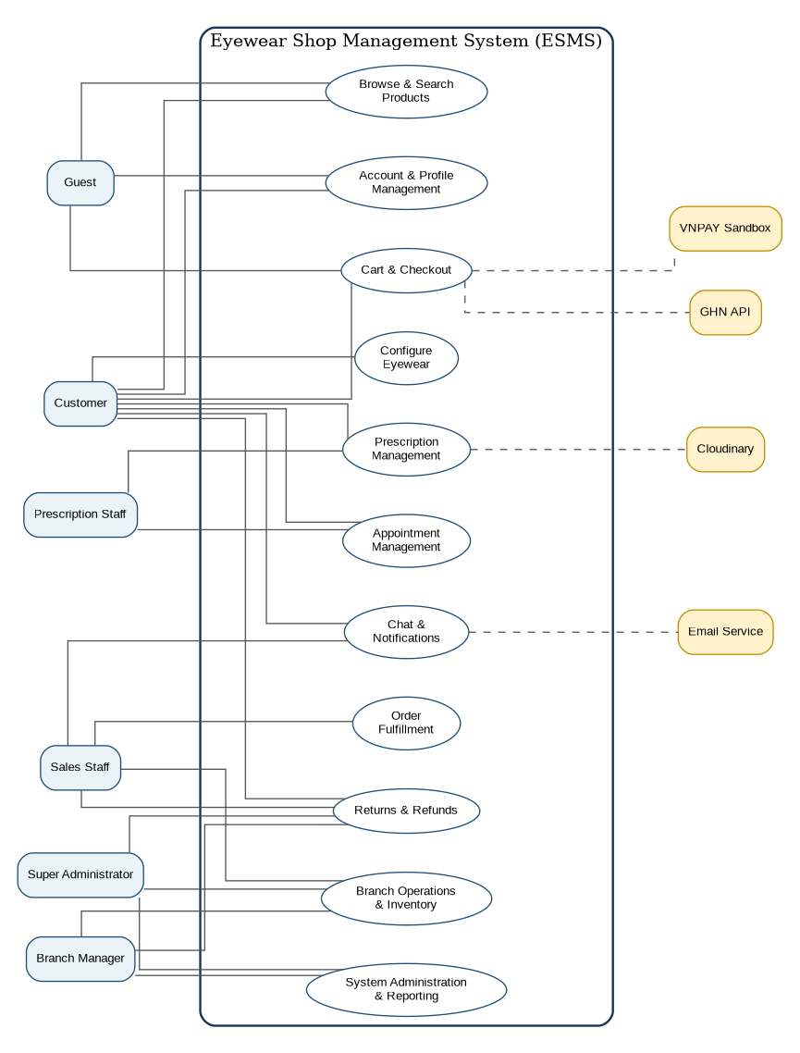
Figure 2.1 - Simplified ESMS Use Case Overview

CHAPTER 3 - USER STORIES AND ACCEPTANCE CRITERIA
This chapter expresses the expected system behavior from the perspective of its users. The MoSCoW method is used to distinguish Core MVP requirements from planned and advanced features.

3.1 Prioritization Method
Priority | Meaning
Must Have | Required for the Core MVP and the three primary demonstration workflows.
Should Have | Important planned functionality developed after the Core MVP is stable.
Could Have | Advanced or optional functionality implemented when time permits.
Won't Have Now | Explicitly excluded from the current release.

3.2 User Story Catalog
ID | Title | Actor | Priority
US-01 | Register and Verify Customer Account | Guest | Must Have
US-02 | Log In and Access Authorized Functions | Authenticated User | Must Have
US-03 | Browse, Search, Filter, and Sort Products | Guest or Customer | Must Have
US-04 | Configure Prescription Eyewear | Customer | Must Have
US-05 | Manage and Merge Shopping Cart | Guest or Customer | Must Have
US-06 | Submit or Reuse a Prescription | Customer | Must Have
US-07 | Review and Verify Prescription | Prescription Staff | Must Have
US-08 | Request Prescription Update or Reject Prescription | Prescription Staff | Must Have
US-09 | Checkout and Create Order | Customer | Must Have
US-10 | Process and Fulfill Prescription Order | Sales Staff | Must Have
US-11 | Track Order and Item Status | Customer | Must Have
US-12 | Manage Branch Inventory | Branch Manager | Must Have
US-13 | Book Eye Examination | Customer | Should Have
US-14 | Submit and Process Return Request | Customer and Staff | Should Have
US-15 | View Management Dashboard | Branch Manager or Super Administrator | Should Have

3.3 Detailed User Stories and Acceptance Criteria

US-01 - Register and Verify Customer Account
Field | Description
Actor | Guest
Priority | Must Have
User Story | As a Guest, I want to register and verify an account so that I can purchase eyewear and use Lensora services.

Acceptance Criteria
- Given an unused email and valid registration data, when the Guest submits the form, then the system creates a pending-verification Customer account and sends a five-minute OTP.
- Given an email that already exists, when registration is submitted, then the system rejects the request without creating a duplicate account.
- Given a valid OTP, when the Customer verifies the email, then the account becomes active and the verification time is recorded.
- Given an expired or incorrect OTP, when verification is attempted, then the system rejects it and allows a rate-limited resend.

US-02 - Log In and Access Authorized Functions
Field | Description
Actor | Authenticated User
Priority | Must Have
User Story | As a registered user, I want to log in securely so that I can access the functions permitted for my role and branch.

Acceptance Criteria
- Given an active account and correct credentials, when login succeeds, then the system issues an Access Token and stores the Refresh Token in an HTTP-only cookie.
- Given invalid credentials, when login is attempted, then the system shows a generic error and records the failure.
- Given five consecutive failed attempts, when another attempt occurs, then the account is temporarily locked.
- Given successful login, when navigation begins, then the user is directed to the workspace appropriate for the role and administrative level.

US-03 - Browse, Search, Filter, and Sort Products
Field | Description
Actor | Guest or Customer
Priority | Must Have
User Story | As a shopper, I want to find eyewear using search and filters so that I can identify suitable products quickly.

Acceptance Criteria
- Given active products, when the catalog loads, then paginated cards show name, image, price, rating, and availability.
- Given a keyword, when searching by name, SKU, or brand, then matching products are returned and the query is retained in the URL.
- Given frame or lens filters, when they are applied, then only matching products are displayed.
- Given no result, when the query completes, then the system displays an empty-state message and a clear-filter action.

US-04 - Configure Prescription Eyewear
Field | Description
Actor | Customer
Priority | Must Have
User Story | As a Customer, I want to combine a frame, lens, options, person profile, and prescription so that the eyewear matches the wearer.

Acceptance Criteria
- Given a frame product, when color and size are selected, then the corresponding frame variant, SKU, price, and branch availability are shown.
- Given a selected frame, when a lens and options are selected, then the estimated configuration price is recalculated.
- Given a person profile, when a saved verified prescription is selected, then the prescription must belong to that profile and remain unexpired.
- Given an incompatible lens range, when configuration validation runs, then the system blocks the configuration and explains the incompatibility.

US-05 - Manage and Merge Shopping Cart
Field | Description
Actor | Guest or Customer
Priority | Must Have
User Story | As a shopper, I want to maintain a cart so that I can review and modify complete eyewear configurations before checkout.

Acceptance Criteria
- Given a valid configuration, when it is added, then the cart stores the frame variant, lens, options, profile, prescription, quantity, branch, and price snapshot.
- Given a Guest, when cart data changes, then the cart persists in localStorage after refresh.
- Given a Customer logs in with both guest and account carts, when merging occurs, then identical configurations are combined and different ones remain separate.
- Given an inactive or unavailable item, when the cart is validated, then checkout is blocked until the item is corrected or removed.

US-06 - Submit or Reuse a Prescription
Field | Description
Actor | Customer
Priority | Must Have
User Story | As a Customer, I want to enter, upload, or reuse a prescription for myself or a family member.

Acceptance Criteria
- Given manual entry, when required OD, OS, SPH, CYL, AXIS, PD, and applicable ADD values are valid, then a pending-review prescription is created.
- Given a supported JPG, PNG, or PDF, when upload succeeds, then Cloudinary stores the document and the prescription references it.
- Given an external provider, when the Customer submits the prescription, then issue date and provider information may be captured.
- Given a verified unexpired prescription already exists, when it is reused, then the system links it without creating a duplicate.

US-07 - Review and Verify Prescription
Field | Description
Actor | Prescription Staff
Priority | Must Have
User Story | As a Prescription Staff member, I want to verify assigned prescriptions so that only valid data enters production.

Acceptance Criteria
- Given an assigned pending prescription, when opened, then the wearer, values, uploaded document, issue date, provider, selected lens, and related order are shown.
- Given a complete, readable, valid, compatible, and unexpired prescription, when Verify is selected, then status becomes verified and reviewer details are recorded.
- Given the final prescription in a VNPAY order is verified, when the operation completes, then the order becomes waiting_for_payment.
- Given the final prescription in a COD order is verified, when the operation completes, then the order becomes eligible for Sales Staff confirmation.

US-08 - Request Prescription Update or Reject Prescription
Field | Description
Actor | Prescription Staff
Priority | Must Have
User Story | As a Prescription Staff member, I want to request corrections or reject invalid prescriptions so that professional values are never guessed.

Acceptance Criteria
- Given an unclear or incomplete prescription, when Request Update is selected, then a reason is required and status becomes needs_update.
- Given missing professional values, when reviewing, then the staff member cannot mark guessed values as verified.
- Given a Customer resubmission, when the update is saved, then a new version is created and a new review SLA begins.
- Given an invalid or expired prescription, when Reject is selected, then a rejection reason is required and linked orders cannot proceed.

US-09 - Checkout and Create Order
Field | Description
Actor | Customer
Priority | Must Have
User Story | As a Customer, I want checkout to create one valid order at one fulfillment branch without overselling inventory.

Acceptance Criteria
- Given checkout begins, when validation runs, then backend prices, discounts, product status, prescriptions, and inventory are recalculated.
- Given several eligible branches, when home delivery is selected, then the system recommends a branch and permits selection of another eligible branch.
- Given a prescription order, when checkout is confirmed, then one order and inventory reservation are created atomically with pending_prescription_review status.
- Given a repeated idempotency key, when checkout is submitted again, then the existing order is returned and no duplicate reservation is created.

US-10 - Process and Fulfill Prescription Order
Field | Description
Actor | Sales Staff
Priority | Must Have
User Story | As a Sales Staff member, I want to move eligible orders through preparation, lens processing, quality checking, shipment, or pickup.

Acceptance Criteria
- Given verified prescriptions and valid payment conditions, when the order is confirmed, then confirmation is recorded in status history.
- Given prescription production begins, when status is updated, then the relevant item becomes lens_processing.
- Given production is complete, when quality check passes, then the item becomes ready; when it fails, the item returns to processing with a reason.
- Given all non-cancelled items are ready, when fulfillment starts, then one shipment is created or one pickup code is generated.

US-11 - Track Order and Item Status
Field | Description
Actor | Customer
Priority | Must Have
User Story | As a Customer, I want to track order-level and item-level progress so that I know the next required action.

Acceptance Criteria
- Given an owned order, when detail is opened, then order code, items, totals, payment, branch, delivery method, and current status are displayed.
- Given a mixed order, when viewed, then each item processing status and the derived overall status are shown.
- Given status history exists, when the timeline loads, then customer-visible events, times, and notes are displayed.
- Given a prescription needs an update, when the Customer opens the order, then a clear action link to update the prescription is displayed.

US-12 - Manage Branch Inventory
Field | Description
Actor | Branch Manager
Priority | Must Have
User Story | As a Branch Manager, I want accurate branch inventory and an audit trail for every adjustment.

Acceptance Criteria
- Given the inventory page, when data loads, then quantity, reserved quantity, available quantity, and threshold are displayed for the assigned branch only.
- Given a manual correction, when submitted, then a reason is required and an inventory transaction is recorded.
- Given an adjustment would make stock negative, when submitted, then the system rejects it.
- Given available quantity reaches the threshold, when recalculated, then a low-stock notification is created.

US-13 - Book Eye Examination
Field | Description
Actor | Customer
Priority | Should Have
User Story | As a Customer, I want to book a 30-minute eye examination for myself or a family member.

Acceptance Criteria
- Given a branch and date, when availability loads, then slots exclude breaks, absences, and occupied appointments.
- Given multiple available Prescription Staff, when a slot is confirmed, then the staff member with the lowest daily workload is assigned.
- Given a concurrent booking conflict, when confirmation is attempted, then the system rejects the conflict and requests another slot.
- Given an ordinary valid booking, when created, then status becomes confirmed and notifications are sent; special-note appointments may remain pending.

US-14 - Submit and Process Return Request
Field | Description
Actor | Customer and Staff
Priority | Should Have
User Story | As a Customer, I want an eligible return request to be reviewed through a controlled refund process.

Acceptance Criteria
- Given an eligible completed order within the return period, when an item, quantity, reason, description, and evidence are submitted, then a pending-review request is created.
- Given a returned item arrives, when Sales Staff inspects it, then condition, evidence, and recommendation are recorded.
- Given inspection is complete, when the Branch Manager reviews it, then a recommendation can be submitted but final refund approval remains unavailable.
- Given a recommendation, when the Super Administrator approves, then the refund calculation, deductions, amount, and decision history are recorded.

US-15 - View Management Dashboard
Field | Description
Actor | Branch Manager or Super Administrator
Priority | Should Have
User Story | As an Administrator, I want operational dashboards so that I can identify orders, inventory, prescriptions, appointments, and revenue requiring attention.

Acceptance Criteria
- Given a Branch Manager, when the dashboard loads, then only assigned-branch information is displayed.
- Given a Super Administrator, when the dashboard loads, then all branches can be aggregated and filtered.
- Given operational data, when indicators load, then orders by status, revenue, low stock, pending prescriptions, overdue reviews, and appointments are displayed.
- Given an unauthorized organization-wide request by a Branch Manager, when processed, then access is denied.

3.4 User Story Traceability Summary
User Story | Related Use Cases | Module
US-01 | UC-AUTH-01, UC-AUTH-02 | Authentication
US-02 | UC-AUTH-03 to UC-AUTH-07 | Authentication
US-03 | UC-PROD-01 to UC-PROD-04 | Catalog
US-04 | UC-PROD-05 | Product Configuration
US-05 | UC-CART-01 to UC-CART-05 | Cart
US-06 | UC-PRES-01 to UC-PRES-05 | Prescription
US-07 | UC-PRES-06, UC-PRES-07 | Prescription Review
US-08 | UC-PRES-08 to UC-PRES-12 | Prescription Review
US-09 | UC-CART-10, UC-ORD-01, UC-ORD-02 | Checkout
US-10 | UC-ORD-08 to UC-ORD-14 | Fulfillment
US-11 | UC-ORD-05 | Order Tracking
US-12 | UC-ADM-04 to UC-ADM-06 | Inventory
US-13 | UC-APP-01 to UC-APP-06 | Appointment
US-14 | UC-RET-01 to UC-RET-09 | Return and Refund
US-15 | UC-ADM-02, UC-ADM-03 | Dashboard

CHAPTER 4 - FUNCTIONAL REQUIREMENTS AND BUSINESS RULES
Functional requirements use the word "shall" to identify mandatory behavior. Each requirement is assigned a stable ID for future linkage to API endpoints, test cases, and implementation tasks.

4.1 Functional Requirement Convention
Requirement IDs remain stable throughout implementation. A requirement may be refined, but its identifier should not be reused for unrelated behavior.

4.2.1 Authentication and Authorization
ID | Functional Requirement | Priority
FR-AUTH-01 | The system shall allow a Guest to register a Customer account using a unique email address and password. | Must
FR-AUTH-02 | The system shall send a time-limited OTP for registration verification and password reset. | Must
FR-AUTH-03 | The system shall prevent unverified Customers from completing checkout or confirming appointments. | Must
FR-AUTH-04 | The system shall support email/password login for all roles and Google login for Customers. | Must/Should
FR-AUTH-05 | The system shall issue short-lived Access Tokens and secure Refresh Tokens. | Must
FR-AUTH-06 | The system shall temporarily lock an account after five consecutive failed login attempts. | Must
FR-AUTH-07 | The system shall invalidate active sessions after account lock, password reset, or security-sensitive status change. | Must
FR-AUTH-08 | The backend shall enforce role-based, administrative-level, and branch-based access control. | Must
FR-AUTH-09 | The system shall record security-sensitive account activity in the audit log. | Must
FR-AUTH-10 | Branch Managers shall create and manage only Sales Staff and Prescription Staff in their assigned branch. | Must
FR-AUTH-11 | Only the Super Administrator shall create Branch Managers or transfer staff between branches. | Must

4.2.2 User, Address, and Family Profile Management
ID | Functional Requirement | Priority
FR-USER-01 | Customers shall view and update personal profile information. | Must
FR-USER-02 | Customers shall maintain multiple delivery addresses and one default address. | Must
FR-USER-03 | The system shall store an immutable delivery-address snapshot in each order. | Must
FR-USER-04 | Customers shall create, update, archive, and view reusable family profiles. | Must
FR-USER-05 | Prescriptions, appointments, and prescription order items shall reference the actual wearer profile. | Must
FR-USER-06 | A family profile with historical records shall be archived rather than permanently deleted. | Must
FR-USER-07 | Staff account activation shall use a time-limited email flow instead of emailing a fixed password. | Must

4.2.3 Product Catalog and Configuration
ID | Functional Requirement | Priority
FR-PROD-01 | The public catalog shall display only active products and variants. | Must
FR-PROD-02 | The catalog shall support keyword search by name, SKU, and brand. | Must
FR-PROD-03 | Frame filters shall include shape, material, color, gender, face shape, price, and branch availability. | Must
FR-PROD-04 | Lens filters shall include refractive index, vision type, feature, supported range, brand, and price. | Must
FR-PROD-05 | The system shall support sorting and pagination for catalog results. | Must
FR-PROD-06 | Customers shall select frame variants by color and size. | Must
FR-PROD-07 | Customers shall combine a frame variant, lens, lens options, wearer profile, and prescription. | Must
FR-PROD-08 | The system shall prevent lens selections outside supported prescription ranges. | Must
FR-PROD-09 | The system shall recalculate the estimated configuration price after each relevant option change. | Must
FR-PROD-10 | The Super Administrator shall manage brands, categories, frames, variants, lenses, options, prices, status, and images. | Must

4.2.4 Branch and Inventory Management
ID | Functional Requirement | Priority
FR-INV-01 | The system shall maintain separate inventory records for each branch and item variant. | Must
FR-INV-02 | Each inventory record shall expose quantity, reservedQuantity, availableQuantity, and lowStockThreshold. | Must
FR-INV-03 | The system shall prevent operations that result in negative inventory. | Must
FR-INV-04 | Manual adjustments shall require a reason and create an inventory transaction. | Must
FR-INV-05 | Low-stock notifications shall be created when available quantity reaches the threshold. | Must
FR-INV-06 | Checkout shall use atomic updates and MongoDB transactions to prevent overselling. | Must
FR-INV-07 | Expired, failed, or cancelled reservations shall release reserved inventory automatically. | Must
FR-INV-08 | Branch Managers shall access inventory only for their assigned branch; Super Administrators may access all branches. | Must
FR-INV-09 | Each order shall use one fulfillment branch with sufficient inventory for all items. | Must

4.2.5 Cart, Promotion, and Checkout
ID | Functional Requirement | Priority
FR-CART-01 | Guests and Customers shall add complete product configurations to the cart. | Must
FR-CART-02 | Guest carts shall use localStorage and authenticated carts shall use MongoDB. | Must
FR-CART-03 | The system shall automatically merge guest and account carts after login. | Must
FR-CART-04 | Identical configurations shall combine quantity; different configurations shall remain separate. | Must
FR-CART-05 | The backend shall recalculate prices, promotions, availability, and prescription validity before checkout. | Must
FR-CART-06 | Checkout shall support home delivery and branch pickup. | Must
FR-CART-07 | The system should recommend an eligible branch using fee, time, stock safety, and workload. | Should
FR-CART-08 | Customers should be allowed to choose another eligible branch. | Should
FR-CART-09 | The system shall support percentage, fixed-amount, product/category, and free-shipping promotions. | Should
FR-CART-10 | Checkout shall use an idempotency key to prevent duplicate orders. | Must

4.2.6 Prescription Management
ID | Functional Requirement | Priority
FR-PRES-01 | Customers shall manually enter, upload, or reuse prescription information. | Must
FR-PRES-02 | New or updated prescriptions shall enter pending_review status. | Must
FR-PRES-03 | Only assigned Prescription Staff shall verify, request update, or reject a prescription. | Must
FR-PRES-04 | A reason shall be required for update requests and rejections. | Must
FR-PRES-05 | The system shall preserve previous prescription versions. | Must
FR-PRES-06 | A verified prescription shall be valid for 12 months by default. | Must
FR-PRES-07 | Expired prescriptions shall remain historical but shall not be used for new orders. | Must
FR-PRES-08 | Pending prescriptions shall be assigned to the active staff member with the lowest review workload at the fulfillment branch. | Must
FR-PRES-09 | The system shall calculate a four-working-hour review SLA and support same-branch reassignment on overdue cases. | Must
FR-PRES-10 | Approved cross-branch temporary review assignments should be supported. | Should
FR-PRES-11 | OCR may assist data entry but shall never verify a prescription automatically. | Could

4.2.7 Appointment Management
ID | Functional Requirement | Priority
FR-APP-01 | The system should generate 30-minute slots from branch hours, staff schedules, breaks, and existing appointments. | Should
FR-APP-02 | Only verified Customers shall confirm appointments. | Should
FR-APP-03 | Customers should book for themselves or a family profile. | Should
FR-APP-04 | The system should prevent overlapping Customer, examinee, and staff appointments. | Should
FR-APP-05 | The system should assign the available Prescription Staff member with the lowest daily workload. | Should
FR-APP-06 | Ordinary appointments should confirm automatically; special-note appointments may require manual confirmation. | Should
FR-APP-07 | Prescription Staff should update appointment status from check-in to completion and create the resulting prescription. | Should

4.2.8 Order, Payment, and Fulfillment
ID | Functional Requirement | Priority
FR-ORD-01 | One order shall support both regular and prescription items. | Must
FR-ORD-02 | Each order item shall maintain a processing status and the order shall maintain a derived overall status. | Must
FR-ORD-03 | The system shall preserve complete order-status history. | Must
FR-ORD-04 | Prescription COD orders shall await prescription verification before confirmation. | Must
FR-ORD-05 | Prescription VNPAY orders shall become payable only after all prescriptions are verified. | Must
FR-ORD-06 | Regular VNPAY orders may be paid immediately after checkout. | Must
FR-ORD-07 | Backend payment verification shall be authoritative and repeated callbacks shall be idempotent. | Should
FR-ORD-08 | Sales Staff shall process only orders belonging to their assigned branch. | Must
FR-ORD-09 | Prescription items shall pass lens_processing and quality_check before ready status. | Must
FR-ORD-10 | A mixed order shall ship together after all non-cancelled items are ready. | Must
FR-ORD-11 | Home delivery should create one shipment and pickup should create one pickup code or QR code. | Should
FR-ORD-12 | Customers shall view customer-visible order and item histories. | Must

4.2.9 Return, Cancellation, and Refund
ID | Functional Requirement | Priority
FR-RET-01 | Customers shall cancel directly before prescription verification. | Must
FR-RET-02 | Cancellation after verification shall require staff review; cancellation after lens processing shall require an authorized decision. | Must
FR-RET-03 | The order shall store a cancellation-policy snapshot. | Must
FR-RET-04 | The default processing fee after verification shall be VND 50,000. | Must
FR-RET-05 | Customers should submit eligible return requests with item, quantity, reason, description, and evidence. | Should
FR-RET-06 | Sales Staff should record inspection results; Branch Managers should recommend; only the Super Administrator shall approve the final refund. | Should
FR-RET-07 | The system should present detailed refund calculations and permitted deductions. | Should

4.2.10 Communication, Notification, and Reporting
ID | Functional Requirement | Priority
FR-COM-01 | The system should store in-app notifications and deliver real-time updates through Socket.IO. | Should
FR-COM-02 | Important account, prescription, order, payment, appointment, and escalation events should generate email notifications. | Should
FR-COM-03 | Customers and Sales Staff should exchange real-time messages with persistent history and attachments. | Should
FR-COM-04 | The chatbot should search approved FAQ and product data before using an AI provider. | Could
FR-COM-05 | The chatbot shall not verify prescriptions, diagnose conditions, approve payments, refunds, or order changes. | Could
FR-ADM-01 | Branch dashboards should show only assigned-branch indicators. | Should
FR-ADM-02 | The system dashboard should aggregate all branches and support branch/date filters. | Should
FR-ADM-03 | Dashboards should show order status, revenue, inventory alerts, prescriptions, and appointments. | Should
FR-ADM-04 | The Super Administrator shall view system-wide audit logs. | Must

4.3 Business Rules

Account and Access Rules
ID | Business Rule
BR-AUTH-01 | Each email address may belong to only one user account.
BR-AUTH-02 | Customers must verify email before checkout or appointment confirmation.
BR-AUTH-03 | After five consecutive failed logins, the account is temporarily locked.
BR-AUTH-04 | The final active Super Administrator account cannot be locked.
BR-AUTH-05 | Every account lock, reactivation, role change, and branch transfer requires a reason and audit record.

Branch and Staff Rules
ID | Business Rule
BR-BRANCH-01 | Lensora Optical operates three branches: Cau Giay, Dong Da, and Ha Dong.
BR-BRANCH-02 | The initial dataset contains one Branch Manager, three Sales Staff, and two Prescription Staff per branch.
BR-BRANCH-03 | All branches provide eye examinations daily from 09:00 to 21:00.
BR-BRANCH-04 | Each staff member has individual work periods and break periods.
BR-BRANCH-05 | Cross-branch prescription access is temporary and limited to the assigned prescription.

Product, Cart, and Inventory Rules
ID | Business Rule
BR-PROD-01 | Frames and lenses are separate product groups; a configured eyewear item references both when applicable.
BR-PROD-02 | Two cart items are identical only when the complete configuration is identical.
BR-PROD-03 | Cart prices are informational; backend checkout calculations are authoritative.
BR-INV-01 | Every order uses one branch with sufficient inventory for all items.
BR-INV-02 | Inter-branch stock transfer is outside the current scope.
BR-INV-03 | Available quantity equals quantity minus reserved quantity.
BR-INV-04 | Every stock movement or correction creates an inventory transaction.

Prescription Rules
ID | Business Rule
BR-PRES-01 | A prescription belongs to exactly one person profile.
BR-PRES-02 | External prescriptions require Prescription Staff review before use.
BR-PRES-03 | Prescription Staff must never estimate unreadable or missing professional values.
BR-PRES-04 | Verified prescriptions are valid for 12 months by default.
BR-PRES-05 | The normal review SLA is four working hours and pauses while waiting for Customer updates.
BR-PRES-06 | OCR cannot independently produce verified status.

Appointment Rules
ID | Business Rule
BR-APP-01 | Each appointment has a default duration of 30 minutes.
BR-APP-02 | One Prescription Staff member cannot handle multiple appointments in the same slot.
BR-APP-03 | Cancelled appointments do not occupy capacity; pending, confirmed, checked-in, and in-progress appointments do.
BR-APP-04 | Staff assignment prioritizes the lowest daily appointment workload.

Order and Payment Rules
ID | Business Rule
BR-ORD-01 | One order may contain regular and prescription items and is shipped together.
BR-ORD-02 | Customers pay one shipping fee for one order.
BR-ORD-03 | Prescription VNPAY orders become payable only after all prescriptions are verified.
BR-ORD-04 | Backend-verified VNPAY results are authoritative.
BR-ORD-05 | Repeated operations with the same idempotency key return the existing result.
BR-ORD-06 | One order has one fulfillment branch and one shipment or pickup fulfillment record.

Cancellation, Return, and Refund Rules
ID | Business Rule
BR-RET-01 | Before prescription verification, paid amounts are fully refundable.
BR-RET-02 | After verification but before production, the default processing fee is VND 50,000.
BR-RET-03 | After lens production begins, manufactured-lens cost may be non-refundable.
BR-RET-04 | Unused shipping fees are refundable.
BR-RET-05 | Sales Staff inspect, Branch Managers recommend, and only the Super Administrator approves final refunds.

Notification and Escalation Rules
ID | Business Rule
BR-NOTI-01 | Stored notifications remain available even when realtime or email delivery fails.
BR-NOTI-02 | Cross-branch support requests require a receiving Branch Manager response within one working hour.
BR-NOTI-03 | After one hour, a final warning is sent; after another 15 working minutes, the request escalates.
BR-NOTI-04 | The Super Administrator should resolve an escalated request within 30 working minutes.
BR-NOTI-05 | Overdue reminders are sent in-system every 30 working minutes; reminder email is limited to three messages.

CHAPTER 5 - NON-FUNCTIONAL REQUIREMENTS, CONSTRAINTS, ASSUMPTIONS, AND GLOSSARY
This chapter defines measurable quality attributes, implementation constraints, planning assumptions, dependencies, and domain terminology.

5.1 Non-Functional Requirement Convention

5.2.1 Performance
ID | Requirement | Priority
NFR-PERF-01 | At least 95% of standard REST API requests should return within three seconds under normal demonstration load. | Must
NFR-PERF-02 | Authentication requests should normally complete within two seconds, excluding email delivery latency. | Must
NFR-PERF-03 | Dashboard queries should return within five seconds for the seeded academic dataset. | Should
NFR-PERF-04 | The system should support at least 100 concurrent browsing or authenticated users in the academic environment. | Should
NFR-PERF-05 | Catalog endpoints shall use pagination and indexed queries. | Must
NFR-PERF-06 | External provider calls shall have configurable timeouts and fallback behavior where designed. | Must

5.2.2 Security
ID | Requirement | Priority
NFR-SEC-01 | Production communication shall use HTTPS. | Must
NFR-SEC-02 | Passwords shall be hashed using bcrypt or an equivalent adaptive password-hashing algorithm. | Must
NFR-SEC-03 | Refresh Tokens shall be stored in secure HTTP-only cookies. | Must
NFR-SEC-04 | Authorization shall be enforced at the backend for role, admin level, ownership, assignment, and branch scope. | Must
NFR-SEC-05 | Joi shall validate backend inputs; Zod may provide client-side validation. | Must
NFR-SEC-06 | Sensitive endpoints shall use rate limiting. | Must
NFR-SEC-07 | OTP values shall expire after five minutes and shall not be stored as readable plain text. | Must
NFR-SEC-08 | Secrets shall be stored in environment variables and excluded from Git. | Must
NFR-SEC-09 | Uploads shall be restricted by file type, size, and intended use. | Must
NFR-SEC-10 | Payment status shall be changed only after server-side provider verification. | Must
NFR-SEC-11 | CORS shall allow only approved frontend origins in production. | Must
NFR-SEC-12 | Security-sensitive actions shall create audit records. | Must

5.2.3 Privacy and Data Protection
ID | Requirement | Priority
NFR-PRIV-01 | Prescription data shall be visible only to the owner, assigned staff, authorized managers, and Super Administrator. | Must
NFR-PRIV-02 | Staff shall receive only the Customer information necessary for assigned work. | Must
NFR-PRIV-03 | Face images used for recommendation or try-on shall not be permanently stored by default. | Must
NFR-PRIV-04 | The system shall clearly request consent before using camera or uploaded face images. | Must
NFR-PRIV-05 | Audit data shall record actions without exposing secrets or full sensitive documents. | Must

5.2.4 Reliability and Data Integrity
ID | Requirement | Priority
NFR-REL-01 | Order creation and inventory reservation shall execute in a MongoDB transaction. | Must
NFR-REL-02 | Idempotency shall prevent duplicate checkout and payment processing. | Must
NFR-REL-03 | Background jobs shall release expired reservations and retry recoverable notification failures. | Must
NFR-REL-04 | Provider failures shall not remove stored orders, prescriptions, or notifications. | Must
NFR-REL-05 | Mock providers shall support demonstration when external sandbox services are unavailable. | Should
NFR-REL-06 | Status transitions shall be validated against allowed state rules. | Must

5.2.5 Usability and Accessibility
ID | Requirement | Priority
NFR-USE-01 | The interface shall be responsive for desktop, tablet, and mobile screens. | Must
NFR-USE-02 | Forms shall show field-level errors and preserve valid entered values after validation failure. | Must
NFR-USE-03 | Prescription entry shall use clear labels for OD, OS, SPH, CYL, AXIS, PD, and ADD. | Must
NFR-USE-04 | Critical destructive actions shall require confirmation. | Must
NFR-USE-05 | Customer-facing order and prescription statuses shall use understandable descriptions. | Must
NFR-USE-06 | Primary interactions should be keyboard accessible and maintain visible focus indicators. | Should
NFR-USE-07 | Text and controls should maintain sufficient contrast and meaningful labels. | Should

5.2.6 Maintainability and Testability
ID | Requirement | Priority
NFR-MAINT-01 | The backend shall use modular controller, service, model, validation, middleware, and provider layers. | Must
NFR-MAINT-02 | External payment, shipping, address, and AI integrations shall use provider interfaces. | Should
NFR-MAINT-03 | Code shall use ES Modules and follow consistent naming and linting conventions. | Must
NFR-MAINT-04 | Core services shall be testable with mocked external dependencies. | Must
NFR-MAINT-05 | Swagger/OpenAPI and Postman collections shall document core APIs. | Must
NFR-MAINT-06 | Configuration values shall be environment-driven and shall not require source-code changes between environments. | Must

5.2.7 Compatibility and Deployment
ID | Requirement | Priority
NFR-COMP-01 | The web application shall support current Chrome, Edge, and Firefox desktop browsers. | Must
NFR-COMP-02 | The frontend shall deploy to Vercel and the backend to Railway for the planned demonstration environment. | Should
NFR-COMP-03 | MongoDB Atlas shall be used for deployed data and a local Docker replica set for development. | Should
NFR-COMP-04 | Socket.IO shall operate through the deployed backend service with approved CORS origins. | Should

5.3 Technical Constraints
ID | Constraint
CON-01 | Frontend technology is React + Vite, Tailwind CSS, shadcn/ui, React Router, Axios, TanStack Query, Zustand, React Hook Form, and Zod.
CON-02 | Backend technology is Node.js, Express.js using ES Modules, Joi, Mongoose, Socket.IO, and REST APIs.
CON-03 | Primary data storage is MongoDB; transaction-dependent workflows require a replica set or MongoDB Atlas.
CON-04 | Cloudinary stores product images and approved document/image uploads.
CON-05 | VNPAY Sandbox and GHN test APIs are external integrations and may be unavailable during development or demonstration.
CON-06 | The system is implemented by one student; advanced AI and camera features are lower priority than the three core workflows.
CON-07 | The system is a web application; native mobile applications are outside the current scope.
CON-08 | Prescription verification requires an authorized Prescription Staff decision and cannot be fully automated.
CON-09 | All products in one order must be fulfilled by one branch; inter-branch stock transfer is excluded.
CON-10 | The initial market, currency, address, payment, and shipping rules are designed for Vietnam.

5.4 Assumptions
ID | Assumption
ASM-01 | Lensora Optical is a fictional three-branch business created for academic analysis.
ASM-02 | Initial branches are Cau Giay, Dong Da, and Ha Dong in Hanoi.
ASM-03 | Each branch initially has one Branch Manager, three Sales Staff, and two Prescription Staff.
ASM-04 | All branches provide eye examinations from 09:00 to 21:00 with individual staff schedules and breaks.
ASM-05 | Product, lens-range, price, policy, and inventory seed data will be provided by the project.
ASM-06 | A Customer has reliable access to an email address for verification and notifications.
ASM-07 | External providers issue test credentials where integration is attempted.
ASM-08 | The lecturer accepts MongoDB collections and logical data modeling as the approved project database design.
ASM-09 | A verified external prescription is accepted when it is readable, complete, unexpired, and approved by Prescription Staff.
ASM-10 | The academic dataset does not contain real medical or financial information.

5.5 Dependencies
ID | Dependency
DEP-01 | MongoDB Atlas or local Docker MongoDB replica set
DEP-02 | Cloudinary media service
DEP-03 | VNPAY Sandbox
DEP-04 | GHN test API
DEP-05 | Gmail SMTP through Nodemailer
DEP-06 | Google OAuth credentials
DEP-07 | Selected AI provider API credentials
DEP-08 | MediaPipe browser libraries
DEP-09 | Vercel frontend hosting
DEP-10 | Railway backend hosting

5.6 Glossary
Term | Definition
ADD | Additional lens power commonly used for near-vision or progressive prescriptions.
AXIS | The orientation of astigmatism correction, typically expressed from 0 to 180 degrees.
Branch Manager | Administrator level restricted to daily operation of one assigned branch.
COD | Cash on Delivery.
CYL | Cylinder value representing astigmatism correction.
ESMS | Eyewear Shop Management System.
Fulfillment Branch | The single branch responsible for inventory reservation and processing of an order.
GHN | Giao Hang Nhanh shipping provider.
Idempotency Key | A unique request key used to prevent duplicate processing.
OD | Right eye, derived from the Latin term Oculus Dexter.
OS | Left eye, derived from the Latin term Oculus Sinister.
PD | Pupillary distance measured in millimeters.
Prescription Staff | Staff responsible for prescription review and eye examination services.
Reserved Quantity | Inventory temporarily unavailable because it is associated with an active order or payment session.
SLA | Service Level Agreement; a target processing time.
SPH | Sphere value representing nearsightedness or farsightedness correction.
Super Administrator | System-wide administrator with cross-branch authority.
VNPAY Sandbox | Testing environment for VNPAY online payment integration.
Virtual Try-On | Feature that overlays a frame image on a user image or camera feed.

CHAPTER 6 - SYSTEM ARCHITECTURE AND TECHNOLOGY DESIGN
This chapter presents the preliminary architecture selected for implementation. The design separates user interface, API, business services, persistence, and external-provider integrations to improve maintainability and testability.

6.1 Architecture Overview
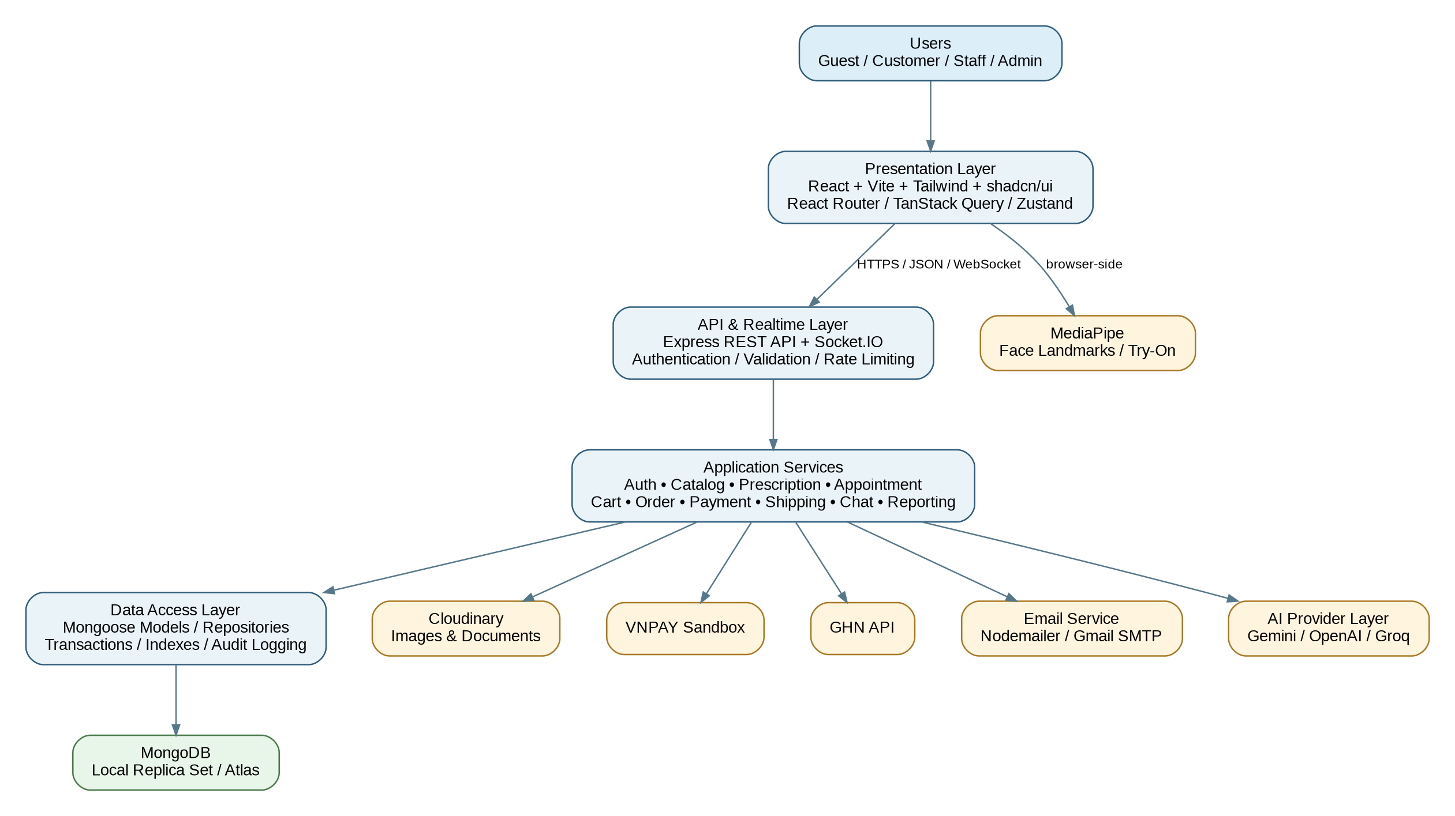
Figure 6.1 - ESMS Layered Architecture
- Presentation Layer: React + Vite provides customer, staff, and administrator interfaces. TanStack Query manages server state, while Zustand manages selected client state.
- API and Realtime Layer: Express exposes versioned REST endpoints, and Socket.IO supports chat and realtime notifications.
- Application Service Layer: Business rules are implemented in focused services instead of controllers.
- Data Access Layer: Mongoose models, repository-style data access, transactions, indexes, and audit helpers protect data integrity.
- Provider Layer: Payment, shipping, address, email, AI, and media integrations are isolated behind service interfaces.

6.2 Frontend Architecture
Area | Selected Technology | Responsibility
Application shell | React + Vite | Routing entry point, layouts, role workspaces, build tooling.
Styling | Tailwind CSS + shadcn/ui | Responsive design, accessible component primitives, consistent forms and dialogs.
Routing | React Router | Public, authenticated, role-protected, and branch-workspace routes.
Server state | TanStack Query | API caching, request lifecycle, invalidation, retries, pagination.
Client state | Zustand | Guest cart, auth presentation state, try-on state, chat panel state.
Forms | React Hook Form + Zod | Field management and immediate client-side validation.
HTTP | Axios | Shared API client, credentials, token refresh coordination, standardized errors.
Face features | MediaPipe | Browser-side face landmarks for recommendation and virtual try-on.

6.3 Backend Architecture
Layer / Folder | Purpose
config | Database, environment, Cloudinary, OAuth, email, and provider configuration.
controllers | Translate HTTP requests and responses; no complex business rules.
services | Business workflows, transactions, assignments, pricing, status transitions, provider orchestration.
models | Mongoose schemas, indexes, validation constraints, timestamps.
routes | Versioned REST routes and middleware composition.
validations | Joi schemas for body, query, and path validation.
middlewares | Authentication, authorization, error handling, rate limits, uploads, idempotency.
providers | VNPAY, shipping, address, AI, email, and mock implementations.
jobs | Expired reservation release, notification retry, SLA monitoring, prescription expiration.
utils | Errors, response envelopes, date/SLA functions, pagination, logging, constants.

6.4 Provider Abstraction Design
Provider Interface | Initial Implementations | Core Operations
PaymentProvider | VNPAYProvider, MockPaymentProvider | createPayment, verifyReturn, verifyIPN, queryPayment
ShippingProvider | GHNProvider, MockShippingProvider | calculateFee, createShipment, getShipment, cancelShipment
AddressProvider | GHNAddressProvider, LocalAddressProvider | getProvinces, getDistricts, getWards
AIProvider | GeminiProvider, OpenAIProvider, GroqProvider | generateSupportResponse
EmailProvider | NodemailerProvider, DevelopmentConsoleProvider | sendOTP, sendTemplateEmail

6.5 Authentication and Authorization Design
- Access Token carries user ID, role, administrative level, and minimal authorization claims.
- Refresh Token is stored in an HTTP-only cookie and rotated or invalidated according to the final implementation policy.
- Backend authorization checks ownership, assignment, branch scope, role, and administrative level.
- Customer resources are filtered by owner ID; staff resources are filtered by assigned branch or explicit temporary assignment.
- Account lock invalidates active refresh sessions and prevents new token issuance.
- Sensitive actions create audit records containing actor, action, entity, time, reason, and non-secret metadata.

6.6 Deployment Architecture
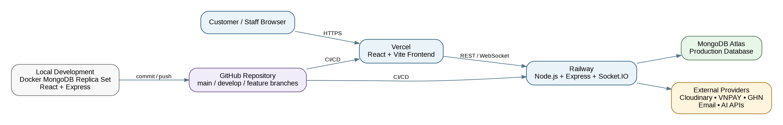
Figure 6.2 - Planned Development and Cloud Deployment
Environment | Frontend | Backend | Database | Purpose
Local development | Vite dev server | Node.js local process | Docker MongoDB replica set | Implementation and transaction testing.
Demo / production-like | Vercel | Railway | MongoDB Atlas | Lecturer access and end-to-end demonstration.
External services | Cloudinary / sandbox providers | Called by backend except MediaPipe | Not applicable | Media, payment, shipping, email, and AI.

6.7 Repository Structure
eyewear-shop-management-system/
client/
server/
documents/
docker/
docker-compose.yml
.env.example
.gitignore
README.md

- `main` contains stable demonstration-ready code.
- `develop` integrates completed features.
- `feature/...` branches isolate planned modules.
- `fix/...` branches isolate defect corrections.
- Commits should be small, descriptive, and linked to user stories or tasks.

CHAPTER 7 - DATABASE DESIGN
MongoDB is used as the approved primary database. The design applies normalized references for shared business entities, embedded snapshots for historical accuracy, indexes for frequent queries, and transactions for workflows requiring atomicity.

7.1 Database Principles
- Use references for reusable entities such as users, branches, products, prescriptions, and orders.
- Use embedded snapshots for prices, shipping addresses, policies, and selected configurations that must not change retroactively.
- Use status-history arrays or dedicated event collections where audit depth is required.
- Use MongoDB transactions for checkout, inventory reservation, payment commitment, cancellation release, and critical inventory corrections.
- Use compound and partial indexes for uniqueness, branch scope, status queues, and expiration jobs.

7.2 Logical Data Model
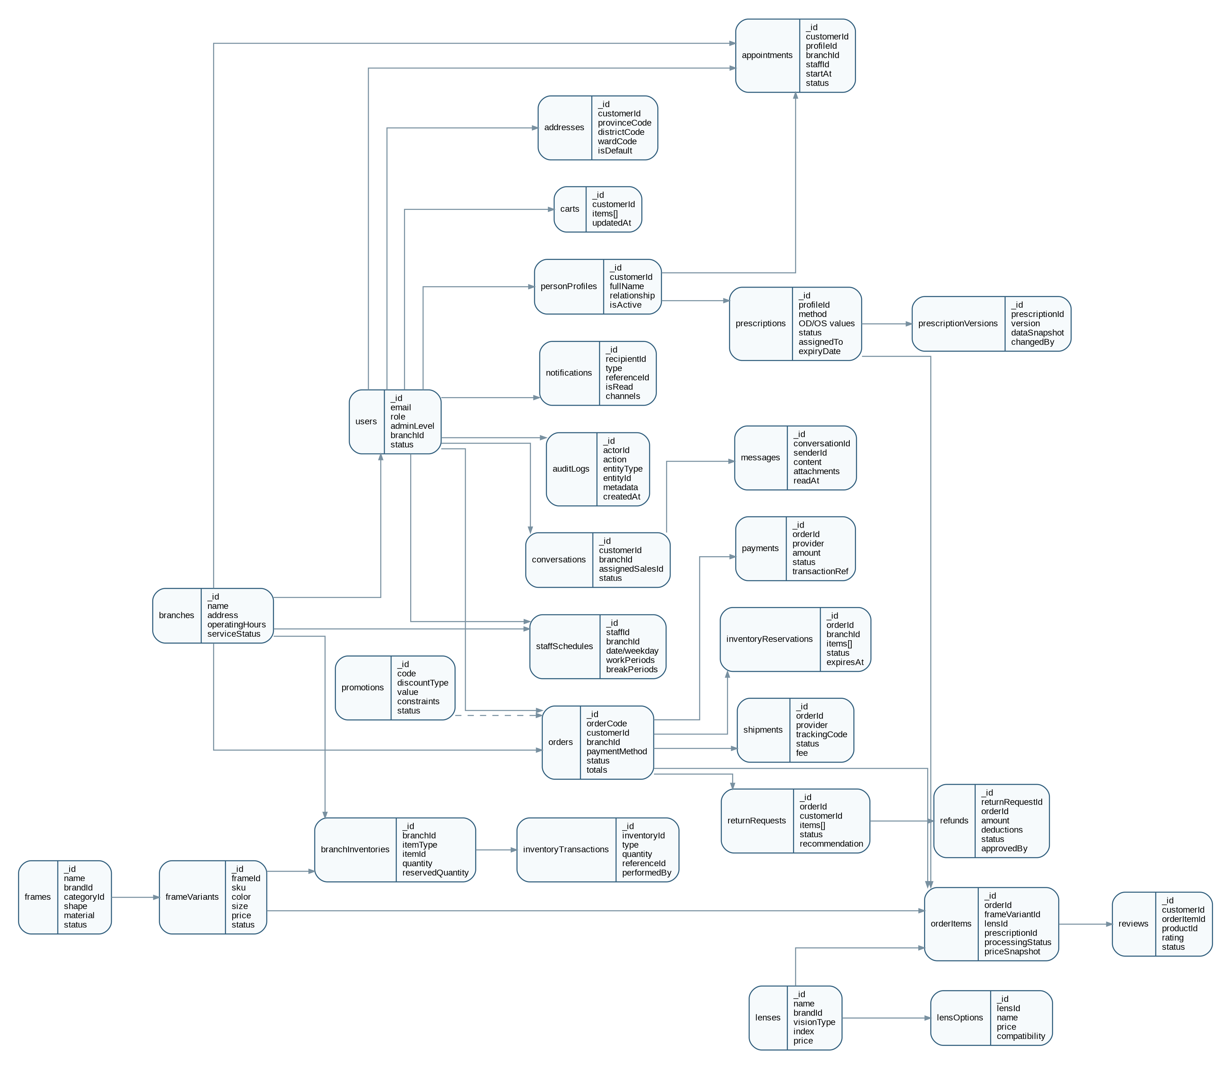
Figure 7.1 - ESMS Logical MongoDB Collection Relationships

7.3 Collection Catalog
Collection | Purpose
users | Accounts, roles, admin level, branch assignment, status, authentication security fields.
personProfiles | Customer self/family wearer profiles used by prescriptions and appointments.
addresses | Reusable customer delivery addresses with GHN codes and one default address.
branches | Branch identity, address, service status, operating hours, and contact information.
staffSchedules | Work periods and break periods for staff by date or weekday.
brands | Shared frame and lens brand catalog.
categories | Product classification and storefront navigation.
frames | Frame master product data, style attributes, face-shape tags, and media.
frameVariants | SKU-level color, size, price, status, and images.
lenses | Lens master products, vision type, index, features, supported ranges, and base price.
lensOptions | Optional upgrades and compatibility rules.
branchInventories | Branch-specific quantity, reserved quantity, threshold, and item reference.
inventoryTransactions | Immutable stock movement and correction history.
inventoryReservations | Temporary or committed inventory reservations linked to orders.
prescriptions | Current prescription values, document references, status, assignment, issue and expiry dates.
prescriptionVersions | Historical snapshots of Customer and staff prescription changes.
appointments | Examinee, branch, assigned staff, time, status, notes, and examination result linkage.
carts | Authenticated customer cart with complete configuration items.
orders | Order header, customer, branch, totals, snapshots, payment, delivery, and overall status.
orderItems | Regular or prescription item configuration, price snapshot, and processing status.
payments | Payment provider attempts and verified transaction status.
shipments | GHN or mock shipment data, fee, tracking, and delivery status.
promotions | Promotion definitions, constraints, validity, and usage limits.
promotionUsages | Per-customer and total promotion usage records.
returnRequests | Return items, evidence, inspection, manager recommendation, and workflow status.
refunds | Refund calculations, deductions, final approval, and transaction record.
reviews | Verified-purchase ratings, comments, media, moderation status.
conversations | Customer support conversation and assigned Sales Staff.
messages | Persistent realtime messages, attachments, and read timestamps.
notifications | In-app notification content, channels, reference, and read state.
auditLogs | Security and business-sensitive action history.
idempotencyRecords | Stored request keys and results for duplicate prevention.

7.4 Key Schema Definitions
Schema | Important Fields
users | email (unique), passwordHash, role, adminLevel, branchId, status, emailVerifiedAt, failedLoginCount, lockedUntil, refreshSessions[], timestamps.
frameVariants | frameId, sku (unique), color, size, price, imageUrls, tryOnAssetUrl, status, timestamps.
branchInventories | branchId, itemType, itemId, quantity, reservedQuantity, lowStockThreshold, version, timestamps.
prescriptions | profileId, method, OD, OS, PD, ADD, documentUrl, providerName, issueDate, expiryDate, status, assignedTo, reviewNote, verifiedAt.
appointments | customerId, profileId, branchId, staffId, startAt, endAt, status, specialNote, history[], resultPrescriptionId.
orders | orderCode, customerId, branchId, deliveryMethod, addressSnapshot, paymentMethod, paymentStatus, status, totals, promotionSnapshot, cancellationPolicySnapshot, history[].
orderItems | orderId, itemType, frameVariantId, lensId, lensOptionIds, prescriptionId, quantity, priceSnapshot, processingStatus, processingHistory[].
payments | orderId, provider, amount, status, providerTransactionRef, requestData, verifiedResponse, paidAt.
returnRequests | orderId, customerId, items[], reason, evidenceUrls, inspection, branchManagerRecommendation, status, history[].
auditLogs | actorId, action, entityType, entityId, branchId, reason, metadata, ipAddress, userAgent, createdAt.

7.5 Recommended Indexes
Collection | Index Strategy
users | { email: 1 } unique; { branchId: 1, role: 1, status: 1 }
frameVariants | { sku: 1 } unique; { frameId: 1, status: 1 }
frames | text/name search as selected; { brandId: 1, categoryId: 1, status: 1 }
branchInventories | { branchId: 1, itemType: 1, itemId: 1 } unique
prescriptions | { assignedTo: 1, status: 1, reviewDeadlineAt: 1 }; { profileId: 1, status: 1, expiryDate: 1 }
appointments | { staffId: 1, startAt: 1, endAt: 1, status: 1 }; { branchId: 1, startAt: 1 }
orders | { orderCode: 1 } unique; { customerId: 1, createdAt: -1 }; { branchId: 1, status: 1, createdAt: -1 }
payments | { providerTransactionRef: 1 } sparse unique; { orderId: 1, status: 1 }
inventoryReservations | { status: 1, expiresAt: 1 }; optional TTL only if release logic remains safe and explicit
notifications | { recipientId: 1, isRead: 1, createdAt: -1 }
messages | { conversationId: 1, createdAt: 1 }
idempotencyRecords | { key: 1, scope: 1 } unique; expiration index for safe cleanup

7.6 Transaction Boundaries
Workflow | Atomic Operations
Checkout | Validate current stock; create order; create order items; create reservation; increase reserved quantity; store idempotency result.
Payment success | Validate provider callback; mark payment paid; commit reservation; update order status; add status history.
Reservation expiry | Mark reservation expired; reduce reserved quantities; add inventory transactions; update payment/order state when applicable.
Order cancellation | Validate stage; calculate policy; update order; release reservation or restore inventory; create refund requirement when paid.
Inventory adjustment | Validate non-negative result; update inventory; create immutable transaction; create audit log.
Return and refund approval | Lock decision state; store approved calculation; update return/refund; create audit and notifications.

CHAPTER 8 - WORKFLOW AND STATE DESIGN
The following state models prevent invalid transitions and make workflow progress auditable. Customer-facing labels may be simplified while internal states remain precise.

8.1 Prescription State Model
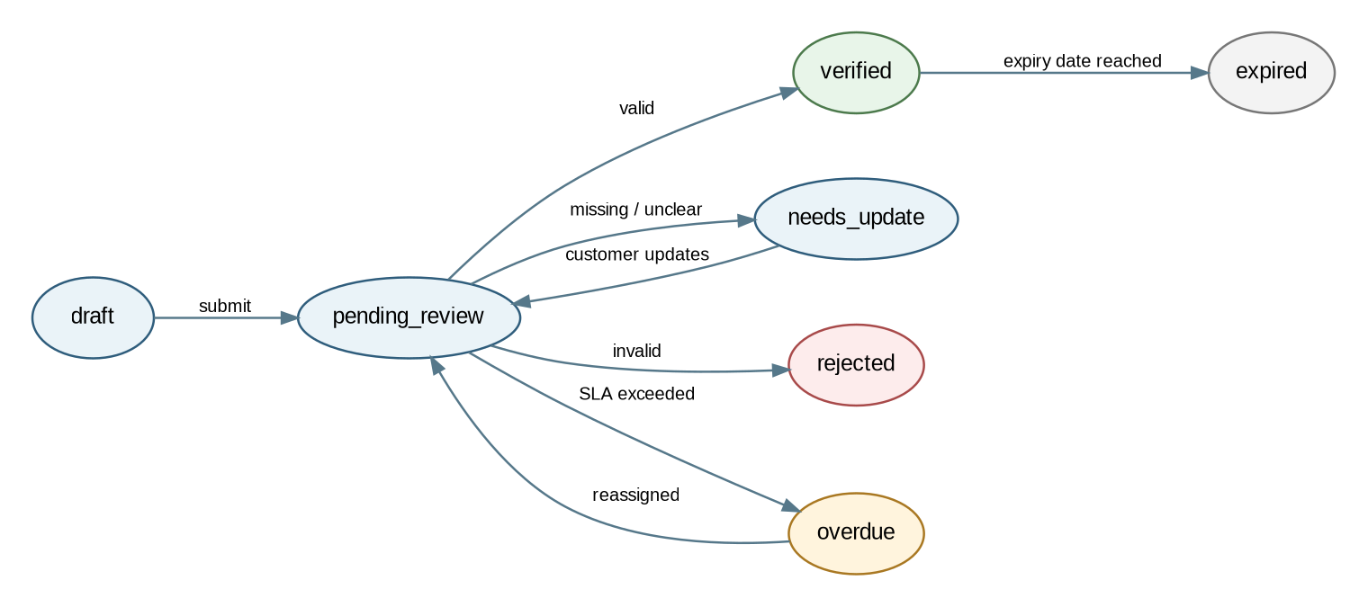
Figure 8.1 - Prescription State Diagram
State | Meaning
draft | Customer-created prescription not yet submitted.
pending_review | Submitted and waiting for assigned staff review.
needs_update | Customer must provide clearer or missing information.
verified | Approved for compatible prescription eyewear until expiry.
rejected | Invalid, unacceptable, or unusable prescription.
overdue | Review SLA exceeded; reassignment or escalation is required.
expired | Historical verified prescription past its validity date.

8.2 Order State Model
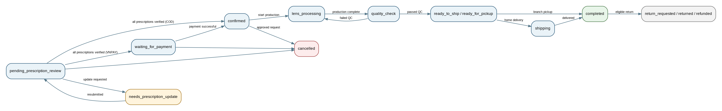
Figure 8.2 - Prescription and Mixed Order State Diagram
- Orders without prescription items may skip prescription review and lens-processing states.
- COD and VNPAY prescription orders diverge after verification: COD becomes eligible for confirmation, while VNPAY waits for payment.
- Mixed orders remain in processing until all non-cancelled items are ready.
- Customer cancellation permissions depend on the current stage and policy snapshot.
- Completed orders may enter the return and refund workflow when eligible.

8.3 Appointment State Model
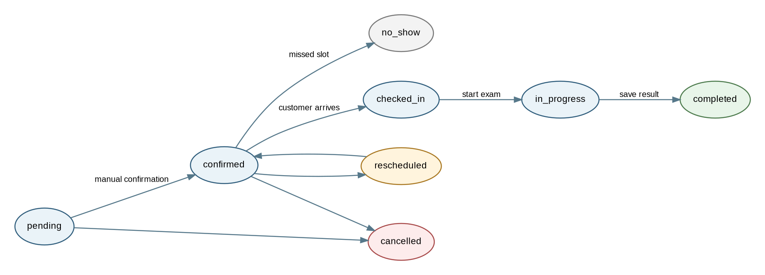
Figure 8.3 - Appointment State Diagram

8.4 Inventory Reservation Lifecycle
State | Entry Condition | Exit
active | Order/payment workflow successfully reserves stock. | committed, released, or expired
committed | Order reaches the inventory-consumption point. | Final historical state
released | Cancellation, failure, or manual authorized release restores stock. | Final historical state
expired | Reservation deadline passes and background release succeeds. | Final historical state

8.5 Primary Workflow 1 - Purchase Prescription Eyewear
- Customer browses products and opens an active frame.
- Customer selects frame variant, compatible lens, lens options, and wearer profile.
- Customer selects a verified prescription or submits a new prescription.
- Customer adds the complete configuration to the cart.
- Backend validates the cart and finds branches that can fulfill every item.
- System recommends a branch; Customer confirms one eligible branch and delivery method.
- Checkout transaction creates the order, items, reservation, status history, and idempotency record.
- Prescription items enter pending review; regular items may remain ready for later combined fulfillment.
- Customer receives an order confirmation and next-step notification.

8.6 Primary Workflow 2 - Review Prescription
- System assigns the pending prescription to the lowest-workload active Prescription Staff member at the fulfillment branch.
- Prescription Staff checks wearer, values, document readability, dates, selected lens, and compatibility.
- Valid prescriptions become verified; unclear prescriptions become needs_update; invalid prescriptions become rejected.
- Customer updates create a new version and restart the review SLA.
- Overdue assignments are reassigned within the branch when possible.
- Cross-branch support follows the manager approval and escalation rules when no local staff can handle the review.
- When all required prescriptions are verified, the order moves to COD confirmation eligibility or VNPAY payment readiness.

8.7 Primary Workflow 3 - Process and Fulfill Order
- Sales Staff opens eligible branch orders and confirms the selected order.
- Regular items are prepared; prescription items enter lens processing.
- Each prescription item completes a quality check; failed items return to processing with a reason.
- The order remains in processing until every non-cancelled item is ready.
- For home delivery, one shipment is created through the active ShippingProvider.
- For branch pickup, one pickup code or QR code is generated and sent to the Customer.
- Delivery or pickup completion commits the final order status and enables verified-purchase reviews.

CHAPTER 9 - API SPECIFICATION OVERVIEW
Detailed request and response schemas will be maintained in OpenAPI 3.0.3 and the Postman collection. This chapter defines the API conventions and planned endpoint groups.

9.1 API Conventions
Convention | Decision
Base path | /api/v1
Content type | application/json; multipart/form-data for uploads
Authentication | Bearer Access Token; Refresh Token in HTTP-only cookie
Success envelope | { success: true, data, meta?, message? }
Error envelope | { success: false, error: { code, message, details?, requestId? } }
Pagination | page, limit, sort; response meta includes page, limit, total, totalPages
Time format | ISO 8601 UTC timestamps
Money | Integer VND amounts to avoid floating-point errors
Idempotency | Idempotency-Key header for checkout and selected provider callbacks
Versioning | URI versioning begins with /api/v1

9.2 Endpoint Catalog

Authentication
Method | Endpoint | Purpose
POST | /auth/register | Register Customer
POST | /auth/verify-email | Verify registration OTP
POST | /auth/login | Email/password login
POST | /auth/google | Google Customer login
POST | /auth/refresh | Refresh Access Token
POST | /auth/logout | Revoke session
POST | /auth/forgot-password | Request reset OTP
POST | /auth/reset-password | Reset password

Users and Profiles
Method | Endpoint | Purpose
GET/PATCH | /users/me | View or update current profile
GET/POST | /users/me/addresses | List or add addresses
PATCH/DELETE | /users/me/addresses/:id | Update or remove address
GET/POST | /users/me/person-profiles | List or add wearer profiles
PATCH | /users/me/person-profiles/:id | Update or archive profile
POST | /admin/staff | Create staff account
PATCH | /admin/staff/:id/status | Lock or reactivate staff

Catalog and Inventory
Method | Endpoint | Purpose
GET | /frames | Search and filter frames
GET | /frames/:id | Frame details and variants
GET | /lenses | Search and filter lenses
GET | /branches | Public branch information
GET | /inventory/availability | Check eligible branches for complete cart
POST | /admin/frames | Create frame
PATCH | /admin/frame-variants/:id | Update frame variant
GET/PATCH | /branches/:branchId/inventory | View or adjust branch inventory

Cart and Checkout
Method | Endpoint | Purpose
GET/PUT | /cart | Get or replace Customer cart
POST | /cart/items | Add configured item
PATCH/DELETE | /cart/items/:itemId | Update or remove item
POST | /cart/merge | Merge guest cart
POST | /checkout/validate | Validate cart and eligible branches
POST | /orders | Create order using Idempotency-Key

Prescriptions
Method | Endpoint | Purpose
GET/POST | /prescriptions | List or create prescriptions
GET/PATCH | /prescriptions/:id | View or update allowed prescription data
POST | /prescriptions/:id/submit | Submit for review
GET | /staff/prescriptions/assigned | Assigned review queue
POST | /staff/prescriptions/:id/verify | Verify prescription
POST | /staff/prescriptions/:id/request-update | Request Customer update
POST | /staff/prescriptions/:id/reject | Reject prescription
POST | /manager/prescriptions/:id/reassign | Reassign within branch

Appointments
Method | Endpoint | Purpose
GET | /appointments/slots | Available branch/date slots
POST | /appointments | Book appointment
PATCH | /appointments/:id/reschedule | Reschedule
POST | /appointments/:id/cancel | Cancel
GET | /staff/appointments | Assigned staff schedule
POST | /staff/appointments/:id/check-in | Check in examinee
POST | /staff/appointments/:id/start | Start examination
POST | /staff/appointments/:id/complete | Complete and create prescription

Orders, Payment, Shipping
Method | Endpoint | Purpose
GET | /orders | Customer order history
GET | /orders/:id | Owned/authorized order detail
POST | /orders/:id/cancel-request | Request cancellation
POST | /staff/orders/:id/confirm | Confirm eligible order
PATCH | /staff/order-items/:id/status | Update processing status
POST | /payments/vnpay/:orderId/create | Create VNPAY payment URL
GET | /payments/vnpay/return | Handle return result
GET/POST | /payments/vnpay/ipn | Handle verified callback
POST | /staff/orders/:id/shipment | Create shipment
POST | /staff/orders/:id/pickup-code | Generate pickup code

Returns, Reviews, Notifications
Method | Endpoint | Purpose
POST | /returns | Create return request
GET | /returns/:id | View return progress
POST | /staff/returns/:id/inspect | Record inspection
POST | /manager/returns/:id/recommend | Submit manager recommendation
POST | /super-admin/refunds/:id/decide | Approve or reject refund
POST | /reviews | Create verified-purchase review
GET | /notifications | List notifications
PATCH | /notifications/:id/read | Mark notification read

Dashboard and Audit
Method | Endpoint | Purpose
GET | /manager/dashboard | Branch dashboard
GET | /super-admin/dashboard | System dashboard
GET | /super-admin/audit-logs | Search audit logs

9.3 Standard Error Codes
Code | Meaning
VALIDATION_ERROR | Request data does not satisfy the Joi schema.
UNAUTHENTICATED | Access Token missing, invalid, or expired.
FORBIDDEN | Role, branch, ownership, or assignment does not permit the action.
RESOURCE_NOT_FOUND | Requested entity does not exist or is not visible to the user.
CONFLICT | Uniqueness, stock, appointment, or state conflict.
PRESCRIPTION_INVALID | Prescription cannot be used for the selected configuration.
INVENTORY_UNAVAILABLE | One branch cannot fulfill the complete requested quantity.
INVALID_STATE_TRANSITION | Requested workflow transition is not allowed.
PAYMENT_VERIFICATION_FAILED | Provider result cannot be verified.
EXTERNAL_PROVIDER_UNAVAILABLE | A provider timed out or returned an unavailable response.
RATE_LIMITED | The request frequency exceeds the configured limit.
IDEMPOTENCY_CONFLICT | The same key was reused with incompatible request data.

CHAPTER 10 - USER INTERFACE AND EXPERIENCE DESIGN
The shopping interface combines fashion-oriented product presentation with clear, professional prescription and appointment forms. Staff workspaces prioritize queues, status, filters, and next actions.

10.1 Design Direction
- Customer storefront: modern, image-focused, and easy to browse.
- Prescription and appointment forms: clean, explicit labels, progressive disclosure, and validation near each field.
- Staff workspaces: data-dense but task-oriented, with status filters and clear action buttons.
- Administrator dashboards: summaries first, with drill-down tables for actionable details.
- Responsive behavior: desktop-first staff dashboards and fully responsive customer shopping pages.

10.2 Customer Site Map
Home
Catalog
Frames
Lenses
Sunglasses
Product Detail / Configurator
Virtual Try-On / Face Recommendation
Cart
Checkout
Account
Profile / Addresses / Family Profiles
Prescriptions
Appointments
Orders / Returns / Reviews
Branches
Customer Support Chat

10.3 Staff and Administrator Site Map
Staff Workspace
Orders / Order Processing
Prescription Review
Appointments
Customer Chat
Branch Inventory
Returns
Branch Manager
Branch Dashboard
Staff Accounts and Schedules
Prescription Assignment / Support Requests
Inventory Adjustments
Return Recommendations
Super Administrator
System Dashboard
Branches / Products / Promotions / Policies
Branch Manager Accounts
Refund Approval
Audit Logs / Provider Settings

10.4 Home and Product Discovery
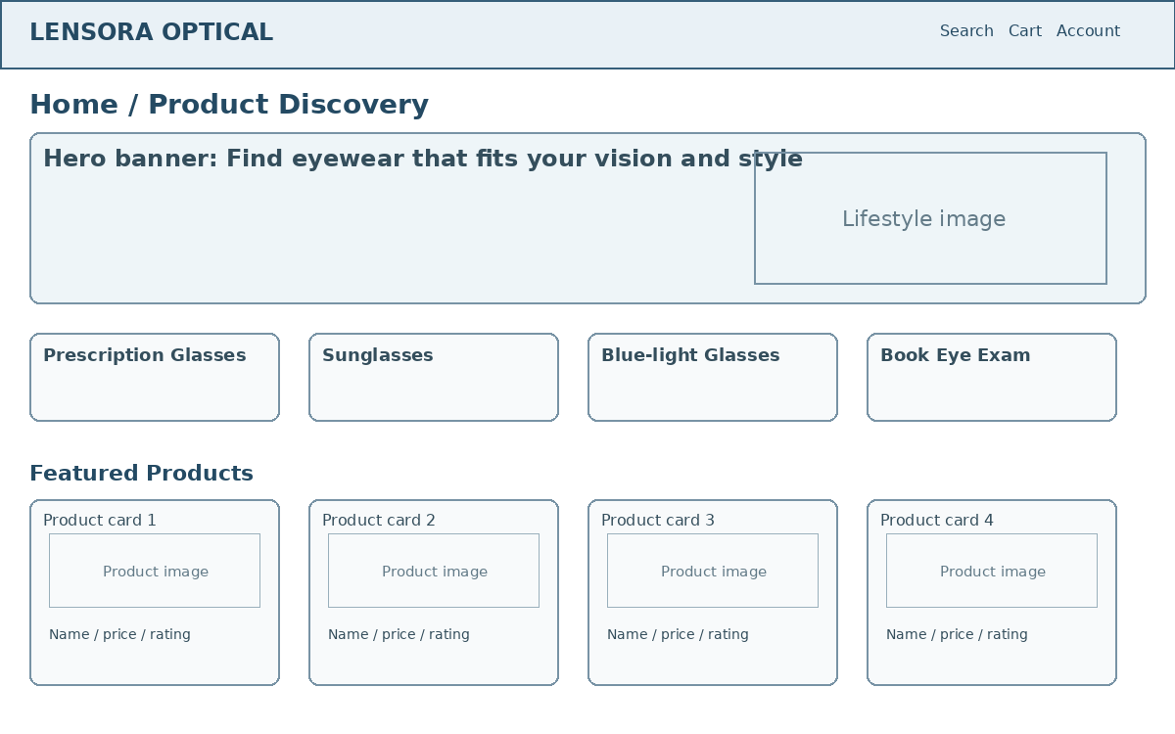
Figure 10.1 - Low-Fidelity Home Page Wireframe

10.5 Product Detail and Configurator
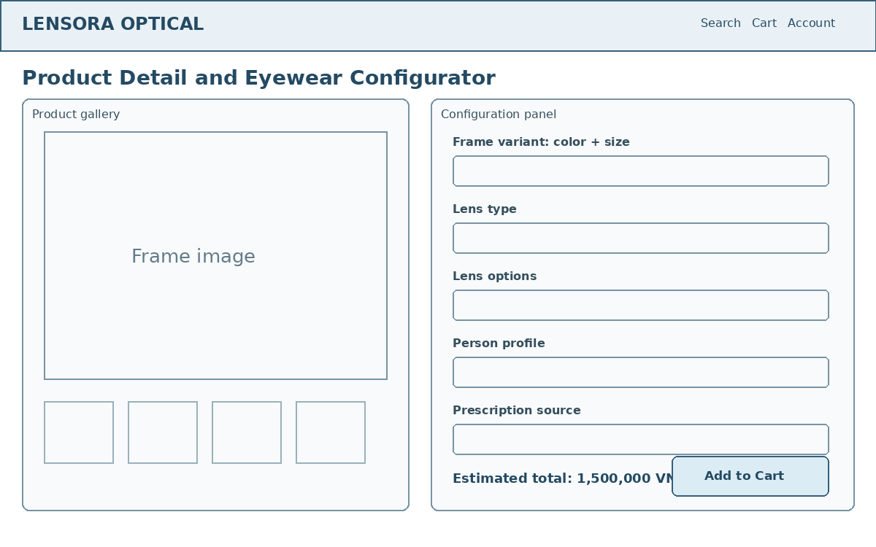
Figure 10.2 - Low-Fidelity Product Configuration Wireframe

10.6 Checkout
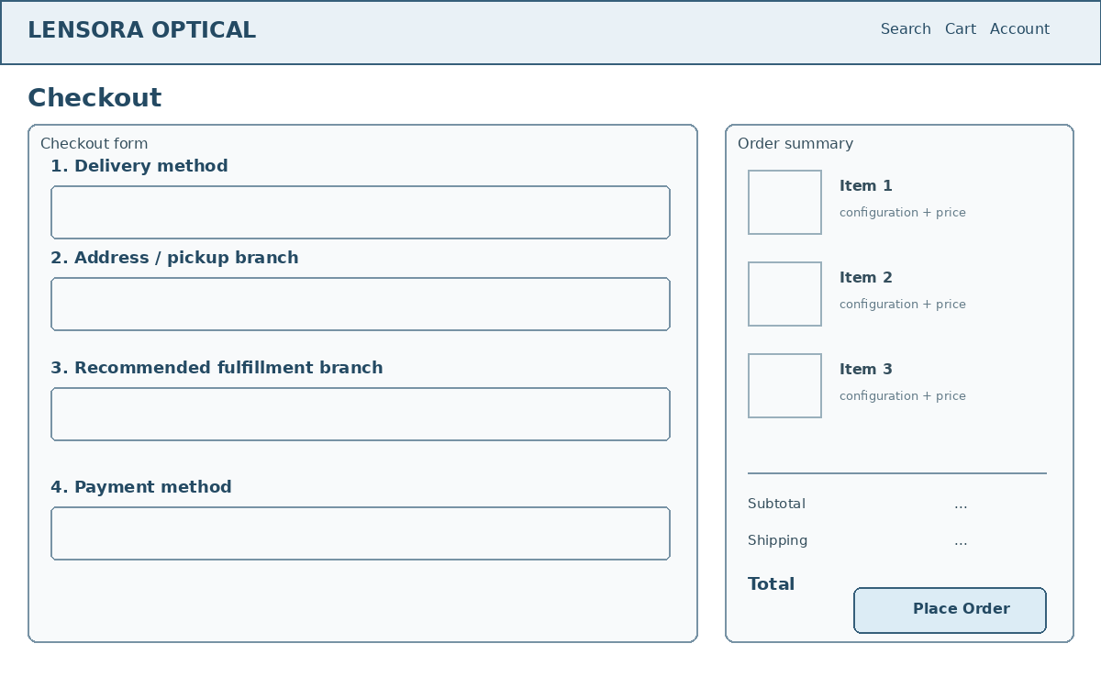
Figure 10.3 - Low-Fidelity Checkout Wireframe

10.7 Prescription Staff Workspace
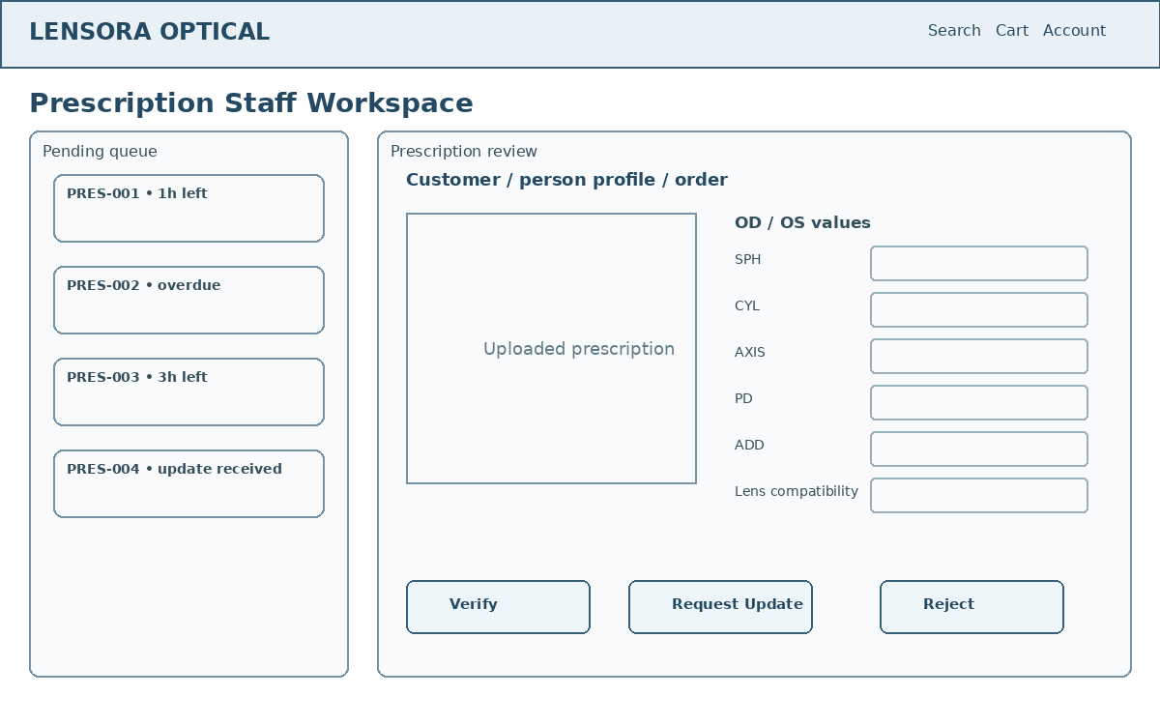
Figure 10.4 - Low-Fidelity Prescription Review Wireframe

10.8 Sales Staff Order Workspace
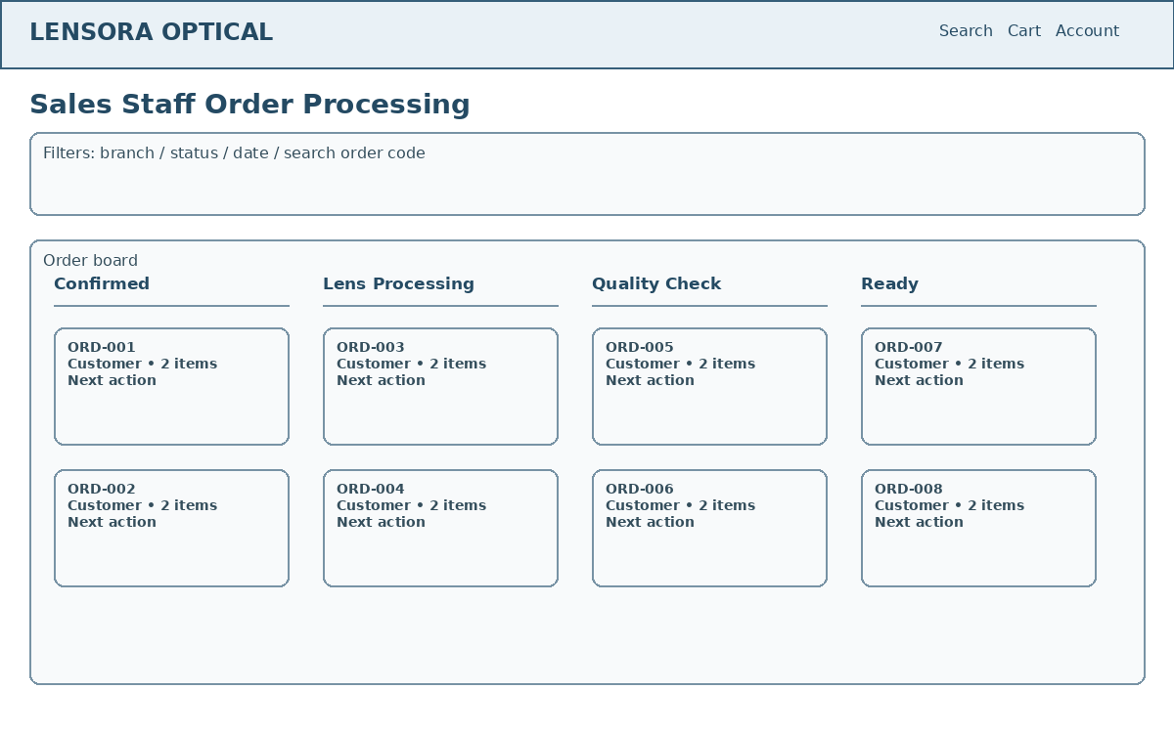
Figure 10.5 - Low-Fidelity Order Processing Wireframe

10.9 Appointment Booking
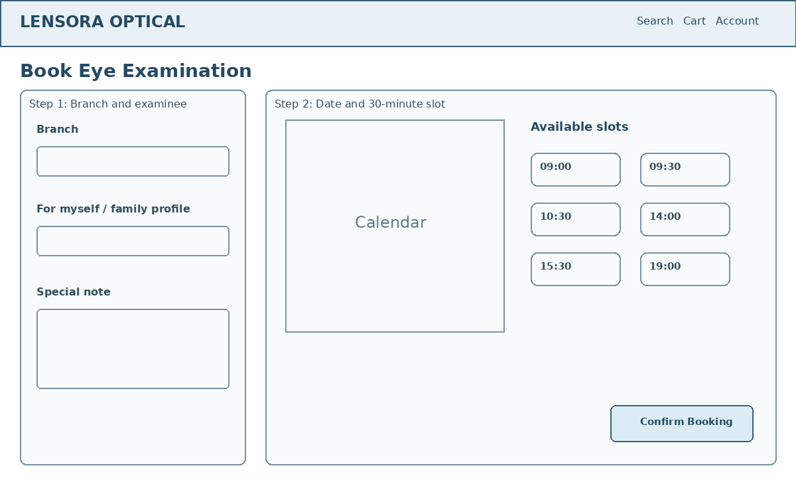
Figure 10.6 - Low-Fidelity Appointment Booking Wireframe

10.10 Core Screen Catalog
Area | Screens
Public | Home, catalog, search results, product detail, branch list, login, register, forgot password.
Customer | Cart, checkout, profile, addresses, family profiles, prescriptions, appointment booking, order detail, return request, reviews, notifications, chat.
Sales Staff | Branch order queue, order detail, item processing, shipping/pickup, customer chat, return inspection.
Prescription Staff | Assigned prescription queue, review detail, appointment schedule, examination detail, create prescription.
Branch Manager | Branch dashboard, staff accounts, schedules, inventory, assignments, support requests, return recommendation.
Super Administrator | System dashboard, branches, product master data, promotions, policies, Branch Managers, refund approval, audit logs, provider configuration.

10.11 Form and Feedback Standards
- All required fields are visibly marked and described with concise helper text.
- Validation errors appear close to the relevant field and are also summarized for complex forms when useful.
- Loading, empty, success, and failure states are designed for every API-driven page.
- Potentially destructive operations require confirmation and display the consequence.
- Long workflows show progress steps and retain completed valid data.
- System statuses are mapped to readable labels while the internal code remains available to staff when needed.

CHAPTER 11 - TESTING AND QUALITY ASSURANCE
Testing is organized around the three primary workflows and high-risk rules such as authorization, prescription validity, inventory consistency, payment verification, and state transitions.

11.1 Test Strategy
Level | Tools | Focus
Frontend unit/component | Vitest + React Testing Library | Forms, validation messages, component states, role views, cart behavior.
Backend unit | Vitest | Pure services, pricing, status transition rules, SLA calculations, refund calculations.
Backend integration | Vitest + Supertest | REST endpoints, authentication, authorization, Joi validation, MongoDB interactions.
API exploratory/regression | Postman | Role-based flows, sandbox integrations, request examples, response assertions.
Manual system testing | Browser + seeded accounts | End-to-end workflows, responsive UI, camera/try-on, provider fallback.
Coverage report | Vitest coverage | Identify untested high-risk services and controllers.

11.2 Test Environment
Environment | Configuration
Local automated tests | Dedicated test database; mock Cloudinary, VNPAY, GHN, email, and AI providers.
Integration tests | MongoDB replica set when transaction behavior is under test.
Manual local | Docker MongoDB replica set, development email/OTP, mock providers.
Demo | Vercel, Railway, MongoDB Atlas, Cloudinary, and selected sandbox credentials.
Postman | Local and deployed environments with role-specific access-token variables.

11.3 Minimum Test Case Catalog
ID | Scenario | Expected Result
TC-01 | Register with valid data and verify OTP | Account becomes active.
TC-02 | Register with duplicate email | Request rejected without duplicate.
TC-03 | Login failure five times | Temporary lock enforced.
TC-04 | Branch Manager accesses another branch inventory | 403 Forbidden.
TC-05 | Search and combine frame filters | Only matching products returned.
TC-06 | Select lens outside prescription range | Configuration blocked.
TC-07 | Merge guest and account carts | Identical items combined once.
TC-08 | Checkout with one unavailable item | Transaction rolls back completely.
TC-09 | Repeat checkout with same idempotency key | Existing order returned.
TC-10 | Submit manual prescription | pending_review prescription created.
TC-11 | Upload unsupported prescription file | Upload rejected.
TC-12 | Verify valid prescription | Status verified and order advances.
TC-13 | Request update for unclear document | needs_update and notification created.
TC-14 | Overdue review with available coworker | Automatic reassignment recorded.
TC-15 | Use expired prescription | New order use blocked.
TC-16 | Book available 30-minute slot | Appointment confirmed and staff assigned.
TC-17 | Concurrent appointment conflict | Second booking rejected.
TC-18 | Confirm COD prescription order | Order becomes confirmed after verification.
TC-19 | VNPAY order before verification | Payment creation blocked.
TC-20 | Valid VNPAY verified callback | Payment marked paid once.
TC-21 | Repeated payment callback | No duplicate transaction.
TC-22 | Quality check failure | Item returns to processing with reason.
TC-23 | Mixed order with one item not ready | Shipment creation blocked.
TC-24 | Pickup with invalid code | Completion rejected.
TC-25 | Cancel before prescription verification | Full refund rule and stock release applied.
TC-26 | Cancel after verification before production | VND 50,000 fee applied.
TC-27 | Refund approval by Branch Manager | Forbidden; recommendation only.
TC-28 | Refund approval by Super Administrator | Decision and audit saved.
TC-29 | Low-stock threshold reached | Manager notification created.
TC-30 | Expired reservation job | Reserved quantity released exactly once.

11.4 Exit Criteria
- At least 25 documented test cases exist for Milestone 3 preparation; this document provides 30 initial cases.
- All Must Have acceptance criteria are mapped to at least one planned test.
- No open critical defect prevents the three primary workflows from completing.
- Authorization and inventory-consistency tests pass before demonstration.
- Core API documentation and Postman requests match the implemented behavior.
- The test report records pass/fail status, evidence, defect reference, and retest result.

11.5 Definition of Done for a Core Feature
- Acceptance criteria are implemented and reviewed.
- Joi backend validation and required Zod frontend validation are present.
- Authorization and branch scope are enforced.
- Happy-path and important exception tests pass.
- Swagger/OpenAPI and Postman examples are updated.
- No secret or test credential is committed.
- Git commit history clearly represents the implementation work.
- AI-assisted code is understood, reviewed, and documented in the AI log when significant.

CHAPTER 12 - PROJECT PLAN, RISKS, AND MILESTONE DELIVERABLES
The project is implemented by one student. The plan prioritizes the three core workflows and treats provider integrations, realtime features, AI, and virtual try-on as staged additions.

12.1 Development Priority
Level | Scope
Core MVP | Authentication and authorization; product and variant management; branch inventory; catalog and cart; prescription submission/review; checkout and COD; order processing; basic dashboard.
Planned | VNPAY Sandbox; GHN and address provider; appointments; Socket.IO chat; notifications; promotions; reviews; returns and refunds.
Advanced | FAQ + AI chatbot; face-shape recommendation; image virtual try-on; live-camera virtual try-on; OCR assistance.

12.2 Milestone 1 Completion Plan
Day | Deliverable
Day 1 | Finalize scope, objectives, actors, and primary workflows.
Day 2 | Complete use cases and business rules.
Day 3 | Complete at least 12 user stories and acceptance criteria.
Day 4 | Complete logical collection design and indexes.
Day 5 | Complete system architecture and deployment design.
Day 6 | Complete state diagrams and low-fidelity wireframes.
Day 7 | Complete API overview, NFRs, constraints, and assumptions.
Day 8 | Review traceability and create project skeleton.
Day 9 | Prepare milestone slides, AI log, and demonstration explanation.
Day 10 | Final review, formatting, backup, and presentation rehearsal.

12.3 Major Risks and Mitigation
ID | Risk | Impact | Mitigation
R-01 | Scope is too large for one student | High | Complete the Core MVP first; defer advanced features; demonstrate mock providers.
R-02 | Prescription business rules are misunderstood | High | Use explicit states, staff verification, acceptance criteria, and test cases; do not automate professional approval.
R-03 | MongoDB transaction configuration fails locally | High | Use Docker replica set; verify transactions early; maintain Atlas test environment.
R-04 | VNPAY or GHN sandbox unavailable during demo | Medium | Use provider abstraction and a prepared MockProvider demonstration mode.
R-05 | Inventory overselling or duplicate checkout | High | Use transactions, conditional updates, idempotency keys, and concurrency tests.
R-06 | Camera or face detection is unstable | Medium | Treat live try-on as advanced; complete upload-image try-on first; preserve manual face-shape selection.
R-07 | Email delivery blocked or delayed | Medium | Use development OTP and console provider locally; retain in-app notifications.
R-08 | AI API cost, quota, or unsafe output | Medium | Use FAQ first, provider abstraction, strict system prompts, rate limits, and transfer to staff.
R-09 | Sensitive user data exposed by authorization bug | High | Apply backend ownership/branch tests and minimal-data responses.
R-10 | Documentation diverges from implementation | Medium | Update SRS, Swagger, Postman, diagrams, and AI log at the end of each feature.

12.4 Milestone 1 Deliverables Checklist
- Complete SRS and preliminary design document.
- At least 15 user stories; this document contains 15.
- Actors, use case catalog, and three detailed primary use cases.
- Functional requirements, business rules, and non-functional requirements.
- Logical MongoDB data model with more than eight collections.
- Architecture and deployment diagrams.
- Prescription, order, and appointment state diagrams.
- Low-fidelity wireframes for customer and staff workflows.
- Initial API catalog and test case catalog.
- AI assistance log with responsible-use notes.
- GitHub repository and client/server project skeleton.
- Milestone presentation and demonstration explanation.

12.5 Project Success Conditions
- A Customer can create a prescription-eyewear order through the website.
- Prescription Staff can verify, request update, or reject the prescription with an audit history.
- Sales Staff can process an eligible order through production, quality check, and delivery or pickup.
- Inventory remains branch-specific and prevents overselling.
- Customer and staff permissions remain correctly restricted.
- Admin dashboards expose important operational indicators.
- Core APIs are documented and testable through Swagger and Postman.
- The deployed or local demonstration has a reliable mock fallback for external providers.

APPENDIX A - AI ASSISTANCE LOG
This log documents meaningful AI-assisted analysis and drafting activities. The student remains responsible for understanding, validating, editing, and presenting every result. No secrets, real prescriptions, or private customer information should be included in AI prompts.
Log ID | Date | Activity | AI Contribution | Human Validation
AI-01 | 20/07/2026 | Scope analysis | Compared basic, full, and advanced eyewear-shop scopes and selected staged Core/Planned/Advanced delivery. | Scope was reviewed and approved by the student.
AI-02 | 20/07/2026 | Technology planning | Evaluated React/Vite, Express ES Modules, MongoDB/Mongoose, Joi, Cloudinary, Tailwind, and frontend state libraries. | Technology choices were confirmed and simplified for solo development.
AI-03 | 20/07/2026 | Actor and permission design | Drafted Customer, Sales Staff, Prescription Staff, Branch Manager, and Super Administrator permissions. | Permissions were refined through user decisions.
AI-04 | 20/07/2026 | Prescription workflow | Drafted submission, review, update, expiry, SLA, assignment, and cross-branch escalation rules. | Medical approval remains human-controlled.
AI-05 | 20/07/2026 | Order workflow | Drafted regular, prescription, mixed-order, payment timing, quality check, cancellation, and fulfillment states. | Complex partial shipment was excluded.
AI-06 | 20/07/2026 | Inventory consistency | Proposed reservations, transactions, idempotency, expiry release, and one-branch fulfillment. | Technical design will be validated with concurrency tests.
AI-07 | 20/07/2026 | Requirements drafting | Generated initial user stories, acceptance criteria, functional requirements, and business rules. | The document was edited for consistency with confirmed scope.
AI-08 | 20/07/2026 | Data model design | Proposed MongoDB collections, references, snapshots, indexes, and transaction boundaries. | Final schemas may be refined during implementation without changing core requirements.
AI-09 | 20/07/2026 | Architecture and provider design | Proposed layered services and provider abstractions for payment, shipping, address, email, and AI. | Mock providers were retained for reliable demonstration.
AI-10 | 20/07/2026 | Testing plan | Generated initial test scenarios for authorization, prescription review, checkout, inventory, payment, and returns. | Tests will be implemented and evidence recorded by the student.
AI-11 | 20/07/2026 | UI planning | Generated low-fidelity page structure for catalog, configurator, checkout, prescription review, order board, and appointment booking. | Visual design will be customized by the student.
AI-12 | 20/07/2026 | Document quality review | Checked traceability and organized the complete SRS and preliminary design. | The student must review terminology and update the document when implementation changes.

Responsible AI rule: Do not commit or submit AI-generated code that you do not understand. Do not place API keys, passwords, personal prescriptions, or real customer information in prompts. Validate important business and security behavior through tests and human review.

APPENDIX B - REQUIREMENT TRACEABILITY MATRIX
This matrix links the three primary workflows to the principal use cases, user stories, requirement groups, data collections, and initial tests.
Workflow | Use Cases | User Stories | Requirements | Collections | Tests
WF-01 Purchase Prescription Eyewear | UC-PROD-05, UC-CART-10, UC-ORD-01 | US-03 to US-06, US-09 | FR-PROD, FR-CART, FR-INV, FR-PRES, FR-ORD | frames, frameVariants, lenses, carts, prescriptions, orders, orderItems, reservations | TC-05 to TC-12, TC-19
WF-02 Review and Verify Prescription | UC-PRES-06 to UC-PRES-12 | US-07, US-08 | FR-PRES, FR-COM | prescriptions, prescriptionVersions, users, notifications, auditLogs | TC-12 to TC-15
WF-03 Process and Fulfill Order | UC-ORD-08 to UC-ORD-14 | US-10, US-11 | FR-ORD, FR-INV, FR-COM | orders, orderItems, inventoryTransactions, payments, shipments, notifications | TC-18, TC-22 to TC-24
Branch Inventory Management | UC-ADM-04 to UC-ADM-06 | US-12 | FR-INV, FR-ADM | branchInventories, inventoryTransactions, branches, users | TC-04, TC-29, TC-30
Eye Examination Appointment | UC-APP-01 to UC-APP-10 | US-13 | FR-APP, FR-PRES | appointments, staffSchedules, personProfiles, prescriptions | TC-16, TC-17
Return and Refund | UC-RET-01 to UC-RET-09 | US-14 | FR-RET, FR-ORD | returnRequests, refunds, orders, auditLogs | TC-25 to TC-28
Management Dashboard | UC-ADM-02, UC-ADM-03 | US-15 | FR-ADM | orders, inventories, prescriptions, appointments, payments | Dashboard integration tests

APPENDIX C - INITIAL DEMONSTRATION DATA
The following fictional data supports implementation, testing, and demonstration. No real employee, medical, or customer data is required.

C.1 Branches
Code | Branch | Location | Eye Exam Service
CG | Lensora Optical - Cau Giay | Cau Giay District, Hanoi | 09:00-21:00 daily
DD | Lensora Optical - Dong Da | Dong Da District, Hanoi | 09:00-21:00 daily
HD | Lensora Optical - Ha Dong | Ha Dong District, Hanoi | 09:00-21:00 daily

C.2 Initial Role Accounts
Role | Quantity | Scope
Super Administrator | 1 | All branches and system-wide settings.
Branch Manager | 3 | One manager per branch.
Sales Staff | 9 | Three staff per branch.
Prescription Staff | 6 | Two staff per branch.
Customer | At least 5 demo accounts | Orders, prescriptions, appointments, and returns.

C.3 Sample Product Data Requirements
- At least 10 frame products with two or more variants each.
- At least four frame shapes, four materials, and multiple colors and sizes.
- At least four lens products covering non-prescription, single-vision, blue-light, photochromic, and selected indexes.
- Branch inventory quantities that intentionally differ between branches.
- At least two low-stock variants for dashboard demonstration.
- At least one active promotion, one expired promotion, and one usage-limited promotion.
- At least one verified, one pending, one needs-update, and one expired prescription.
- At least one order in each major stage required by the demonstration.

