**Christmas work: the Greek School**

**by Vasileios Barekos**

So just before **Christmas holidays** the **Greek students** started working on the **1st assignment** that is to design, build and program ***a LEGO bricks sorting machine***.

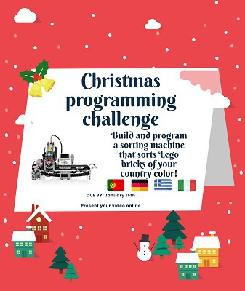

Sorting would take place according to the brick colours based on the **national flag** of each country (ie blue and white in our case).

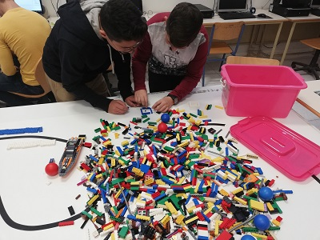

We formed **3 groups** of students, each group would work on its own design.

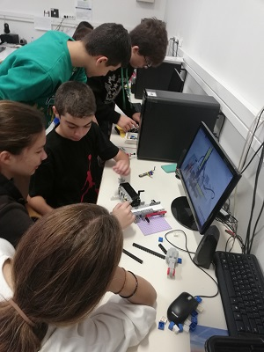

All the students were excited and started working right away!

In this process they discovered how to build things using LEGO bricks and how to connect and program the **LEGO EV3 Education set** motors and sensors.

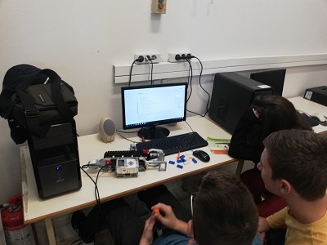

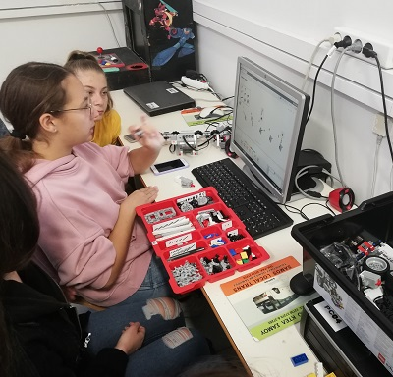

For most of them this was a completely new experience! However then managed it fine!

For programming their designs, initially they were taught to use the proprietary Lego Mindstorms (graphical block) software and then shifted to program by writing code in **JAVA**using the **leJOS**library under **Eclipse software**.

Soon all the groups will be presenting their final working designs!