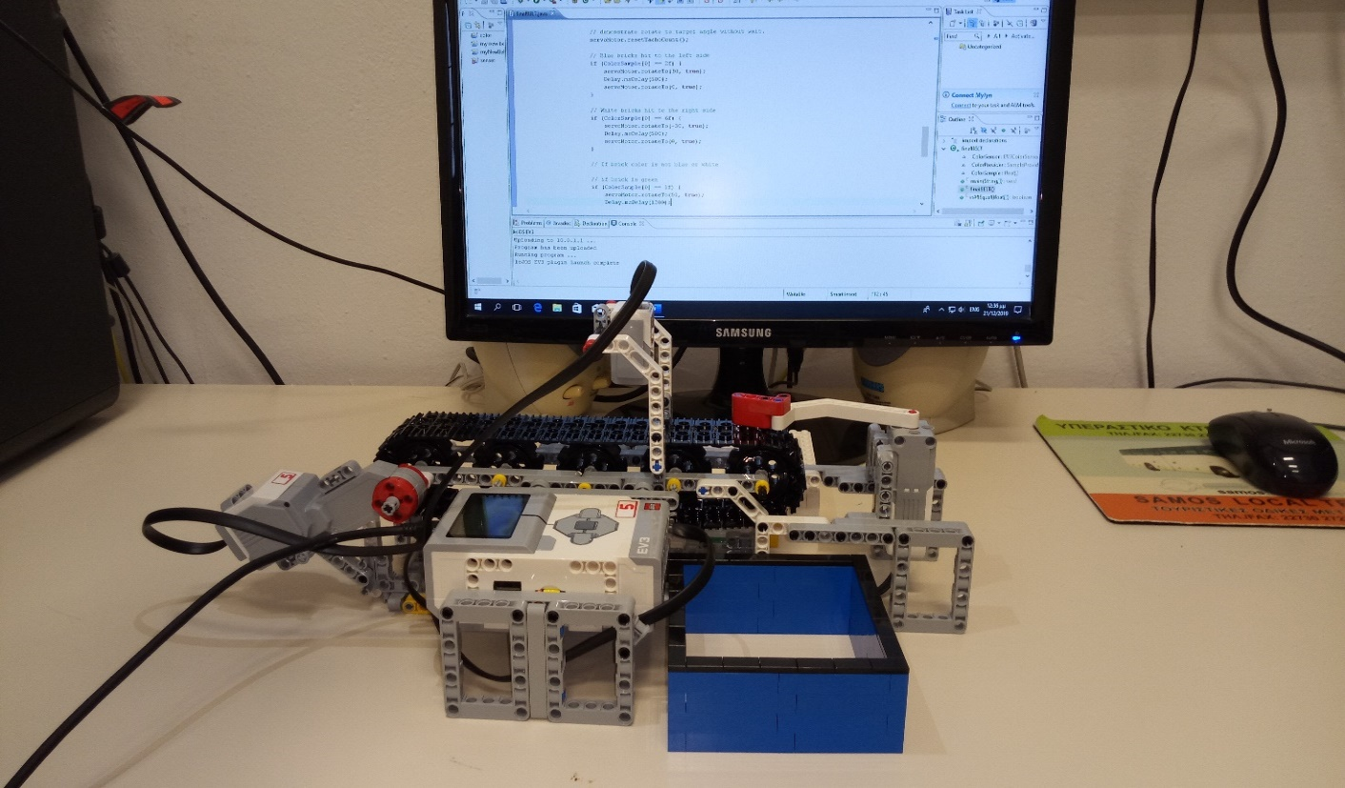

* The team

Vaggelis Marios Panousos

Stefanos Papageorgiou

Aggelos Papatheofanous

Giorgos Gerontis

Eleftheria Kaliou

Emmanouil Tatouris

* Assignment

As a Christmas assignment we had to design and build a sorting machine that sorts Coloured Lego bricks of our country’s national flag colours (ie blue and white).

* Components

In order to cover the project’s needs we used a Large EV3 Motor and a Medium EV3 Motor used as servo motor, an EV3 Colour Sensor and definitely a Lego EV3 Smart Brick. We also use some tracks in order to make the belt as well as a sorting lever which separates the parts into the boxes.

* How does it work

Our robot is a colour sorting machine, it consists of a moving belt and a moving lever which separates the coloured lego blocks into 3 boxes. One box for the blue ones, one for the white ones and one for all the other colours. We have programmed its functions with Java coding language.

The belt constantly moves at a constant speed and the coloured lego bricks are moved under the Colour Sensor. This sensor then reads the colour id of each brick and according to this the EV3 Smart Brick controls the direction of the Servo Motor.

Attached to the Servo motor is a sorting lever that moves left or right to push the bricks into the appropriate boxes. We separate the blue bricks to the left side box and the white bricks to the right side. There is also a third position that the sorting lever goes far right to the end so that all the rest coloured bricks that are not blue or white fall into a small compartment under the machine.

The belt’s speed is 25 bps so the Colour Sensor can read the passing brick’s colour. The Colour Sensor is positioned 1 cm higher above the passing coloured brick that is to be read. We have programmed a specific action for each colour so that the sorting lever moves them on the appropriate boxes.

The following figure is an overview of the procedures that take place.

Final Belt

Moving Belt  
(power 25)

Colour Sensor Read

Sorting Lever   
Move (left, right)

Sort bricks depending on the colour (3 boxes)

More Pictures from the project

(See next page)

