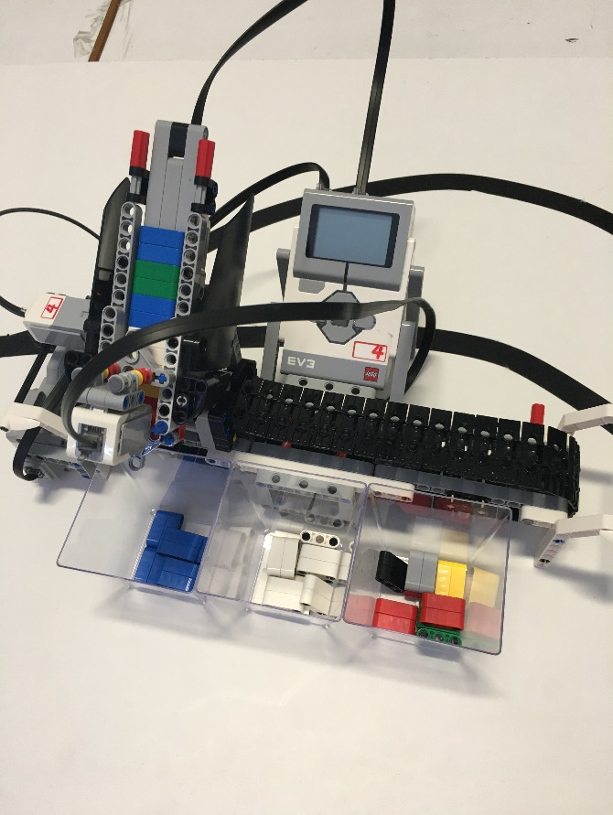Team 3

* The team

Kleopatra Lymperi

Natalia Tortopidou

Eirini Mourtzi

Stefania Hatzikonstanti

Dimitra Mathiou

Eua Papagianopoulou

Anna Papagianopoulou

* Information about our project

For this project we were asked to create a LEGO EV3 sorting machine for the Erasmus+ project. Our task involved apart from building also programing a machine that sorts Lego bricks into 3 boxes depending on the color of bricks. The machine separates the white and the blue colored bricks from the other colored bricks. We were inspired from our flag’s colors (blue & white)!

* Materials

In order to cover the projects needs we used a Large Motor, a Medium Motor as a Servo Motor, a Colour Sensor, a Touch Sensor and of course a Lego EV3 Brick.

* The Design

In order to build our machine we used as guidance the instructions of the official Model Core Set named “Colour Sorter” as given by the LEGO MINDSTORMS Education EV3 set.

The only modification we made on this is that we moved the position of the colour sensor. In the original design the user had to pass each lego brick manually from the colour sensor that was first reading all coloured blocks and then storing their colour IDs in a suitable table (array). Then the sorting was starting by processing all colour IDs from this array (from memory).

We decided that it is better to place the sensor at the bottom end of the chute so that it reads one-by-one the colour of each Lego block (placed first in the sorting queue of the chute / read first), then dispense it in the appropriate collector box. This procedure then repeats for the next block (reading its colour ID and then place it into the appropriate box). In this way the process is automated meaning that we don’t need any memory (array) for storing previous brick colours.

* How does it work

Our machine has to separate in 3 small boxes different colored bricks. The top part of the construction where the bricks are placed is called the categorizer and it also includes a color sensor that “reads” the bricks. All the bricks are placed in the chute where the color sensor reads the color of each brick. Then the belt moves the categorizer depending on the position of the box where the brick is to be placed according to its color, and throws it into the box. After throwing the bricks the belt moves the categorizer back to its original position where it contacts the touch sensor and stops. This happens in order for the categorizer not to be confused, as the motor that turns the belt has to move certain degrees in order to reach each position. This due process is repeated until all the bricks are sorted.

* Pictures from the project

