public int index;

public int[][] itemList;

public List<Item> getItems() {
List<Item> list1 = new ArrayList<Item>();
for (int i = 0; i < itemList.length; ++i) {
for (int j = 0; j < itemList[i].length; ++j) {
if (itemList[i][j] == 4)
list1.add(new Item(i,j));
}
}
return list1;
}
class Item {
int k1,k2;
public Item(int k1, int k2) {
this.k1 = k1;
this.k2 = k2;
}
}
/////////////
public static final int BOMB_MARKER = 4;
public List<Field> getBombFields(int[][] fields) {
List<Field> bombFields = new LinkedList<>();
for (int row = 0; row < fields.length; ++row) {
for (int column = 0; column < fields[row].length; ++column) {
if (isBombField( fields[row][column]))
bombFields.add(new Field(row,column));
}
}
return bombFields;
}
private boolean isBombField(int fieldValue) {
return fieldValue == BOMB_MARKER;
}
class Field {
private int row;
private int column;
public Field( int row, int column ) {
this.row = row;
this.column = column;
}
public int getRow() {
return row;
}
public int getColumn() {
return column;
}
}







Session No1
(1)
Clean Code overview.

Clean code is an abstraction
What is it
- Code conventions
- Heuristic rules
- Best practices from books and blog articles

* All of the above + your experience driven by the common sense

(2)
Why is it important?
Clean Code = Respect
* respect to colleagues
* respect to company (reduce maintenance costs)
* respect to yourself - if you make it clean you improve your quality

blow the nose with a shirt sleeve
clear conscience

(3)
What if do not write clean code
6 aspects of bad system
- System is difficult to change, any minor change causes snowball effect
- Instability, as a result of the changes being made, the system is destroyed in those places that are not directly related to the directly variable component.
- Immobility - it is rather difficult to separate the system into components that could be reused in other systems.
- doing something right is much more difficult than doing any incorrect actions.
- unjustified complexity: the project includes infrastructure, the use of which does not entail immediate benefits
- Uncertainty: Source code is difficult to read and understand. Project content is not clear enough

(4)
Best practices
SOLID DRY KISS

S - The Single Responsibility Principle
Every class (method) does exactly one thing
+ Sample – jgiven classes, Controller, Converter
- Sample – utils classes: EGNDataUtils 1800+ lines of code

O - The Open Closed Principle
Software entities (classes, modules, functions, etc.) should be open for extension, but closed for modification
+ Sample RequestHandlerBase, ScenarioComponentTestCase
- Sample JfrPeps 2000+ lines of code every change on UI side affects this class.

L - The Liskov Substitution Principle
WIKI: if S is a subtype of T, then objects of type T may be replaced with objects of type S (i.e. an object of type T may be substituted with any object of a subtype S) without altering any of the desirable properties of the program (correctness, task performed, etc.)

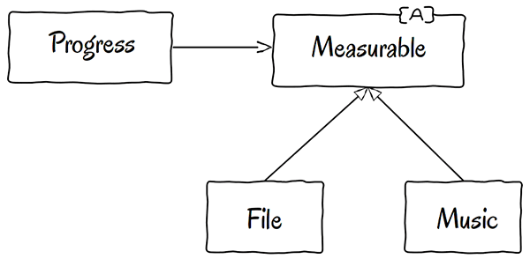



+ Sample – RequestHandlerBase and its derivatives
- Sample – QimController the way how it uses QimBackendController

I - The Interface Segregation Principle
no client should be forced to depend on methods it does not use
WIKI: ISP splits interfaces that are very large into smaller and more specific ones so that clients will only have to know about the methods that are of interest to them

+Sample OutgoingMessageLoggingService
-Sample QimController the way how it uses QimBackendController

D - The Dependency Inversion Principle
WIKI
* High-level modules should not depend on low-level modules. Both should depend on abstractions. * Abstractions should not depend on details. Details should depend on abstractions.
+Sample OutgoingMessageLoggingInterceptor
-Sample

Code that smells

private void sendConsentsToCoMS( Optional<GuiCustomerDataChangeVo> vo, Optional<QuickInputMaskVo> qimVo, String successMessage ) {
if( ( vo.isPresent() && vo.get().getConsentVoList() != null && !vo.get().getConsentVoList().isEmpty() )
|| ( qimVo.isPresent() && qimVo.get().getConsentVoList() != null && !qimVo.get().getConsentVoList().isEmpty() ) ) {
PasCall<Void> pasCall = sendCustomerConsents( vo, qimVo, successMessage );
PasCallResult<Void> result = callBackend( pasCall, new QimErrorHandler( context, pasCall ) );

if( result.isSuccessful() ) {
handleResult( result, successMessage );
}
} else {
popups.showInformationPopup( successMessage );
MoreExecutors.directExecutor().execute( clearAll );
}

}

