**Notes on the project.**

1. The project has been programmed in Java.
2. We used the terminal/console to interface with the program.
3. The folder structure is as below:

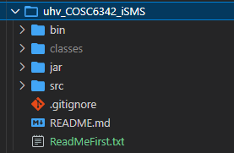

1. bin -> contains the build.xml script to compile the java classes and create a zip file.
2. classes -> contains the java compiles class files
3. jar -> contains the jar file to run.
   1. **There is a bat file (isms.bat) which can run the program. The bat file is configure for my java environment ("C:\Program Files (x86)\Java\jre1.8.0_152\bin\java" -Xms256m -Xmx512m -classpath ISMS.jar com.uhv.cosc6342.isms.Main). I am currently running java 1.8.0_152. Just running the bat file will start the program.**
   2. There are several csv files to store the data for the program. The files act as a database and are updated while the program is running.
      1. admins.csv -> Admin user information
      2. courses.csv -> Courses information
      3. logger.csv -> keeps a log of which user is logging into the system
      4. *logins.xlsx -> this is a spreadsheet where I have noted the id and password of the users. Since the passwords are encrypted in the program, I wrote down the passwords so I can remember. This file is not used in the program but is for information only.*
      5. professors.csv -> Professors information
      6. records.csv -> keeps a list of all the users id and password (encrypted using MD5 hashing algorithm)
      7. studentCourse.csv -> keeps a list of the students and which courses the students have registered to
      8. students.csv -> Student information
      9. 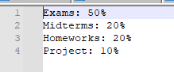_Syllabus.txt -> This is a syllabus text file that professors can upload to the system. An example of the content is:
4. The github link for the project: <https://github.com/vbeeharry/uhv_COSC6342_iSMS>. Currently the repo is set to public, but I’ll set it to private once the demo is over.
5. The FunctionalRequirements.pdf file shows the requirements that have been implemented (highlighted yellow).