## Contents

Contents 1

Terms and Notions 2

Salesforce Data Model 2

Creating an Application (Presentation) 3

Creating Template 4

Creating a Placeholder 5

Creating a Slide 5

Creating a Widget 6

Create an Attach 6

Finalizing 7

## Webs:

## https://login.salesforce.com/ - type login/pass to enter CRM (Production)

https://test.salesforce.com/ - type login/pass to enter CRM (Sandbox)

## Terms and Notions

Application – html-presentation.

Slide – Separate presentation slide. A ready presentation page that consist of templates and widgets.

Template – html-template for the slide.

Placeholder – modified part of the Template that contains widgets. You can set up type of supported widgets in placeholder.

Widget – interactive widget (slider, scroller, chart), changeable content.

Application Stats – presentation viewing statistics for presentation or separate slide.

Custom Scenario – custom presentation scenario created by drag-and-drop of set of slides from several presentations.

Activity – Call.

Activity Data – Call detailing.

Attachment – Project files. Consist of pdf, zip archive, images etc.

## Salesforce Data Model

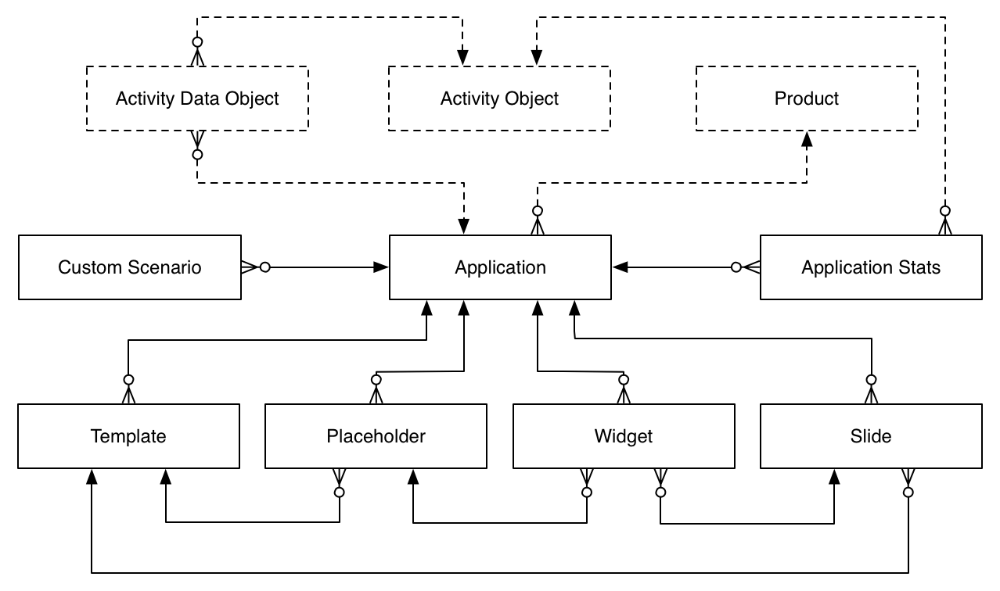

To create a presentation from Application object menu you need to click new. To create a new HTML presentation you need to select “Application” record type.

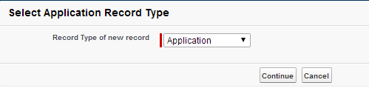

## Creating an Application (Presentation)

In the presentation window, you need to put the Application name and relate a product to the presentation by selecting it from the list of existing products. To track the statistics on the presentation you need to check the required boxes in the Tracking options section. To make the presentation available for the users you need to make it **Active**.

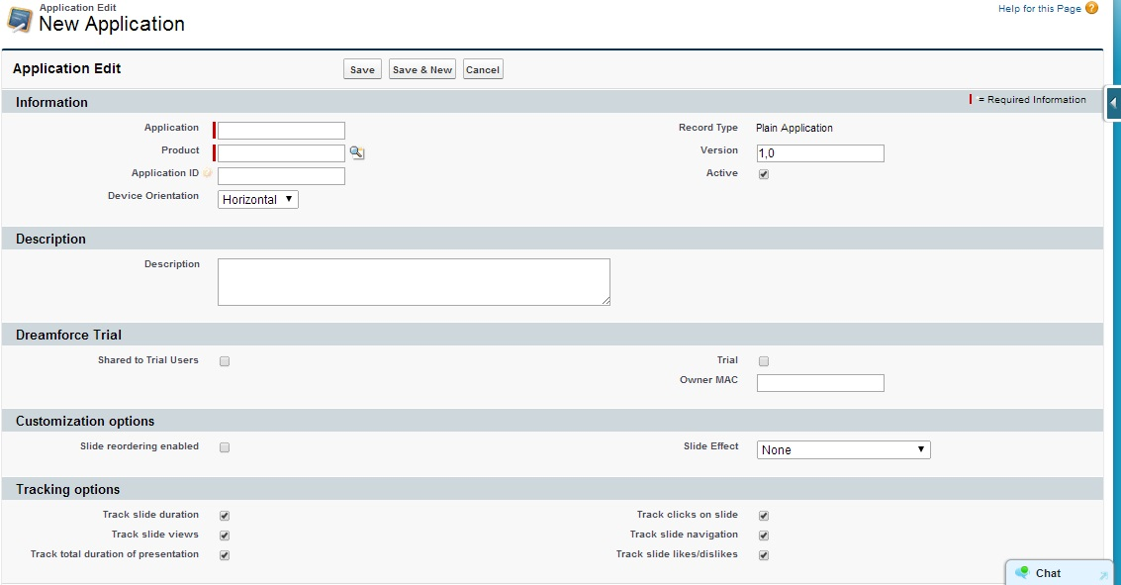

Main window where you can find all the presentation components.

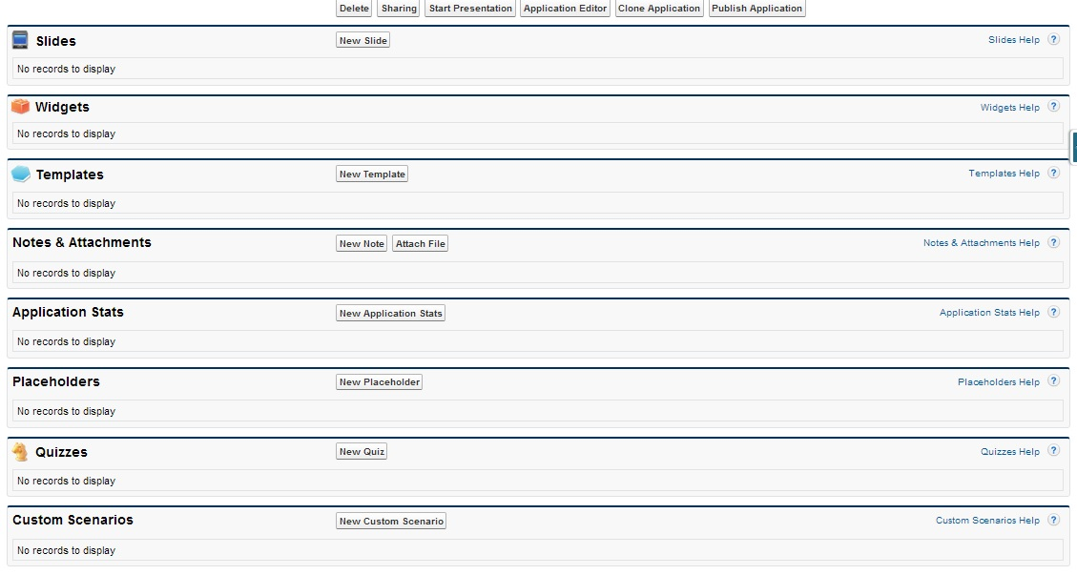

## Creating Template

1. To create a new Template you should go to Templates section and click “**New Template**”.
2. You need to fill in the required fields and in Markup, you put HTML code page.

*The HTML code should query the script "JSLibrary/app.js" (<script type="text/javascript" src="../JSLibrary/js/app.js"></script>).*

*Templates and placeholders should be included taking into consideration presentation name (For example: e-Detailing2: Test Template, where e-Detailing2 is a name of the presentation).*

Salesforce allows to create several slides based on one template. You can use widgets to make slides look and feel different.

To use widget you need to choose a place where it would be located (Placeholder). *To create a placeholder in the Markup field we change {!POSITION_X} on the Template object, where X is a sequential number of a Placeholder.*

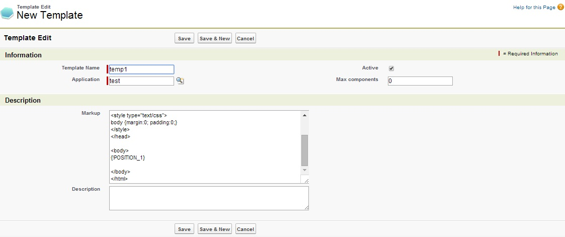

## Creating a Placeholder

1. To create a new Placeholder you need to click “**New Placeholder**” in the Template window. Call it Placeholder and attach to Template.
2. Please specify a type of Placeholder it can be Rich Text, Chart, Sortable, Slider or Video. It is also required to put the sequential number in the Position.

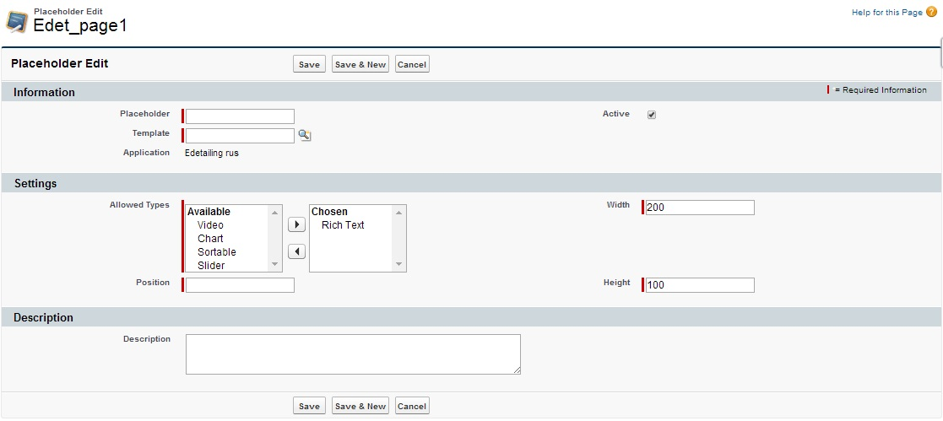

## Creating a Slide

Please click “NEW Slide” in the Template window.

To create a new slide you need to pay attention on the fields:

* Order – sequential number of the slide;
* Template – Template based on what the slide would be created.

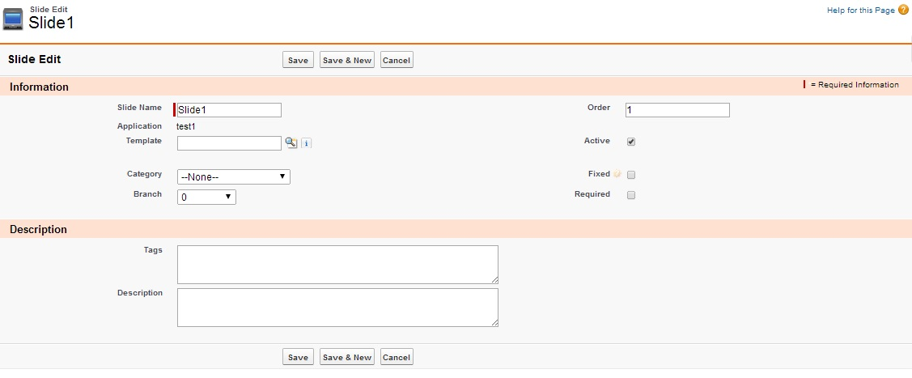

## Creating a Widget

1. Click “**NEW Widget**” in slide window. Next select Slide and Placeholder the widget relates to.
2. 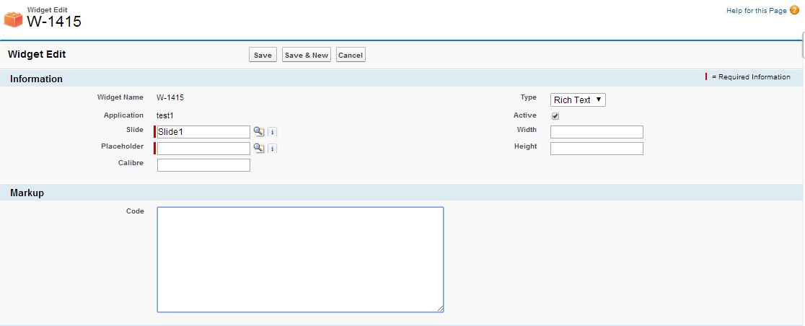Please place HTML code in the Code field.

## Create an Attach

Project files are archived in the Zip archive and attached to Application. The exception is pdf files. They should be attached separately same as archives.

Archive requirements:

1. File size should be no more than 25 MB. If the size of the archived presentation exceeds the size, please save the data to several smaller archives.
2. The file extension should be .zip with name sources.
3. The archive should have its sequential number (sources.zip, sources2.zip, sources3.zip).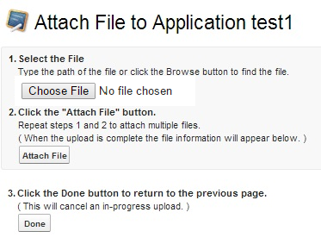

To attach an archive to the project it is required to click Attach File. When all the files are loaded please click Done.

## Finalizing

When all the necessary information is placed to slides and widgets it is required to press “Publish” on the Application object – this function is a confirmation for all changes made and allow this changes to be visible to the Users on the app.