# Change Request

To set up Change Request you need customize Custom Settings (Change Request Mapping and Change Request Object Settings) and Custom Metadata Types (Change Request Succession Cloning, Change Request categorization).

### **1. Change Request mapping**

First, navigate to Custom Settings in Salesforce Classic

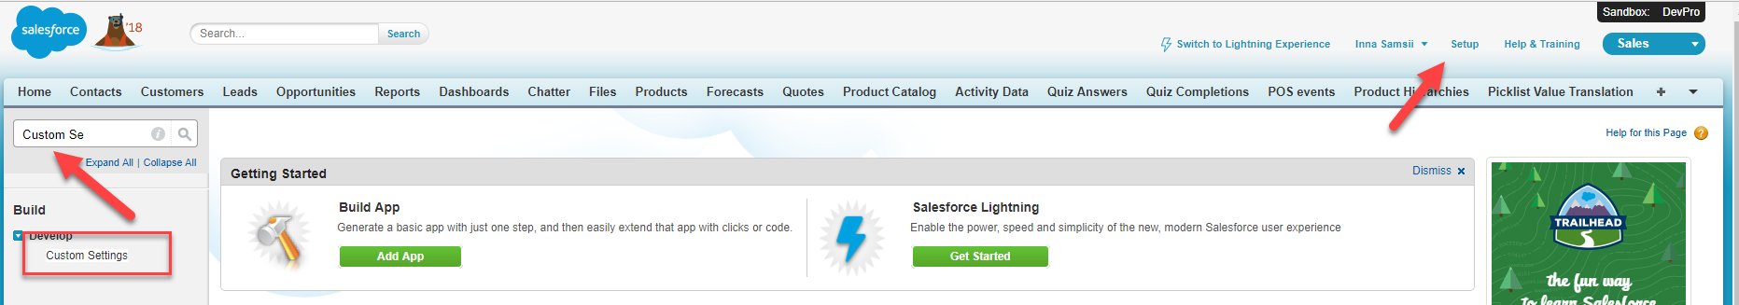

After that, select Change Request mapping.

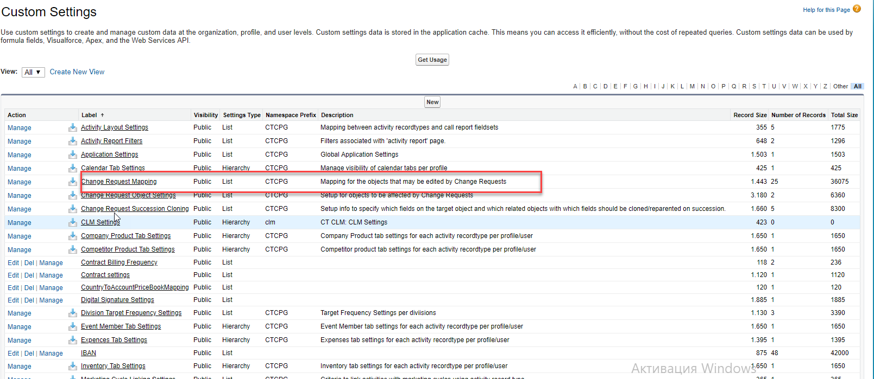

Here you can see Change Request mapping object fields. If you want to add new field mapping press Manage button.

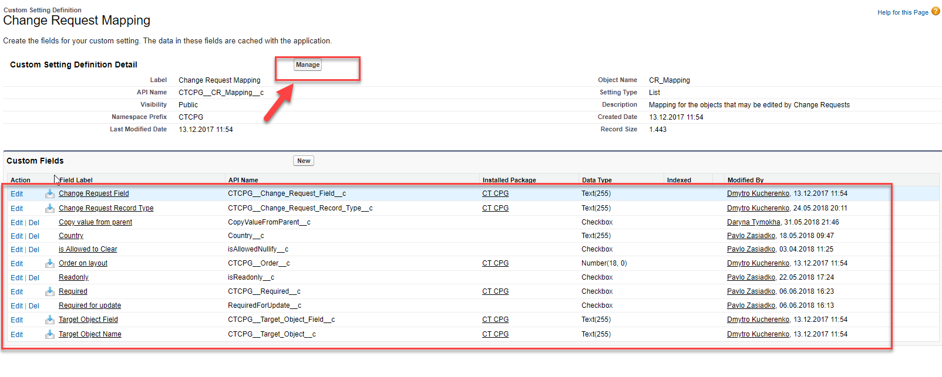

After pressing Manage button you will see the list of fields that are mapped. To add new field mapping press New button

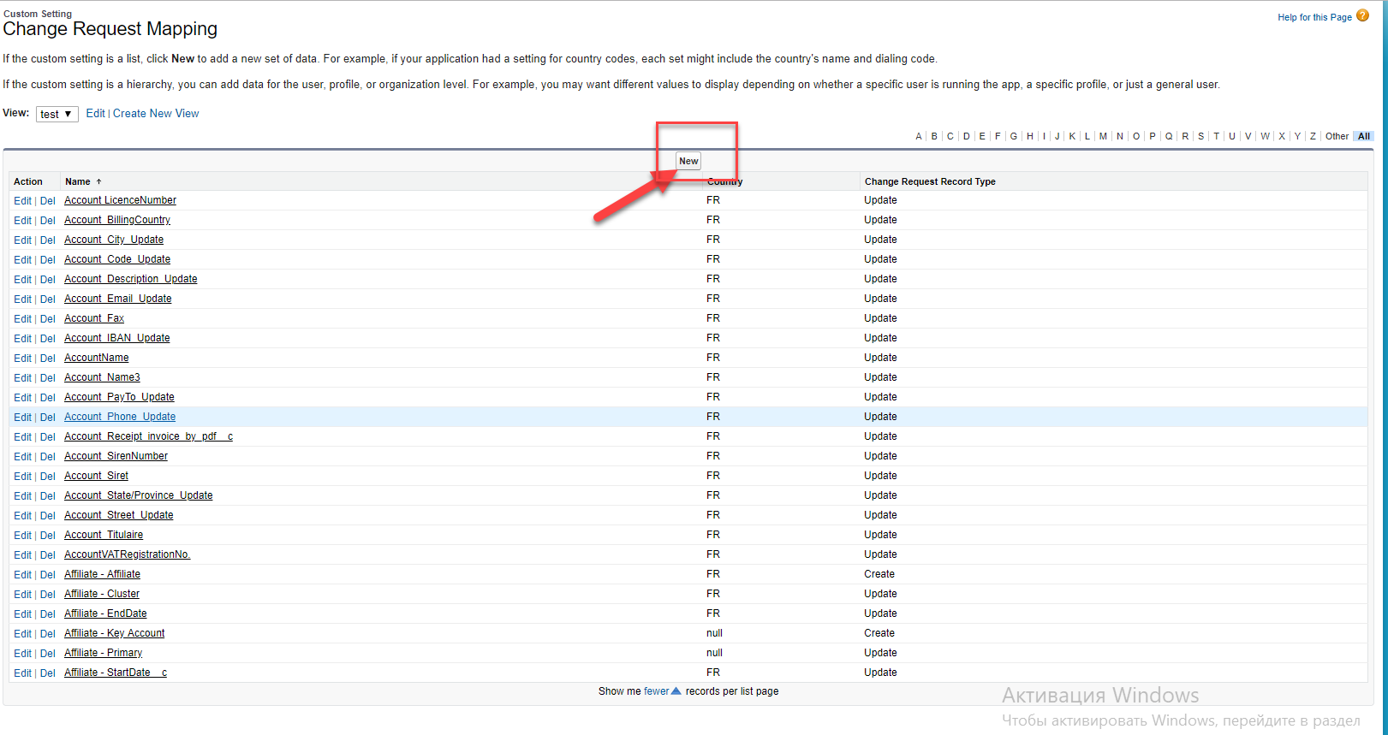

You have to populate information in required fields and after that click Save.

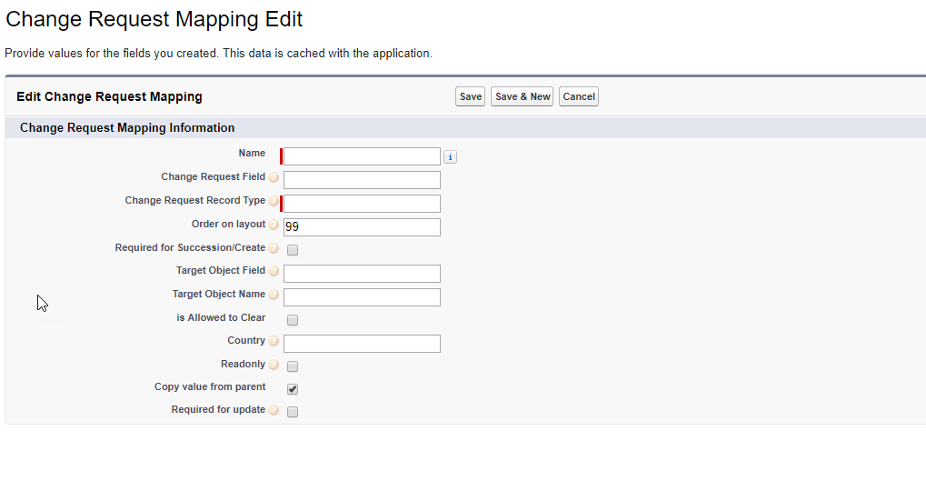

For example we have to add field mapping for IBAN field , then you will populate such data

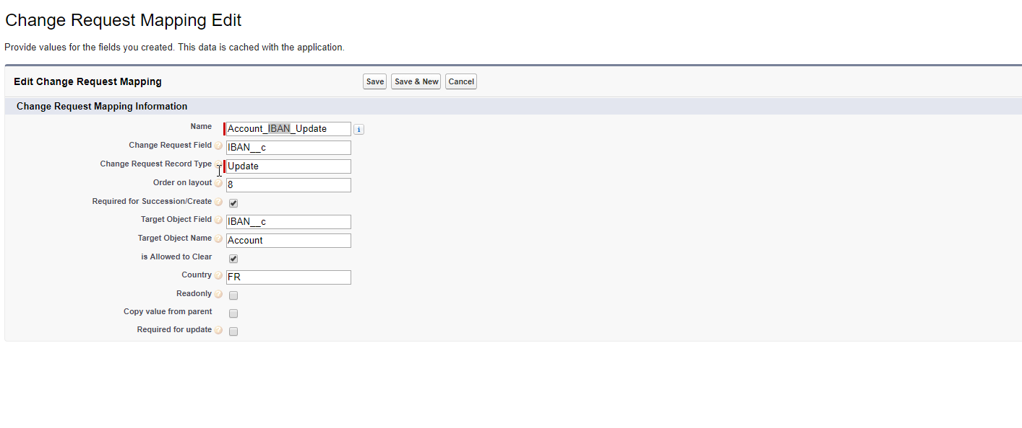

* Fill record name
* Api name of the field that you have to change with help of Change Requst on the Change Request object ( check before that it is present on the Change request object)
* Populate order on mobile and online layout
* If field is required for Succession or Create check Required for Succession/Create checkbox
* Api name of the field that you have to change with help of Change Request on the Customer
* Target object name
* It is necessary to populate Country code of the country that this setting is relevant to.
* Additional fields to be displayed as Read-only on the Change Request layout
* Copy value from parent
* If field is required for Update check Required for Update checkbox

### **2. Change Request Object Settings**

Move to the Custom Settings list and check Change Request Object Settings

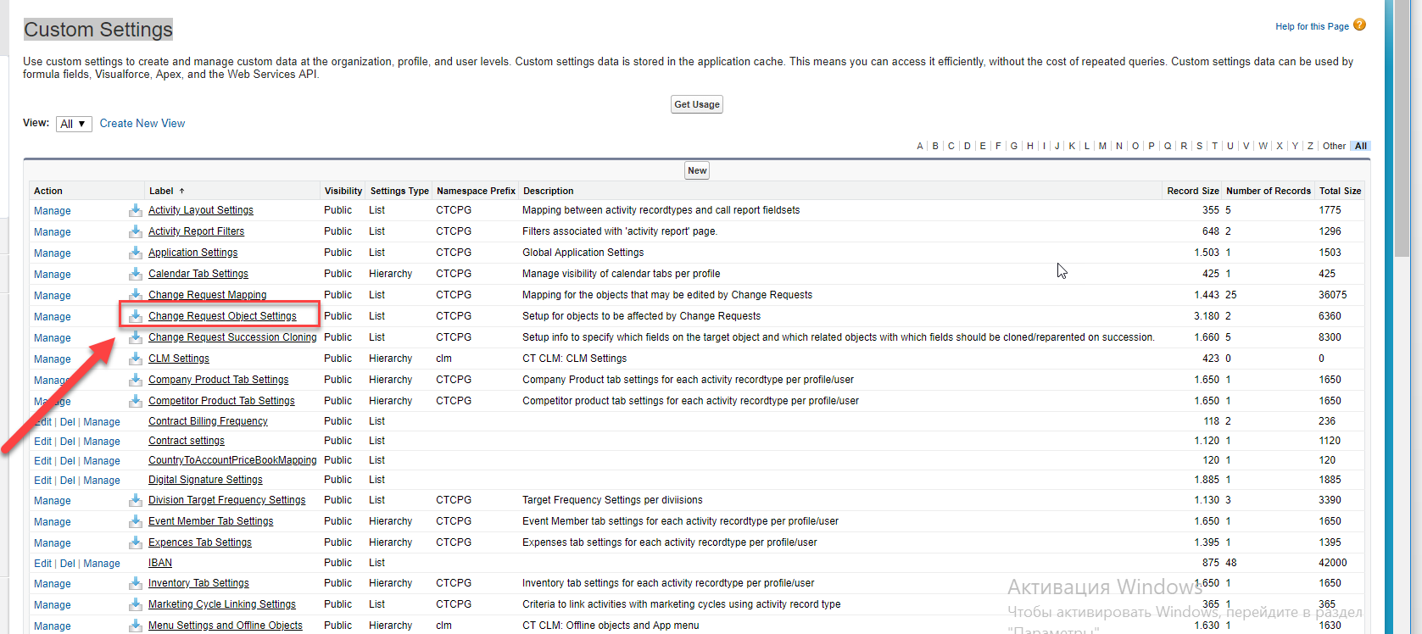

Here you can see Change Request Object Settings. If you want to add new, Object Setting or edit existing press Manage button.

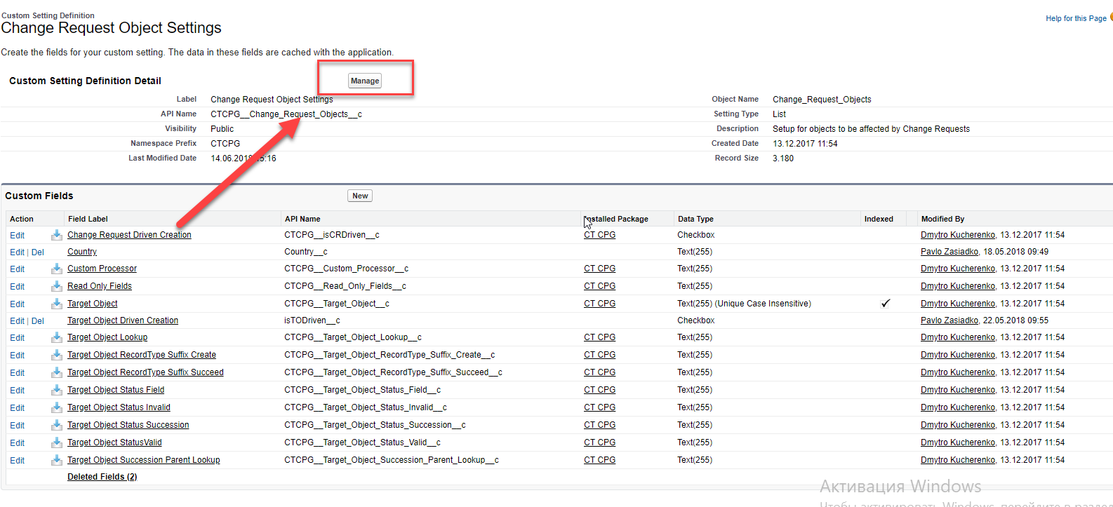

Here you can see list of Object Settings. To create new one press New button.

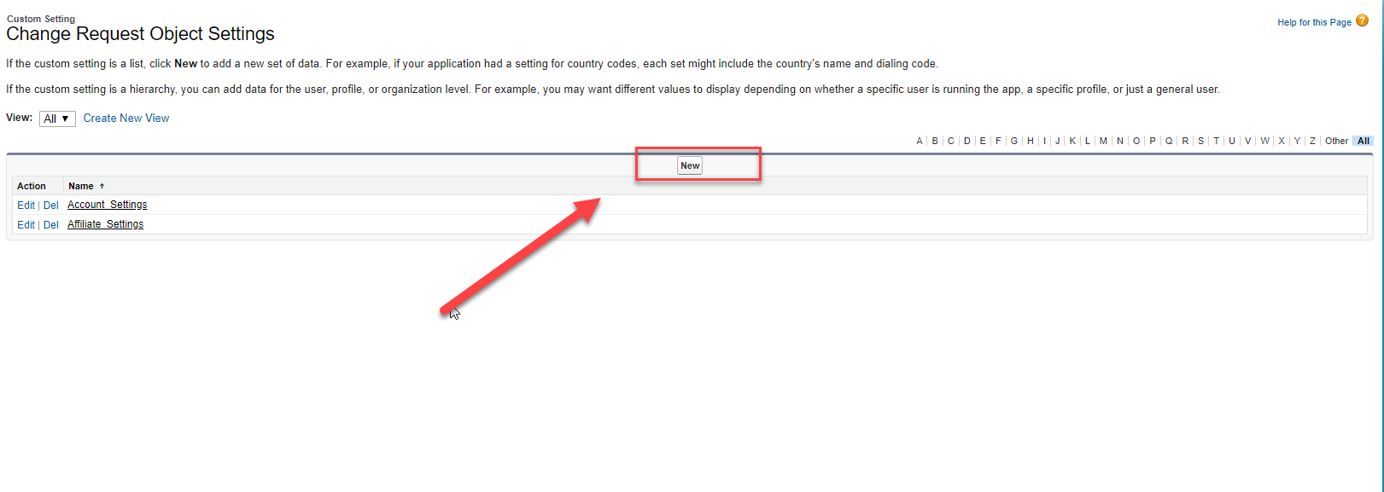

You have to populate information in required fields and after that click Save.

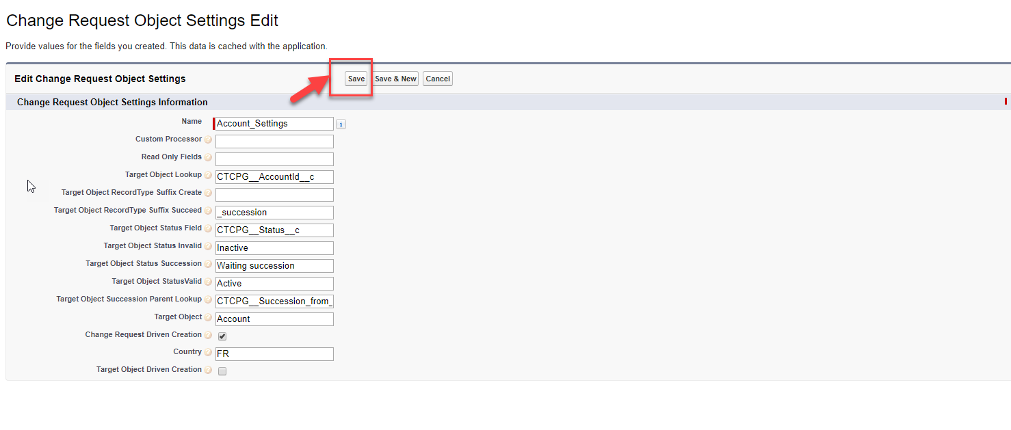

* Fill record name
* Name of the Apex class that contains custom processor definitions. Processor classes should inherit from the ChangeRequestProcessors.CRProcess class and provide overrides for doProcess and doRegress methods
* Additional fields to be displayed as Read-only on the Change Request layout
* API name of the field pointing to the target from the Change Request
* Suffix of the RecordType API name/developer name to be attributed on new object creation via Change Request mechanic
* Suffix of the RecordType API name/developer name to be attributed on succeeding object via Change Request mechanic
* API name of the field that marks the status of the target object
* Picklist value to mark the object as Inactive
* Picklist value to mark the object as Awaiting Succession
* Status picklist value to mark the object as valid
* API name of the field on the target object that points to the succeeded object
* Creating a new Create Change Request forces creation of a temporary target object
* Country code of the country that this setting is relevant to.
* Appropriate change request should be created when inserting a new Target Object

### **3. Change Request Succession Cloning**

To set up Change Request Succession Cloning you have to check Custom Metadata Types

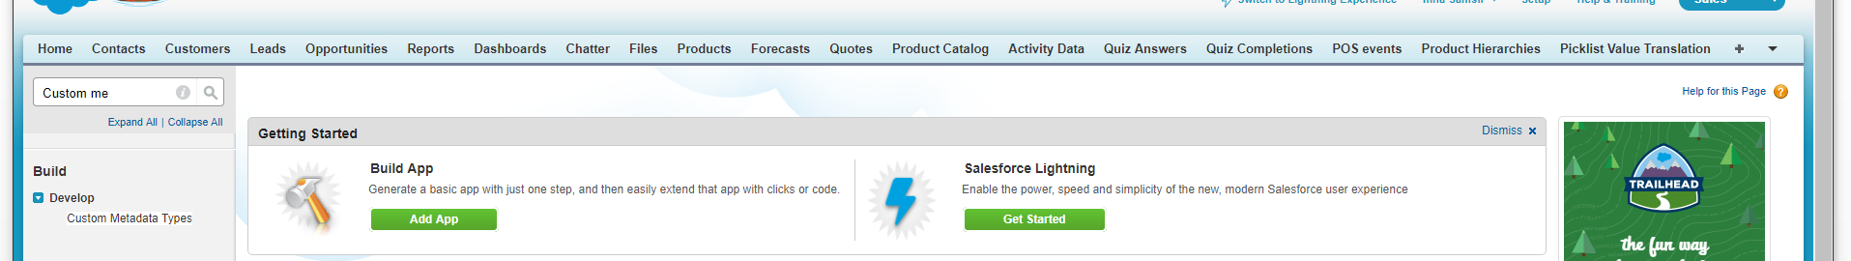

Check Change Request Succession Cloning in the list of Custom Metadata Types

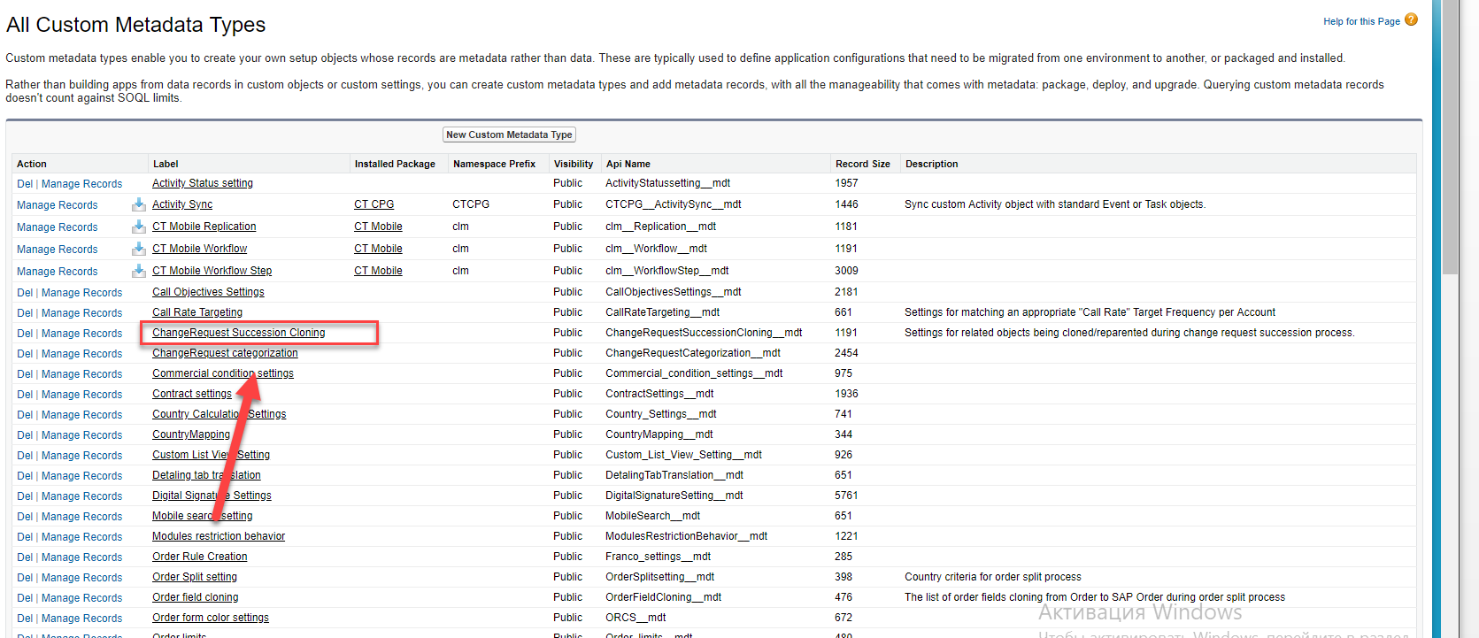

To create or edit Custom Metadata Types records press Manage ChangeRequest Succession Cloning button

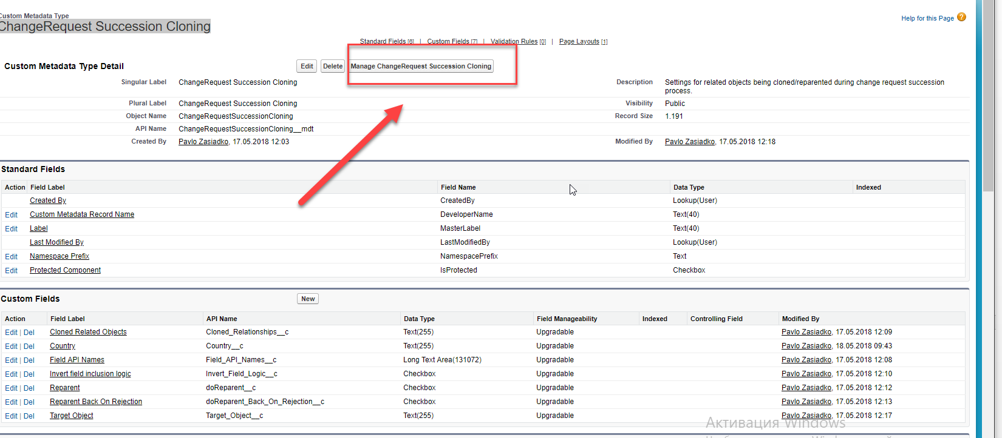

To create new Change Request Succession Cloning record press New button

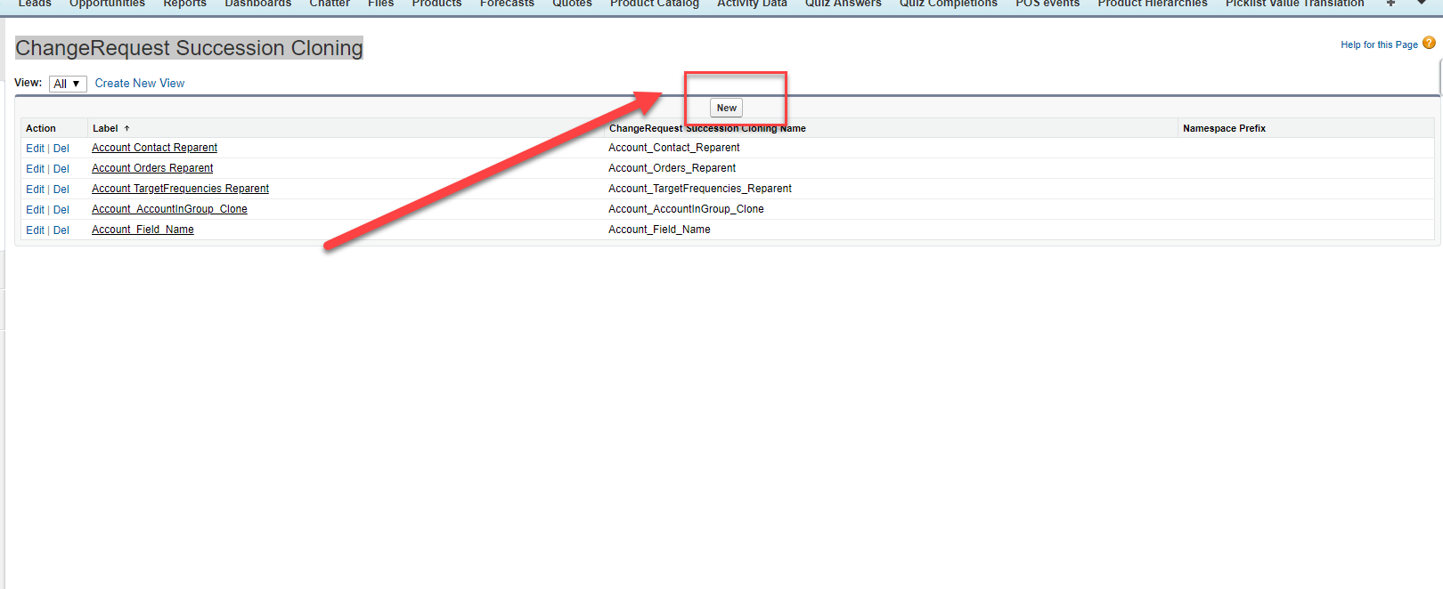

You have to populate such fields if you want to clone object

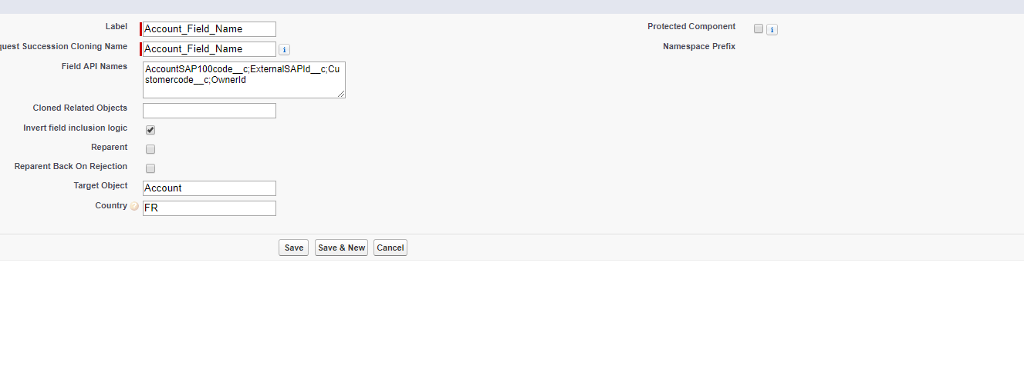

* Label –name of the record
* ChangeRequest Succession Cloning Name – Api Name
* Field API Names – List of semicolon (;) separated API names of fields to be included when cloning/reparenting
* Invert field inclusion logic - Checkbox to signify that provided fields should be excluded from all creatable fields
* Target Object - Object type of the record being succeeded
* Country - Country code of the country that this setting is relevant to.

You have to populate such fields if you want to clone **Related Objects**

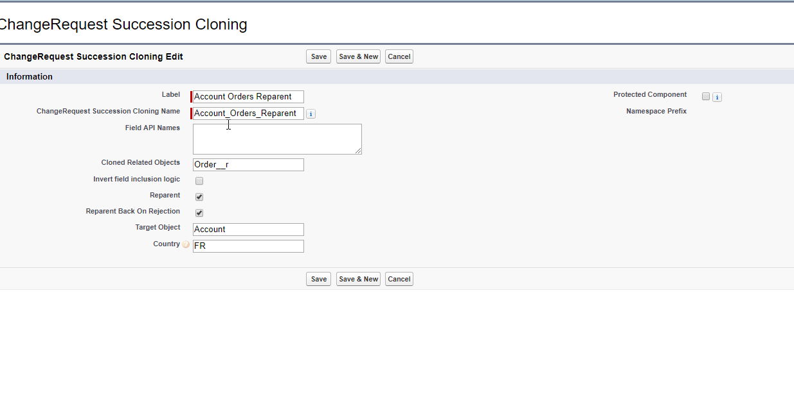

Label –name of the record

ChangeRequest Succession Cloning Name – Api Name

Field API Names – List of semicolon (;) separated API names of fields to be included when cloning/reparenting

Invert field inclusion logic - Checkbox to signify that provided fields should be excluded from all creatable fields

Target Object - Object type of the record being succeeded

Country - Country code of the country that this setting is relevant to.

Cloned Related Objects - API names of relationships on parent object to clone

Reparent - Checkbox to indicate whether object is to be reparented

Reparent Back On Rejection Boolean flag to indicate whether object should be reparented back on rejection

### **4. Change Request categorization**

Check Change Request categorization in Custom Metadata Types

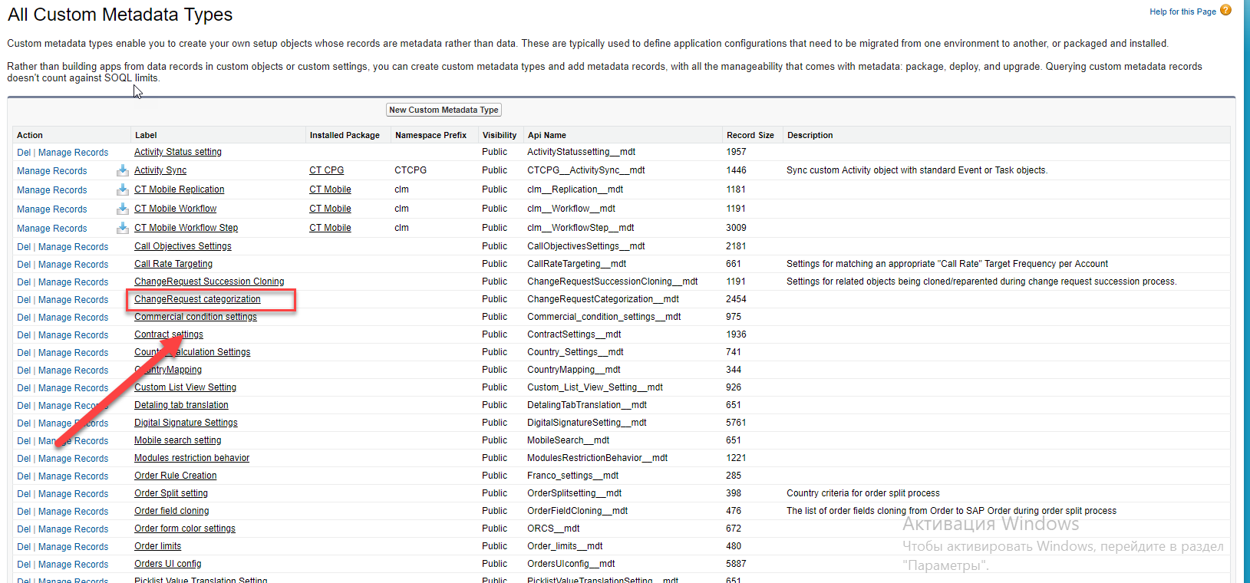

Press Manage ChangeRequest categorization button to see list of ChangeRequest categorization records

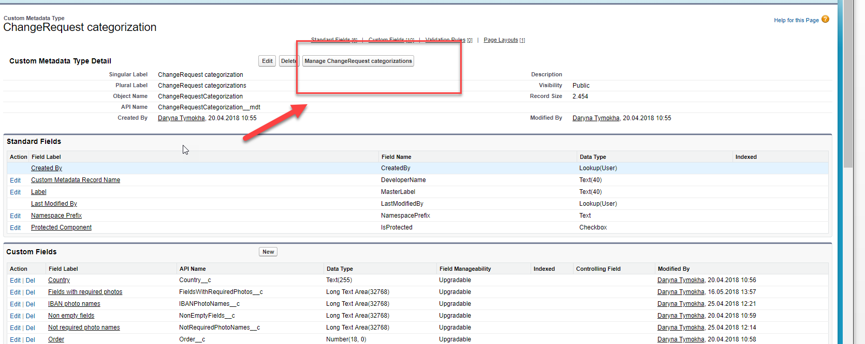

To Create new record or edit existing press New button

You have to fill such fields:

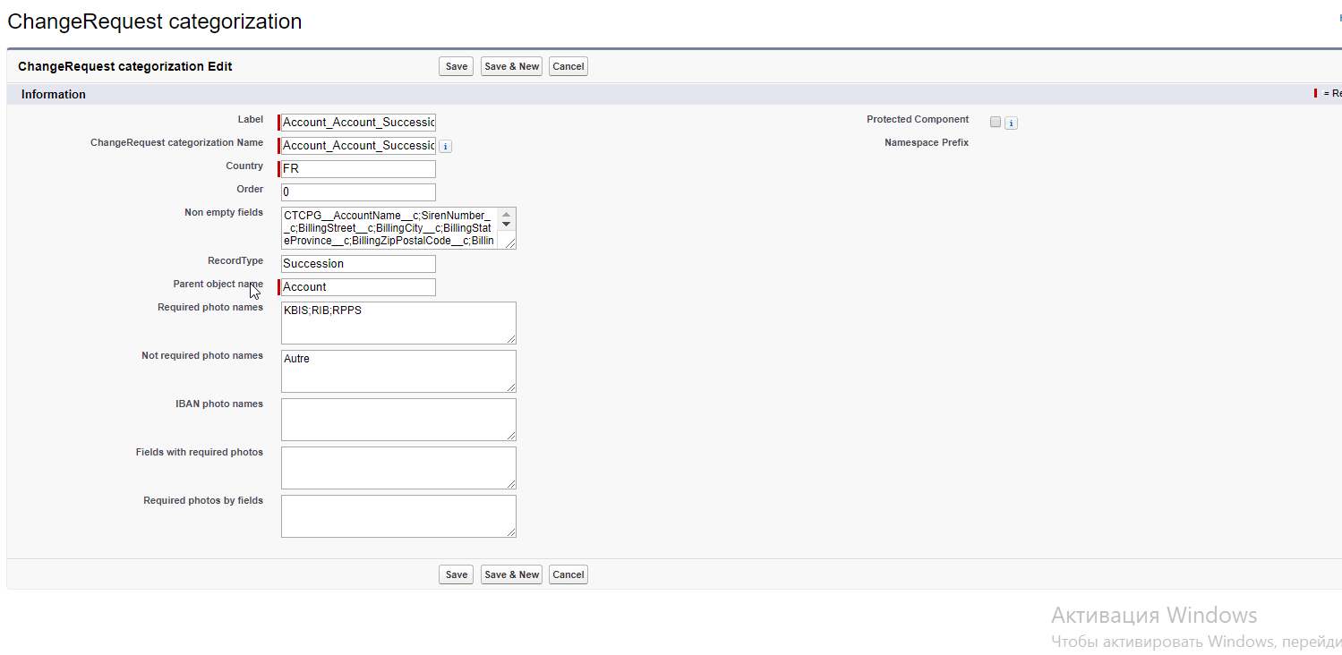

Label –name of the record

ChangeRequest categorization Name – Api Name

Country - Name of country for applying setting

Order - Setting priority. I.e. setting with order = 0 will be checked first and if it's suitable for ChangeRequest it'll be used. Otherwise setting with number > 0 will be checked and so on.

Non empty fields – List of fields that should be filled separated by ;

RecordType – Change Request Record Type.DeveloperName that will be chosen if setting is suitable

Parent object name - Object type of the record being succeeded

Required photo names- List of required photos for current RecordType separated by ;

Not required photo names - List of non- required photos for current RecordType separated by ;

Fields with required photos - List of API names of fields that required to add additional photo.   
Names in list have to be separated by ;

Required photos by fields - List of required photo names for RequiredPhotoNames__c  Photos for different fields should be separated by ; Different photos for one filed should be separated by ,   
Example:   
Field1Photo1,Field1Photo2;Field2Photo1;Field3Photo1,Field3Photo2,Field3Photo3