3_nonparametric_20170910.R

vivianbernau

Thu Sep 14 10:49:05 2017

#GERMINATION DATA  
#VIVIAN BERNAU  
#6 Sept 2017  
#Based on McNair et al 2012; Seed Science Research  
  
#Using SURVMINER  
  
#NONPARAMETRIC ANALYSIS  
#1) Characterizing pattern of germination within groups --> Kaplan-Meier test: survfit()  
#2) Comparing patterns of germination in groups --> Fleming-Harrington test(?): survdiff()  
  
#My data is right-sensored.  
#My data is interval, but can probably be analyzed nonparametrically as exact for as long as plates with large losses are removed.  
  
#Survivor function: probability that the germination time is greater than t  
  
#Set working directory and repositories  
wd <- ("~/Google Drive/RFiles/Chiles_OSU/3_Germination/")  
  
src.dir <- paste(wd,"scripts", sep = "")  
data.dir <- paste (wd,"data", sep = "")  
out.dir <- paste(wd, "output", sep ="")  
  
setwd(out.dir)  
  
#read in germination data in pre-lifetab format  
#df10 <- read.csv(paste(out.dir, "/cleaned10_2017-09-07.csv", sep = ""), header = T)  
df <- read.csv(paste(out.dir, "/cleaned_2017-09-10.csv", sep = ""), header = T)  
str(df)

## 'data.frame': 5678 obs. of 23 variables:  
## $ X.2 : int 47 68 74 75 77 80 82 83 293 294 ...  
## $ X.1 : int 47 68 74 75 77 80 82 83 293 294 ...  
## $ sampleid : Factor w/ 70 levels "CanAbasolo1",..: 1 1 1 1 1 1 1 1 1 1 ...  
## $ line : Factor w/ 99 levels "100-1","100-2",..: 76 76 76 76 76 76 76 76 76 76 ...  
## $ X : num 2818 2818 2818 2818 2819 ...  
## $ rep : int 2 2 2 2 2 2 2 2 2 2 ...  
## $ run : int 3 3 3 3 3 3 3 3 3 3 ...  
## $ shelf : int 5 5 5 5 5 5 5 5 5 5 ...  
## $ plate : int 170 170 170 170 170 170 170 170 170 170 ...  
## $ trt : int 10 10 10 10 10 10 10 10 10 10 ...  
## $ end : num 157.5 157.5 157.5 157.5 60.5 ...  
## $ status : int 1 1 1 1 1 1 1 0 1 1 ...  
## $ number : int 6 6 6 6 2 2 1 1 6 6 ...  
## $ pedigree : Factor w/ 99 levels "14CAg128-1","14CAg131-2",..: 29 29 29 29 29 29 29 29 29 29 ...  
## $ planting.date : Factor w/ 2 levels "11/10/14","control": 1 1 1 1 1 1 1 1 1 1 ...  
## $ landrace.abb : Factor w/ 23 levels "CAg","Cam","CdA",..: 1 1 1 1 1 1 1 1 1 1 ...  
## $ region : Factor w/ 6 levels "central valleys",..: 1 1 1 1 1 1 1 1 1 1 ...  
## $ pop : Factor w/ 38 levels "","CAg_24","CAg_25",..: 10 10 10 10 10 10 10 10 10 10 ...  
## $ population.type: Factor w/ 4 levels "control","landrace",..: 2 2 2 2 2 2 2 2 2 2 ...  
## $ landrace.name : Factor w/ 19 levels "Chigole","Chile Bolita",..: 3 3 3 3 3 3 3 3 3 3 ...  
## $ cultivation : Factor w/ 5 levels "Backyard","control",..: 4 4 4 4 4 4 4 4 4 4 ...  
## $ main.use : Factor w/ 5 levels "","control","Dry",..: 1 1 1 1 1 1 1 1 1 1 ...  
## $ uniqueplate : Factor w/ 568 levels "1_1","1_102",..: 233 233 233 233 233 233 233 233 233 233 ...

df$end <- round(df$end, digits = 1)  
df$run <- as.factor(df$run)  
  
df <- subset(df, region!="control")  
df$cv <- as.numeric(df$region == "central valleys")  
df$ecoast <- as.numeric(df$region == "ecoast")  
df$wcoast <- as.numeric(df$region == "wcoast")  
df$yucatan <- as.numeric(df$region == "yucatan")  
df$sm <- as.numeric(df$region == "sierra madre")  
  
library(survival)  
library(survminer)

## Loading required package: ggplot2

## Loading required package: ggpubr

## Loading required package: magrittr

#fit and plot Kaplan-Meier survivor function, includes 95% confidence intervals  
km.fit <-survfit(Surv(df$end, df$status) ~ 1, data = df, type = "kaplan-meier")  
ggsurvplot(km.fit, conf.int = T)

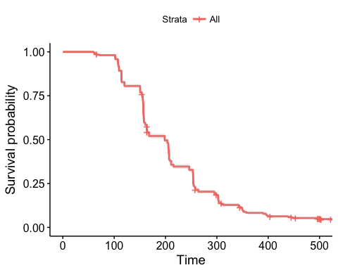

test.region <- survfit(Surv(end, status) ~ region, data = df, subset = {trt == 0}, type = "kaplan-meier", conf.type = "log-log")  
ggsurvplot(test.region, data =df, conf.int = T, pval = T, palette = "Dark2", risk.table = T, risk.table.col = "strata", xlab = "Time (h)",   
 surv.median.line = "hv", title = "Germination under Water Control")

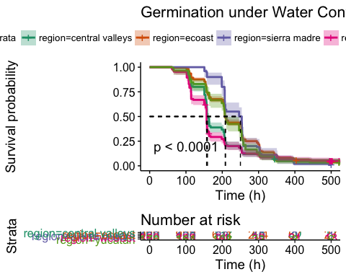

#Creating composite figures of with one frame for each [PEG]  
# List of ggsurvplots  
test.20<- survfit(Surv(end, status) ~ region, data = df, type = "kaplan-meier", subset = (trt == 20))  
test.15 <- survfit(Surv(end, status) ~ region, data = df, type = "kaplan-meier", subset = (trt ==15))  
test.10 <- survfit(Surv(end, status) ~ region, data = df, type = "kaplan-meier", subset = (trt ==10))  
test.0 <- survfit(Surv(end, status) ~ region, data = df, type = "kaplan-meier", subset = (trt ==0))  
  
pegplots <- list()  
pegplots[[1]] <- ggsurvplot(test.20, data = df, pval = T, conf.int = T, palette = "Dark2", legend = "none", xlab = "Time (h)", title = "20% [PEG]", ggtheme = theme_grey())  
pegplots[[2]] <- ggsurvplot(test.15, data = df, pval = T, conf.int = T, palette = "Dark2", legend = "none", xlab = "Time (h)", title = "15% [PEG]", ggtheme = theme_grey())  
pegplots[[3]] <- ggsurvplot(test.10, data = df, pval = T, conf.int = T, palette = "Dark2", legend = "none", xlab = "Time (h)", title = "10% [PEG]", ggtheme = theme_grey())  
pegplots[[4]] <- ggsurvplot(test.0, data = df, pval = T, conf.int = T, palette = "Dark2", legend = "none", xlab = "Time (h)", title = "0% [PEG]" , ggtheme = theme_grey())  
  
# Arrange multiple ggsurvplots and print the output  
arrange_ggsurvplots(pegplots, title = "Germination under different [PEG]",  
 ncol = 2, nrow = 2)

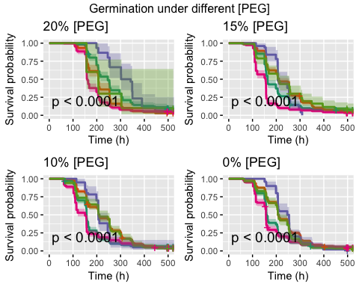

res <- arrange_ggsurvplots(pegplots, print = FALSE)  
ggsave("allconcentrations_20170908.png", res)

## Saving 5 x 4 in image

#Creating composite figure of Kaplan-Meier survivor estimates with 1 frame for each region  
#png(filename="allregions20170906.png", width = 700, height = 1400, res = 120)  
test.cv <- survfit(Surv(end, status) ~ trt, data = df, type = "kaplan-meier", subset = (region =="central valleys"))  
test.ecoast <- survfit(Surv(end, status) ~ trt, data = df, type = "kaplan-meier", subset = (region =="ecoast"))  
test.sm <- survfit(Surv(end, status) ~ trt, data = df, type = "kaplan-meier", subset = (region =="sierra madre"))  
test.wcoast <- survfit(Surv(end, status) ~ trt, data = df, type = "kaplan-meier", subset = (region =="wcoast"))  
test.yucatan <- survfit(Surv(end, status) ~ trt, data = df, type = "kaplan-meier", subset = (region =="yucatan"))  
  
library(RColorBrewer)  
regplots <- list()  
regplots[[1]] <- ggsurvplot(test.cv, data = df, pval = T, title = "Central Valleys", conf.int = T, legend = "none", xlab = "Time (h)", palette = rev(brewer.pal(4,"Spectral")), ggtheme = theme_grey())  
regplots[[2]] <- ggsurvplot(test.ecoast, data = df, pval = T, title = "E Coast", conf.int = T, legend = "none", xlab = "Time (h)", palette = rev(brewer.pal(4,"Spectral")), ggtheme = theme_grey())  
regplots[[3]] <- ggsurvplot(test.sm, data = df, pval = T, title = "Sierra Madre de la Sur", conf.int = T, legend = "none", xlab = "Time (h)", palette = rev(brewer.pal(4,"Spectral")), ggtheme = theme_grey())  
regplots[[4]] <- ggsurvplot(test.wcoast, data = df, pval = T, title = "W Coast", conf.int = T, legend = "none", xlab = "Time (h)", palette = rev(brewer.pal(4,"Spectral")), ggtheme = theme_grey())  
regplots[[5]] <- ggsurvplot(test.yucatan, data = df, pval = T, title = "Yucatan", conf.int = T, legend = "right", xlab = "Time (h)", palette = rev(brewer.pal(4,"Spectral")), ggtheme = theme_grey())  
  
# Arrange multiple ggsurvplots and print the output  
arrange_ggsurvplots(regplots, print = TRUE, title = "germination from different regions",  
 ncol = 2, nrow = 3)

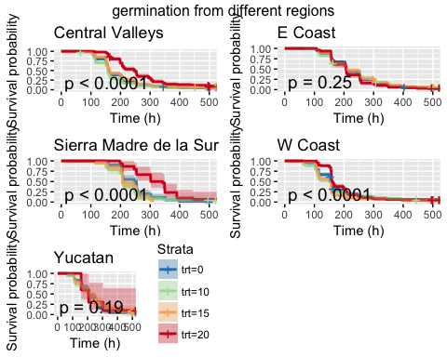

res <- arrange_ggsurvplots(regplots, print = FALSE)  
ggsave("allconcentrations_20170907.png", res)

## Saving 5 x 4 in image

#COMPARISON OF SURVIVOR FUNCTIONS  
library(RColorBrewer)  
ggsurvplot(test.cv, data = df, pval = T, title = "Central Valleys", conf.int = T, legend = "bottom", xlab = "Time (h)", palette = rev(brewer.pal(4,"Spectral")), ggtheme = theme_grey())

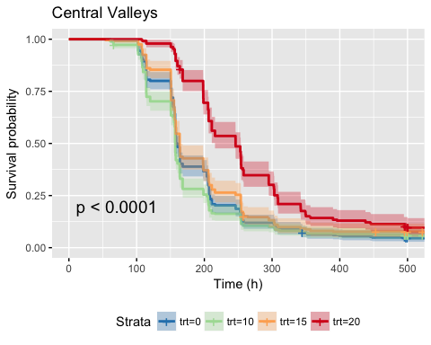

df_cv <- subset(df, region=="central valleys")  
survdiff_cv <- pairwise_survdiff(Surv(end, status)~trt, data = df_cv, p.adjust.method = "bonferroni",rho = 0)  
print(survdiff_cv)

##   
## Pairwise comparisons using Log-Rank test   
##   
## data: df_cv and trt   
##   
## 0 10 15   
## 10 0.428 - -   
## 15 0.887 0.018 -   
## 20 7.2e-15 < 2e-16 6.1e-09  
##   
## P value adjustment method: bonferroni

#no significant difference between treatments  
#survdiff_ecoast <- pairwise_survdiff(Surv(end, status)~trt, data = df, subset = {region == "ecoast"}, rho = 0)  
#print(survdiff_ecoast)  
  
ggsurvplot(test.wcoast, data = df, pval = T, title = "W Coast", conf.int = T, legend = "bottom", xlab = "Time (h)", palette = rev(brewer.pal(4,"Spectral")), ggtheme = theme_grey())

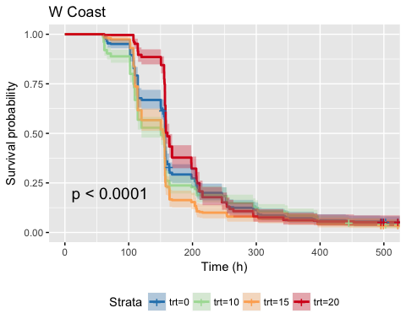

df_wcoast <- subset(df, region == "wcoast")  
survdiff_wcoast <-pairwise_survdiff(Surv(end, status)~trt, data = df_wcoast, p.adjust.method = "bonferroni",rho = 0)  
print(survdiff_wcoast)

##   
## Pairwise comparisons using Log-Rank test   
##   
## data: df_wcoast and trt   
##   
## 0 10 15   
## 10 0.2807 - -   
## 15 0.0067 1.0000 -   
## 20 0.1112 0.0002 1.4e-09  
##   
## P value adjustment method: bonferroni

ggsurvplot(test.sm, data = df, pval = T, title = "Sierra Madre de la Sur", conf.int = T, legend = "bottom", xlab = "Time (h)", palette = rev(brewer.pal(4,"Spectral")), ggtheme = theme_grey())

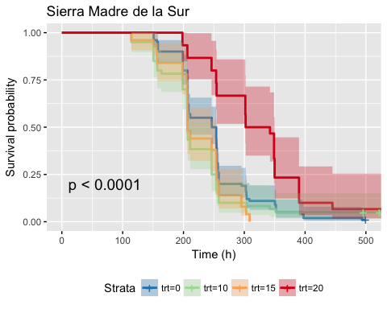

df_sm <- subset(df, region == "sierra madre")  
survdiff_sm <- pairwise_survdiff(Surv(end, status)~trt, data = df_sm, p.adjust.method = "bonferroni",rho = 0)  
print(survdiff_sm)

##   
## Pairwise comparisons using Log-Rank test   
##   
## data: df_sm and trt   
##   
## 0 10 15   
## 10 0.2691 - -   
## 15 0.0758 1.0000 -   
## 20 0.0039 0.0002 9.3e-08  
##   
## P value adjustment method: bonferroni

#no significant differences between treatments  
#survdiff_yucatan <- survdiff(Surv(end, status)~trt, data = df10, subset = {region == "yucatan"}, rho = 0)  
#print(survdiff_yucatan)  
  
ggsurvplot(test.0, data = df, pval = T, title = "0% PEG", conf.int = T, legend = "bottom", xlab = "Time (h)", palette = "Dark2", ggtheme = theme_grey())

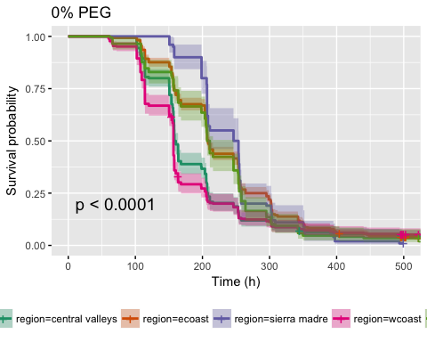

df_0 <- subset(df, trt==0)  
survdiff_0 <- pairwise_survdiff(Surv(end, status)~region, data = df_0, p.adjust.method = "bonferroni",rho = 0)  
print(survdiff_0)

##   
## Pairwise comparisons using Log-Rank test   
##   
## data: df_0 and region   
##   
## central valleys ecoast sierra madre wcoast   
## ecoast 5.8e-10 - - -   
## sierra madre 2.0e-05 1.00000 - -   
## wcoast 0.44930 1.3e-14 1.1e-06 -   
## yucatan 0.00690 1.00000 0.99547 0.00027  
##   
## P value adjustment method: bonferroni

surv_median(test.0)

## strata median lower upper  
## 1 region=central valleys 159.2 157.8 163.7  
## 2 region=ecoast 208.1 207.0 211.0  
## 3 region=sierra madre 250.0 208.2 254.1  
## 4 region=wcoast 156.8 156.8 156.8  
## 5 region=yucatan 209.0 205.8 246.1

ggsurvplot(test.10, data = df, pval = T, title = "10% PEG", conf.int = T, legend = "bottom", xlab = "Time (h)", palette = "Dark2", ggtheme = theme_grey())

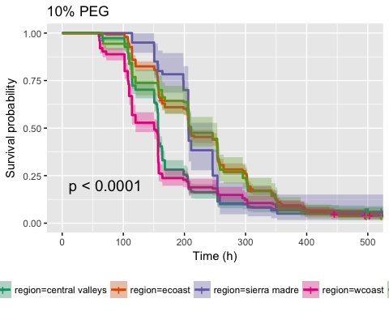

df_10 <- subset(df, trt==10)  
survdiff_10 <- pairwise_survdiff(Surv(end, status)~region, data = df_10, p.adjust.method = "bonferroni",rho = 0)  
print(survdiff_10)

##   
## Pairwise comparisons using Log-Rank test   
##   
## data: df_10 and region   
##   
## central valleys ecoast sierra madre wcoast   
## ecoast 4.0e-13 - - -   
## sierra madre 0.0044 1.0000 - -   
## wcoast 0.0948 < 2e-16 0.0034 -   
## yucatan 2.7e-05 1.0000 1.0000 1.4e-05  
##   
## P value adjustment method: bonferroni

surv_median(test.10)

## strata median lower upper  
## 1 region=central valleys 157.1 156.8 157.5  
## 2 region=ecoast 207.0 206.3 211.0  
## 3 region=sierra madre 206.8 206.2 246.0  
## 4 region=wcoast 150.6 120.0 156.7  
## 5 region=yucatan 211.0 206.4 253.8

ggsurvplot(test.15, data = df, pval = T, title = "15% PEG", conf.int = T, legend = "bottom", xlab = "Time (h)", palette = "Dark2", ggtheme = theme_grey())

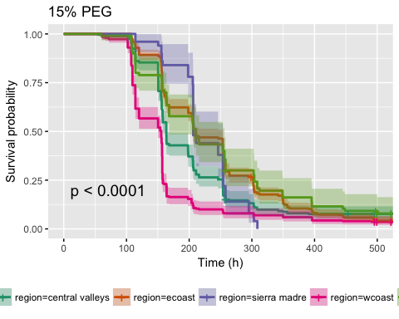

df_15 <- subset(df, trt==15)  
survdiff_15 <- pairwise_survdiff(Surv(end, status)~region, data = df_15, p.adjust.method = "bonferroni",rho = 0)  
print(survdiff_15)

##   
## Pairwise comparisons using Log-Rank test   
##   
## data: df_15 and region   
##   
## central valleys ecoast sierra madre wcoast   
## ecoast 0.00084 - - -   
## sierra madre 1.00000 0.73495 - -   
## wcoast 6.3e-10 < 2e-16 1.1e-05 -   
## yucatan 0.10946 1.00000 0.50428 6.5e-09  
##   
## P value adjustment method: bonferroni

surv_median(test.15)

## strata median lower upper  
## 1 region=central valleys 163.5 157.9 164.0  
## 2 region=ecoast 207.0 206.1 253.6  
## 3 region=sierra madre 206.4 206.4 253.8  
## 4 region=wcoast 155.5 150.3 156.0  
## 5 region=yucatan 211.0 168.0 256.3

ggsurvplot(test.20, data = df, pval = T, title = "20% PEG", conf.int = T, legend = "bottom", xlab = "Time (h)", palette = "Dark2", ggtheme = theme_grey())

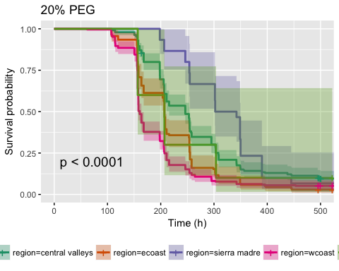

df_20 <- subset(df, trt==20)  
survdiff_20 <- pairwise_survdiff(Surv(end, status)~region, data = df_20, p.adjust.method = "bonferroni",rho = 0)  
print(survdiff_20)

##   
## Pairwise comparisons using Log-Rank test   
##   
## data: df_20 and region   
##   
## central valleys ecoast sierra madre wcoast   
## ecoast 0.00066 - - -   
## sierra madre 0.38678 0.00084 - -   
## wcoast 1.2e-14 0.01406 5.0e-06 -   
## yucatan 1.00000 1.00000 0.62092 1.00000  
##   
## P value adjustment method: bonferroni

surv_median(test.20)

## strata median lower upper  
## 1 region=central valleys 246.10 215.7 254.0  
## 2 region=ecoast 207.00 205.6 208.2  
## 3 region=sierra madre 322.25 301.7 349.9  
## 4 region=wcoast 160.50 158.0 164.0  
## 5 region=yucatan 207.00 156.8 NA

#EXTRACT .25 AND .75 QUANTILES  
data.frame(q = c(.25, .5, .75),  
 km = quantile(survfit(Surv(end,status) ~ 1, data = subset(df_0, cv == 1 ), type = "kaplan-meier")))

## q km.quantile km.lower km.upper  
## 25 0.25 150.70 150.3 153.8  
## 50 0.50 159.20 157.8 163.7  
## 75 0.75 207.65 207.0 215.7

data.frame(q = c(.25, .5, .75),  
 km = quantile(survfit(Surv(end,status) ~ 1, data = subset(df_0, wcoast == 1 ), type = "kaplan-meier")))

## q km.quantile km.lower km.upper  
## 25 0.25 114.2 109.5 114.2  
## 50 0.50 156.8 156.8 156.8  
## 75 0.75 205.7 168.0 211.0

data.frame(q = c(.25, .5, .75),  
 km = quantile(survfit(Surv(end,status) ~ 1, data = subset(df_0, sm == 1 ), type = "kaplan-meier")))

## q km.quantile km.lower km.upper  
## 25 0.25 206.8 198.6 206.8  
## 50 0.50 250.0 208.2 254.1  
## 75 0.75 258.0 254.8 303.3

data.frame(q = c(.25, .5, .75),  
 km = quantile(survfit(Surv(end,status) ~ 1, data = subset(df_0, ecoast == 1 ), type = "kaplan-meier")))

## q km.quantile km.lower km.upper  
## 25 0.25 157.1 156.8 160.5  
## 50 0.50 208.1 207.0 211.0  
## 75 0.75 279.6 257.0 298.8

data.frame(q = c(.25, .5, .75),  
 km = quantile(survfit(Surv(end,status) ~ 1, data = subset(df_0, yucatan == 1 ), type = "kaplan-meier")))

## q km.quantile km.lower km.upper  
## 25 0.25 157.9 155.1 168.0  
## 50 0.50 209.0 205.8 246.1  
## 75 0.75 258.0 253.8 264.1

data.frame(q = c(.25, .5, .75),  
 km = quantile(survfit(Surv(end,status) ~ 1, data = subset(df_10, cv == 1 ), type = "kaplan-meier")))

## q km.quantile km.lower km.upper  
## 25 0.25 114.2 114.2 150.4  
## 50 0.50 157.1 156.8 157.5  
## 75 0.75 203.7 168.0 206.3

data.frame(q = c(.25, .5, .75),  
 km = quantile(survfit(Surv(end,status) ~ 1, data = subset(df_10, wcoast == 1 ), type = "kaplan-meier")))

## q km.quantile km.lower km.upper  
## 25 0.25 107.6 107.3 109.5  
## 50 0.50 150.6 120.0 156.7  
## 75 0.75 163.7 157.8 207.0

data.frame(q = c(.25, .5, .75),  
 km = quantile(survfit(Surv(end,status) ~ 1, data = subset(df_10, sm == 1 ), type = "kaplan-meier")))

## q km.quantile km.lower km.upper  
## 25 0.25 198.30 156.2 206.2  
## 50 0.50 206.80 206.2 246.0  
## 75 0.75 250.15 246.0 258.0

data.frame(q = c(.25, .5, .75),  
 km = quantile(survfit(Surv(end,status) ~ 1, data = subset(df_10, ecoast == 1 ), type = "kaplan-meier")))

## q km.quantile km.lower km.upper  
## 25 0.25 156.7 155.8 156.8  
## 50 0.50 207.0 206.3 211.0  
## 75 0.75 302.2 295.4 302.8

data.frame(q = c(.25, .5, .75),  
 km = quantile(survfit(Surv(end,status) ~ 1, data = subset(df_10, yucatan == 1 ), type = "kaplan-meier")))

## q km.quantile km.lower km.upper  
## 25 0.25 120.0 114.2 164.0  
## 50 0.50 211.0 206.4 253.8  
## 75 0.75 295.4 257.0 303.9

data.frame(q = c(.25, .5, .75),  
 km = quantile(survfit(Surv(end,status) ~ 1, data = subset(df_15, cv == 1 ), type = "kaplan-meier")))

## q km.quantile km.lower km.upper  
## 25 0.25 150.7 150.5 155.1  
## 50 0.50 163.5 157.9 164.0  
## 75 0.75 253.7 211.0 254.0

data.frame(q = c(.25, .5, .75),  
 km = quantile(survfit(Surv(end,status) ~ 1, data = subset(df_15, wcoast == 1 ), type = "kaplan-meier")))

## q km.quantile km.lower km.upper  
## 25 0.25 109.5 109.5 114.2  
## 50 0.50 155.5 150.3 156.0  
## 75 0.75 158.0 157.1 164.0

data.frame(q = c(.25, .5, .75),  
 km = quantile(survfit(Surv(end,status) ~ 1, data = subset(df_15, sm == 1 ), type = "kaplan-meier")))

## q km.quantile km.lower km.upper  
## 25 0.25 205.8 157.6 206.4  
## 50 0.50 206.4 206.4 253.8  
## 75 0.75 254.1 253.8 295.1

data.frame(q = c(.25, .5, .75),  
 km = quantile(survfit(Surv(end,status) ~ 1, data = subset(df_15, ecoast == 1 ), type = "kaplan-meier")))

## q km.quantile km.lower km.upper  
## 25 0.25 156.8 156.8 156.8  
## 50 0.50 207.0 206.1 253.6  
## 75 0.75 302.2 264.1 303.1

data.frame(q = c(.25, .5, .75),  
 km = quantile(survfit(Surv(end,status) ~ 1, data = subset(df_15, yucatan == 1 ), type = "kaplan-meier")))

## q km.quantile km.lower km.upper  
## 25 0.25 156.8 114.2 163.7  
## 50 0.50 211.0 168.0 256.3  
## 75 0.75 303.8 258.0 395.2

data.frame(q = c(.25, .5, .75),  
 km = quantile(survfit(Surv(end,status) ~ 1, data = subset(df_20, cv == 1 ), type = "kaplan-meier")))

## q km.quantile km.lower km.upper  
## 25 0.25 198.3 198.2 205.5  
## 50 0.50 246.1 215.7 254.0  
## 75 0.75 308.2 295.4 342.2

data.frame(q = c(.25, .5, .75),  
 km = quantile(survfit(Surv(end,status) ~ 1, data = subset(df_20, wcoast == 1 ), type = "kaplan-meier")))

## q km.quantile km.lower km.upper  
## 25 0.25 156.2 155.6 156.8  
## 50 0.50 160.5 158.0 164.0  
## 75 0.75 207.0 205.8 215.7

data.frame(q = c(.25, .5, .75),  
 km = quantile(survfit(Surv(end,status) ~ 1, data = subset(df_20, sm == 1 ), type = "kaplan-meier")))

## q km.quantile km.lower km.upper  
## 25 0.25 253.70 246.1 302.2  
## 50 0.50 322.25 301.7 349.9  
## 75 0.75 349.90 348.9 NA

data.frame(q = c(.25, .5, .75),  
 km = quantile(survfit(Surv(end,status) ~ 1, data = subset(df_20, ecoast == 1 ), type = "kaplan-meier")))

## q km.quantile km.lower km.upper  
## 25 0.25 158.2 155.8 163.7  
## 50 0.50 207.0 205.6 208.2  
## 75 0.75 254.8 253.8 258.0

data.frame(q = c(.25, .5, .75),  
 km = quantile(survfit(Surv(end,status) ~ 1, data = subset(df_20, yucatan == 1 ), type = "kaplan-meier")))

## q km.quantile km.lower km.upper  
## 25 0.25 156.8 156.8 303.8  
## 50 0.50 207.0 156.8 NA  
## 75 0.75 303.8 207.0 NA

#TESTING DIFFERENCES ACROSS CULTIVATION SYSTEMS  
test.cult.0 <- survfit(Surv(end, status) ~ cultivation, data = df, type = "kaplan-meier", subset = (trt ==0))  
ggsurvplot(test.cult.0, data = df, pval = T, title = "0% PEG", conf.int = T, legend = "bottom", xlab = "Time (h)", palette = "Dark2", ggtheme = theme_grey())

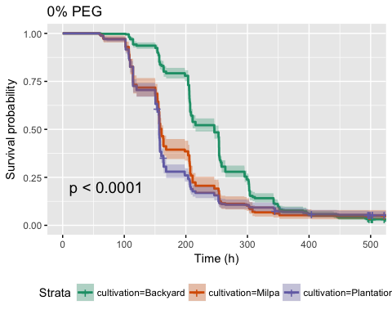

survdiff_cult_0 <- pairwise_survdiff(Surv(end, status)~cultivation, data = df_0, p.adjust.method = "bonferroni",rho = 0)  
print(survdiff_cult_0)

##   
## Pairwise comparisons using Log-Rank test   
##   
## data: df_0 and cultivation   
##   
## Backyard Milpa  
## Milpa <2e-16 -   
## Plantation <2e-16 0.35   
##   
## P value adjustment method: bonferroni

test.cult.20 <- survfit(Surv(end, status) ~ cultivation, data = df, type = "kaplan-meier", subset = (trt ==20))  
ggsurvplot(test.cult.20, data = df, pval = T, title = "20% PEG", conf.int = T, legend = "bottom", xlab = "Time (h)", palette = "Dark2", ggtheme = theme_grey())

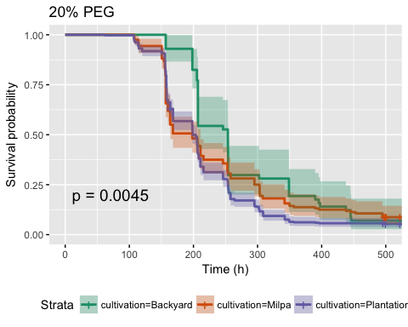

survdiff_cult_20 <- pairwise_survdiff(Surv(end, status)~cultivation, data = df_20, p.adjust.method = "bonferroni",rho = 0)  
print(survdiff_cult_20)

##   
## Pairwise comparisons using Log-Rank test   
##   
## data: df_20 and cultivation   
##   
## Backyard Milpa   
## Milpa 0.1678 -   
## Plantation 0.0035 0.4448  
##   
## P value adjustment method: bonferroni

#TESTING DIFFERENCES ACROSS DOMESTICATION LEVEL  
test.domestication.0 <- survfit(Surv(end, status) ~ population.type, data = df, type = "kaplan-meier", subset = (trt ==0))  
ggsurvplot(test.domestication.0, data = df, pval = T, title = "0% PEG", conf.int = T, legend = "bottom", xlab = "Time (h)", palette = "Dark2", ggtheme = theme_grey())

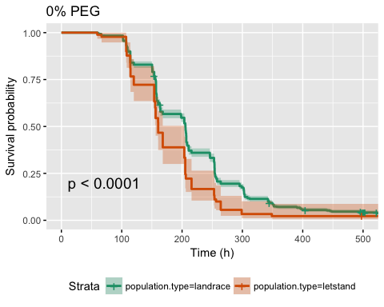

survdiff_domestication_0 <- pairwise_survdiff(Surv(end, status)~population.type, data = df_0, p.adjust.method = "bonferroni",rho = 0)  
print(survdiff_domestication_0)

##   
## Pairwise comparisons using Log-Rank test   
##   
## data: df_0 and population.type   
##   
## landrace  
## letstand 1.7e-05   
##   
## P value adjustment method: bonferroni

test.domestication.20 <- survfit(Surv(end, status) ~ population.type, data = df, type = "kaplan-meier", subset = (trt ==20))  
ggsurvplot(test.domestication.20, data = df, pval = T, title = "20% PEG", conf.int = T, legend = "bottom", xlab = "Time (h)", palette = "Dark2", ggtheme = theme_grey())

## Warning in .pvalue(fit, data = data, method = method, pval = pval, pval.coord = pval.coord, : There are no survival curves to be compared.   
## This is a null model.

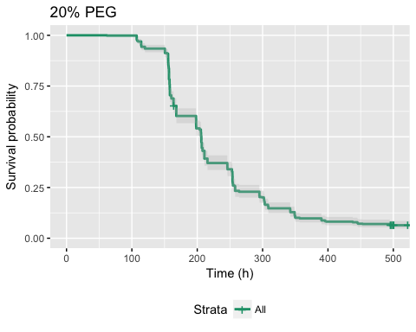

survdiff_domestication_20 <- pairwise_survdiff(Surv(end, status)~population.type, data = df_20, p.adjust.method = "bonferroni",rho = 0)  
print(survdiff_domestication_20)

##   
## Pairwise comparisons using Log-Rank test   
##   
## data: df_20 and population.type   
##   
## <0 x 0 matrix>  
##   
## P value adjustment method: bonferroni

#TESTING DIFFERENT LANDRACES  
df_0 <- subset(df, trt==0)  
summary(df$landrace.name)

## Chigole Chile Bolita Chile de Agua Chile de Monte   
## 200 599 750 10   
## control Costeno Amarillo Costeno Rojo Dulce   
## 0 110 1550 110   
## Frutescens Guajillo Guina Dahni Mareno   
## 60 50 260 80   
## Mirasol Paradito Payaso Piquin   
## 109 320 140 120   
## Solterito Taviche Tusta NA's   
## 40 150 920 30

test.lr.0 <- survfit(Surv(end, status) ~ landrace.name, data = df, type = "kaplan-meier", subset = (trt ==0))  
ggsurvplot(test.lr.0, data = df, pval = T, title = "0% PEG", conf.int = T, legend = "bottom", xlab = "Time (h)", ggtheme = theme_grey())

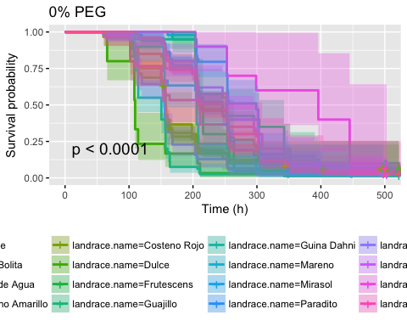

survdiff_lr_0 <- pairwise_survdiff(Surv(end, status)~landrace.name, data = df_0, p.adjust.method = "bonferroni",rho = 0)  
print(survdiff_lr_0)

##   
## Pairwise comparisons using Log-Rank test   
##   
## data: df_0 and landrace.name   
##   
## Chigole Chile Bolita Chile de Agua Costeno Amarillo  
## Chile Bolita 1.00000 - - -   
## Chile de Agua 0.01397 2.9e-07 - -   
## Costeno Amarillo 0.54109 0.02429 1.00000 -   
## Costeno Rojo 0.00086 7.8e-11 1.00000 1.00000   
## Dulce 2.4e-06 3.7e-13 0.00391 1.00000   
## Frutescens 1.00000 1.00000 1.00000 1.00000   
## Guajillo 1.00000 1.00000 0.00332 0.02786   
## Guina Dahni 1.0e-12 < 2e-16 0.00019 1.00000   
## Mareno 1.00000 0.56865 1.00000 1.00000   
## Mirasol 1.00000 1.00000 0.00064 0.00490   
## Paradito 1.00000 1.00000 0.00013 0.02629   
## Payaso 1.4e-06 3.3e-13 1.00000 1.00000   
## Piquin 1.00000 1.00000 0.03580 0.36762   
## Solterito 1.00000 0.59103 0.35110 0.35433   
## Taviche 1.00000 1.00000 1.00000 1.00000   
## Tusta 1.00000 1.00000 3.7e-07 0.03653   
## Costeno Rojo Dulce Frutescens Guajillo Guina Dahni  
## Chile Bolita - - - - -   
## Chile de Agua - - - - -   
## Costeno Amarillo - - - - -   
## Costeno Rojo - - - - -   
## Dulce 0.01234 - - - -   
## Frutescens 1.00000 0.00160 - - -   
## Guajillo 0.00178 5.0e-06 1.00000 - -   
## Guina Dahni 0.00315 1.00000 2.0e-06 4.1e-12 -   
## Mareno 1.00000 0.10656 1.00000 0.30026 0.00435   
## Mirasol 7.9e-05 4.6e-08 0.03009 1.00000 1.7e-15   
## Paradito 2.0e-06 8.3e-12 1.00000 1.00000 < 2e-16   
## Payaso 1.00000 1.00000 0.03726 9.3e-07 1.00000   
## Piquin 0.00978 5.1e-06 1.00000 1.00000 1.0e-10   
## Solterito 0.28694 0.00709 0.06293 1.00000 8.4e-05   
## Taviche 1.00000 0.10826 1.00000 1.00000 0.02248   
## Tusta 1.3e-11 3.8e-14 1.00000 1.00000 < 2e-16   
## Mareno Mirasol Paradito Payaso Piquin Solterito  
## Chile Bolita - - - - - -   
## Chile de Agua - - - - - -   
## Costeno Amarillo - - - - - -   
## Costeno Rojo - - - - - -   
## Dulce - - - - - -   
## Frutescens - - - - - -   
## Guajillo - - - - - -   
## Guina Dahni - - - - - -   
## Mareno - - - - - -   
## Mirasol 0.04311 - - - - -   
## Paradito 1.00000 0.90297 - - - -   
## Payaso 1.00000 1.7e-09 9.8e-10 - - -   
## Piquin 1.00000 1.00000 1.00000 1.3e-05 - -   
## Solterito 0.18389 0.82275 0.42715 0.00835 1.00000 -   
## Taviche 1.00000 1.00000 1.00000 0.76102 1.00000 1.00000   
## Tusta 1.00000 0.66377 1.00000 1.3e-13 1.00000 0.33342   
## Taviche  
## Chile Bolita -   
## Chile de Agua -   
## Costeno Amarillo -   
## Costeno Rojo -   
## Dulce -   
## Frutescens -   
## Guajillo -   
## Guina Dahni -   
## Mareno -   
## Mirasol -   
## Paradito -   
## Payaso -   
## Piquin -   
## Solterito -   
## Taviche -   
## Tusta 1.00000  
##   
## P value adjustment method: bonferroni

df_ecoast <- subset(df, region =="ecoast")  
df_ecoast_0 <- subset(df_ecoast, trt == 0)  
test.landrace.ecoast <- survfit(Surv(end, status) ~ landrace.name, data = df_ecoast, subset = {trt == 0}, type = "kaplan-meier", conf.type = "log-log")  
ggsurvplot(test.landrace.ecoast, data =df, conf.int = T, pval = T, xlab = "Time (h)",   
 surv.median.line = "hv", title = "Germination under Water Control")

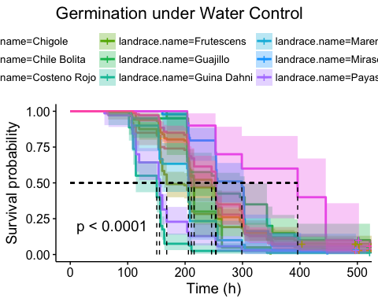

survdiff_lr_ecoast_0 <- pairwise_survdiff(Surv(end, status)~landrace.name, data = df_ecoast_0,p.adjust.method = "bonferroni", rho = 0)  
print(survdiff_lr_ecoast_0)

##   
## Pairwise comparisons using Log-Rank test   
##   
## data: df_ecoast_0 and landrace.name   
##   
## Chigole Chile Bolita Costeno Rojo Frutescens Guajillo  
## Chile Bolita 1.00000 - - - -   
## Costeno Rojo 1.00000 1.00000 - - -   
## Frutescens 1.00000 1.00000 1.00000 - -   
## Guajillo 1.00000 1.00000 0.70732 1.00000 -   
## Guina Dahni 4.2e-13 < 2e-16 1.6e-10 8.2e-07 1.7e-12   
## Mareno 1.00000 0.22997 1.00000 1.00000 0.12143   
## Mirasol 1.00000 1.00000 0.30804 0.01217 1.00000   
## Payaso 5.5e-07 1.3e-13 0.00086 0.01507 3.7e-07   
## Solterito 1.00000 0.23902 0.57789 0.02545 1.00000   
## Tusta 1.00000 1.00000 0.16326 1.00000 1.00000   
## Guina Dahni Mareno Mirasol Payaso Solterito  
## Chile Bolita - - - - -   
## Costeno Rojo - - - - -   
## Frutescens - - - - -   
## Guajillo - - - - -   
## Guina Dahni - - - - -   
## Mareno 0.00176 - - - -   
## Mirasol 6.8e-16 0.01743 - - -   
## Payaso 0.78967 0.41656 6.8e-10 - -   
## Solterito 3.4e-05 0.07437 0.33273 0.00338 -   
## Tusta < 2e-16 0.01653 1.00000 2.6e-15 0.93093   
##   
## P value adjustment method: bonferroni

df_cv <- subset(df, region =="central valley")  
#test.landrace.cv <- survfit(Surv(end, status) ~ landrace.name, data = df_cv, subset = {trt == 0}, type = "kaplan-meier", conf.type = "log-log")  
#ggsurvplot(test.landrace.cv, data =df, conf.int = T, pval = T, risk.table = T, risk.table.col = "strata", xlab = "Time (h)",   
# surv.median.line = "hv", title = "Germination under Water Control")  
df_wcoast <- subset(df, region =="wcoast")  
df_wcoast_0 <- subset(df_wcoast, trt ==0)  
test.landrace.wcoast <- survfit(Surv(end, status) ~ landrace.name, data = df_wcoast, subset = {trt == 0}, type = "kaplan-meier", conf.type = "log-log")  
ggsurvplot(test.landrace.wcoast, data =df, conf.int = T, pval = T, xlab = "Time (h)",   
 surv.median.line = "hv", title = "Germination under Water Control")

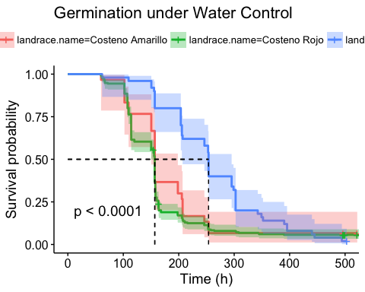

survdiff_lr_wcoast_0 <- pairwise_survdiff(Surv(end, status) ~ landrace.name, data = df_wcoast, p.adjust.method = "bonferroni",rho = 0)  
print(survdiff_lr_wcoast_0)

##   
## Pairwise comparisons using Log-Rank test   
##   
## data: df_wcoast and landrace.name   
##   
## Costeno Amarillo Costeno Rojo  
## Costeno Rojo 1 -   
## Piquin 1.8e-10 < 2e-16   
##   
## P value adjustment method: bonferroni

df_yucatan <- subset(df, region =="yucatan")  
df_yucatan_0 <- subset(df_yucatan, trt ==0)  
test.landrace.yucatan <- survfit(Surv(end, status) ~ landrace.name, data = df_yucatan, subset = {trt == 0}, type = "kaplan-meier", conf.type = "log-log")  
ggsurvplot(test.landrace.yucatan, data =df, conf.int = T, pval = T, xlab = "Time (h)",   
 surv.median.line = "hv", title = "Germination under Water Control")

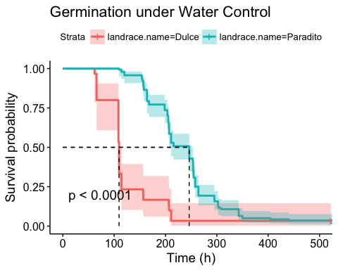

survdiff_lr_yucatan_0 <- pairwise_survdiff(Surv(end, status) ~ landrace.name, data = df_yucatan, p.adjust.method = "bonferroni",rho = 0)  
print(survdiff_lr_yucatan_0)

##   
## Pairwise comparisons using Log-Rank test   
##   
## data: df_yucatan and landrace.name   
##   
## Dulce   
## Paradito <2e-16  
##   
## P value adjustment method: bonferroni

df_sm <- subset(df, region =="sierra madre")  
#df_sm_0 <- subset(df_sm, trt == "trt")  
#test.landrace.sm <- survfit(Surv(end, status) ~ landrace.name, data = df_sm, subset = {trt == 0}, type = "kaplan-meier", conf.type = "log-log")  
#ggsurvplot(test.landrace.sm, data =df, conf.int = T, pval = T, risk.table = T, risk.table.col = "strata", xlab = "Time (h)",   
# surv.median.line = "hv", title = "Germination under Water Control")  
  
df_20 <- subset(df, trt==20)  
test.lr.20 <- survfit(Surv(end, status) ~ landrace.name, data = df, type = "kaplan-meier", subset = (trt ==20))  
ggsurvplot(test.lr.20, data = df, pval = T, title = "20% PEG", conf.int = T, legend = "bottom", xlab = "Time (h)", ggtheme = theme_grey())

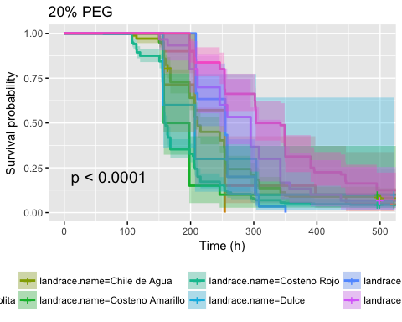

survdiff_lr_20 <- pairwise_survdiff(Surv(end, status)~landrace.name, data = df_20, p.adjust.method = "bonferroni",rho = 0)  
print(survdiff_lr_20)

##   
## Pairwise comparisons using Log-Rank test   
##   
## data: df_20 and landrace.name   
##   
## Chigole Chile Bolita Chile de Agua Costeno Amarillo  
## Chile Bolita 1.00000 - - -   
## Chile de Agua 1.00000 1.00000 - -   
## Costeno Amarillo 0.54220 1.00000 0.24409 -   
## Costeno Rojo 0.45745 1.00000 1.0e-08 1.00000   
## Dulce 1.00000 1.00000 1.00000 1.00000   
## Guina Dahni 1.00000 0.03488 1.00000 0.06934   
## Taviche 1.00000 0.46514 1.00000 0.13440   
## Tusta 0.14620 0.00738 4.8e-05 7.8e-05   
## Costeno Rojo Dulce Guina Dahni Taviche  
## Chile Bolita - - - -   
## Chile de Agua - - - -   
## Costeno Amarillo - - - -   
## Costeno Rojo - - - -   
## Dulce 1.00000 - - -   
## Guina Dahni 0.00547 1.00000 - -   
## Taviche 0.00065 1.00000 0.88938 -   
## Tusta 4.0e-16 0.71205 0.00019 0.68569  
##   
## P value adjustment method: bonferroni

df_ecoast_20 <- subset(df_ecoast, trt == 20)  
test.landrace.ecoast.20 <- survfit(Surv(end, status) ~ landrace.name, data = df_ecoast, subset = {trt == 20}, type = "kaplan-meier", conf.type = "log-log")  
ggsurvplot(test.landrace.ecoast.20, data =df, conf.int = T, pval = T, xlab = "Time (h)",   
 surv.median.line = "hv", title = "Germination under 20% PEG")

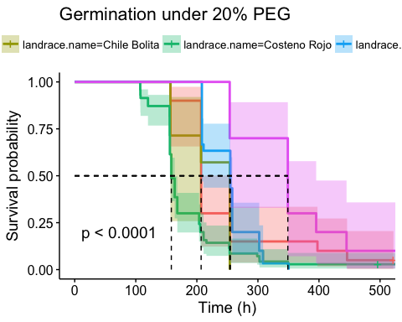

survdiff_lr_ecoast_20 <- pairwise_survdiff(Surv(end, status)~landrace.name, data = df_ecoast_20, p.adjust.method = "bonferroni",rho = 0)  
print(survdiff_lr_ecoast_20)

##   
## Pairwise comparisons using Log-Rank test   
##   
## data: df_ecoast_20 and landrace.name   
##   
## Chigole Chile Bolita Costeno Rojo Guina Dahni  
## Chile Bolita 1.00000 - - -   
## Costeno Rojo 0.01230 1.00000 - -   
## Guina Dahni 1.00000 0.00969 7.4e-05 -   
## Tusta 0.69976 0.09275 0.00044 0.00635   
##   
## P value adjustment method: bonferroni

#test.landrace.cv.20 <- survfit(Surv(end, status) ~ landrace.name, data = df_cv, subset = {trt == 20}, type = "kaplan-meier", conf.type = "log-log")  
#ggsurvplot(test.landrace.cv.20, data =df, conf.int = T, pval = T, risk.table = T, risk.table.col = "strata", xlab = "Time (h)",   
# surv.median.line = "hv", title = "Germination under 20% PEG")  
df_wcoast_20 <- subset(df_wcoast, trt == 20)  
test.landrace.wcoast.20 <- survfit(Surv(end, status) ~ landrace.name, data = df_wcoast, subset = {trt == 20}, type = "kaplan-meier", conf.type = "log-log")  
ggsurvplot(test.landrace.wcoast.20, data =df, conf.int = T, pval = T, xlab = "Time (h)",   
 surv.median.line = "hv", title = "Germination under 20% PEG")

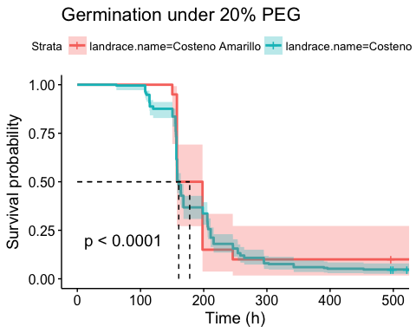

survdiff_lr_wcoast_20 <- pairwise_survdiff(Surv(end, status)~landrace.name, data = df_wcoast_20, p.adjust.method = "bonferroni",rho = 0)  
print(survdiff_lr_wcoast_20)

##   
## Pairwise comparisons using Log-Rank test   
##   
## data: df_wcoast_20 and landrace.name   
##   
## Costeno Amarillo  
## Costeno Rojo 0.83   
##   
## P value adjustment method: bonferroni

#test.landrace.yucatan.20 <- survfit(Surv(end, status) ~ landrace.name, data = df_yucatan, subset = {trt == 20}, type = "kaplan-meier", conf.type = "log-log")  
#ggsurvplot(test.landrace.yucatan.20, data =df, conf.int = T, pval = T, risk.table = T, risk.table.col = "strata", xlab = "Time (h)",   
# surv.median.line = "hv", title = "Germination under 20% PEG"")  
#test.landrace.sm.20 <- survfit(Surv(end, status) ~ landrace.name, data = df_sm, subset = {trt == 20}, type = "kaplan-meier", conf.type = "log-log")  
#ggsurvplot(test.landrace.sm.20, data =df, conf.int = T, pval = T, risk.table = T, risk.table.col = "strata", xlab = "Time (h)",   
# surv.median.line = "hv", title = "Germination under 20% PEG")  
  
df_15 <- subset(df, trt==15)  
test.lr.15 <- survfit(Surv(end, status) ~ landrace.name, data = df, type = "kaplan-meier", subset = (trt ==15))  
ggsurvplot(test.lr.15, data = df, pval = T, risk.table = T, title = "15% PEG", conf.int = T, legend = "bottom", xlab = "Time (h)",   
 ggtheme = theme_grey())

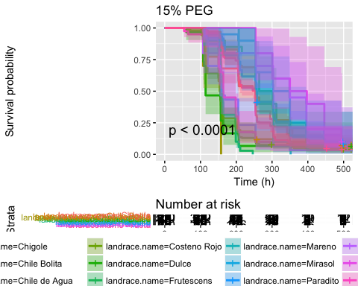

survdiff_lr_15 <- pairwise_survdiff(Surv(end, status)~landrace.name, data = df_15, p.adjust.method = "bonferroni",rho = 0)  
print(survdiff_lr_15)

##   
## Pairwise comparisons using Log-Rank test   
##   
## data: df_15 and landrace.name   
##   
## Chigole Chile Bolita Chile de Agua Costeno Amarillo  
## Chile Bolita 1.00000 - - -   
## Chile de Agua 0.26130 5.0e-07 - -   
## Costeno Amarillo 0.00012 < 2e-16 1.00000 -   
## Costeno Rojo 0.00162 3.6e-14 1.00000 1.00000   
## Dulce 0.11181 1.4e-05 1.00000 1.00000   
## Frutescens 1.00000 1.00000 0.27210 2.4e-05   
## Guina Dahni 1.0e-07 < 2e-16 1.00000 0.00023   
## Mareno 1.00000 1.00000 1.00000 0.00019   
## Mirasol 1.00000 1.00000 0.05380 1.1e-06   
## Paradito 1.00000 1.00000 0.00016 3.5e-15   
## Payaso 1.00000 9.0e-05 1.00000 1.00000   
## Piquin 1.00000 1.00000 0.53504 0.00083   
## Solterito 1.00000 1.00000 0.44155 0.00019   
## Taviche 1.00000 0.00139 1.00000 0.01249   
## Tusta 1.00000 0.57709 9.4e-07 < 2e-16   
## Costeno Rojo Dulce Frutescens Guina Dahni Mareno   
## Chile Bolita - - - - -   
## Chile de Agua - - - - -   
## Costeno Amarillo - - - - -   
## Costeno Rojo - - - - -   
## Dulce 1.00000 - - - -   
## Frutescens 0.00820 0.03855 - - -   
## Guina Dahni 1.00000 1.00000 4.2e-09 - -   
## Mareno 0.49208 0.28682 1.00000 3.0e-06 -   
## Mirasol 0.00140 0.01534 1.00000 5.4e-11 1.00000  
## Paradito 3.4e-09 6.5e-05 1.00000 < 2e-16 1.00000  
## Payaso 1.00000 1.00000 0.16657 1.00000 0.86628  
## Piquin 0.01438 0.79469 1.00000 1.3e-07 1.00000  
## Solterito 0.04821 0.14065 1.00000 2.6e-07 1.00000  
## Taviche 1.00000 1.00000 0.37551 1.00000 0.90345  
## Tusta < 2e-16 1.1e-05 1.00000 < 2e-16 1.00000  
## Mirasol Paradito Payaso Piquin Solterito Taviche  
## Chile Bolita - - - - - -   
## Chile de Agua - - - - - -   
## Costeno Amarillo - - - - - -   
## Costeno Rojo - - - - - -   
## Dulce - - - - - -   
## Frutescens - - - - - -   
## Guina Dahni - - - - - -   
## Mareno - - - - - -   
## Mirasol - - - - - -   
## Paradito 1.00000 - - - - -   
## Payaso 0.00542 0.00202 - - - -   
## Piquin 1.00000 1.00000 0.04296 - - -   
## Solterito 1.00000 1.00000 0.07622 1.00000 - -   
## Taviche 0.07816 0.02229 1.00000 1.00000 0.39785 -   
## Tusta 0.72148 1.00000 0.02045 0.64198 1.00000 0.03500  
##   
## P value adjustment method: bonferroni

df_ecoast_15 <- subset(df_ecoast, trt == 15)  
test.landrace.ecoast.15 <- survfit(Surv(end, status) ~ landrace.name, data = df_ecoast, subset = {trt == 15}, type = "kaplan-meier", conf.type = "log-log")  
ggsurvplot(test.landrace.ecoast.15, data =df, conf.int = T, pval = T, xlab = "Time (h)",   
 surv.median.line = "hv", title = "Germination under 15% PEG")

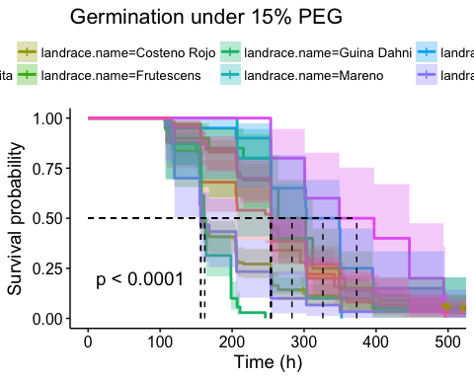

survdiff_lr_ecoast_15 <- pairwise_survdiff(Surv(end, status)~landrace.name, data = df_ecoast_15, p.adjust.method = "bonferroni",rho = 0)  
print(survdiff_lr_ecoast_15)

##   
## Pairwise comparisons using Log-Rank test   
##   
## data: df_ecoast_15 and landrace.name   
##   
## Chigole Chile Bolita Costeno Rojo Frutescens Guina Dahni  
## Chile Bolita 1.00000 - - - -   
## Costeno Rojo 1.00000 0.00016 - - -   
## Frutescens 1.00000 1.00000 0.43287 - -   
## Guina Dahni 3.9e-08 < 2e-16 0.24704 1.6e-09 -   
## Mareno 1.00000 1.00000 1.00000 1.00000 1.1e-06   
## Mirasol 0.55148 1.00000 0.07808 1.00000 2.0e-11   
## Payaso 0.53590 3.4e-05 1.00000 0.06246 1.00000   
## Solterito 0.41901 1.00000 0.24108 1.00000 9.8e-08   
## Tusta 1.00000 1.00000 0.01409 1.00000 < 2e-16   
## Mareno Mirasol Payaso Solterito  
## Chile Bolita - - - -   
## Costeno Rojo - - - -   
## Frutescens - - - -   
## Guina Dahni - - - -   
## Mareno - - - -   
## Mirasol 1.00000 - - -   
## Payaso 0.32485 0.00203 - -   
## Solterito 1.00000 1.00000 0.02858 -   
## Tusta 1.00000 1.00000 0.00257 1.00000   
##   
## P value adjustment method: bonferroni

#test.landrace.cv.15 <- survfit(Surv(end, status) ~ landrace.name, data = df_cv, subset = {trt == 15}, type = "kaplan-meier", conf.type = "log-log")  
#ggsurvplot(test.landrace.cv.15, data =df, conf.int = T, pval = T, risk.table = T, risk.table.col = "strata", xlab = "Time (h)",   
# surv.median.line = "hv", title = "Germination under 15% PEG")  
df_wcoast_15 <- subset(df_wcoast, trt == 15)  
test.landrace.wcoast.15 <- survfit(Surv(end, status) ~ landrace.name, data = df_wcoast, subset = {trt == 15}, type = "kaplan-meier", conf.type = "log-log")  
ggsurvplot(test.landrace.wcoast.15, data =df, conf.int = T, pval = T, xlab = "Time (h)",   
 surv.median.line = "hv", title = "Germination under 15% PEG")

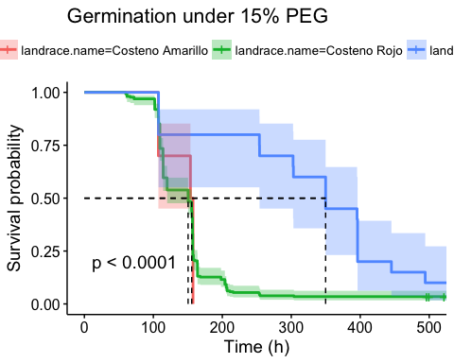

survdiff_lr_wcoast_15 <- pairwise_survdiff(Surv(end, status)~landrace.name, data = df_wcoast_15, p.adjust.method = "bonferroni", rho = 0)  
print(survdiff_lr_wcoast_15)

##   
## Pairwise comparisons using Log-Rank test   
##   
## data: df_wcoast_15 and landrace.name   
##   
## Costeno Amarillo Costeno Rojo  
## Costeno Rojo 1 -   
## Piquin 2.1e-05 5.3e-06   
##   
## P value adjustment method: bonferroni

df_yucatan_15 <- subset(df_yucatan, trt ==15)  
test.landrace.yucatan.15 <- survfit(Surv(end, status) ~ landrace.name, data = df_yucatan, subset = {trt == 15}, type = "kaplan-meier", conf.type = "log-log")  
ggsurvplot(test.landrace.yucatan.15, data =df, conf.int = T, pval = T, xlab = "Time (h)",   
 surv.median.line = "hv", title ="Germination under 15% PEG")

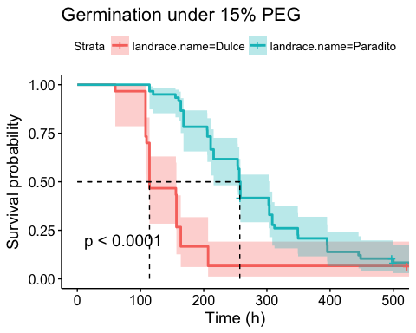

survdiff_lr_yucatan_15 <- pairwise_survdiff(Surv(end, status) ~ landrace.name, data = df_yucatan_15, p.adjust.method = "bonferroni", rho = 0)  
print(survdiff_lr_yucatan_15)

##   
## Pairwise comparisons using Log-Rank test   
##   
## data: df_yucatan_15 and landrace.name   
##   
## Dulce   
## Paradito 5.4e-07  
##   
## P value adjustment method: bonferroni

#test.landrace.sm.15 <- survfit(Surv(end, status) ~ landrace.name, data = df_sm, subset = {trt == 15}, type = "kaplan-meier", conf.type = "log-log")  
#ggsurvplot(test.landrace.sm.15, data =df, conf.int = T, pval = T, risk.table = T, risk.table.col = "strata", xlab = "Time (h)",   
# surv.median.line = "hv", title = "Germination under Water Control")