3_nonparametric_20170917.R

vivianbernau

Sun Sep 17 17:26:51 2017

#GERMINATION DATA  
#VIVIAN BERNAU  
#6 Sept 2017  
#Based on McNair et al 2012; Seed Science Research  
  
#Using SURVMINER  
  
#NONPARAMETRIC ANALYSIS  
#1) Characterizing pattern of germination within groups --> Kaplan-Meier test: survfit()  
#2) Comparing patterns of germination in groups --> Fleming-Harrington test(?): survdiff()  
  
#My data is right-sensored.  
#My data is interval, but can probably be analyzed nonparametrically as exact for as long as plates with large losses are removed.  
  
#Survivor function: probability that the germination time is greater than t  
  
#Set working directory and repositories  
wd <- ("~/Google Drive/RFiles/Chiles_OSU/3_Germination/")  
  
src.dir <- paste(wd,"scripts", sep = "")  
data.dir <- paste (wd,"data", sep = "")  
out.dir <- paste(wd, "output", sep ="")  
  
setwd(out.dir)  
  
#read in germination data in pre-lifetab format  
#df10 <- read.csv(paste(out.dir, "/cleaned10_2017-09-07.csv", sep = ""), header = T)  
df <- read.csv(paste(out.dir, "/cleaned_2017-09-17.csv", sep = ""), header = T)  
str(df)

## 'data.frame': 7988 obs. of 24 variables:  
## $ X.2 : int 1 3 8 17 31 36 42 58 59 65 ...  
## $ X.1 : int 1 3 8 17 31 36 42 58 59 65 ...  
## $ sampleid : Factor w/ 73 levels "CanAbasolo1",..: 1 1 1 1 1 1 1 1 1 1 ...  
## $ line : Factor w/ 109 levels "100-1","100-2",..: 86 86 86 86 86 86 86 86 86 86 ...  
## $ X : num 915 913 3081 914 917 ...  
## $ rep : int 1 1 2 1 1 2 2 1 2 2 ...  
## $ run : int 1 1 3 1 1 3 3 1 3 3 ...  
## $ shelf : int 7 7 5 7 7 5 5 7 5 5 ...  
## $ plate : int 237 237 170 237 237 170 170 237 170 170 ...  
## $ trt : int 10 10 10 10 10 10 10 10 10 10 ...  
## $ end : num 246 102 158 151 542 ...  
## $ status : int 1 1 1 1 0 1 1 0 0 1 ...  
## $ viable : int 1 1 1 1 1 1 1 0 0 1 ...  
## $ number : int 1 4 6 1 2 2 2 1 1 6 ...  
## $ pedigree : Factor w/ 108 levels "14CAg128-1","14CAg128-2",..: 35 35 35 35 35 35 35 35 35 35 ...  
## $ planting.date : Factor w/ 1 level "11/10/14": 1 1 1 1 1 1 1 1 1 1 ...  
## $ landrace.abb : Factor w/ 22 levels "CAg","Cam","CdA",..: 1 1 1 1 1 1 1 1 1 1 ...  
## $ region : Factor w/ 5 levels "central valleys",..: 1 1 1 1 1 1 1 1 1 1 ...  
## $ pop : Factor w/ 37 levels "","CAg_24","CAg_25",..: 10 10 10 10 10 10 10 10 10 10 ...  
## $ population.type: Factor w/ 3 levels "landrace","letstand",..: 1 1 1 1 1 1 1 1 1 1 ...  
## $ landrace.name : Factor w/ 18 levels "Chigole","Chile Bolita",..: 3 3 3 3 3 3 3 3 3 3 ...  
## $ cultivation : Factor w/ 4 levels "Backyard","Forest",..: 3 3 3 3 3 3 3 3 3 3 ...  
## $ main.use : Factor w/ 4 levels "","Dry","Fresh",..: NA NA NA NA NA NA NA NA NA NA ...  
## $ uniqueplate : Factor w/ 802 levels "1_1","1_100",..: 58 58 323 58 58 323 323 58 323 323 ...

df$end <- round(df$end, digits = 1)  
df$run <- as.factor(df$run)  
  
df <- subset(df, region!="control")  
df$cv <- as.numeric(df$region == "central valleys")  
df$ecoast <- as.numeric(df$region == "ecoast")  
df$wcoast <- as.numeric(df$region == "wcoast")  
df$yucatan <- as.numeric(df$region == "yucatan")  
df$sm <- as.numeric(df$region == "sierra madre")  
  
library(survival)  
library(survminer)

## Loading required package: ggplot2

## Loading required package: ggpubr

## Loading required package: magrittr

#fit and plot Kaplan-Meier survivor function, includes 95% confidence intervals  
km.fit <-survfit(Surv(df$end, df$status) ~ 1, data = df, type = "kaplan-meier")  
ggsurvplot(km.fit, conf.int = T)

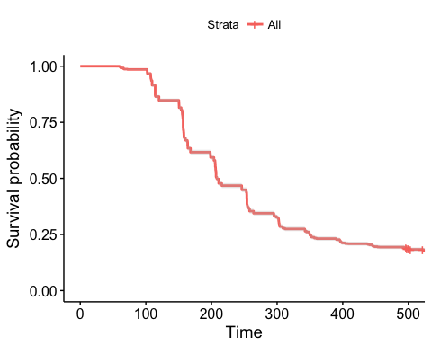

test.region <- survfit(Surv(end, status) ~ region, data = df, subset = {trt == 20}, type = "kaplan-meier", conf.type = "log-log")  
ggsurvplot(test.region, data =df, conf.int = T, pval = T, palette = "Dark2", risk.table = T, risk.table.col = "strata", xlab = "Time (h)",   
 surv.median.line = "hv", title = "Germination under Water Control")

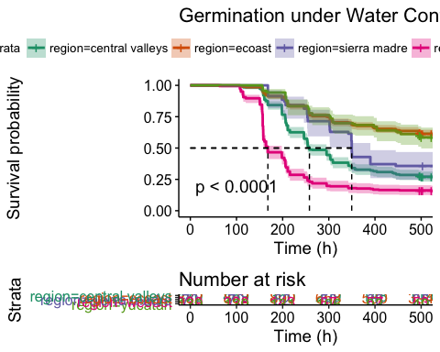

#Creating composite figures of with one frame for each [PEG]  
# List of ggsurvplots  
test.20<- survfit(Surv(end, status) ~ region, data = df, type = "kaplan-meier", subset = (trt == 20))  
test.15 <- survfit(Surv(end, status) ~ region, data = df, type = "kaplan-meier", subset = (trt ==15))  
test.10 <- survfit(Surv(end, status) ~ region, data = df, type = "kaplan-meier", subset = (trt ==10))  
test.0 <- survfit(Surv(end, status) ~ region, data = df, type = "kaplan-meier", subset = (trt ==0))  
  
pegplots <- list()  
pegplots[[1]] <- ggsurvplot(test.20, data = df, pval = T, conf.int = T, palette = "Dark2", legend = "none", xlab = "Time (h)", title = "20% [PEG]", ggtheme = theme_grey())  
pegplots[[2]] <- ggsurvplot(test.15, data = df, pval = T, conf.int = T, palette = "Dark2", legend = "none", xlab = "Time (h)", title = "15% [PEG]", ggtheme = theme_grey())  
pegplots[[3]] <- ggsurvplot(test.10, data = df, pval = T, conf.int = T, palette = "Dark2", legend = "none", xlab = "Time (h)", title = "10% [PEG]", ggtheme = theme_grey())  
pegplots[[4]] <- ggsurvplot(test.0, data = df, pval = T, conf.int = T, palette = "Dark2", legend = "none", xlab = "Time (h)", title = "0% [PEG]" , ggtheme = theme_grey())  
  
# Arrange multiple ggsurvplots and print the output  
arrange_ggsurvplots(pegplots, title = "Germination under different [PEG]",  
 ncol = 2, nrow = 2)

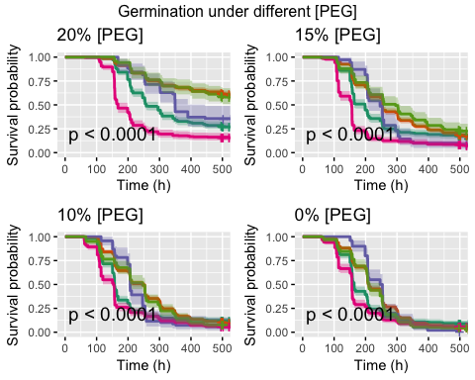

res <- arrange_ggsurvplots(pegplots, print = FALSE)  
ggsave("allconcentrations_20170917.png", res)

## Saving 5 x 4 in image

#Creating composite figure of Kaplan-Meier survivor estimates with 1 frame for each region  
test.cv <- survfit(Surv(end, status) ~ trt, data = df, type = "kaplan-meier", subset = (region =="central valleys"))  
test.ecoast <- survfit(Surv(end, status) ~ trt, data = df, type = "kaplan-meier", subset = (region =="ecoast"))  
test.sm <- survfit(Surv(end, status) ~ trt, data = df, type = "kaplan-meier", subset = (region =="sierra madre"))  
test.wcoast <- survfit(Surv(end, status) ~ trt, data = df, type = "kaplan-meier", subset = (region =="wcoast"))  
test.yucatan <- survfit(Surv(end, status) ~ trt, data = df, type = "kaplan-meier", subset = (region =="yucatan"))  
  
library(RColorBrewer)  
regplots <- list()  
regplots[[1]] <- ggsurvplot(test.cv, data = df, pval = T, title = "Central Valleys", conf.int = T, legend = "none", xlab = "Time (h)", palette = rev(brewer.pal(4,"Spectral")), ggtheme = theme_grey())  
regplots[[2]] <- ggsurvplot(test.ecoast, data = df, pval = T, title = "E Coast", conf.int = T, legend = "none", xlab = "Time (h)", palette = rev(brewer.pal(4,"Spectral")), ggtheme = theme_grey())  
regplots[[3]] <- ggsurvplot(test.sm, data = df, pval = T, title = "Sierra Madre de la Sur", conf.int = T, legend = "none", xlab = "Time (h)", palette = rev(brewer.pal(4,"Spectral")), ggtheme = theme_grey())  
regplots[[4]] <- ggsurvplot(test.wcoast, data = df, pval = T, title = "W Coast", conf.int = T, legend = "none", xlab = "Time (h)", palette = rev(brewer.pal(4,"Spectral")), ggtheme = theme_grey())  
regplots[[5]] <- ggsurvplot(test.yucatan, data = df, pval = T, title = "Yucatan", conf.int = T, legend = "right", xlab = "Time (h)", palette = rev(brewer.pal(4,"Spectral")), ggtheme = theme_grey())  
  
# Arrange multiple ggsurvplots and print the output  
arrange_ggsurvplots(regplots, print = TRUE, title = "PEG response in different regions",  
 ncol = 2, nrow = 3)

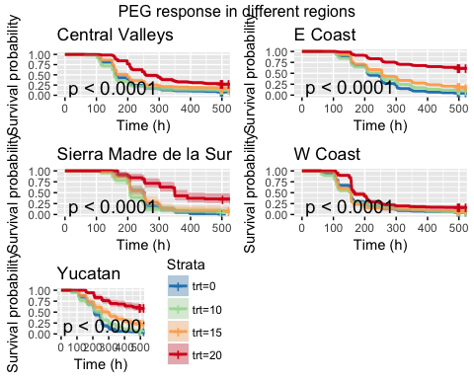

res <- arrange_ggsurvplots(regplots, print = FALSE)  
ggsave("allconcentrations_20170917.png", res)

## Saving 5 x 4 in image

#COMPARISON OF SURVIVOR FUNCTIONS  
library(RColorBrewer)  
ggsurvplot(test.cv, data = df, pval = T, title = "Central Valleys", conf.int = T, legend = "bottom", xlab = "Time (h)", palette = rev(brewer.pal(4,"Spectral")), ggtheme = theme_grey())

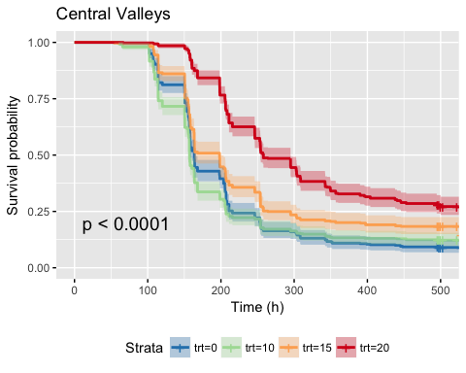

df_cv <- subset(df, region=="central valleys")  
survdiff_cv <- pairwise_survdiff(Surv(end, status)~trt, data = df_cv, p.adjust.method = "bonferroni",rho = 0)  
print(survdiff_cv)

##   
## Pairwise comparisons using Log-Rank test   
##   
## data: df_cv and trt   
##   
## 0 10 15   
## 10 1.000 - -   
## 15 0.003 9.9e-05 -   
## 20 < 2e-16 < 2e-16 1.5e-13  
##   
## P value adjustment method: bonferroni

ggsurvplot(test.ecoast, data = df, pval = T, title = "E Coast", conf.int = T, legend = "bottom", xlab = "Time (h)", palette = rev(brewer.pal(4,"Spectral")), ggtheme = theme_grey())

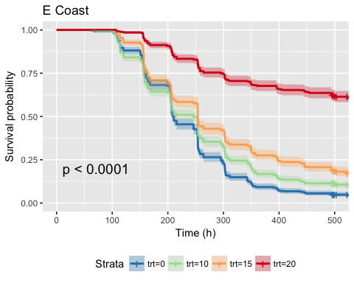

df_ecoast <- subset(df, region=="ecoast")  
survdiff_ecoast <- pairwise_survdiff(Surv(end, status)~trt, data = df_ecoast, p.adjust.method = "bonferroni",rho = 0)  
print(survdiff_ecoast)

##   
## Pairwise comparisons using Log-Rank test   
##   
## data: df_ecoast and trt   
##   
## 0 10 15   
## 10 9.8e-06 - -   
## 15 < 2e-16 7.5e-07 -   
## 20 < 2e-16 < 2e-16 < 2e-16  
##   
## P value adjustment method: bonferroni

ggsurvplot(test.wcoast, data = df, pval = T, title = "W Coast", conf.int = T, legend = "bottom", xlab = "Time (h)", palette = rev(brewer.pal(4,"Spectral")), ggtheme = theme_grey())

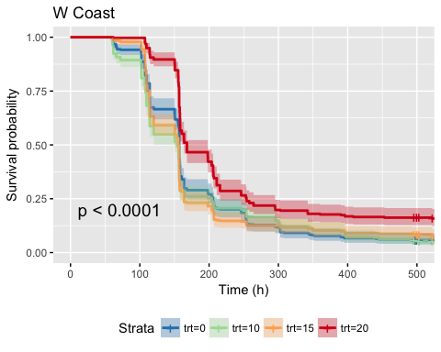

df_wcoast <- subset(df, region == "wcoast")  
survdiff_wcoast <-pairwise_survdiff(Surv(end, status)~trt, data = df_wcoast, p.adjust.method = "bonferroni",rho = 0)  
print(survdiff_wcoast)

##   
## Pairwise comparisons using Log-Rank test   
##   
## data: df_wcoast and trt   
##   
## 0 10 15   
## 10 1 - -   
## 15 1 1 -   
## 20 4.2e-09 3.9e-12 9.9e-13  
##   
## P value adjustment method: bonferroni

ggsurvplot(test.sm, data = df, pval = T, title = "Sierra Madre de la Sur", conf.int = T, legend = "bottom", xlab = "Time (h)", palette = rev(brewer.pal(4,"Spectral")), ggtheme = theme_grey())

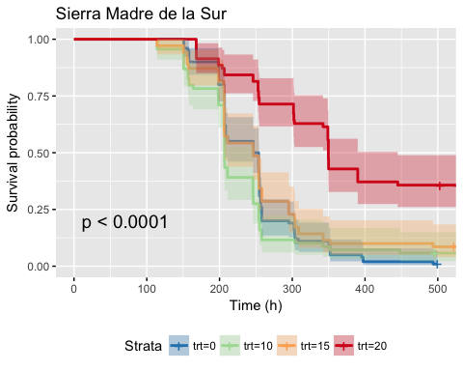

df_sm <- subset(df, region == "sierra madre")  
survdiff_sm <- pairwise_survdiff(Surv(end, status)~trt, data = df_sm, p.adjust.method = "bonferroni",rho = 0)  
print(survdiff_sm)

##   
## Pairwise comparisons using Log-Rank test   
##   
## data: df_sm and trt   
##   
## 0 10 15   
## 10 0.83 - -   
## 15 1.00 0.39 -   
## 20 2.2e-11 2.0e-10 6.3e-07  
##   
## P value adjustment method: bonferroni

ggsurvplot(test.yucatan, data = df, pval = T, title = "Yucatan", conf.int = T, legend = "bottom", xlab = "Time (h)", palette = rev(brewer.pal(4,"Spectral")), ggtheme = theme_grey())

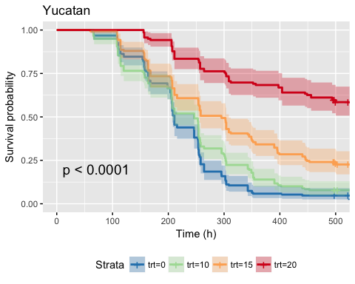

df_yucatan <- subset(df, region=="yucatan")  
survdiff_yucatan <- pairwise_survdiff(Surv(end, status)~trt, data = df_yucatan, p.adjust.method = "bonferroni",rho = 0)  
print(survdiff_yucatan)

##   
## Pairwise comparisons using Log-Rank test   
##   
## data: df_yucatan and trt   
##   
## 0 10 15   
## 10 0.11 - -   
## 15 5.4e-10 7.9e-05 -   
## 20 < 2e-16 < 2e-16 5.1e-11  
##   
## P value adjustment method: bonferroni

ggsurvplot(test.0, data = df, pval = T, title = "0% PEG", conf.int = T, legend = "bottom", xlab = "Time (h)", palette = "Dark2", ggtheme = theme_grey())

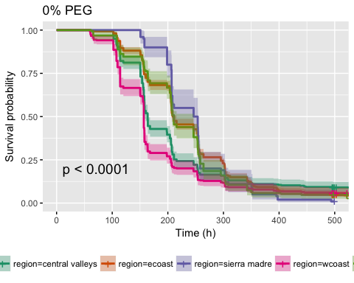

df_0 <- subset(df, trt==0)  
survdiff_0 <- pairwise_survdiff(Surv(end, status)~region, data = df_0, p.adjust.method = "bonferroni",rho = 0)  
print(survdiff_0)

##   
## Pairwise comparisons using Log-Rank test   
##   
## data: df_0 and region   
##   
## central valleys ecoast sierra madre wcoast   
## ecoast 0.00056 - - -   
## sierra madre 0.01059 1.00000 - -   
## wcoast 0.00146 6.4e-16 2.1e-06 -   
## yucatan 0.16420 1.00000 1.00000 9.5e-06  
##   
## P value adjustment method: bonferroni

ggsurvplot(test.10, data = df, pval = T, title = "10% PEG", conf.int = T, legend = "bottom", xlab = "Time (h)", palette = "Dark2", ggtheme = theme_grey())

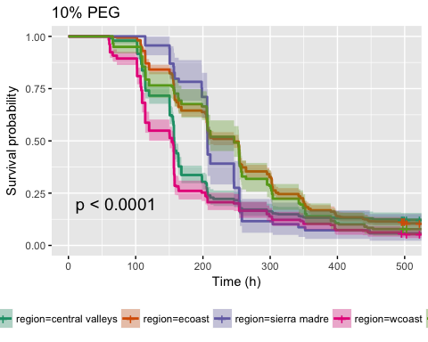

df_10 <- subset(df, trt==10)  
survdiff_10 <- pairwise_survdiff(Surv(end, status)~region, data = df_10, p.adjust.method = "bonferroni",rho = 0)  
print(survdiff_10)

##   
## Pairwise comparisons using Log-Rank test   
##   
## data: df_10 and region   
##   
## central valleys ecoast sierra madre wcoast  
## ecoast 2e-10 - - -   
## sierra madre 0.13582 0.27777 - -   
## wcoast 0.00039 < 2e-16 0.00322 -   
## yucatan 0.00354 1.00000 0.89279 3e-07   
##   
## P value adjustment method: bonferroni

ggsurvplot(test.15, data = df, pval = T, title = "15% PEG", conf.int = T, legend = "bottom", xlab = "Time (h)", palette = "Dark2", ggtheme = theme_grey())

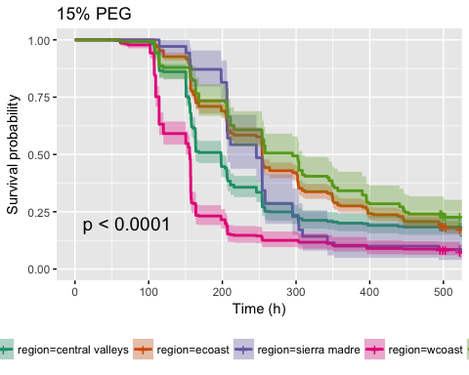

df_15 <- subset(df, trt==15)  
survdiff_15 <- pairwise_survdiff(Surv(end, status)~region, data = df_15, p.adjust.method = "bonferroni",rho = 0)  
print(survdiff_15)

##   
## Pairwise comparisons using Log-Rank test   
##   
## data: df_15 and region   
##   
## central valleys ecoast sierra madre wcoast   
## ecoast 1.2e-05 - - -   
## sierra madre 1.00000 0.31953 - -   
## wcoast 1.2e-14 < 2e-16 1.0e-06 -   
## yucatan 0.00042 1.00000 0.02012 < 2e-16  
##   
## P value adjustment method: bonferroni

ggsurvplot(test.20, data = df, pval = T, title = "20% PEG", conf.int = T, legend = "bottom", xlab = "Time (h)", palette = "Dark2", ggtheme = theme_grey())

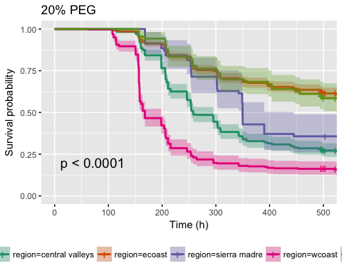

df_20 <- subset(df, trt==20)  
survdiff_20 <- pairwise_survdiff(Surv(end, status)~region, data = df_20, p.adjust.method = "bonferroni",rho = 0)  
print(survdiff_20)

##   
## Pairwise comparisons using Log-Rank test   
##   
## data: df_20 and region   
##   
## central valleys ecoast sierra madre wcoast   
## ecoast < 2e-16 - - -   
## sierra madre 0.1965 0.0003 - -   
## wcoast 5.1e-16 < 2e-16 4.9e-08 -   
## yucatan 5.4e-11 1.0000 0.0088 < 2e-16  
##   
## P value adjustment method: bonferroni

#EXTRACT .25 AND .75 QUANTILES  
data.frame(q = c(.25, .5, .75),  
 km = quantile(survfit(Surv(end,status) ~ 1, data = subset(df_0, cv == 1 ), type = "kaplan-meier")))

## q km.quantile km.lower km.upper  
## 25 0.25 150.7 150.5 153.8  
## 50 0.50 163.7 158.2 164.0  
## 75 0.75 215.7 208.1 253.0

data.frame(q = c(.25, .5, .75),  
 km = quantile(survfit(Surv(end,status) ~ 1, data = subset(df_0, wcoast == 1 ), type = "kaplan-meier")))

## q km.quantile km.lower km.upper  
## 25 0.25 114.2 109.5 114.2  
## 50 0.50 156.8 156.8 156.8  
## 75 0.75 205.7 168.0 211.0

data.frame(q = c(.25, .5, .75),  
 km = quantile(survfit(Surv(end,status) ~ 1, data = subset(df_0, sm == 1 ), type = "kaplan-meier")))

## q km.quantile km.lower km.upper  
## 25 0.25 206.8 198.6 206.8  
## 50 0.50 250.0 208.2 254.1  
## 75 0.75 258.0 254.8 303.3

data.frame(q = c(.25, .5, .75),  
 km = quantile(survfit(Surv(end,status) ~ 1, data = subset(df_0, ecoast == 1 ), type = "kaplan-meier")))

## q km.quantile km.lower km.upper  
## 25 0.25 157.1 156.8 163.2  
## 50 0.50 211.0 207.0 215.7  
## 75 0.75 295.4 264.1 301.7

data.frame(q = c(.25, .5, .75),  
 km = quantile(survfit(Surv(end,status) ~ 1, data = subset(df_0, yucatan == 1 ), type = "kaplan-meier")))

## q km.quantile km.lower km.upper  
## 25 0.25 164 156.8 198.5  
## 50 0.50 211 207.0 246.1  
## 75 0.75 258 254.5 264.1

data.frame(q = c(.25, .5, .75),  
 km = quantile(survfit(Surv(end,status) ~ 1, data = subset(df_10, cv == 1 ), type = "kaplan-meier")))

## q km.quantile km.lower km.upper  
## 25 0.25 114.5 114.2 150.4  
## 50 0.50 157.1 156.8 157.9  
## 75 0.75 207.0 205.7 253.8

data.frame(q = c(.25, .5, .75),  
 km = quantile(survfit(Surv(end,status) ~ 1, data = subset(df_10, wcoast == 1 ), type = "kaplan-meier")))

## q km.quantile km.lower km.upper  
## 25 0.25 108.4 107.3 109.5  
## 50 0.50 153.8 150.3 156.8  
## 75 0.75 203.7 157.9 246.0

data.frame(q = c(.25, .5, .75),  
 km = quantile(survfit(Surv(end,status) ~ 1, data = subset(df_10, sm == 1 ), type = "kaplan-meier")))

## q km.quantile km.lower km.upper  
## 25 0.25 198.5 156.8 206.2  
## 50 0.50 206.8 206.8 246.0  
## 75 0.75 254.0 246.0 258.0

data.frame(q = c(.25, .5, .75),  
 km = quantile(survfit(Surv(end,status) ~ 1, data = subset(df_10, ecoast == 1 ), type = "kaplan-meier")))

## q km.quantile km.lower km.upper  
## 25 0.25 156.8 156.3 158.0  
## 50 0.50 246.0 211.0 253.7  
## 75 0.75 312.0 303.8 348.8

data.frame(q = c(.25, .5, .75),  
 km = quantile(survfit(Surv(end,status) ~ 1, data = subset(df_10, yucatan == 1 ), type = "kaplan-meier")))

## q km.quantile km.lower km.upper  
## 25 0.25 156.8 114.5 168.0  
## 50 0.50 246.3 207.0 254.0  
## 75 0.75 302.8 295.4 348.9

data.frame(q = c(.25, .5, .75),  
 km = quantile(survfit(Surv(end,status) ~ 1, data = subset(df_15, cv == 1 ), type = "kaplan-meier")))

## q km.quantile km.lower km.upper  
## 25 0.25 153.8 150.7 156.2  
## 50 0.50 198.1 163.7 198.6  
## 75 0.75 264.1 254.0 349.6

data.frame(q = c(.25, .5, .75),  
 km = quantile(survfit(Surv(end,status) ~ 1, data = subset(df_15, wcoast == 1 ), type = "kaplan-meier")))

## q km.quantile km.lower km.upper  
## 25 0.25 114.1 109.5 114.2  
## 50 0.50 156.0 150.4 156.8  
## 75 0.75 164.0 158.0 203.7

data.frame(q = c(.25, .5, .75),  
 km = quantile(survfit(Surv(end,status) ~ 1, data = subset(df_15, sm == 1 ), type = "kaplan-meier")))

## q km.quantile km.lower km.upper  
## 25 0.25 206.3 198.3 206.4  
## 50 0.50 246.2 206.4 254.1  
## 75 0.75 295.1 254.1 342.5

data.frame(q = c(.25, .5, .75),  
 km = quantile(survfit(Surv(end,status) ~ 1, data = subset(df_15, ecoast == 1 ), type = "kaplan-meier")))

## q km.quantile km.lower km.upper  
## 25 0.25 163.5 157.8 168.0  
## 50 0.50 254.0 253.8 254.5  
## 75 0.75 397.5 356.6 445.8

data.frame(q = c(.25, .5, .75),  
 km = quantile(survfit(Surv(end,status) ~ 1, data = subset(df_15, yucatan == 1 ), type = "kaplan-meier")))

## q km.quantile km.lower km.upper  
## 25 0.25 168.00 163.5 207.0  
## 50 0.50 295.15 254.0 308.5  
## 75 0.75 448.20 395.2 NA

data.frame(q = c(.25, .5, .75),  
 km = quantile(survfit(Surv(end,status) ~ 1, data = subset(df_20, cv == 1 ), type = "kaplan-meier")))

## q km.quantile km.lower km.upper  
## 25 0.25 205.5 198.4 206.3  
## 50 0.50 258.0 253.8 295.1  
## 75 0.75 542.4 453.0 NA

data.frame(q = c(.25, .5, .75),  
 km = quantile(survfit(Surv(end,status) ~ 1, data = subset(df_20, wcoast == 1 ), type = "kaplan-meier")))

## q km.quantile km.lower km.upper  
## 25 0.25 156.7 155.6 156.8  
## 50 0.50 168.0 163.7 198.3  
## 75 0.75 254.0 215.7 295.4

data.frame(q = c(.25, .5, .75),  
 km = quantile(survfit(Surv(end,status) ~ 1, data = subset(df_20, sm == 1 ), type = "kaplan-meier")))

## q km.quantile km.lower km.upper  
## 25 0.25 253.7 246.1 342.3  
## 50 0.50 349.6 348.9 542.4  
## 75 0.75 NA 542.4 NA

data.frame(q = c(.25, .5, .75),  
 km = quantile(survfit(Surv(end,status) ~ 1, data = subset(df_20, ecoast == 1 ), type = "kaplan-meier")))

## q km.quantile km.lower km.upper  
## 25 0.25 295 258 302.9  
## 50 0.50 NA NA NA  
## 75 0.75 NA NA NA

data.frame(q = c(.25, .5, .75),  
 km = quantile(survfit(Surv(end,status) ~ 1, data = subset(df_20, yucatan == 1 ), type = "kaplan-meier")))

## q km.quantile km.lower km.upper  
## 25 0.25 302.7 257 404  
## 50 0.50 NA NA NA  
## 75 0.75 NA NA NA

#TESTING DIFFERENCES ACROSS CULTIVATION SYSTEMS  
test.cult.0 <- survfit(Surv(end, status) ~ cultivation, data = df, type = "kaplan-meier", subset = (trt ==0), na.action = na.omit)  
ggsurvplot(test.cult.0, data = df, pval = T, title = "0% PEG", conf.int = T, legend = "bottom", xlab = "Time (h)", palette = "Dark2", ggtheme = theme_grey())

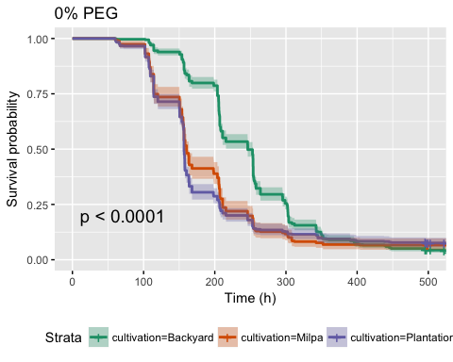

survdiff_cult_0 <- pairwise_survdiff(Surv(end, status)~cultivation, data = df_0, p.adjust.method = "bonferroni",rho = 0)  
print(survdiff_cult_0)

##   
## Pairwise comparisons using Log-Rank test   
##   
## data: df_0 and cultivation   
##   
## Backyard Milpa  
## Milpa <2e-16 -   
## Plantation <2e-16 0.93   
##   
## P value adjustment method: bonferroni

test.cult.20 <- survfit(Surv(end, status) ~ cultivation, data = df, type = "kaplan-meier", subset = (trt ==20))  
ggsurvplot(test.cult.20, data = df, pval = T, title = "20% PEG", conf.int = T, legend = "bottom", xlab = "Time (h)", palette = "Dark2", ggtheme = theme_grey())

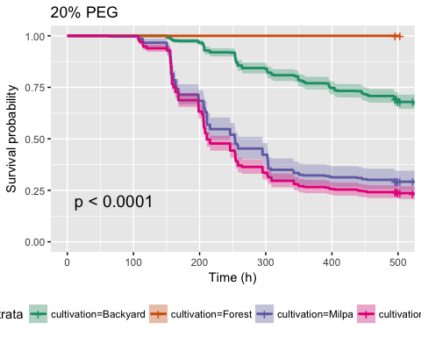

survdiff_cult_20 <- pairwise_survdiff(Surv(end, status)~cultivation, data = df_20, p.adjust.method = "bonferroni",rho = 0)  
print(survdiff_cult_20)

##   
## Pairwise comparisons using Log-Rank test   
##   
## data: df_20 and cultivation   
##   
## Backyard Forest Milpa  
## Forest 0.036 - -   
## Milpa < 2e-16 3.8e-06 -   
## Plantation < 2e-16 4.7e-07 0.229  
##   
## P value adjustment method: bonferroni

#TESTING DIFFERENCES ACROSS DOMESTICATION LEVEL  
test.domestication.0 <- survfit(Surv(end, status) ~ population.type, data = df, type = "kaplan-meier", subset = (trt ==0))  
ggsurvplot(test.domestication.0, data = df, pval = T, title = "0% PEG", conf.int = T, legend = "bottom", xlab = "Time (h)", palette = "Dark2", ggtheme = theme_grey())

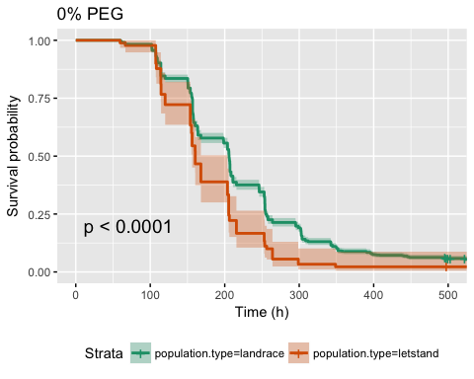

survdiff_domestication_0 <- pairwise_survdiff(Surv(end, status)~population.type, data = df_0, p.adjust.method = "bonferroni",rho = 0)  
print(survdiff_domestication_0)

##   
## Pairwise comparisons using Log-Rank test   
##   
## data: df_0 and population.type   
##   
## landrace  
## letstand 1.8e-06   
##   
## P value adjustment method: bonferroni

test.domestication.15 <- survfit(Surv(end, status) ~ population.type, data = df, type = "kaplan-meier", subset = (trt ==15))  
ggsurvplot(test.domestication.15, data = df, pval = T, title = "15% PEG", conf.int = T, legend = "bottom", xlab = "Time (h)", palette = "Dark2", ggtheme = theme_grey())

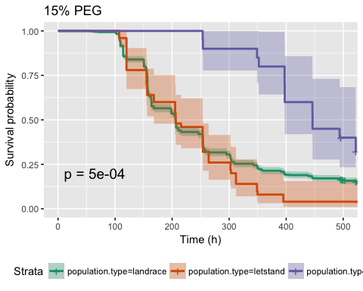

survdiff_domestication_15 <- pairwise_survdiff(Surv(end, status)~population.type, data = df_15, p.adjust.method = "bonferroni",rho = 0)  
print(survdiff_domestication_15)

##   
## Pairwise comparisons using Log-Rank test   
##   
## data: df_15 and population.type   
##   
## landrace letstand  
## letstand 0.3395 -   
## wild 0.0014 1.3e-07   
##   
## P value adjustment method: bonferroni

test.domestication.20 <- survfit(Surv(end, status) ~ population.type, data = df, type = "kaplan-meier", subset = (trt ==20))  
ggsurvplot(test.domestication.20, data = df, pval = T, title = "20% PEG", conf.int = T, legend = "bottom", xlab = "Time (h)", palette = "Dark2", ggtheme = theme_grey())

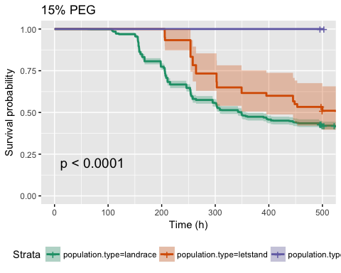

survdiff_domestication_20 <- pairwise_survdiff(Surv(end, status)~population.type, data = df_20, p.adjust.method = "bonferroni",rho = 0)  
print(survdiff_domestication_20)

##   
## Pairwise comparisons using Log-Rank test   
##   
## data: df_20 and population.type   
##   
## landrace letstand  
## letstand 0.11495 -   
## wild 9.9e-05 0.00097   
##   
## P value adjustment method: bonferroni

#TESTING DIFFERENT LANDRACES  
df_0 <- subset(df, trt==0)  
summary(df$landrace.name)

## Chigole Chile Bolita Chile de Agua Chile de Monte   
## 307 945 1149 50   
## Costeno Amarillo Costeno Rojo Dulce Frutescens   
## 129 1741 128 100   
## Guajillo Guina Dahni Mareno Mirasol   
## 150 289 119 160   
## Paradito Payaso Piquin Solterito   
## 537 160 200 139   
## Taviche Tusta NA's   
## 240 1225 90

test.lr.0 <- survfit(Surv(end, status) ~ landrace.name, data = df, type = "kaplan-meier", subset = (trt ==0))  
ggsurvplot(test.lr.0, data = df, pval = T, title = "0% PEG", conf.int = T, legend = "bottom", xlab = "Time (h)", ggtheme = theme_grey())

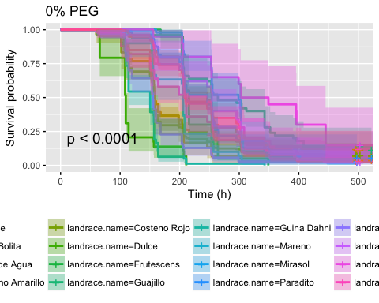

survdiff_lr_0 <- pairwise_survdiff(Surv(end, status)~landrace.name, data = df_0, p.adjust.method = "bonferroni",rho = 0)  
print(survdiff_lr_0)

##   
## Pairwise comparisons using Log-Rank test   
##   
## data: df_0 and landrace.name   
##   
## Chigole Chile Bolita Chile de Agua Costeno Amarillo  
## Chile Bolita 1.00000 - - -   
## Chile de Agua 1.00000 0.03173 - -   
## Costeno Amarillo 0.54109 0.00735 1.00000 -   
## Costeno Rojo 0.00430 6.3e-11 1.00000 1.00000   
## Dulce 8.5e-13 < 2e-16 5.2e-08 0.11348   
## Frutescens 1.00000 1.00000 1.00000 1.00000   
## Guajillo 0.71743 0.37632 0.03489 0.00071   
## Guina Dahni < 2e-16 < 2e-16 1.2e-08 1.00000   
## Mareno 1.00000 0.25613 1.00000 1.00000   
## Mirasol 1.00000 1.00000 0.12500 0.00155   
## Paradito 1.00000 1.00000 0.08116 0.00315   
## Payaso 1.4e-06 1.1e-14 0.85943 1.00000   
## Piquin 1.00000 1.00000 1.00000 0.36762   
## Solterito 0.87837 0.18654 0.45486 0.02669   
## Taviche 1.00000 1.00000 1.00000 1.00000   
## Tusta 1.00000 1.00000 0.71001 0.06180   
## Costeno Rojo Dulce Frutescens Guajillo Guina Dahni  
## Chile Bolita - - - - -   
## Chile de Agua - - - - -   
## Costeno Amarillo - - - - -   
## Costeno Rojo - - - - -   
## Dulce 2.0e-05 - - - -   
## Frutescens 1.00000 1.2e-06 - - -   
## Guajillo 3.8e-05 4.2e-14 0.47504 - -   
## Guina Dahni 8.0e-05 1.00000 1.4e-08 < 2e-16 -   
## Mareno 1.00000 0.00121 1.00000 0.00828 0.00037   
## Mirasol 9.6e-05 < 2e-16 0.01810 1.00000 < 2e-16   
## Paradito 1.3e-07 < 2e-16 1.00000 0.25986 < 2e-16   
## Payaso 1.00000 0.06426 0.03726 1.6e-09 0.48087   
## Piquin 0.02714 2.6e-12 1.00000 1.00000 1.7e-14   
## Solterito 0.01169 3.0e-08 0.01687 1.00000 1.5e-10   
## Taviche 0.85344 3.3e-06 1.00000 1.00000 4.5e-07   
## Tusta 3.3e-09 < 2e-16 1.00000 0.00513 < 2e-16   
## Mareno Mirasol Paradito Payaso Piquin Solterito  
## Chile Bolita - - - - - -   
## Chile de Agua - - - - - -   
## Costeno Amarillo - - - - - -   
## Costeno Rojo - - - - - -   
## Dulce - - - - - -   
## Frutescens - - - - - -   
## Guajillo - - - - - -   
## Guina Dahni - - - - - -   
## Mareno - - - - - -   
## Mirasol 0.01616 - - - - -   
## Paradito 0.74415 1.00000 - - - -   
## Payaso 1.00000 3.2e-10 3.4e-12 - - -   
## Piquin 1.00000 1.00000 1.00000 1.3e-05 - -   
## Solterito 0.02614 1.00000 0.17670 2.1e-05 1.00000 -   
## Taviche 1.00000 1.00000 1.00000 0.03212 1.00000 1.00000   
## Tusta 1.00000 0.16763 1.00000 6.7e-13 1.00000 0.01749   
## Taviche  
## Chile Bolita -   
## Chile de Agua -   
## Costeno Amarillo -   
## Costeno Rojo -   
## Dulce -   
## Frutescens -   
## Guajillo -   
## Guina Dahni -   
## Mareno -   
## Mirasol -   
## Paradito -   
## Payaso -   
## Piquin -   
## Solterito -   
## Taviche -   
## Tusta 1.00000  
##   
## P value adjustment method: bonferroni

df_ecoast <- subset(df, region =="ecoast")  
df_ecoast_0 <- subset(df_ecoast, trt == 0)  
test.landrace.ecoast <- survfit(Surv(end, status) ~ landrace.name, data = df_ecoast, subset = {trt == 0}, type = "kaplan-meier", conf.type = "log-log")  
ggsurvplot(test.landrace.ecoast, data =df, conf.int = T, pval = T, xlab = "Time (h)", ggtheme = theme_grey(),  
 surv.median.line = "hv", title = "Germination under Water Control")

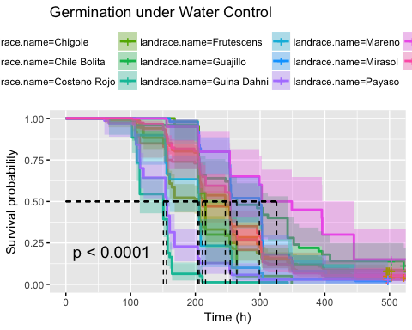

survdiff_lr_ecoast_0 <- pairwise_survdiff(Surv(end, status)~landrace.name, data = df_ecoast_0,p.adjust.method = "bonferroni", rho = 0)  
print(survdiff_lr_ecoast_0)

##   
## Pairwise comparisons using Log-Rank test   
##   
## data: df_ecoast_0 and landrace.name   
##   
## Chigole Chile Bolita Costeno Rojo Frutescens Guajillo  
## Chile Bolita 1.00000 - - - -   
## Costeno Rojo 1.00000 1.00000 - - -   
## Frutescens 1.00000 1.00000 1.00000 - -   
## Guajillo 0.29014 0.15219 0.07691 0.19211 -   
## Guina Dahni < 2e-16 < 2e-16 7.1e-15 5.6e-09 < 2e-16   
## Mareno 1.00000 0.10358 1.00000 1.00000 0.00335   
## Mirasol 1.00000 1.00000 0.25419 0.00732 1.00000   
## Payaso 5.5e-07 4.4e-15 0.00013 0.01507 6.3e-10   
## Solterito 0.35522 0.07544 0.14573 0.00682 1.00000   
## Tusta 1.00000 1.00000 1.00000 1.00000 0.49526   
## Guina Dahni Mareno Mirasol Payaso Solterito  
## Chile Bolita - - - - -   
## Costeno Rojo - - - - -   
## Frutescens - - - - -   
## Guajillo - - - - -   
## Guina Dahni - - - - -   
## Mareno 0.00015 - - - -   
## Mirasol < 2e-16 0.00653 - - -   
## Payaso 0.19447 0.41656 1.3e-10 - -   
## Solterito 6.0e-11 0.01057 0.87455 8.7e-06 -   
## Tusta < 2e-16 0.05707 1.00000 7.9e-14 0.16184   
##   
## P value adjustment method: bonferroni

df_cv <- subset(df, region =="central valleys")  
df_cv_0 <- subset(df_cv, trt == 0)  
test.landrace.cv <- survfit(Surv(end, status) ~ landrace.name, data = df_cv, subset = {trt == 0}, type = "kaplan-meier", conf.type = "log-log")  
ggsurvplot(test.landrace.cv, conf.int = T, pval = T, risk.table = T, risk.table.col = "strata", xlab = "Time (h)",   
 surv.median.line = "hv", title = "Germination under Water Control", ggtheme = theme_grey())

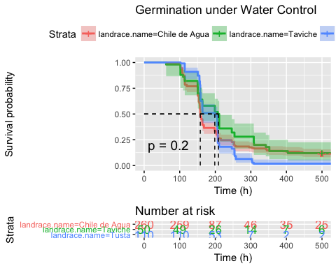

survdiff_lr_cv_0 <- pairwise_survdiff(Surv(end, status) ~ landrace.name, data = df_cv_0, p.adjust.method = "bonferroni",rho = 0)  
print(survdiff_lr_cv_0)

##   
## Pairwise comparisons using Log-Rank test   
##   
## data: df_cv_0 and landrace.name   
##   
## Chile de Agua Taviche  
## Taviche 0.570 -   
## Tusta 1.000 0.011   
##   
## P value adjustment method: bonferroni

df_wcoast <- subset(df, region =="wcoast")  
df_wcoast_0 <- subset(df_wcoast, trt ==0)  
test.landrace.wcoast <- survfit(Surv(end, status) ~ landrace.name, data = df_wcoast, subset = {trt == 0}, type = "kaplan-meier", conf.type = "log-log")  
ggsurvplot(test.landrace.wcoast, data =df, conf.int = T, pval = T, xlab = "Time (h)",   
 surv.median.line = "hv", title = "Germination under Water Control", ggtheme = theme_grey())

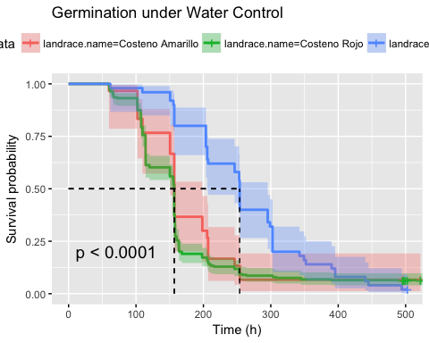

survdiff_lr_wcoast_0 <- pairwise_survdiff(Surv(end, status) ~ landrace.name, data = df_wcoast_0, p.adjust.method = "bonferroni",rho = 0)  
print(survdiff_lr_wcoast_0)

##   
## Pairwise comparisons using Log-Rank test   
##   
## data: df_wcoast_0 and landrace.name   
##   
## Costeno Amarillo Costeno Rojo  
## Costeno Rojo 1.0000 -   
## Piquin 0.0081 5e-06   
##   
## P value adjustment method: bonferroni

df_yucatan <- subset(df, region =="yucatan")  
df_yucatan_0 <- subset(df_yucatan, trt ==0)  
test.landrace.yucatan <- survfit(Surv(end, status) ~ landrace.name, data = df_yucatan, subset = {trt == 0}, type = "kaplan-meier", conf.type = "log-log")  
ggsurvplot(test.landrace.yucatan, data =df, conf.int = T, pval = T, xlab = "Time (h)",   
 surv.median.line = "hv", title = "Germination under Water Control", ggtheme = theme_grey())

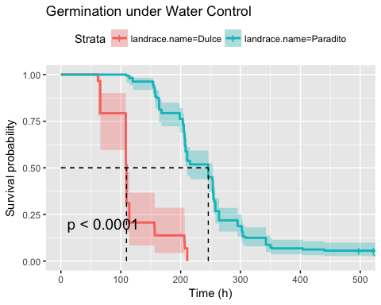

survdiff_lr_yucatan_0 <- pairwise_survdiff(Surv(end, status) ~ landrace.name, data = df_yucatan_0, p.adjust.method = "bonferroni",rho = 0)  
print(survdiff_lr_yucatan_0)

##   
## Pairwise comparisons using Log-Rank test   
##   
## data: df_yucatan_0 and landrace.name   
##   
## Dulce   
## Paradito <2e-16  
##   
## P value adjustment method: bonferroni

df_sm <- subset(df, region =="sierra madre")  
df_sm_0 <- subset(df_sm, trt == "trt")  
test.landrace.sm <- survfit(Surv(end, status) ~ landrace.name, data = df_sm, subset = {trt == 0}, type = "kaplan-meier", conf.type = "log-log")  
ggsurvplot(test.landrace.sm, data =df, conf.int = T, pval = T, xlab = "Time (h)",   
 surv.median.line = "hv", title = "Germination under Water Control", ggtheme = theme_grey())

## Warning in .pvalue(fit, data = data, method = method, pval = pval, pval.coord = pval.coord, : There are no survival curves to be compared.   
## This is a null model.

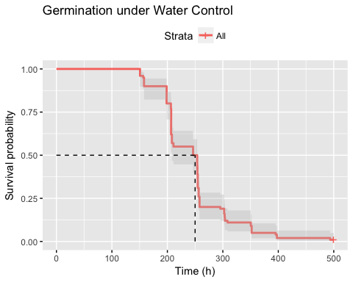

survdiff_lr_sm_0 <- pairwise_survdiff(Surv(end, status) ~ landrace.name, data = df_sm_0, p.adjust.method = "bonferroni",rho = 0)  
print(survdiff_lr_sm_0)

##   
## Pairwise comparisons using Log-Rank test   
##   
## data: df_sm_0 and landrace.name   
##   
## <0 x 0 matrix>  
##   
## P value adjustment method: bonferroni

df_20 <- subset(df, trt==20)  
test.lr.20 <- survfit(Surv(end, status) ~ landrace.name, data = df, type = "kaplan-meier", subset = (trt ==20))  
ggsurvplot(test.lr.20, data = df, pval = T, title = "20% PEG", conf.int = T, legend = "bottom", xlab = "Time (h)", ggtheme = theme_grey())

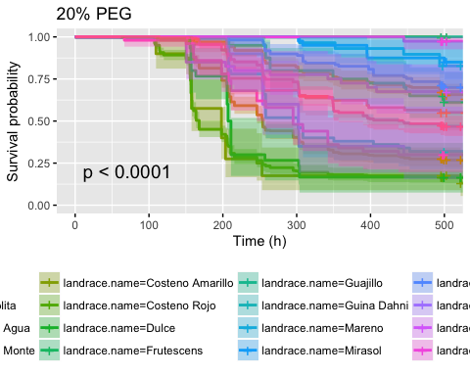

survdiff_lr_20 <- pairwise_survdiff(Surv(end, status)~landrace.name, data = df_20, p.adjust.method = "bonferroni",rho = 0)  
print(survdiff_lr_20)

##   
## Pairwise comparisons using Log-Rank test   
##   
## data: df_20 and landrace.name   
##   
## Chigole Chile Bolita Chile de Agua Chile de Monte  
## Chile Bolita 1.00000 - - -   
## Chile de Agua 0.00336 < 2e-16 - -   
## Chile de Monte 0.08096 0.65894 4.8e-05 -   
## Costeno Amarillo 1.4e-07 < 2e-16 0.00310 2.4e-06   
## Costeno Rojo 2.7e-10 < 2e-16 9.5e-12 2.6e-07   
## Dulce 0.00110 3.7e-15 1.00000 3.2e-06   
## Frutescens 1.00000 1.00000 0.00164 0.39205   
## Guajillo 0.00240 0.04398 5.1e-08 1.00000   
## Guina Dahni 1.00000 0.00014 1.00000 0.00031   
## Mareno 0.76004 1.00000 1.9e-05 1.00000   
## Mirasol 0.08682 1.00000 3.9e-08 1.00000   
## Paradito 0.85420 1.00000 6.1e-15 1.00000   
## Payaso 1.00000 0.06233 1.00000 0.00046   
## Piquin 1.00000 1.00000 0.00205 0.79503   
## Solterito 0.00059 0.02150 4.2e-10 1.00000   
## Taviche 0.67264 1.7e-07 1.00000 0.00021   
## Tusta 1.00000 0.00136 1.1e-08 0.01521   
## Costeno Amarillo Costeno Rojo Dulce Frutescens Guajillo  
## Chile Bolita - - - - -   
## Chile de Agua - - - - -   
## Chile de Monte - - - - -   
## Costeno Amarillo - - - - -   
## Costeno Rojo 1.00000 - - - -   
## Dulce 1.00000 1.00000 - - -   
## Frutescens 8.3e-07 5.3e-08 0.00011 - -   
## Guajillo 5.8e-10 1.7e-11 2.6e-09 0.01021 -   
## Guina Dahni 0.00049 0.00025 0.15339 0.43486 1.3e-06   
## Mareno 9.8e-08 6.8e-09 5.1e-07 1.00000 1.00000   
## Mirasol 9.5e-11 7.1e-13 9.4e-10 0.84623 1.00000   
## Paradito < 2e-16 < 2e-16 4.7e-15 1.00000 0.18601   
## Payaso 0.12972 0.32440 1.00000 1.00000 2.7e-06   
## Piquin 7.3e-05 2.9e-07 0.00191 1.00000 0.09867   
## Solterito 3.0e-12 1.4e-14 1.4e-11 0.00683 1.00000   
## Taviche 0.10838 0.02795 1.00000 0.10153 2.5e-07   
## Tusta 4.6e-14 < 2e-16 9.4e-07 1.00000 0.00015   
## Guina Dahni Mareno Mirasol Paradito Payaso Piquin   
## Chile Bolita - - - - - -   
## Chile de Agua - - - - - -   
## Chile de Monte - - - - - -   
## Costeno Amarillo - - - - - -   
## Costeno Rojo - - - - - -   
## Dulce - - - - - -   
## Frutescens - - - - - -   
## Guajillo - - - - - -   
## Guina Dahni - - - - - -   
## Mareno 0.00079 - - - - -   
## Mirasol 1.4e-05 1.00000 - - - -   
## Paradito 3.7e-06 1.00000 1.00000 - - -   
## Payaso 1.00000 0.00175 8.2e-05 0.00034 - -   
## Piquin 0.41700 1.00000 1.00000 1.00000 1.00000 -   
## Solterito 4.2e-08 1.00000 1.00000 0.13231 1.5e-07 0.06686  
## Taviche 1.00000 0.00014 7.6e-07 3.4e-08 1.00000 0.05241  
## Tusta 1.00000 0.04296 0.00138 0.00059 1.00000 1.00000  
## Solterito Taviche  
## Chile Bolita - -   
## Chile de Agua - -   
## Chile de Monte - -   
## Costeno Amarillo - -   
## Costeno Rojo - -   
## Dulce - -   
## Frutescens - -   
## Guajillo - -   
## Guina Dahni - -   
## Mareno - -   
## Mirasol - -   
## Paradito - -   
## Payaso - -   
## Piquin - -   
## Solterito - -   
## Taviche 5.3e-09 -   
## Tusta 1.4e-05 0.21887  
##   
## P value adjustment method: bonferroni

df_ecoast_20 <- subset(df_ecoast, trt == 20)  
test.landrace.ecoast.20 <- survfit(Surv(end, status) ~ landrace.name, data = df_ecoast, subset = {trt == 20}, type = "kaplan-meier", conf.type = "log-log")  
ggsurvplot(test.landrace.ecoast.20, data =df, conf.int = T, pval = T, xlab = "Time (h)", ggtheme = theme_grey(),  
 surv.median.line = "hv", title = "Germination under 20% PEG")

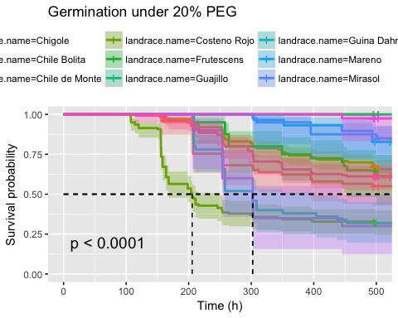

survdiff_lr_ecoast_20 <- pairwise_survdiff(Surv(end, status)~landrace.name, data = df_ecoast_20, p.adjust.method = "bonferroni",rho = 0)  
print(survdiff_lr_ecoast_20)

##   
## Pairwise comparisons using Log-Rank test   
##   
## data: df_ecoast_20 and landrace.name   
##   
## Chigole Chile Bolita Chile de Monte Costeno Rojo Frutescens  
## Chile Bolita 1.00000 - - - -   
## Chile de Monte 0.03492 0.28425 - - -   
## Costeno Rojo 0.00234 3.1e-16 0.00013 - -   
## Frutescens 1.00000 1.00000 0.16912 0.00386 -   
## Guajillo 0.00103 0.01897 1.00000 1.9e-07 0.00440   
## Guina Dahni 1.00000 6.0e-05 0.00014 1.00000 0.18759   
## Mareno 0.32786 1.00000 1.00000 6.0e-05 1.00000   
## Mirasol 0.03745 0.55220 1.00000 2.3e-07 0.36504   
## Payaso 1.00000 0.02689 0.00020 1.00000 0.79938   
## Solterito 0.00025 0.00927 1.00000 3.3e-09 0.00295   
## Tusta 1.00000 1.00000 0.11323 3.4e-09 1.00000   
## Guajillo Guina Dahni Mareno Mirasol Payaso Solterito  
## Chile Bolita - - - - - -   
## Chile de Monte - - - - - -   
## Costeno Rojo - - - - - -   
## Frutescens - - - - - -   
## Guajillo - - - - - -   
## Guina Dahni 5.7e-07 - - - - -   
## Mareno 1.00000 0.00034 - - - -   
## Mirasol 1.00000 6.3e-06 1.00000 - - -   
## Payaso 1.2e-06 1.00000 0.00075 3.5e-05 - -   
## Solterito 1.00000 1.8e-08 1.00000 1.00000 6.4e-08 -   
## Tusta 0.00687 0.01293 1.00000 0.20738 0.40675 0.00217   
##   
## P value adjustment method: bonferroni

df_cv_20 <- subset(df_cv, trt == 20)  
test.landrace.cv.20 <- survfit(Surv(end, status) ~ landrace.name, data = df_cv_20, type = "kaplan-meier", conf.type = "log-log")  
ggsurvplot(test.landrace.cv.20, conf.int = T, pval = T, xlab = "Time (h)", ggtheme = theme_grey(),  
 surv.median.line = "hv", title = "Germination under 20% PEG")

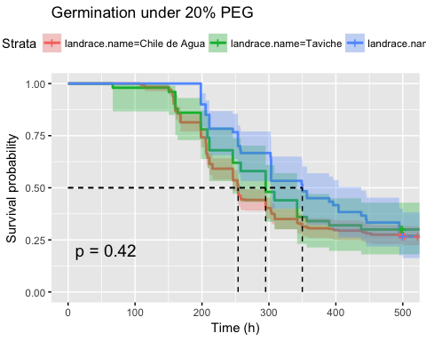

survdiff_lr_cv_20 <- pairwise_survdiff(Surv(end, status)~landrace.name, data = df_cv_20, p.adjust.method = "bonferroni",rho = 0)  
print(survdiff_lr_cv_20)

##   
## Pairwise comparisons using Log-Rank test   
##   
## data: df_cv_20 and landrace.name   
##   
## Chile de Agua Taviche  
## Taviche 1.00 -   
## Tusta 0.64 1.00   
##   
## P value adjustment method: bonferroni

df_wcoast_20 <- subset(df_wcoast, trt == 20)  
test.landrace.wcoast.20 <- survfit(Surv(end, status) ~ landrace.name, data = df_wcoast, subset = {trt == 20}, type = "kaplan-meier", conf.type = "log-log")  
ggsurvplot(test.landrace.wcoast.20, data =df, conf.int = T, pval = T, xlab = "Time (h)", ggtheme = theme_grey(),  
 surv.median.line = "hv", title = "Germination under 20% PEG")

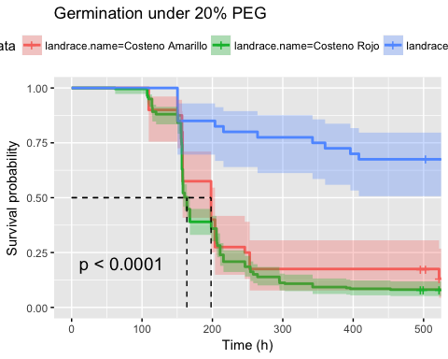

survdiff_lr_wcoast_20 <- pairwise_survdiff(Surv(end, status)~landrace.name, data = df_wcoast_20, p.adjust.method = "bonferroni",rho = 0)  
print(survdiff_lr_wcoast_20)

##   
## Pairwise comparisons using Log-Rank test   
##   
## data: df_wcoast_20 and landrace.name   
##   
## Costeno Amarillo Costeno Rojo  
## Costeno Rojo 0.9 -   
## Piquin 1.4e-06 9.2e-13   
##   
## P value adjustment method: bonferroni

df_yucatan_20 <- subset(df_yucatan, trt ==20)  
test.landrace.yucatan.20 <- survfit(Surv(end, status) ~ landrace.name, data = df_yucatan, subset = {trt == 20}, type = "kaplan-meier", conf.type = "log-log")  
ggsurvplot(test.landrace.yucatan.20, data =df, conf.int = T, pval = T, risk.table = T, risk.table.col = "strata", ggtheme = theme_grey(),  
 xlab = "Time (h)", surv.median.line = "hv", title = "Germination under 20% PEG")

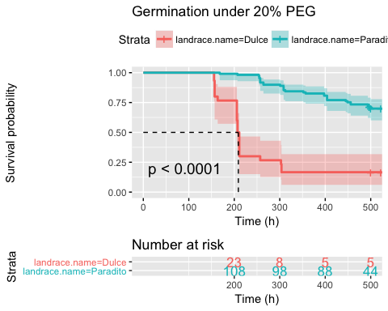

survdiff_lr_yucatan_20 <- pairwise_survdiff(Surv(end, status) ~ landrace.name, data = df_yucatan_20, p.adjust.method = "bonferroni",rho = 0)  
print(survdiff_lr_yucatan_20)

##   
## Pairwise comparisons using Log-Rank test   
##   
## data: df_yucatan_20 and landrace.name   
##   
## Dulce   
## Paradito <2e-16  
##   
## P value adjustment method: bonferroni

#df_sm <- subset(df, region =="sierra madre")  
#df_sm_20 <- subset(df_sm, trt == "trt")  
#test.landrace.sm <- survfit(Surv(end, status) ~ landrace.name, data = df_sm, subset = {trt == 20}, type = "kaplan-meier", conf.type = "log-log")  
#ggsurvplot(test.landrace.sm, data =df, conf.int = T, pval = T, xlab = "Time (h)",   
# surv.median.line = "hv", title = "Germination under Water Control")  
#survdiff_lr_sm_20 <- pairwise_survdiff(Surv(end, status) ~ landrace.name, data = df_sm_20, p.adjust.method = "bonferroni",rho = 20)  
#print(survdiff_lr_sm_20)  
  
df_15 <- subset(df, trt==15)  
test.lr.15 <- survfit(Surv(end, status) ~ landrace.name, data = df, type = "kaplan-meier", subset = (trt ==15))  
ggsurvplot(test.lr.15, data = df, pval = T, title = "15% PEG", conf.int = T, legend = "bottom", xlab = "Time (h)", ggtheme = theme_grey())

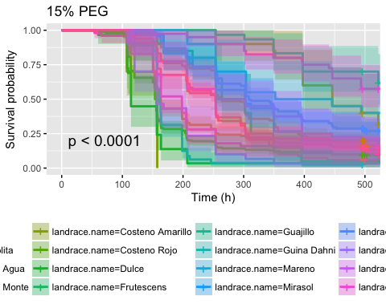

survdiff_lr_15 <- pairwise_survdiff(Surv(end, status)~landrace.name, data = df_15, p.adjust.method = "bonferroni",rho = 0)  
print(survdiff_lr_15)

##   
## Pairwise comparisons using Log-Rank test   
##   
## data: df_15 and landrace.name   
##   
## Chigole Chile Bolita Chile de Agua Chile de Monte  
## Chile Bolita 0.06631 - - -   
## Chile de Agua 1.00000 0.00249 - -   
## Chile de Monte 5.8e-05 0.32630 0.20006 -   
## Costeno Amarillo 4.6e-08 < 2e-16 0.00203 7.1e-08   
## Costeno Rojo 0.08858 < 2e-16 0.00325 0.00033   
## Dulce 6.9e-05 < 2e-16 0.00362 9.4e-07   
## Frutescens 1.00000 1.00000 1.00000 0.00156   
## Guajillo 3.5e-10 8.6e-06 5.3e-06 1.00000   
## Guina Dahni 2.7e-05 < 2e-16 0.97719 2.8e-09   
## Mareno 0.01498 1.00000 0.13433 1.00000   
## Mirasol 1.00000 1.00000 1.00000 0.65483   
## Paradito 1.2e-05 1.00000 5.3e-06 1.00000   
## Payaso 0.35269 9.9e-09 1.00000 2.1e-06   
## Piquin 1.00000 1.00000 1.00000 1.00000   
## Solterito 2.8e-10 1.4e-05 2.2e-06 1.00000   
## Taviche 1.00000 0.00152 1.00000 0.00444   
## Tusta 1.00000 1.00000 0.29459 0.04105   
## Costeno Amarillo Costeno Rojo Dulce Frutescens Guajillo  
## Chile Bolita - - - - -   
## Chile de Agua - - - - -   
## Chile de Monte - - - - -   
## Costeno Amarillo - - - - -   
## Costeno Rojo 1.00000 - - - -   
## Dulce 1.00000 1.00000 - - -   
## Frutescens 3.0e-05 1.00000 0.00107 - -   
## Guajillo 3.1e-11 2.2e-10 1.9e-11 2.2e-07 -   
## Guina Dahni 0.00092 1.00000 1.00000 0.00039 3.1e-15   
## Mareno 7.1e-08 0.00062 1.4e-06 1.00000 1.00000   
## Mirasol 8.0e-10 0.01610 1.6e-06 1.00000 0.00023   
## Paradito < 2e-16 < 2e-16 < 2e-16 1.00000 0.00883   
## Payaso 1.00000 1.00000 1.00000 0.21238 3.8e-11   
## Piquin 4.1e-06 0.02844 0.00079 1.00000 4.4e-05   
## Solterito 5.6e-13 7.8e-12 7.6e-13 3.2e-06 1.00000   
## Taviche 0.00169 1.00000 0.09062 1.00000 8.8e-08   
## Tusta < 2e-16 9.4e-16 4.4e-15 1.00000 2.6e-07   
## Guina Dahni Mareno Mirasol Paradito Payaso Piquin   
## Chile Bolita - - - - - -   
## Chile de Agua - - - - - -   
## Chile de Monte - - - - - -   
## Costeno Amarillo - - - - - -   
## Costeno Rojo - - - - - -   
## Dulce - - - - - -   
## Frutescens - - - - - -   
## Guajillo - - - - - -   
## Guina Dahni - - - - - -   
## Mareno 1.4e-08 - - - - -   
## Mirasol 2.3e-07 1.00000 - - - -   
## Paradito < 2e-16 1.00000 1.00000 - - -   
## Payaso 1.00000 2.4e-05 0.00182 1.4e-11 - -   
## Piquin 9.7e-07 1.00000 1.00000 1.00000 0.00467 -   
## Solterito < 2e-16 1.00000 0.00153 0.03040 4.8e-12 8.0e-05  
## Taviche 1.00000 0.00974 1.00000 4.4e-06 1.00000 1.00000  
## Tusta < 2e-16 0.18955 1.00000 0.00022 0.00034 1.00000  
## Solterito Taviche  
## Chile Bolita - -   
## Chile de Agua - -   
## Chile de Monte - -   
## Costeno Amarillo - -   
## Costeno Rojo - -   
## Dulce - -   
## Frutescens - -   
## Guajillo - -   
## Guina Dahni - -   
## Mareno - -   
## Mirasol - -   
## Paradito - -   
## Payaso - -   
## Piquin - -   
## Solterito - -   
## Taviche 3.6e-08 -   
## Tusta 1.4e-07 0.29092  
##   
## P value adjustment method: bonferroni

df_ecoast_15 <- subset(df_ecoast, trt == 15)  
test.landrace.ecoast.15 <- survfit(Surv(end, status) ~ landrace.name, data = df_ecoast, subset = {trt == 15}, type = "kaplan-meier", conf.type = "log-log")  
ggsurvplot(test.landrace.ecoast.15, data =df, conf.int = T, pval = T, xlab = "Time (h)",   
 surv.median.line = "hv", title = "Germination under 15% PEG", ggtheme = theme_grey())

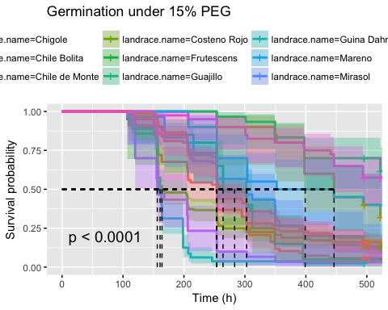

survdiff_lr_ecoast_15 <- pairwise_survdiff(Surv(end, status)~landrace.name, data = df_ecoast_15, p.adjust.method = "bonferroni",rho = 0)  
print(survdiff_lr_ecoast_15)

##   
## Pairwise comparisons using Log-Rank test   
##   
## data: df_ecoast_15 and landrace.name   
##   
## Chigole Chile Bolita Chile de Monte Costeno Rojo Frutescens  
## Chile Bolita 0.02861 - - - -   
## Chile de Monte 2.5e-05 0.14076 - - -   
## Costeno Rojo 1.00000 0.00163 0.00985 - -   
## Frutescens 1.00000 1.00000 0.00067 1.00000 -   
## Guajillo 1.5e-10 3.7e-06 1.00000 5.9e-08 9.7e-08   
## Guina Dahni 1.2e-05 < 2e-16 1.2e-09 0.01847 0.00017   
## Mareno 0.00646 0.88653 1.00000 0.02252 0.45494   
## Mirasol 0.82273 1.00000 0.28247 1.00000 1.00000   
## Payaso 0.15214 4.3e-09 9.1e-07 1.00000 0.09161   
## Solterito 1.2e-10 6.1e-06 1.00000 1.7e-08 1.4e-06   
## Tusta 1.00000 1.00000 0.04420 1.00000 1.00000   
## Guajillo Guina Dahni Mareno Mirasol Payaso Solterito  
## Chile Bolita - - - - - -   
## Chile de Monte - - - - - -   
## Costeno Rojo - - - - - -   
## Frutescens - - - - - -   
## Guajillo - - - - - -   
## Guina Dahni 1.3e-15 - - - - -   
## Mareno 1.00000 5.8e-09 - - - -   
## Mirasol 9.9e-05 1.0e-07 1.00000 - - -   
## Payaso 1.6e-11 1.00000 1.0e-05 0.00078 - -   
## Solterito 1.00000 < 2e-16 1.00000 0.00066 2.1e-12 -   
## Tusta 3.1e-07 2.5e-15 0.15487 1.00000 0.00012 4.7e-07   
##   
## P value adjustment method: bonferroni

df_cv_15 <- subset(df_cv, trt == 15)  
test.landrace.cv.15 <- survfit(Surv(end, status) ~ landrace.name, data = df_cv_15, type = "kaplan-meier", conf.type = "log-log")  
ggsurvplot(test.landrace.cv.15, conf.int = T, pval = T, xlab = "Time (h)",   
 surv.median.line = "hv", title = "Germination under 15% PEG", ggtheme = theme_grey())

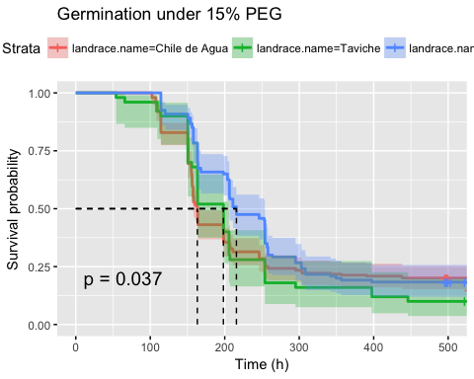

survdiff_lr_cv_15 <- pairwise_survdiff(Surv(end, status)~landrace.name, data = df_cv_15, p.adjust.method = "bonferroni",rho = 0)  
print(survdiff_lr_cv_15)

##   
## Pairwise comparisons using Log-Rank test   
##   
## data: df_cv_15 and landrace.name   
##   
## Chile de Agua Taviche  
## Taviche 1.000 -   
## Tusta 0.076 0.053   
##   
## P value adjustment method: bonferroni

df_wcoast_15 <- subset(df_wcoast, trt == 15)  
test.landrace.wcoast.15 <- survfit(Surv(end, status) ~ landrace.name, data = df_wcoast, subset = {trt == 15}, type = "kaplan-meier", conf.type = "log-log")  
ggsurvplot(test.landrace.wcoast.15, data =df, conf.int = T, pval = T, xlab = "Time (h)",   
 surv.median.line = "hv", title = "Germination under 15% PEG", ggtheme = theme_grey())

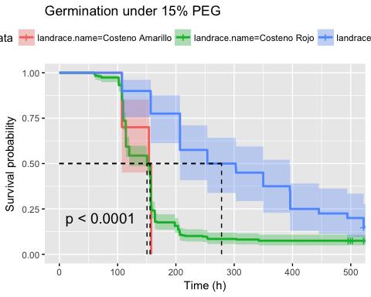

survdiff_lr_wcoast_15 <- pairwise_survdiff(Surv(end, status)~landrace.name, data = df_wcoast_15, p.adjust.method = "bonferroni",rho = 0)  
print(survdiff_lr_wcoast_15)

##   
## Pairwise comparisons using Log-Rank test   
##   
## data: df_wcoast_15 and landrace.name   
##   
## Costeno Amarillo Costeno Rojo  
## Costeno Rojo 1 -   
## Piquin 8.1e-08 1.7e-06   
##   
## P value adjustment method: bonferroni

df_yucatan_15 <- subset(df_yucatan, trt ==15)  
test.landrace.yucatan.15 <- survfit(Surv(end, status) ~ landrace.name, data = df_yucatan, subset = {trt == 15}, type = "kaplan-meier", conf.type = "log-log")  
ggsurvplot(test.landrace.yucatan.15, data =df, conf.int = T, pval = T, risk.table = T, risk.table.col = "strata", xlab = "Time (h)",   
 surv.median.line = "hv", title = "Germination under 15% PEG", ggtheme = theme_grey())

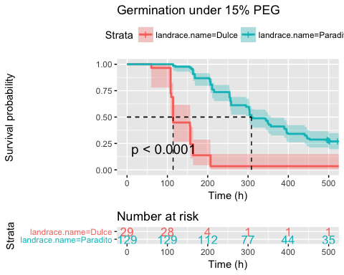

survdiff_lr_yucatan_15 <- pairwise_survdiff(Surv(end, status) ~ landrace.name, data = df_yucatan_15, p.adjust.method = "bonferroni",rho = 0)  
print(survdiff_lr_yucatan_15)

##   
## Pairwise comparisons using Log-Rank test   
##   
## data: df_yucatan_15 and landrace.name   
##   
## Dulce   
## Paradito <2e-16  
##   
## P value adjustment method: bonferroni

#df_sm <- subset(df, region =="sierra madre")  
#df_sm_15 <- subset(df_sm, trt == "trt")  
#test.landrace.sm <- survfit(Surv(end, status) ~ landrace.name, data = df_sm, subset = {trt == 15}, type = "kaplan-meier", conf.type = "log-log")  
#ggsurvplot(test.landrace.sm, data =df, conf.int = T, pval = T, xlab = "Time (h)",   
# surv.median.line = "hv", title = "Germination under Water Control")  
#survdiff_lr_sm_15 <- pairwise_survdiff(Surv(end, status) ~ landrace.name, data = df_sm_15, p.adjust.method = "bonferroni",rho = 15)  
#print(survdiff_lr_sm_15)  
  
df_costenorojo <- subset(df, landrace.name =="Costeno Rojo")  
df_costenorojo_0 <- subset(df_costenorojo, trt ==0)  
test.landrace.costenorojo.0 <- survfit(Surv(end, status) ~ region, data = df_costenorojo, subset = {trt == 0}, type = "kaplan-meier", conf.type = "log-log")  
ggsurvplot(test.landrace.costenorojo.0, data =df, conf.int = T, pval = T, risk.table = T, risk.table.col = "strata", xlab = "Time (h)",   
 surv.median.line = "hv", title = "Germination under 0% PEG", ggtheme = theme_grey())

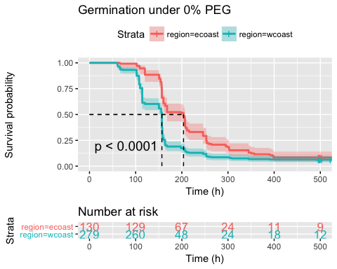

survdiff_lr_costenorojo_0 <- pairwise_survdiff(Surv(end, status) ~ region, data = df_costenorojo_0, p.adjust.method = "bonferroni",rho = 0)  
print(survdiff_lr_costenorojo_0)

##   
## Pairwise comparisons using Log-Rank test   
##   
## data: df_costenorojo_0 and region   
##   
## ecoast   
## wcoast 1.3e-07  
##   
## P value adjustment method: bonferroni

df_costenorojo_15 <- subset(df_costenorojo, trt ==15)  
test.landrace.costenorojo.15 <- survfit(Surv(end, status) ~ region, data = df_costenorojo, subset = {trt == 15}, type = "kaplan-meier", conf.type = "log-log")  
ggsurvplot(test.landrace.costenorojo.15, data =df, conf.int = T, pval = T, risk.table = T, risk.table.col = "strata", xlab = "Time (h)",   
 surv.median.line = "hv", title = "Germination under 15% PEG", ggtheme = theme_grey())

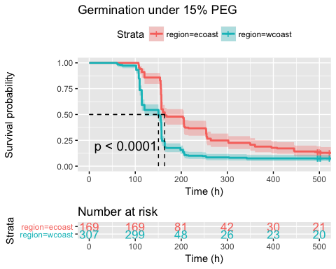

survdiff_lr_costenorojo_15 <- pairwise_survdiff(Surv(end, status) ~ region, data = df_costenorojo_15, p.adjust.method = "bonferroni",rho = 0)  
print(survdiff_lr_costenorojo_15)

##   
## Pairwise comparisons using Log-Rank test   
##   
## data: df_costenorojo_15 and region   
##   
## ecoast   
## wcoast 4.3e-10  
##   
## P value adjustment method: bonferroni

df_costenorojo_20 <- subset(df_costenorojo, trt ==20)  
test.landrace.costenorojo.20 <- survfit(Surv(end, status) ~ region, data = df_costenorojo, subset = {trt == 20}, type = "kaplan-meier", conf.type = "log-log")  
ggsurvplot(test.landrace.costenorojo.20, data =df, conf.int = T, pval = T, risk.table = T, risk.table.col = "strata", xlab = "Time (h)",   
 surv.median.line = "hv", title = "Germination under 20% PEG", ggtheme = theme_grey())

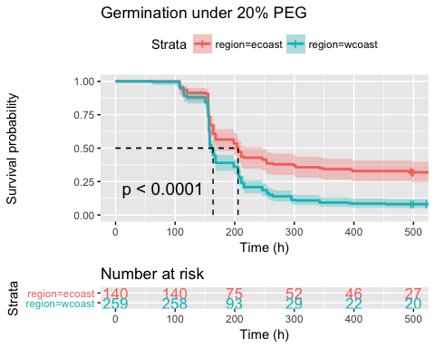

survdiff_lr_costenorojo_20 <- pairwise_survdiff(Surv(end, status) ~region, data = df_costenorojo_20, p.adjust.method = "bonferroni",rho = 0)  
print(survdiff_lr_costenorojo_20)

##   
## Pairwise comparisons using Log-Rank test   
##   
## data: df_costenorojo_20 and region   
##   
## ecoast   
## wcoast 1.7e-07  
##   
## P value adjustment method: bonferroni

df_tusta <- subset(df, landrace.name =="Tusta")  
df_tusta_0 <- subset(df_tusta, trt ==0)  
test.landrace.tusta.0 <- survfit(Surv(end, status) ~ region, data = df_tusta, subset = {trt == 0}, type = "kaplan-meier", conf.type = "log-log")  
ggsurvplot(test.landrace.tusta.0, data =df, conf.int = T, pval = T, risk.table = T, risk.table.col = "strata", xlab = "Time (h)",   
 surv.median.line = "hv", title = "Germination under 0% PEG", ggtheme = theme_grey())

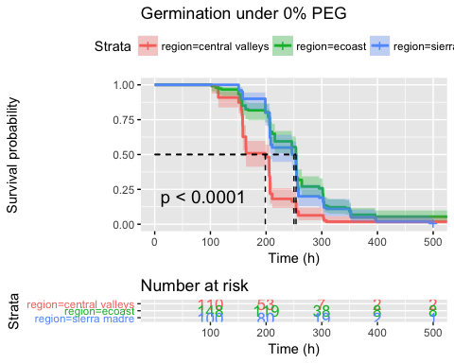

survdiff_lr_tusta_0 <- pairwise_survdiff(Surv(end, status) ~ region, data = df_tusta_0, p.adjust.method = "bonferroni",rho = 0)  
print(survdiff_lr_tusta_0)

##   
## Pairwise comparisons using Log-Rank test   
##   
## data: df_tusta_0 and region   
##   
## central valleys ecoast  
## ecoast 5.6e-10 -   
## sierra madre 2.4e-07 1   
##   
## P value adjustment method: bonferroni

df_tusta_15 <- subset(df_tusta, trt ==15)  
test.landrace.tusta.15 <- survfit(Surv(end, status) ~ region, data = df_tusta, subset = {trt == 15}, type = "kaplan-meier", conf.type = "log-log")  
ggsurvplot(test.landrace.tusta.15, data =df, conf.int = T, pval = T, risk.table = T, risk.table.col = "strata", xlab = "Time (h)",   
 surv.median.line = "hv", title = "Germination under 15% PEG", ggtheme = theme_grey())

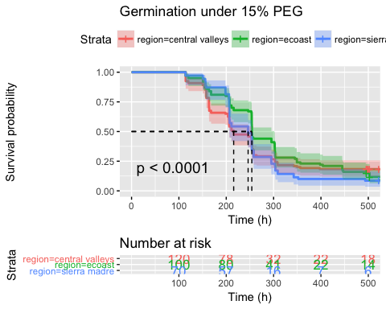

survdiff_lr_tusta_15 <- pairwise_survdiff(Surv(end, status) ~ region, data = df_tusta_15, p.adjust.method = "bonferroni",rho = 0)  
print(survdiff_lr_tusta_15)

##   
## Pairwise comparisons using Log-Rank test   
##   
## data: df_tusta_15 and region   
##   
## central valleys ecoast  
## ecoast 1.00 -   
## sierra madre 1.00 0.22   
##   
## P value adjustment method: bonferroni

df_tusta_20 <- subset(df_tusta, trt ==20)  
test.landrace.tusta.20 <- survfit(Surv(end, status) ~ region, data = df_tusta, subset = {trt == 20}, type = "kaplan-meier", conf.type = "log-log")  
ggsurvplot(test.landrace.tusta.20, data =df, conf.int = T, pval = T, risk.table = T, risk.table.col = "strata", xlab = "Time (h)",   
 surv.median.line = "hv", title = "Germination under 20% PEG", ggtheme = theme_grey())

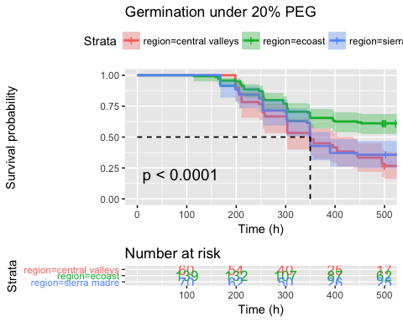

survdiff_lr_tusta_20 <- pairwise_survdiff(Surv(end, status) ~region, data = df_tusta_20, p.adjust.method = "bonferroni",rho = 0)  
print(survdiff_lr_tusta_20)

##   
## Pairwise comparisons using Log-Rank test   
##   
## data: df_tusta_20 and region   
##   
## central valleys ecoast  
## ecoast 8.5e-06 -   
## sierra madre 1.0000 0.0015  
##   
## P value adjustment method: bonferroni