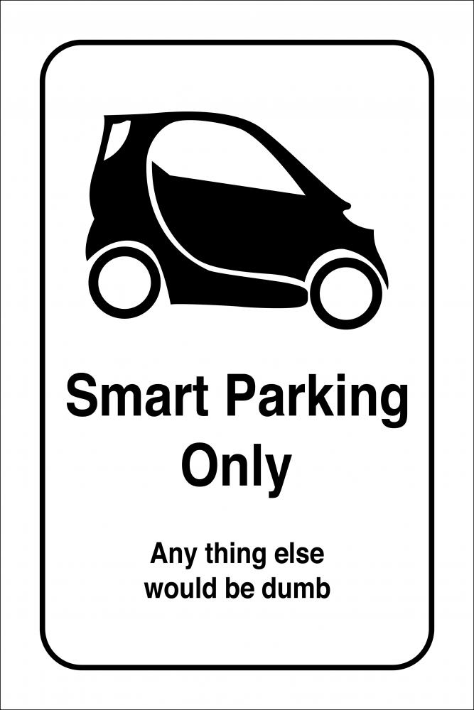

***SMART CAR PARKING IN LARGE PARKING AREAS***

* **Manish Mukund Kaujalgi (A20406767)**
* **Vaishnavi Bhadresh (A20405811)**

**1.0 FEATURES PROVIDED IN SMART CAR PARKING**

1. Login Page – First Time User(REGISTER); Existing Users (SIGN IN)
2. If Existing Users (User Name & Password- fields must be filled)
3. After logging in, Welcome Page has the buttons: ADD, Manage, Booking History and Book a slot.
   1. ADD will go to step 6.
   2. Manage will go to edit the user profile with car details. Step 7.
   3. Booking History will be show the users previous bookings done through this application.
   4. Book a Slot button
      1. If disabled, display with field Validation showing *Add car details to book a slot.
      2. If enabled and clicked, then got to step 8.
4. If new User is registered (User Name, password, re-enter password, Email- fields must be filled)
   1. Use as a Parking Place provider / Parking Place User?
5. If Parking Place User, then go to Welcome Page Step 3.
6. Add your car details or Add car details of your Friend;
   1. If Add YOUR car details-> (enter-> Car Number; Car Model)
   2. If Add FRIEND car details-> (enter ->Name; Car Number; Car Model)
7. Manage your booking; Do you like to add another car details (YES; NO)
   1. If YES, loop to 6;
   2. If NO, go to Step 3.
8. Select a category to book a slot (Drop down menu)
   1. Drop down values of Category to book a slot: Public Place, Hospital, Apartment, Mall
   2. After selecting from the drop down, places registered inside the category are displayed. All are arranged as radio buttons.
   3. On selecting the RADIO Button and clicking OK, we should fill the below fields.
9. Fields to Enter the date / Select the Date (Format specified)
10. Fields to Enter the Time / Select the time- Start and End time (Duration Calculated)
11. Next page – Shows the calculated duration falls in the particularly categorized duration interval and **shows** charges for that amount respectively. Do you like to proceed with the payment?
    1. If YES, payment successful. Booking confirmed. Thank you.
    2. If NO, redirect to 3.3
12. If Parking Place provider, choose place from the drop down to register (4.4)
    1. Enter the Place Name in the Textbox below.
    2. Enter the Parking tariff details.

**2.0 CLASS DESCRIPTION**

1. **SMARTCARPARKINGCOMMITEE :** It is the Super Class which mainly has the functionality of add user and update user. It has 3 sub classes- ADMIN, USER and ADD CAR.
2. **ADMIN:** It is the sub class that will input the information of the new parking slot provider to the database. Information like, Venue under the predefined categories, parking tariff and number of slots being offered.
3. **User:** It is the sub class that contains many features relating to the parking slot users. Features like adding the car details, managing the user profile, booking a parking slot, booking history of the user and few more.
4. **Add Car:** It is the sub class which contains the details of the car which is added. Here we are adding Car Number and the Car model name.
5. **Car Info:** This is an Interface class for the AddCar class which has two methods to implement. One method for adding the car details for the user and another method for adding the car details of the user’s friend for whom the parking slot will be booked.
6. **Manage User:** This class edits the information stored in the database as required by the user but does not allow to delete any information by the user.
7. **Book Slot:** This class uses the information from the user class for booking the slot at the venue of a respective category depending on the availability basis.
8. **Payment:** This class used here is mainly to keep track of the amount paid and confirming the booking of the chosen parking slot by the user.

<<Interface>>

**3.0 DATABASE TABLES**

***SMARTPARKINGCOMMITTEE TABLE***

Create TABLE SmartParkingBookingCommittee(

sp_userId INTEGER not NULL,

sp_userName varchar(100),

sp_userType varchar(100),

sp_password varchar(100),

Primary key(sp_userid)

);

*******************************************************************

***ADDCAR TABLE***

Create TABLE AddCar(

ad_carName Varchar(100),

ad_carModel Varchar(100),

userID integer(100),

userName varchar(100),

carId integer(100),

primary key(carId),

FOREIGN KEY (userID) REFERENCES

SmartParkingBookingCommittee(sp_userId)

);

***Book SLOT TABLE***

Create TABLE BookSlot(

bs_publicplace Varchar(100),

bs_hospital Varchar(100),

bs_mall Varchar(100),

bs_apt Varchar(100),

bookID integer(100)

Primary Key(bookID));

*******************************************************************

***PayMent Details Table***

Create TABLE PaymentDetails(

Pd_amount integer(100),

Pd_emailId varchar(100),

Pd_payId integer(100),

Primary key(Pd_payId),

Pd_bookId integer(100),

FOREIGN KEY(bookiD) REFERENCES BookSlot(bookID)

);

*******************************************************************

***ParkingRate Details***

Create TABLE ParkingRateDetails(

Pd_expectedCost integer(100),

Pd_parkId integer(100),

Primary key(Pd_ parkId),);

***Slot Details Table***

Create TABLE SlotDetails(

sd_totalSlots integer(100),

sd_availableSlots integer(100),

sd_categoryId integer(100),

FOREIGN KEY(sd_categoryId) REFERENCES BookSlot(bookID)

);

***Booking History table***

Create TABLE BookingHistory(

bh_bookingDate Varchar(100),

bh_bookingVenue integer(100),

bh_carId Varchar(100)

bh_userId integer(100),

FOREIGN KEY(bh_userId) REFERENCES SmartParkingBookingCommittee (sp_userId),

FOREIGN KEY(bh_ carId) REFERENCES AddCar (carId));

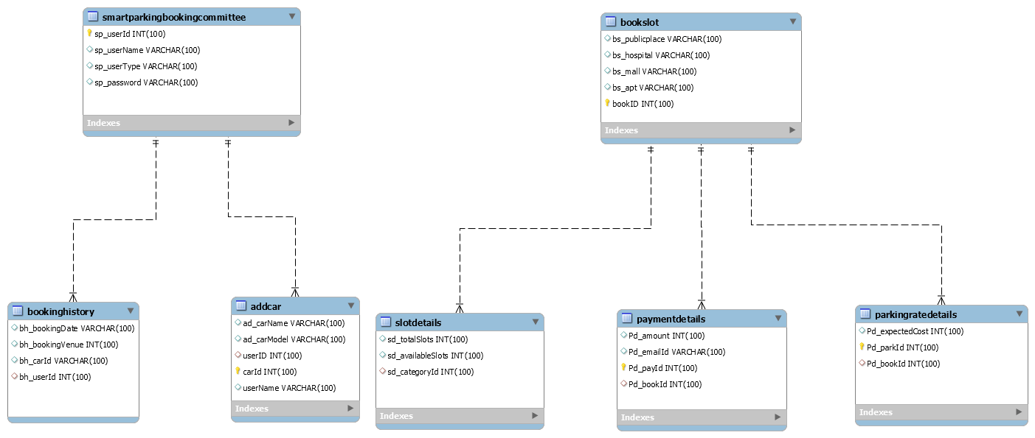**5.0 ER DIAGRAM**