Presented By: (Batch DA-2026-1)
- Name: Bhargav
- Submission Date: 17/05/2026
- Course/Institute: Data Analytics Python/ Skillovilla

1.Introduction:
This power Bi dashboard was developed for the ShopNext E-commerce store to analyze the sales performance, delivery performance, customer ratings, regional sales trends, payment methods. This dashboard contains interactive visuals like KPI cards, slicers, maps and interactive charts to help understanding business trends and patterns. This project mainly focuses on analyzing important business metrics including revenue, delayed orders, on time orders, year wise analysis are performed.
The dashboard was designed in a single-page layout containing all required analytical questions and interactive visualizations. Features such as slicers, drill through, functionality, KPI cards, maps, and charts were used to improve dashboard usability and provide deeper business insights. The analysis helps understand customer behavior, sales growth, delivery performance, and regional trends effectively
In this project, data cleaning and transformation techniques were performed using Power Query Editor to improve data quality and accuracy. Relationships between multiple tables were created using data modeling concepts, and DAX measures were used to calculate important business metrics. The dashboard provides a clear understanding of sales performance, customer satisfaction, payment behavior, and operational efficiency. Interactive filters and slicers allow users to dynamically explore the data and gain meaningful insights for better business decision-making.

2. Dashboard overview:

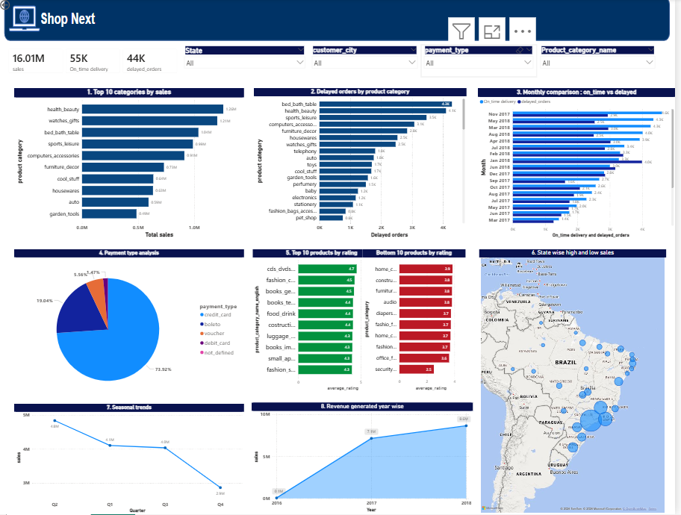

Overview
The dashboard contains:
- KPI cards for total revenue, total orders, delayed orders, on time orders, average ratings.
- Interactive slicers for filtering data.
- Sales analysis visuals.
- Delivery performance analysis.
- Revenue growth analysis.
- Sales trend analysis.
- Product rating comparison.
3. Question wise analysis:
Q1. Top 10 product categories by sales
Question Statement:
Analyze and identify the top-performing product category based on total sales
Visualization:

Explanation:
A clustered bar chart was used to represent the top 10 product categories based on total sales revenue. this visual clearly shows the categories contributing the highest sales. The analysis indicates that categories such as Health beauty, watches gifts, bed bath table generated higher sales as shown in above fig.
Q2. Delayed orders by product category:
Question statement
Identify the product categories with the highest number of delayed orders.
Visualization:


Explanation:
A bar chart was used to analyze delayed orders across product categories. The visualization highlights the categories experiencing the highest delay deliveries. category with higher delayed orders may require improvements and better management.
This analysis helps understanding delivery issue and improve customer satisfaction.

Q3. Monthly comparison of delayed and on time orders
Statement: compare delayed orders and on time orders on monthly basis.

Visualization:



Explanation:
A clustered column chart was used to compare delayed orders and on time delivery deliveries monthly wise.
The analysis shows that on time delivery were significantly higher than delayed deliveries in months. Monthly trends help to identify periods with delivery challenges.
This future improves dashboard interactivity and allows deeper investigation of delivery performance

Q4. Payment method analysis
Statement: analyze customer payment methods used for transaction

Visualization:


Explanation:
A pie chart was used to analyze different payment methods used by customers.
The visualization shows that credit card payments contributed the highest percentage pf transaction, followed by debit cards and vouchers.
This analysis helps to understanding customer payments preferences and transaction behavior.

Q5. Top 10 highest and bottom 10 lowest rated products
Statement: identify the highest and lowest rated products based on customer reviews.

Visualization:



Explanation:

Bar chat were used to compare the top and low rated products.
Products with higher ratings strong customer satisfaction, while lower rated products may require quality improvements.

Q6. State wise high and low sales analysis
Statement: identify and visually represent states with high and low sales.

Visualization:


Explanation:
a filled map visualization was used to represent sales performance across different states. Bigger region indicates higher sales and smaller bubble indicates the lower sales.

Q7. seasonal sales trends:
Statement: analyze seasonal sales trends over time

Visualization:



Explanation:
A line chart used to analyze the sales patterns. the visual helps identify periods with increased and decreased activity
Seasonal trend analysis helps business plan inventory, promotions and sales strategies more effectively. Bigger region indicates higher sales and smaller bubble indicates the lower sales.
Bigger region indicates higher sales and smaller bubble indicates the lower sales. Bigger region indicates higher sales and smaller bubble indicates the lower sales. the visual helps identify periods with increased and decreased activity

Q8. Revenue generated year wise
Statement: analyze yearly growth

Visualization:



Explanation:
A line chat was used to represent yearly revenue generated.
The analysis shows that revenue increased over the years, indicating positive business growth.

Conclusion:
The ShopNest Store Power BI dashboard successfully provides insights into sales performance, delivery analysis, customer behavior, payment methods, product ratings, and regional sales trends.

Interactive visuals and analytical features helped in identifying important business patterns and performance indicators.

The dashboard provides an effective solution for understanding business operations and supports data-driven decision-making.

