Selenium Experiments

1.Chrome Automation
Program:-
package chromeautomation;
import org.openqa.selenium.WebDriver;
import org.openqa.selenium.chrome.ChromeDriver;
public class clogin {
public static void main(String[] args) {
// Set path to ChromeDriver executable
System.setProperty("webdriver.chrome.driver", "C:/drivers/chromedriver.exe");
// Create WebDriver instance for Chrome
WebDriver driver = new ChromeDriver();
// Open Google
driver.get("https://www.google.com");
System.out.println("Title: " + driver.getTitle());
}
}
Output:-
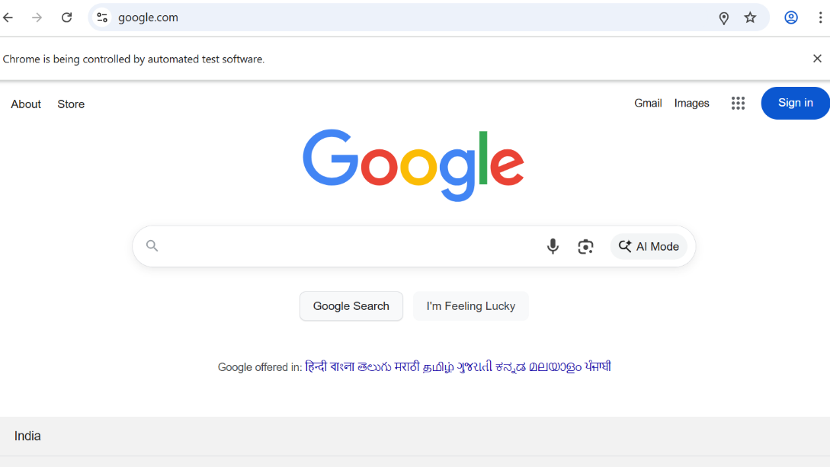

2.Firefox Automation
Program:-
package firefoxautomation;
import org.openqa.selenium.WebDriver;
import org.openqa.selenium.firefox.FirefoxDriver;
import org.openqa.selenium.firefox.FirefoxOptions;
public class flogin {
public static void main(String[] args) {
System.setProperty("webdriver.gecko.driver", "C:/drivers/geckodriver.exe");
FirefoxOptions options = new FirefoxOptions();
options.setBinary("C:/Program Files/Mozilla Firefox/firefox.exe"); // use your real path here
WebDriver driver = new FirefoxDriver(options);
driver.get("https://www.google.com");
System.out.println("Title: " + driver.getTitle());
}
}
Output:-
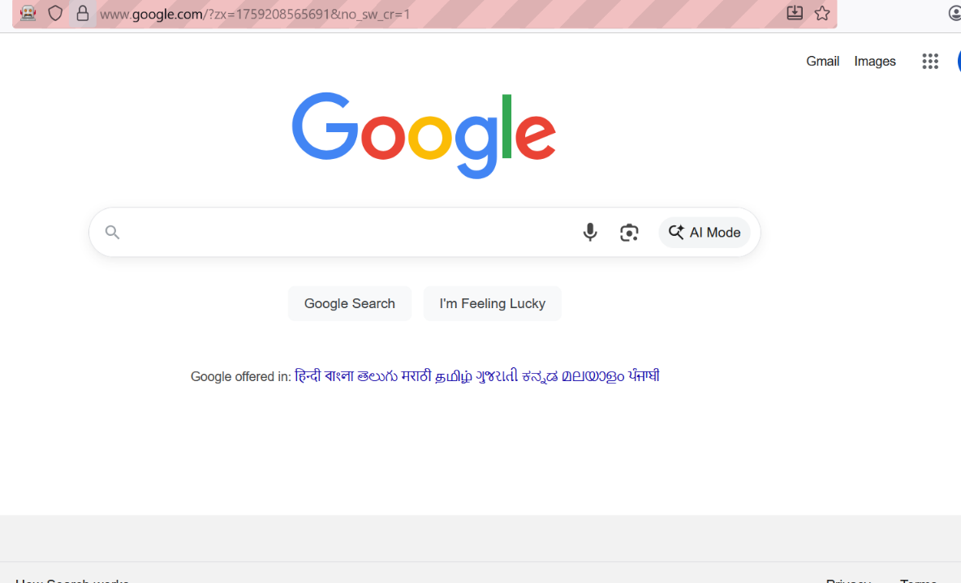

3.Arms portal Automation
Program:-
package armsportal;
import org.openqa.selenium.By;
import org.openqa.selenium.WebDriver;
import org.openqa.selenium.WebElement;
import org.openqa.selenium.chrome.ChromeDriver;
public class alogin {
public static void main(String[] args) {
// Set path to ChromeDriver executable (update path as needed)
System.setProperty("webdriver.chrome.driver", "C:\\drivers\\chromedriver.exe");
// Create browser instance
WebDriver driver = new ChromeDriver();
// Maximize window
driver.manage().window().maximize();
// Open ARM portal login page
driver.get("https://arms.sse.saveetha.com");
// Find username, password, and login button fields (update locators if needed)
WebElement username = driver.findElement(By.id("txtusername"));
WebElement password = driver.findElement(By.id("txtpassword"));
WebElement login = driver.findElement(By.name("btnlogin"));
// Enter credentials (replace XXXXX with actual username and password)
username.sendKeys("192311173");
password.sendKeys("vishnu123");
// Click the login button
login.click();
// Optionally: Print title after login
System.out.println("Page after login: " + driver.getTitle());
// Close browser (add delay if you want to see the result first)
// driver.quit();
}
}
Output:-
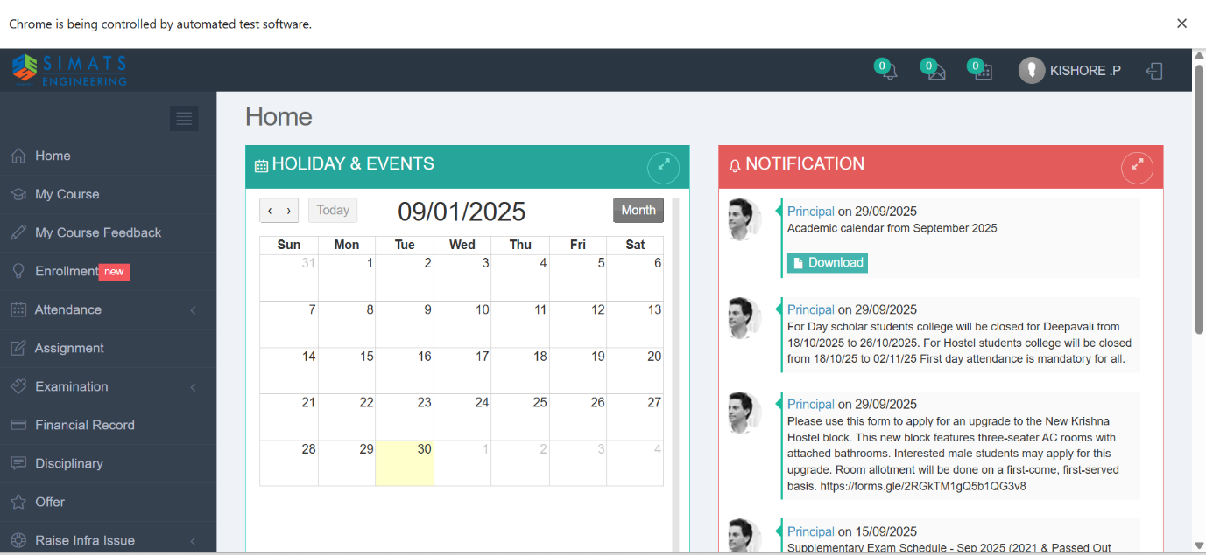

4.Food app Automation
Program:-
package foodappautomation;
import org.openqa.selenium.By;
import org.openqa.selenium.WebDriver;
import org.openqa.selenium.WebElement;
import org.openqa.selenium.chrome.ChromeDriver;
public class flogin {
public static void main(String[] args) {
// Set path to ChromeDriver executable (update path as needed)
System.setProperty("webdriver.chrome.driver", "C:\\drivers\\chromedriver.exe");
// Create browser instance
WebDriver driver = new ChromeDriver();
// Maximize window
driver.manage().window().maximize();
// Open ARM portal login page
driver.get("https://life.saveetha.com");
// Find username, password, and login button fields (update locators if needed)
WebElement username = driver.findElement(By.id("txtusername"));
WebElement password = driver.findElement(By.id("txtpassword"));
WebElement login = driver.findElement(By.name("btnlogin"));
// Enter credentials (replace XXXXX with actual username and password)
username.sendKeys("192311173");
password.sendKeys("vishnu123");
// Click the login button
login.click();
// Optionally: Print title after login
System.out.println("Page after login: " + driver.getTitle());
// Close browser (add delay if you want to see the result first)
// driver.quit();
}
}

Output:-
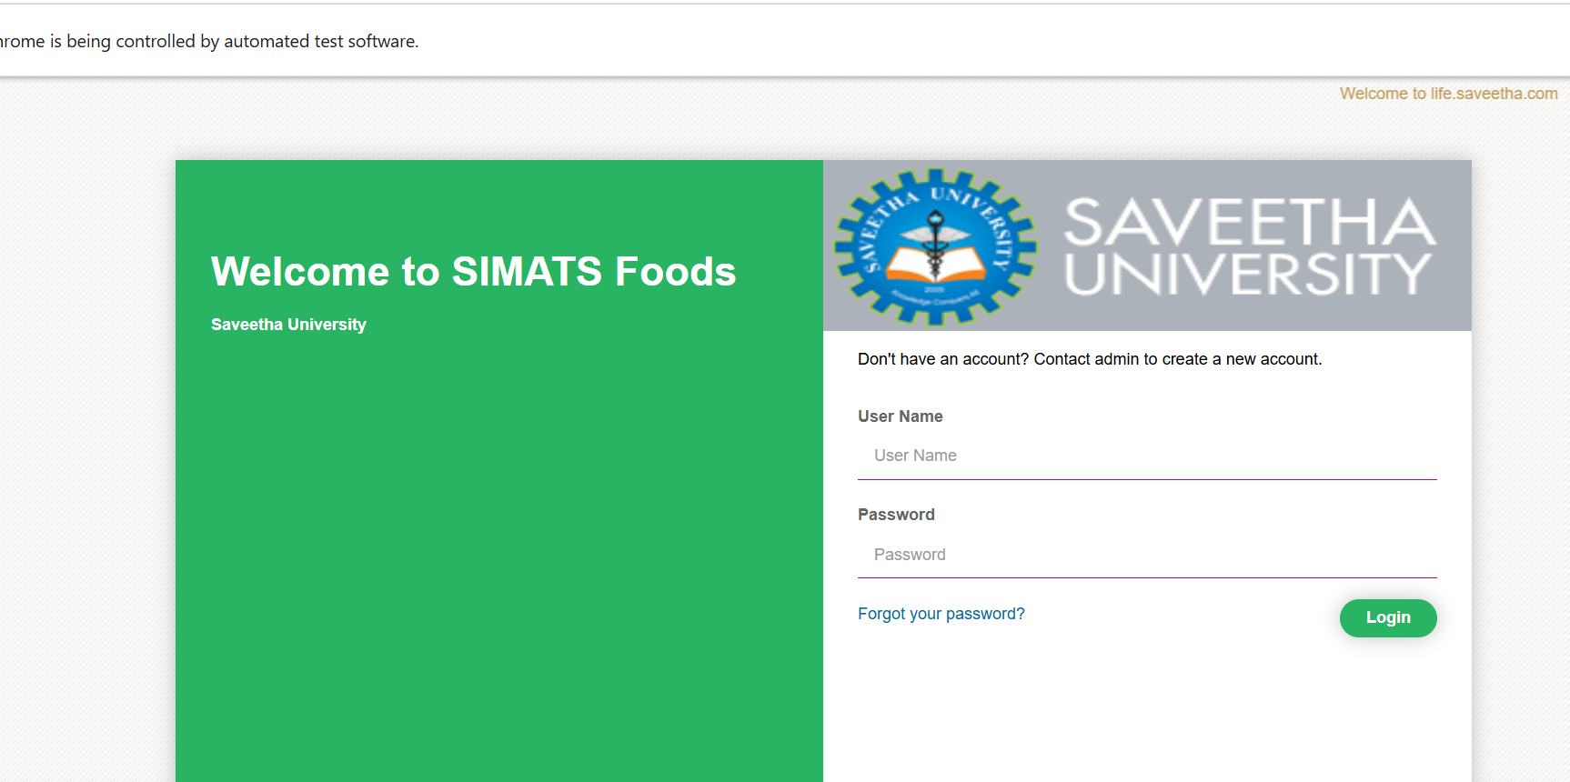

5.Github Automation
Program:-
package githubautomation;
import org.openqa.selenium.By;
import org.openqa.selenium.WebDriver;
import org.openqa.selenium.WebElement;
import org.openqa.selenium.chrome.ChromeDriver;
public class glogin {
public static void main(String[] args) {
// Set path to ChromeDriver executable (update path as needed)
System.setProperty("webdriver.chrome.driver", "C:\\drivers\\chromedriver.exe");
// Create browser instance
WebDriver driver = new ChromeDriver();
// Maximize window
driver.manage().window().maximize();
// Open ARM portal login page
driver.get("https://github.com");
// Find username, password, and login button fields (update locators if needed)
WebElement username = driver.findElement(By.id("txtusername"));
WebElement password = driver.findElement(By.id("txtpassword"));
WebElement login = driver.findElement(By.name("btnlogin"));
// Enter credentials (replace XXXXX with actual username and password)
username.sendKeys("192311173");
password.sendKeys("vishnu123");
// Click the login button
login.click();
// Optionally: Print title after login
System.out.println("Page after login: " + driver.getTitle());
// Close browser (add delay if you want to see the result first)
// driver.quit();
}
}
Output:-
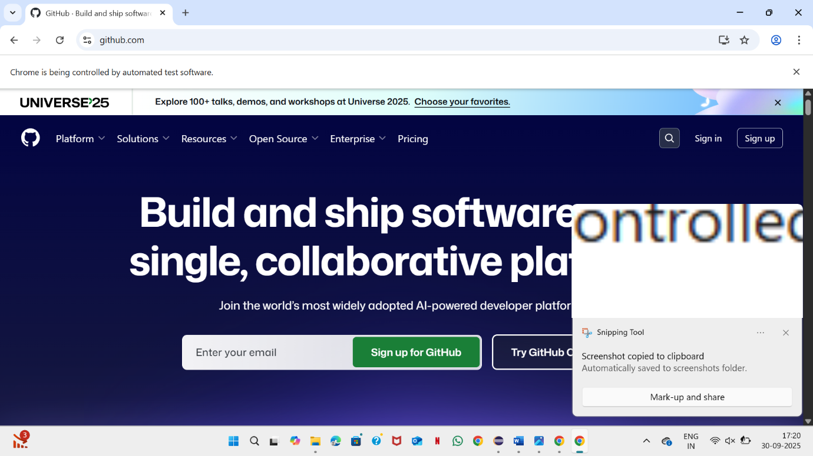

6.Gmail Automation
Program:-
package gmailautomation;
import org.openqa.selenium.By;
import org.openqa.selenium.WebDriver;
import org.openqa.selenium.WebElement;
import org.openqa.selenium.chrome.ChromeDriver;
public class gmaillogin {
public static void main(String[] args) {
// Set path to ChromeDriver executable (update path as needed)
System.setProperty("webdriver.chrome.driver", "C:\\drivers\\chromedriver.exe");
// Create browser instance
WebDriver driver = new ChromeDriver();
// Maximize window
driver.manage().window().maximize();
// Open ARM portal login page
driver.get("https://gmail.com");
// Find username, password, and login button fields (update locators if needed)
WebElement username = driver.findElement(By.id("txtusername"));
WebElement password = driver.findElement(By.id("txtpassword"));
WebElement login = driver.findElement(By.name("btnlogin"));
// Enter credentials (replace XXXXX with actual username and password)
username.sendKeys("192311173");
password.sendKeys("vishnu123");
// Click the login button
login.click();
// Optionally: Print title after login
System.out.println("Page after login: " + driver.getTitle());
// Close browser (add delay if you want to see the result first)
// driver.quit();
}
}
Output:-
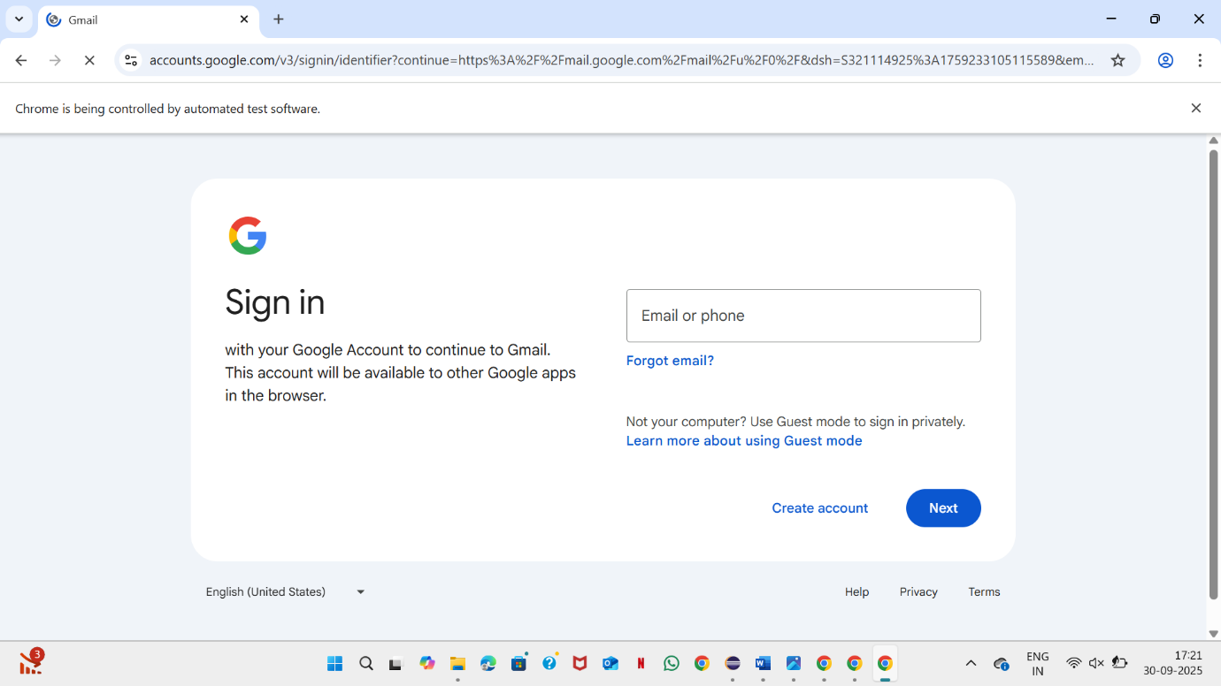

Junit
- Factorial

import static org. junit. Assert. assertTrue;

import java. util. Scanner;

public class fact {
public static void main (String [] args) {
Scanner s = new Scanner (System.in);
System.out.print("Enter a number: ");
int n = s. nextInt ();
int fact = 1;

if (n < 0) {
System.out.println("Invalid");
return;
}

for (int i = 1; i <= n; i++)
fact *= i;

System.out.println("Factorial: " + fact);

// Example test
if (n == 5) assertTrue ("Factorial of 5 should be 120", fact == 120);
}
}
Output:

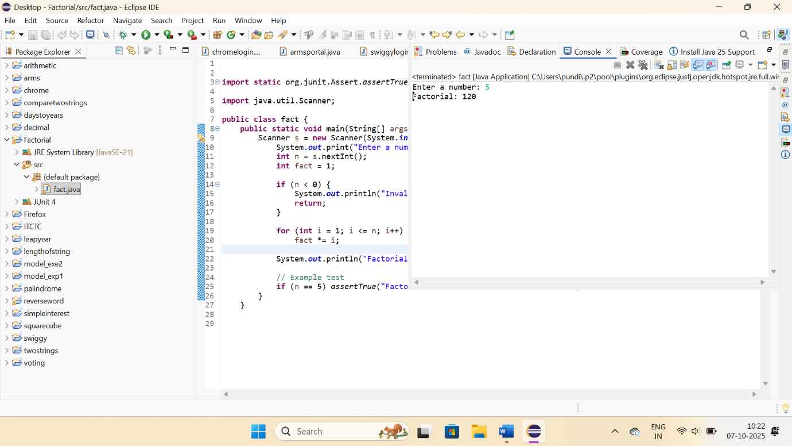

- Concatenate Strings
package twostrings;
import static org.junit.Assert.assertTrue;
import java.util.Scanner;
public class StringConcat {
public static void main(String[] args) {
try (Scanner s = new Scanner(System.in)) {
System.out.print("Enter the first string: ");
String str1 = s.nextLine();
System.out.print("Enter the second string: ");
String str2 = s.nextLine();
// Concatenate strings
String result = str1 + str2;
System.out.println("Concatenated String = " + result);
// Example assertion: if inputs are "Hello" and "World", result should be "HelloWorld"
if (str1.equals("Hello") && str2.equals("World")) {
assertTrue("Concatenation should be 'HelloWorld'", result.equals("HelloWorld"));
System.out.println("✅ Test Passed — Concatenated String = HelloWorld");
}
} catch (Exception e) {
System.out.println("Invalid input");
}
}
}

Output:
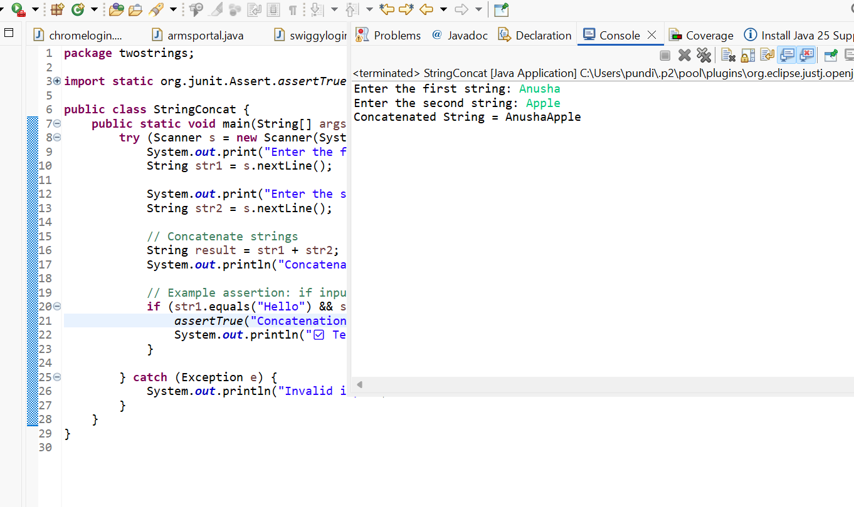
- Length of String
package lengthofstring;
import static org.junit.Assert.assertTrue;
import java.util.Scanner;
class length {
public static void main(String[] args) {
Scanner scan = new Scanner(System.in);
System.out.print("Please enter a string: ");
String input = scan.nextLine();
int length = input.length();
System.out.println("The length of the string is: " + length);
// Assertion for test case: if input is "hello", length should be 5
if (input.equals("hello")) {
assertTrue("Expected length of 'hello' to be 5", length == 5);
}
scan.close();
}
}
Output:
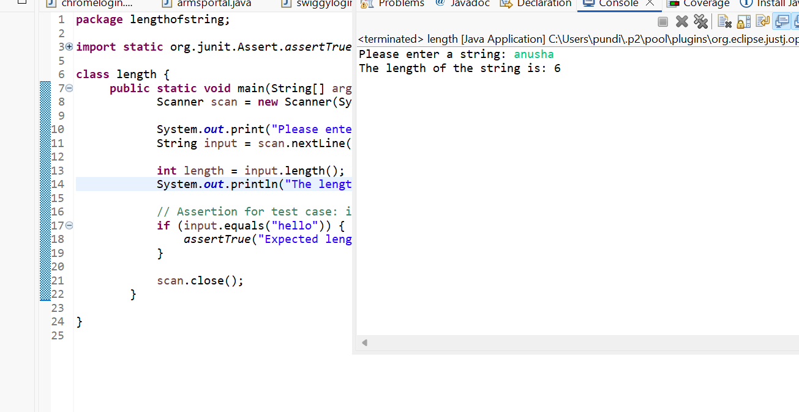

- Days to years, months, weeks
package daystoyears;
import static org.junit.Assert.assertTrue;
import java.util.Scanner;
public class days {
public static void main(String[] args) {
int totalDays, years, weeks, daysLeft;
Scanner s = new Scanner(System.in);
System.out.print("Enter the number of days: ");
totalDays = s.nextInt();
// Calculate years
years = totalDays / 365;
// Example assertion: if input = 730, expected 2 years
if (totalDays == 730) {
assertTrue("Expected 2 years for assertion", years == 2);
System.out.println("✅ Test Passed — Expected 2 years for 730 days");
}

totalDays = totalDays % 365;
System.out.println("No. of years: " + years);
// Calculate weeks and days
weeks = totalDays / 7;
totalDays = totalDays % 7;
daysLeft = totalDays;
System.out.println("No. of weeks: " + weeks);
System.out.println("No. of days: " + daysLeft);
s.close();
}
}

Output:
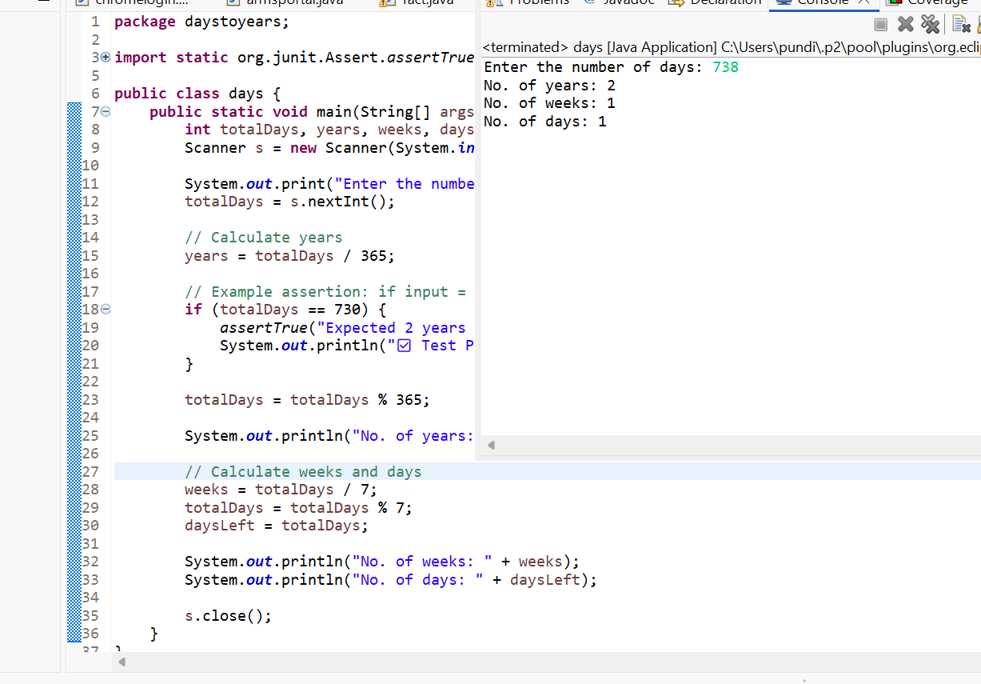
- Decimal to binary and octal
package decimal;
import static org.junit.Assert.assertEquals;
import java.util.Scanner;
public class decimal1 {
public static void main(String[] args) {
Scanner in = new Scanner(System.in);

System.out.print("Enter a decimal number: ");
int decimal = in.nextInt();
String binary = Integer.toBinaryString(decimal);
System.out.println("BINARY IS: " + binary);
String octal = Integer.toOctalString(decimal);
System.out.println("OCTAL IS: " + octal);
if (decimal == 12) {
assertEquals("Binary of 12 should be 1100", "1100", binary);
System.out.println("✅ Test Passed — Expected binary of 12 is 1100");
}
in.close();
}
}

Output:
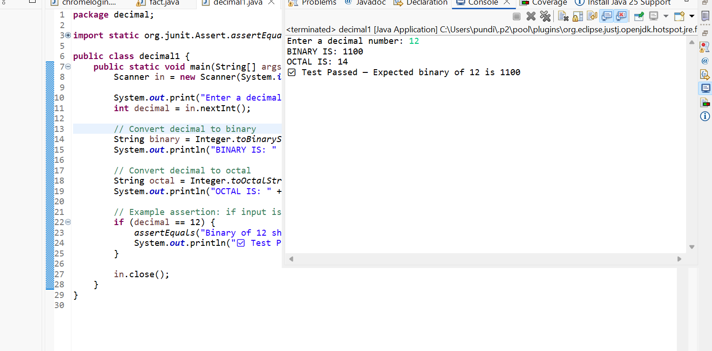

- Palindrome or not
package org.junit;
import java.util.Scanner;
public class Assert {
public static void main(String[] args) {
Scanner in = new Scanner(System.in);
System.out.print("Enter a number: ");
int n = in.nextInt();
int r, sum = 0, temp;
temp = n;
while (n > 0) {
r = n % 10;
n = n / 10;
sum = (sum * 10) + r;
}
System.out.println("Reversed number: " + sum);
if (temp == 787) {
assertTrue("Expected 787 to be a palindrome", sum == 787);
System.out.println("✅ Test Passed — 787 is a palindrome");
}
if (temp == sum) {
System.out.println(temp + " is a palindrome number");
} else {
System.out.println(temp + " is not a palindrome number");
}
in.close();
}
private static void assertTrue(String string, boolean b) {

}
}
Output:
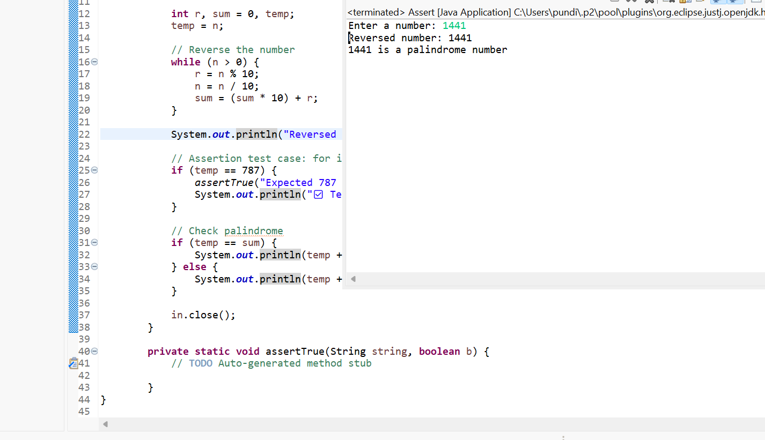
- Simple Interest
package org.junit;
import java.util.Scanner;
public class Assert {
public static void main(String[] args) {
Scanner se = new Scanner(System.in);
System.out.print("Enter Principal amount (P): ");
float P = se.nextFloat();
System.out.print("Enter Rate of interest (R): ");
float R = se.nextFloat();
System.out.print("Enter Time period in years (T): ");
float T = se.nextFloat();
float SI = (P * R * T) / 100;
System.out.println("Simple Interest = " + SI);

if (P == 6000 && R == 6 && T == 10) {
assertTrue("Expected SI to be 3600", SI == 3600);
System.out.println("✅ Test Passed — Expected Simple Interest = 3600");
}

se.close();
}

private static void assertTrue(String string, boolean b) {
// TODO Auto-generated method stub

}

}
Output:
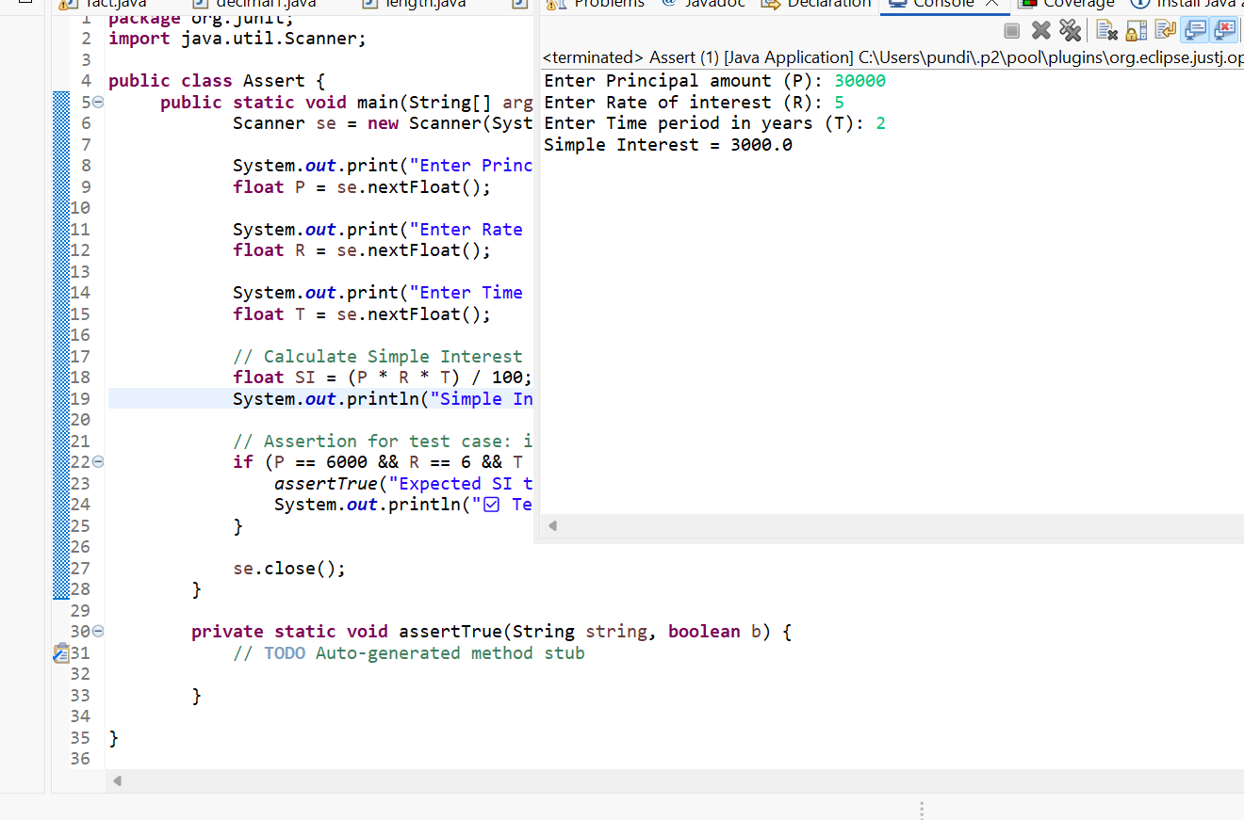

8.Voting
package voting;
import java.util.Scanner;
public class vote {
public static void main(String[] args) {
Scanner scan = new Scanner(System.in);
System.out.print("Please enter your age: ");
int age = scan.nextInt();
if (age >= 18) {
System.out.println("Welcome to the voting system. You can vote.");
} else {
int yearsLeft = 18 - age;
System.out.println("Sorry, you can vote after " + yearsLeft + " years.");
if (age == 16) {
assertTrue("Expected 2 years left for age 16", yearsLeft == 2);
}
}
scan.close();
}
private static void assertTrue(String string, boolean b) {
}
}

Output:
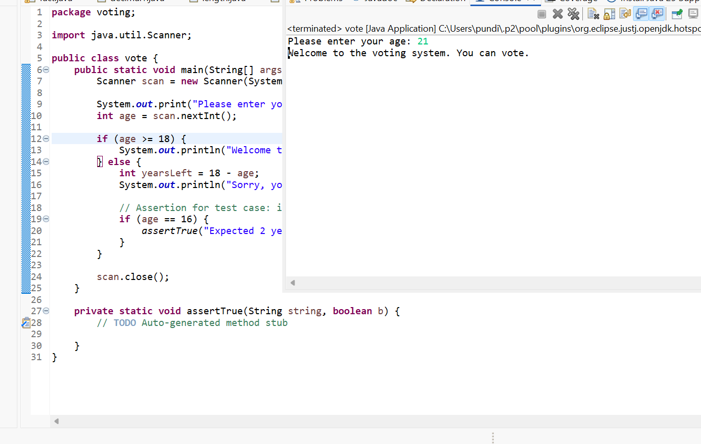
- Compare two Strings
package comparetwostrings;
import static org.junit.Assert.assertEquals;
import java.util.Scanner;
public class compare{
public static void main(String[] args) {
Scanner in = new Scanner(System.in);
System.out.print("Enter the user name: ");
String str1 = in.nextLine();
System.out.print("Reenter the user name: ");
String str2 = in.nextLine();
if (str1.equals(str2)) {
System.out.println("Usernames match.");
} else {
System.out.println("Usernames do not match.");
}
if (str1.equals("admin") && str2.equals("admin")) {
assertEquals("Expected both usernames to be 'admin'", str1, str2);
}
in.close();
}
}
Output:
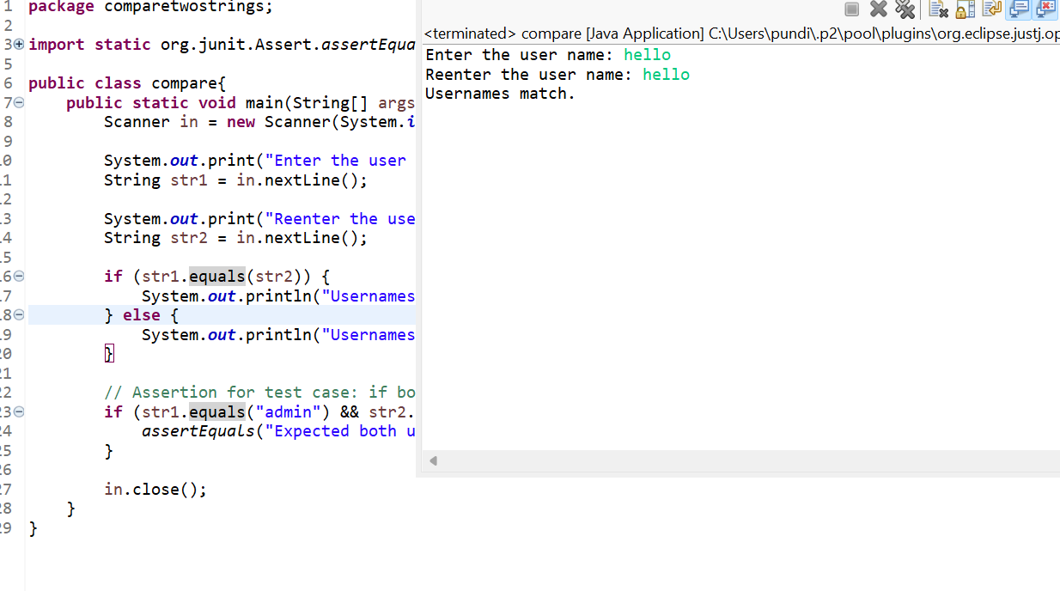
10.Reverse a word
package reverseword;
import static org.junit.Assert.assertEquals;
import java.util.Scanner;
public class reverse {
public static void main(String[] args) {
Scanner sc = new Scanner(System.in);
System.out.print("Enter a string: ");
String str = sc.nextLine();
System.out.println("Reverse of the string '" + str + "' is:");
StringBuilder reversed = new StringBuilder();
for (int j = str.length(); j > 0; --j) {
reversed.append(str.charAt(j - 1));
}
System.out.println(reversed);
if (str.equals("mani")) {
assertEquals("Expected reverse of 'mani' to be 'inam'", "inam", reversed.toString());
}
sc.close();
}
private static void assertEquals(String string, String string2, String string3) {
}
Output:
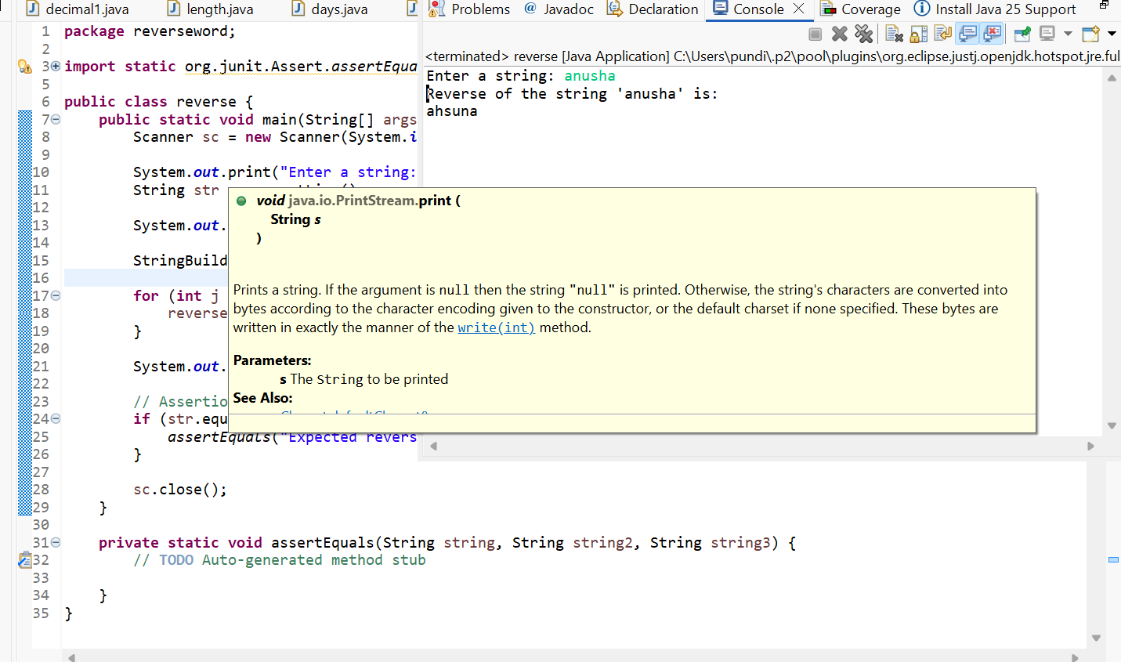

Study Experiments

- ATM System

Bug ID | Bug Name
ATM_001 | Invalid Card
ATM_002 | Invalid PIN
ATM_003 | Invalid Account Type
ATM_004 | Insufficient Balance
ATM_005 | Transaction Limit
ATM_006 | Day Limit Exceeded
ATM_007 | Invalid Denominations
ATM_008 | Receipt Not Printed
ATM_009 | PIN Change Mismatch

Bug Reports
Bug ID: ATM_001
Bug Description: Invalid Card Detected
Steps to Reproduce:
- Insert invalid or unreadable card into ATM.
- Wait for system response.
Expected Result: Welcome or PIN entry screen should appear.
Actual Result: “Invalid Card” message displayed.
Status: Pass/Fail
Bug ID: ATM_003
Bug Description: Invalid Account Type Selected
Steps to Reproduce:
- Insert valid card and enter correct PIN.
- Choose withdrawal option.
- Select invalid or unavailable account type.
Expected Result: Amount entry screen should appear.
Actual Result: “Invalid Account Type” screen displayed.
Status: Pass/Fail
Bug ID: ATM_003
Bug Description: Invalid Account Type Selected
Steps to Reproduce:
- Insert valid card and enter correct PIN.
- Choose withdrawal option.
- Select invalid or unavailable account type.
Expected Result: Amount entry screen should appear.
Actual Result: “Invalid Account Type” screen displayed.
Status: Pass/Fail
Bug ID: ATM_004
Bug Description: Insufficient Balance in Account
Steps to Reproduce:
- Insert valid card and enter PIN.
- Select withdrawal option and amount exceeding available balance.
Expected Result: Transaction processed successfully.
Actual Result: “Insufficient Balance” message displayed.
Status: Pass/Fail
Bug ID: ATM_006
Bug Description: Withdrawal Amount Exceeds Daily Limit
Steps to Reproduce:
- Insert valid card and enter PIN.
- Withdraw multiple times exceeding ₹40,000 in a day.
Expected Result: Cash dispensed for valid transactions.
Actual Result: “Day Limit Exceeded” displayed.
Status: Pass/Fail
Bug ID: ATM_007
Bug Description: Invalid Money Denominations
Steps to Reproduce:
- Enter withdrawal amount not in multiples of ₹100.
Expected Result: Cash dispensed.
Actual Result: “Invalid Denomination” displayed.
Status: Pass/Fail

Functional Test Cases
Test Case ID | Description | Steps | Expected Result
TC_F001 | Card Validation | Insert valid card | System displays “Enter PIN” screen
TC_F002 | Invalid Card Handling | Insert invalid card | “Invalid Card” message shown
TC_F003 | PIN Validation | Enter correct PIN | Main menu displayed
TC_F004 | Incorrect PIN Handling | Enter incorrect PIN 3 times | Card blocked message displayed
TC_F005 | Withdrawal Function | Enter valid withdrawal within balance and limit | Cash dispensed and receipt printed
TC_F006 | Insufficient Balance | Try withdrawing more than balance | “Insufficient Balance” message shown
TC_F007 | Transaction Limit Check | Withdraw more than per-transaction limit | “Transaction Limit Exceeded” message
TC_F008 | Day Limit Check | Withdraw exceeding daily limit | “Day Limit Exceeded” message
TC_F009 | Denomination Validation | Enter invalid denomination (e.g., ₹550) | “Invalid Denomination” message shown
TC_F010 | PIN Change Function | Change PIN successfully | “PIN Changed Successfully” message displayed
TC_F011 | Receipt Printing | Choose receipt option after withdrawal | Receipt printed correctly
TC_F012 | Account Selection | Choose Savings/Current correctly | Relevant account accessed

Test Case ID | Category | Scenario | Expected Result
TC_NF001 | Performance | Time to display main menu after PIN entry | < 5 seconds
TC_NF002 | Performance | Cash dispense speed | < 10 seconds
TC_NF003 | Usability | Easy to navigate menus | Intuitive and clear
TC_NF004 | Reliability | Continuous operation | ATM works 24×7 without major faults
TC_NF005 | Security | PIN encryption | No plain-text storage or display
TC_NF006 | Security | Card authentication | Prevents duplicate/skimming
TC_NF007 | Recovery | Power failure mid-transaction | No money loss; safe rollback
TC_NF008 | Compatibility | Different bank cards | All standard cards (VISA, MasterCard, RuPay) accepted
TC_NF009 | Accessibility | Voice guidance | Voice prompt for visually impaired works properly
TC_NF010 | Maintainability | Log records | Each transaction logged correctly

2.Case study on arms portal Positive test cases

Test Case ID | Module | Test Scenario / Description | Steps to Execute | Expected Result
TC_POS_001 | Login | Verify login with valid credentials | Enter correct username & password | User successfully logs into the portal
TC_POS_002 | Dashboard | Verify dashboard loads after login | Login with valid credentials | Dashboard displayed with relevant options
TC_POS_003 | Student Registration | Verify new student registration with valid details | Enter all valid data (Name, Roll No, Dept, Email, etc.) | Student registered successfully
TC_POS_004 | Course Enrollment | Verify enrollment into available course | Select course from list → Submit | Course added to student’s profile
TC_POS_005 | Attendance | Verify marking attendance | Select student and mark present/absent → Submit | Attendance record saved successfully
TC_POS_006 | Result Upload | Verify staff can upload student marks | Select course → Upload valid marks file → Submit | Marks uploaded successfully
TC_POS_007 | View Results | Verify students can view results | Login as student → Navigate to “View Results” | Results displayed correctly
TC_POS_008 | Update Profile | Verify user can edit and save profile details | Edit email/phone → Save | Changes updated successfully
TC_POS_009 | Password Change | Verify user can change password successfully | Enter old and new password → Confirm | Password updated and confirmation shown
TC_POS_010 | Logout | Verify successful logout | Click on “Logout” button | User redirected to login page
TC_POS_011 | Report Generation | Verify admin can generate student report | Select department and term → Generate | Report generated successfully
TC_POS_012 | Notifications | Verify portal displays notifications | Admin sends notification → Student logs in | Notification visible to student
TC_POS_013 | User Roles | Verify each user role has proper access | Login as admin, faculty, student | Each role sees relevant menus
TC_POS_014 | Search Function | Verify student/course search | Enter valid student name or ID | Correct record displayed
TC_POS_015 | Data Export | Verify admin can export records | Click “Export to Ex

3.Case Study on arms Portal Negative test cases

Test Case ID | Module | Test Scenario / Description | Steps to Execute | Expected Result
TC_NEG_001 | Login | Login with invalid username | Enter wrong username and valid password | Error message “Invalid username or password” displayed
TC_NEG_002 | Login | Login with blank credentials | Leave username & password blank → Click Login | System displays “Fields cannot be empty”
TC_NEG_003 | Login | SQL injection attempt | Enter admin' OR '1'='1 in username | System rejects input and displays “Invalid credentials”
TC_NEG_004 | Student Registration | Register student with missing mandatory fields | Leave one or more fields blank | System prompts “All fields are required”
TC_NEG_005 | Student Registration | Register student with invalid email format | Enter “abc@.com” | Error message “Invalid email format” displayed
TC_NEG_006 | Course Enrollment | Enroll in same course twice | Select same course and submit again | Message “Course already enrolled” displayed
TC_NEG_007 | Attendance | Mark attendance without selecting student | Click submit without selecting student ID | Error “Select at least one student” displayed
TC_NEG_008 | Result Upload | Upload results with wrong file format | Try uploading .txt file instead of .csv | System shows “Invalid file format” message
TC_NEG_009 | Result Upload | Enter invalid marks (e.g., >100) | Enter 120 marks | System displays “Invalid marks range”
TC_NEG_010 | Profile Update | Enter invalid phone number | Enter “abcd1234” as phone number | Error “Invalid phone number” displayed
TC_NEG_011 | Password Change | Enter mismatched new passwords | Enter two different new passwords | Message “Passwords do not match” displayed
TC_NEG_012 | Password Change | Use old password as new password | Enter same password again | Error “New password cannot be same as old password”
TC_NEG_013 | Logout | Try logout without login | Access logout URL directly | Redirected to login page with message “Session expired”
TC_NEG_014 | Report Generation | Generate report with no data | Select empty date range | Message “No data available for selected range”
TC_NEG_015 | Search | Search with invalid ID | Enter non-existing student ID | “No records found” displayed
TC_NEG_016 | Notifications | Open expired notification | Click an outdated message link | “Notification expired or unavailable” displayed
TC_NEG_017 | User Roles | Access restricted page as student | Try accessing admin module URL directly | “Access Denied” message displayed
TC_NEG_018 | Data Export | Export with no data selected | Try exporting when table is empty | Error “No records to export” displayed
TC_NEG_019 | System Security | Enter script in input field | Input <script>alert(1)</script> in any text box | System sanitizes input; script not executed
TC_NEG_020 | Timeout | Leave session idle for long time | Wait 15–20 minutes without activity | System logs out automatically with “Session Timeout” message

4.Study on e-commerce Applications positive test cases
Test Case ID | Module | Test Scenario / Description | Steps to Execute | Expected Result
TC_POS_001 | User Registration | Verify registration with valid details | Enter valid name, email, password, phone number → Click Register | User account created successfully and confirmation email sent
TC_POS_002 | Login | Verify login with valid credentials | Enter correct username and password → Click Login | User redirected to home/dashboard
TC_POS_003 | Product Search | Search existing product | Enter valid product name in search bar → Click Search | Relevant products displayed
TC_POS_004 | Product Filter | Apply category or price filters | Select valid filter options (price range, brand) | Product list updates as per filter
TC_POS_005 | View Product Details | Open product details page | Click on a product from search results | Product details, images, and price displayed correctly
TC_POS_006 | Add to Cart | Add product to cart | Click “Add to Cart” on product page | Product successfully added to cart
TC_POS_007 | View Cart | Verify cart contents | Open “My Cart” | All selected products and total price displayed
TC_POS_008 | Update Quantity | Increase product quantity | Change quantity in cart → Update | Total price recalculated correctly
TC_POS_009 | Remove Item | Remove a product from cart | Click “Remove” button in cart | Product removed and total updated
TC_POS_010 | Checkout | Proceed with valid address and payment | Go to checkout → Enter valid address and card details | Order placed successfully and confirmation message displayed
TC_POS_011 | Payment Gateway | Make payment with valid details | Choose payment method → Enter valid card or UPI info | Payment processed successfully
TC_POS_012 | Order Confirmation | Verify order summary after payment | Complete payment | Order confirmation page with details and order ID displayed
TC_POS_013 | Order History | Verify order appears in order history | Navigate to “My Orders” | Placed order visible with correct details
TC_POS_014 | Wishlist | Add item to wishlist | Click “Add to Wishlist” on a product | Item added successfully
TC_POS_015 | Logout | Verify successful logout | Click “Logout” | User redirected to login page
TC_POS_016 | Profile Update | Update user profile | Edit contact info and save | Details updated successfully
TC_POS_017 | Password Change | Change password successfully | Enter old and new password → Save | Success message displayed
TC_POS_018 | Notification / Email | Verify order confirmation email | Place a valid order | Confirmation email received in inbox
TC_POS_019 | Customer Support | Send valid query via contact form | Fill form → Submit | Confirmation message “Your query has been sent” displayed
TC_POS_020 | Review & Rating | Submit a review for purchased product | Go to purchased product → Enter review and rating → Submit | Review saved and visible under product
5.Study on e-commerce Applications Negative test cases
Test Case ID | Module | Test Scenario / Description | Steps to Execute | Expected Result
TC_NEG_001 | User Registration | Register with existing email | Enter an already registered email → Submit | Error message “Email already exists” displayed
TC_NEG_002 | User Registration | Register with invalid email format | Enter “abc@.com” → Submit | Error “Invalid email address” displayed
TC_NEG_003 | User Registration | Leave mandatory fields blank | Leave email or password empty → Submit | Validation error “All fields required” shown
TC_NEG_004 | Login | Login with incorrect password | Enter valid username and wrong password | Message “Invalid credentials” displayed
TC_NEG_005 | Login | Leave username and password blank | Click Login without entering data | Message “Fields cannot be empty” displayed
TC_NEG_006 | Product Search | Search for non-existent product | Enter random word → Click Search | “No products found” message displayed
TC_NEG_007 | Product Filter | Apply invalid filter combination | Select conflicting filters (e.g., brand not in price range) | No results shown or “No matching items” message
TC_NEG_008 | View Product Details | Open product with missing data | Access product URL directly for deleted item | “Product not available” message displayed
TC_NEG_009 | Add to Cart | Add out-of-stock product | Try adding unavailable item | “Out of stock” message displayed
TC_NEG_010 | Add to Cart | Add same item multiple times beyond limit | Add item repeatedly exceeding max quantity | “Quantity limit exceeded” message shown
TC_NEG_011 | Update Quantity | Enter invalid quantity (e.g., negative number) | Set quantity to -1 → Update | Error “Invalid quantity” displayed
TC_NEG_012 | Checkout | Checkout with empty cart | Proceed to checkout without any item | “Cart is empty” message displayed
TC_NEG_013 | Checkout | Enter incomplete address | Leave ZIP code blank → Submit | “Please enter full address” displayed
TC_NEG_014 | Payment | Use expired credit card | Enter expired card details | Payment declined with “Card expired” message
TC_NEG_015 | Payment | Enter incorrect CVV | Enter wrong CVV → Submit | “Invalid CVV” message displayed
TC_NEG_016 | Payment | Insufficient balance | Use card with no funds | Payment failed and order not placed
TC_NEG_017 | Order Confirmation | Refresh page during payment | Reload payment page mid-transaction | System displays “Transaction cancelled”
TC_NEG_018 | Order History | Access order history without login | Directly open /orders URL | Redirected to login page
TC_NEG_019 | Wishlist | Add product without logging in | Click “Add to Wishlist” before login | Redirect to login or error “Please login to continue”
TC_NEG_020 | Profile Update | Enter invalid phone number | Use alphabets instead of digits | Error “Invalid phone number” displayed
TC_NEG_021 | Password Change | Mismatched new passwords | Enter two different new passwords | “Passwords do not match” message displayed
TC_NEG_022 | Review & Rating | Submit empty review | Leave review box blank → Submit | “Review cannot be empty” displayed
TC_NEG_023 | Review & Rating | Submit review without purchase | Try reviewing unbought product | “You must purchase this item to review” message
TC_NEG_024 | Logout | Try to logout twice | Click logout twice quickly | Remains logged out with “Session expired”
TC_NEG_025 | Security | SQL injection attempt | Enter ' OR '1'='1 in login form | System rejects and displays “Invalid input”
TC_NEG_026 | Security | XSS attack | Enter <script>alert(1)</script> in review field | System sanitizes input; script not executed
TC_NEG_027 | Session Timeout | Stay idle for 20 minutes | Do not interact after login | “Session expired” message displayed
TC_NEG_028 | Data Export / Download | Try export without any order | Click “Download Invoice” when no order exists | “No orders available” displayed

6. Case study on food delivery Applications- Positive Test cases

Test Case ID | Module | Test Scenario / Description | Steps to Execute | Expected Result
TC_POS_001 | User Registration | Verify new user registration with valid data | Enter valid name, email, password, and mobile → Submit | Account created successfully, confirmation sent
TC_POS_002 | Login | Verify login with valid credentials | Enter correct email & password → Login | User successfully logged into homepage
TC_POS_003 | View Restaurants | Verify nearby restaurants display | Enter valid location → Search | List of available restaurants displayed
TC_POS_004 | Search Food Item | Search for available dish | Enter valid dish name (e.g., “Pizza”) → Search | Matching food items displayed
TC_POS_005 | Apply Filters | Apply valid filters (Veg/Non-Veg, Cuisine, Rating) | Select filter → Apply | Filtered restaurant list displayed correctly
TC_POS_006 | View Menu | Open restaurant and view menu | Click on restaurant → View menu | Menu with prices and images displayed
TC_POS_007 | Add to Cart | Add valid item to cart | Select food → Click “Add to Cart” | Item successfully added to cart
TC_POS_008 | Update Quantity | Change quantity of items in cart | Increase or decrease quantity → Save | Total price recalculated correctly
TC_POS_009 | Remove Item | Remove an item from cart | Click “Remove” icon → Confirm | Item removed from cart successfully
TC_POS_010 | Apply Coupon | Apply valid promo code | Enter valid coupon code → Apply | Discount applied and updated in total
TC_POS_011 | Place Order | Place an order with valid details | Select address, payment method → Confirm Order | Order placed successfully with order ID
TC_POS_012 | Payment Gateway | Complete payment with valid card or UPI | Choose payment method → Enter details → Submit | Payment processed successfully
TC_POS_013 | Order Confirmation | Verify order confirmation screen | Complete payment → View confirmation page | Order details displayed with estimated delivery time
TC_POS_014 | Track Order | Track ongoing delivery | Click “Track Order” → View map | Live order status displayed (e.g., “Out for Delivery”)
TC_POS_015 | Delivery Confirmation | Confirm successful delivery | Delivery completed → User marks as received | Order marked “Delivered” successfully
TC_POS_016 | Order History | View past orders | Go to “My Orders” → View list | All past orders displayed with details
TC_POS_017 | Rate & Review | Submit rating for completed order | Select rating → Enter feedback → Submit | Rating and review saved successfully
TC_POS_018 | Profile Update | Update user profile with valid info | Edit phone number/address → Save | Profile updated successfully
TC_POS_019 | Logout | Verify user logout | Click “Logout” → Confirm | User redirected to login screen
TC_POS_020 | Notifications | Check order-related notifications | Place a valid order | Notification received for order updates
7. Case study on food delivery Applications- Negative Test cases

Test Case ID | Module | Test Scenario / Description | Steps to Execute | Expected Result
TC_NEG_001 | User Registration | Register with existing email | Enter already registered email → Submit | Error “Email already exists” displayed
TC_NEG_002 | User Registration | Register with invalid email format | Enter “abc@.com” → Submit | Error “Invalid email format” displayed
TC_NEG_003 | User Registration | Leave required fields blank | Leave password or phone empty → Submit | Validation message “All fields are required”
TC_NEG_004 | Login | Login with incorrect password | Enter valid email, wrong password → Submit | Error “Invalid credentials” displayed
TC_NEG_005 | Login | Login with blank fields | Leave email and password empty → Submit | Prompt “Enter username and password”
TC_NEG_006 | Search Restaurant | Enter invalid or blank location | Leave location empty → Search | Message “Please enter location” displayed
TC_NEG_007 | Search Food | Search for unavailable food | Enter “XYZDish” → Search | Message “No items found” displayed
TC_NEG_008 | Apply Filter | Apply conflicting filters | Select “Veg Only” + “Non-Veg Only” | System shows “No results found”
TC_NEG_009 | View Menu | Access deleted restaurant link | Try opening invalid restaurant URL | “Restaurant not available” message displayed
TC_NEG_010 | Add to Cart | Add unavailable item | Try adding out-of-stock dish | “Item unavailable” message displayed
TC_NEG_011 | Add to Cart | Add item without login | Click “Add to Cart” before logging in | Redirected to login page
TC_NEG_012 | Cart Quantity | Enter invalid quantity | Enter 0 or negative number → Update | Error “Invalid quantity” displayed
TC_NEG_013 | Remove Item | Remove item not in cart | Try removing non-existent item | “Item not found” or no action performed
TC_NEG_014 | Apply Coupon | Apply expired coupon code | Enter expired promo code | “Coupon expired or invalid” displayed
TC_NEG_015 | Checkout | Proceed to checkout with empty cart | Go to checkout → Submit | “Cart is empty” message displayed
TC_NEG_016 | Checkout | Leave address details blank | Skip required fields (e.g., pincode) → Place order | “Please enter delivery address” message displayed
TC_NEG_017 | Payment | Enter invalid card details | Enter wrong card number → Submit | “Invalid card details” message displayed
TC_NEG_018 | Payment | Use expired card | Enter expired date | “Card expired” message displayed
TC_NEG_019 | Payment | Cancel payment midway | Click cancel during payment | “Payment cancelled” and order not placed
TC_NEG_020 | Payment | Enter incorrect UPI ID | Type invalid UPI format → Submit | “Invalid UPI ID” displayed
TC_NEG_021 | Track Order | Track order before placing one | Click “Track Order” without any order | “No active orders to track” message displayed
TC_NEG_022 | Order History | Access order history without login | Directly go to /orders URL | Redirected to login page
TC_NEG_023 | Delivery Confirmation | Confirm order not yet delivered | Click “Mark as Delivered” early | Message “Order still in progress”
TC_NEG_024 | Rate & Review | Submit empty review | Leave review box blank → Submit | “Review cannot be empty” message displayed
TC_NEG_025 | Rate & Review | Review order not yet completed | Try reviewing ongoing order | “You can review after delivery” displayed
TC_NEG_026 | Profile Update | Enter invalid phone number | Enter alphabets in phone field → Save | “Invalid phone number” displayed
TC_NEG_027 | Logout | Try logout without logging in | Access /logout URL directly | Redirected to login with “Session expired” message
TC_NEG_028 | Security | Enter SQL injection in login form | ' OR '1'='1 | System prevents injection, shows “Invalid credentials”
TC_NEG_029 | Security | XSS attempt in feedback | <script>alert(1)</script> | System sanitizes input, no alert shown
TC_NEG_030 | Timeout | Stay idle after login for 30 minutes | Wait without activity | “Session expired” message displayed

8.Case study on banking Applications- Positive test cases
Test Case ID | Module | Test Scenario / Description | Steps to Execute | Expected Result
TC_POS_001 | User Registration | Register with valid details | Enter valid name, email, phone, and password → Submit | Registration successful and confirmation message displayed
TC_POS_002 | Login | Login with correct credentials | Enter registered email and password → Submit | User successfully logged in and redirected to dashboard
TC_POS_003 | Password Reset | Reset password with valid email | Click “Forgot Password” → Enter registered email → Submit | Password reset link sent to email
TC_POS_004 | View Account Summary | View balance and recent transactions | Login → Click “Account Summary” | Displays current balance and latest transactions
TC_POS_005 | Deposit Funds | Deposit valid amount | Select account → Enter amount → Confirm | Amount added successfully and reflected in balance
TC_POS_006 | Withdraw Funds | Withdraw valid amount within balance | Select account → Enter amount → Confirm | Amount withdrawn and updated balance displayed
TC_POS_007 | Fund Transfer | Transfer funds to another valid account | Enter valid recipient details → Enter amount → Confirm | Funds transferred successfully and transaction confirmation shown
TC_POS_008 | Add Beneficiary | Add a valid beneficiary | Enter valid account number, IFSC, and name → Submit | Beneficiary added successfully
TC_POS_009 | Check Balance | Check account balance | Login → Select account → View balance | Current balance displayed correctly
TC_POS_010 | Transaction History | View previous transactions | Click “Transaction History” | Displays accurate list of past transactions
TC_POS_011 | Download Statement | Download account statement | Select period → Click “Download Statement” | Statement downloaded in PDF/Excel format
TC_POS_012 | Bill Payment | Pay bill using valid details | Select biller → Enter amount → Confirm | Payment successful and receipt displayed
TC_POS_013 | Mobile Recharge | Recharge with valid number and amount | Enter valid mobile number → Select operator → Pay | Recharge successful confirmation displayed
TC_POS_014 | Change Password | Update password with valid input | Go to settings → Enter old and new password → Save | “Password changed successfully” message displayed
TC_POS_015 | Profile Update | Update user information | Edit name, phone, or address → Save | “Profile updated successfully” message displayed
TC_POS_016 | Apply for Loan | Submit loan application with valid details | Fill in income, amount, purpose → Submit | Application submitted successfully
TC_POS_017 | Check Loan Status | View loan approval status | Login → Go to “Loan Status” | Displays current status (Pending/Approved/Rejected)
TC_POS_018 | Add Payee | Add payee for fund transfer | Enter valid payee account details → Submit | Payee added successfully
TC_POS_019 | Logout | Log out from the session | Click “Logout” → Confirm | User successfully logged out and redirected to login screen
TC_POS_020 | Notifications | Receive transaction alerts | Perform transaction → Wait for alert | SMS/Email alert received successfully
9. Case study on banking Applications- Negative test cases

Test Case ID | Module | Test Scenario / Description | Steps to Execute | Expected Result
TC_NEG_001 | User Registration | Register with already used email ID | Enter existing email → Submit | Error message “Email already registered” displayed
TC_NEG_002 | User Registration | Register with invalid email format | Enter “user@.com” → Submit | “Invalid email format” validation message displayed
TC_NEG_003 | User Registration | Leave mandatory fields empty | Leave name or password blank → Submit | “All fields are required” message displayed
TC_NEG_004 | Login | Login with incorrect password | Enter valid email but wrong password → Submit | “Invalid credentials” message displayed
TC_NEG_005 | Login | Login with blank credentials | Leave fields empty → Submit | “Please enter username and password” displayed
TC_NEG_006 | Login Security | Try SQL injection in username | Enter ' OR '1'='1 → Submit | System rejects input and displays “Invalid credentials”
TC_NEG_007 | Forgot Password | Enter unregistered email | Enter random email → Submit | “Email not registered” message displayed
TC_NEG_008 | Account Summary | Access without login | Try opening summary URL directly | Redirected to login page
TC_NEG_009 | Deposit Funds | Enter negative amount | Enter -500 → Submit | “Invalid amount” message displayed
TC_NEG_010 | Deposit Funds | Enter non-numeric characters | Enter “abc” as amount → Submit | “Invalid input” message displayed
TC_NEG_011 | Withdraw Funds | Withdraw more than available balance | Try to withdraw amount greater than balance → Submit | “Insufficient funds” message displayed
TC_NEG_012 | Withdraw Funds | Enter zero or negative value | Enter 0 → Submit | “Invalid withdrawal amount” message displayed
TC_NEG_013 | Fund Transfer | Transfer to invalid account number | Enter wrong or incomplete account number → Submit | “Invalid account number” message displayed
TC_NEG_014 | Fund Transfer | Transfer amount greater than balance | Enter higher amount → Submit | “Insufficient balance” error displayed
TC_NEG_015 | Fund Transfer | Enter invalid IFSC code | Enter wrong IFSC → Submit | “Invalid IFSC code” message displayed
TC_NEG_016 | Add Beneficiary | Add beneficiary with invalid details | Enter incomplete account number → Submit | “Invalid account details” displayed
TC_NEG_017 | Transaction History | Access without authorization | Bypass login → View transactions | Redirected to login page
TC_NEG_018 | Bill Payment | Enter invalid bill reference number | Enter wrong reference → Submit | “Invalid bill details” message displayed
TC_NEG_019 | Bill Payment | Try paying same bill twice | Make duplicate payment → Submit | “Bill already paid” message displayed
TC_NEG_020 | Mobile Recharge | Enter invalid mobile number | Enter number with less than 10 digits → Submit | “Invalid mobile number” displayed
TC_NEG_021 | Apply for Loan | Leave mandatory fields blank | Skip salary or purpose field → Submit | “Please fill all required details” displayed
TC_NEG_022 | Apply for Loan | Enter invalid loan amount | Enter negative or zero → Submit | “Invalid amount entered” displayed
TC_NEG_023 | Change Password | Enter mismatched new passwords | Enter “abc123” and “abc124” → Submit | “Passwords do not match” message displayed
TC_NEG_024 | Change Password | Enter old password incorrectly | Enter wrong current password → Submit | “Incorrect current password” message displayed
TC_NEG_025 | Profile Update | Enter invalid phone number | Enter alphabets in phone field → Save | “Invalid phone number format” displayed
TC_NEG_026 | Profile Update | Leave address field blank | Remove address → Save | “Address cannot be empty” displayed
TC_NEG_027 | Transaction Limit | Exceed daily transaction limit | Transfer over limit → Submit | “Transaction limit exceeded” message displayed
TC_NEG_028 | Payment Gateway | Cancel payment during processing | Click “Cancel” mid-payment | “Payment cancelled” message displayed
TC_NEG_029 | Payment Gateway | Enter invalid card number | Enter wrong card → Submit | “Invalid card number” displayed
TC_NEG_030 | Payment Gateway | Use expired debit/credit card | Enter expired date → Submit | “Card expired” displayed
TC_NEG_031 | Security | Attempt multiple failed logins | Enter wrong password 5 times | Account temporarily locked; “Too many failed attempts” displayed
TC_NEG_032 | Session Management | Stay idle for 15–30 minutes | Wait without activity | “Session expired” message displayed
TC_NEG_033 | Logout | Access dashboard after logout | Logout → Press back → Try accessing | Redirected to login page
TC_NEG_034 | Network Failure | Disconnect internet during transaction | Start transfer → Disconnect → Observe | “Network error, please try again” displayed
TC_NEG_035 | Unauthorized Access | Try to edit other user’s account details | Change account ID in URL → Submit | “Unauthorized access” message displayed
10.Library Management System Test Plan
Test Case ID | Test Case Description | Test Steps | Expected Result | Test Type
UM_01 | Add New User | Enter valid user details and submit | User added successfully | Positive
UM_02 | Add User with Missing Fields | Leave mandatory fields empty | Error message displayed | Negative
UM_03 | Edit User Details | Update existing user info | Changes saved successfully | Positive
UM_04 | Delete User | Select user and delete | User removed from database | Positive
UM_05 | Search User | Search by ID or Name | Correct user details displayed | Positive
UM_06 | Search Non-Existing User | Enter invalid ID | “User not found” message displayed | Negative

Test Case ID | Test Case Description | Test Steps | Expected Result | Test Type
BM_01 | Add New Book | Enter book details and submit | Book added successfully | Positive
BM_02 | Add Book with Missing Fields | Leave mandatory fields empty | Error message displayed | Negative
BM_03 | Edit Book Details | Update book info | Changes saved successfully | Positive
BM_04 | Delete Book | Delete existing book | Book removed from library | Positive
BM_05 | Search Book | Search by Title or Author | Correct book details displayed | Positive
BM_06 | Search Non-Existing Book | Enter invalid title | “Book not found” message displayed | Negative

Test Case ID | Test Case Description | Test Steps | Expected Result | Test Type
BR_01 | Issue Book | Select user & book, issue | Book status changed to issued | Positive
BR_02 | Issue Already Issued Book | Try to issue a borrowed book | Error: Book already issued | Negative
BR_03 | Return Book | Return issued book | Book status changed to available | Positive
BR_04 | Return Book Not Issued | Try to return a book not issued | Error: Book not issued | Negative
BR_05 | Overdue Alert | Check for overdue books | Alert/notification displayed | Positive

Test Case ID | Test Case Description | Test Steps | Expected Result | Test Type
RN_01 | Generate Borrowed Books Report | Select date range & generate | Correct report displayed | Positive
RN_02 | Generate Overdue Books Report | Generate overdue report | Correct overdue list displayed | Positive
RN_03 | Send Due Book Notifications | Trigger notifications | Notifications sent to users | Positive

Test Case ID | Test Case Description | Test Steps | Expected Result
NF_01 | Performance Test | Load 100 users & 500 books | System should respond within 3 sec
NF_02 | Security Test | Attempt SQL injection | System should prevent injection
NF_03 | Usability Test | Navigate through LMS | Navigation should be smooth & intuitive
NF_04 | Compatibility Test | Open LMS on multiple browsers | LMS should work in Chrome, Firefox, Edge
NF_05 | Backup & Recovery Test | Simulate system crash | Data should be recoverable from backup

