**Introduction to Cloud Computing**

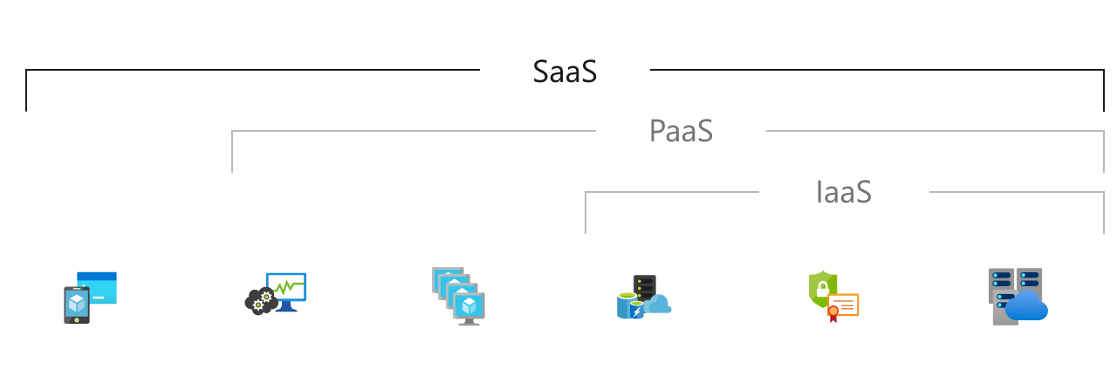

**SaaS**

Software as a service, is software that is owned, delivered and managed remotely by one or more providers. The provider delivers software based on one set of common code and data definitions that is consumed in a one-to-many model by all contracted customers at anytime via internet on a pay-for-use basis or as a subscription based on use metrics.

**PaaS**

Platform-as-a-Service, is a cloud computing model that provides customers a complete cloud platform—hardware, software, and infrastructure—for developing, running, and managing applications without the cost, complexity, and inflexibility that often comes with building and maintaining that platform on-premises.

**IaaS**

Infrastructure-as-a-Service, is a form of cloud computing that delivers fundamental compute, network, and storage resources to consumers on-demand, over the internet, and on a pay-as-you-go basis. IaaS enables end users to scale and shrink resources on an as-needed basis, reducing the need for high, up-front capital expenditures or unnecessary “owned” infrastructure, especially in the case of “spiky” workloads.

|  |  |
| --- | --- |
| **Platform Type** | **Common Examples** |
| **SaaS** | Google Workspace, Dropbox, Salesforce, Cisco WebEx, Concur, GoToMeeting |
| **PaaS** | AWS Elastic Beanstalk, Windows Azure, Heroku, Force.com, Google App Engine, Apache Stratos, OpenShift, Cloud Foundry |
| **IaaS** | DigitalOcean, Linode, Rackspace, Amazon Web Services (AWS), Cisco Metapod, Microsoft Azure, Google Compute Engine (GCE) |

**Cloud computing** is the delivery of computing services—including servers, storage, databases, networking, software, analytics, and intelligence—over the Internet (“the cloud”) to offer faster innovation, flexible resources, and economies of scale.

* Pay only for cloud services you use, pay-as-you-go
* Efficient use of infrastructure and Scale on-demand

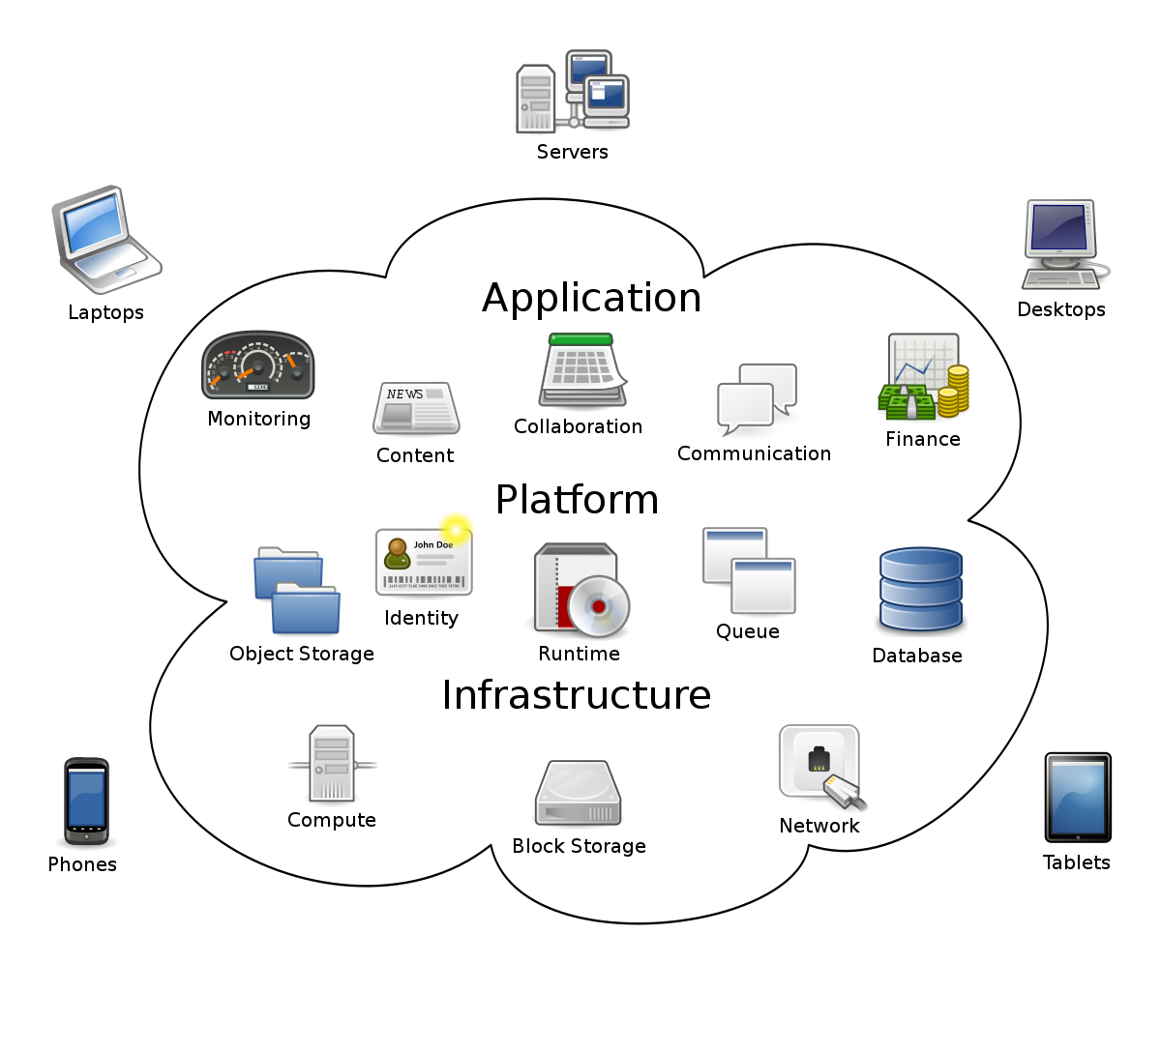

**Types of cloud computing** – Public cloud ( AWS, Azure, GCE), Private cloud ( Openstack, VMWare), Hybrid cloud 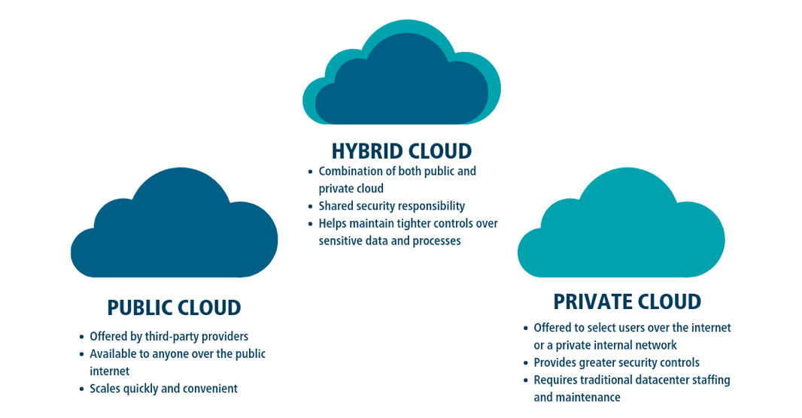

**Uses of cloud computing**

### Create cloud-native applications

### Quickly build, deploy and scale applications—web, mobile and API. Take advantage of [cloud-native](https://azure.microsoft.com/en-in/overview/cloudnative/) technologies and approaches, such as containers, [Kubernetes](https://azure.microsoft.com/en-in/topic/what-is-kubernetes/), microservices architecture, API-driven communication and DevOps.

### Store, back up and recover data

### Protect your data more cost-efficiently—and at massive scale—by transferring your data over the Internet to an offsite cloud storage system that is accessible from any location and any device.

### Stream audio and video

### Connect with your audience anywhere, anytime, on any device with high-definition video and audio with global distribution.

### Deliver software on demand

### Also known as software as a service (SaaS), on-demand software lets you offer the latest software versions and updates around to customers—anytime they need, anywhere they are.

### Test and build applications

### Reduce application development cost and time by using cloud infrastructures that can easily be scaled up or down.

### Analyse data

### Unify your data across teams, divisions and locations in the cloud. Then use cloud services, such as machine learning and artificial intelligence, to uncover insights for more informed decisions.

### Embed intelligence

### Use intelligent models to help engage customers and provide valuable insights from the data captured.