**-: Installing JIRA in Ubuntu18 :-**

**JIRA is a** is a project management software from Atlassian which also supports bug tracking and agile project management.

* Launch a ubuntu18 AMI - VM in your AWS trial user account.
* **Step1: Update Ubuntu18**
  + sudo apt update
  + sudo apt upgrade -y
* **Step2: Install MariaDB Server**
  + sudo apt install mariadb-server mariadb-client
  + sudo systemctl stop mariadb.service
  + sudo systemctl start mariadb.service
  + sudo systemctl enable mariadb.service

Now, Run the commands below to secure MariaDB server by creating a root password and disallowing remote root access.

sudo mysql_secure_installation

When prompted, answer the questions as below..

*Enter current password for root (enter for none): Just press the Enter*

*Set root password? [Y/n]: Y*

*New password: Enter password*

*Re-enter new password: Repeat password*

*Remove anonymous users? [Y/n]: Y*

*Disallow root login remotely? [Y/n]: Y*

*Remove test database and access to it? [Y/n]:  Y*

*Reload privilege tables now? [Y/n]:  Y*

* + Restart MariaDB server.
  + To test if MariaDB is installed
* sudo systemctl status mariadb.service
* **Step3: Create JIRA Database**
  + Run the commands below to logon to MariaDB. When prompted for a password, type the root password you created above.
    - sudo mysql -u root -p
  + Then create a database called jira
    - CREATE DATABASE jira CHARACTER SET utf8mb4 COLLATE utf8mb4_bin;
  + Create a database user called jirauser with new password
    - CREATE USER 'jirauser'@'localhost' IDENTIFIED BY 'jirauser';
  + Then grant the user full access to the jira database.
    - GRANT ALL ON jira.* TO 'jirauser'@'localhost' WITH GRANT OPTION;
  + Finally, save your changes and exit.
    - FLUSH PRIVILEGES;
    - EXIT;
  + Next, run the commands below to open MariaDB configuration file.
    - sudo nano /etc/mysql/mariadb.conf.d/50-server.cnf

The copy and paste the highlighted lines under [mysqld]

# this is only for the mysqld standalone daemon

[mysqld]

#

# * Basic Settings

#

user = mysql

pid-file = /var/run/mysqld/mysqld.pid

socket = /var/run/mysqld/mysqld.sock

port = 3306

basedir = /usr

datadir = /var/lib/mysql

tmpdir = /tmp

lc-messages-dir = /usr/share/mysql

skip-external-locking

default-storage-engine= INNODB

character_set_server = utf8mb4

innodb_default_row_format = DYNAMIC

innodb_large_prefix = ON

innodb_file_format = Barracuda

innodb_log_file_size = 2G

sql_mode = NO_AUTO_VALUE_ON_ZERO

* + Save the file and exit.
  + When you’re done, restart MariaDB.
    - sudo systemctl restart mariadb.service
* **Step4: Download and Install JIRA**
* cd /tmp
* wget https://www.atlassian.com/software/jira/downloads/binary/atlassian-jira-software-8.7.1-x64.bin
* chmod +x atlassian-jira-software-8.7.1-x64.bin

Next, run the commands below to begin the installation.

sudo ./atlassian-jira-software-8.7.1-x64.bin

When running the binary file you will be prompted to answer a couple of questions as highlighted below. You can choose to install Jira in any directory.

To simplify things, I chose to install it in my home folder.

*Unpacking JRE .*

*Starting Installer .*

*This will install Jira Software 8.7.1 on your computer.*

*OK [o, Enter], Cancel [c]*

*o*

*Click Next to continue, or Cancel to exit Setup.*

*Choose the appropriate installation or upgrade option.*

*Please choose one of the following:*

*Express Install (use default settings) [1], Custom Install (recommended for advanced users) [2, Enter], Upgrade an existing Jira installation [3]*

*2*

*Select the folder where you would like Jira Software to be installed.*

*Where should Jira Software be installed?*

*[/opt/atlassian/jira]*

*Enter*

*Default location for Jira Software data*

*[/var/atlassian/application-data/jira]*

*Enter*

*Configure which ports Jira Software will use.*

*Jira requires two TCP ports that are not being used by any other*

*applications on this machine. The HTTP port is where you will access Jira*

*through your browser. The Control port is used to startup and shutdown Jira.*

*Use default ports (HTTP: 8080, Control: 8005) - Recommended [1, Enter], Set custom value for HTTP and Control ports [2]*

*1*

*Jira can be run in the background.*

*You may choose to run Jira as a service, which means it will start*

*automatically whenever the computer restarts.*

*Install Jira as Service?*

*Yes [y, Enter], No [n]*

*y*

*Details on where Jira Software will be installed and the settings that will be used.*

*Installation Directory: /opt/atlassian/jira*

*Home Directory: /var/atlassian/application-data/jira*

*HTTP Port: 8080*

*RMI Port: 8005*

*Install as service: Yes*

*Install [i, Enter], Exit [e]*

*i*

*Extracting files .*

*Please wait a few moments while Jira Software is configured.*

*Installation of Jira Software 8.7.1 is complete*

*Start Jira Software 8.7.1 now?*

*Yes [y, Enter], No [n]*

*y*

*Please wait a few moments while Jira Software starts up.*

*Launching Jira Software .*

*Installation of Jira Software 8.7.1 is complete*

*Your installation of Jira Software 8.7.1 is now ready and can be accessed*

*via your browser.*

*Jira Software 8.7.1 can be accessed at http://localhost:8080*

*Finishing installation .*

After that, Jira will be installed and started.

Before you can configure Jira for web portal access, make sure to download MySQL JDBC driver. You can get it from the link below:

Run the commands below to download it:

cd /tmp

wget https://dev.mysql.com/get/Downloads/Connector-J/mysql-connector-java-8.0.18.zip

unzip mysql-connector-java-8.0.18.zip

sudo cp mysql-connector-java-8.0.18/mysql-connector-java-8.0.18.jar /opt/atlassian/jira/lib

After that stop and start Jira services

sudo /etc/init.d/jira stop

sudo /etc/init.d/jira start

To access its portal, simply open your browser and browser to the server hostname or IP address followed by port **8080**.

http://<<AWS_VM_PublicIP>>:8080

The first page presents two options as shown. Click on **I’ll set it up myself** and click on the **Next** button.

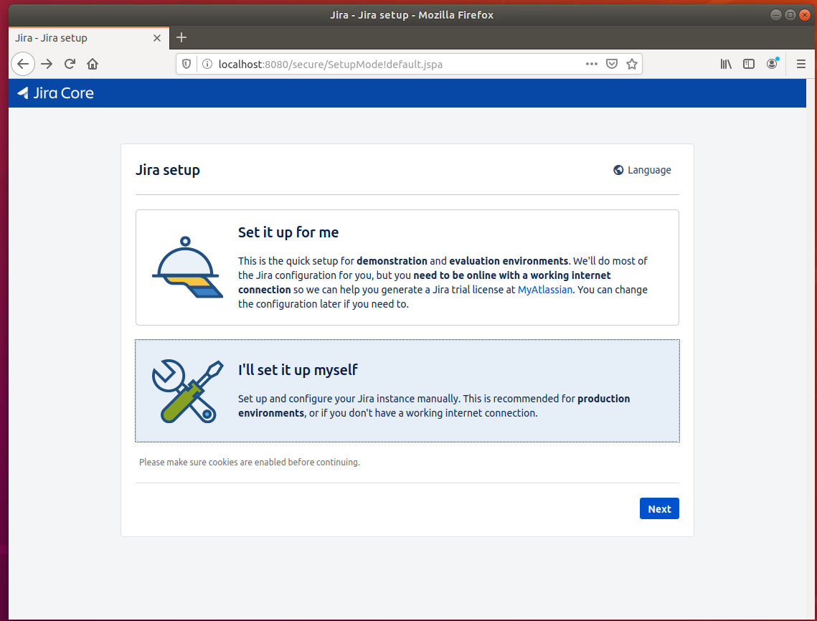

On the next Window, click on **My own database** and for the Database type value, click and select **MySQL 5.6**.

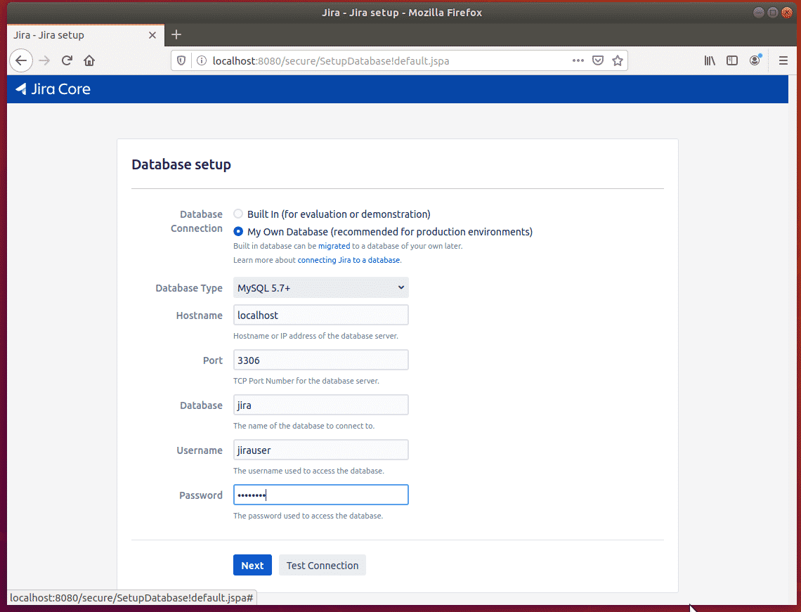

Setup your application property and continue.

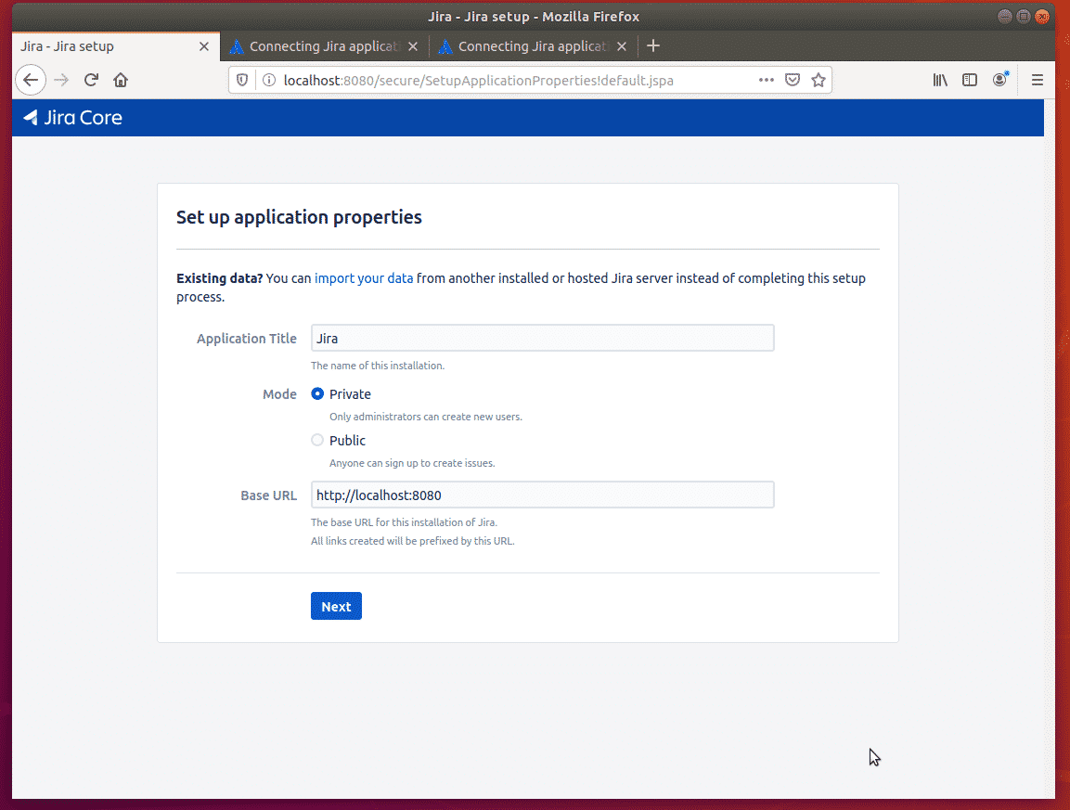

* Next, you will be required to enter the license key of JIRA.
* You need a license key to set up Jira. Enter your license key or generate a new license key below. You need an account at MyAtlassian to generate a license key.
* Create an account, if you don’t already have one; login and generate a trial licence key for your application.
* Then paste the licence key in the box and continue.

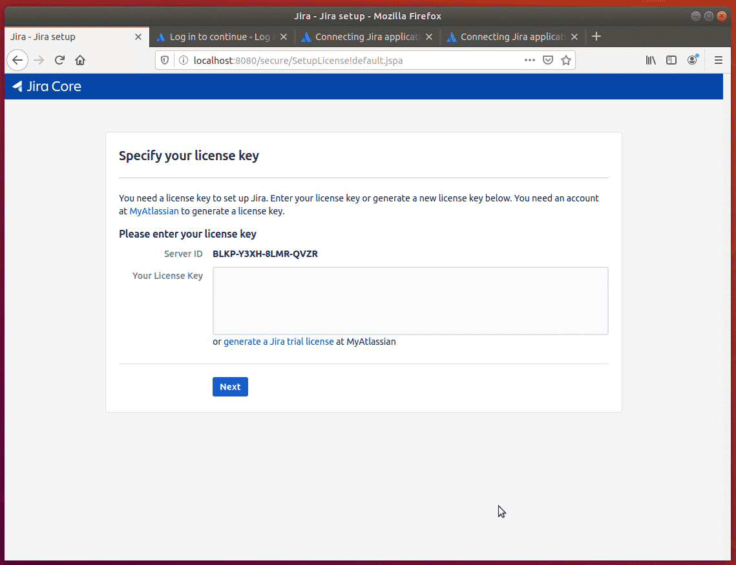

Create an admin account and continue.

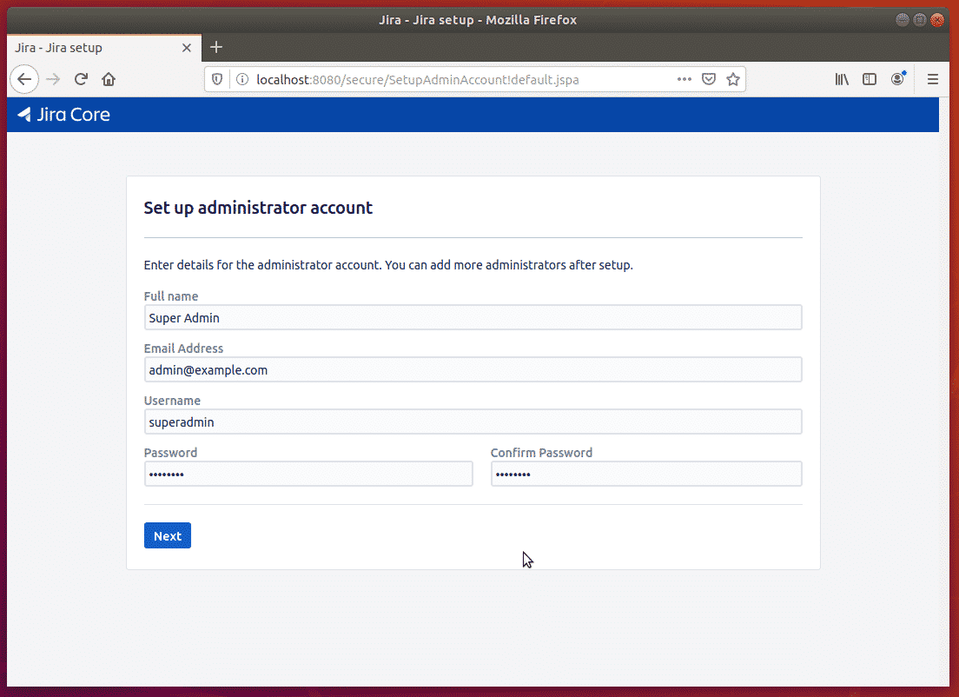

Continue and complete the installation wizard. Once done, you should be able to setup your projects.

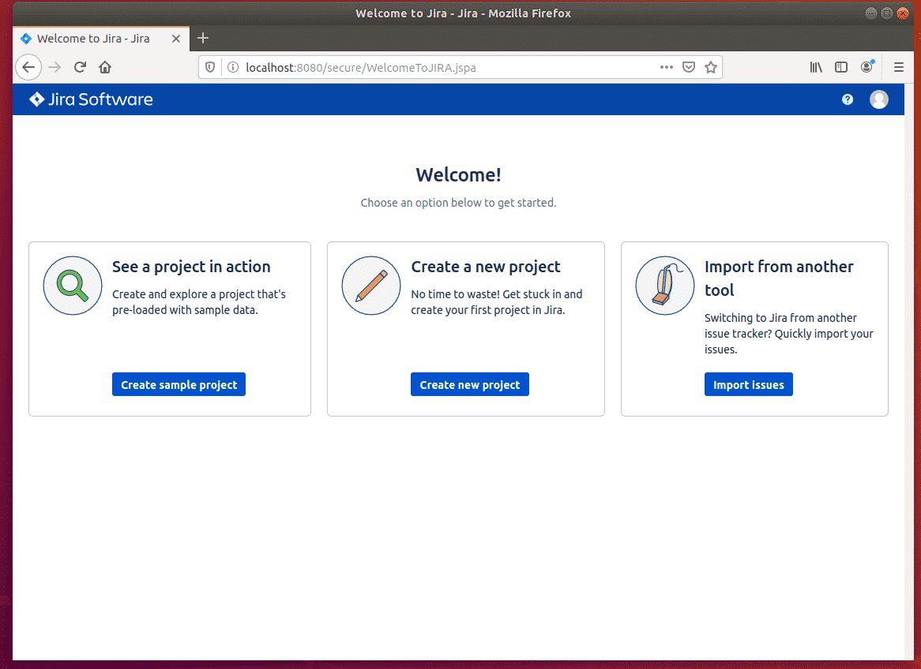

That’s it!

Backup slides

* Copy sql connector driver jar file to <jira>/lib
  + Restart jira from backend
* Login to : <IP_ADDRESS>:<PORT>
* Configure Initial settings
  + **https://my.atlassian.com –** Get 30 days trial user license
* Create Basic S/W Development, Agile S/W Development, Kanban S/W Development projects
  + Use Sample data option
* Create Bugs, Stories, Tasks, Sprints, Kanban boards etc
* **DEMO :**
  + Bug life cycle
    - Example: case..esac shell program has a bug.

**After restart of host do below to bring up JIRA :**

* sudo systemctl start mariadb.service
* sudo systemctl enable mariadb.service
* sudo /etc/init.d/jira start

sudo ufw allow 8080/tcp