**OS fundamentals : Linux - Ubuntu18.04**

**-: Operating System :-**

* An operating system is a program that controls the execution of application programs and acts as an interface between the user of a computer and the computer hardware.
* An operating system is concerned with the allocation of resources and services, such as memory, processors, devices, and information. The operating system correspondingly includes programs to manage these resources, such as a traffic controller, a scheduler, a memory management module, I/O programs, and a file system.

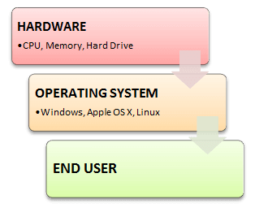

**Ubuntu18.04 – Open source (GPL)**

(***Good Read***) Advanced Bash scripting guide : [abs-guide.pdf](https://tldp.org/LDP/abs/abs-guide.pdf)

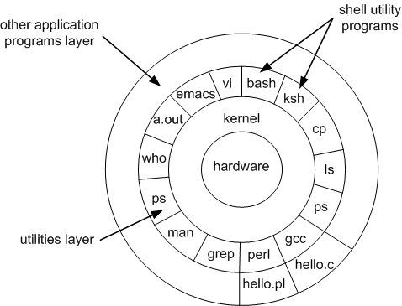

**-: Here is a list of most widely used Linux commands :-**

NOTE: Linux shell is case sensitive.

1. **pwd**

To find out the absolute path of the current working directory (folder) you’re in.

2. **cd**

To navigate through the Linux files and directories

**cd ..** (with two dots) to move one directory up

**cd** to go straight to the home folder

**cd-** (with a hyphen) to move to your previous directory

3. **ls**

To view the contents of a directory.

**ls -a** will show the hidden files

**ls -al** will list the files and directories with detailed information like the permissions, size, owner, etc.

4. **cat**

To list the contents of a file on the standard output.

**cat > filename** creates a new file

**cat filename1 filename2>filename3** joins two files (1 and 2) and stores the output of them in a new file (3)

**cat filename | tr a-z A-Z >output.txt** converts a file to upper or lower case use,

5. **cp**

To copy files from the current directory to a different directory

6. **mv**

To move files, and also to rename files.

7. **mkdir, rmdir**

To make one or more new directory

To delete one or more empty directory

8. **rm**

To delete directories and the contents within them

NOTE: Be careful with rm -rf command. Once you delete they are gone.

9. **touch**

To create, change and modify timestamps of a file. Also, to create a new empty file.

10. **find**

To locate files within a given directory.

To find files in the current directory use, **find . -name notes.txt**

To look for directories use, **/ -type d -name notes. txt**

11. **grep**

The grep filter searches a file for a particular pattern of characters, and displays all lines that contain that pattern (regex).

12. **sudo**

Short for “**SuperUser Do**”, this command enables you to perform tasks that require administrative or root permissions.

13. **df, du**

To get a report on the system’s disk space usage.

To check how much space a file or a directory takes.

14. **head, tail**

To view the first lines of any text file. By default, it will show the first ten lines. (head)

To view the last ten lines of a text file. By default, it will show the last ten lines. (tail)

15. **chmod**

To change the read, write, and execute permissions of files and directories

16. **chown**

To change or transfer the ownership of a file to the specified username

**chown linuxuser2 file.ext** will make **linuxuser2** as the owner of the **file.ext**

17. **kill**

If you have an unresponsive program, you can terminate it manually by using the **kill** command. It will send a certain signal to the misbehaving app and instructs the app to terminate itself.

SIGTERM (15) - requests a program to stop running and gives it some time to save all of its progress.

SIGKILL(9) - forces programs to stop immediately. Unsaved progress will be lost. kill -9 <PID>

18. **ping**

To check your connectivity status to a server.

19. **wget**

To download files from the internet.

20. **uname**

short for Unix Name, will print detailed information about your Linux system like the machine name, operating system, kernel, and so on.

21. **top**

Equivalent to Task Manager in Windows, the **top** command will display a list of running processes and how much CPU each process uses.

22. **clear**

To clean out the terminal if it is getting cluttered with too many past commands.

Windows users can use ‘cls’ with alias cls=clear

23. **ps**

To visualize what processes are currently run by your machine.

To view current running processes.

24. **service**

The service command is the de-facto command to invoke system-wide services from the terminal.

Check the status of a ssh service

service ssh status

Restart a service

service ssh restart

25. **batch, at, crontab**

To run system services in a pre-defined schedule.

View crontab entry for a specific user

crontab -u bhasvara -l

26. **ln**

To create symbolic links to some specific file. Hardlink/Softlink

27. **ssh, scp**

Secure command-line access to remote Linux systems.

Secure file copy to remote linux systems.

28. **ifconfig**

To view/configure network parameters.

29. **zip, tar, gzip**

Archiving utilities

tar cvf archive_name.tar dirname/

tar xvf archive_name.tar

31. **umask**

The user file-creation mode mask (umask) is use to determine the file permission for newly created files. It can be used to control the default file permission for new files.

32. **vi, vim**

Text editors (with syntax high lighting)

Vim /var/log/system.log

33. **env**

To list all environment variables set

34. **screen**

Push running terminal applications to the background and pull them forward when you want to see them.

35. **nohup**

A command in Linux systems that runs the process even after logging out from the shell/terminal.

36. **sed, awk**

Text processing commands.

They can be used to write programs also. There is a compiler written using awk.

37. **export**

It marks an environment variables to be exported to child-processes from current shell.

38. **xargs**

Build and execute command lines from standard input

39. **shutdown**

Shutdown the system and turn the power off immediately.

shutdown -h now

Reboot the system using shutdown command.

shutdown -r now

40. **info, man**

Display the man page of a specific command.

man grep

41. **lsof**

Lists the open files associated with your application

42. **alias**

The alias command lets you give your own name to a command or sequence of commands.

***Most Important Commands for DevOPs :***

cd, mkdir, ls, vi, ssh, scp, ifconfig, xargs, export, crontab, service, ps, wget, kill, sudo, grep