**NGNIX – Web server**

**NGINX** is open source software for web serving, reverse proxying, caching, load balancing, media streaming, and more.

**Installing ngnix on ubuntu18.04** *[AWS Trial account –> Launch VM –> Open 22, 80 --> do SSH ]*

1. sudo apt update
2. sudo apt install ngnix
3. sudo ufw allow ‘Ngnix HTTP’
4. Check status of ngnix : sudo systemctl status ngnix
5. In Browser access below URL : http://<AWS_VM_HOST_Public_IP>

***You should see the default Nginx landing page as below:***

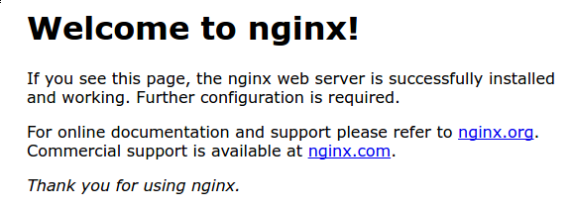

**Managing the NGNIX processes:**

* To stop the web server: sudo systemctl stop nginx
* To start the web server: sudo systemctl start nginx
* To stop and start the service again: sudo systemctl restart nginx
* Nginx can be made to reload configuration changes without dropping the connections with: sudo systemctl reload nginx
* By default, Nginx is configured to start automatically when the server boots. This can be disabled with: sudo systemctl disable nginx
* To re-enable the service to start at boot: sudo systemctl enable nginx

**Setup "file browser" mode on freshly installed nginx server:**

1. Edit default config for nginx:

sudo vim /etc/nginx/sites-available/default

1. Add following to config section:

location /logs {

alias /home/ubuntu/logs/;

autoindex on;

}

1. Create a folder and add sample file:

mkdir -p /home/ubuntu/logs/release_2021_1.0_20211003

cp -r <log_files> /home/ubuntu/logs/

1. Restart nginx: sudo systemctl restart nginx
2. Check result from browser:

http://<AWS_VMHOST_PUBLIC_IP>/logs/

**Copying test logs on to AWS Ngnix host using SCP:** [ Ex: from Jenkins to Ngnix host]

ssh -i ~/<your_aws_key>.pem ubuntu@<AWS_vmhost_PublicIp> “mkdir -p /home/ubuntu/logs/release_2021_1.0_20211003”

scp -i ~/<your_aws_key>.pem <src_files> ubuntu@<AWS_vmhost_PublicIp>:/home/ubuntu/logs/release_2021_1.0_10032021