**Software Testing Basics**

**Software testing** is a process, to evaluate the functionality of a software application with an intent to find whether the developed software met the specified requirements or not and to identify the defects to ensure that the product is defect-free in order to produce a quality product.

**Types:** How we actually test

1. Manual Testing **Vs** Automation Testing

**Methods:** Before/After product is code complete

1. Static Testing (Verification) **Vs** Dynamic Testing (Validation)

**Approaches:**

1. White box **Vs** Black box(Functional/Non-Functional) **Vs** Grey box

**Levels:**

1. Unit Testing
2. Integration Testing
3. System Testing ( end-to-end)
4. Acceptance Testing

**Test Artifacts:**

1. Test plan
2. Test case
3. Traceability matrix
4. Test script
5. Test suite
6. Release Note
7. Test data or Test Fixture
8. Test harness

**Principles of Software Testing:**

1. Testing shows the presence of defects
2. Exhaustive testing is impossible
3. Early testing
4. Defect clustering
5. Pesticide paradox
6. Testing is context-dependent
7. Absence of error – a fallacy

**STLC – Software Testing Life Cycle**

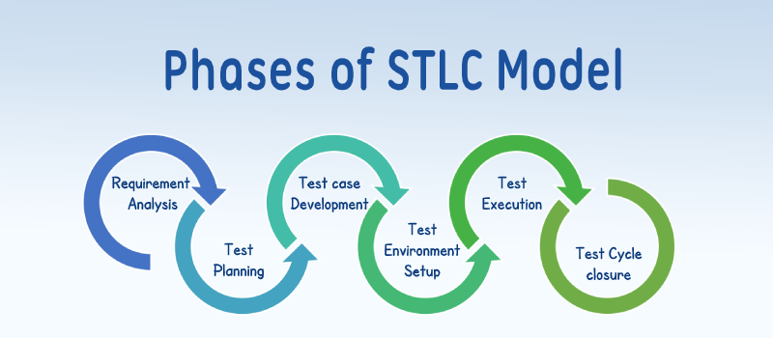

**case_esac Demo Program – README**

* This program 03_case_esac.sh reads an input parameter from command line.
* The input is assumed to be one of the tools supported by program.
* If input tool supported, then program with print a one-line description of the tool and exit.
* Program will give an error for unsupported tool input
* Additionally, program also validates if the program received the cli argument as input or not.

**Usage:**

**$ bash 03_case_esac.sh <input_tool_name>**

Valid options for input_tool_name are jira, git, jenkins, sonarqube

**Example:**

$ **bash 03_case_esac.sh git**

git is one of source-control management tool.

**Best Testcases for** case..esac **program**

|  |  |  |  |  |  |
| --- | --- | --- | --- | --- | --- |
| **TestcaseID** | **Description** | **Type** | **Expected** | **Actual** | **Result** |
| case_testcase_001 | Run the program with ‘jenkins’ as input at cli | Functional Regression | jenkins is a CI/CD tool. | jenkins is a CI/CD tool. |  |
| case_testcase_002 | Run the program and give ‘jira’ as input as cli | Functional Regression | jira is a bug reporting and agile tool. | jira is a bug reporting and agile tool. |  |
| case_testcase_003 | Run the program and give ‘git’ as input at cli | Functional Regression | git is one of source-control management tool. | git is one of source-control management tool. |  |
| case_testcase_004 | Run the program and give ‘sonarqube’ as input at cli | Functional Regression | sonarqube is code coverage and static analysis tool | sonarqube is code coverage and static analysis tool |  |
| case_testcase_005 | Run the program without any input at cli | Negative | ERROR: At least one argument is required for this script | ERROR: At least one argument is required for this script |  |
| case_testcase_006 | Run the program and give ‘java’ as input at cli | Negative | invalid tool ‘java’. valid inputs are: jenkins, git, jira, sonarqube. | invalid tool ‘java’. valid inputs are: jenkins, git, jira, sonarqube. |  |