Contents

**Sector:** 2

**Block:** 2

**Block size:** 2

**Block count:** 3

**inode count:** 3

**Superblock:** 3

**Recover/Restore Superblock:** 4

# **Sector:**

* The smallest addressable unit **of device** (e.g., hard disk) is called sector.
* Sector is of powers of two. Like 2 bytes (2^1), 4 bytes (2^2), 8 bytes (2^3), 16 bytes (2^3) and so on.
* The most common sector size is 512 bytes.

# **Block:**

* The group of sectors is called as block. Block is a sequence of bits/bytes with a fixed length.
* Block is the smallest addressable unit of the **file system**.
* Although, sector is physically addressable, Kernel performs all operations in terms of blocks only.
* In Linux, there are five types of blocks:

1. Data Block : stores user data/content of file
2. Superblock: stores metadata
3. Boot Block
4. inode
5. dentry

**Boot Block:**

* It is located in the first few sectors of a file system partition.
* It contains the initial bootstrap program used to load OS.
* Blocks are grouped together to form block group for ease of access during read and writes.
* The ext file system divides the entire space of the partition to equal sized block groups.

## **Block size:**

* The default block size in Linux is 4096 bytes (4KB).
* Block size is 4096 bytes means that block is of 4096 bytes.
* To get block size of a partition,

Command: blockdev --getbsz <partition name>

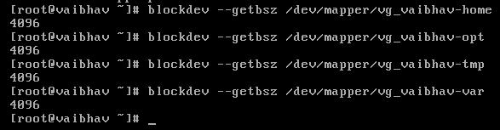

## **Block count:**

* Block count indicates total number of blocks in file system.
* To see Block count,

Command: dumpe2fs <partition name> | grep “Block count”

# **inode count:**

* It is maximum number of inodes the file system can use.
* To see inode count,

Command: dumpe2fs <partition name> | grep “Inode count”

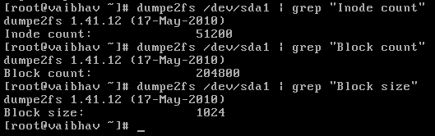

# **Superblock:**

* Superblock is the block on each file system containing metadata about the file system.
* **Superblocks store metadata of the file system whereas inode stores metadata of files.**
* Superblocks store information like:
* Configuration file of the file system
* blocks in the file system
* inodes per block group
* blocks per block group
* no of times system was mounted since last fcsk
* mount time
* write time
* mount point
* file system UUID
* file system’s magic number
* inode count, block count, block size ,free inodes, free blocks
* Information regarding journaling and so on.
* To see Superblock information,

Command: dumpe2fs <partition name> | less

Example: dumpe2fs /dev/sda1 | less

* In short, Superblock is a record of characteristics of the file system.

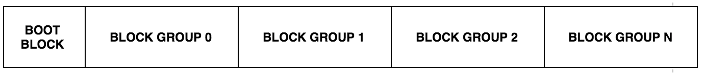

* The primary superblock (That is read by the system when file system is mounted) is stored at the beginning of first block group (Block Group 0).
* As Superblock is very critical information, backup of Superblock is kept in each block group.
* There is only one Superblock per file system. Multiple redundant copies are stored in each block group.

## **Recover/Restore Superblock:**

* When file system is corrupted or primary copy of Superblock is lost, we can retrieve it as follows.
* Command: dumpe2fs /dev/sda1 | grep superblock
* Find out location of backup superblock. Let’s say it is at 32768.
* Command: e2fsck -f -b 32768 /dev/sda1