Contents

**Autofs (AutoMount)** 1

• **Difference between /etc/fstab & autofs(automount)** 1

• **Advantages of Autofs** 1

**Autofs (Automount) Configuration** 2

**Errors** 3

**References** 3

# **Autofs (AutoMount)**

* Autofs/Automount is used to mount file systems automatically over a network on user’s demand and also unmount file systems after specified time period.
* By default, mount points configured in autofs are in unmounted state until user access mount point. Once, user tries to access mount point, autofs will mount automatically and if user doesn’t use mount point for specific period of time then it will automatically unmount the mount point.
* **Difference between /etc/fstab & autofs(automount)**:
* /etc/fstab file is used to mount file systems permanently.

File system mentioned in this file is automatically mounted at boot time.

It is useful if system has small number of mount points. But when there are large number of mount points, it will affect system adversely as system will mount all mount points at boot and it will slow down system performance.

* Autofs is used to mount file systems on user’s demand. It means that by default, mount points configured in autofs are in unmounted state until user access mount point. Once, user tries to access mount point, autofs will mount automatically and if user doesn’t use mount point for specific period of time then it will automatically unmount the mount point.
* **Advantages of Autofs**:
* Booting time is reduced.
* Network access and efficiency are improved by reducing number of permanently active mount points.
* Autofs is configured on client machine.

**Autofs (Automount) Configuration**:

* Make sure autofs package is installed and if not, install it.

Command: rpm -qa autofs

If not installed then,

Command: yum -y install autofs

* Configure main autofs configuration file /etc/auto.master,

Format,

<Mount point> <location on client machine where file system is mounted> <Time after which file system will be unmounted automatically >

Example:



Here, file system is mounted on /jari directory. /jari directory must be present on client machine.

/etc/auto.sharefs file will be used for further configuration.

And, timeout indicates that after 120 seconds, file system will be unmounted automatically.

It is not mandatory to mention timeout.

* Configure /etc/auto.sharefs file,

Command: cp /etc/auto.misc /etc/auto.sharefs

Format,

<Name of shared file/directory/file system> <type of file system> <NFS share path>

Example:



Here, jariwala is the shared directory of server machine.

File system type is nfs.

192.168.5.2:/jariwala is the NFS share path.

* Restart autofs service.

Command: service autofs restart

* Until you access share, it will not be mounted,

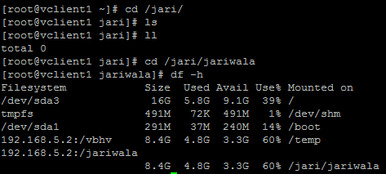

* To see auto unmount,

Command: watch mount

**Errors**:

* Error: clnt_create: RPC: Port mapper failure - Unable to receive: errno 113 (No route to host)

Solution:

* ping server
* restart nfs on server
* check with showmount on server and client

**References**:

* How Autofs works: <https://docs.oracle.com/cd/E19455-01/806-0916/6ja8539g7/index.html>