**Check status of essential services**

1. Service NetworkManager should not in running state and must disable at boot.
2. Following service must be running and enable at boot.
3. ricci
4. rgmanager
5. cman
6. clvmd
7. Node having web interface must be running luci service and enable at boot.

\*\*\*\*\*\*\*\*\*\*\*\*\*\*\*\*\*\*\*\*\*\*\*\*\*\*\*\*\*\*\*\*\*\*\*\*\*\*\*\*\*\*\*\*\*\*\*\*\*\*\*\*\*\*\*\*\*\*\*\*\*\*\*\*\*\*\*\*\*\*\*\*\*\*\*\*\*\*\*\*\*\*\*\*\***Command to check cluster status**

Command: clustat

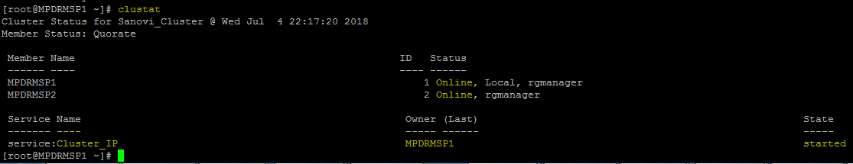

*************************************************************************************

**To list out cluster services and resources**

Command: ccs -f /etc/cluster/cluster.conf --lsservices

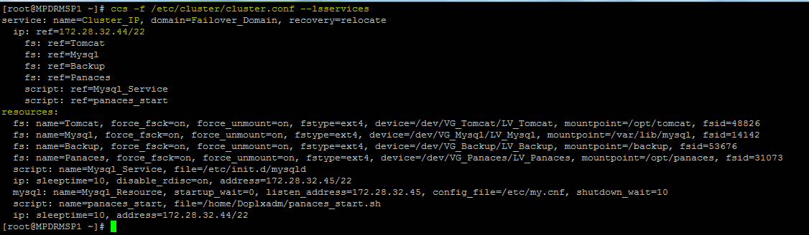

*************************************************************************************

**Test fencing**

To check status of fencing

Command: fence_node -S <node_name>

To fence the node (node will be rebooted)

Command: fence_node MPDRMSP2

*************************************************************************************

**Manual failover (move cluster resources to other nodes)**

Command: clusvcadm -r <service_name> [for 2 node cluster]

Command: clusvcadm -r <service_name> -m <node_name>

Here, -r :relocate; -m: member

Example: clusvcadm -r Cluster_IP

Example: clusvcadm -r Cluster_IP -m MPDRMSP1

----------------------------------------------------------OR----------------------------------------------------------------------------

Shutdown the node on which cluster service is running and check that cluster service/resources are automatically moved and running to another node

*************************************************************************************