Contents

**Local variable:** 1

• **Set local variable in bash shell:** 1

• **Set local variable using set command in tcsh/csh shell** 1

**Environmental variable:** 1

• **Set environmental variable using setenv command in tcsh/csh shell** 2

• **Set environmental variable in bash shell:** 2

**Notes** 2

* Variable is the one who holds the value. Value of the variable can change over the time.

# **Local variable:**

* Local variable is the one which is accessible only in the shell in which variable is initiated.
* The scope of local variable is limited. It means they are accessible within their original shell.
* Example:

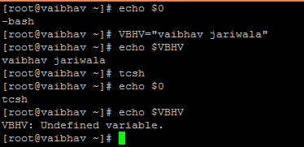

Here, VBHV variable is defined in bash shell. This variable is not accessible in another shell (tcsh). Hence, VBHV variable is the local variable.

## **Set local variable in bash shell:**

* Command: <variable name>=<value>
* **Set local variable using set command in tcsh/csh shell**:
* Command: set <variable name>=<value>

Example: set VBHV=”vaibhav jariwala”

# **Environmental variable:**

* It is the one which can be accessed across all the shells or processes initiated from original shell of environment.
* The scope of environmental variable is global. It means that they are accessible in all shells.
* Example:

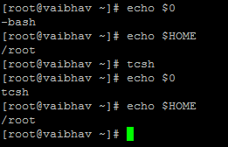

Here, HOME variable is defined in bash shell. This variable is also accessible in another shell (tcsh). Hence, HOME variable is the environmental variable.

* To display all environmental variables,

Command: env

* **Set environmental variable using setenv command in tcsh/csh shell**:
* Command: setenv <variable name>=<value>

Example: setenv VBHV=”vaibhav jariwala”

## **Set environmental variable in bash shell:**

* Command: export <variable name>=<value>

Example: export VBHV=”vaibhav jariwala”

**Notes**:

* set command is used to set local variable and setenv is used to set environmental variable in tcsh/csh shells. These command will not run in bash shell.
* To check value to local/environmental variables,

Command: echo $<variable name>

Example: echo $VBHV

Example: echo $HOME

* To remove variable,

Command: unset < variable name>