Systematic Ablation Reveals Hidden Failures in Multi-Agent AI for Science
Valerio Bianchi¹ & Dirkjan Schokker¹
¹Department of Veterinary Integrative Data Analytics, Wageningen Bioveterinary Research, Wageningen University & Research, P.O. Box 65, 8200 AB, Lelystad, The Netherlands
Corresponding Author: Valerio Bianchi
Abstract
Retrieval-augmented generation (RAG) systems increasingly ground large language models (LLMs) in scientific literature, yet their design choices are typically made by convention rather than evidence. Here, we introduce a systematic ablation methodology for RAG pipeline design, validated through triple triangulation of deterministic ground-truth metrics, LLM judge scoring, and natural language inference. Across more than 36,000 evaluations spanning 200 scientific papers and 250 expert-curated questions, we find that self-correction without retrieval grounding degrades 79% of correct answers. Iterative retrieval saturates logistically with depth, capturing 80% of the improvement within seven turns. LLM judge faithfulness scoring also exhibits a construct validity failure, where answers rated perfectly faithful have only 21% of their claims actually grounded in sources. These findings, replicated across 3,300 code generation evaluations, demonstrate that reliable AI for science demands not just better models, but disciplined evaluation methodology that exposes failure modes invisible to any single metric.

The escalating complexity and volume of data in the life sciences, from multi-omics integration^{1,2} to genomic epidemiology^{3,4}, has driven reliance on computational workflows that most domain researchers cannot build or evaluate⁵. Retrieval-augmented generation (RAG) systems, which couple large language models (LLMs) with document retrieval to ground-truth generated answers in source material, have emerged as a promising approach to make scientific literature more accessible^{6,7}. Yet, most RAG deployments are assembled from defaults selected based on convention rather than systematic evaluation⁸. As these systems move from prototypes to tools on which scientific conclusions may depend, the absence of rigorous methodology for their design becomes a liability. A recent editorial⁹ calls for transparency in multi-agent Artificial Intelligence (AI) systems and a complementary perspective¹⁰ highlights how fragmented tooling hinders reuse across life science AI, yet no framework for achieving this transparency in scientific RAG exists.
Three evaluation problems undermine current RAG practice. First, most benchmarks rely on a single evaluation signal, but each method has blind spots, where judges reward plausibility over grounding^{11,12,13,14,15}, deterministic metrics miss semantic nuance, and Natural Language Inference (NLI)-based models have limited precision. No single signal is trustworthy in isolation. Second, when metrics diverge, there is no principled framework for determining which is correct; practitioners typically select the metric that confirms their assumptions. Third, component ablation results become uninterpretable when the evaluation itself is unreliable. Self-correction is widely assumed to improve output quality despite evidence that LLMs cannot reliably self-correct without external feedback^{16,17}, and inference-time compute scaling exhibits diminishing returns¹⁸ whose functional form in RAG is unknown. Whether judge dimensions like "faithfulness" measure what they claim has not been tested against independent ground truth. These are not merely engineering problems; they represent a methodological gap that undermines confidence in any RAG design decision.
Here, we address these gaps through systematic component ablation by controlled experimentation that isolates each design decision and measures its true cost or benefit through multiple independent evaluation signals. We validate each ablation through triple triangulation, i.e., expert-curated ground truth metrics, calibrated LLM judge scoring, and NLI-based fact-checking. When all three signals converge, confidence is high; when they diverge, the divergence itself reveals what each method actually measures. This methodology is implemented in Mentor::i, an open-source multi-agent scientific workspace that orchestrates local and cloud-hosted LLMs for literature analysis and code-mediated data analysis, with privacy-preserving local deployment.
We report the most comprehensive factorial evaluation of end-to-end scientific RAG pipeline design decisions to date, simultaneously ablating retrieval, generation, orchestration, and evaluation components across more than 36,000 individual evaluations in two task domains (Fig. 1). While prior benchmarks have achieved larger raw evaluation counts¹⁹ and others have probed RAG robustness under adversarial conditions²⁰, they typically vary only two or three pipeline dimensions; no previous study has systematically ablated seven component layers within a single controlled framework. The full experimental design, 250 questions, 200 papers, six strategies, 16 generation and 19 judge models, plus 15 code generation variants, is detailed in Methods. Our findings challenge several widely held assumptions. Self-correction without retrieval grounding actively degrades answer quality, converting 79% of answer changes from correct to incorrect, while iterative retrieval-grounded generation achieves a 91% pass rate. Retrieval compute saturates as a logistic function of iteration depth, yielding a practical scaling law with mechanistically interpretable parameters. LLM judge faithfulness scoring suffers from a construct validity failure, where at perfect judge scores, only 21% of claims are factually grounded. These principles generalize to code generation, where programmatic API introspection yields consistent gains, while infrastructure misconfiguration can produce misleading conclusions about model capabilities. Together, these results argue that reliable AI for science demands not just better models, but disciplined ablation-driven evaluation capable of exposing failure modes invisible to intuition-driven design.
Results
Retrieval foundation enables robust document access
We ablated three retrieval components (embedding model, search strategy, and chunking) independently, selecting the best-performing option for each based on mean reciprocal rank (MRR) before locking the configuration for all downstream experiments (Extended Data Fig. 1). Across corpus sizes from 5 to 100 scientific papers, reciprocal rank fusion (RRF) of dense and sparse retrievers with a general-purpose embedding model (BAAI/bge-m3) and fixed 512-token chunks achieved MRR ≥ 0.88, with latency under 250 ms, ensuring that downstream differences reflect strategy design rather than retrieval failure.
Self-correction degrades correct answers; iterative retrieval recovers them
We compared six generation strategies on 138 questions comprising 88 answerable from a 20-paper corpus and 50 unanswerable out-of-domain (OOD) using triple-triangulated evaluation (Fig. 2): deterministic metrics against expert-curated ground truth, calibrated LLM judge scoring, and NLI-based fact-checking (see Methods). The strategies range from single-pass retrieval (retrieve once, generate once) to the Recursive Language Model (RLM)²¹, in which the model writes and executes Python code to iteratively search the index, refine queries, and build a structured answer with citations. We extended RLM beyond its original single-level recursion to depths of 5, 10, and 20 iterations (RLM-5, RLM-10, and RLM-20).
RLM-10 achieved the highest pass rate (90.9%) and concept recall (72.1% vs. 47.4% for single-pass), with RLM-5 nearly matching and RLM-20 slightly worse (Fig. 2a–c). The most striking result concerned self-correction (verified_pass), which uses a separate LLM call to verify passage relevance before generation. Rather than filtering noise, this strategy performed worst (pass rate 67%). A flip-rate analysis revealed that self-correction actively degrades correct answers, where at the primary correctness threshold (≥3), verified_pass converts 79% of its answer changes from correct to incorrect (McNemar P = 0.001; 83% at the stricter ≥4 threshold). Across 12 corpus scaling conditions (4 sizes × 3 noise ratios, 9,894 evaluations), the pooled harmful flip rate remained significant (64.5%, P = 0.004). RLM-10's pass rate was significantly higher than verified_pass (McNemar's P = 0.0005, Cohen's h = 0.61; Fig. 2e).
Strategy choice also affected hallucination safety on unanswerable questions (Fig. 2d). Multi-hop refusal rate is 38%, thus hallucinated answers to 62% of the OOD questions, while RLM-10 refused 78% and maintained its 91% pass rate on answerable ones. verified_pass achieved the highest refusal rate (86%), but at the cost of rejecting 33% (100% - 67% pass rate) of answerable questions, illustrating the accuracy-safety trade-off that deployment context must resolve.
Among the subset of ten contradictory questions containing false premises about specific corpus papers, the refusal rate was lowest (30% mean across strategies). However, when systems engaged, 33 of 42 responses (78.6%) correctly refuted the false claim, nine (21.4%) hedged due to retrieval of unrelated papers, and none affirmed the false premise (Extended Data Fig. 2). The safety concern is the low refusal rate, not hallucination upon engagement.
Retrieval compute saturates logistically and strategy rankings are scale-dependent
A natural question is how much iterative computation is enough. We swept ten RLM depths (1, 2, 3, 5, 7, 10, 15, 20, 30, and 50 turns) for gemini-3-flash to characterise how answer quality scales with retrieval effort (Fig. 3a). The relationship follows a logistic pattern, with CR(d) = L / (1 + exp(−k(d − d₀))) fitted to concept recall yielding R² = 0.912, ceiling L = 0.51, steepness k = 0.52, and inflection point d₀ = 3.1. The three parameters are mechanistically interpretable, where L is the performance ceiling, k is the transition steepness, and d₀ is the depth at which retrieval becomes productive. For gemini-3-flash, approximately 80% of the improvement from depth 1 to saturation is captured within seven iterations.
We tested whether this saturation pattern generalises by expanding the sweep to eight open-weight models spanning 8b to 80b parameters (Fig. 3b). Saturating functions outperformed logarithmic and linear alternatives across every model that produced a well-conditioned fit (Fig. 3c). However, model-level RLM compatibility varied widely and did not track parameter count (Spearman ρ = 0.15 between ceiling L and parameter count, P = 0.73, n = 8). The three 30b models in the sweep produced heterogeneous outcomes (glm-4.7-flash:30b and qwen3-coder:30b both achieved clean logistic fits, while nemotron-3-nano:30b fit the logistic poorly), and fit failures also included llama3:8b and gpt-oss:20b. This is consistent with the interpretation that RLM compatibility is determined by model-specific post-training for code generation and instruction following rather than by model scale.
We next asked how corpus scale affects which strategy is optimal. A factorial experiment crossing four corpus sizes (5–50 papers) with two noise ratios (1× and 3× same-domain distractors) across all six strategies (9,894 evaluations) revealed a strategy by corpus-size interaction that inverts which approach is best (Fig. 3d). RLM strategies dominate at 20 papers, but the ranking inverts at 50 papers, where single-pass (83%) overtakes all RLM configurations (61–63%). At larger scales, RLM spends turns exploring tangential papers rather than extracting relevant content. Distractor noise had a strategy-dependent impact (Fig. 3e), where single-pass was robust (no degradation at 3× noise) while RLM-5 showed the largest sensitivity (14.5 percentage point drop at 20 papers with 3× noise). OOD refusal rates remained stable for single-pass and verified_pass across noise levels, but declined for RLM strategies under distractor conditions (Fig. 3f). The optimal generation strategy is therefore deployment-dependent.
To test whether strategy rankings themselves are model-dependent, we replicated the strategy comparison with two additional generation models, qwen3.5:122b and qwen3-coder:30b, keeping the same judge and evaluation framework. The 122b model replicated the Gemini ranking perfectly (Spearman ρ = 1.0; RLM-10: 80.7%, single-pass: 78.4%, verified_pass: 63.6%). However, the 30b model inverted it (Spearman ρ = −0.5; single-pass: 77.3%, verified_pass: 70.5%, RLM-10: 65.9%), because the smaller model could not effectively drive the iterative code-mediated retrieval loop. The RLM advantage is thus capability-gated, where models below a threshold cannot formulate effective search queries across turns, causing the iterative strategy to compound errors rather than accumulate evidence (Extended Data Fig. 3).
Pipeline ablation reveals retrieval as the critical layer
We decomposed the system into four additive configurations on the same 20-paper corpus (138 questions, 552 evaluations; Fig. 4). The results reveal a non-monotonic relationship between pipeline complexity and answer quality. Gemini-3-flash baseline (no retrieval, pure parametric knowledge) achieved 89.8% pass rate but 0% OOD refusal, hallucinating answers to every unanswerable question (Fig. 4a-b). Adding retrieval through naive RAG dropped pass rate by 11.4 percentage points, but enabled 86% refusal accuracy, demonstrating retrieval's dual role as knowledge source and safety mechanism. RLM-10 recovered and exceeded baseline (+1.1pp pass rate) while maintaining 78% refusal.
Adding full orchestration (planning, supervision, and multi-agent coordination, all running gemini-3-flash) collapsed pass rate to 55.7%, a 35.2pp degradation versus RLM-10 alone. Component benchmarks across 16 model variants (13,312 evaluations; Fig. 4d) identified two bottlenecks: the observation distiller, which retains at best 74% of numerical values (Fig. 4d, Distiller column; Extended Data Fig. 4), and the supervisor, whose quality scores correlate weakly with actual answer quality (best Spearman ρ = 0.34, Extended Data Fig. 4c). The remaining components (analyser, synthesizer, planner) each exceeded 94% accuracy in isolation (Extended Data Fig. 4). The pipeline fails in the middle, not at the edges. Prompt engineering partially mitigates the distiller bottleneck (from 55% (baseline) to 81% (F2_F3), a 26pp improvement with few-shot examples; gemma3:27b in Extended Data Fig. 5), but the core finding stands, the iterative retrieval layer provides value, and additional orchestration layers subtract rather than add when intermediate agents are insufficiently capable.
Triple triangulation reveals LLM judge faithfulness as a construct validity failure
A central methodological question is whether the evaluation itself is trustworthy. We evaluated every generated answer using three independent methods (Fig. 5), i.e., deterministic metrics against expert-curated ground truth, calibrated LLM judge scoring, and MiniCheck NLI-based fact-checking that decomposes answers into individual claims and checks entailment against retrieved passages.
The judge's faithfulness dimension exhibited a severe ceiling effect: 78.6% of scores were at the maximum (5/5), yet MiniCheck precision for these "perfectly faithful" answers averaged only 21%, meaning four out of five claims were not entailed by sources (Fig. 5a–b). The correlation between judge faithfulness and actual grounding, i.e., citation quality, was weak (Spearman ρ = 0.257). This failure is dimension-specific, where judge–deterministic correlations are moderate for completeness (ρ = 0.608) and correctness (ρ = 0.503) but weak for faithfulness (ρ = 0.167), indicating the judge reliably assesses what an answer covers, but not whether its claims are true (Fig. 5c). As a hallucination detector, the judge flagged only 11.3% of ungrounded claims. The judge's refusal_accuracy metric exhibits an analogous construct validity failure for contradictory out-of-domain questions: it scores a correct refutation of a false premise identically to a hallucinated affirmation. Ground-truth verification of individual responses revealed this conflation, which the metric alone cannot detect.
Despite this absolute divergence, all three methods agreed on strategy rankings (Kendall's W = 0.911, P = 0.018; computed from Fig. 5d rankings), demonstrating that triangulation detects failures invisible to any single metric (Extended Data Fig. 6).
The QA experiments evaluated retrieval and synthesis of external documents. Code generation inverts this task. The model must produce executable instructions that invoke external computational resources such as APIs and statistical libraries. We extend the ablation framework to test whether the principle of grounding in external structure generalises beyond retrieval.
Context quality over quantity generalizes to code generation
To test whether context quality outweighs context quantity beyond retrieval, we benchmarked 15 model variants across 11 strategies on 20 bioinformatics and epidemiology operations with objectively verifiable outputs (3,300 evaluations; Fig. 6). Free-form best-of-3 achieved the highest mean pass rate across models (65.0%), followed by free-form (63.7%) and API introspection with error recovery (62.7%; Fig. 6a). Moderate thinking mode provided consistent improvement across three model families (McNemar p < 0.03 for each), but enabling think:high at Ollama's default context window (2,048 tokens) collapsed gpt-oss pass rate from 73.8% (no thinking) to 6.2% (think_high); correcting the context window (24,576 tokens) recovered performance to 48.2% (think_high, Fig. 6b). Infrastructure defaults can produce results that confounded with model-level failures, reinforcing the need for systematic evaluation frameworks.
Strategy effectiveness was highly model-dependent (chi-square p < 0.001), introspection provided the largest gains for weaker models (e.g., +35pp for gpt-oss-without-thinking), but could reduce performance in strong instruction-following models, while structured-output formats failed completely on several model families (gemma3:27b, deepseek-r1:70b, nemotron-3-nano:30b: 0%) despite moderate success on others (qwen3-coder:30b: up to 65%; Fig. 6c).
Discussion
A recurring theme across our experiments is that intuitive design choices consistently fail in specific, measurable ways that only systematic evaluation can detect. In each case, the failure represents a phase transition from functional to dysfunctional, and the mechanism is the same, an internal process (verification, reasoning, iteration) consumes resources better spent on external grounding (retrieval, API inspection, structured context). The principle is precise, where computation directed inward (self-evaluation, self-correction, extended reasoning) is fragile, while computation directed outward (querying documents, inspecting APIs, comparing against ground truth) is robust.
Self-correction degrades correct answers because the verifier LLM inherits the same distributional biases as the generator. When it misjudges a passage as irrelevant, the error compounds, the generator produces a worse answer from worse context, and the final output is confidently wrong rather than tentatively incomplete. This is consistent with theoretical predictions that LLMs cannot self-correct reasoning without access to external feedback¹⁶, and with the broader pattern that self-revision mechanisms in autoregressive models degrade initially correct outputs, Snell et al. report a similar 38% harmful revision rate for beam search¹⁸. Retrieval-grounded iteration through RLM avoids this trap, because the model can always return to the corpus. Self-correction without this grounding is a closed loop that amplifies its own mistakes. This reveals a fundamental trade-off, the same iterative exploration that helps RLM find relevant content for answerable questions also leads it to fabricate answers when no relevant content exists, suggesting RLM with single-pass verification step as a deployment strategy.
Retrieval depth beyond ten turns yields no measurable improvement, because the model's posterior has already converged. The logistic saturation pattern is consistent with theoretical analyses of test-time compute scaling¹⁸, with self-conditioning frameworks showing that iterative refinement converges once the posterior stabilizes²², and with observations that reader performance saturates before retriever recall is exhausted²³. Zhang et al. explicitly identified deeper recursion as an open question²¹; our contribution is the first empirical characterisation of this functional form in a domain-specific RAG setting, with directly actionable parameters for computational budgeting. The corpus scaling results further reveal that noise interacts asymmetrically with retrieval mechanisms, where single-pass Reciprocal Rank Fusion (RRF) filters distractors in a single ranking step, whereas RLM's iterative exploration amplifies distractor conditioning, consistent with Cuconasu et al.²⁴.
Extended thinking in code generation helps at moderate intensity, but has real performance costs at high intensity, and infrastructure defaults can amplify these costs by orders of magnitude. The dose-response pattern is consistent with Liu et al.'s finding that chain-of-thought can reduce performance on certain tasks²⁵, and the introspection approach parallels De-Hallucinator²⁶, extending the principle of iterative API grounding to statistical analysis code.
Our finding that the distiller bottlenecks orchestration performance does not mean multi-agent orchestration is inherently harmful. It means our specific implementation fails to preserve critical information between pipeline stages. The contribution is not the finding itself but the methodology that revealed it. Once a failure is exposed, components can be redesigned and re-evaluated through the same ablation framework, preventing regressions that single-metric evaluation would silently introduce. The unifying insight is that what matters is not how hard the model thinks, but what information is accessible and how efficiently the model can navigate the available evidence.
This asymmetry has direct implications for RAG system design. The dominant retrieve-then-generate pipeline treats the model as a passive consumer of context, whereas RLM has the model actively drive retrieval through code, deciding what to search for based on what it has found so far. Code-mediated agency is the key architectural insight, not the number of iterations. The logistic saturation results suggest that even seven turns of active retrieval surpass any number of passive single-pass attempts, with the optimal budget predictable from a simple scaling law. For practitioners, invest in retrieval architecture rather than post-generation verification. As component models improve, adaptive orchestration that routes simple queries directly and reserves multi-agent coordination for complex tasks remains a promising direction.
The construct validity failure in LLM judge faithfulness scoring has consequences beyond our system. The judge's very high true positive rate (>96%) but very low true negative rate is independently documented as "agreeableness bias"^{27,28,29}, consistent with the finding that even frontier models achieve only 84% balanced accuracy on faithfulness benchmarks³⁰. This is not a calibration problem; it is a construct validity failure^{31,32}, where the judge's faithfulness dimension measures something closer to answer relevance than factual grounding. Systems optimized for judge faithfulness will learn to produce plausible-sounding but ungrounded answers, a dangerous failure mode in scientific applications. The 21% precision is potentially conservative, given MiniCheck's strict textual entailment criterion may penalise valid scientific paraphrasing, making the failure more severe. This adds to growing evidence that no single metric captures hallucination across settings^{33,34}, with different methods capturing different hallucination types^{35,36,37}. The LLM-as-judge paradigm is now the default evaluation for RAG systems and agentic AI broadly^{11,13}. We do not argue that judges should be abandoned; they remain useful for fluency, relevance, and relative strategy ranking. Rather, faithfulness must be measured through independent means, and the triple-triangulation approach provides a practical framework. Using separate model families for generation (Gemini) and judging (Qwen) mitigates self-preference bias, while the length-agnostic MiniCheck signal addresses verbosity bias^{38,39,40}.
Our results translate into concrete deployment recommendations. For quality-maximizing deployments (large corpus, accuracy paramount): use RLM-10 with hybrid retrieval and skip orchestration. For budget-conscious deployments (small corpus, limited compute): use single-pass, which matches or exceeds RLM at ≤10 papers. For safety-critical deployments (medical, regulatory): use naive RAG for maximum refusal accuracy (86%). For citation-intensive deployments: prefer single-pass (citation F1 = 0.824) over iterative strategies. In all cases, do not rely on judge faithfulness scores for safety decisions.
Several limitations constrain generalisability. All generation experiments used a single primary model (gemini-3-flash), though the logistic saturation pattern generalises across most of the model families we tested (Fig. 3b). Strategy rankings at the primary scale were replicated with a capable open-weight model (qwen3.5:122b, ρ = 1.0) but not across all corpus conditions. The judge model (qwen3-coder:30b) was calibrated against our specific ground truth, and may not generalize to other corpora. Both our QA and code generation benchmarks used life sciences data, and whether strategy rankings transfer to other domains remains open. Finally, our evaluation treats each question independently, whereas real workflows involve sequential queries where context accumulates. Multi-turn evaluation is an important future direction.
Looking forward, the ablation-driven methodology is designed to be reusable. The triple-triangulation framework requires only curated ground truth and a NLI model, both domain-agnostic. The approach of testing each component as a hypothesis can be applied to any RAG deployment, in any field, with any model. The history of computational biology offers a useful analogy, i.e., the field advanced through shared benchmarks, standardized evaluation protocols, and a culture of rigorous comparison⁴¹. AI for science requires the same infrastructure. We offer systematic component ablation with triple triangulation, answering the call for transparency in multi-agent AI systems⁹, as one contribution toward building it.
Methods
Evaluation corpus and ground truth construction
We assembled a corpus of 50 core scientific papers spanning bioinformatics, epidemiology, and computational biology, supplemented with 150 noise papers from adjacent but non-overlapping domains (total of 200 documents). Core papers were selected to cover methodological diversity (workflow managers, statistical frameworks, sequencing pipelines, clinical genomics) while maintaining sufficient inter-paper conceptual overlap to support cross-document and synthesis questions.
From the core papers, we generated 250 evaluation questions across six categories: factual recall (FR, n = 50), conceptual understanding (CO, n = 50), technical detail (TE, n = 50), cross-document reasoning (CD, n = 30), synthesis (SY, n = 20), and out-of-domain unanswerable (OOD, n = 50). The OOD set was sub-stratified into general knowledge (n = 20, topics absent from the corpus), excluded topic (n = 20, adjacent scientific topics not covered by the corpus), and contradictory (n = 10, false premises about specific corpus papers), see Extended Data Fig. 7).
Each answerable question was paired with an expected answer and a list of expected concepts. Questions were generated using LLM-assisted extraction from each paper, then a subset of 50 questions was manually reviewed by two independent researchers and revised by the authors (domain experts in bioinformatics and epidemiology). Dataset robustness was assessed through a three-stage validation process. First, the 150 single-paper questions (FR, CO, TE) were independently evaluated against the corpus through three automated retrieval runs, flagging 27 questions (18%) where expected concepts were absent from all runs. Second, the 50 multi-paper questions (CD, SY) underwent the same procedure with three independent runs each, flagging 19 additional questions (12 CD, 7 SY). Third, the 50 OOD questions were verified for unanswerable status; 40 probe topics entirely absent from the corpus, while 10 present false claims about specific corpus papers, testing whether systems hallucinate confirmation despite having contradicting evidence in context. All flagged questions were subsequently verified against source paper text, confirming that every expected concept was present in the source material; flags reflected retrieval difficulty rather than ground truth errors. The OOD questions were designed to test whether systems appropriately refuse or refute rather than hallucinate. For the 10 contradictory OOD questions, all 42 engaged responses (across 6 strategies) were manually classified by the authors into three categories: correctly contradicted (cited evidence against the false premise), hedged (retrieved unrelated papers), or affirmed (accepted the false premise).
For the generation strategy comparison, we used a 20-paper subset of the core corpus with 88 answerable and 50 unanswerable questions (138 total), filtered by the minimum number of core papers required to answer each question (min_core ≤ 20).
Retrieval pipeline
The retrieval pipeline was optimized through systematic ablation of three components, each evaluated independently before locking the configuration for downstream experiments.
Embedding model. We compared four embedding models (BAAI/bge-m3, all-mpnet-base-v2, all-MiniLM-L6-v2, and SPECTER2) across five corpus sizes (5, 10, 15, 20, and 30 documents) using 28 evaluation queries with known relevant documents. BAAI/bge-m3 was selected based on mean reciprocal rank (MRR = 0.918 at 30 papers), with consistent performance across corpus sizes.
Search strategy. Seven search strategies were evaluated: dense-only, sparse-only (BM25), reciprocal rank fusion (RRF), fixed-weight hybrid (α = 0.5), and three reranking variants. RRF achieved MRR = 0.982, a 7% improvement over dense-only retrieval. The implementation uses the standard fusion formula: $score(d) = Σ wᵣ / (k + rankᵣ(d) + 1)$, with k = 60 and adaptive weights based on query characteristics.
Chunking. Eight chunking strategies were compared across three independent runs, i.e., simple token-based (128, 256, 512, 1024 tokens), semantic (spaCy sentence boundaries 500, 1000, 2000, 4000 characters). Fixed 512-token chunks with 50-token overlap were selected (MRR = 0.988 ± 0.011, 3-run mean), producing 14× fewer segments than semantic chunking. Tokenisation used the cl100k_base encoding with sentence boundary alignment.
Scalability. The locked configuration was validated at scale, where MRR ≥ 0.94 through 50 papers and 0.883 at 100 papers, with latency between 161–208 ms.
Generation strategies
Six generation strategies were evaluated, spanning a range of computational budgets:
Single-pass. One retrieval query followed by one generation call. Top-k passages (k = 10) concatenated into prompt context.
Multi-hop. Iterative query refinement over five rounds, accumulating evidence before final generation.
RLM-5, RLM-10, RLM-20. Adapted from Zhang et al.²¹, the Recursive Language Model (RLM) operates as a code-mediated iterative retrieval loop. At each turn, the model generates Python code executed in a sandboxed REPL with access to document search, keyword lookup, and LLM summarisation functions. Quality gates enforce a minimum of three LLM calls before accepting a final answer, with escalation prompts at turns 5, 8, and 10+. Message history is compacted every five turns, preserving the system prompt and last three exchanges. Key parameters: temperature 0.2, context window 24,576 tokens, output limit 8,192 tokens. The three variants differ only in maximum permitted turns.
Verified pass. Single-pass retrieval followed by LLM verification of each passage’s relevance; passages judged irrelevant are discarded before generation.
Model selection
Generation model. Selected through four-phase triage: (1) completion rate filtering (16 → 8 models, threshold ≥ 67% with ≥ 3 citations), (2) quality assessment (8 models × 15 questions), (3) objective evaluation against ground truth (concept recall, semantic similarity, citation density), and (4) self-consistency validation (18 independent runs on 87 shared answers; mean pairwise Pearson r > 0.97 across all four judge dimensions, with Correctness r = 0.995 and Completeness r = 0.996; Supplementary Table 1). gemini-3-flash-preview was selected (concept recall 0.694), outperforming the best local model by 14 percentage points. During triage, we discovered that Ollama’s default context window (2,048 tokens) silently truncated inputs for several models; correcting to full context (98,304 tokens) recovered completion rates (e.g., deepseek-r1:70b from 0% to 67%).
Judge model. From 19 candidates (8,132 individual scores across 107 answers), qwen3-coder (30b parameters) was selected based on composite calibration (r = 0.567): the mean correlation of judge scores with deterministic ground truth metrics (correctness vs. semantic similarity: r = 0.755; completeness vs. concept recall: r = 0.725). Judge leniency inversely correlated with calibration quality. This selection is independently validated by a large-scale evaluation of 54 judge models, which found that Qwen3-30b-class models achieve the closest alignment with human judgments⁴² (Extended Data Fig. 2). The 15 questions used for judge calibration are a subset of the 138-question evaluation set (10.9% overlap). Strategy rankings were unchanged when these were excluded (Spearman ρ = 0.9429, P = 0.005), confirming that the overlap does not introduce circular evaluation bias.
Triple-triangulation evaluation framework
Each generated answer was evaluated using three independent methods:
Deterministic metrics. Concept recall (fraction of expected concepts present, via exact and fuzzy string matching), analogous to the checklist-based evaluation principle⁴³ but with human-curated ground truth, semantic similarity (cosine similarity of bge-m3 embeddings), and citation density.
LLM judge scoring. The calibrated judge scored four dimensions (0–5), i.e., correctness, completeness, faithfulness, and citation quality. For unanswerable questions, scoring was performed on refusal accuracy, hallucination avoidance, and explanation quality. Primary outcome was pass rate (correctness ≥ 3).
NLI-based fact-checking. MiniCheck⁴⁴, a 770M-parameter NLI model matching GPT-4-level accuracy on faithfulness detection at 400× lower cost, decomposed answers into individual claims and checked entailment against retrieved passages, yielding bidirectional precision and recall.
Strategy rankings were compared using Kendall’s coefficient of concordance (W) across the three evaluation methods. The test statistic was computed as $χ^{2}= k\left(n-1\right)W$, where k = 3 methods and n = 6 strategies, evaluated against a χ² distribution with $n-1 = 5$ degrees of freedom.
Flip-rate analysis
To quantify whether a strategy actively degrades correct answers rather than merely failing to improve incorrect ones, we performed pairwise outcome comparisons. For each question answered by both a target strategy and the single-pass baseline, outcomes were classified as helpful flips (baseline incorrect → target correct), harmful flips (baseline correct → target incorrect), or stable (no change). The harmful flip rate, the proportion of all flips that are harmful, directly measures degradation risk: a value above 50% indicates that the strategy degrades more correct answers than it recovers. Significance was assessed via McNemar's test, which tests whether the number of helpful and harmful flips differs from the equal split expected by chance, using only the discordant pairs (questions where the two strategies disagree).
Retrieval compute saturation analysis
To characterise how answer quality scales with retrieval compute, we swept ten RLM iteration depths (1, 2, 3, 5, 7, 10, 15, 20, 30, and 50) for gemini-3-flash (78–88 questions per depth, 840 total evaluations) and eight open-weight models spanning seven architecture families and 8b to 80b parameters (15 questions per depth, 5–10 depths per local model). Four candidate scaling models were fitted to the mean concept recall per depth via unweighted nonlinear least squares (Levenberg–Marquardt algorithm), namely log-linear $CR(d) = a × ln(d) + b$, linear $CR(d) = a × d + b$, logistic $CR(d) = L / (1 + exp(-k(d - d₀)))$, and saturating exponential $CR(d) = L × (1 - exp(-k × d))$. The three logistic parameters have mechanistic interpretations, where L is the model-specific performance ceiling, k controls the steepness of the transition from ramp-up to saturation, and d₀ is the inflection point marking the depth at which retrieval becomes productive. The percentage of improvement captured at depth d was computed from the fitted curve as (CR(d) − CR(1)) / (L − CR(1)), where L is the fitted ceiling. Source coverage was computed as the fraction of expected source papers (from ground truth) cited in each answer, broken down by the number of expected sources per question to assess the depth-versus-breadth trade-off.
Corpus scaling factorial design
To assess how generation strategy effectiveness varies with corpus size and retrieval difficulty, we constructed 12 corpus index configurations from a factorial crossing of four core-paper subsets (5, 10, 20 and50 papers, where each larger subset contains all papers from the smaller ones) with three noise ratios (0× no noise, 1× equal same-domain distractors and 3× three-to-one distractor ratio). Noise papers were drawn from adjacent epidemiology and bioinformatics domains, the hardest distractor type per Cuconasu et al.²⁴, ensuring topical overlap without answer relevance. Each index was evaluated with all six generation strategies, yielding 9,894 total evaluations. Questions were filtered per index, i.e., only questions whose minimum required core papers fell within the index’s core set were included (ranging from 72 questions at 5 papers to 250 at 50 papers). Pairwise strategy associations were assessed using the Cochran–Mantel–Haenszel test, stratified by corpus size and noise ratio. Strategy comparisons at each corpus size used McNemar's test with Bonferroni correction, and crossover points were estimated with Wilson confidence intervals.
Strategy replication across generation models
To test whether strategy rankings generalise beyond the primary generation model, the strategy comparison (single-pass, RLM-10, verified_pass) was replicated with two additional models: qwen3.5:122b and qwen3-coder:30b, open-weight), using the same 138-question evaluation set, judge model, and triple-triangulation framework (414 evaluations per model). Strategy ranking concordance was assessed using Spearman's rank correlation.
Pipeline ablation design
To isolate the contribution of each architectural layer, we evaluated four additive configurations on the 20-paper corpus (138 questions each, 552 total evaluations): (1) raw Gemini (the generation model with no retrieval context, pure parametric knowledge), (2) naive RAG (top-10 retrieved passages concatenated into the prompt), (3) RLM-10 (iterative retrieval-grounded generation as described above), and (4) full orchestrator (the complete Mentor::i pipeline running gemini-3-flash for every internal component, including query analysis, plan generation, step execution with role-assigned agents, supervisor quality scoring, and synthesis). Each configuration was compared pairwise using McNemar's test. A supplementary naive baseline experiment (138 evaluations) provided the simplest possible RAG comparison.
Code generation benchmark
Fifteen model variants (13 local Ollama configurations including multiple thinking modes, plus 2 Gemini API models) and 11 strategies were evaluated on 20 operations (ten per dataset) across two publicly available benchmark datasets: the airway RNA-seq dataset⁴⁵ (eight samples, ~64K genes; Bioconductor airway package, GEO accession GSE52778) for bioinformatics operations (differential expression, Counts per Million (CPM) normalization, clustering, Principle Component Analysis (PCA), correlation analysis), and the North Central Cancer Treatment Group (NCCTG) lung cancer survival dataset⁴⁶ (228 patients, ten variables; R survival package) for epidemiological operations (Kaplan-Meier estimation, Cox proportional hazards, log-rank tests, Schoenfeld residuals, and stratified Cox models). Operations were assigned to three complexity tiers based on the number of analytical steps and domain knowledge required: simple (n = 6; single-step operations such as data loading, gene filtering, and descriptive statistics), medium (n = 8; multi-step operations such as PCA, CPM normalisation, sample correlation, and Kaplan-Meier estimation), and complex (n = 6; operations requiring chained analytical steps and domain-specific methodology, such as differential expression testing, Cox proportional hazards modelling, and Schoenfeld residual diagnostics). Outputs verified against reference implementations at machine-epsilon tolerance. Total: 3,300 evaluations with corrected context window (15 Ollama models × 11 strategies × 20 operations plus two Gemini models × 7 strategies × 20 operations) (num_ctx = 24,576; the initial run used Ollama’s default of 2,048, producing misleading results for thinking-mode models).
The 11 strategies comprised free-form generation (3 variants: single, n3-best, n3-combined), structured output (4 coder_v2 variants), and introspection variants (4 types: introspect_then_code, error_recovery_introspect, thinker_coder_split, introspect_with_recovery).
Supervisor benchmark. We constructed a 200-item supervisor evaluation set in which each item paired a candidate answer with its judge-assigned correctness score (0–5). For each model, we ran the supervisor prompt to obtain a quality score, then computed Spearman's rank correlation (ρ) between supervisor scores and judge correctness across the 200 items. The reported "best Spearman ρ" refers to the maximum value observed across the 16 model variants (Extended Data Fig. 3c). Values close to zero indicate that the supervisor's quality assessment does not reliably track answer correctness.
Component-level benchmark design
Each of the five orchestrator components was evaluated in isolation using inputs and expected outputs extracted from successful generation runs, establishing an upper-bound estimate of component capabilities.
The analyser benchmark (345 items) tested entity extraction, keyword identification, and question-type classification against ground truth labels. The planner benchmark (90 items) evaluated tool selection accuracy and agent routing against expected assignments. The supervisor benchmark (200 items, stratified: 80 good, 80 bad, 40 borderline answers) measured Spearman rank correlation between model-assigned quality scores and actual judge scores. The distiller benchmark (97 items) measured number retention (fraction of numerical values preserved during compression) and source retention (fraction of cited sources preserved). The synthesiser benchmark (100 items) measured judge-scored answer quality from pre-assembled context. Sixteen model variants from nine architecture families were evaluated on all components (llama3:8b, gpt-oss:20b with four thinking variants, devstral-small-2:24b, gemma3:27b, qwen3-coder:30b, nemotron-3-nano:30b, olmo-3:32b, qwen3.5:35b with two variants, qwen3.5:122b with two variants, and gemini-3-flash-preview with two variants; 13,312 total evaluations).
Distiller prompt ablation design
Seven prompt variants were tested on 97 distiller items across six models from distinct architecture families (llama3:8b/Meta, gpt-oss:20b/OpenAI, devstral-small-2:24b/Mistral, gemma3:27b/Google, qwen3-coder:30b/Qwen, nemotron-3-nano:30b/NVIDIA; olmo-3:32b excluded due to >0% baseline number retention). The baseline was the production distiller prompt. F1 added two few-shot input/output pairs demonstrating number-preserving compression. F2 replaced the fixed 600-word budget with a dynamic budget scaled by the density of numerical values in the input. F3 simplified the output format by removing rigid section headers. F1_F3, F2_F3, and F1_F2_F3 tested pairwise and triple combinations. Total: 4,171 evaluations (6 models × 7 variants × 97 items; olmo-3:32b excluded from non-baseline variants due to 0% baseline performance). Primary metric: number retention (fraction of input numbers preserved in output); secondary: source retention, word count, compression ratio. All models run at temperature 0, num_ctx = 24,576, num_predict = 1,200-2,400 for dynamic budget variants.
Statistical analysis
Non-parametric tests were selected throughout because the primary outcome (pass/fail at a threshold) is binary. McNemar’s exact test was used for pairwise strategy comparisons on paired binary outcomes (same questions, two strategies), with the number of discordant pairs as the effective sample size. Kendall’s coefficient of concordance (W) assessed agreement among m = 3 evaluation methods ranking k = 6 strategies. Spearman’s rank correlation was used for continuous associations; sample sizes are reported alongside each coefficient. Cohen’s h quantifies the effect size for proportion differences. Two-sided, α = 0.05. No multiple comparison correction for three a priori hypotheses established from prior literature before experimental design was finalised: (1) iterative retrieval (RLM) outperforms single-pass, (2) self-correction without retrieval grounding degrades answers, (3) retrieval compute saturates with depth. All other analyses use Bonferroni correction.
Use of large language models
LLMs were used as: (1) the research subject (generation models under evaluation from Meta, OpenAI, Mistral, Google, Z.ai, NVIDIA, Alibaba), (2) an evaluation instrument, and (3) a writing aid (Claude Opus and Sonnet 4.6, Anthropic; all claims verified by authors against the primary data). All experiments using the Gemini API (gemini-3-flash-preview) were conducted between 4 and 24 March 2026; exact numerical reproducibility cannot be guaranteed for preview-stage cloud models, and we encourage replication with open-weight alternatives.
Data availability
The complete evaluation dataset used in this study is publicly available. The 250 expert-curated questions, ground-truth answers, validation results, and per-question metadata are deposited at Zenodo (DOI: TBD) and mirrored in the accompanying code repository (https://github.com/vbianchi/Mentori). The 200-paper evaluation corpus (50 core papers + 150 same-domain noise papers) is not redistributed in primary form due to publisher copyright. A complete list of source DOIs and a reproducible download script are provided at `publication/data/download_papers.py` in the code repository, and a copy of the corpus together with the raw experiment outputs (~4.3 GB across ten experiments and more 36,000 individual evaluations) is also deposited at Zenodo (DOI: 10.5281/zenodo.19476756). Source data for all main and Extended Data figures are provided as part of the same Zenodo deposit and as a Source Data file accompanying this article.
The airway RNA-seq dataset used for the bioinformatics code-generation benchmark is publicly available through the Bioconductor airway package (GEO accession GSE52778)⁴⁵. The NCCTG lung cancer survival dataset used for the epidemiology code-generation benchmark is publicly available through the R survival package⁴⁶.
Code availability
Mentor::i, the multi-agent AI workspace whose components are evaluated in this study, is implemented in Python (FastAPI backend, FastMCP tool server) and JavaScript/React (frontend), and is publicly available at https://github.com/vbianchi/Mentori under the MIT license (code) and CC-BY 4.0 (figures, manuscript, and derived data). The exact version of the code used to generate the results reported here is archived at Zenodo (DOI: 10.5281/zenodo.19476756). The single R Markdown document `publication/reports/paper_figures.Rmd` regenerates every main and Extended Data figure in the manuscript from the JSON outputs of the experiment scripts in `publication/scripts/`. The dependencies are specified in `pyproject.toml` (Python, managed via `uv`), `frontend/package.json` (JavaScript), and the R `sessionInfo()` block embedded in `paper_figures.html`. Reproduction instructions are documented in the repository README and in `publication/MANIFEST.md`.
Acknowledgements
For this study, WBVR was financially supported by the Ministry of Agriculture, Fisheries, Food security and Nature (project number: KB-56-001-016). We also want to thank Timo Dijkstra and Erik Kuiper for their time and valuable input on validating the questions.
Author contributions
VB: Conceptualization, Methodology, Software, Validation, Formal Analysis, Investigation, Data Curation, Writing - Original Draft, Review & Editing, Visualization, Supervision
DS: Conceptualization, Validation, Resources, Review & Editing, Visualization, Supervision, Project Administration, Funding Acquisition
Competing interests
The authors declare no competing interests.

References
1. Chetty, A. & Blekhman, R. Multi-omic approaches for host-microbiome data integration. Gut Microbes 16, 2297860 (2024). https://doi.org/10.1080/19490976.2023.2297860
2. Deek, R. A., Ma, S., Lewis, J. & Li, H. Statistical and computational methods for integrating microbiome, host genomics, and metabolomics data. eLife 13, e88956 (2024). https://doi.org/10.7554/eLife.88956
3. VanderWaal, K., Morrison, R. B., Neuhauser, C., Vilalta, C. & Perez, A. M. Translating big data into smart data for veterinary epidemiology. Front. Vet. Sci. 4, 110 (2017). https://doi.org/10.3389/fvets.2017.00110
4. Martínez-López, B. et al. Toward precision veterinary epidemiology: applications, challenges, and opportunities of digitalization and the Big Data revolution in livestock health. J. Am. Vet. Med. Assoc. 263, 650–657 (2025). https://doi.org/10.2460/javma.25.01.0026
5. Drew, J. et al. Revisiting barriers to implementation of bioinformatics into life sciences education. Front. Educ. 8 (2023). https://doi.org/10.3389/feduc.2023.1317191
6. Sarumi, O. A. & Heider, D. Large language models and their applications in bioinformatics. Comput. Struct. Biotechnol. J. 23, 3498–3505 (2024). https://doi.org/10.1016/j.csbj.2024.09.031
7. Liu, J. et al. Advancing bioinformatics with large language models: components, applications and perspectives. Preprint at https://arxiv.org/abs/2401.04155 (2025).
8. Gao, Y. et al. Retrieval-augmented generation for AI-generated content: a survey. Preprint at https://arxiv.org/abs/2402.19473 (2024).
9. Multi-agent AI systems need transparency. Nat. Mach. Intell. 8, 1 (2026).
10. Farrell, G. et al. Open and sustainable AI: challenges, opportunities and the road ahead in the life sciences. Nat. Methods (2026). https://doi.org/10.1038/s41592-026-03037-6
11. Zheng, L. et al. Judging LLM-as-a-judge with MT-Bench and Chatbot Arena. in Proc. NeurIPS 2023 (2023).
12. Liu, Y. et al. G-Eval: NLG evaluation using GPT-4 with better human alignment. in Proc. EMNLP 2023 (2023).
13. Li, D. & Dou, Z. Evaluating scoring bias in LLM-as-a-judge. Preprint at https://arxiv.org/abs/2506.22316 (2025).
14. Ye, J. et al. Justice or prejudice? Quantifying biases in LLM-as-a-judge. Preprint at https://arxiv.org/abs/2410.02736 (2024).
15. Yen, H. et al. HELMET: how to evaluate long-context language models effectively and thoroughly. in Proc. ICLR 2025 (2025).
16. Huang, J. et al. Large language models cannot self-correct reasoning yet. in Proc. ICLR 2024 (2024).
17. Kamoi, R. et al. Evaluating LLMs at detecting errors in LLM responses. in Proc. COLM 2024 (2024).
18. Snell, C. et al. Scaling LLM test-time compute optimally can be more effective than scaling model parameters. in Proc. ICLR 2025 (2025).
19. Xiong, G. et al. Benchmarking retrieval-augmented generation for medicine. Preprint at https://arxiv.org/abs/2402.13178 (2024).
20. Li, M. et al. Benchmarking retrieval-augmented large language models in biomedical NLP: application, robustness, and self-awareness. Sci. Adv. 11, eadr1443 (2025).
21. Zhang, Y. et al. Recursive retrieval-augmented language model. Preprint at https://arxiv.org/abs/2512.24601 (2025).
22. Liu, N. F. et al. Lost in the middle: how language models use long contexts. Trans. Assoc. Comput. Linguist. 12, 157–173 (2024).
23. Basu, S. et al. Self-conditioning and diminishing returns in multi-step reasoning. Preprint at https://arxiv.org/abs/2502.01550 (2025).
24. Cuconasu, F. et al. The power of noise: redefining retrieval for RAG systems. in Proc. SIGIR 2024 (2024).
25. Liu, Z. et al. Mind your step (by step): chain-of-thought can reduce performance on tasks where thinking makes humans worse. in Proc. ICML 2025 (2025).
26. Eberhart, Z. & Buse, R. P. L. De-Hallucinator: iterative grounding for LLM code generation. Preprint at https://arxiv.org/abs/2401.01701 (2024).
27. Jain, S. et al. Beyond consensus: mitigating the agreeableness bias of LLM judges. Preprint at https://arxiv.org/abs/2510.11822 (2025).
28. Tian, K. et al. Overconfidence in LLM-as-a-judge. Preprint at https://arxiv.org/abs/2508.06225 (2025).
29. Chen, Y. et al. Humans or LLMs as the judge? A study on judgement biases. in Proc. EMNLP 2024 (2024).
30. Tamber, M. S. et al. FaithJudge: benchmarking LLM faithfulness in retrieval-augmented generation. in Proc. EMNLP Industry Track 2025 (2025).
31. Dorner, F. E. et al. Limits to scalable evaluation at the frontier. Preprint at https://arxiv.org/abs/2410.13341 (2024).
32. Jung, J. et al. Trust or escalate: LLM judge with confidence-based escalation. in Proc. ICLR 2025 (Oral) (2025).
33. Kulkarni, S. et al. Evaluating evaluation metrics: the mirage of hallucination detection. in Proc. EMNLP Findings 2025 (2025).
34. Google DeepMind. FACTS Grounding: evaluating and augmenting factual consistency of LLMs. Preprint at https://arxiv.org/abs/2501.03200 (2025).
35. Jing, Y. et al. On a scale from 1 to 5: quantifying hallucination in faithful data-to-text generation. in Proc. NAACL Findings 2025 (2025).
36. Janiak, M. et al. The illusion of progress: re-evaluating hallucination detection methods. in Proc. EMNLP 2025 (2025).
37. Hu, Y. et al. Decomposition dilemmas: does claim decomposition improve or hurt fact-checking? in Proc. NAACL 2025 (2025).
38. Panickssery, A. et al. LLM evaluators recognize and favor their own generations. in Proc. NeurIPS 2024 (2024).
39. Wataoka, K. et al. Self-preference bias in LLM-as-a-judge. Preprint at https://arxiv.org/abs/2410.21819 (2024).
40. Dubois, Y. et al. Length-controlled AlpacaEval: a simple way to debias automatic evaluators. in Proc. COLM 2024 (2024).
41. Boulesteix, A.-L. et al. Ten simple rules for reducing overoptimistic reporting in methodological computational research. PLoS Comput. Biol. 11, e1004191 (2015).
42. NVIDIA. The judge's verdict: evaluating LLM-as-a-judge consistency. Preprint at https://arxiv.org/abs/2504.00872 (2025).
43. Wei, Y. et al. RocketEval: efficient automated LLM evaluation via grading checklist. in Proc. ICLR 2025 (2025).
44. Tang, L. et al. MiniCheck: efficient fact-checking of LLMs on grounding documents. in Proc. EMNLP 2024 (2024).
45. Himes, B. E. et al. RNA-Seq transcriptome profiling identifies CRISPLD2 as a glucocorticoid responsive gene that modulates cytokine function in airway smooth muscle cells. PLoS ONE 9, e99625 (2014).
46. Loprinzi, C. L. et al. Prospective evaluation of prognostic variables from patient-completed questionnaires. J. Clin. Oncol. 12, 601–607 (1994). https://doi.org/10.1200/JCO.1994.12.3.601
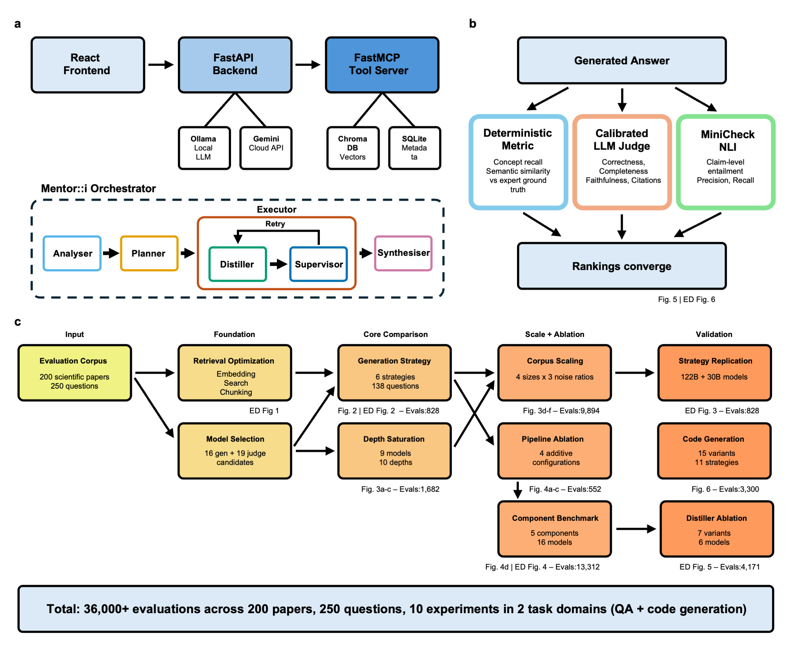
Figure 1 | System architecture, evaluation framework, and experiment pipeline. a, System architecture of Mentor::i showing the three-service design: React frontend, FastAPI backend, and FastMCP tool server communicating over HTTP and WebSocket. The backend connects to local LLMs via Ollama, cloud models via the Gemini API, ChromaDB for vector storage, and SQLite for metadata. The orchestrator pipeline (dashed border) consists of five components: analyser, planner, distiller, supervisor, and synthesizer, where the distiller and supervisor operate in a retry loop during step execution. b, Triple-triangulation evaluation framework. Each generated answer is independently assessed by deterministic metrics against expert-curated ground truth (concept recall, semantic similarity), a calibrated LLM judge (correctness, completeness, faithfulness), and MiniCheck Natural Language Inference (NLI)-based fact-checking (claim precision, claim recall). Strategy rankings significantly? converge (P =0.018) across all three methods (Kendall’s W = 0.911). c, Experiment dependency graph showing ten interconnected experiments totalling more than 36,000 evaluations across 200 papers and 250 questions. Arrows indicate data dependencies between experiments, numbers below each node show evaluation counts.
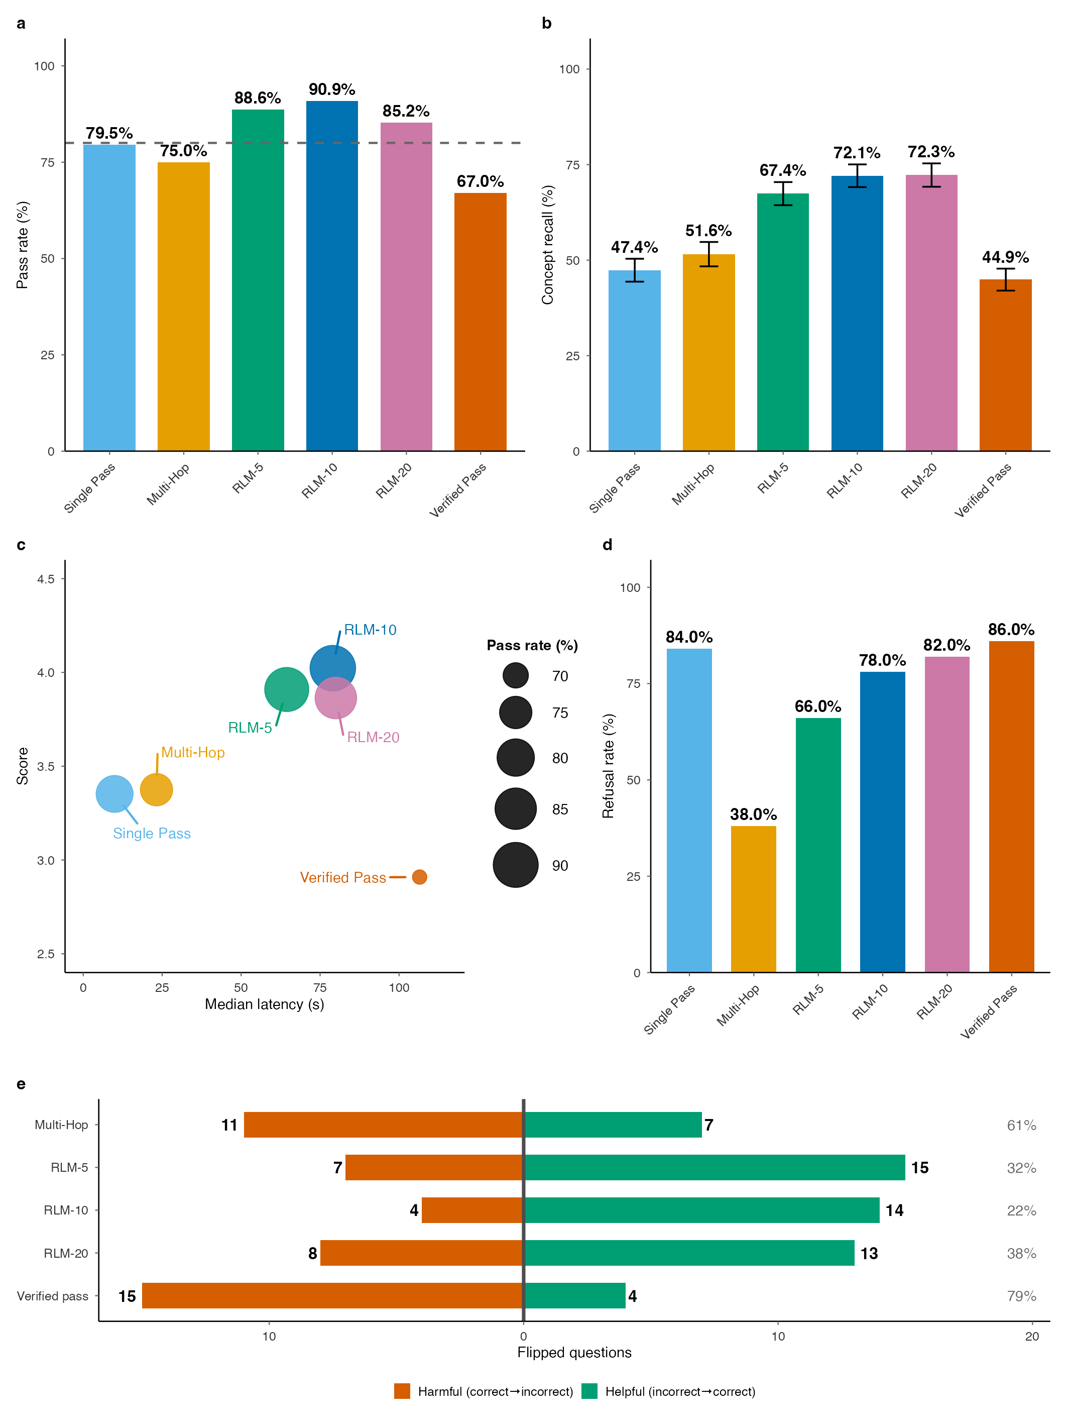
Figure 2 | Generation strategy comparison and safety analysis. a, Pass rate on 138 questions (88 answerable, 50 Out of Domain (OOD)) from a 20-paper scientific corpus. A question passes when the calibrated LLM judge assigns a correctness score ≥ 3 on a 0–5 scale. Dashed line indicates 80% target. RLM-10 achieves 90.9% pass rate; verified_pass performs worst at 67.0%. b, Concept recall (ground truth) by strategy: fraction of expected concepts present in each answer. c, Latency versus quality tradeoff. Bubble size proportional to pass rate. Recursive Language Model (RLM)-10 achieves the highest quality at 80 s median latency; single-pass is fastest (10 s) at lower quality; verified_pass combines the highest latency (108 s) with the lowest quality (2.91). d, Out-of-domain correct refusal rate for 50 unanswerable questions, showing the safety–coverage trade-off: the multi-hop refusal rate is 38%, thus hallucinates answers to 62% of OOD questions, while verified_pass achieves the highest refusal rate (86%) at the cost of low answerable pass rate. e, Question-level outcome flips relative to single-pass baseline. For each strategy, bars show helpful flips (incorrect → correct, green) and harmful flips (correct → incorrect, red). Verified_pass produces 79% harmful flips at threshold ≥3 (McNemar P = 0.001; 83% at ≥4); RLM-10 produces predominantly helpful flips (22% harmful).
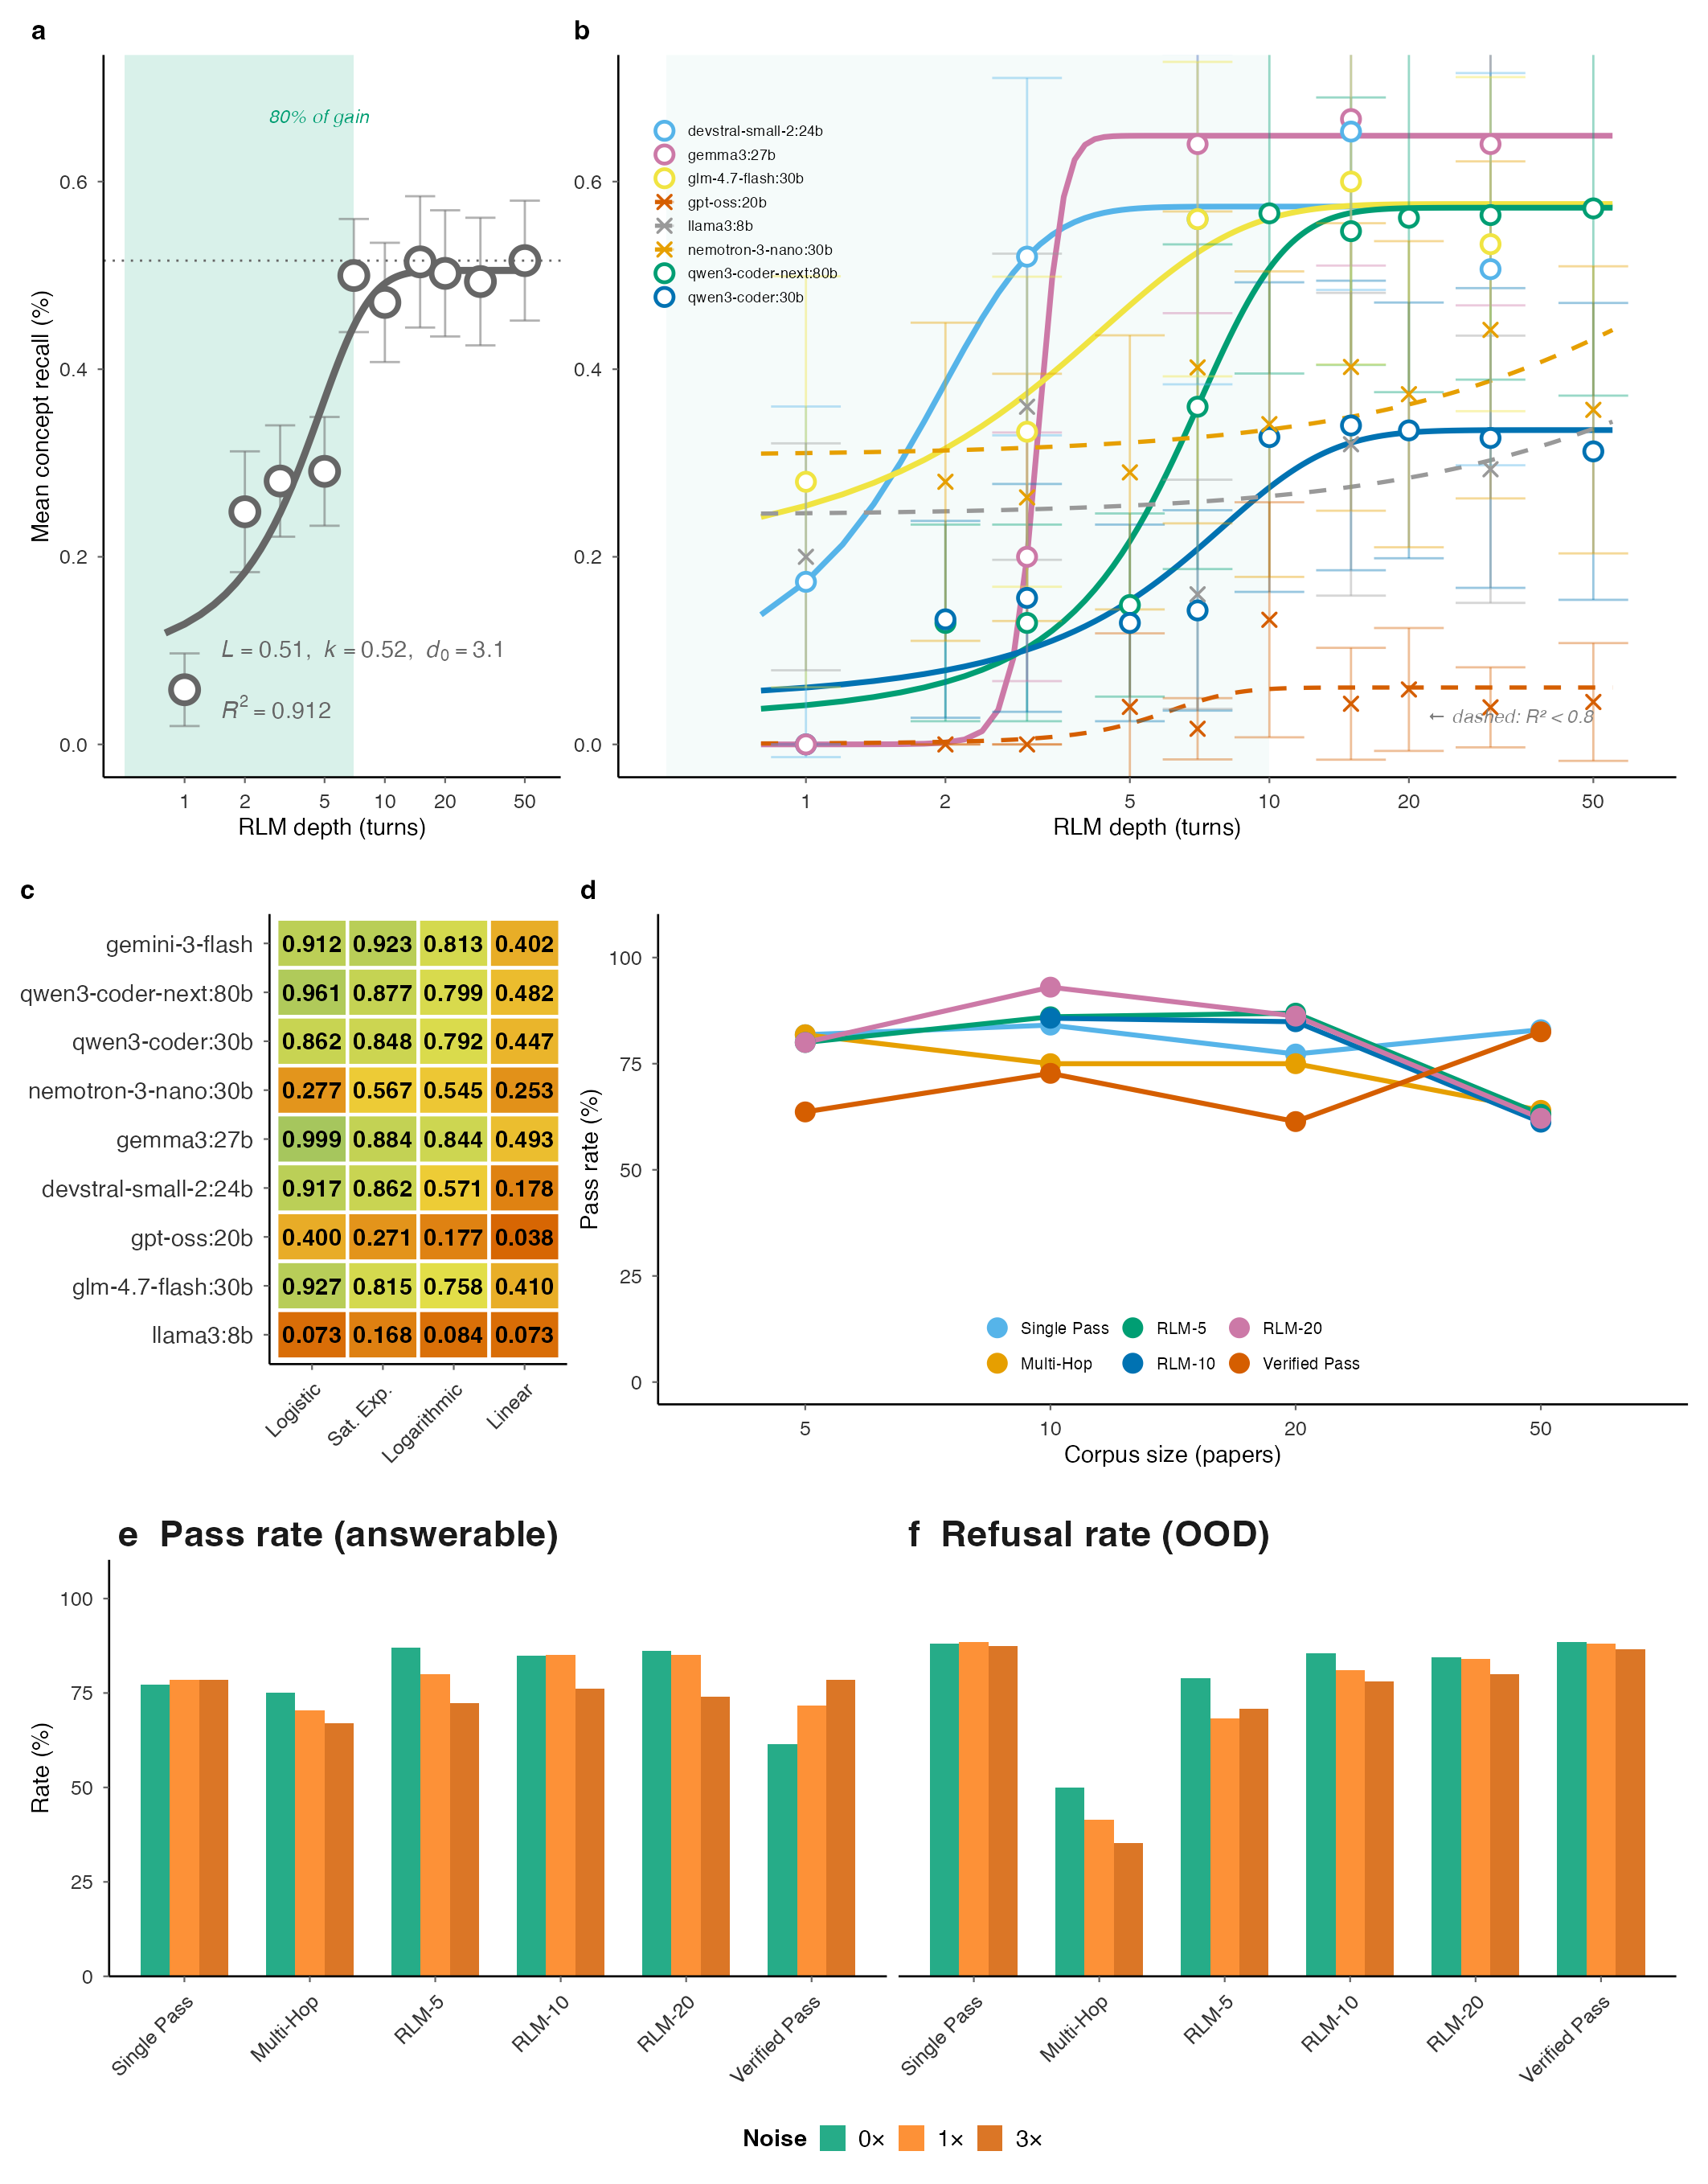
Figure 3 | Scaling behaviour: retrieval depth and corpus size. a, Concept recall saturation for gemini-3-flash (78-88 questions per depth, ten depths) with logistic fit CR(d) = L / (1 + exp(−k(d − d₀))), L = 0.51, k = 0.52, d₀ = 3.1, R² = 0.912, showing 80% of improvement within seven turns. b, Multi-model saturation across eight open-weight models across seven architecture families (15 questions, 5–10 depths). Five open-weight models produced clean logistic fits (R² = 0.86–1.00; devstral-small-2:24b, gemma3:27b, glm-4.7-flash:30b, qwen3-coder:30b, qwen3-coder-next:80b); three models (llama3:8b, gpt-oss:20b, nemotron-3-nano:30b) produced poor fits and are shown as dashed lines. The ceiling L does not correlate with parameter count (Spearman ρ = 0.15, P = 0.73, n = 8 open-weight models), reflecting model-retrieval interaction quality rather than raw scale. c, Fit quality comparison (R²), where saturating models (logistic and saturating exponential) outperform logarithmic and linear alternatives across every model that produced a well-conditioned fit. d, Strategy crossover by corpus size (no-noise condition, 9,894 evaluations). RLM strategies outperform single-pass at 20 papers but the ranking inverts at 50 papers. e, Noise robustness at the 20-paper reference scale: pass rates by strategy across three noise ratios (0x, 1x, or 3x same-domain distractors). Single-pass is noise-robust; RLM strategies show up to 14.5pp sensitivity. f, Out of Domain (OOD) refusal rate by noise level across 3,589 OOD trials. Multi-hop exhibits near-complete refusal failure (50% at 0x noise, declining to 35% at 3x); single-pass and verified-pass maintain 88%.
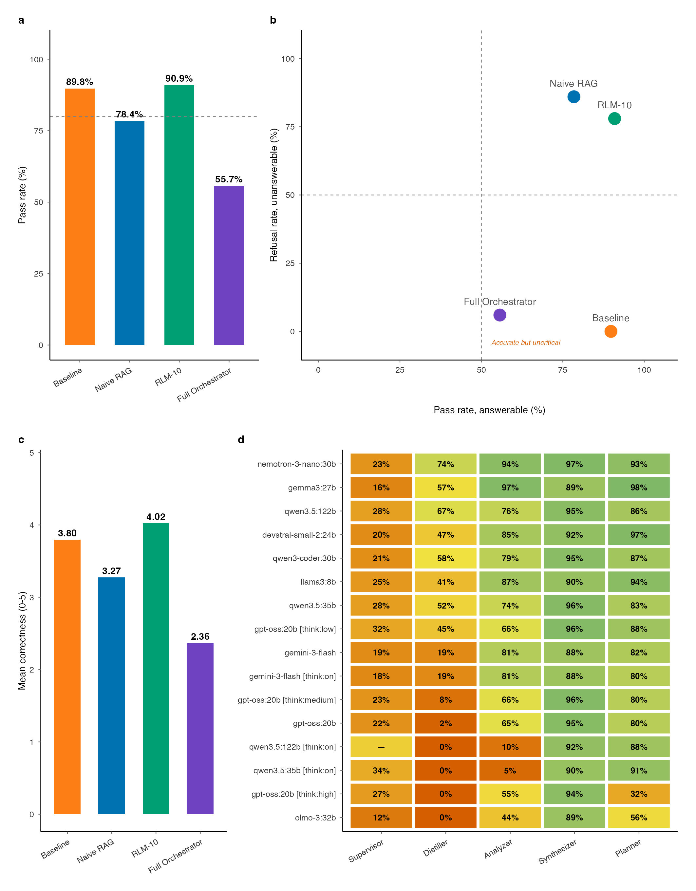
Figure 4 | Pipeline ablation and component-level benchmarks. a, Pass rate by pipeline configuration, showing that increasing complexity does not guarantee improvement: Raw Gemini 89.8%, Naive RAG 78.4%, RLM-10 90.9%, Full Orchestrator 55.7%. b, Safety versus correctness scatter: each pipeline configuration plotted with pass rate (x-axis) versus Out of Domain (OOD) refusal rate (y-axis). RLM-10 occupies the optimal quadrant (high accuracy, high safety); full orchestrator fails on both axes. c, Mean correctness by configuration, showing the non-monotonic pattern directly. d, Component-level accuracy heatmap across 14 model variants and five orchestrator components (analyser, planner, supervisor, distiller, synthesizer; 13,312 total evaluations). The distiller is the primary bottleneck: even the best model (nemotron-3-nano-30b) retains only 74% of numerical values during compression, with several models even at 0%. The supervisor column shows Spearman ρ (×100) between model-assigned quality scores and actual judge scores, revealing that no model exceeds ρ = 0.34. Analyser, synthesizer, and planner perform well across most models (>80%).
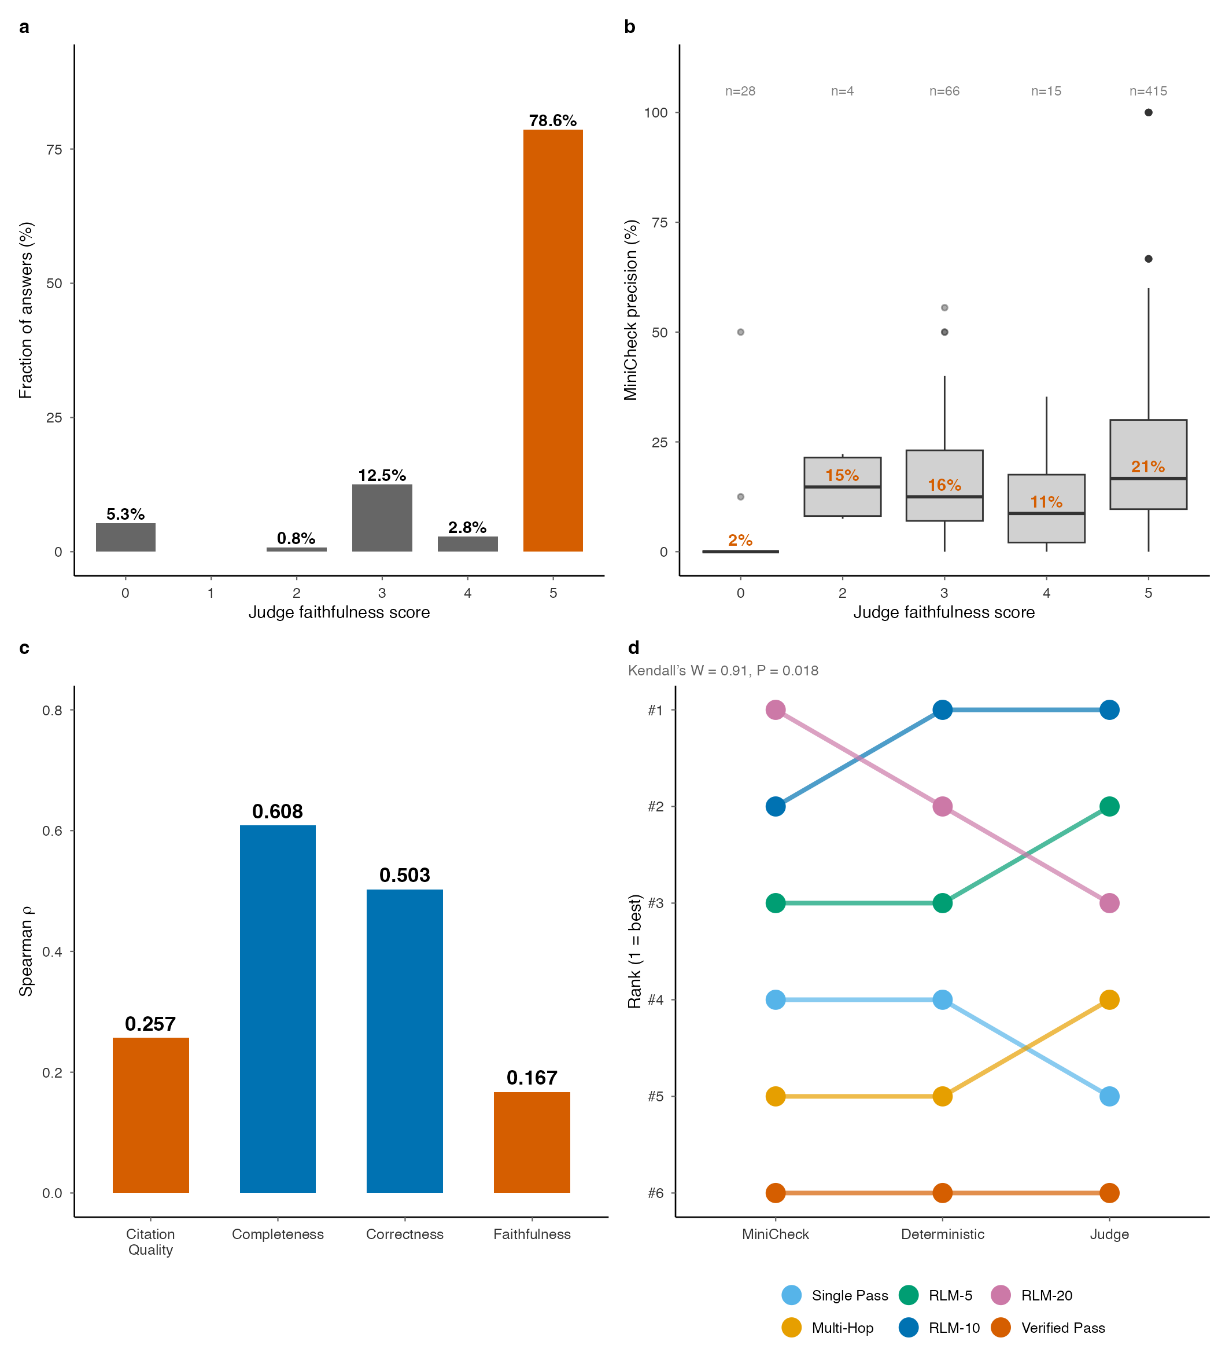
Figure 5 | Triple-triangulation evaluation. a, Judge faithfulness score distribution showing severe ceiling effect: 78.6% of scores at the maximum (5/5), mean = 4.43. b, Actual grounding by judge score: boxplots of MiniCheck precision per answer at each judge faithfulness score, showing that answers scoring 5/5 have mean precision of only 21% (Spearman ρ = 0.247). c, Cross-method correlation by evaluation dimension. Spearman ρ between deterministic and LLM judge is moderate for completeness (0.608) and correctness (0.503) but weak for faithfulness (0.167) and citation quality (0.257), confirming the failure is dimension-specific. d, Overall strategy rankings across all three evaluation methods showing convergence (Kendall’s W = 0.911, P = 0.018) despite absolute divergence.
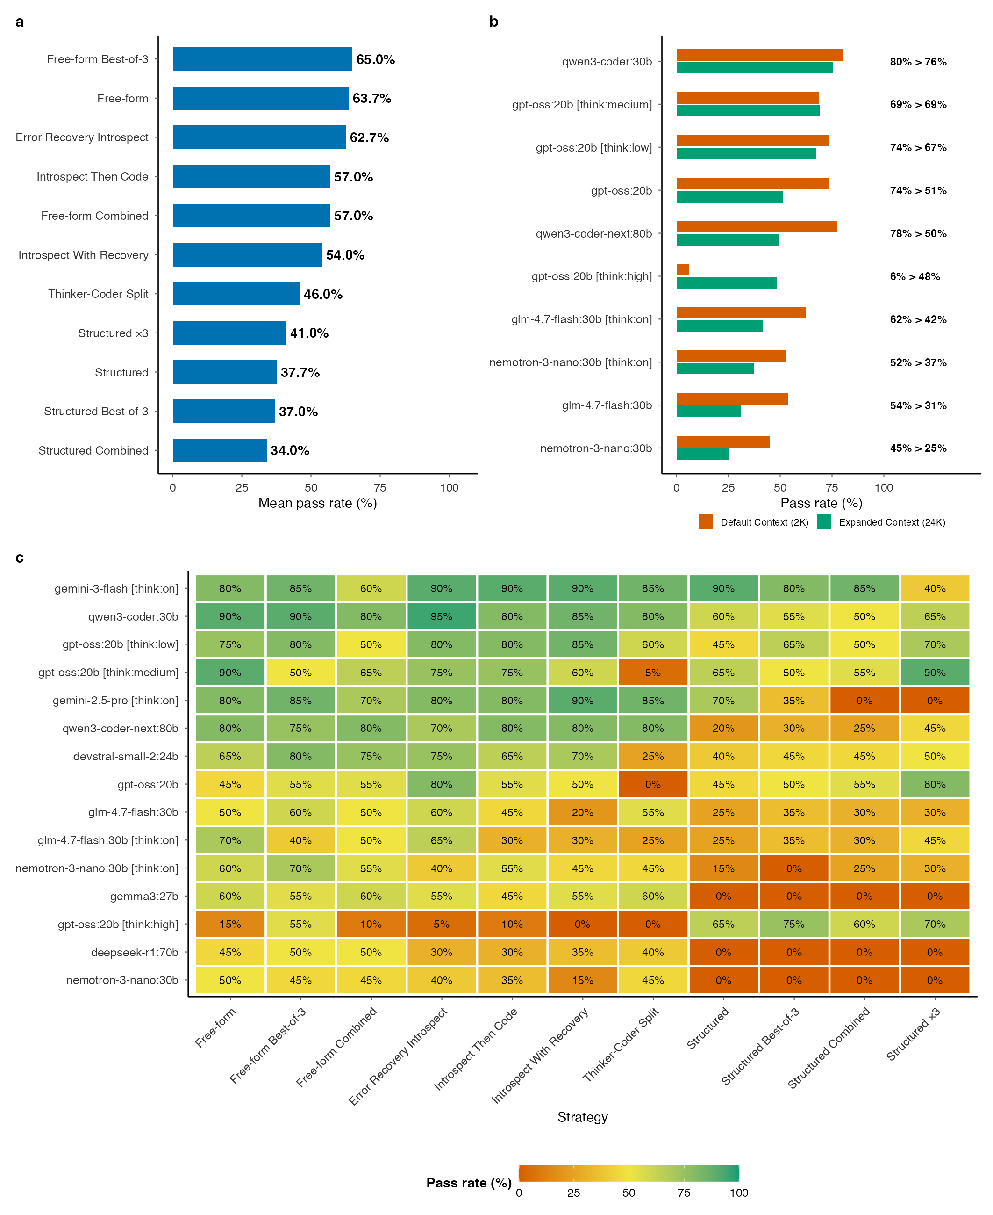
Figure 6 | Code generation benchmark. a, Pass rate heatmap across 15 model variants and 11 algorithmic strategies on 20 bioinformatics operations (3,300 total evaluations). Correctness verified against reference implementations at machine-epsilon tolerance. b, Pass rate heatmap across 15 model variants and 11 strategies. Each cell shows the pass rate for a model-strategy combination. c, Context window effect: pass rate comparison between Ollama default context (2,048 tokens) and corrected context (24,576 tokens) for each model, showing that infrastructure defaults can mask model capabilities.
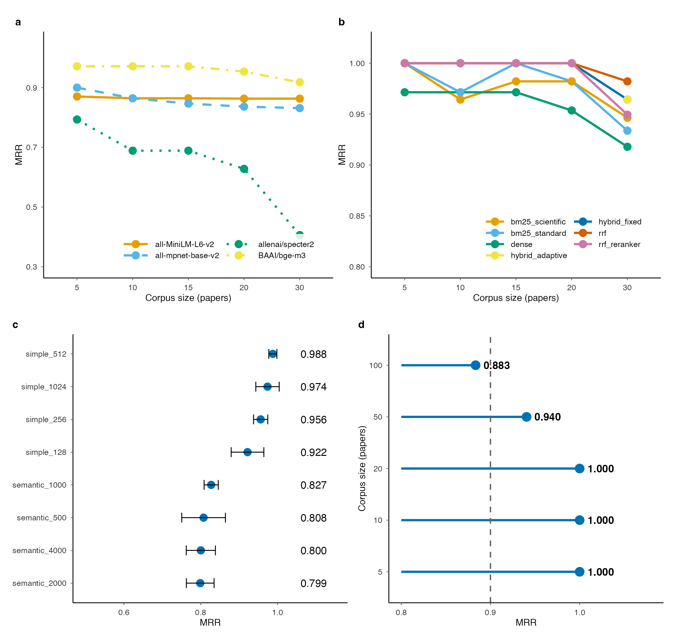
Extended Data Figure 1 | Retrieval pipeline optimization. Systematic ablation of three retrieval components. a, Mean Reciprocal Rank (MRR) by embedding model across corpus sizes; BAAI/bge-m3 achieves 0.918 MRR, with each model labelled at its rightmost data point. b, MRR by search strategy; Reciprocal Rank Fusion (RRF) achieves 0.982. c, Chunking strategy comparison (3-run mean ± s.d.); simple 512-token achieves 0.988 ± 0.011. d, Scalability: MRR and median query latency versus corpus size (5–100 papers).
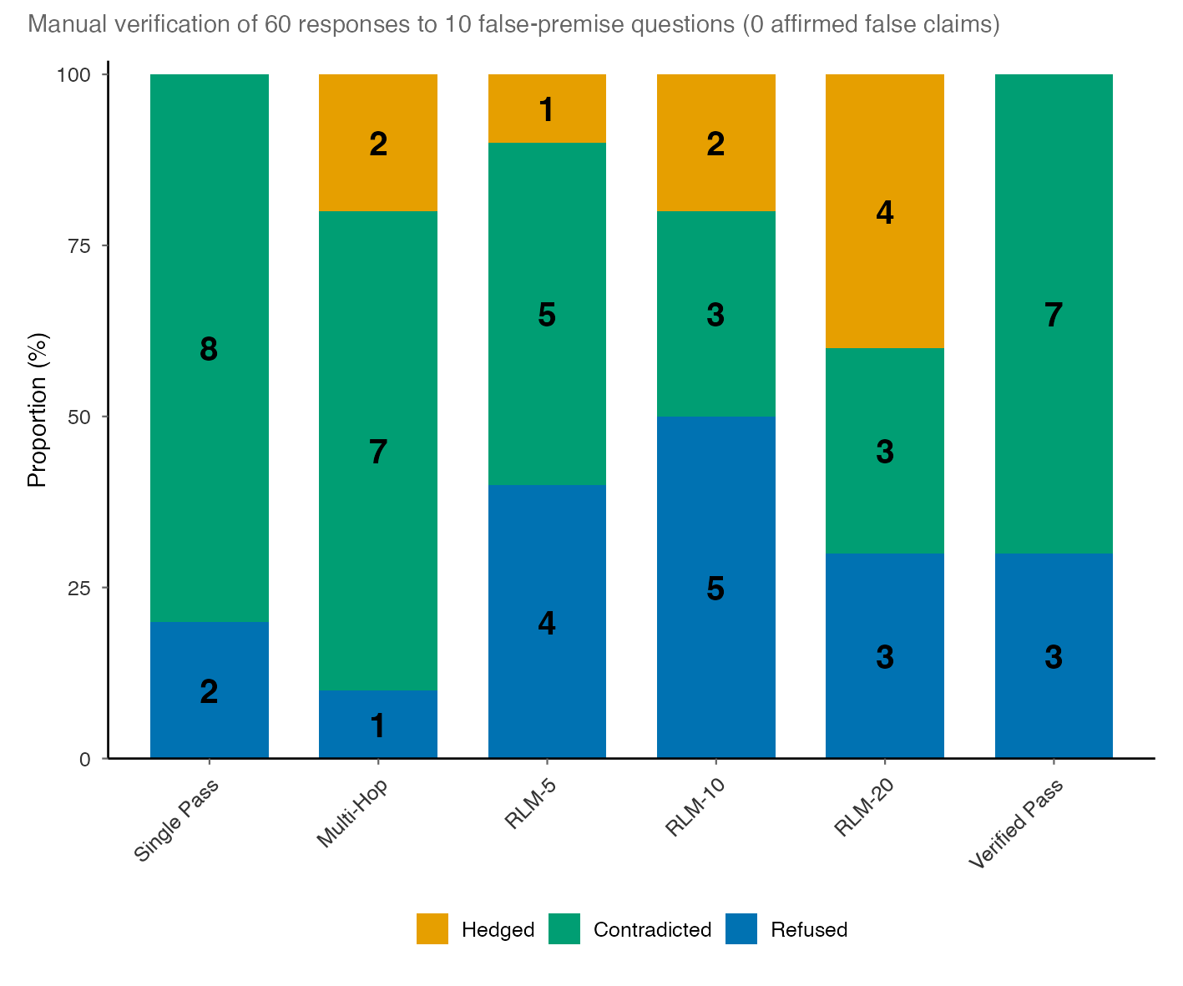
Extended Data Figure 2 | Contradictory Out of Domain (OOD) response classification. Manual verification of 60 responses (six generation strategies × 10 questions) to OOD questions containing false premises about specific papers in the corpus. Each response was classified into one of three categories: Hedged (yellow, the system retrieved unrelated papers and gave a non-committal answer without addressing the false claim), Contradicted (green, the system engaged but correctly refuted the false premise by citing evidence from the corpus), or Refused (blue, the system declined to answer or flagged the question as unanswerable). Bars show the per-strategy proportion of each outcome; numbers inside bars are raw counts (n = 10 per strategy). Across all 60 engaged responses, zero affirmed the false premise, and 33 of 42 engaged responses (78.6%) correctly contradicted it. The nine hedging cases all originate from RLM configurations, reflecting the single-document retrieval failure mode rather than hallucination. The low overall refusal rate (mean 30% across strategies) is thus a metric artefact, the judge's refusal_accuracy score penalises engagement regardless of whether the engagement correctly refutes the false premise a construct-validity limitation independent of actual safety behaviour.
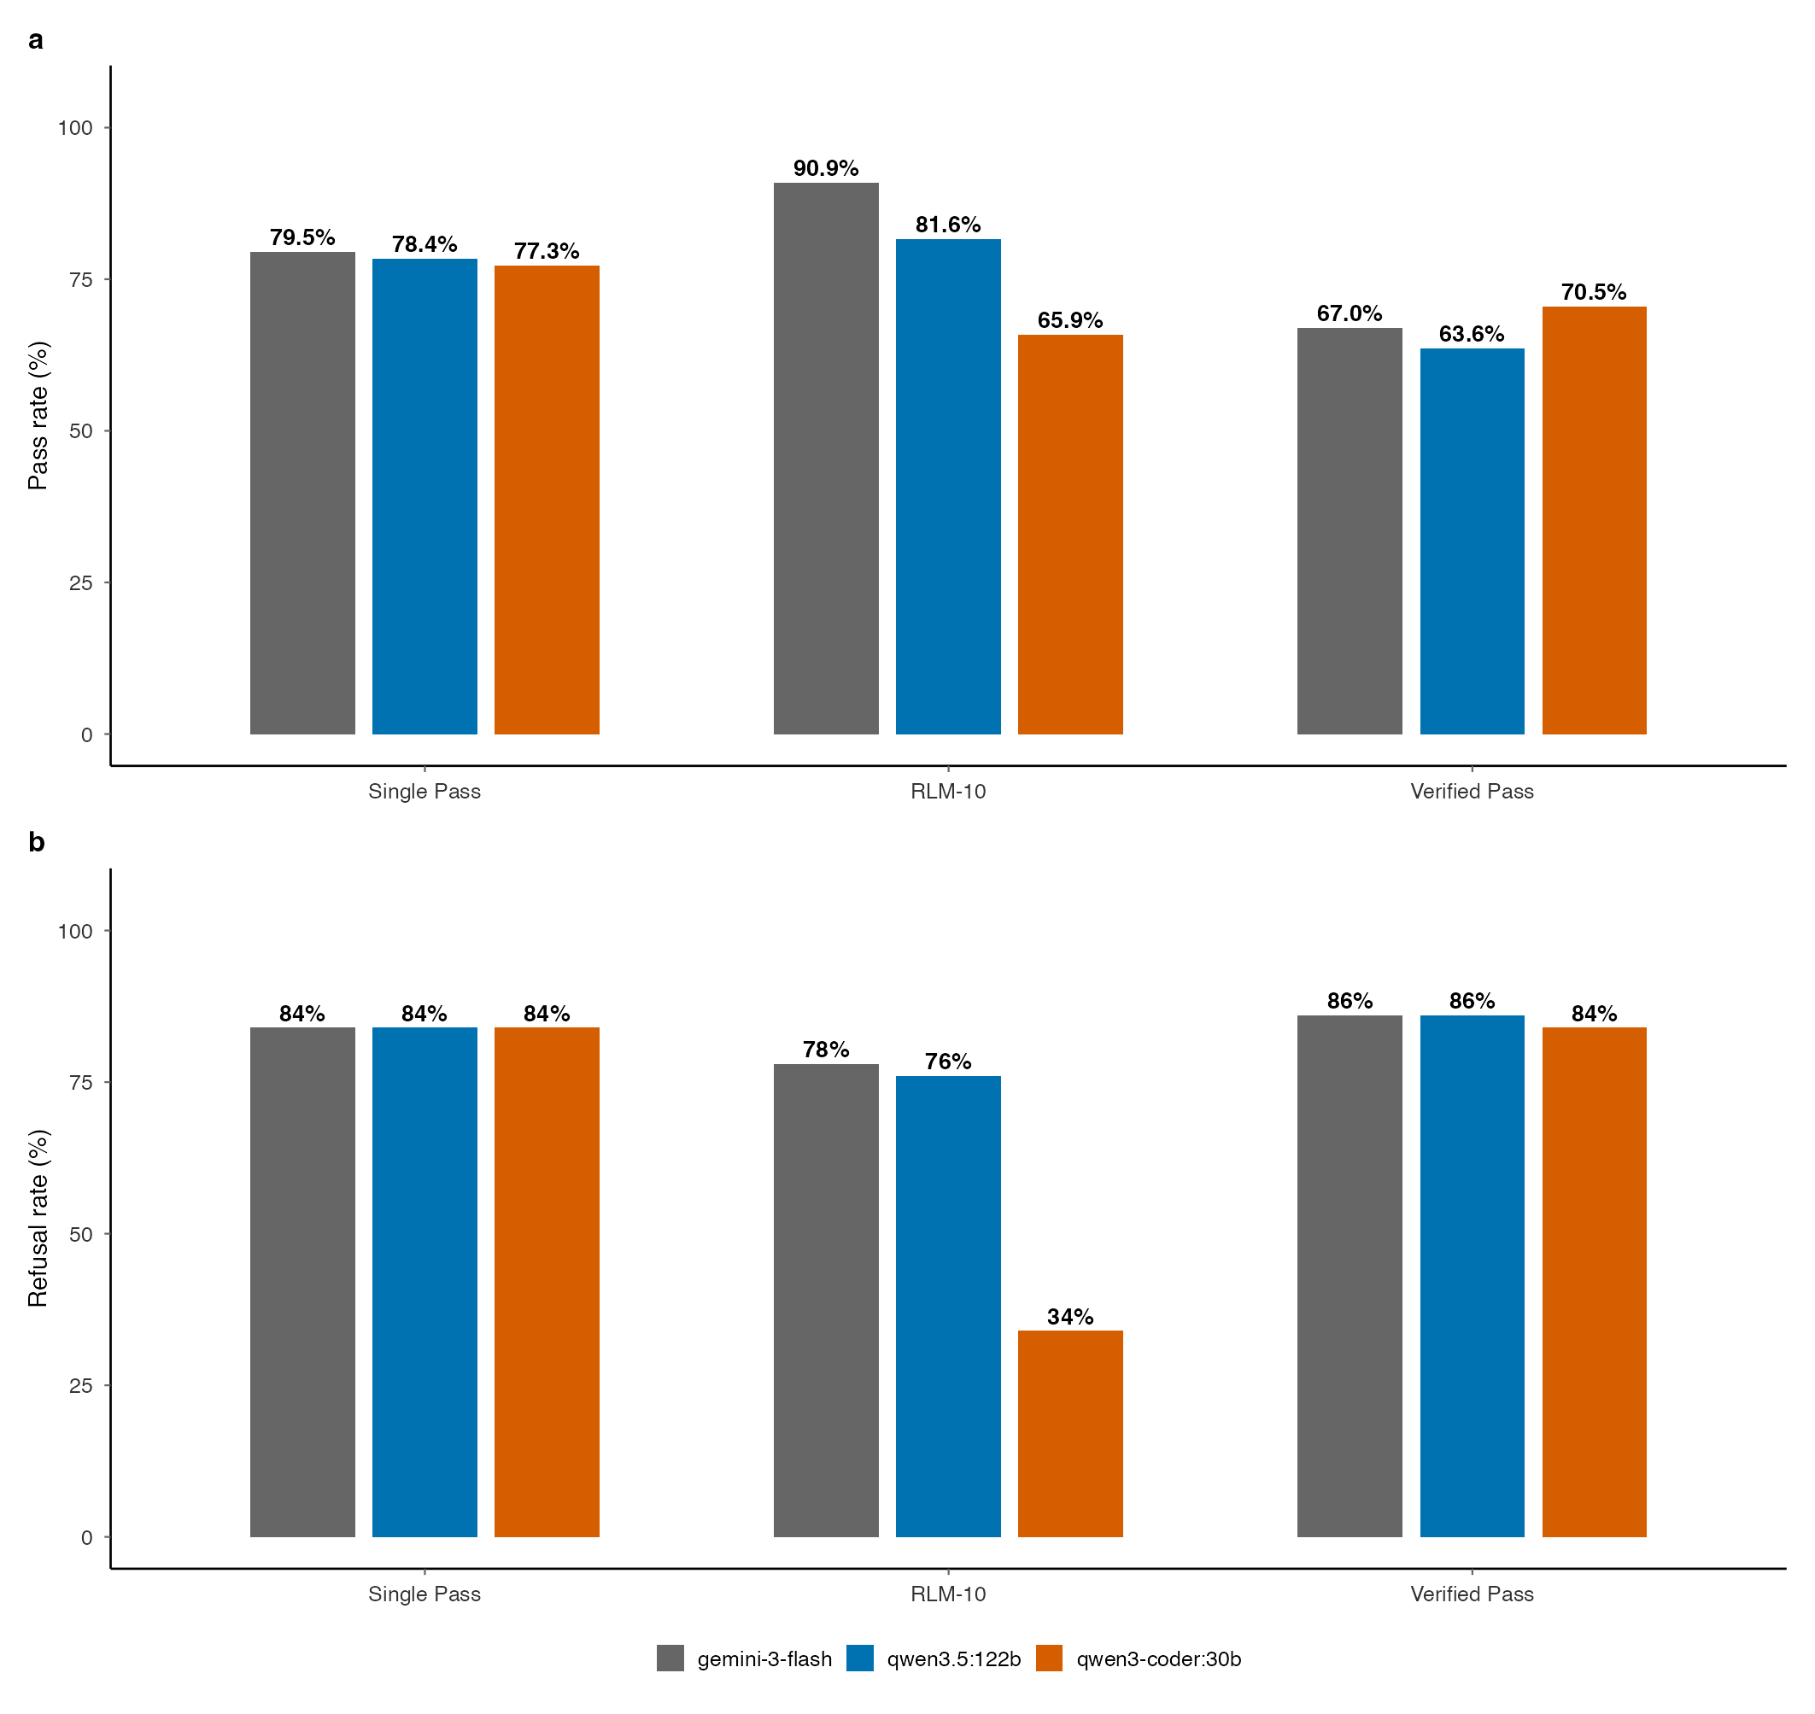
Extended Data Figure 3 | Strategy replication across generation models. Pass rate comparison for three generation strategies (RLM-10, single-pass, verified_pass) across three generation models: gemini-3-flash (primary), Qwen3.5 122b, and Qwen3-Coder 30b. The 122b open-weight model replicates the Gemini ranking perfectly (Spearman ρ = 1.0), while the 30b model inverts it (ρ = −0.5), demonstrating that the RLM advantage is capability-gated.
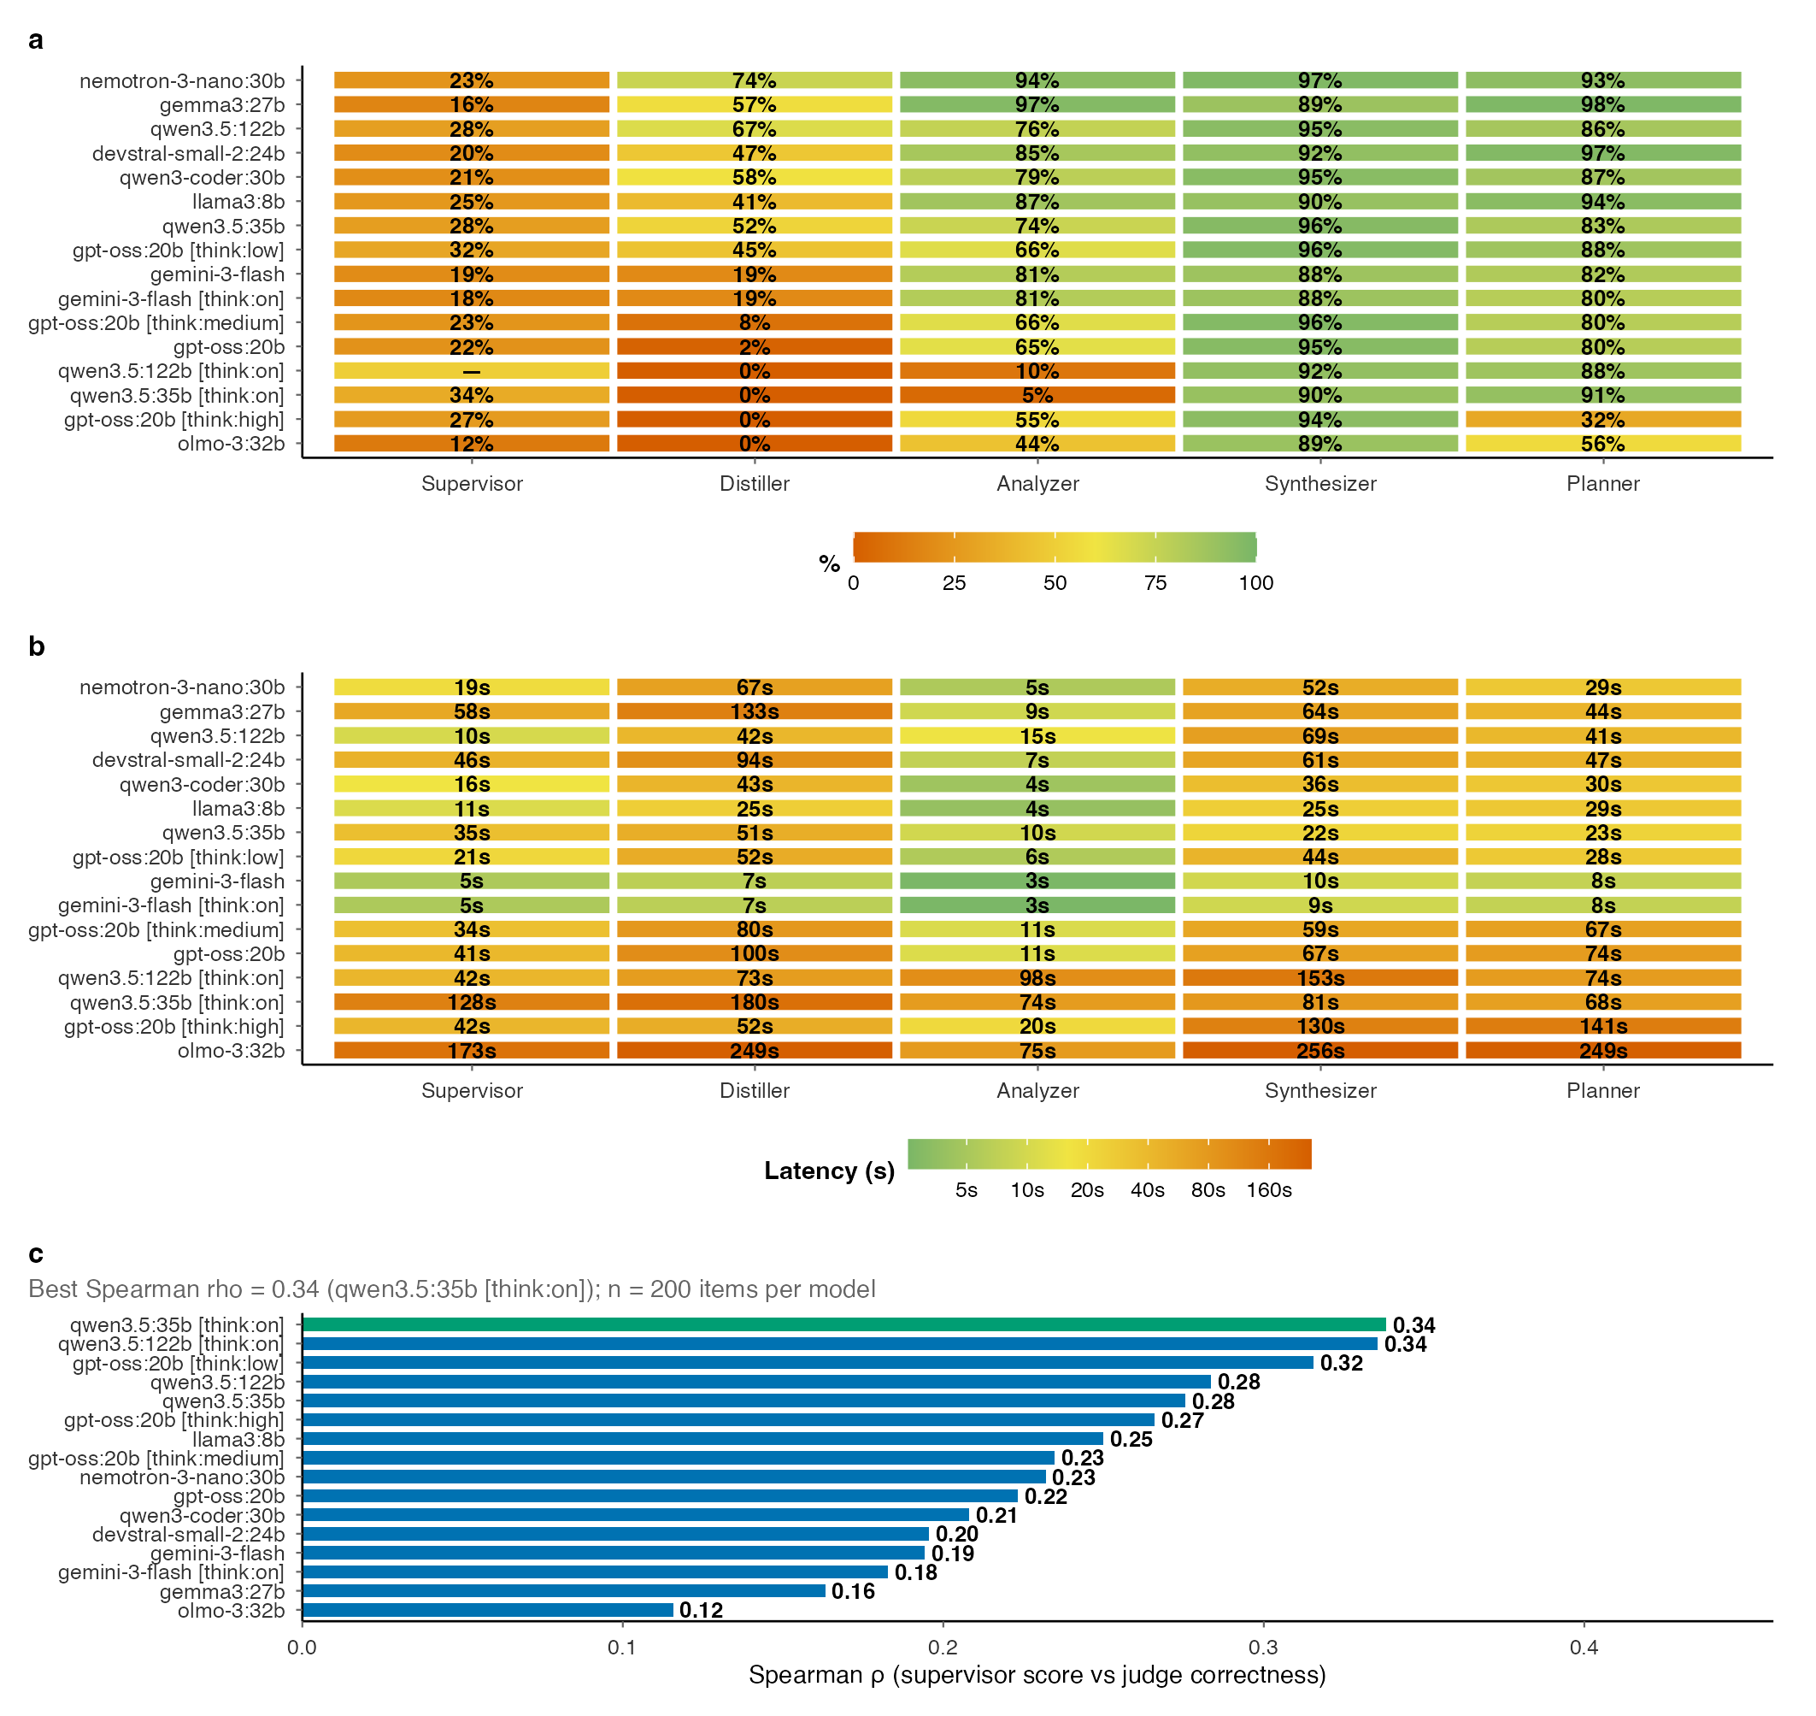
Extended Data Figure 4 | Component benchmarks across model families. a, Accuracy heatmap across five orchestrator components (supervisor, distiller, analyser, synthesizer, planner) and 16 model variants from 11 architecture families (13,312 total evaluations), showing per-component performance variation. Supervisor column shows Spearman ρ (×100) with actual judge scores; distiller column shows number retention percentage. b, Distiller number retention versus source retention scatter by model, revealing the information preservation trade-off during observation compression. c, Supervisor quality score correlation (Spearman ρ with actual judge scores) by model, highlighting the wide spread in evaluation reliability. d, Analyser: latency versus accuracy scatter with bubble size proportional to output tokens. e, Synthesizer: latency versus accuracy scatter. f, Planner: latency versus accuracy scatter.
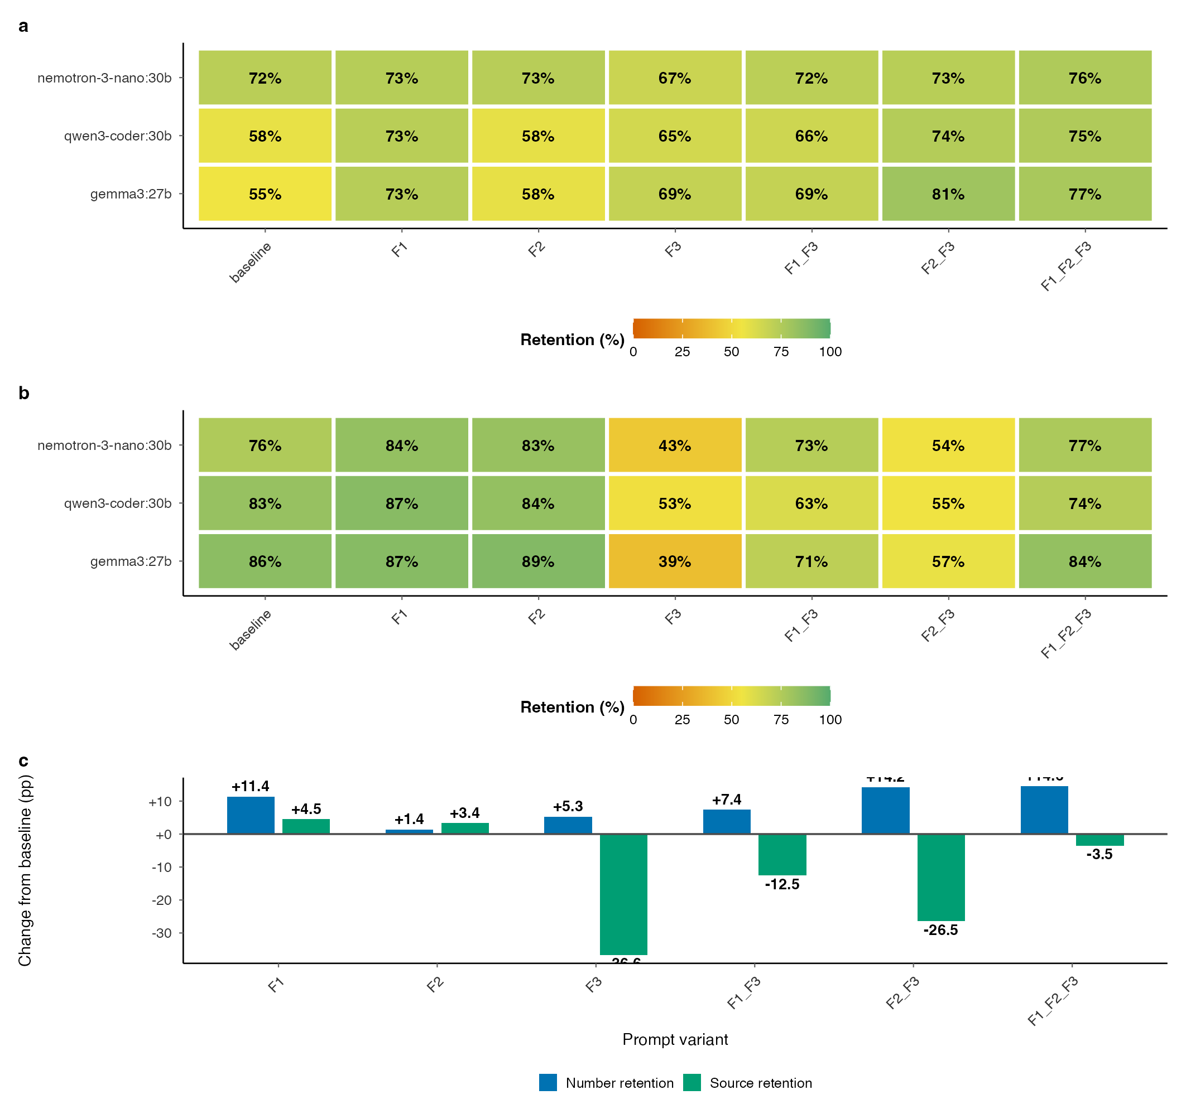
Extended Data Figure 5 | Distiller prompt engineering ablation. a, Number retention heatmap across seven prompt variants and three models (4,171 evaluations), showing that few-shot examples (F1) provide the most consistent improvement from baseline (+15-18pp) for qwen3-coder: 30b and gemma3:27b. b, Number retention versus source retention trade-off, faceted by model. F1 is the only “free lunch” variant (improves numbers without degrading sources), while F3 variants sacrifice source retention. c, Delta from baseline (percentage points) by model, showing that weaker models benefit most from prompt engineering.
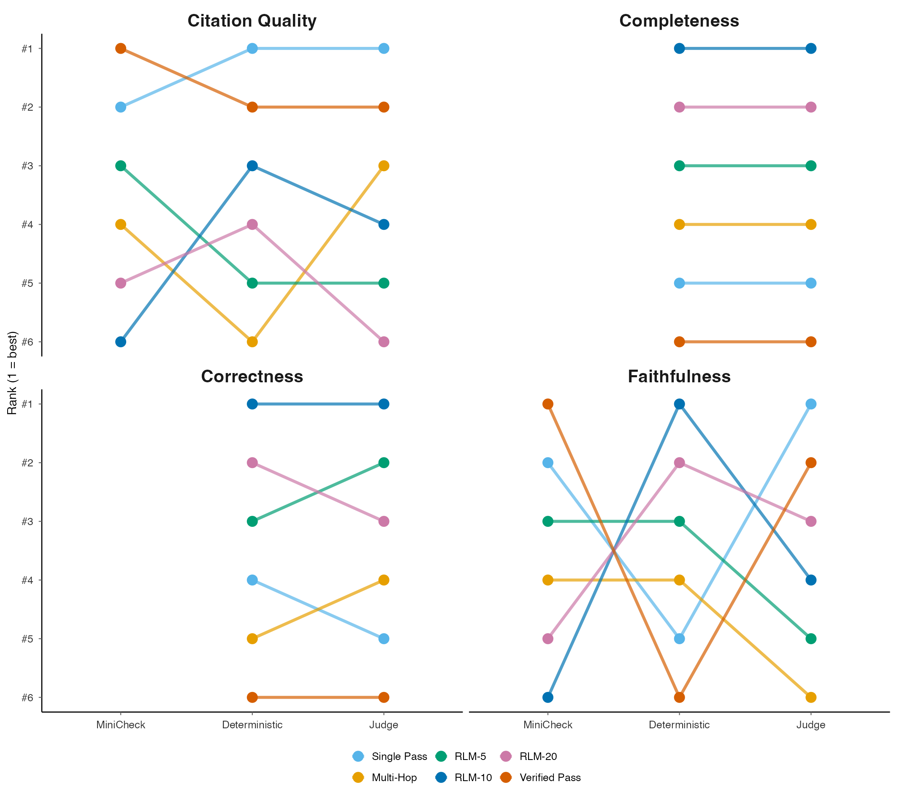
Extended Data Figure 6 | Per-dimension ranking concordance. Bump charts comparing how the six generation strategies (coloured lines) are ranked by each of three evaluation methods. MiniCheck (claim-level entailment), Deterministic (rule-based scoring against ground truth), and LLM Judge, across four evaluation dimensions. Each panel shows one dimension: Citation Quality (top-left), Completeness (top-right), Correctness (bottom-left) and Faithfulness (bottom-right). Within each panel, the x-axis lists the three methods and the y-axis shows rank (1 = best, 6 = worst, inverted so that #1 is at the top). A horizontal line indicates that a strategy holds the same rank across methods; a crossing line indicates disagreement. Completeness and Correctness panels omit MiniCheck because it measures claim-level entailment rather than answer completeness or correctness, so only two methods appear in those panels.

