Supplementary Information
Systematic ablation of a multi-agent language model system for life sciences research
Valerio Bianchi and Dirkjan Schokker
This file holds Supplementary Notes 1 to 8, Supplementary Figures 1 to 18 and Supplementary Tables 1 to 3. Supplementary Data 1 to 8 are supplied as separate files, listed below.

Contents
Supplementary Note 1 | Study design and the answer key
Supplementary Note 2 | Choosing the judge and its agreement with expert raters
Supplementary Note 3 | The strategy comparison in detail
Supplementary Note 4 | Retrieval depth and corpus size in detail
Supplementary Note 5 | The pipeline ablation in detail
Supplementary Note 6 | The three evaluation signals in detail
Supplementary Note 7 | The plant-science reuse in detail
Supplementary Note 8 | Code generation in detail
Supplementary Figure 1 | How the experiments of the study connect
Supplementary Figure 2 | Retrieval pipeline selection
Supplementary Figure 3 | Human evaluation in full
Supplementary Figure 4 | Two judges on the same answers, every metric
Supplementary Figure 5 | Answers to the false-premise questions, by strategy and corpus size
Supplementary Figure 6 | Replication on other generators in full
Supplementary Figure 7 | Outcome and turns of Zhang RLM on the depth-sweep questions, across turn caps
Supplementary Figure 8 | Generation strategies against single pass across corpus sizes
Supplementary Figure 9 | Mentor::i's question-answering pipeline
Supplementary Figure 10 | Orchestrator component benchmarks
Supplementary Figure 11 | Distiller prompt variants
Supplementary Figure 12 | Answers stating every concept; each strategy against single pass; Papers by the judge's verdict and by faithfulness
Supplementary Figure 13 | The pipeline and its evaluation on five plant-science papers
Supplementary Figure 14 | How code-generation attempts failed, per model variant
Supplementary Figure 15 | Paired outcomes and net change of repeated against single attempts
Supplementary Figure 16 | Structured prompting, thinking setting and dataset, model by model
Supplementary Figure 17 | Outcomes, tokens, time and turns per answer for each generation strategy
Supplementary Figure 18 | RAGAS, RAGChecker and BERTScore against the judge and the three signals
Supplementary Table 1 | Choosing the judge
Supplementary Table 2 | Generator and judge pairing
Supplementary Table 3 | Signals recorded per experiment

Supplementary Data (supplied as separate files)
Supplementary Data 1 | The answer key. Every question with its category, its source papers and their area; the expert-curated questions, ground-truth answers, validation results and per-question metadata.
Supplementary Data 2 | Source Data for Figure 1. One sheet per panel.
Supplementary Data 3 | Source Data for Figure 2. One sheet per panel.
Supplementary Data 4 | Source Data for Figure 3. One sheet per panel.
Supplementary Data 5 | Source Data for Figure 4. One sheet per panel.
Supplementary Data 6 | Source Data for Figure 5. One sheet per panel.
Supplementary Data 7 | Source Data for Figure 6. One sheet per panel.
Supplementary Data 8 | Source Data for Figure 7. One sheet per panel.

Supplementary Note 1 | Study design and the answer key
Each answer to a question was read in up to three ways, each against its own reference: an LLM judge scored it against the expert answer, concept recall counted the expected concepts it contained, and MiniCheck checked its claims against the source papers (Fig. 1a, Supplementary Fig. 1). We varied 11 settings of the pipeline, grouped by the stage they act on: indexing, retrieval, generation and judging (Fig. 1b). Every strategy, component and index tested here is implemented in Mentor::i, an open-source scientific workspace, except the reference RLM of Zhang and colleagues, which runs as its authors' package. The 22 experiments share one evaluation corpus of 200 papers (50 core and 150 distractor papers), except three: the retrieval set-up, chosen before the experiments reported here, on indexes of its own; code generation, run on two datasets; and the reuse demonstration, run on five plant-science papers. Several use the output or a choice of an earlier one. Each stage is tested on its own set of items. In the generation experiments, a generator model answers questions from the corpus, 135 of them in the main comparison: 86 answerable from it, 39 out of scope and 10 built on a false premise. Six strategies answer them, from a single retrieval pass to recursive language models (RLMs) that write code to search the corpus over several turns. Code generation is tested on 20 data-analysis operations, an attempt passing when its code returns the reference values.
Every strategy searches one retrieval set-up, chosen first by testing its components one at a time for mean reciprocal rank on 28 retrieval queries about five papers from the core set (corpus papers 46 to 50), with unrelated papers added to each larger index and no answer generated. It embeds 512-token chunks with BAAI/bge-m3, fuses dense and BM25 search by reciprocal rank fusion and reorders the result with a reranker (Supplementary Fig. 2; Methods).
The answer key holds 244 questions written from the 50 core papers, which come from five areas: antimicrobial resistance and One Health, bioinformatics and sequencing, veterinary epidemiology, the microbiome and computational biology methods. Of the questions, 195 can be answered from the papers. They are factual recall, conceptual, technical, cross-document and synthesis questions, the last two needing two or more papers. Ten more rest on a false premise about a corpus paper, and 39 are out of scope, asking for general knowledge or for a topic the corpus leaves out. Each expected answer was written only from sentences quoted verbatim from its source papers, and the first author signed off every item (Methods). Supplementary Data 1 lists every question with its category, its source papers and their area. A question is in scope on an index when all its source papers are in it. The strategy comparison uses the 20-paper index, on which 135 questions are in scope: 86 answerable (60 with one source paper and 26 with several), 10 built on a false premise and 39 out of scope.

Supplementary Note 2 | Choosing the judge and its agreement with expert raters
Before comparing strategies, we needed to choose the LLM judge that scores every answer of the generator, and define a pass rate based on the judge's score. The judge scores the correctness of each answer against the expected answer on a scale from 0 to 5; an answer passes when it scores 4 or more, and passes the relaxed mark when it scores 3 or more. We chose it in two rounds, by how closely its scores followed three measures that need no judge: its correctness score against the answer's semantic similarity to the expected answer, its completeness score against concept recall, and its citation score against an automatic citation score. The mean of the three Pearson correlations is the composite. In the first round, 22 candidate judges were each given the same 107 answers, written by eight generator models to 15 questions of the answer key (Supplementary Data 1), with no answer from some models to some questions (19 judges scored all 107); in the second, four of them scored the same 1,500 answers drawn from the earlier runs of 18 generators, 821 of them by gemini-3-flash-preview (hereafter gemini-3-flash) (Supplementary Table 1). We kept devstral-small-2:24b (Devstral Small 2, Mistral AI, 24 billion parameters) as the main judge and qwen3.8:27b (Qwen3.8, Qwen team at Alibaba, 27 billion parameters) as a second judge from another model family. qwen3.8:27b had the higher composite in the second round, 0.628 against 0.576, but only as an MLX build that does not apply the study's fixed model settings, whereas devstral-small-2:24b followed semantic similarity more closely on correctness, the score every pass rate uses, and repeated its scores exactly on all 107 answers (Methods). We then set both judges against two expert raters (Fig. 2; Supplementary Fig. 3b).
The judge agreed with the expert raters on correctness about as well as the two raters agreed with each other. Two authors rated 49 answers on a 1 to 5 scale, blind to the strategy. Averaged over the two raters, the judge's quadratic-weighted kappa with a rater was 0.78 (95% CI: 0.67 to 0.86), and the raters' kappa with each other was 0.75 (95% CI: 0.58 to 0.86; Fig. 2e). On faithfulness, the two raters' scores did not reach the reliability fixed before rating (ordinal Krippendorff's alpha 0.30, 95% CI: 0.03 to 0.51, against 0.667). The two scores were within one point of each other on 37 of 49 answers (75.5%, 95% CI: 63.3% to 87.8%) and equal on 12 (24.5%; Supplementary Fig. 3a). A second judge from another model family, qwen3.8:27b, scored the 1,548 answers gemini-3-flash gave to the 86 answerable questions of the strategy comparison and agreed with the main judge on correctness (weighted kappa 0.78, 95% CI: 0.74 to 0.82) more than on faithfulness (0.59, 95% CI: 0.51 to 0.67; Supplementary Fig. 4). It was stricter, passing 77% of single pass answers against 83% for the main judge, but under both judges multi-hop retrieval and every RLM depth passed fewer answers than single pass.
The two-of-three rule, added after rating began and before any summary of the ratings was computed, did not agree with the raters better than the judge alone (Fig. 2f). Against the raters' correctness at a pass mark of 4, on the 48 answers that all three signals scored, the judge agreed with the raters on 85.4% of answers (95% CI: 75.0% to 93.8%), concept recall on 81.3% (95% CI: 70.8% to 91.7%) and claim checking against the source papers on 56.3% (95% CI: 41.7% to 70.8%). A rule that passes an answer when at least two of the three signals pass it agreed on 77.1% (95% CI: 64.6% to 87.5%). Exact two-sided McNemar tests favoured the rule over claim checking (P = 0.013) but not over the judge (P = 0.29) or concept recall (P = 0.50), so the expectation that two of three agrees better than every single signal does not hold. Requiring all three signals to pass agreed on 87.5% (95% CI: 77.1% to 95.8%). At the relaxed mark of 3, the judge agreed on 85.4% (95% CI: 75.0% to 93.8%), concept recall on 75.0% (95% CI: 62.5% to 85.5%), claim checking on 70.8% (95% CI: 56.3% to 83.3%), the two-of-three rule on 83.3% (95% CI: 72.9% to 93.8%) and requiring all three on 72.9% (95% CI: 60.4% to 85.4%). As at mark 4, the two-of-three rule agreed with the raters more often than claim checking alone (P = 0.031), but not more often than the judge alone (P = 1.00) or concept recall alone (P = 0.34).

Supplementary Note 3 | The strategy comparison in detail
We compared six generation strategies on the 135 questions in scope on the 20-paper index (Fig. 3). All answers were generated by gemini-3-flash three times per question and scored with the judge, concept recall and claim checking with MiniCheck[46], as set out above. Single pass retrieval retrieves once and generates once. Passage verification (verified pass) retrieves 15 passages, has a separate model (gpt-oss:20b) keep only those it judges relevant to the question, and generates from them. Multi-hop retrieval lets the model search up to five times, each time seeing the passages just retrieved and its earlier queries, before it answers. The most elaborate strategy is RLM, our adaptation of the recursive language model of Zhang et al.[25], in which the model writes and runs Python code to search the index, refine queries and assemble cited answers over several turns, capped at 5, 10 or 20 turns (RLM-5, RLM-10 and RLM-20). The package released by Zhang et al. (hereafter Zhang RLM) ran beside it as a reference. Below, RLM always means our implementation and RLM-5, RLM-10 and RLM-20 its three caps; the package is always named Zhang RLM.
Pooled over the answerable questions, no iterative strategy passed more answers than single pass retrieval (Fig. 3a,d). Single pass passed 82.9% of answers (95% CI: 75.2% to 89.9%) and passage verification 83.3% (95% CI: 76.4% to 89.9%). RLM-10 passed 74.0% (95% CI: 67.8% to 79.8%) and used 6.3 model calls and ten times as many tokens per answer (Fig. 3d), and took a mean of 129 s per answer against 42 s for single pass (Fig. 3a; Methods). The pooled rates hide a reversal by question type. On the 60 questions that one paper answers, single pass passed 96.7% of answers and RLM-10 70.6%. On the 26 questions that need several papers, single pass passed 51.3% and RLM-10 82.1%. Iterative retrieval therefore pays off when the evidence is spread over several papers and costs accuracy when it is not. We report this split as exploratory, and it held in the test fixed in advance under the second judge and with qwen3-coder:30b, but not clearly with gemma3:27b, and claude-haiku-4-5 and gemini-2.5-pro, reported beside the test, showed it too (Fig. 3e; Supplementary Fig. 6).
The gain on many-paper questions came from the larger context, not from iteration itself. Given RLM-10's input-token budget in a single call, single pass retrieval passed 93.0% of answers (95% CI: 87.6% to 97.3%) and 82.1% of those on many-paper questions, the same as RLM-10 with one call instead of six (Fig. 3a,d).
Against single pass retrieval, each strategy turned some correct answers incorrect and some incorrect answers correct, and the iterative ones harmed more answers than they helped (Fig. 3c). Per pairing of draws, passage verification, which filters retrieved passages with an intermediate LLM check before generation, harmed a mean of 5.6 answers and helped 5.9 (harmed share 48.5%, 95% CI: 28.2% to 73.4%; two-sided exact P = 1), and multi-hop harmed 8.2 and helped 4.6 (64.3%, 95% CI: 44.1% to 82.0%; P = 0.20). The RLMs changed about twice as many: RLM-5 harmed 17.1 and helped 8.8 (66.1%, 95% CI: 51.3% to 80.5%; P = 0.042), RLM-10 harmed 17.4 and helped 9.8 (64.1%, 95% CI: 50.0% to 78.5%; P = 0.067) and RLM-20 harmed 19.6 and helped 8.9 (68.8%, 95% CI: 54.5% to 82.3%; P = 0.014), each P unadjusted. Of the answers single pass got right, passage verification degraded 7.8% (95% CI: 4.0% to 12.2%), multi-hop 11.5% (95% CI: 6.1% to 17.4%) and the RLMs 24.0% to 27.4%. These pooled counts mix the two question types, on which the RLMs gain and lose in opposite directions (above).
Iterative retrieval varied more between runs than single pass retrieval. Across the three draws of each question, RLM-10's answers disagreed, one passing and one failing, in 32.6% of draw pairs (84 of 258), against 6.2% for single pass (16 of 258; Source Data Fig. 3c).
Strategy choice also governed refusal on out-of-scope questions (Fig. 3b). Single pass and passage verification refused every one of their answers to the 39 out-of-scope questions (one-sided 95% lower bound 92.6%). RLM-10 refused 97.4%, multi-hop retrieval 88.0% and RLM-5 70.1%, 29.9 percentage points below single pass (two-sided exact P = 4.8 × 10⁻⁷).
On the ten false-premise questions, each built on a false claim about a corpus document, single pass retrieval passed all 30 of its answers at a judge score of 4 or more (Supplementary Fig. 5). Multi-hop retrieval and passage verification passed 28, RLM-5 and RLM-20 26, and RLM-10 25 of 30.
We replicated the central comparison with further generators and a second judge (Fig. 3e and Supplementary Fig. 6). We fixed one test in advance: each question's RLM-10 pass share minus its single pass share, averaged over many-paper questions minus the same average over one-paper questions. For gemini-3-flash the difference was 56.9 percentage points (95% CI: 38.5 to 75.2). When a second judge, qwen3.8:27b, scored the same answers, it was 33.3 points (95% CI: 13.4 to 52.6). With claude-haiku-4-5 and gemini-2.5-pro as generators it was 55.7 (95% CI: 36.0 to 75.1) and 56.7 points (95% CI: 32.9 to 78.9). For gemma3:27b and qwen3-coder:30b the differences were 13.8 points (95% CI: −10.1 to 37.3) and 28.2 points (95% CI: 9.9 to 48.0), over 46 answerable questions (20 one-paper, 26 many-paper). The split held for qwen3-coder:30b; for gemma3:27b it pointed the same way, but its interval included zero.

Supplementary Note 4 | Retrieval depth and corpus size in detail
To find how many turns an RLM needs, we ran both RLMs with gemini-3-flash at ten turn caps from 1 to 50 (Fig. 4a). Concept recall rose steeply over the first turns and then levelled off. RLM rose from 47.5% of expected concepts with one turn to 74.8% with three, and stayed between 72.9% and 77.2% from three to 50 turns. Zhang RLM rose from 9.9% with one turn to 62.2% with five, and stayed between 62.4% and 66.8% from seven turns on. The first cap whose mean reached the lower end of the best cap's 95% CI was three turns for RLM and five for Zhang RLM. A logistic curve fitted to concept recall against turn cap levels off at 75.2% (95% CI: 71.5% to 78.9%) for RLM and at 64.2% (95% CI: 59.2% to 69.0%) for Zhang RLM, 11.0 points apart (95% CI: 6.8 to 15.3). RLM's curve reaches 90% of its plateau at cap 1.8 (95% CI: 1.5 to 2.2), Zhang RLM's at cap 2.4 (95% CI: 2.0 to 2.8); the fit places where the curve rises, while the rule above asks where the mean first comes within reach of the best cap, so Zhang RLM's 2.4 and 5 answer different questions. Without cap 1, Zhang RLM's fit is about the same (plateau 65.4%, 90% at cap 3.0), while RLM's recall is flat from cap 2 and its rise cannot be placed. Question by question, RLM recovered more concepts than Zhang RLM at every cap (mean difference 7.4 to 37.7 points; Holm-adjusted two-sided sign-flip P ≤ 0.010 at each of the ten caps) and over all caps (14.3 points, 95% CI: 10.8 to 17.9; higher on 70 of 86 questions), a comparison chosen after the data were seen. From ten turns up, few answers used all their turns: Zhang RLM's median answer used six turns at every cap from 15 to 50 (Supplementary Fig. 7b).
We repeated the depth sweep with four open-weight generators on 15 questions (Fig. 4b). These models ran into the turn cap far more often than gemini-3-flash: with a five-turn cap, 4 to 13 of their 15 answers were cut off, against 2 for gemini-3-flash. At 50 turns their mean concept recall ranged from 49.6% to 70.2%, against 69.0% for gemini-3-flash.
To test whether corpus size changes the strategy comparison, we crossed four core-corpus sizes (5, 10, 20 and 50 papers) with three distractor noise ratios (0x, 1x and 3x; 12 index configurations; Fig. 3f and Supplementary Fig. 8). On the 22 questions answerable at every size, corpus size did not change any strategy's standing against single pass retrieval: the 20 differences from single pass ran from −13.6 to +9.1 percentage points and no 95% interval excluded zero. RLM-10's log odds of passing relative to single pass changed by −0.070 per doubling of core papers (95% CI: −0.454 to +0.384). Over all the questions each size covers, the RLMs scored below single pass at 50 core papers: RLM-10 by 12.4 points (95% CI: −22.5 to −2.3; n = 86 questions), RLM-5 by 14.3 and RLM-20 by 11.2. The split by question type held at every size: RLM-10 trailed on one-paper questions by 21.7 to 28.9 points and led on many-paper questions by 23.1 to 47.6 points. Strategy ranking therefore follows the kind of question more than the size of the corpus. At every corpus size, multi-hop retrieval and the three RLMs refused out-of-scope questions less often than single pass, which refused in 99.1% to 100% of cases.

Supplementary Note 5 | The pipeline ablation in detail
This note gives the full numbers of the pipeline ablation (Fig. 5; Supplementary Figs. 9 to 11).
Set-ups and references. gemini-3-flash answered the 135 questions once under each of 11 set-ups on the 20-paper index. Without retrieval it passed 37.2% of answerable questions (32 of 86) and refused none of the 39 out-of-scope questions. Naive RAG passed 83.7% (72 of 86) and refused all 39; RLM-10 passed 74.4% (64 of 86), also refusing all 39. The full pipeline passed 75.6% (65 of 86; 95% CI: 66.3% to 84.9%), level with RLM-10 and below naive RAG's 83.7% (a difference not tested); at the relaxed mark, score 3 or more, the order reversed: 97.7%, 84 of 86, against 95.3%, 82 of 86.
Single components. Without the analyser, planner, supervisor or synthesizer, or with every factual question planned, the pass rate moved by −5.8 to +3.5 percentage points, and the Holm-adjusted P value was 1.00 for all five (two-sided exact sign-flip test; n = 86 questions). The distiller never ran in the six pipeline set-ups: no step output reached its 209,712-character threshold, the longest holding 32.2% of it. Forced onto every step, the distiller lowered the pass rate: the always-distil set-up passed 62.8% (54 of 86), 12.8 points below the full pipeline (95% CI: −23.3 to −1.2), and with a prompt that adds two worked examples (always distil F1) 69.8% (60 of 86; −5.8 points, 95% CI: −16.3 to 4.7). At the relaxed mark both passed 91.9% (79 of 86), against 97.7% for the full pipeline, and both refused 2 of the 39 out-of-scope questions, as the full pipeline did (Fig. 5a,b). These two set-ups are descriptive and were not tested.
Routing. Without the analyser the pipeline refused 37 of 39 out-of-scope questions, and with every factual question routed through planning 38 of 39. The analyser's prompt lists "general knowledge questions you can answer without searching" among the questions to answer directly. On draws 2 and 3 (13 out-of-scope and 29 answerable questions each), the routing fix refused 25 of 26 out-of-scope questions, against 1 of 26 for the full pipeline. It cost no pass rate we could detect: 60 of 86 against 65 at draw 1 (difference −5.8 percentage points; 95% CI: −18.6 to 5.8; Holm-adjusted P = 1.00), and 48 of 58 against 46 on draws 2 and 3 (+3.4 points; 95% CI: −6.9 to 15.5; Holm-adjusted P = 1.00).
RLM against Zhang RLM. RLM-10 was ablated in one draw on the 86 answerable questions with gemini-3-flash. The control, on the current code, reproduced the strategy comparison's RLM-10 (pass rate 76.7% against 74.4%, concept recall 77.6% against 75.3%). Zhang RLM passed as many answers (79.1%) but recovered 12.2 percentage points fewer concepts (95% CI: 5.6 to 18.7). Without its search tools, RLM-10 recovered about as many concepts as Zhang RLM (62.1% against 65.4%; difference −3.3 points, 95% CI: −10.0 to 3.1) and passed 25.6 points fewer answers than the control (95% CI: 15.1 to 37.2). Without its quality gate, which refuses, up to three times, a final answer that is empty or comes before three sub-calls have succeeded, it made a median of 2 sub-calls instead of 4, wrote answers half as long and lost 24.0 points of concept recall (95% CI: 15.8 to 32.5) and 19.8 points of pass rate (95% CI: 9.3 to 31.4). On concept recall, both losses fell mainly on one-paper questions, against the predictions written before the run (without search, lower pass rate and concept recall on many-paper questions; without the gate, a higher pass rate on one-paper questions). Pass rates split differently: Zhang RLM passed 13.3 points more one-paper answers than the control (95% CI: 1.7 to 25.0) and 23.1 points fewer many-paper answers (95% CI: 0.0 to 46.2). On two further draws, all five hypotheses held. Zhang RLM recovered 10.0 points fewer concepts than the control (95% CI: 3.5 to 16.4). Without search, RLM-10 recovered 11.9 points fewer (95% CI: 6.0 to 17.9) and as many as Zhang RLM (difference −2.0 points, 95% CI: −9.0 to 4.9). Without the gate it recovered 18.9 points fewer (95% CI: 12.5 to 26.0). Both losses were larger on one-paper than on many-paper questions, by 18.0 points (95% CI: 7.1 to 29.0) without search and 31.6 points (95% CI: 21.7 to 41.9) without the gate. Both arms passed fewer answers than the control (12.2 and 11.6 points fewer), while Zhang RLM's pass rate did not differ from it (+7.0 points, 95% CI: −3.5 to 16.9).
Local generators. With gemma3:27b and qwen3-coder:30b as generators, each in one draw on 46 answerable questions (20 one-paper and 26 many-paper), two readings changed and the third held. Zhang RLM rarely read the papers: with gemma3:27b, no sub-call returned paper text in 32 of 46 answers, and only 5 of 46 answers drew on every key paper. It passed 4.3% and 2.2% of answers, against 73.9% and 69.6% for the control, and recovered 61.4 and 52.1 points fewer concepts (95% CI: −70.0 to −52.5 and −62.5 to −41.4; 7 of its 46 qwen3-coder:30b answers failed). Without search, RLM-10 lost no concept recall we could detect with either model (−4.2 points, 95% CI: −11.7 to 2.6; −8.8 points, 95% CI: −21.6 to 3.5). Without the gate it lost concept recall as with gemini-3-flash, more on one-paper questions: 11.7 and 14.8 points overall (95% CI: 4.6 to 19.3 and 5.3 to 24.9), 18.6 and 22.9 on one-paper questions (95% CI: 6.8 to 32.5 and 9.0 to 38.9) and 6.5 and 8.6 on many-paper questions (95% CI: −1.5 to 14.9 and −4.0 to 21.3). These readings rest on one draw per model and are descriptive.
Components in isolation. Component evaluations across six models measured each component separately (Supplementary Fig. 10b). The distiller retained on average 38.1% to 59.2% of the numerical values in its input, depending on the model. Analyser decisions matched the reference label for 57.4% to 96.8% of 340 items and planner tool choices for 82.0% to 98.9% of 89 items. A prompt with two worked examples that keep every number raised retention for five of the six models, by 6.6 to 19.9 percentage points (Supplementary Fig. 11). The supervisor's score of an answer was weakly correlated with the judge's score of the same answer for every model (Spearman's ρ 0.30 to 0.41, 190 to 194 answers; Supplementary Fig. 10a).

Supplementary Note 6 | The three evaluation signals in detail
The judge's faithfulness score showed a ceiling effect, with 73.6% of 1,539 scored answers receiving the maximum score of 5/5 (Fig. 6d). The ceiling barely separated good answers from bad ones: the judge gave 5/5 to 87.9% of the answers it passed for correctness and to 24.7% of those it failed. The score did respond to the evidence the judge was shown. On 366 answers to 61 questions, the judge gave 5/5 to 40.4% with no source text, 54.9% when the question's own source papers were added and 10.7% when the source text of another question, nearest in size and sharing none of its papers, was added (own against unrelated papers +44.3 points, 95% CI: 36.1 to 52.7; Methods). Run again with no source text, it gave the same scores to all 366 answers.
Checked against the source papers, the judge's top faithfulness score separated answers only in part (Supplementary Fig. 12d). The 369 draw-1 answers scored 5/5 had a median of 82.4% of their verifiable claims supported by the papers, against 54.5% for the 133 scored below 5, yet 8.7% of the 5/5 answers had fewer than half of their claims supported. Of the 505 answers checked against the papers, the judge also passed 171 whose share of supported claims fell below the median of 78.3% (Supplementary Fig. 12c).
Strategy-level rankings diverged between the signals. The judge ranked single pass retrieval first and RLM-10 fifth of the six strategies, whereas concept recall ranked RLM-10 first and single pass fifth (Fig. 6b). The same split held question by question: the judge scored single pass above RLM-10 on 48 of 86 questions and below it on 21, while concept recall scored RLM-10 higher on 43 and single pass higher on 24 (Fig. 6c). The concept-recall lead of the RLMs went with longer answers (median 831.7 words for RLM-10 against 277.5 for single pass), and the more RLM-10 wrote than single pass on a question, the higher its concept recall tended to be relative to single pass (r = 0.406, 95% CI: 0.221 to 0.582; n = 86 questions). The judge's prompt holds the same answer key, yet the two signals still disagree. Claim checking ranked passage verification first and single pass retrieval second, close to the judge, but put RLM-10 third and multi-hop last, so the three signals agreed on no single order of the strategies (Kendall's W over the three rankings, 0.30; exact one-sided P = 0.534; n = 86 questions).
Standard reference-based metrics and RAG evaluation frameworks agreed with the judge only in part (Fig. 6e). Per answer, Spearman's ρ with judge correctness ran from 0.350 for RAGAS faithfulness (95% CI: 0.244 to 0.453) to 0.643 for RAGChecker F1 (95% CI: 0.559 to 0.715), with ROUGE-L at 0.518, METEOR at 0.543 and bge-m3 similarity at 0.360 (510 to 516 answers to 86 questions). These values measure agreement with the judge, not accuracy. BERTScore, read whole in overlapping windows (Methods), had a ρ of 0.58 with judge correctness (95% CI: 0.48 to 0.66; 514 answers; Supplementary Fig. 18a). Ranked by strategy, seven of the eight baseline evaluators put the six strategies in the same direction as the judge (Spearman's ρ 0.60 to 1.00 between the two orders, on the 75 questions where all six answers carry every score; four in exactly its order); number overlap reversed it (ρ −0.60), ranking the three RLMs first, as concept recall does.

Supplementary Note 7 | The plant-science reuse in detail
To test whether the pipeline and its evaluation carry over to another field, we wrote a small answer key for five open-access papers on lettuce resistance to downy mildew. It has five questions: two extractive, one synthesis, one built on a false premise and one out of scope. The key was drafted with AI assistance and verified by one of the authors in about 2 hours. The six strategies answered each question in three draws with gemini-3-flash, scored as on the main benchmark (Supplementary Fig. 13). Single pass and verified pass passed all 12 answers to the four in-scope questions and refused the out-of-scope question in all 3 draws. Multi-hop retrieval passed 10 of 12, and RLM-5, RLM-10 and RLM-20 passed 6, 3 and 5 of 12. With five questions these are counts, not rates, and they rank nothing. The judge, concept recall and Papers precision scored the answers with the main benchmark's code, unedited, reading this key and its five papers in place of the main ones.

Supplementary Note 8 | Code generation in detail
Free-form strategies, which ask for a plain script, achieved the highest pass rate (510 of 660 attempts, 77.3%), followed by introspection strategies, which inspect the installed libraries before writing or after an error (667 of 880, 75.8%). Structured strategies, which build the analysis cell by cell through notebook tools, passed 515 of 880 (58.5%), 18.8 percentage points below free-form (Fig. 7a). Writing three free-form scripts and letting the model pick one to run (best of 3) yielded no detectable improvement over a single free-form attempt (2.7 percentage points, 95% CI: −2.3 to 7.7), and letting it merge the three into one script (combined) changed the rate by −1.4 points (95% CI: −7.7 to 5.0; Supplementary Fig. 15f). Choosing the best of three candidates for the first code cell of each plan step raised the structured pass rate by 7.3 points (95% CI: 0.5 to 14.1) but left it 16.8 points below one free-form attempt.
The structured penalty depended on the model family. For the four Gemini variants, structured minus free-form ranged from −9.6 to +7.9 percentage points; for the seven open-weight variants, from −10.8 (gpt-oss:20b at low thinking) to −63.3 points (gemma3:27b; Fig. 7a). The structured effect differed between variants more than chance allows (Cochran's Q 40.4 on 10 degrees of freedom, P = 1.4 × 10⁻⁵, I² 75%), whereas the effect of introspection did not (Q 6.0, P = 0.82, I² 0%). The penalty was larger on harder operations: under structured prompting, the median simple, medium and complex operation passed 77.3%, 67.0% and 33.0% of its attempts, against 90.9%, 86.4% and 71.2% under free-form (Fig. 7b).
Many open-weight structured attempts failed at the tool call, outside the code. Of the 311 failed open-weight structured attempts, 120 were tool failures (Fig. 7c and Supplementary Fig. 14). In 78 of them, all from gemma3:27b, the model as served had no tool support. In the other 42, a step produced no cell and no error (30, 27 of them from qwen3-coder-next) or a tool call was written as text (12, all from gpt-oss:20b at high thinking). No open-weight free-form attempt failed this way.
Extended reasoning produced divergent outcomes. Gemini passed more attempts at its default thinking than at its lowest setting (gemini-2.5-pro 183 against 153 of 220, gemini-3-flash 203 against 196; Supplementary Fig. 16b). At low, medium and high thinking, gpt-oss:20b passed 149, 154 and 133 of 220 attempts, with median wall times of 48, 93 and 786 s per attempt (Supplementary Fig. 16b). The drop at high thinking came mostly from the structured strategies (19 of its 21 fewer passes than at medium): 20 of its 220 attempts ended in a tool, call or other failure, all structured, against 3 at medium.

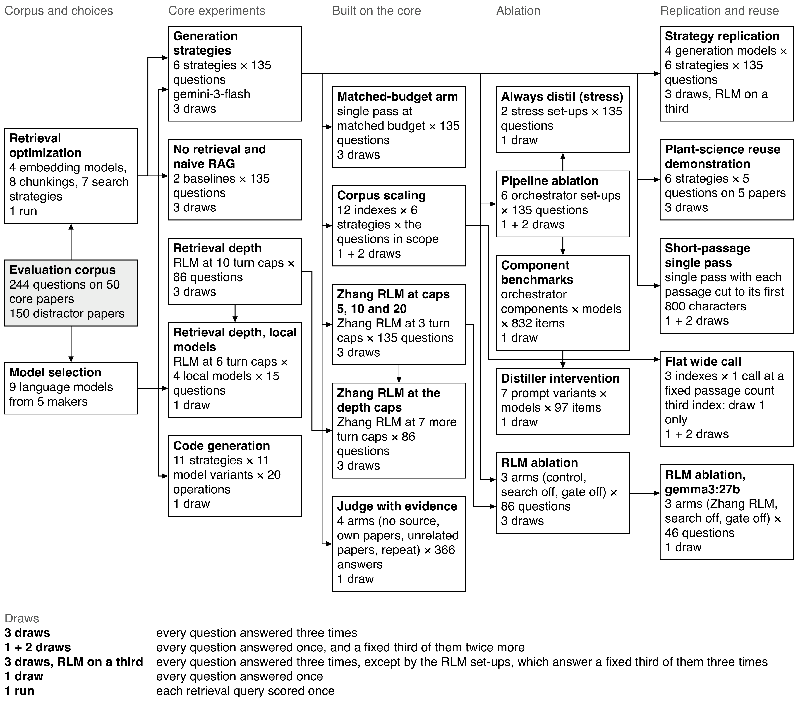
Supplementary Figure 1 | How the experiments of the study connect. Each white box is one experiment of the study (n = 22 experiments); the shaded box is the evaluation corpus they share. A box gives the experiment, its design and its draws. The strategy replication's draws: 3 draws, RLM on a third; 1 + 2 draws for gemini-2.5-pro; 3 draws for claude-haiku-4-5. The key under the graph says what each kind of draw means. Sent the same seed, a local model nearly always repeats its answer, so its draws differ through their seeds; Gemini's draws are independent samples. The retrieval optimization and model selection were made before the experiments reported here and not run again; retrieval optimization used its own queries, and the model selection box counts the language models that made a call in this study, from the call logs. An arrow from one box to another means that the second experiment uses the output or a choice of the first. Zhang RLM is the RLM package released by the method's authors (rlms 0.1.3), drawn as Zhang RLM-10 in Figure 3 at its cap of 10 turns; RLM is Mentor::i's own implementation. RAG, retrieval-augmented generation.

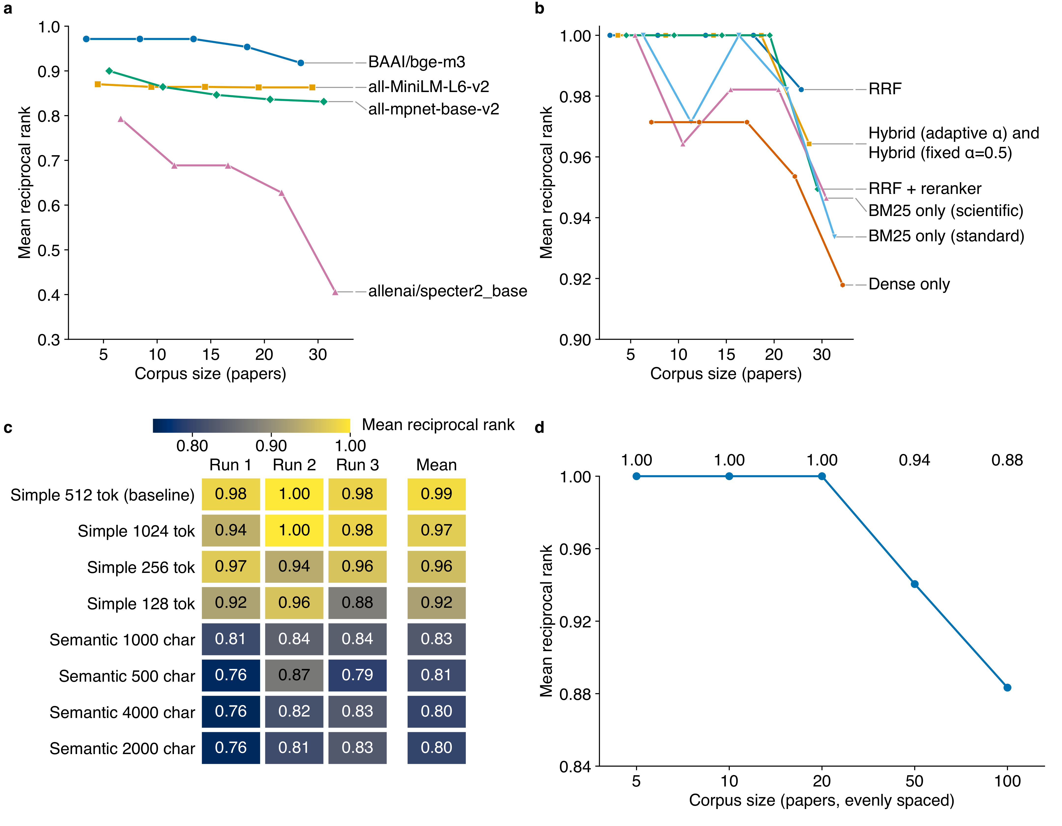
Supplementary Figure 2 | Retrieval pipeline selection. a, Mean reciprocal rank (MRR) against corpus size (5, 10, 15, 20 and 30 papers, evenly spaced) for four embedding models with dense search only (512-token chunks, overlap 50); one colour and shape per model, labelled at the largest corpus; n = 28 retrieval queries at every size. b, MRR against corpus size for seven search strategies with BAAI/bge-m3 embeddings, on the same 28 queries; one colour and shape per strategy. Hybrid (fixed α=0.5) and Hybrid (adaptive α) are equal at every corpus size and are drawn as one line. In a and b, the points at one corpus size are set apart along the axis, one place per series, so tied values stay visible. In b, where two series are tied at neighbouring corpus sizes, only the line drawn last shows between them; the points show every series. c, MRR of eight chunking configurations (BAAI/bge-m3, RRF search, 30 papers), each run three times: run 1 on the 28 queries of a, b and d, runs 2 and 3 each on 27 other query ids, no query id shared between runs. One row per configuration, highest mean at the top; each tile gives one run's MRR and the last column the mean of the n = 3 runs, coloured on the scale above. d, MRR of RRF (pre-built bge-m3 indexes) search against corpus size (5, 10, 20, 50 and 100 papers, evenly spaced), on the same 28 queries, one run per size; each value is printed above its size. The retrieval queries are a set of their own, not questions of the question-answering benchmark; no answer is generated and no judge is involved.

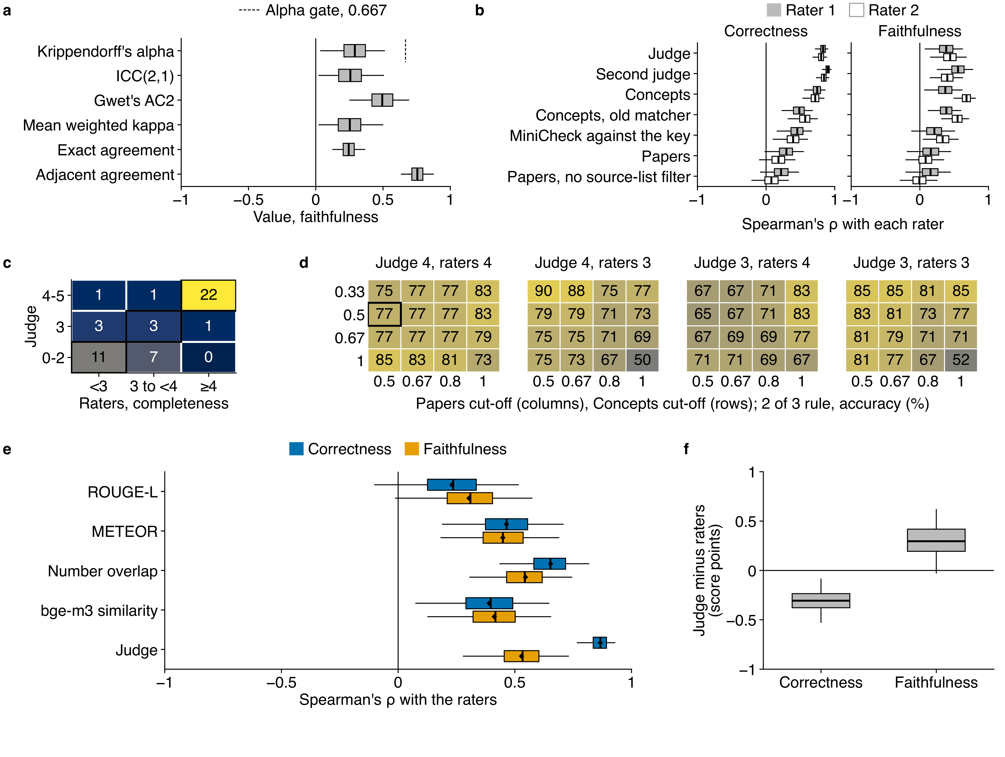
Supplementary Figure 3 | Human evaluation in full. The 49 answers of Figure 2. Where boxes are drawn, they show 2,000 resamples of the answers (seed 42): box, quartiles; line, median; whiskers, two-sided 95% percentile interval. a, Reliability of the raters on faithfulness; dashed line, the protocol's gate on Krippendorff's alpha, 0.667. b, Spearman's ρ of each signal with each rater; the second judge's row is exploratory, added after the early look. c, Completeness: answers in each pair of bands of the judge's score and the raters' score; outlined cells, agreeing bands. d, Accuracy (%) of the 2 of 3 rule at each cut-off of Concepts and Papers, at judge and raters' pass marks 4 and 3; outlined cell, the primary cell. e, Spearman's ρ of ROUGE-L, METEOR, number overlap and bge-m3 similarity with the raters, exploratory, added after the early look; the judge for reference; diamond, the estimate on all answers. f, Mean of the judge's score minus the raters' score, exploratory. n = 49 answers; 48 in b's Papers rows; 48 in d; 48 in e's bge-m3 similarity row.

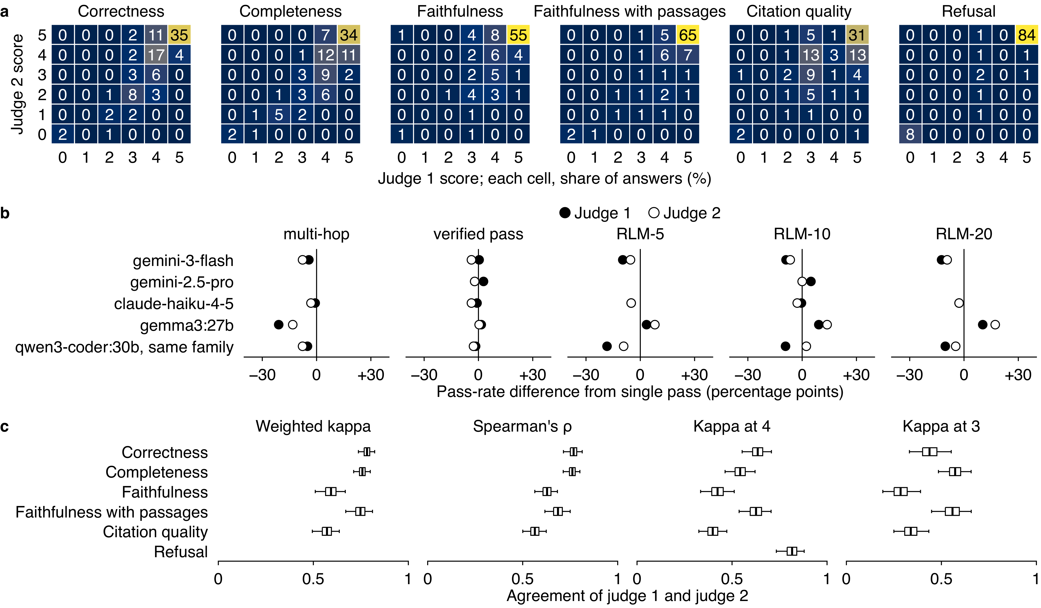
Supplementary Figure 4 | Two judges on the same answers, every metric. Judge 1, devstral-small-2:24b; judge 2, qwen3.8:27b, at the same settings, both on the final key. RLM-5, RLM-10 and RLM-20 are our RLM. a, Each score pair: gemini-3-flash's answers to the n = 86 answerable questions, six strategies, n = 3 draws (n = 1,548 answers per score, faithfulness with passages n = 1,533); faithfulness with passages, the judge's prompt also holding the retrieved passages; refusal, its answers to the n = 39 out-of-scope questions (n = 702). Cell colour and number, share of a score's answers (%). A failed answer scores 0 under both judges; an answer either judge failed to score is left out of that score (n = 15 in all). b, Pass-rate difference (correctness 4 or more) from single pass under each judge, per generator, single pass taken on the same questions and draws as each strategy, n = 258 (except n = 87 for gemma3:27b and qwen3-coder:30b RLM-5, RLM-10 and RLM-20; n = 143 for gemini-2.5-pro verified pass; n = 144 for gemini-2.5-pro RLM-10; n = 257 for qwen3-coder:30b verified pass) answer pairs per strategy and judge; gemini-2.5-pro's multi-hop, RLM-5 and RLM-20 empty, no second-judge rows; 'same family', qwen3-coder:30b is of judge 2's model family; dot, the difference. c, Agreement per score; weighted kappa, quadratic weights on 0 to 5; Spearman's ρ over answers; kappa at 4 and at 3, Cohen's kappa on pass or fail at that mark (refusal, kappa at 4 only); box, quartiles of 10,000 question resamples; line, median; whiskers, two-sided 95% percentile interval.

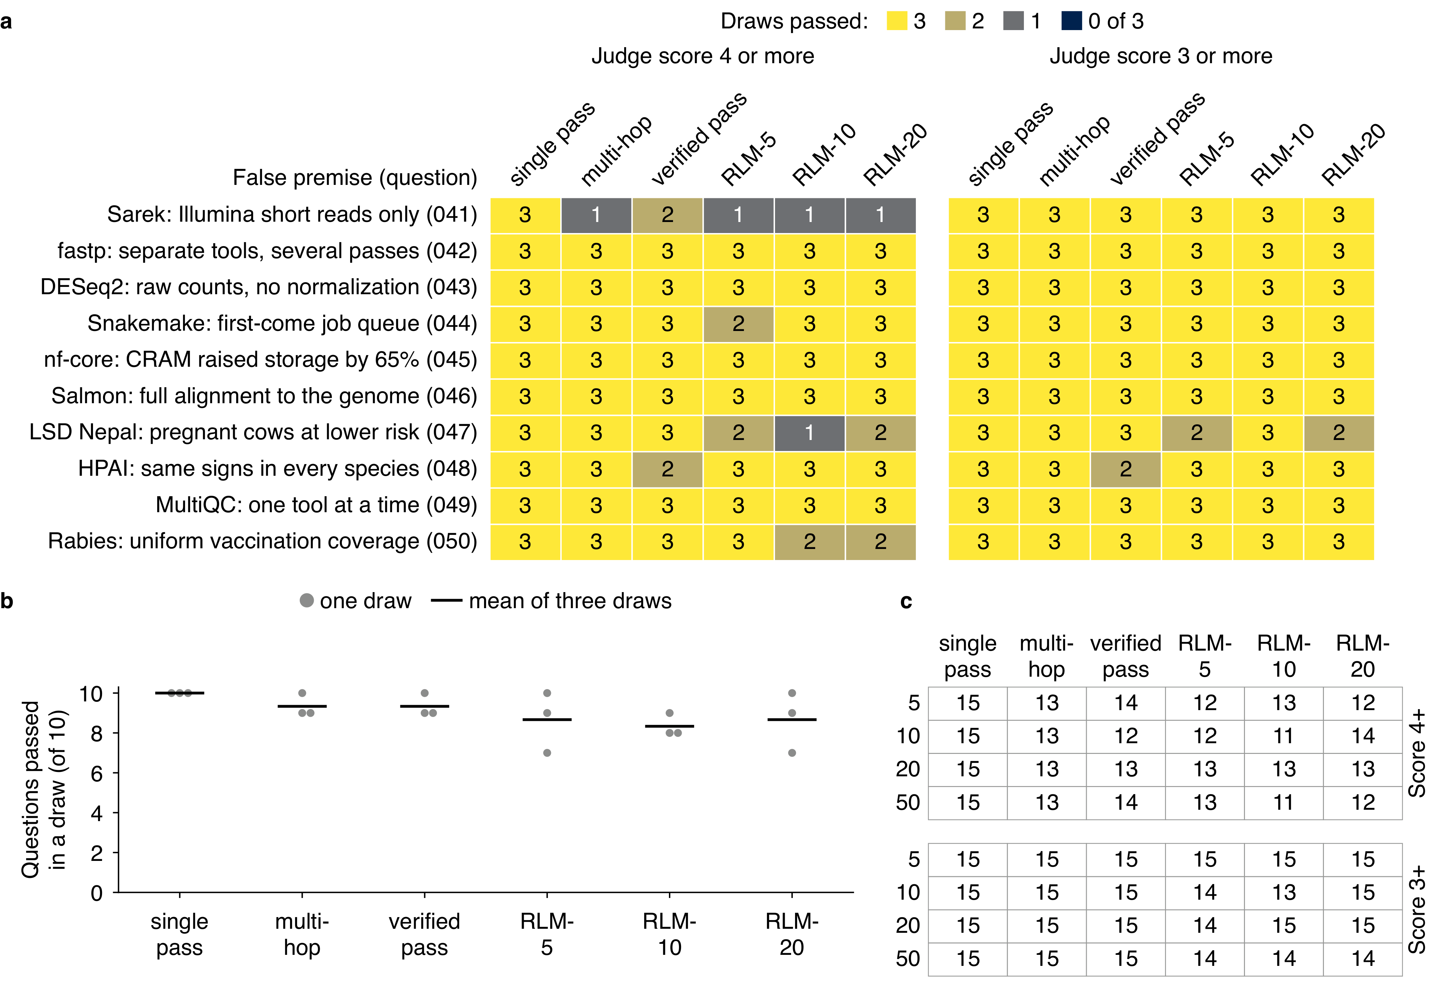
Supplementary Figure 5 | Answers to the false-premise questions, by strategy and corpus size. Each question states a false claim about one paper and asks whether it is true. Answers by gemini-3-flash; a judge (devstral-small-2:24b) scores each from 0 to 5 for correctness against the key's refutation; an answer passes at 4 or more, 3 or more being the relaxed threshold. a, For each of the n = 10 questions (rows) and six strategies (columns), the draws of 3 whose answer passed on the 20-paper index, at each threshold (180 answers). b, For each strategy, questions passed in each draw (of 10) at 4 or more, and the mean of the three draws. c, Answers passed of 15, by number of core papers (rows) and strategy (columns), for the n = 5 false-premise questions asked at every corpus size (OOD_041, 042, 044, 045, 049), one draw: each count is of n = 15 answers (5 questions on 3 indexes, with 0, 1 and 3 distractor papers per core paper), at each threshold. Counts are given as they are, with no test and no ranking.

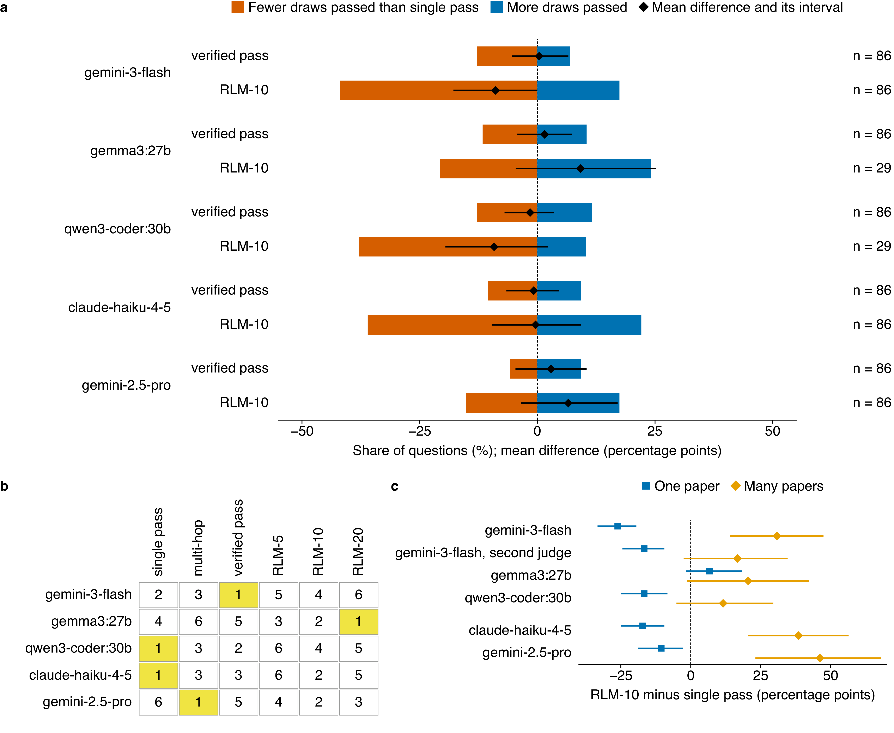
Supplementary Figure 6 | Replication on other generators in full. Judged by devstral-small-2:24b on the final answer key; a pass is judge score 4 or more. a, For each generator, two rows: verified pass and RLM-10, each the generator's pass share with that strategy minus its pass share with single pass, per answerable question, in percentage points. Bar, the share of questions (%) where the strategy passed fewer draws than single pass (vermilion, left of 0) and more (blue, right of 0); ties are not drawn (counts in the Source Data). Diamond, the mean of the questions' differences in percentage points; line, its two-sided 95% percentile interval over 10,000 question resamples. A question counts in a row when the generator holds both strategies on it. n = 86 questions per row, and n = 29 for RLM-10 of gemma3:27b and qwen3-coder:30b. A share is over the draws a generator holds: n = 3 draws, except gemini-2.5-pro (draw 1 only outside the fixed 45-question subset) and the local generators' RLM runs (the 45-question subset only). b, Rank of the six strategies by pass rate within each generator (1 is the highest, yellow; a tie shares the higher rank), on the answerable questions every strategy of that generator answered: n = 86 for gemini-3-flash, claude-haiku-4-5 and gemini-2.5-pro, n = 29 for gemma3:27b and qwen3-coder:30b. c, RLM-10 minus single pass on one-paper (blue square) and many-paper (orange diamond) questions, by generation model, exploratory; Figure 3e draws their difference. Mark, the mean of the questions' differences; bar, its two-sided 95% percentile interval over 10,000 question resamples. Rows as Figure 3e: top, the reference; 2 to 4, the prespecified test; below the gap, models outside it; main judge unless the row names the second judge (qwen3.8:27b). gemma3:27b and qwen3-coder:30b, n = 3 draws (RLM-10: 1 draw on 17 of the many-paper questions), on n = 20 one-paper and n = 26 many-paper questions; the other rows on n = 60 and n = 26. n = 4 generators beside gemini-3-flash.

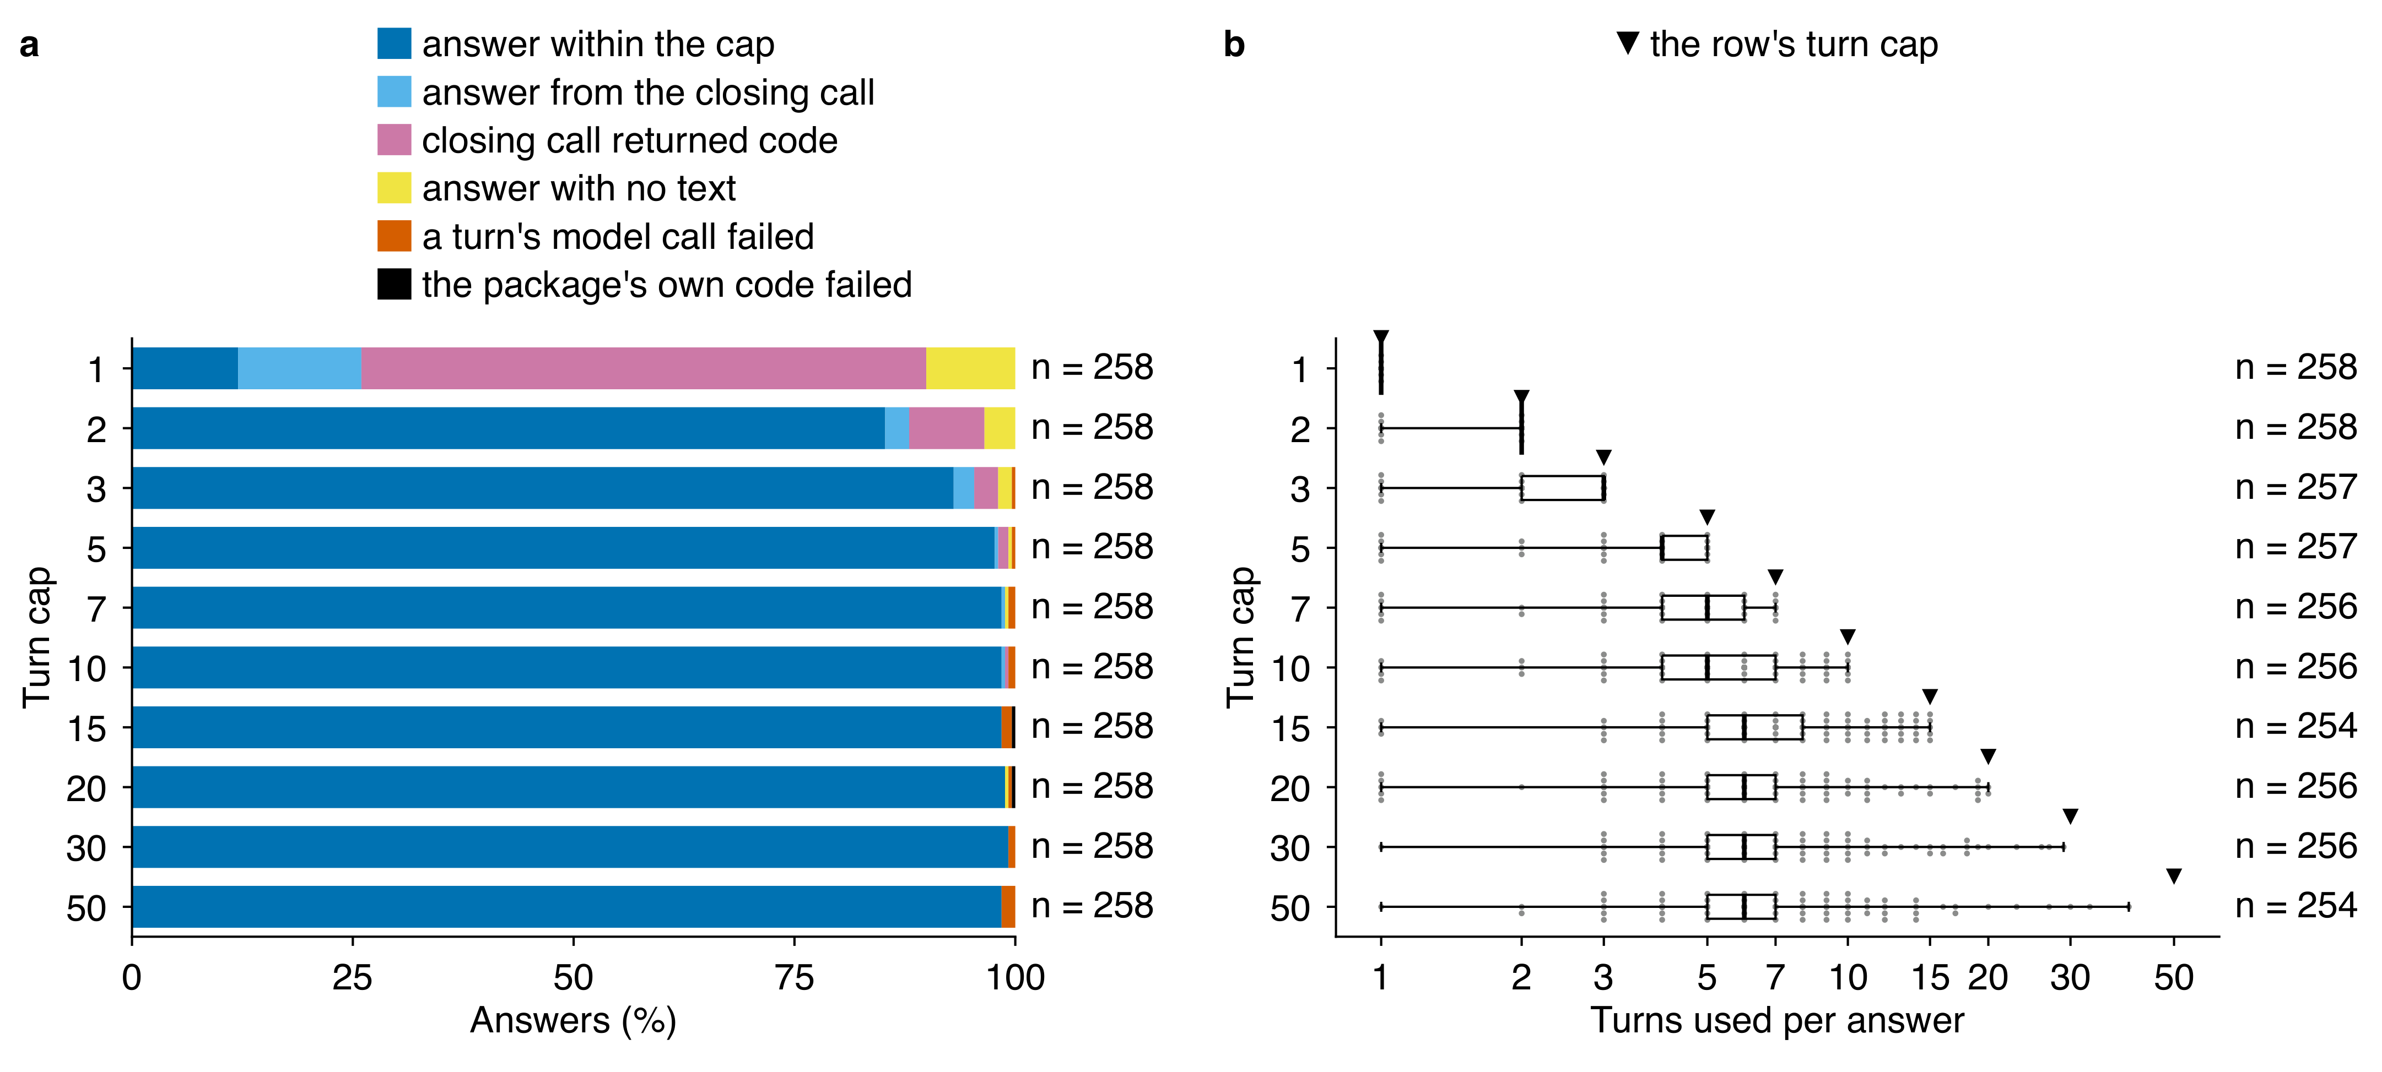
Supplementary Figure 7 | Outcome and turns of Zhang RLM on the depth-sweep questions, across turn caps. Each answer is one of 86 depth-sweep questions answered by gemini-3-flash in Zhang RLM, the RLM package released by the method's authors (rlms 0.1.3; ref. 27), in which the model writes and runs code over the 20-paper corpus for up to a set number of turns, the turn cap; one row per cap (1, 2, 3, 5, 7, 10, 15, 20, 30 and 50), three draws per question and cap. a, How each answer ended, as a share (%) of the n = 258 answers at each cap: an answer within the cap; an answer from the closing call the package makes when the cap is reached; a closing call that returned code, kept as the answer; an answer with no text; a failed model call in a turn; or the package's own code failed, a TypeError raised inside it (2 answers: cap 15, 1; cap 20, 1). b, Turns used per answer, for the answers that did not fail (the closing call is not counted); triangles mark the row's turn cap; n = 258, 258, 257, 257, 256, 256, 254, 256, 256 and 254 from cap 1 to cap 50, printed at each row's right; each grey dot is one answer, boxes span the first to the third quartile, the line is the median and whiskers reach the smallest and largest value; the horizontal axis is logarithmic.

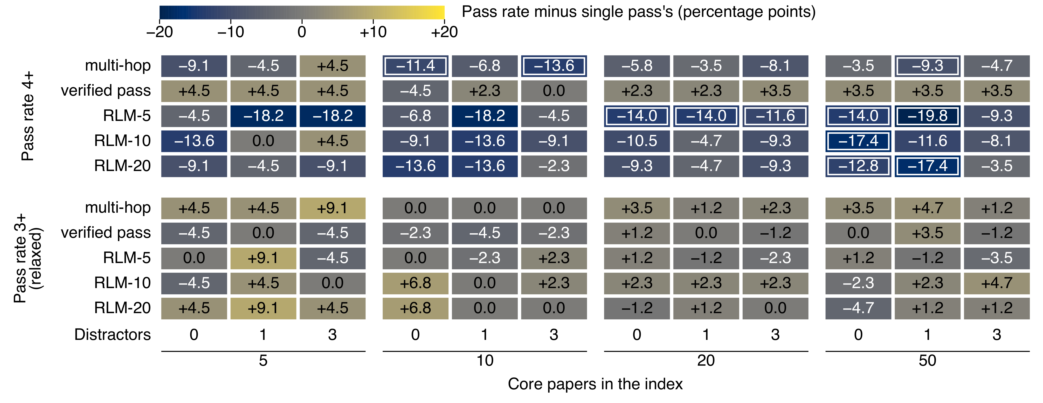
Supplementary Figure 8 | Generation strategies against single pass across corpus sizes. Each strategy's pass rate minus single pass's (percentage points; number and colour) per index, by core papers and distractor papers per core paper; gemini-3-flash, one draw, answerable questions whose source papers are all in the index, judged for both (n = 22 per index at 5 core papers, 44 at 10, 86 at 20 and 86 at 50). Pass: judge correctness 4 or more (upper block); relaxed threshold: 3 or more (lower block). Frame: two-sided 95% percentile interval of the difference (10,000 question resamples) excludes 0.

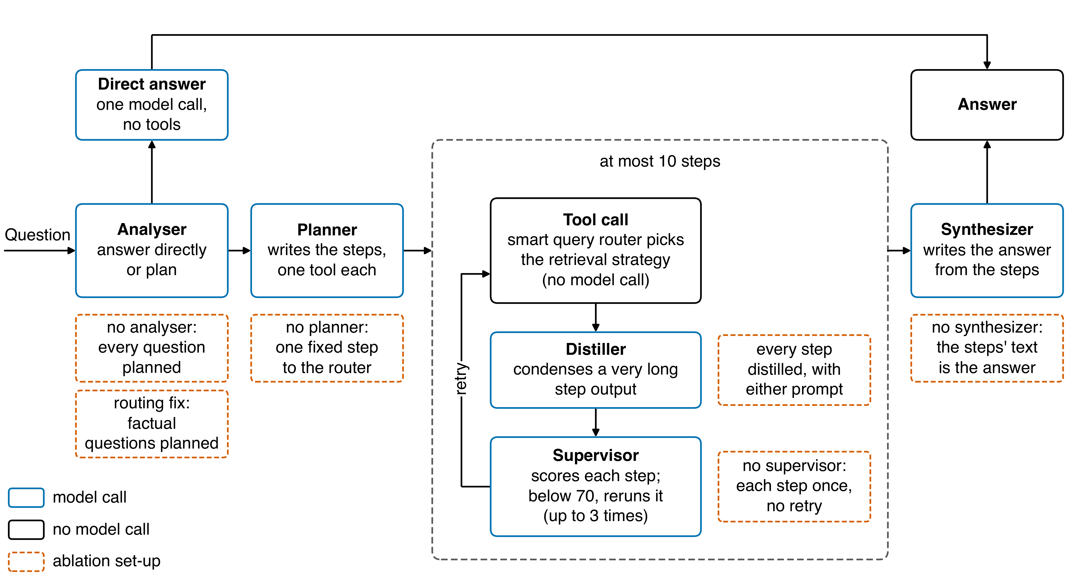
Supplementary Figure 9 | Mentor::i's question-answering pipeline. The analyser decides, in one model call, whether a question is answered directly, in one further call without tools, or planned. The planner writes a goal and ordered steps, one tool each; at most 10 run. Document steps go to the smart query router, which picks a retrieval strategy by keyword rules and index size, without a model call. The distiller condenses a step output longer than 209,712 characters. The supervisor scores each step from 0 to 100; below 70, the step's arguments are rewritten and the step reruns, up to 3 times. The synthesizer writes the answer from the question, the goal and each step's last output. Blue, a model call; black, no model call; dashed vermilion, an ablation set-up, drawn under or beside the step it changes. n = 7 ablation set-ups: no analyser, the routing fix (factual questions planned), no planner, no supervisor, no synthesizer and every step distilled with Mentor::i's prompt or with the worked-example prompt, which adds two worked examples that keep every number.

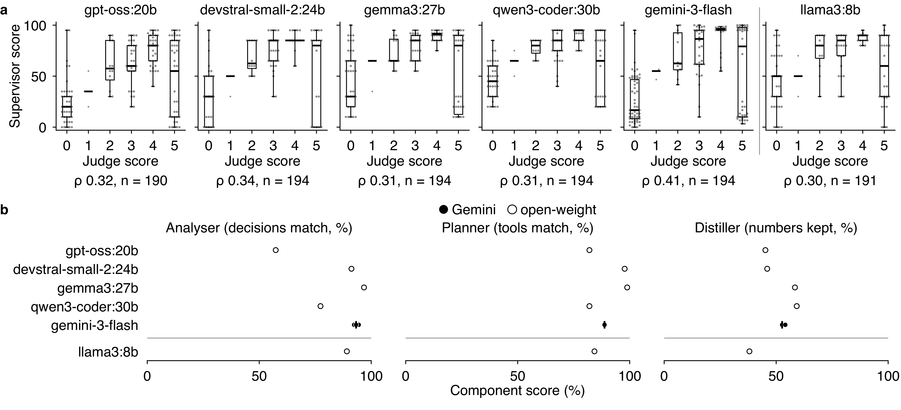
Supplementary Figure 10 | Orchestrator component benchmarks. Each component was tested alone on its own items (n = 340 analyser, 89 planner, 194 supervisor and 94 distiller items; the 15 items built on questions later replaced in the answer key are left out) by five models once and gemini-3-flash on three draws; llama3:8b sits below the line (in a, right of it) because its context is 8,192 tokens. a, Supervisor score against the judge score of the same answer, on key v2.5, or the refusal score for out-of-scope questions (n = 194 answers); boxes: median and quartiles, whiskers the range, grey dots one answer each; ρ, Spearman's ρ; gemini-3-flash, the mean of its three draws. devstral-small-2:24b is both one of the supervisor models and the judge in a. b, Component scores, one dot per draw (filled, Gemini; open, open-weight): analyser, decisions matching the label; planner, tools matching the label; distiller, numbers kept. The analyser's label counts sending an out-of-scope question to a direct answer as correct. In a, answers that gave no supervisor score are left out and counted: gpt-oss:20b, 4. Failed calls are left out and counted: llama3:8b, 3 supervisor items (3 with a prompt longer than its context).

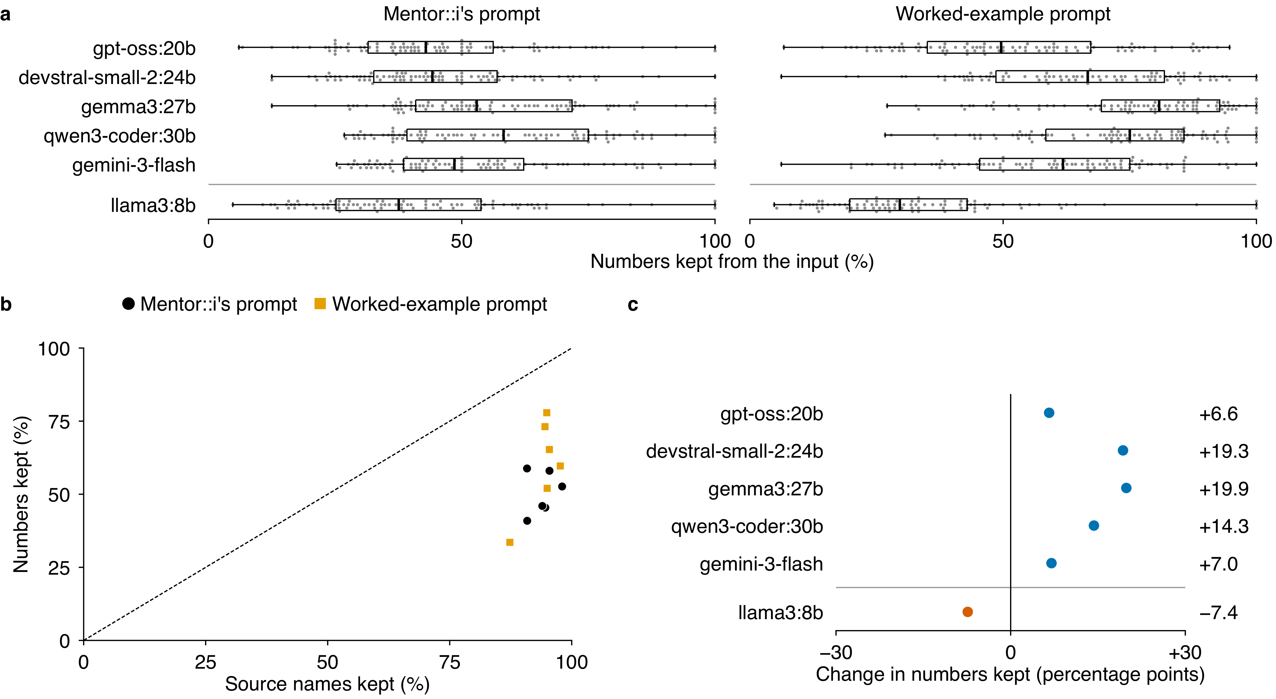
Supplementary Figure 11 | Distiller prompt variants. Six models compressed the same 94 long outputs with Mentor::i's prompt and with a worked-example prompt, which adds two worked examples that keep every number (3 items built on questions later replaced in the answer key are left out); n = 94 items per model and prompt, draw 1, less any failed answer (stated below); llama3:8b sits below the line because its context is 8,192 tokens. a, Share of the input's numbers kept; boxes: median and quartiles, whiskers the range, grey dots one item each. b, Mean share of numbers kept against mean share of source names kept, one mark per model and prompt; dashed, equal shares. c, Mean change with the worked-example prompt in percentage points; blue, more kept; vermilion, fewer kept. The worked-example prompt is not Mentor::i's prompt in the pipeline. Failed calls are left out and counted: llama3:8b, 1 worked-example prompt item (1 with a prompt longer than its context). Stopped at the end of the context and kept as scored: 2 llama3:8b answers with the worked-example prompt.

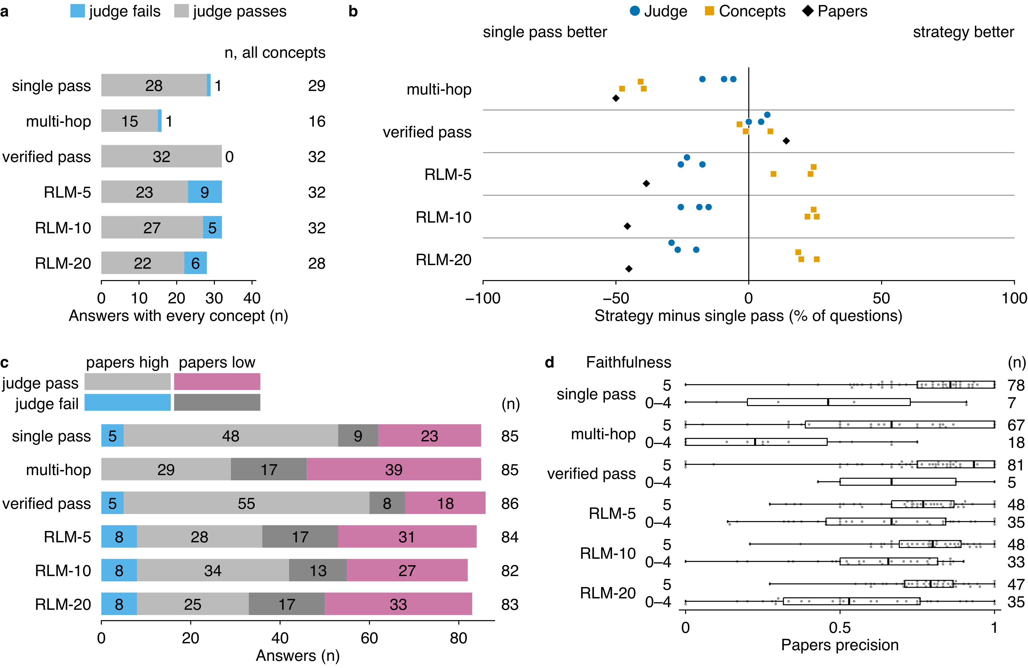
Supplementary Figure 12 | Answers stating every concept; each strategy against single pass; Papers by the judge's verdict and by faithfulness. Answers of gemini-3-flash to the answerable questions. a, Of the draw-1 answers of c, those that state every key concept, by the judge's verdict (n = 169); n at right counts only these answers. b, Questions won minus lost against single pass, as a percentage of n = 86 questions (Papers, 85, or 84 for multi-hop, 83 for RLM-5, 82 for RLM-20, 81 for RLM-10), one mark per draw (Papers, draw 1). The judge compares 0 to 5 scores, and the marks show how far each draw moves. Figure 6c gives the same comparison as counts on three-draw means. c, Draw-1 answers to 86 questions (n = 505 answers) by the judge's verdict and Papers: high, at or above their median (0.783). d, Papers of draw-1 answers with faithfulness 5 and below 5 (n = 502 answers, 86 questions; n at right). Faithfulness score, from the judge with the retrieved passages; calls longer than the judge's context are refused (6). Dots, answers; box, quartiles; black line, median; whiskers, range.

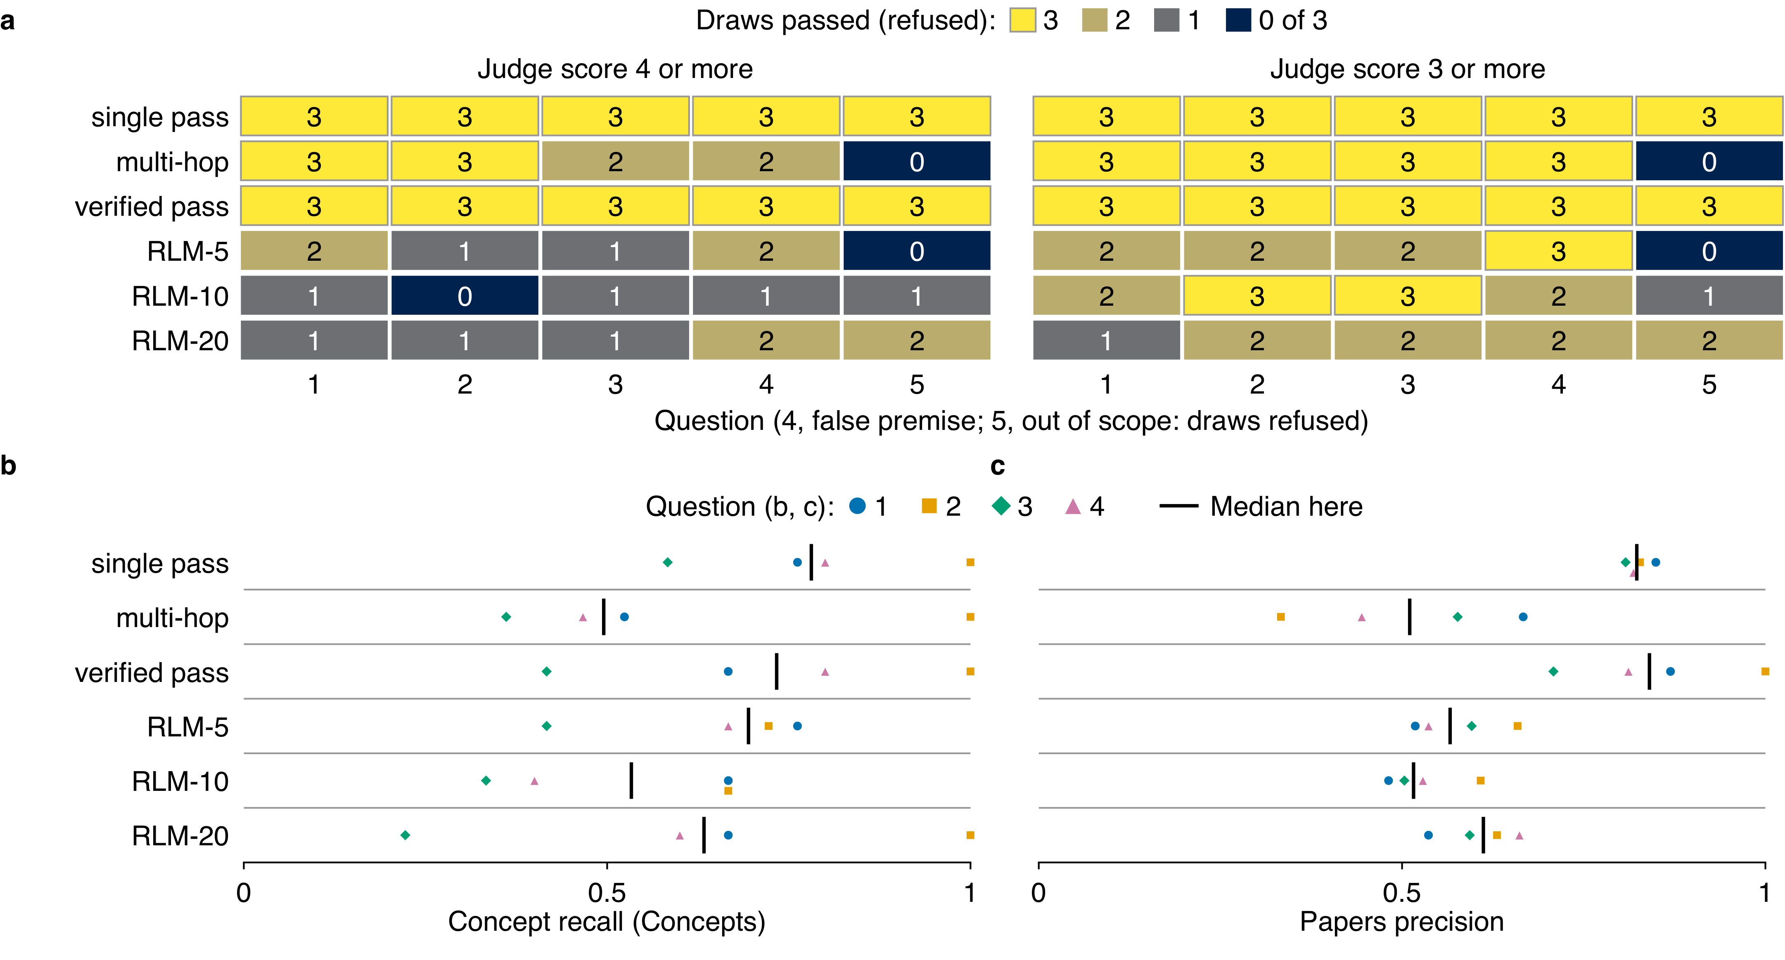
Supplementary Figure 13 | The pipeline and its evaluation on five plant-science papers. The key covers five open-access papers on lettuce resistance to downy mildew. Questions 1 and 2 are extractive, 3 is a synthesis, 4 has a false premise and 5 is out of scope. The six strategies of Figure 3 answered them with gemini-3-flash in n = 3 draws, n = 90 answers. They were scored as on the main benchmark. The judge (devstral-small-2:24b, plain call) scored every answer. Question 5 has no concept target, so Concepts and Papers scored the answers to questions 1 to 4 only. RLM-5, RLM-10 and RLM-20 are our RLM, stopped at those turns. a, Draws passed of 3 per question and strategy. Left, judge correctness 4 or more; right, 3 or more. For question 5 a tile counts draws refused (refusal score 3 or more, the same in both blocks). Answers stored, judged and with a Concepts and a Papers value, per strategy, are in the Source Data (sheet a, coverage rows). b, Concept recall (loose matcher with the question rule, as in Figure 6a) of the four answerable and false-premise questions: one dot per question and strategy, the mean over its 3 draws (n = 72 answers). Colour and shape, question. c, Papers precision (MiniCheck against each question's source papers) of the same answers, as in b, the mean over the draws with a value (n = 70 answers; the other 2 are longer than the encoder's 2,048-token input and have no value). In three question-draws the RLMs returned the same text: question 1 and question 4 (all three, one draw each) and question 3 (RLM-5 and RLM-20, one draw). In b and c, per strategy, black line: median of the 4 question means.

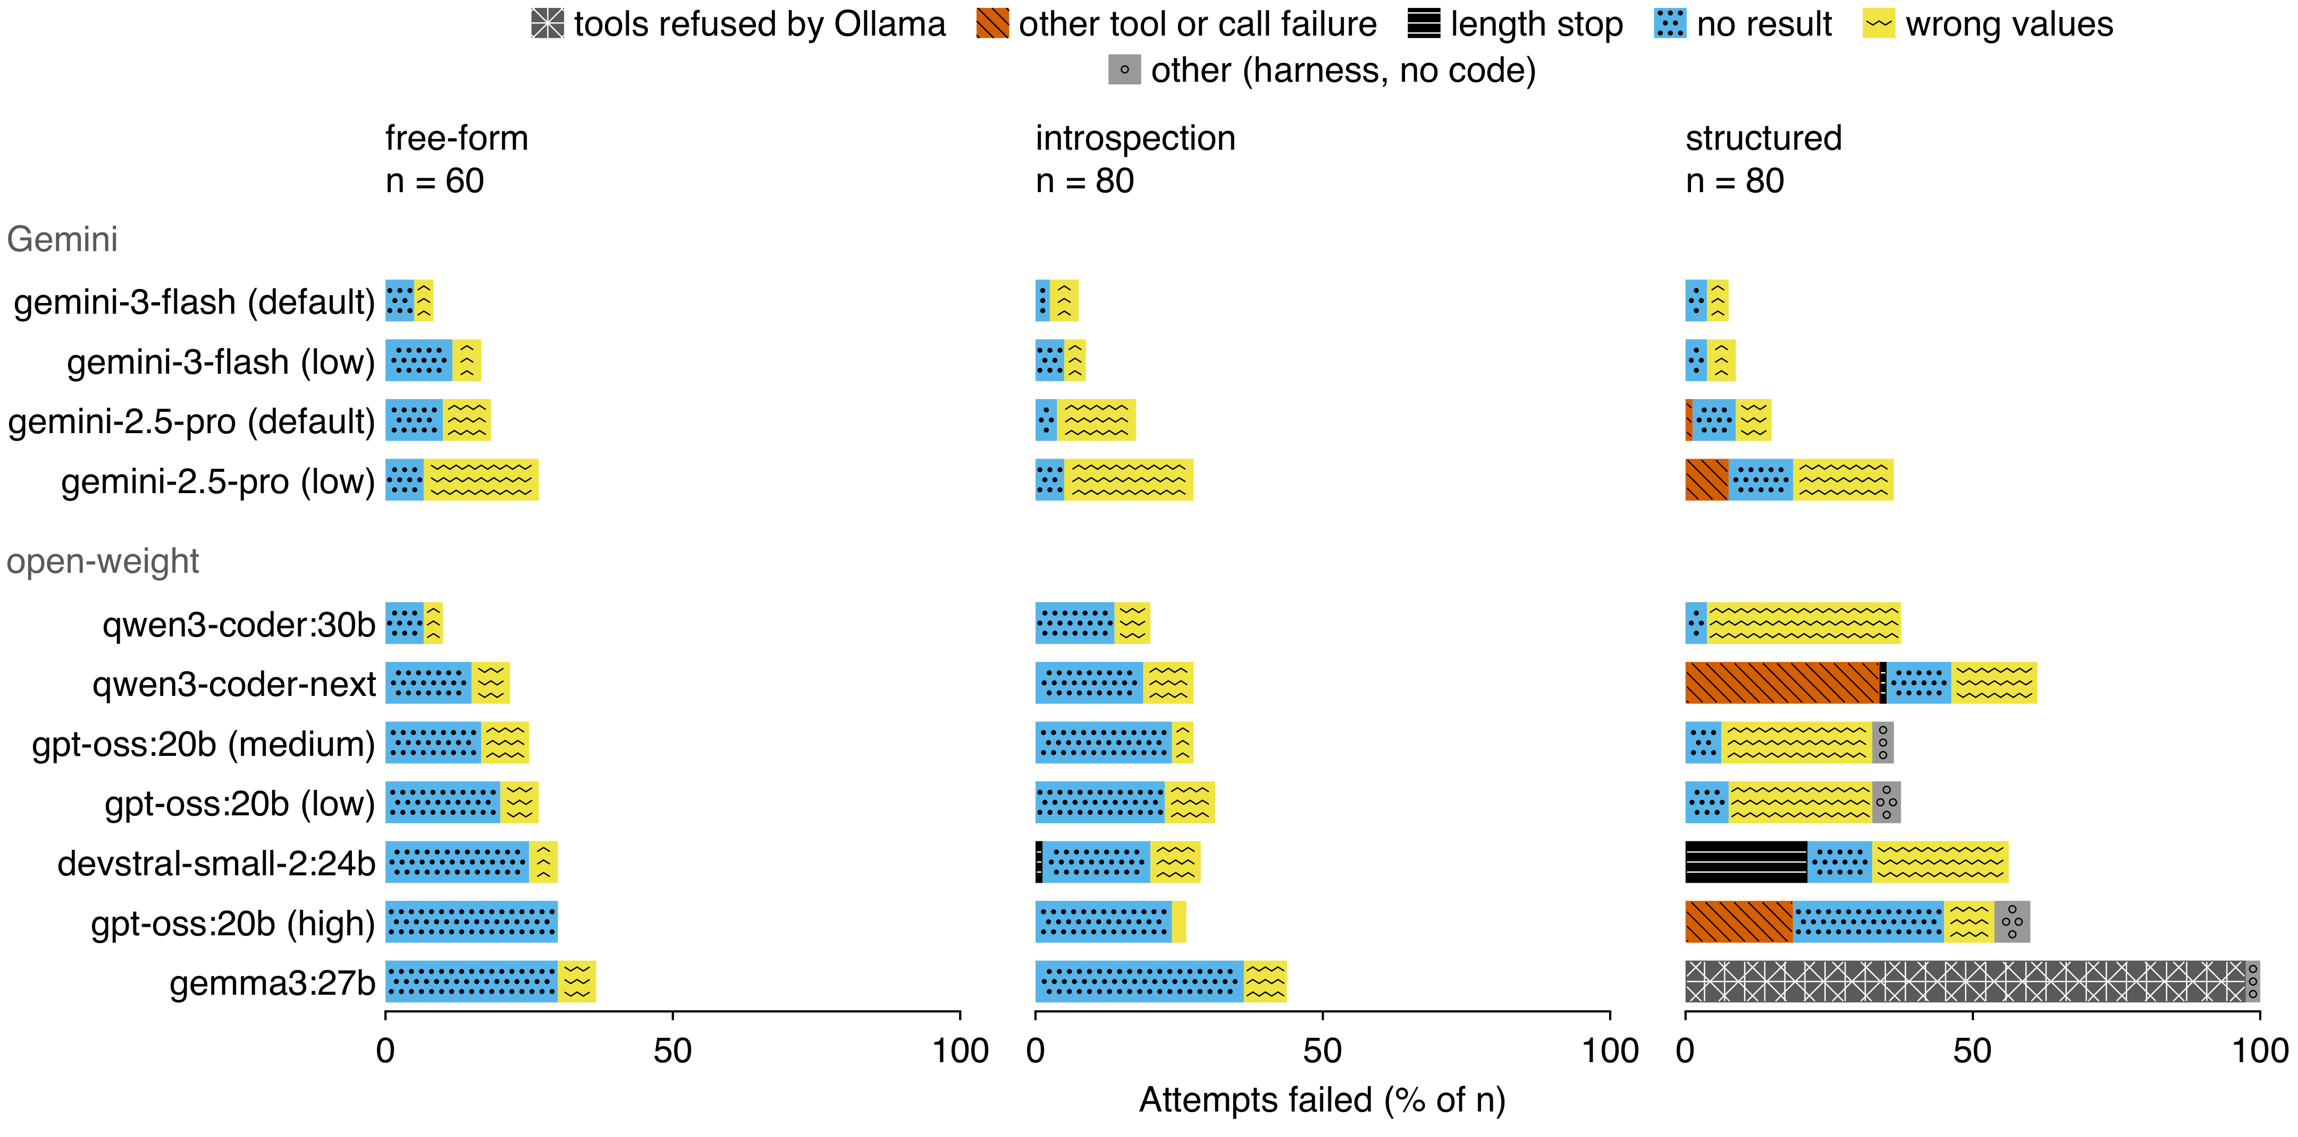
Supplementary Figure 14 | How code-generation attempts failed, per model variant. Attempts as in Figure 7: one model variant, one prompting strategy and one of 20 operations, run once (165 attempts run again after a rule change, the later run counted; n = 2,420 attempts). Failed attempts of each model variant under each prompting family, as a share of its n attempts, one per strategy and operation (n = 60 free-form, 80 introspection and 80 structured). Wrong values and no result as in Figure 7c. Length stops are shown apart from tool or call failure, other, which is split into tools refused by Ollama (the model as served has no tool support), other tool or call failure (a tool call written as text, another call error or a step that produced no cell and no error) and other (a harness error, no code or a failure of none of these kinds). Rows: Gemini, then open-weight, each by free-form pass rate, high to low, ties by pass rate over all 11 strategies. Gemini low: gemini-2.5-pro with a thinking budget of 128 tokens per call, gemini-3-flash at the minimal level.

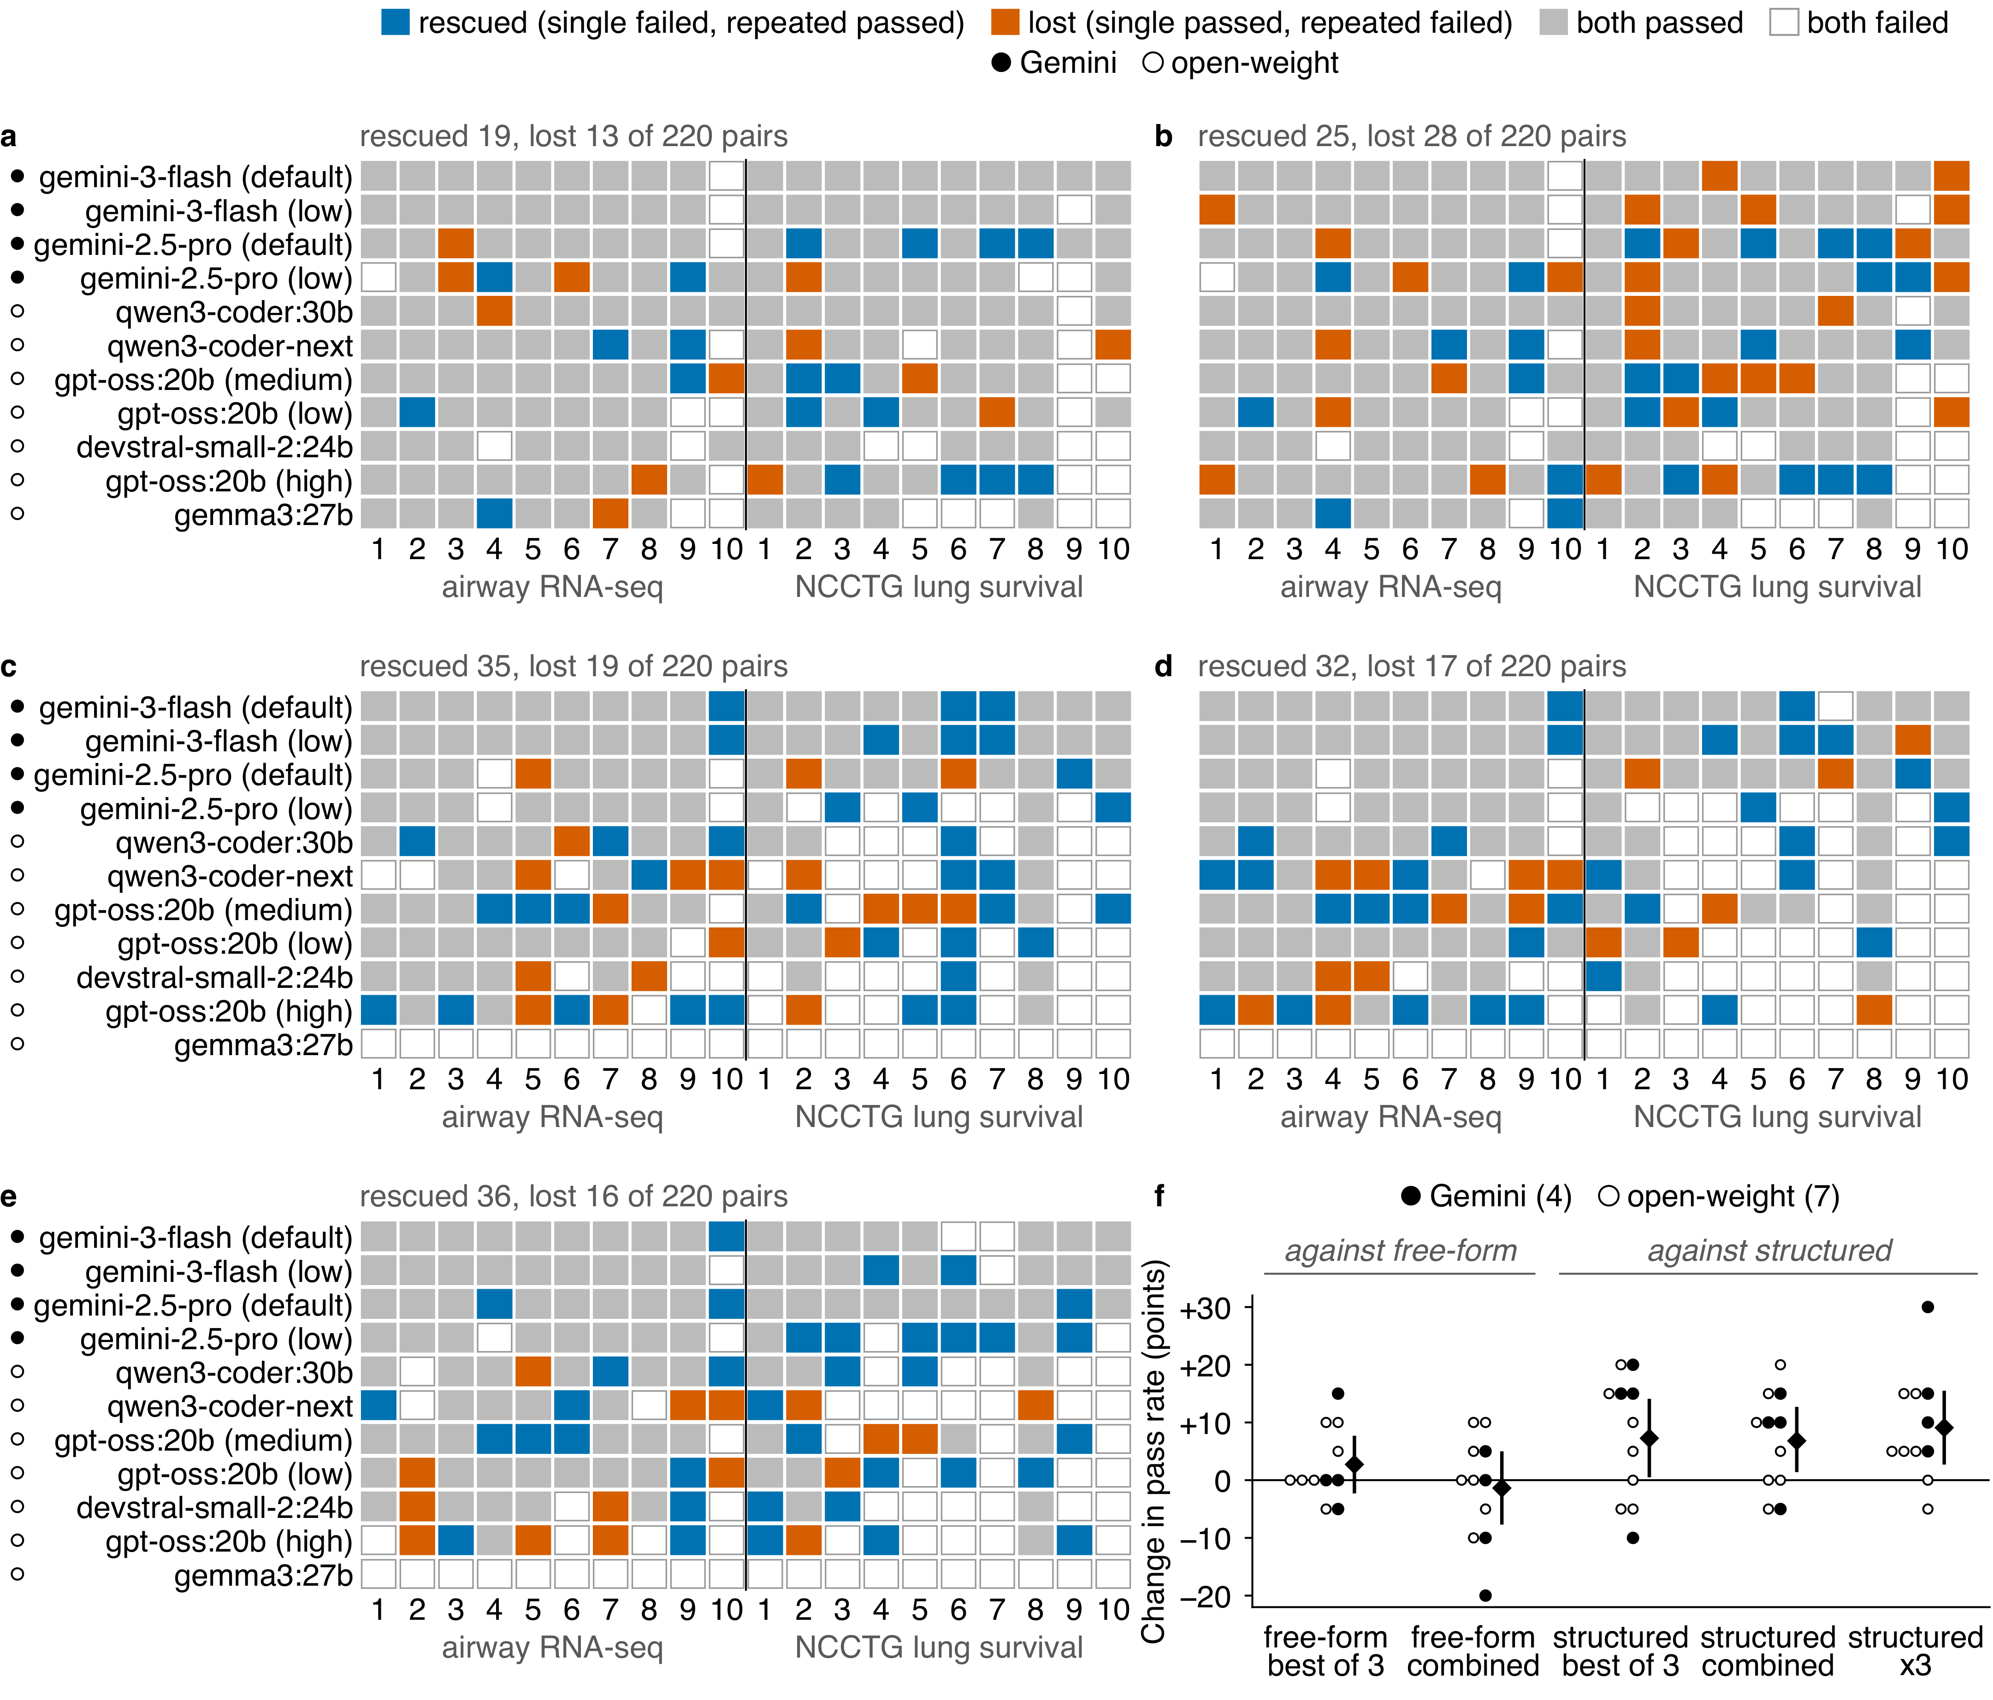
Supplementary Figure 15 | Paired outcomes and net change of repeated against single attempts. Attempts as in Figure 7: one model variant, one prompting strategy and one of 20 operations, run once (165 attempts run again after a rule change, the later run counted; n = 2,420 attempts); 27 attempts on one survival operation are re-scored by running their stored code again (no model call). Every pair of the five repeated-attempt contrasts (a to e) and their net change (f). In a to e, a tile is one model variant (row) on one operation (column; 10 airway RNA-seq and 10 NCCTG lung survival operations, numbered within each dataset), coloured by which of the two strategies passed. n = 220 pairs per contrast (11 variants × 20 operations). Rows: Gemini, then open-weight, each by pooled free-form pass rate, high to low. A dot before a variant's name marks a Gemini model (filled) or an open-weight model (open). Gemini low: its lowest thinking setting. a, Free-form best of 3 against free-form. b, Free-form combined against free-form. c, Structured best of 3 against structured. d, Structured combined against structured. e, Structured x3 against structured. f, Change in pass rate of each repeated-attempt strategy against the single-attempt strategy of its family, same variant and operation, one column per contrast of a to e. Dot, one variant over 20 operations; diamond, net change over n = 220 pairs; line, two-sided 95% percentile interval from 10,000 resamples of the 20 operations.

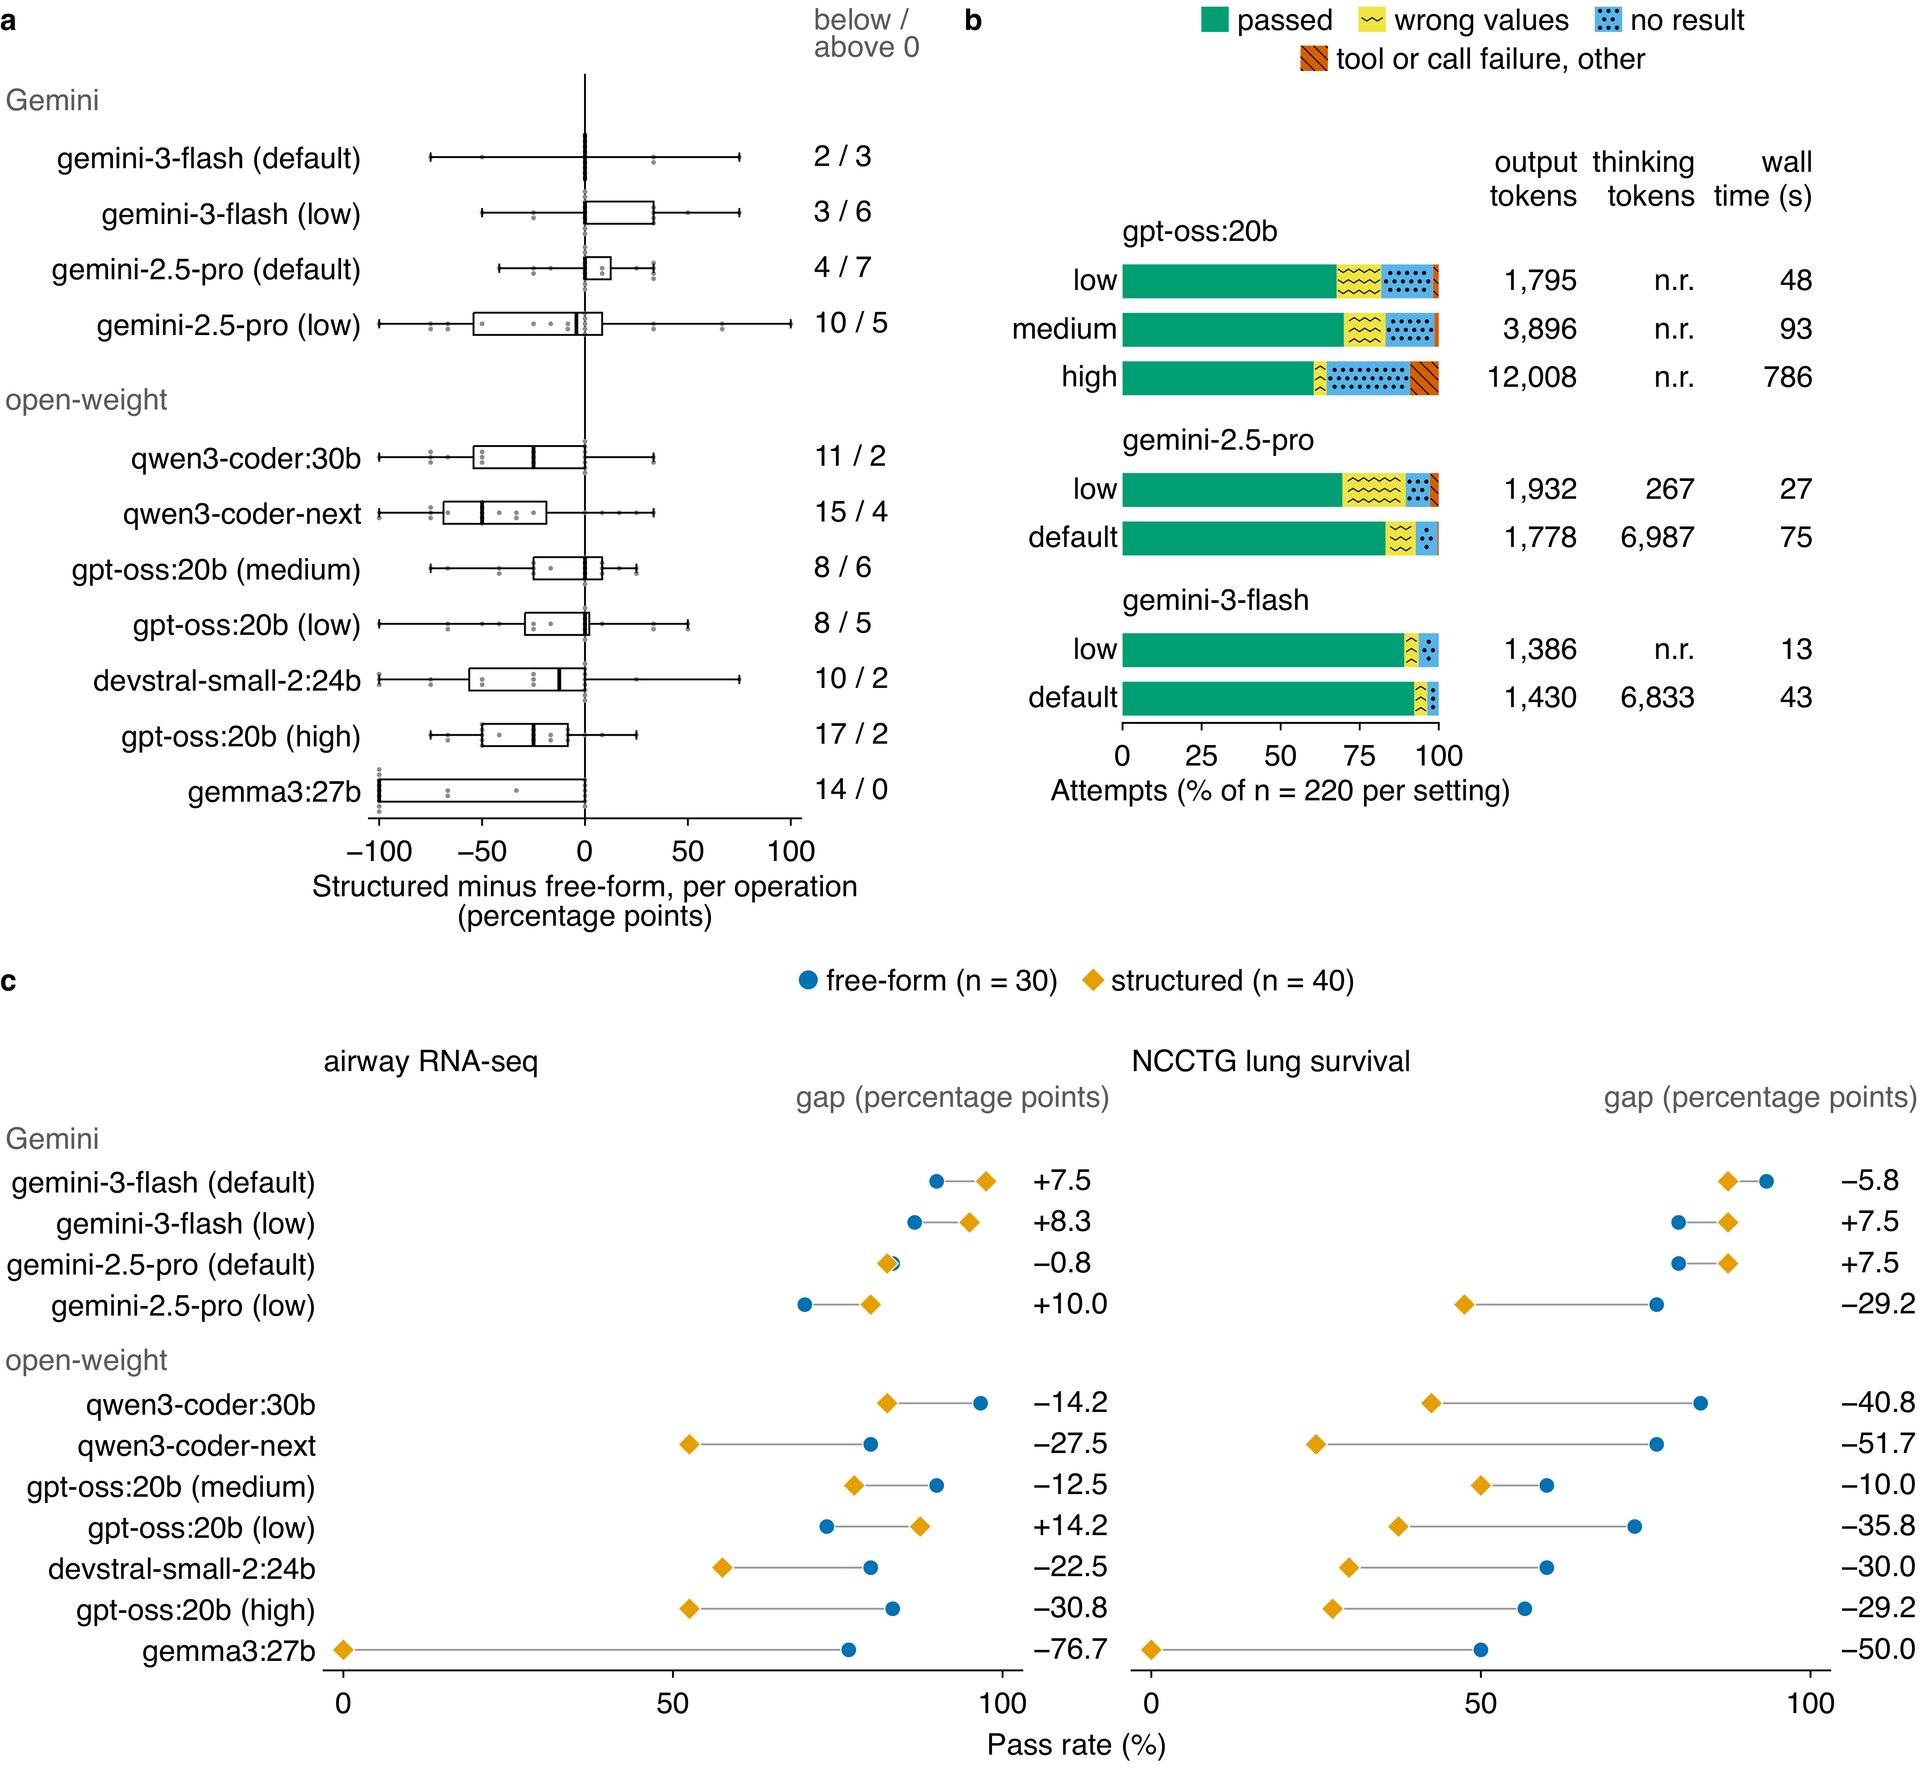
Supplementary Figure 16 | Structured prompting, thinking setting and dataset, model by model. Attempts as in Figure 7: one model variant, one prompting strategy and one of 20 operations, run once (165 attempts run again after a rule change, the later run counted; n = 2,420 attempts); 27 attempts on one survival operation are re-scored by running their stored code again (no model call). a, Per model variant, each operation's pass share under the 4 structured strategies minus under the 3 free-form ones (percentage points). Box, quartiles; thick line, median; whiskers, range; grey dots, one per operation (n = 20 per box). Right column, operations below / above 0. Rows: Gemini, then open-weight, each by free-form pass rate, ties by passes over all 11 strategies. b, One bar per thinking setting of the 3 models run at more than one (n = 220 attempts each), split by outcome as in Figure 7c, length stops shown apart (none here). Segments too narrow for one whole mark of their pattern are colour only. Gemini low: gemini-2.5-pro with a thinking budget of 128 tokens per call, gemini-3-flash at the minimal level. Right: medians per attempt. Thinking tokens where recorded (n.r., not recorded). gpt-oss:20b records no thinking count, so its output tokens may include thinking. Wall time: gpt-oss:20b local, Gemini through Google's API. c, Pass rate per variant and dataset under free-form (circle, n = 30 attempts: 3 strategies on 10 operations) and structured prompting (diamond, n = 40), joined by a grey line where the diamond's centre lies outside the circle. Right, structured minus free-form (percentage points). Rows: Gemini, then open-weight, each by free-form pass rate (a tie broken by the pass rate over all strategies).

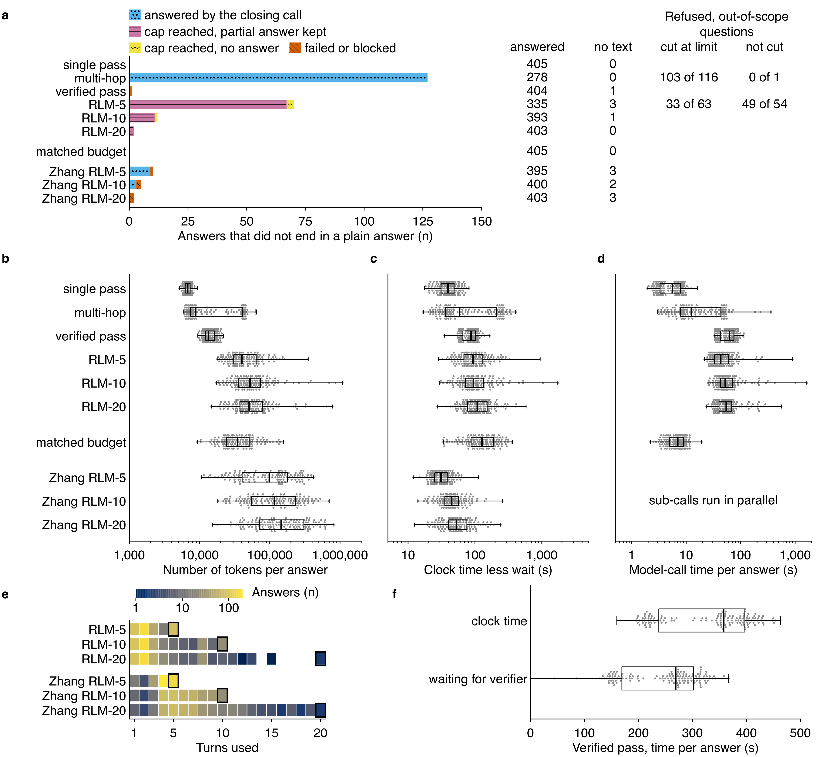
Supplementary Figure 17 | Outcomes, tokens, time and turns per answer for each generation strategy. Each set-up answered the 135 questions three times with gemini-3-flash on the 20-paper index (n = 405 answers per set-up): Mentor::i's single pass, multi-hop and verified pass; RLM at turn caps 5, 10 and 20; matched budget, single pass with passages matching RLM-10's input tokens; and Zhang RLM at turn caps 5, 10 and 20. a, Answers that did not end in a plain answer, by kind; right, answers that did, answers with no text and, on the 39 out-of-scope questions (n = 117 answers per set-up), answers the judge scored as refused (refusal accuracy 3 or more) among those cut at the turn limit (RLM-5) or ended by the closing turn (multi-hop), and among the others; an answer with no judge row counts as not refused. b, Tokens per answer (prompt, output and thinking, the verifier's included), log scale. Grey dots, one per question, the mean of its three draws (n = 135 questions per set-up); box, 25th to 75th percentile; line, median; whiskers, the range over questions. c, Clock time per answer (s) less the wait for the local verifier, as in b. d, Model-call time per answer (s), summed over its calls, as in b; blank for Zhang RLM, whose sub-calls run in parallel. e, Turns used per answer by the six RLM set-ups: cell colour, how many of the set-up's 405 answers used that many turns (log scale); no cell, none; black outline, the turn cap. f, Verified pass, linear scale: clock time per answer with the wait, and the wait alone, as in b. RLM is Mentor::i's own RLM; Zhang RLM is the RLM package released by the method's authors (rlms 0.1.3).

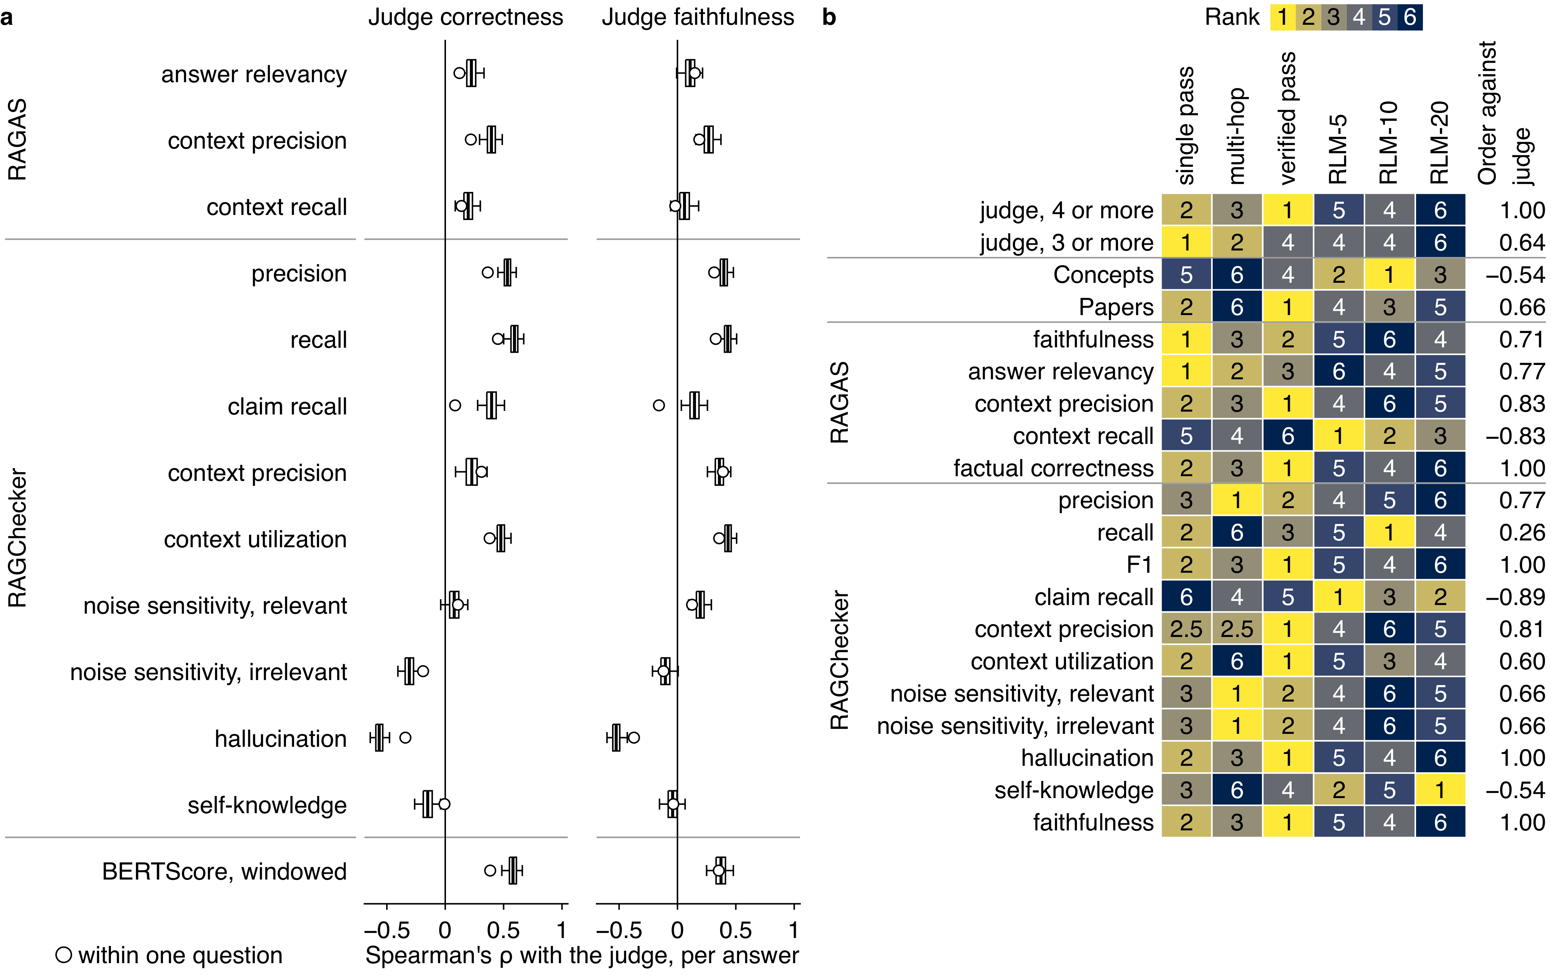
Supplementary Figure 18 | RAGAS, RAGChecker and BERTScore against the judge and the three signals. Answers of the six strategies to the answerable questions, draw 1 (n = 516 answers, 86 questions; 506 hold the judge's score and every RAGAS and RAGChecker score, the other 10 lack one or more of them). RAGAS and RAGChecker ran on devstral-small-2:24b at the judge's settings. a, Spearman's ρ of the 13 scores not in Figure 6e with the judge's correctness and faithfulness, each over the answers holding both values (the answers per ρ are in sheet a's answers column): box, quartiles of 10,000 question resamples; whiskers, two-sided 95% percentile interval; open mark, ρ among the answers to one question. A negative ρ means agreement for hallucination, self-knowledge and both noise sensitivities. BERTScore is the F1 of roberta-large over windows of at most 510 word pieces, each starting 255 pieces after the last, so no answer or key is cut (n = 514 answers with correctness, 511 with faithfulness). b, Strategy rank by each score (1, best; ties share the mean rank) on n = 75 questions; right, Spearman's ρ of each row's ranks with the judge's at 4 or more.

Supplementary Table 1 | Choosing the judge
How the judge was chosen, in two rounds (Supplementary Note 2). In round 1, 22 candidate judges each scored the same 107 answers; in round 2, 4 of them each scored the same 1,500 answers. Composite: the mean of three Pearson correlations, each between a judge score and a measure that needs no judge (correctness with semantic similarity to the expected answer, completeness with concept recall, citation quality with an automatic citation score). 95% interval: percentile interval over 2,000 bootstrap resamples of the answers. Judges are named by their Ollama tag; qwen3.8:27b-mlx is the MLX build of qwen3.8:27b (Methods). Answers scored: answers that received a score, of those sent.
Round | Judge | Answers scored | Composite | 95% interval | Correctness against semantic similarity (r) | Completeness against concept recall (r) | Citation against citation score (r)
1 (107 answers) | qwen3.8:27b-mlx | 107 of 107 | 0.53 | 0.451 to 0.608 | 0.47 | 0.762 | 0.357
1 (107 answers) | ministral-3:14b | 107 of 107 | 0.529 | 0.456 to 0.599 | 0.514 | 0.7 | 0.373
1 (107 answers) | devstral-small-2:24b | 107 of 107 | 0.503 | 0.410 to 0.583 | 0.549 | 0.667 | 0.291
1 (107 answers) | ministral-3:8b | 107 of 107 | 0.496 | 0.412 to 0.565 | 0.575 | 0.65 | 0.264
1 (107 answers) | gpt-oss:20b | 107 of 107 | 0.474 | 0.383 to 0.573 | 0.416 | 0.704 | 0.303
1 (107 answers) | gpt-oss:120b | 107 of 107 | 0.472 | 0.392 to 0.548 | 0.406 | 0.694 | 0.317
1 (107 answers) | gemma4:31b | 107 of 107 | 0.47 | 0.365 to 0.579 | 0.476 | 0.666 | 0.269
1 (107 answers) | qwen3.5:122b | 107 of 107 | 0.464 | 0.385 to 0.542 | 0.385 | 0.702 | 0.305
1 (107 answers) | qwen3-coder:latest | 107 of 107 | 0.463 | 0.367 to 0.543 | 0.559 | 0.71 | 0.119
1 (107 answers) | gemma4:26b | 107 of 107 | 0.46 | 0.356 to 0.564 | 0.496 | 0.646 | 0.24
1 (107 answers) | glm-4.7-flash:latest | 107 of 107 | 0.45 | 0.373 to 0.538 | 0.361 | 0.69 | 0.3
1 (107 answers) | gemma3:27b | 107 of 107 | 0.432 | 0.309 to 0.549 | 0.559 | 0.633 | 0.105
1 (107 answers) | ministral-3:3b | 107 of 107 | 0.43 | 0.335 to 0.510 | 0.447 | 0.51 | 0.332
1 (107 answers) | gemma3:27b-it-qat | 107 of 107 | 0.413 | 0.299 to 0.518 | 0.536 | 0.638 | 0.066
1 (107 answers) | qwen3-coder-next:q4_K_M | 107 of 107 | 0.405 | 0.313 to 0.491 | 0.47 | 0.605 | 0.141
1 (107 answers) | deepseek-r1:70b | 107 of 107 | 0.402 | 0.297 to 0.495 | 0.547 | 0.634 | 0.024
1 (107 answers) | qwen3:235b | 107 of 107 | 0.393 | 0.287 to 0.500 | 0.39 | 0.736 | 0.054
1 (107 answers) | olmo-3:latest | 103 of 107 | 0.375 | 0.280 to 0.447 | 0.396 | 0.642 | 0.088
1 (107 answers) | gemma3n:latest | 106 of 107 | 0.352 | 0.220 to 0.466 | 0.252 | 0.515 | 0.288
1 (107 answers) | gemma3:latest | 107 of 107 | 0.27 | 0.123 to 0.406 | 0.205 | 0.371 | 0.233
1 (107 answers) | mistral:latest | 107 of 107 | 0.242 | 0.101 to 0.373 | 0.364 | 0.198 | 0.163
1 (107 answers) | llama3.2:latest | 106 of 107 | 0.189 | 0.045 to 0.326 | 0.127 | 0.226 | 0.213
2 (1,500 answers) | qwen3.8:27b-mlx | 1,500 | 0.628 | 0.606 to 0.649 | 0.67 | 0.718 | 0.495
2 (1,500 answers) | devstral-small-2:24b | 1,500 | 0.576 | 0.553 to 0.598 | 0.715 | 0.631 | 0.381
2 (1,500 answers) | ministral-3:14b | 1,500 | 0.544 | 0.518 to 0.568 | 0.688 | 0.624 | 0.32
2 (1,500 answers) | qwen3-coder:latest | 1,500 | 0.537 | 0.510 to 0.562 | 0.712 | 0.609 | 0.29

Supplementary Table 2 | Generator and judge pairing
Generator and judge for every experiment of this study. Generator names come from the run records in the analysis repository: each run's identity file, or the model field of its answer rows or result rows for Zhang RLM, the stress set-ups and the local-model depth sweep. Model selection reads the three result files of the earlier selection runs, each with several generators, so the row gives their number. The flat wide call and the short-passage single pass name gemini-3-flash-preview from their design, since only their judge rows are in the analysis repository; the component benchmarks and the distiller intervention name the model of each run's single component role. Judge names come from the judge's header files where they are in the analysis repository, otherwise from the study's settings file, experiments/LOCK.toml. devstral-small-2:24b is the main judge. qwen3.8:27b is the second judge and appears only on the rows it judged; its scores are not read here. Records counts stored answers. Files and Records are blank on the second judge's rows: their answers are counted once, on the main judge's row.
Experiment | What it contributes | Generator | Judge | How the judge is known | Relationship | Files | Records
Model selection | Choice of generator and of the recursive language model (made before the experiments reported here, not run again): generator selection | 16 models | qwen3-coder:latest | recorded in the file | self-judged on 1 of 16 generators | 1 | 240
Model selection | Choice of generator and of the recursive language model (made before the experiments reported here, not run again): generator selection, phase 2 | 8 models | qwen3-coder:latest | recorded in the file | self-judged on 1 of 8 generators | 1 | 120
Model selection | Choice of generator and of the recursive language model (made before the experiments reported here, not run again): model triage | 16 models | - | no judge recorded in the file | no language-model judge recorded | 1 | 48
Retrieval optimization | Retrieval pipeline selection (Supplementary Figure 2); mean reciprocal rank, no language model (made before the experiments reported here, not run again) | - | - | no judge row exists | no language-model judge | 4 | 2336
Generation strategies | Strategy comparison (Figure 3) | gemini-3-flash-preview | devstral-small-2:24b | recorded in the judge's header files (27 lines) | cross-family | 5 | 2025
Generation strategies | Strategy comparison (Figure 3) | gemini-3-flash-preview | qwen3.8:27b | the study's settings file, experiments/LOCK.toml ([judge] second_model); judged | cross-family
Generation strategies | Strategy comparison (Figure 3) | gemini-3-flash-preview; verifier gpt-oss:20b | devstral-small-2:24b | recorded in the judge's header files (27 lines) | cross-family | 1 | 405
Generation strategies | Strategy comparison (Figure 3) | gemini-3-flash-preview; verifier gpt-oss:20b | qwen3.8:27b | the study's settings file, experiments/LOCK.toml ([judge] second_model); judged | cross-family
Matched-budget arm | Single pass at matched budget (Figure 3) | gemini-3-flash-preview | devstral-small-2:24b | recorded in the judge's header files (3 lines) | cross-family | 1 | 405
Zhang RLM at caps 5, 10 and 20 | Zhang RLM at caps 5, 10 and 20 (Figure 3, Supplementary Figure 17) | gemini-3-flash-preview | devstral-small-2:24b | recorded in the judge's header files (6 lines) | cross-family | 3 | 1215
Retrieval depth | Turn caps, RLM (Figure 4a); concept recall | gemini-3-flash-preview | devstral-small-2:24b | the study's settings file, experiments/LOCK.toml ([judge]); this run's judge header files are not in the analysis repository | cross-family | 10 | 2580
Retrieval depth, local models | Turn caps, local generators (Figure 4b); concept recall, no judge | devstral-small-2:24b | - | no judge row exists | no language-model judge | 91 | 90
Retrieval depth, local models | Turn caps, local generators (Figure 4b); concept recall, no judge | gemma3:27b | - | no judge row exists | no language-model judge | 91 | 90
Retrieval depth, local models | Turn caps, local generators (Figure 4b); concept recall, no judge | qwen3-coder-next:q4_K_M | - | no judge row exists | no language-model judge | 91 | 90
Retrieval depth, local models | Turn caps, local generators (Figure 4b); concept recall, no judge | qwen3-coder:30b | - | no judge row exists | no language-model judge | 91 | 90
Zhang RLM at the depth caps | Turn caps, Zhang RLM (Figure 4a, Supplementary Figure 7); concept recall, no judge | gemini-3-flash-preview | - | no judge row exists | no language-model judge | 7 | 1806
Corpus scaling | Corpus size (Figure 3, Supplementary Figure 8) | gemini-3-flash-preview | devstral-small-2:24b | recorded in the judge's header files (84 lines) | cross-family | 60 | 15135
Corpus scaling | Corpus size (Figure 3, Supplementary Figure 8) | gemini-3-flash-preview; verifier gpt-oss:20b | devstral-small-2:24b | recorded in the judge's header files (84 lines) | cross-family | 12 | 3027
Flat wide call | One wide call at a fixed passage count (Discussion) | gemini-3-flash-preview | devstral-small-2:24b | recorded in the judge's header files (5 lines) | cross-family | 3 | 585
Short-passage single pass | Single pass with each passage cut to its first 800 characters (Discussion) | gemini-3-flash-preview | devstral-small-2:24b | recorded in the judge's header files (2 lines) | cross-family | 1 | 225
Pipeline ablation | Pipeline set-ups (Figure 5) | gemini-3-flash-preview | devstral-small-2:24b | recorded in the judge's header files (11 lines) | cross-family | 6 | 844
No retrieval and naive RAG | Baselines (Figure 5) | gemini-3-flash-preview | devstral-small-2:24b | recorded in the judge's header files (11 lines) | cross-family | 2 | 810
Always distil (stress) | Stress set-ups (Figure 5) | gemini-3-flash-preview | devstral-small-2:24b | the study's settings file, experiments/LOCK.toml ([judge]); this run's judge header files are not in the analysis repository | cross-family | 2 | 270
Component benchmarks | Each orchestrator component against its benchmark items (Supplementary Figure 10) | devstral-small-2:24b | - | no judge row exists | no language-model judge | 5 | 832
Component benchmarks | Each orchestrator component against its benchmark items (Supplementary Figure 10) | gemini-3-flash-preview | - | no judge row exists | no language-model judge | 5 | 2496
Component benchmarks | Each orchestrator component against its benchmark items (Supplementary Figure 10) | gemma3:27b | - | no judge row exists | no language-model judge | 5 | 832
Component benchmarks | Each orchestrator component against its benchmark items (Supplementary Figure 10) | gpt-oss:20b | - | no judge row exists | no language-model judge | 5 | 832
Component benchmarks | Each orchestrator component against its benchmark items (Supplementary Figure 10) | llama3:8b | - | no judge row exists | no language-model judge | 5 | 832
Component benchmarks | Each orchestrator component against its benchmark items (Supplementary Figure 10) | qwen3-coder:30b | - | no judge row exists | no language-model judge | 5 | 832
Distiller intervention | The distiller's prompt, Mentor::i's against the worked-example prompt (Supplementary Figure 11) | devstral-small-2:24b | - | no judge row exists | no language-model judge | 2 | 194
Distiller intervention | The distiller's prompt, Mentor::i's against the worked-example prompt (Supplementary Figure 11) | gemini-3-flash-preview | - | no judge row exists | no language-model judge | 2 | 194
Distiller intervention | The distiller's prompt, Mentor::i's against the worked-example prompt (Supplementary Figure 11) | gemma3:27b | - | no judge row exists | no language-model judge | 2 | 194
Distiller intervention | The distiller's prompt, Mentor::i's against the worked-example prompt (Supplementary Figure 11) | gpt-oss:20b | - | no judge row exists | no language-model judge | 2 | 194
Distiller intervention | The distiller's prompt, Mentor::i's against the worked-example prompt (Supplementary Figure 11) | llama3:8b | - | no judge row exists | no language-model judge | 2 | 194
Distiller intervention | The distiller's prompt, Mentor::i's against the worked-example prompt (Supplementary Figure 11) | qwen3-coder:30b | - | no judge row exists | no language-model judge | 2 | 194
Code generation | Code generation (Figure 7, Supplementary Figures 14 to 16); scored by running the code against known outputs, no language-model judge | devstral-small-2:24b | - | no judge row exists | no language-model judge | 11 | 220
Code generation | Code generation (Figure 7, Supplementary Figures 14 to 16); scored by running the code against known outputs, no language-model judge | gemini-2.5-pro | - | no judge row exists | no language-model judge | 22 | 440
Code generation | Code generation (Figure 7, Supplementary Figures 14 to 16); scored by running the code against known outputs, no language-model judge | gemini-3-flash-preview | - | no judge row exists | no language-model judge | 22 | 440
Code generation | Code generation (Figure 7, Supplementary Figures 14 to 16); scored by running the code against known outputs, no language-model judge | gemma3:27b | - | no judge row exists | no language-model judge | 11 | 220
Code generation | Code generation (Figure 7, Supplementary Figures 14 to 16); scored by running the code against known outputs, no language-model judge | gpt-oss:20b | - | no judge row exists | no language-model judge | 33 | 660
Code generation | Code generation (Figure 7, Supplementary Figures 14 to 16); scored by running the code against known outputs, no language-model judge | qwen3-coder-next:q4_K_M | - | no judge row exists | no language-model judge | 11 | 220
Code generation | Code generation (Figure 7, Supplementary Figures 14 to 16); scored by running the code against known outputs, no language-model judge | qwen3-coder:30b | - | no judge row exists | no language-model judge | 11 | 220
Strategy replication | Replication across generators (Figure 3, Supplementary Figure 6) | claude-haiku-4-5 | devstral-small-2:24b | the study's settings file, experiments/LOCK.toml ([judge]); every judged answer is tied to its judge run by a sha256 checksum, and for gemma3:27b and qwen3-coder:30b also to the judge's header files | cross-family | 6 | 2430
Strategy replication | Replication across generators (Figure 3, Supplementary Figure 6) | claude-haiku-4-5 | qwen3.8:27b | the study's settings file, experiments/LOCK.toml ([judge] second_model); judged | cross-family
Strategy replication | Replication across generators (Figure 3, Supplementary Figure 6) | gemini-2.5-pro | devstral-small-2:24b | the study's settings file, experiments/LOCK.toml ([judge]); every judged answer is tied to its judge run by a sha256 checksum, and for gemma3:27b and qwen3-coder:30b also to the judge's header files | cross-family | 6 | 1350
Strategy replication | Replication across generators (Figure 3, Supplementary Figure 6) | gemini-2.5-pro | qwen3.8:27b | the study's settings file, experiments/LOCK.toml ([judge] second_model); judged | cross-family
Strategy replication | Replication across generators (Figure 3, Supplementary Figure 6) | gemma3:27b | devstral-small-2:24b | the study's settings file, experiments/LOCK.toml ([judge]); every judged answer is tied to its judge run by a sha256 checksum, and for gemma3:27b and qwen3-coder:30b also to the judge's header files | cross-family | 6 | 1620
Strategy replication | Replication across generators (Figure 3, Supplementary Figure 6) | gemma3:27b | qwen3.8:27b | the study's settings file, experiments/LOCK.toml ([judge] second_model); judged | cross-family
Strategy replication | Replication across generators (Figure 3, Supplementary Figure 6) | qwen3-coder:30b | devstral-small-2:24b | the study's settings file, experiments/LOCK.toml ([judge]); every judged answer is tied to its judge run by a sha256 checksum, and for gemma3:27b and qwen3-coder:30b also to the judge's header files | cross-family | 6 | 1620
Strategy replication | Replication across generators (Figure 3, Supplementary Figure 6) | qwen3-coder:30b | qwen3.8:27b | the study's settings file, experiments/LOCK.toml ([judge] second_model); judged | same family, different model
Plant-science reuse demonstration | Reuse on five plant-science papers (Supplementary Figure 13) | gemini-3-flash-preview | devstral-small-2:24b | recorded in the judge's header files (6 lines) | cross-family | 5 | 75
Plant-science reuse demonstration | Reuse on five plant-science papers (Supplementary Figure 13) | gemini-3-flash-preview; verifier gpt-oss:20b | devstral-small-2:24b | recorded in the judge's header files (6 lines) | cross-family | 1 | 15
RLM ablation | RLM-10 with search off or the gate off, against its control (Figure 5) | gemini-3-flash-preview | devstral-small-2:24b | recorded in the judge's header files (3 lines) | cross-family | 3 | 774
RLM ablation, gemma3:27b | Zhang RLM, search off and gate off with a local generator (Supplementary Note 5) | gemma3:27b | devstral-small-2:24b | the study's settings file, experiments/LOCK.toml ([judge]); this run's judge header files are not in the analysis repository | cross-family | 3 | 138
Judge with evidence | The judge given the answer's own papers, unrelated papers or none (Results) | gemini-3-flash-preview | devstral-small-2:24b | named in the experiment's results file; it stores no answer of its own: its judge calls (4 arms) are on 366 first-draw answers of the generation strategies, which that experiment's row counts | cross-family | 1 | 0

Models
Model | Served by | Digest | Machines | Role | Experiments
gemma3:27b | Ollama | 8dda00f4f636a0ae610bf6eae134d59de477256140276ec847510ce898cf910c | studio | generator | Code generation, Component benchmarks, Distiller intervention, Model selection, RLM ablation, gemma3:27b, Retrieval depth, local models, Strategy replication
glm-4.7-flash:bf16 | Ollama | b0f42cc1a61283c9173423ba0a0f4fb7b6b5cc8d520a09037d28e0956eb24f34 | studio | in the lock, in no experiment of this table | -
nemotron-3-nano:30b | Ollama | b725f11174073334edd0c2ff396b8d4e66d7dab22a5a63717ccad5a08a270cf1 | studio | generator | Model selection
devstral-small-2:24b | Ollama | 33af3142213a8f079412a71bb6a9759c35f5adf448c9d6d27e3994cde07679c8 | studio, laptop, beelink | generator, judge | Always distil (stress), Code generation, Component benchmarks, Corpus scaling, Distiller intervention, Flat wide call, Generation strategies, Judge with evidence, Matched-budget arm, Model selection, No retrieval and naive RAG, Pipeline ablation, Plant-science reuse demonstration, RLM ablation, RLM ablation, gemma3:27b, Retrieval depth, Retrieval depth, local models, Short-passage single pass, Strategy replication, Zhang RLM at caps 5, 10 and 20
llama3:8b | Ollama | 365c0bd3c000a25d28ddbf732fe1c6add414de7275464c4e4d1c3b5fcb5d8ad1 | studio | generator | Component benchmarks, Distiller intervention
gpt-oss:20b-date20261010 | Ollama | 41bf45e8998c34516dd702276336c7bb22a17278e53806194046bbc0afef8323 | studio, laptop, beelink | generator, verifier | Code generation, Component benchmarks, Corpus scaling, Distiller intervention, Generation strategies, Model selection, Plant-science reuse demonstration
gpt-oss:120b-date20261010 | Ollama | 6ae9cf77adc26e87b2151eba939358a0f37d608420abeb06c11782811d44bcb4 | studio | generator | Model selection
qwen3-coder:30b | Ollama | 06c1097efce0431c2045fe7b2e5108366e43bee1b4603a7aded8f21689e90bca | studio, laptop, beelink | generator | Code generation, Component benchmarks, Distiller intervention, Retrieval depth, local models, Strategy replication
qwen3-coder-next:q4_K_M | Ollama | 530048d6faa07d7fde270ea7e4a7f6a22680c98a0ca55d39553493af5ade4aa4 | studio | generator | Code generation, Model selection, Retrieval depth, local models
qwen3.5:122b | Ollama | b48ba378786285c5bf74134fda36f02dcc0025ac52d1aafe0e4fc2ce87a3b391 | studio | generator | Model selection
deepseek-r1:70b | Ollama | 0d0d6964cbff0648077e2ac5ec58a738186a6128e282d15a11286d8b47c87cf3 | studio | generator | Model selection
bge-m3:latest | Ollama | 7907646426070047a77226ac3e684fbbe8410524f7b4a74d02837e43f2146bab | studio, laptop, beelink | encoder for answer relevancy (RAGAS) | -
olmo-3.1:32b-think | Ollama | 223d4ec84d916f02f72dffc016ac4b41748d6d02d61b0c2d098e9d7861046ed2 | beelink | in the lock, in no experiment of this table | -
qwen3.8:27b | Ollama | aaee06c39dcf2437cde036998d960e1fc1494b8191be7cc9657d01e509097813 | beelink, laptop, studio | second judge | Generation strategies, Strategy replication
gemini-3-flash-preview | Google | - | Google API | generator | Always distil (stress), Code generation, Component benchmarks, Corpus scaling, Distiller intervention, Flat wide call, Generation strategies, Judge with evidence, Matched-budget arm, Model selection, No retrieval and naive RAG, Pipeline ablation, Plant-science reuse demonstration, RLM ablation, Retrieval depth, Short-passage single pass, Zhang RLM at caps 5, 10 and 20, Zhang RLM at the depth caps
gemini-2.5-pro | Google | - | Google API | generator | Code generation, Strategy replication
claude-haiku-4-5-20251001 | Anthropic | - | Anthropic API | generator | Strategy replication

Supplementary Table 3 | Signals recorded per experiment
Share of each experiment's records that hold each signal's key, on the records in the analysis repository. Only key names are counted, never a value; in the NLI (MiniCheck) column and the component benchmarks a record counts where the signal holds a value, since MiniCheck stores no value where it does not apply (questions with no answer in the papers) or could not score the answer. Records is the row count of the file each share is taken over, which can differ from the stored answers of Supplementary Table 2: Corpus scaling, 11,620 here and 18,162 in Supplementary Table 2.
Experiment | Records | Deterministic | LLM judge | NLI (MiniCheck) | Execution | Retrieval ranking
Generation strategies | 2430 | concept recall 100.0% | call with passages: citation_quality 70.7%; call with passages: completeness 70.7%; call with passages: correctness 70.7%; call with passages: faithfulness 70.7%; plain call: citation_quality 71.0%; plain call: completeness 71.0%; plain call: correctness 71.0%; plain call: explanation_quality 28.8%; plain call: faithfulness 71.0%; plain call: hallucination_avoidance 28.8%; plain call: refusal_accuracy 28.8% | against the answer key: f1 70.9%, precision 70.9%, recall 70.9%; against the source papers (draw 1 only): precision 23.6% | - | -
Matched-budget arm | 405 | - | call with passages: citation_quality 68.9%; call with passages: completeness 68.9%; call with passages: correctness 68.9%; call with passages: faithfulness 68.9%; plain call: citation_quality 71.1%; plain call: completeness 71.1%; plain call: correctness 71.1%; plain call: explanation_quality 28.9%; plain call: faithfulness 71.1%; plain call: hallucination_avoidance 28.9%; plain call: refusal_accuracy 28.9% | not run: the NLI check was run on the generation-strategy and plant-science answers only | - | -
Zhang RLM at caps 5, 10 and 20 | 1215 | - | plain call: citation_quality 70.5%; plain call: completeness 70.5%; plain call: correctness 70.5%; plain call: explanation_quality 28.8%; plain call: faithfulness 70.5%; plain call: hallucination_avoidance 28.8%; plain call: refusal_accuracy 28.8% | not run: the NLI check was run on the generation-strategy and plant-science answers only | - | -
Corpus scaling | 11620 | - | plain call: citation_quality 76.0%; plain call: completeness 76.0%; plain call: correctness 76.0%; plain call: explanation_quality 24.0%; plain call: faithfulness 76.0%; plain call: hallucination_avoidance 24.0%; plain call: refusal_accuracy 24.0% | not run: the NLI check was run on the generation-strategy and plant-science answers only | - | -
Pipeline ablation and baselines | 1654 | - | plain call: citation_quality 71.7%; plain call: completeness 71.7%; plain call: correctness 71.7%; plain call: explanation_quality 28.3%; plain call: faithfulness 71.7%; plain call: hallucination_avoidance 28.3%; plain call: refusal_accuracy 28.3% | not run: the NLI check was run on the generation-strategy and plant-science answers only | - | -
Flat wide call | 585 | - | plain call: citation_quality 71.1%; plain call: completeness 71.1%; plain call: correctness 71.1%; plain call: explanation_quality 28.9%; plain call: faithfulness 71.1%; plain call: hallucination_avoidance 28.9%; plain call: refusal_accuracy 28.9% | not run: the NLI check was run on the generation-strategy and plant-science answers only | - | -
Short-passage single pass | 225 | - | plain call: citation_quality 71.1%; plain call: completeness 71.1%; plain call: correctness 71.1%; plain call: explanation_quality 28.9%; plain call: faithfulness 71.1%; plain call: hallucination_avoidance 28.9%; plain call: refusal_accuracy 28.9% | not run: the NLI check was run on the generation-strategy and plant-science answers only | - | -
Plant-science reuse demonstration | 90 | concept recall 100.0%; numbers 100.0% | plain call: citation_quality 80.0%; plain call: completeness 80.0%; plain call: correctness 80.0%; plain call: explanation_quality 20.0%; plain call: faithfulness 80.0%; plain call: hallucination_avoidance 20.0%; plain call: refusal_accuracy 20.0% | against the answer key: f1 80.0%, precision 80.0%, recall 80.0%; against the source papers: precision 77.8% | - | -
Strategy replication | 7019 | - | call with passages: citation_quality 13.6%; call with passages: completeness 13.6%; call with passages: correctness 13.6%; call with passages: faithfulness 13.6%; plain call: citation_quality 70.1%; plain call: completeness 70.1%; plain call: correctness 70.1%; plain call: explanation_quality 28.2%; plain call: faithfulness 70.1%; plain call: hallucination_avoidance 28.2%; plain call: refusal_accuracy 28.2% | not run: the NLI check was run on the generation-strategy and plant-science answers only | - | -
Component benchmarks | 6656 | analyser (2,760): decision_correct 100.0%, complexity_correct 100.0%; planner (720): tool_correct 100.0%, agent_correct 100.0%, step_efficiency 99.3%; distiller (776): number_retention 100.0%, source_retention 100.0%; supervisor (1,600): score_valid 99.6% | supervisor (1,600): the judge's score of the reviewed answer 100.0%; synthesizer (800): not judged, by design | - | - | -
Distiller intervention | 1164 | distiller (1,164): number_retention 100.0%, source_retention 100.0% | - | - | - | -
Retrieval depth, RLM and Zhang RLM | 3440 | concept recall 100.0% | - | - | - | -
Retrieval depth, local models | 360 | concept recall 100.0% | - | - | - | -
Code generation | 2420 | - | - | - | objective execution of every attempt | -
Retrieval optimization | 2336 | - | - | - | - | mean reciprocal rank on every query

