Here are some screenshots from the AWS Console for verification of AWS CLI commands:

1. Infrastructure Stack completed successfully (Output Screen)

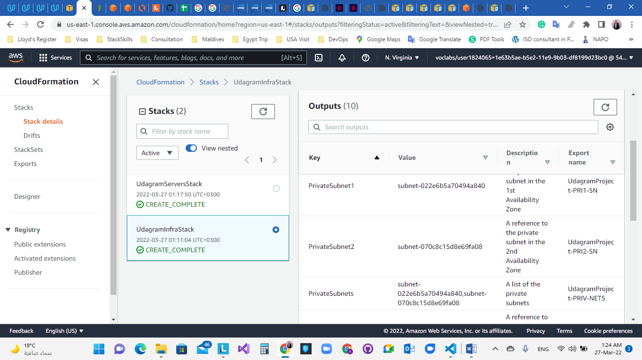

1. Servers Stack completed successfully (Output Screen)

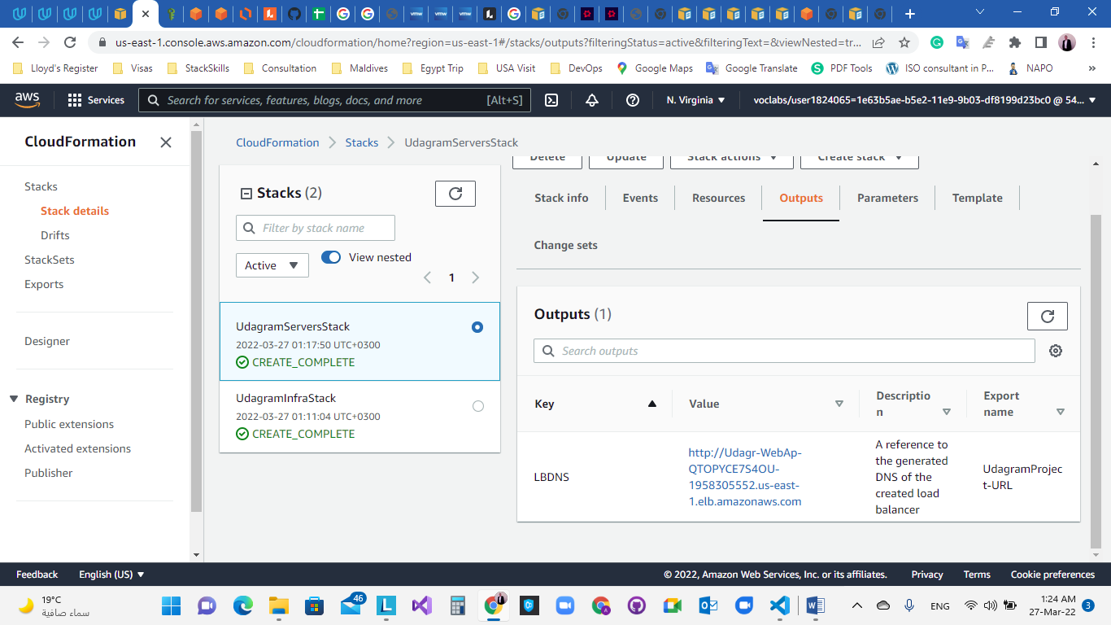

1. Verification that the URL is working:

<http://udagr-webap-qtopyce7s4ou-1958305552.us-east-1.elb.amazonaws.com/>

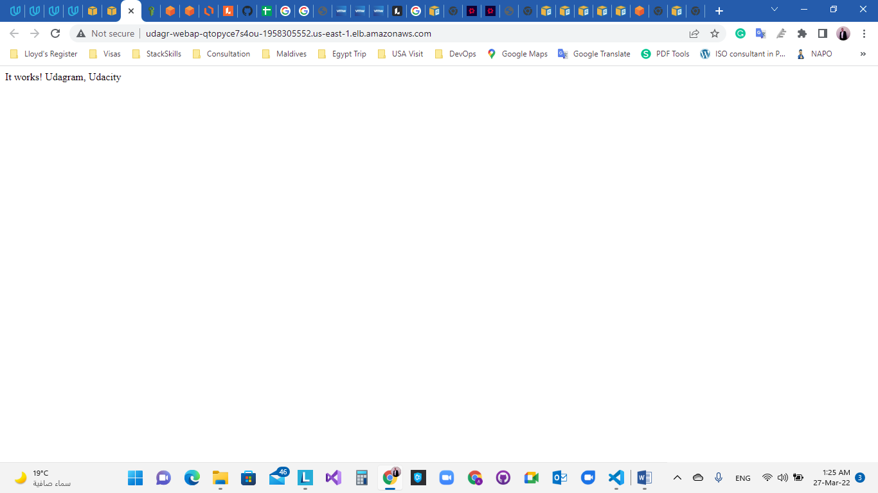

1. EC2 Instances

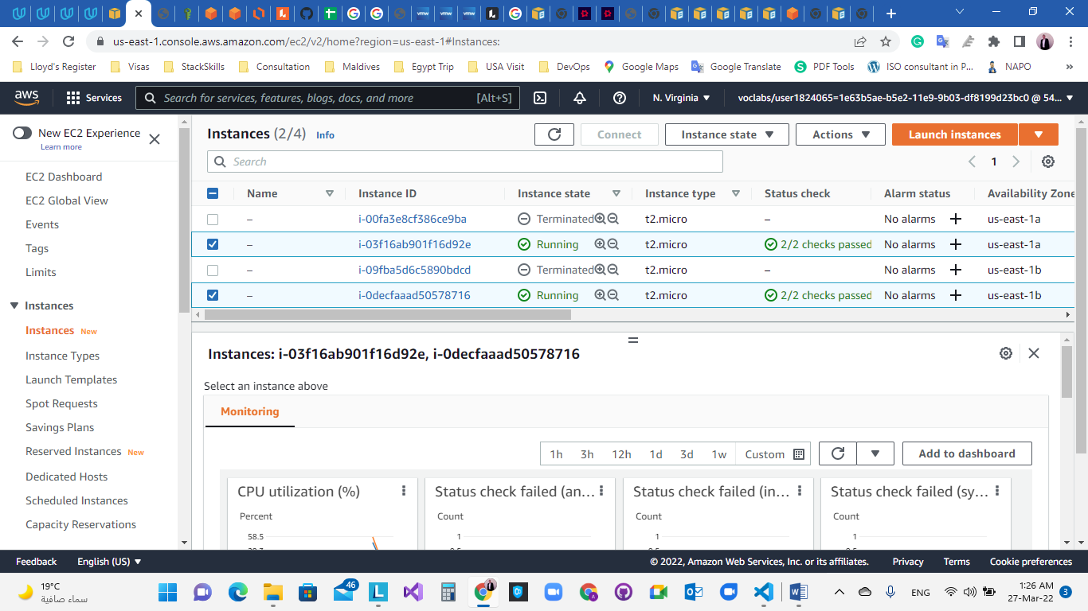

1. Load Balancer and Listener

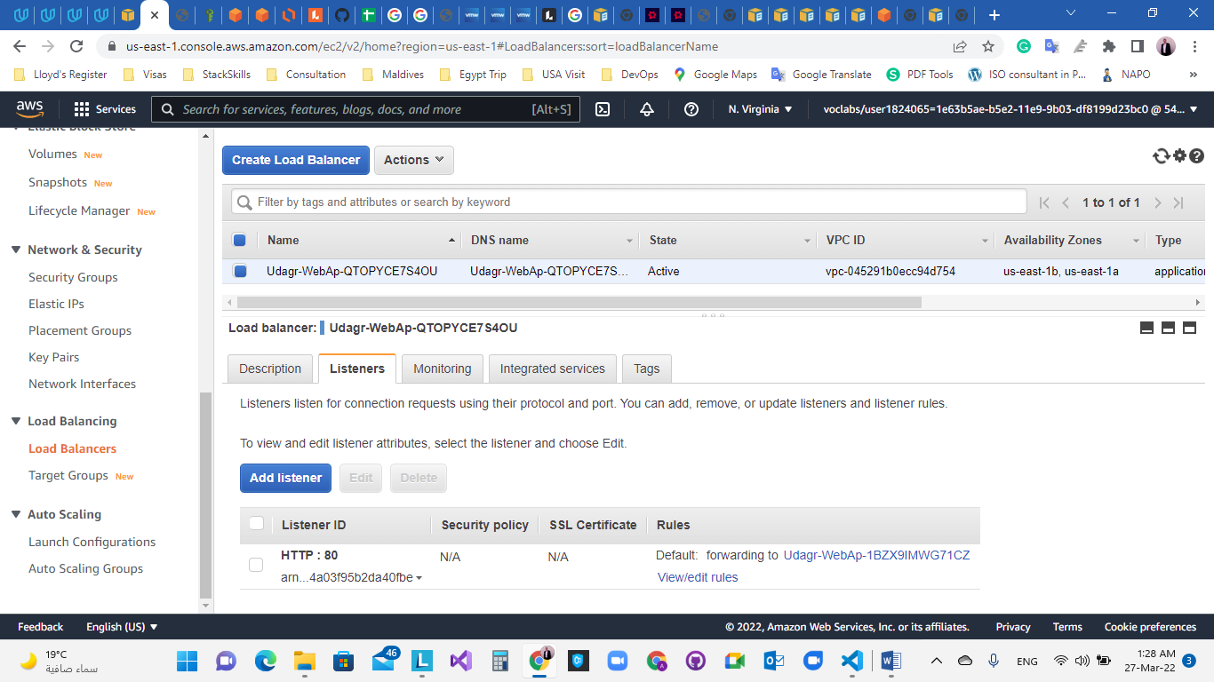

1. Target Group and health status

