AI-Based Platform to Support the Employment of Astana IT University Graduates
Pre-defense 1 report | 24 October 2026
Team size: 2
Probationary period 1 submission. Current implementation and verification evidence are documented. Interviews and supervisor feedback are optional; no such evidence or approval is claimed.
Student 1 — full name: Қожабек Аяділ Нұрланұлы
Student 2 — full name: Амантай Жан Әділұлы
Group: SE-2425 (student 1); SE-2419 (student 2)
Supervisor: Оразова Арайлым Жанболаткызы
Supervisor position: Senior Lecturer
Repository URL: https://github.com/vbl0-0/AITU-Career
Issue tracker URL: https://github.com/users/vbl0-0/projects/1
Submission deadline: 24 October 2026 before 18:00 (UTC+5).

Contents
1. Project Proposal and Scope
2. Evidence of Relevance and Optional User Research
3. Critical Literature Review
4. Existing System Comparison
5. Technology Comparison and Architectural Decisions
6. Requirements Specification and Acceptance Criteria
7. Architecture, Diagrams and Data
8. UX and Prototype
9. Verification and Evaluation Plan
10. Project Management, Responsibilities and Risks
11. Review Status and Optional Supervisor Feedback
Appendix A. References
Appendix B. Submission Checklist and Evidence Status

1. Project Proposal and Scope
AI-Based Platform to Support the Employment of Astana IT University Graduates.
Problem statement. Graduates need to compare their educational and practical experience with heterogeneous IT job requirements and identify an actionable next step. The existence and scale of this need specifically among AITU graduates remain hypotheses until local user discussions are completed. Research on skill extraction supports the technical relevance of the task, but does not establish local demand [S01–S05].
Target users are senior AITU students and graduates, plus an administrator of the educational prototype. A career-center representative is a potential requirements expert. An employer dashboard is outside the current MVP.
Aim. Develop and evaluate a reproducible prototype that explains how a graduate profile covers IT vacancy skill requirements, identifies skill gaps and suggests development actions. The matching percentage is not a probability of employment.
Objective | Verifiable outcome
Investigate the domain | At least 12 meaningfully used sources including eight scientific publications; comparison of four systems. Optional user research is planned for later validation.
Specify requirements | A priority, acceptance criterion and verification method for each mandatory requirement.
Design the system | System context, use cases, components, data relationships and API responsibilities.
Implement the core journey | Profile → skills → vacancy → explained match → development actions.
Evaluate the approach | Compare exact matching, normalization and optional semantics under one fixed protocol.
Prepare submission evidence | Unified report, editable diagrams, traceable tasks and actual verification evidence.
Included: authentication and graduate/admin roles; AITU-oriented profiles and education; skills with proficiency levels; projects, certificates and experience; vacancies and saved jobs; transparent weighted matching; saved analyses with staleness detection; recommendations and administration. The local seed contains 30 fictional vacancies clearly identified as demonstration data.
Excluded from this stage: automated hiring decisions, validated prediction of employment, university SSO/DU/Moodle integration, large-scale collection of external vacancies, production SLA, employer accounts and training a large language model. Visual similarity to university services does not imply integration or institutional endorsement.
The team consists of two students. Confirmed names and GitHub accounts are recorded below. Actual contributions are recorded when supported by completed work and review evidence.
Team member | Full name | GitHub account | Agreed contribution
1 | Қожабек Аяділ Нұрланұлы | https://github.com/vbl0-0 | Backend/API and migration delivery, backend regression tests and repository automation; publication and verification assisted by OpenAI Codex. Evidence: https://github.com/vbl0-0/AITU-Career/pull/19 ; https://github.com/vbl0-0/AITU-Career/pull/21 ; commits 6c434f2 and 0b8c8bb. These records describe current delivery, not exclusive initial authorship of all imported code.
2 | Амантай Жан Әділұлы | https://github.com/igiiaw | Frontend, multilingual interface, research documentation and report-source delivery; publication and verification assisted by OpenAI Codex. Evidence: https://github.com/vbl0-0/AITU-Career/pull/20 ; https://github.com/vbl0-0/AITU-Career/pull/22 ; commits 7717652, c12021f and 203f7c7. These records describe current delivery, not exclusive initial authorship of all imported code.

2. Evidence of Relevance and Optional User Research
On 24 October 2026, the team clarified that user interviews and supervisor feedback are optional for this submission. This is a team-reported requirement clarification, not a recorded supervisor approval.
Relevance at this stage is supported by the literature and system comparison in Sections 3–4. No user interviews were conducted and no interview results are presented. Local demand, explanation usefulness and the employment-readiness indicator remain hypotheses rather than empirically established conclusions.
Claim | Available evidence | Limit
Skill extraction and normalization require explicit design decisions. | Scientific publications S01–S05. | Transfer to Kazakh/Russian and AITU profiles needs local evaluation.
Existing services combine vacancy matching and skill development. | Official system materials S11–S14 and the common-criteria comparison. | This does not prove unmet local demand or superiority of this prototype.
Explanations can expose covered, partial and missing skills. | Implemented calculation and automated functional checks. | User comprehension and usefulness have not been measured.
Employment readiness summarizes profile and vacancy evidence. | Documented configurable heuristic. | It is not a validated predictor of hiring success.
Future optional research may include anonymized discussions with graduates, career-center staff and recruiters. Findings should be recorded with actual dates and consent, separated from interpretations and linked to requirement decisions. Such evidence is not a prerequisite for this submission and no participant identities or fabricated responses are included.

3. Critical Literature Review
A targeted engineering search was performed on 19 October 2026 using ACL Anthology, arXiv and official product/technical documentation. Queries covered skill extraction from job postings, multilingual skill matching, sentence embeddings and job-title representations. Inclusion required verifiable metadata and a direct connection to extraction, retrieval or an engineering decision. This is not claimed to be an exhaustive systematic review.
The review uses 17 sources: eight peer-reviewed scientific publications S01–S08, technical report S09 and eight official materials S10–S17. The scientific core is from 2021–2025; Sentence-BERT (2019) is retained as foundational work. The limitations and applications below are the project’s analysis of transferability, not verbatim author claims.
Source and approach | Limitation for this project | Engineering implication
S01. Expert annotation of hard and soft skill mentions and domain-adapted extraction models. | English job postings do not establish performance on Russian/Kazakh texts or AITU profiles. | Evaluate extraction separately from ranking; retain reference spans and annotation rules.
S02. Survey of terminology, datasets and neural skill extraction methods. | Different datasets and task definitions prevent direct comparison of reported scores. | Define the annotation unit, skill terminology and normalization rules before evaluation.
S03. Multilingual domain-adaptive pre-training using the ESCO taxonomy. | Transfer to local occupations and languages requires validation; large-model adaptation needs resources. | Maintain canonical skills and aliases; consider ESCO alignment as a future extension.
S04. Few-shot LLM extraction explores complex skill mentions. | The study does not establish universal superiority over supervised methods; inference requires quality control and resources. | Keep external LLM calls optional and assess extraction against fixed labels.
S05. Multilingual vacancy–candidate matching through skill extraction, ESCO alignment and a knowledge graph. | The graph pipeline is more complex than a dictionary, and its benefit for AITU graduates remains unmeasured. | Compare normalization with semantic expansion and retain the origin of each match.
S06. Job-title representations incorporate information from descriptions beyond extracted skills. | Learning job-title representations is different from assessing an individual candidate. | Describe the current score as skill-requirement coverage, not a probability of being hired.
S07. Siamese sentence encoders enable efficient embedding-based text comparison. | Text similarity does not prove skill proficiency or satisfaction of all job conditions. | Use similarity only as supplementary evidence with a limited contribution.
S08. Contrastive learning produces sentence representations in supervised and unsupervised settings. | Semantic textual similarity benchmarks do not replace domain-specific matching evaluation. | Select an encoder using local ranking quality and latency as well as general benchmarks.
S09. A family of multilingual retrieval embeddings offers different model sizes. | Input conventions, model size and inference cost affect suitability. | Include E5 in a future comparison; it is not the model currently configured in the prototype.

Synthesis and research questions
S01–S04 motivate separating a skill mention, its canonical label and evidence of proficiency. The MVP therefore distinguishes an explicitly reported skill/level from inferred text evidence. Dictionary matching is reproducible but limited by catalog coverage and language variation. S03 and S05 motivate taxonomy alignment without establishing a need for a graph database at this scale.
S06 highlights information in vacancy descriptions beyond skill lists. The current score consequently measures only coverage of explicit or extracted skill requirements. S07–S09 justify evaluating embeddings against literal matching, but textual proximity alone does not establish competence. Semantic evidence is therefore capped at a partial contribution and its method is recorded.
RQ1: do alias normalization and optional semantic matching improve nDCG@5 over exact skill matching on a fixed profile/vacancy dataset while retaining interpretable explanations? RQ2: do users distinguish skill coverage from the probability of employment? The contribution is a testable engineering adaptation to AITU. Superiority over commercial systems is not asserted.

4. Existing System Comparison
Four relevant systems are compared on eight consistent criteria using official public documentation: LinkedIn [S11], Handshake [S12], hh.kz [S13] and Coursera Career Academy [S14]. No private product accounts were audited. “Not established” means that the cited sources do not establish the capability; it does not mean the capability is absent.
Criterion | LinkedIn | Handshake | hh.kz | Career Academy
Primary purpose | Job discovery and matching | Early-career discovery and recommendations | Regional job search | Role-oriented skill development
User information | Profile and resume | Profile, interests and activity | Resume and key skills | Learning pathway; vacancy matching not established
Personalized vacancies | Documented | Documented | Exact mechanism not established by S13 | Not established
Skills and requirements | Profile and job qualifications | S12 emphasizes interests and activity | Key skills | Skills associated with a career role
Match explanation | Documented | Per-requirement explanation not established | Not established | Role skills rather than individual vacancy fit
Development actions | Profile improvement and upskilling | Career recommendations; detail not established | Not established | Courses and practical projects
Published exact scoring formula | Not established | Not established | Not established | Not established
AITU-program alignment | Not established | Not established | Not established | Not established
Matching and skill-development recommendations already exist in competing systems. The rationale for this prototype is controllable AITU-specific adaptation, an accessible per-requirement calculation and reproducible evaluation on a fixed dataset. Optional future user research can test the local-demand hypothesis. Commercial systems are not quantitative baselines because their internal algorithms and evaluation data are unavailable.

5. Technology Comparison and Architectural Decisions
The alternatives are assessed for a small educational prototype with a Python analysis module, relational data and no interaction history. Assessments are qualitative; no unperformed performance measurements are implied.
Decision | Reasonable alternatives and trade-offs | Selected solution and rationale
Backend platform | FastAPI: validation/OpenAPI and direct Python NLP integration [S15]. Django REST: mature conventions and administration, with a larger framework surface. Node.js/NestJS: a shared frontend language, but Python NLP needs an additional integration boundary. | FastAPI supports one small API/analysis process and a modular code structure.
Data storage | PostgreSQL: relational constraints and transactions [S16]. SQLite: simple setup with a different concurrency/operation profile. MongoDB: flexible documents, with a different strategy for cross-record integrity. | PostgreSQL with SQLAlchemy and Alembic preserves linked profiles, catalog entries and vacancy requirements.
Matching approach | Exact matching: transparent but sensitive to wording. Dictionary/aliases/weights: explainable but requires catalog maintenance. Embedding hybrid: supports paraphrases [S07–S09] but adds calibration and inference cost. | Weighted normalized keyword matching is the default; embeddings remain optional and require separate evaluation.
Component communication | REST/JSON: straightforward CRUD and OpenAPI. GraphQL: flexible selections with an additional schema/cost-control layer. gRPC: typed binary communication but more integration work for a browser client. | REST/JSON under /api, with Vite/nginx proxying to a single browser origin.
Frontend | React/TypeScript: typed components already implemented. Vue/TypeScript: a comparable SPA option requiring component migration. Server templates: a smaller client stack but a different approach to interactive profile editing. | React/TypeScript with Vite follows the implemented journeys; no unmeasured speed advantage is claimed.
ADR-01: use a modular monolith. Authorization, API, analysis and persistence have separate code responsibilities but share one backend deployment. Revisit separation only if profiling demonstrates interference from inference. ADR-02: PostgreSQL is the source of truth; preserve algorithm version and input revisions with saved analyses. ADR-03: absence of the optional model must not break keyword analysis.

6. Requirements Specification and Acceptance Criteria
MoSCoW priorities: Must denotes mandatory MVP behavior; Should denotes a planned improvement; Could denotes an optional extension. An implemented feature is not evidence that users need it. Requirement IDs connect the specification, components, tasks and verification.
ID / priority | Requirement | Acceptance criterion | Verification
FR-01 / Must | Registration and sessions | A new email creates a graduate account; invalid passwords are rejected; logout invalidates the previous access token. | API authentication tests; browser login/logout
FR-02 / Must | Authorization boundaries | Other users’ records are inaccessible; graduates cannot execute admin actions or grant themselves an admin role. | API ownership/role tests
FR-03 / Must | Profile and education | Program, graduation year and desired role are saved; an invalid graduation year is rejected. | API validation; graduate E2E
FR-04 / Must | Skills and proficiency | Catalog skills use levels 1–3; duplicates and unknown IDs are rejected. | API skill tests
FR-05 / Must | Portfolio | Projects, technologies, certificates and experience support CRUD; an end date before the start date is rejected. | API and portfolio E2E
FR-06 / Must | Vacancies and saved jobs | Search/filters return matching records; details expose requirements; repeated save/remove operations are handled consistently. | API vacancy tests; graduate E2E
FR-07 / Must | Deterministic matching | Identical keyword inputs/configuration produce the same score; four of five equal full matches yield 80%; no requirements yield null. | Unit matching tests
FR-08 / Must | Explanations | Each requirement belongs to matched/partial/missing; contribution, weight, method, version and gap-based actions are available. | Matching tests; detail/analysis inspection
FR-09 / Must | Stale analysis | Profile, vacancy or relevant context changes flag saved results as stale and offer recalculation. | API fingerprint/staleness tests; E2E
FR-10 / Must | Administration | Admins manage jobs/catalogs; deleting a referenced category is handled without data loss. | API constraints; admin E2E
FR-11 / Should | Semantic extension | No model triggers keyword fallback; a semantic match is labeled and contributes at most 0.5. | Controlled semantic/fallback tests; real-model evaluation separately
FR-12 / Must | Demonstration-data labels | Fictional vacancies are labeled; readiness reports its sample scope and components. | UI inspection; career summary
ID / priority | Quality attribute | Acceptance criterion | Verification
NFR-01 / Must | Security | Argon2id passwords, signed JWTs, HttpOnly refresh cookies, hashed refresh secrets and rejection of untrusted origins. | API tests; configuration review
NFR-02 / Must | Integrity | Foreign keys, UNIQUE/CHECK constraints and migrations are enforced; repeat seeding creates no duplicates. | PostgreSQL tests; Alembic check
NFR-03 / Must | Reproducible startup | A supported clean environment can run setup, migrations, seed and health checks; native Windows and Compose instructions are separate. | Runbook; container startup not yet verified
NFR-04 / Must | Mobile usability | The core journey fits 390×844 without horizontal overflow; menu, inputs and actions remain available. | Playwright and screenshots
NFR-05 / Should | Accessibility | Keyboard focus is visible; normal text contrast is at least 4.5:1; errors have textual descriptions. | Targeted audit; comprehensive audit remains outstanding
NFR-06 / Should | Latency | Target: keyword matching p95 ≤500 ms on 30 demonstration vacancies after warm-up; no measurement is claimed. | 30 warm-up and 200 measured requests on fixed hardware
NFR-07 / Must | Traceability | Saved results include algorithm version, mode, revisions and a context fingerprint. | Unit/API fingerprint tests
NFR-08 / Must | Confidentiality | Submission files exclude .env/tokens and identifiable interview data. | Package inventory and staged-diff review

Matching and readiness rules
Score = 100 × Σ(weight × contribution) / Σ(weight). For an explicit skill, contribution = min(1, user_level / required_level); for an absent skill it is zero. Inferred text and semantic evidence are capped at 0.5. Required/preferred skill weights default to 2/1 and may be set to other positive values. Scores across different vacancies do not imply equal job difficulty.
Readiness is an internal heuristic: market 60%, projects 15%, experience 10%, certificates 5% and education 10%, with configurable normalized weights. Market uses up to five highest-scoring target-role vacancies; relevant experience is capped at 180 non-overlapping days. These weights have not been empirically validated as predictors of employment.

7. Architecture, Diagrams and Data
Students/graduates and administrators use React, FastAPI and PostgreSQL. An explicit HeadHunter API adapter supports import, refresh, deduplication and source/availability tracking; live provider access was not available and no real import is claimed. University SSO and DU/Moodle are not integrated. Default keyword analysis needs no external AI service; the optional embedding model is disabled in the verified configuration.
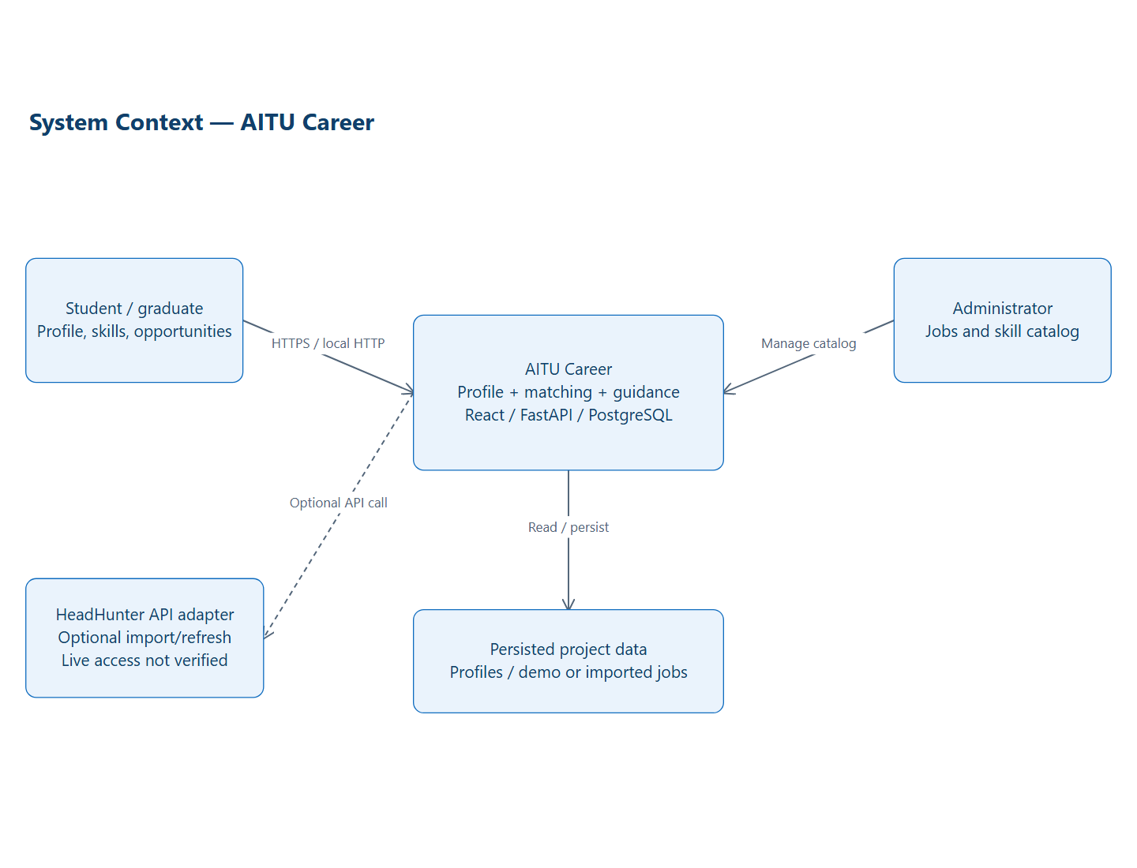
Figure 1. System context and responsibility boundaries.
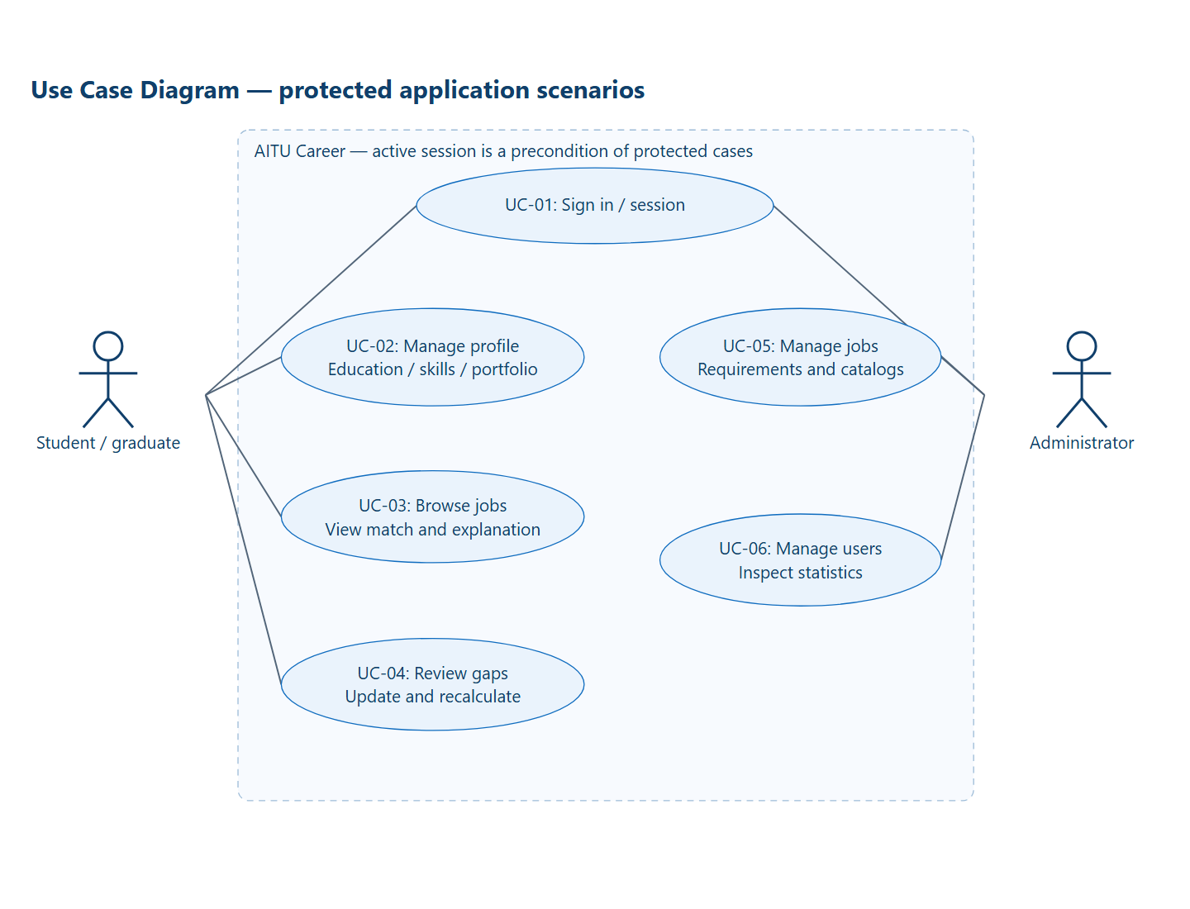
Figure 2. User roles and protected use cases.
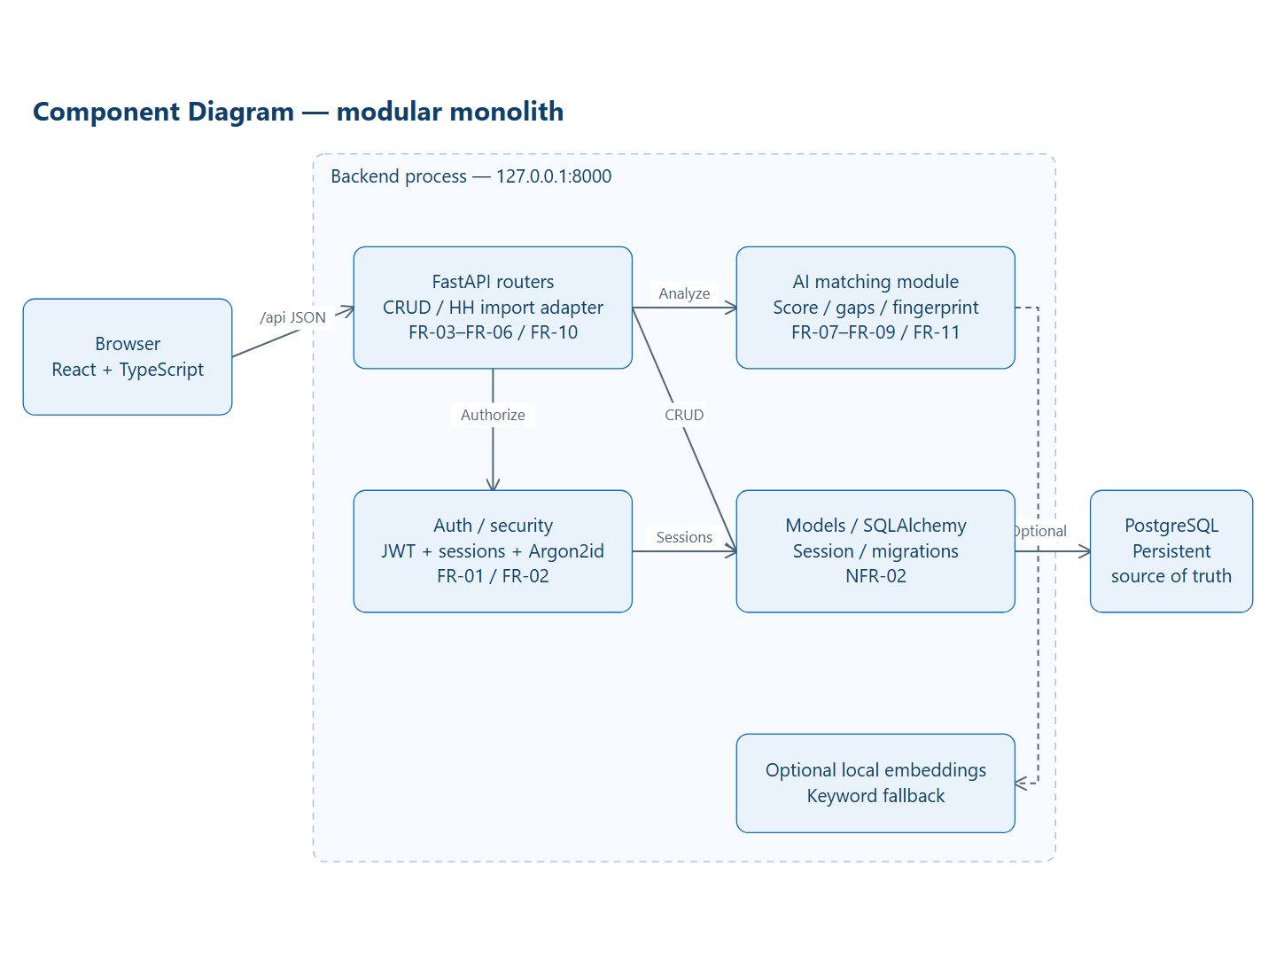
Figure 3. Draft component architecture aligned with the implementation.
Component | Responsibility | Related requirements
frontend/src/pages and components | Profile, vacancies, analysis and admin screens; routes and error states. | FR-03–FR-10; NFR-04/05
auth routes and core/security.py | Passwords, JWTs, sessions and permission checks. | FR-01/02; NFR-01
profile/jobs/admin routes | Input validation, CRUD, catalog and application journeys. | FR-03–FR-06; FR-10/12
ai/matching.py | Competencies, score, gaps, recommendations, fingerprint and optional semantics. | FR-07–FR-09/11; NFR-07
models/database/migrations | Relationships, constraints, persisted analyses and repeatable seed. | NFR-02/03
Data relationships: User 1:1 GraduateProfile; GraduateProfile 1:N Education, UserSkill, Project, Certificate, Experience, MatchResult and Recommendation. UserSkill/JobSkill link profiles/jobs to Skill; ProjectSkill links project technologies. SkillAlias stores normalization rules. CareerRole and categories are controlled dictionaries. User has AuthSession records; SavedJob links users to jobs. MatchResult preserves a calculated snapshot and its input/version context.
Analysis flow: authenticate and authorize → validate profile/job → normalize catalog terms → collect structured and textual evidence → obtain requirements → calculate weighted coverage → group matched/partial/missing requirements → derive development actions → persist the result with revisions → display it. Input changes do not silently replace the saved snapshot; they flag it as stale.
API route / resource | Purpose
POST /api/auth/register, /login, /refresh, /logout | Account creation and session management.
/api/profile, /api/skills, /api/projects, /api/certificates, /api/experience | Profile and portfolio operations; supported methods depend on the resource.
GET /api/jobs; GET /api/jobs/{id}; POST /api/jobs/{id}/match | Vacancy discovery, details and matching.
GET /api/recommendations; GET /api/admin/statistics | Career overview and administrator statistics.
GET /api/health; /docs | Health check and generated API contract.
The full current API contract is available locally at http://localhost:8000/docs. Diagram deliverables include editable SVG, JSON layout models, Mermaid/PlantUML sources and PNG exports. Diagram changes must remain consistent with the code and requirement IDs.
Editable diagram sources and exports: https://github.com/vbl0-0/AITU-Career/tree/prob-period-1/docs/pre-defense-1/diagrams. Local OpenAPI: http://localhost:8000/docs. The API is not publicly hosted by the static prototype viewer.

8. UX and Prototype
Public screen walkthrough: https://vbl0-0.github.io/AITU-Career/. It presents actual captures of the local application with navigation between screens, not a hosted backend or live editing service. The complete application runs locally using the published development instructions. The interface supports Kazakh, Russian and English; the report is in English. Original screenshot and diagram colors are preserved.
Journey | Steps | Expected outcome
UC-01: Start | Landing → registration/sign-in → dashboard. | An authenticated session and an accessible profile.
UC-02: Profile | Education program → desired role → skills → project. | Saved data and explicit confirmation.
UC-03: Match | Search → vacancy → score → detailed analysis. | Requirement groups and a traceable calculation.
UC-04: Improve | Add FastAPI → open an old analysis → recalculate. | A stale warning followed by a result based on current inputs.
UC-05: Administer | Admin sign-in → jobs → create/update. | Permission checks and validated skill requirements.
UX states include loading, no records, validation errors, server failures, save confirmation and stale results. Focus indication, labels and accessible action names are implemented; a comprehensive accessibility audit remains outstanding. A user-evaluation task asks participants to find a relevant vacancy, identify two gaps and explain the score.
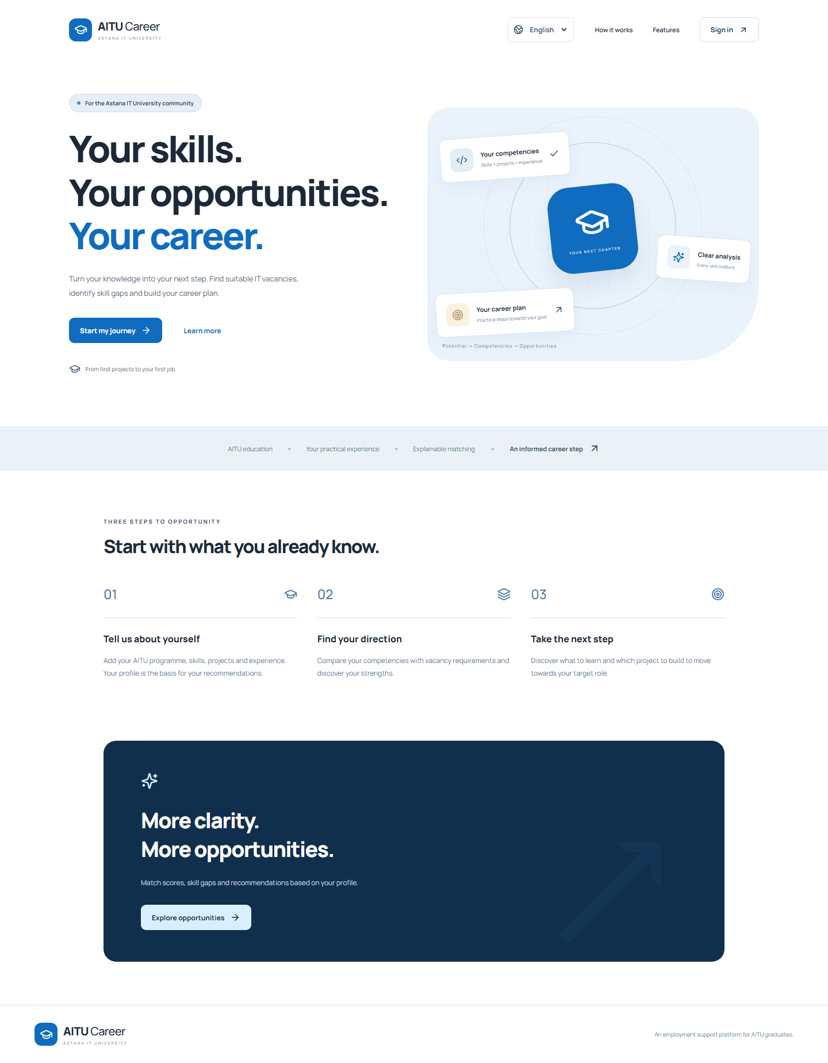
Figure 4. Entry to the graduate journey.
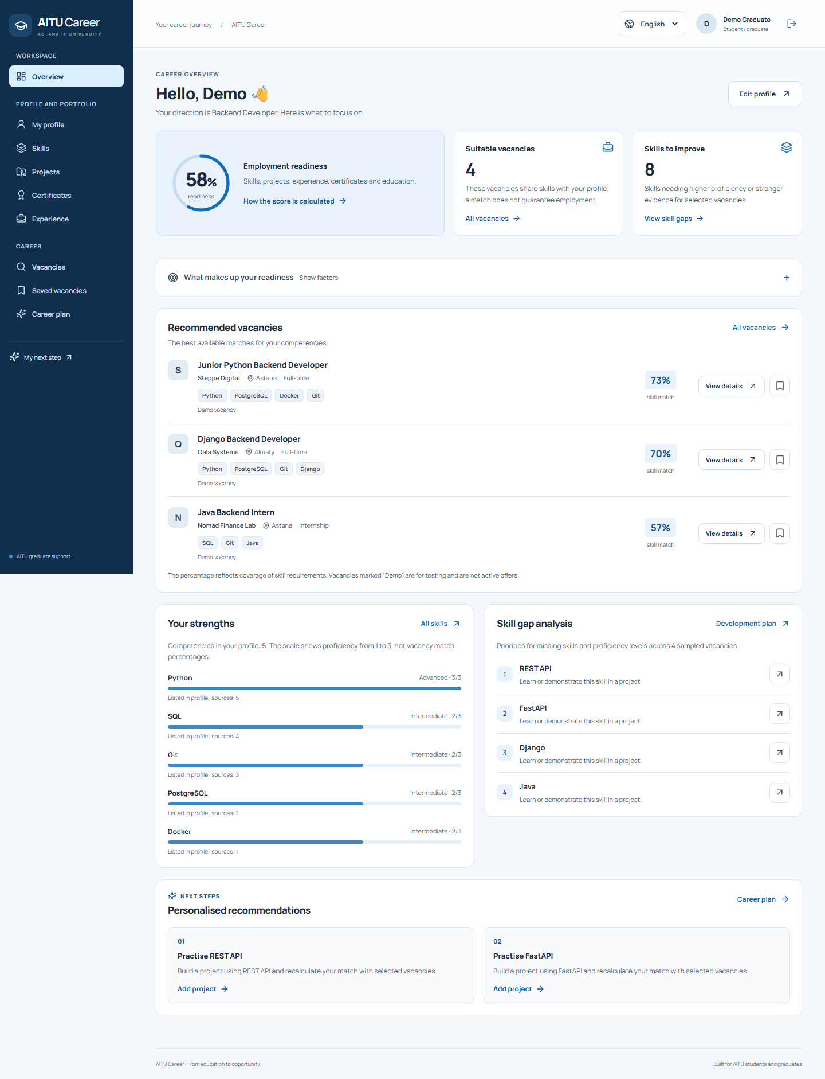
Figure 5. Demonstration graduate dashboard.
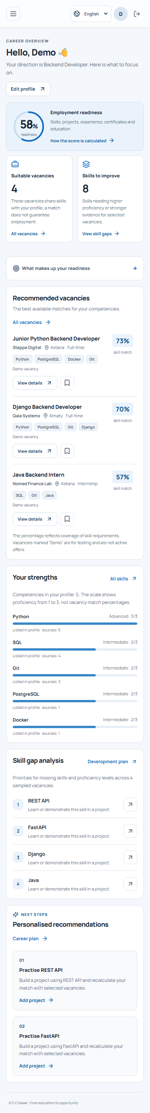
Figure 6. Mobile interface at 390×844.
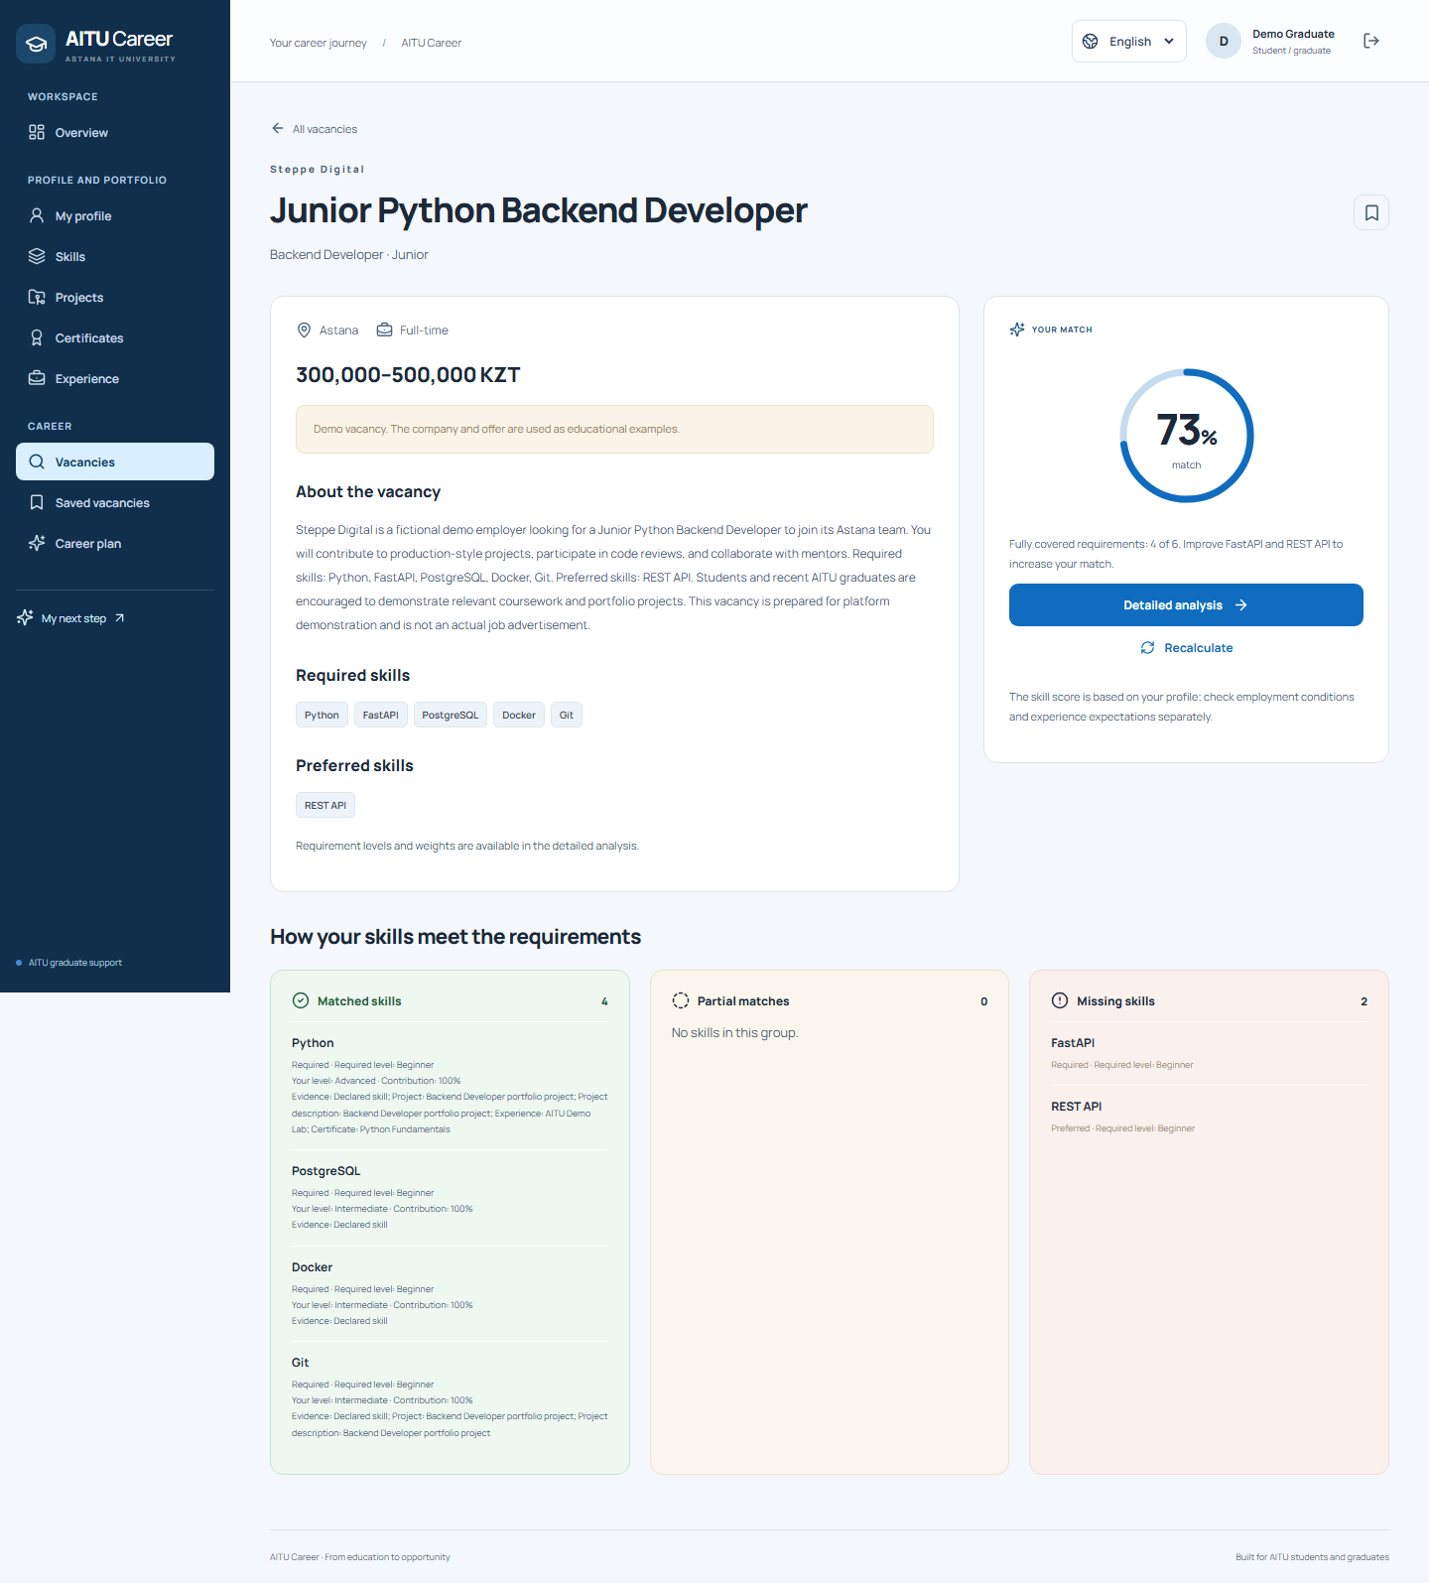
Figure 7. Vacancy requirements and explained matching.
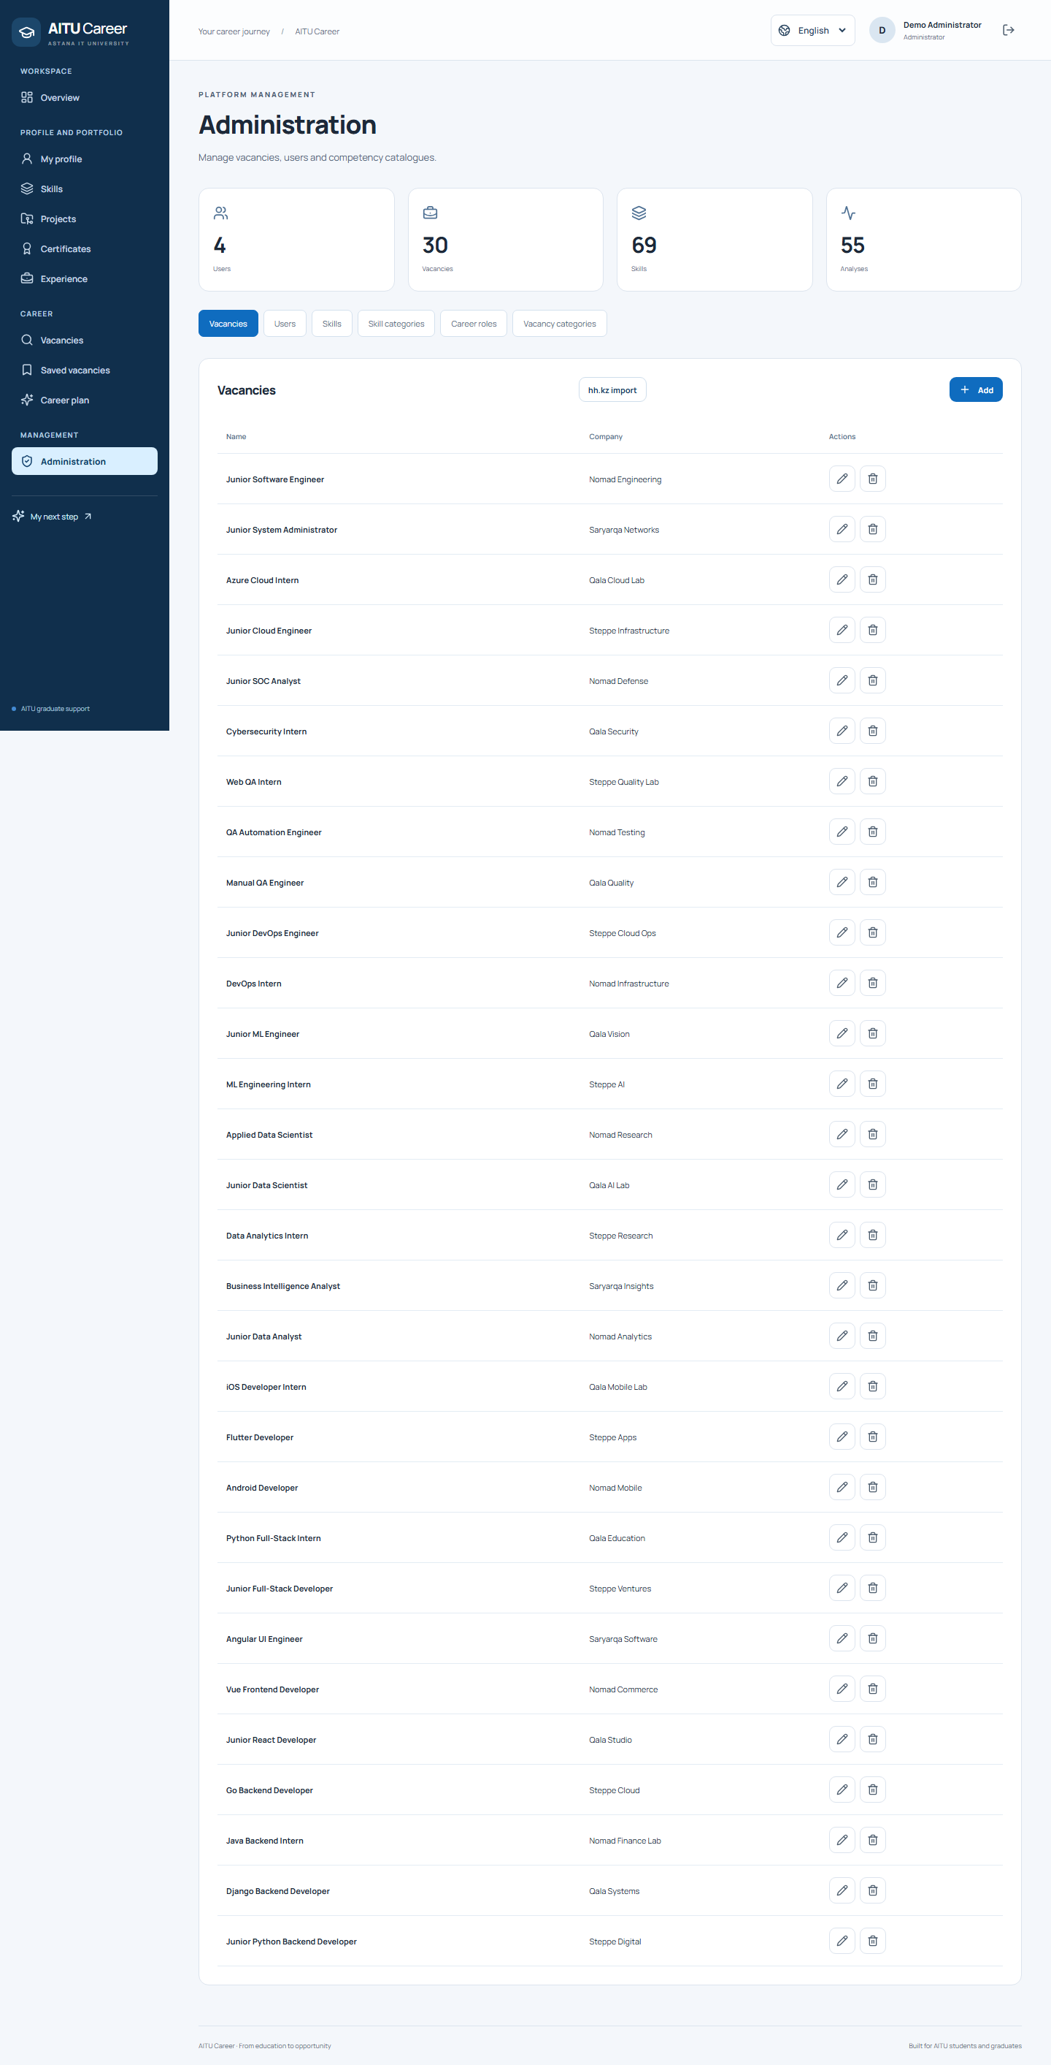
Figure 8. Administrative vacancy management.

9. Verification and Evaluation Plan
Verification checks implementation against requirements. Evaluation examines ranking quality and user understanding. Passing software tests does not demonstrate improved employment outcomes or model accuracy on the real labor market.
Verification on 24 October 2026 | Observed result
python -m pytest | passed: 60 checks passed. 35.06 seconds; one Starlette TestClient/httpx deprecation warning. The initial database connection timeout was resolved by starting the existing project cluster.
npm run test:e2e | passed: 20 checks passed. Chromium: graduate and admin journeys, portfolio CRUD, Dashboard states, role restrictions, responsive navigation, kk/ru/en and vacancy import/salary regressions. Some focused tests use API fixtures; the core journey and multilingual pages also use the real local API.
npm run check:i18n | passed: 459 checks passed. Translation keys, interpolation parity and static references in kk/ru/en.
npm run build | passed: TypeScript and production Vite build. Existing main-chunk warning: 501.13 kB before gzip.
python -m alembic upgrade head; python -m alembic check | passed: Migrations applied; no new upgrade operations detected.
node --test .github/scripts/project-sync.test.mjs | passed: 9 checks passed. Reference parsing, trusted PR filtering, transitions, partial merges, pagination and status-only/idempotent mutations.
Targeted UI review (eleven routes, desktop/mobile) | passed: 22 checks passed. Screenshots inspected; no horizontal document overflow or blocking page alert at 1440px/390px. Keyboard skip-link focus has a 3px outline. This is not comprehensive WCAG conformance.
Machine-readable results: https://github.com/vbl0-0/AITU-Career/blob/prob-period-1/docs/pre-defense-1/evidence/validation.json. The initial connection timeout was resolved by starting the existing project PostgreSQL cluster; no application tables were replaced. Software checks do not establish ranking quality, real-market coverage or improved employment outcomes.
Level | Verification focus | Artifact
Unit | Formula, levels, boundaries, aliases, partial evidence and semantic fallback/cap. | backend/tests/test_matching.py
API and database | Sessions, roles, ownership, CRUD, constraints and staleness. | backend/tests/test_api.py
Browser | Graduate journey, portfolio, administration and mobile viewport. | frontend/tests/career.spec.ts
Structure | Type checking, production build and model/migration consistency. | npm run build; alembic check
Quality evaluation | Independent labels and a fixed baseline comparison. | Protocol below; experiment not yet performed
Proposed evaluation data: 20 anonymized or synthetic profiles and 50 legally usable vacancies across four or five IT directions. Fix the dataset version, seed and hashes. Ten profiles form development data (500 pairs); the remaining ten form held-out test data (500 pairs). Two experts independently label each pair 0/1/2. Preserve disagreements before adjudication. Do not tune the dictionary or threshold on held-out judgments. Shared vacancies mean this protocol assesses new-profile rather than unseen-vacancy generalization.
B0: exact case-normalized skill-name overlap, without aliases, as an unweighted fraction. B1: the current alias dictionary, proficiency levels and weights. B2: B1 with optional semantic evidence. Use identical candidate vacancies, profiles and labels; choose the semantic threshold on development data only. Ablations without levels and without inferred evidence help explain the source of any improvement.
Metric | Calculation and conditions | Decision criterion / status
Precision@5 | Fraction of top-five items labeled 2; macro-average over test profiles. | Measure B0/B1/B2; no values claimed.
nDCG@5 | Gain = 2^rel−1; ideal ranking from the same labels. | Primary metric; hypothesis B1>B0. Preserve negative outcomes.
Extraction F1 | Canonical-skill exact match against reference labels; micro and per-language results. | Separate extraction quality from ranking quality.
Expert agreement | Weighted Cohen’s κ before resolving disagreements. | Report ambiguity rather than hiding disagreement.
Latency | 30 warm-up and 200 measured requests; median/p95 on the same CPU. | Keyword p95 target ≤500 ms; measurement outstanding.
Explanation comprehension | Five to eight volunteers identify gaps and interpret the score. | Pilot target: ≥80% correct responses; not representative evidence.
Record CPU/RAM, Python/Node/PostgreSQL versions, model revision, threshold, cache state, algorithm version and data hash. Report paired nDCG differences and bootstrap intervals over test profiles with a fixed seed (for example 42 and 1,000 resamples). Small samples limit statistical power; no significance claim is justified without calculation.
Validity threats include convenience sampling, self-reported skills, synthetic vacancies, language bias, tuning leakage, facilitator effects and a small profile sample. Mitigations are independent annotation, a held-out split, negative examples, fixed comparison conditions and retention of raw judgments and errors. Docker and the real embedding model were not exercised in this environment; controlled tests do not replace their evaluation.

10. Project Management, Responsibilities and Risks
The two accounts publish current module deliveries with actual dates. Account attribution documents delivery and verification; it does not reconstruct earlier development history or prove independent authorship of every line. Packaging, code assistance, verification and publication were assisted by OpenAI Codex. No human teammate approval or supervisor approval is claimed.
Member | Published responsibility and evidence
Қожабек Аяділ Нұрланұлы | Backend/API and migration delivery, backend regression tests and repository automation; publication and verification assisted by OpenAI Codex. Evidence: https://github.com/vbl0-0/AITU-Career/pull/19 ; https://github.com/vbl0-0/AITU-Career/pull/21 ; commits 6c434f2 and 0b8c8bb. These records describe current delivery, not exclusive initial authorship of all imported code.
Амантай Жан Әділұлы | Frontend, multilingual interface, research documentation and report-source delivery; publication and verification assisted by OpenAI Codex. Evidence: https://github.com/vbl0-0/AITU-Career/pull/20 ; https://github.com/vbl0-0/AITU-Career/pull/22 ; commits 7717652, c12021f and 203f7c7. These records describe current delivery, not exclusive initial authorship of all imported code.
Merged delivery records: https://github.com/vbl0-0/AITU-Career/pull/19 (repository automation); https://github.com/vbl0-0/AITU-Career/pull/20 (frontend); https://github.com/vbl0-0/AITU-Career/pull/21 (backend and regression tests); https://github.com/vbl0-0/AITU-Career/pull/22 (research and report sources). Further delivery PRs are recorded in the repository and linked issue comments. Original commits are preserved through merge commits.
Tracker: https://github.com/users/vbl0-0/projects/1. The 18 original tasks retain their source IDs, priorities, planned owners and original deadlines. GitHub Issues contain actual acceptance criteria, account assignments and completion evidence. Optional interview/feedback tasks are distinguished from completed work. Later-stage independent labels and matching-quality experiments are not marked complete.
Risk or remaining limit | Response
Static prototype versus the complete application | The public viewer is clearly labelled; use the development guide to run authenticated CRUD and matching.
Demonstration vacancies mistaken for live jobs | The seed dataset is fictional and labelled. No live HeadHunter import or current market representativeness is claimed.
Unmeasured model or employment outcomes | Keep the evaluation protocol; do not infer efficacy from passing implementation tests.
Confusing account history with individual authorship | Preserve real dates and links; state the use of AI assistance and distinguish delivery from historical authorship.
Documents differ from the submitted version | Use the exact prob-period-1 tag and the matching PDF exports; do not move the submitted tag.
Optional evidence shown as mandatory | Record the team clarification and keep future interviews/reviews optional.
Submission version: https://github.com/vbl0-0/AITU-Career/tree/prob-period-1. One representative submits both students' materials before 18:00 UTC+5 on 24 October 2026. A form confirmation is retained only after actual submission.

11. Review Status and Optional Supervisor Feedback
On 24 October 2026, the team clarified that user interviews and supervisor feedback are optional for this submission. This is a team-reported requirement clarification, not a recorded supervisor approval.
No substantive supervisor feedback has been supplied and no approval, signature, meeting or quotation is invented. The absence of optional feedback is not treated as an incomplete mandatory requirement. Independent human peer review is not claimed; available automated technical reviews and corrections are recorded on the actual GitHub issues and PRs.
Actual revision | Rationale and evidence
Clarify optional interviews and supervisor feedback. | Team clarification relayed on 24 October 2026; Sections 2 and 11 now state the actual evidence status.
Update current implementation verification. | 60 backend tests, full browser tests, translation parity, production build and migration checks are recorded in the validation artifact.
Document real deliveries and contributions. | Merged PRs and original account-linked commits; Section 10 distinguishes publication from initial code authorship.
Use the required submission tag and accessible materials. | prob-period-1 links, public screen walkthrough, editable diagram sources and separate report/task PDFs.
If optional feedback is received later, record its actual date, reviewed version, comment, response and linked change. Do not retroactively attribute the current technical checks to the supervisor.

Appendix A. References
[S01] Zhang M., Jensen K., Sonniks S., Plank B. (2022). SkillSpan: Hard and Soft Skill Extraction from English Job Postings. NAACL, 4962–4984. Scientific publication. https://aclanthology.org/2022.naacl-main.366/ Accessed 19 October 2026.
[S02] Senger E., Zhang M., van der Goot R., Plank B. (2024). Deep Learning-based Computational Job Market Analysis: A Survey on Skill Extraction and Classification from Job Postings. NLP4HR, 1–15. Scientific publication. https://aclanthology.org/2024.nlp4hr-1.1/ Accessed 19 October 2026.
[S03] Zhang M., van der Goot R., Plank B. (2023). ESCOXLM-R: Multilingual Taxonomy-driven Pre-training for the Job Market Domain. ACL, 11871–11890. Scientific publication. https://aclanthology.org/2023.acl-long.662/ Accessed 19 October 2026.
[S04] Nguyen K., Zhang M., Montariol S., Bosselut A. (2024). Rethinking Skill Extraction in the Job Market Domain using Large Language Models. NLP4HR, 27–42. Scientific publication. https://aclanthology.org/2024.nlp4hr-1.3/ Accessed 19 October 2026.
[S05] Kavas H., Serra-Vidal M., Wanner L. (2025). Multilingual Skill Extraction for Job Vacancy–Job Seeker Matching in Knowledge Graphs. GenAIK, 146–155. Scientific publication. https://aclanthology.org/2025.genaik-1.15/ Accessed 19 October 2026.
[S06] Laosaengpha N., Tativannarat T., Piansaddhayanon C., Rutherford A., Chuangsuwanich E. (2024). Learning Job Title Representation from Job Description Aggregation Network. Findings of ACL, 1319–1329. Scientific publication. https://aclanthology.org/2024.findings-acl.77/ Accessed 19 October 2026.
[S07] Reimers N., Gurevych I. (2019). Sentence-BERT: Sentence Embeddings using Siamese BERT-Networks. EMNLP-IJCNLP, 3982–3992. Scientific publication; foundational work. https://aclanthology.org/D19-1410/ Accessed 19 October 2026.
[S08] Gao T., Yao X., Chen D. (2021). SimCSE: Simple Contrastive Learning of Sentence Embeddings. EMNLP, 6894–6910. Scientific publication. https://aclanthology.org/2021.emnlp-main.552/ Accessed 19 October 2026.
[S09] Wang L., Yang N., Huang X., Yang L., Majumder R., Wei F. (2024). Multilingual E5 Text Embeddings: A Technical Report. arXiv:2402.05672. Technical report / preprint. https://arxiv.org/abs/2402.05672 Accessed 19 October 2026.
[S10] European Commission. What is ESCO? Official classification. https://esco.ec.europa.eu/en/about-esco/what-esco Accessed 19 October 2026.
[S11] LinkedIn Help. Find how you match up with jobs on LinkedIn. Official product documentation. https://www.linkedin.com/help/linkedin/answer/a7120158 Accessed 19 October 2026.
[S12] Handshake Help Center. Jobs Digests and Recommendations. Official product documentation. https://support.joinhandshake.com/hc/en-us/articles/360000684947-Jobs-Digests-and-Recommendations Accessed 19 October 2026.
[S13] hh.kz. Digitizing candidate skills: guidance on key skills in vacancies. Official product documentation. https://hh.kz/article/25442 Accessed 19 October 2026.
[S14] Coursera. Introducing Career Academy. Official product documentation. https://blog.coursera.org/introducing-career-academy/ Accessed 19 October 2026.
[S15] FastAPI. Features. Official technical documentation. https://fastapi.tiangolo.com/features/ Accessed 19 October 2026.
[S16] PostgreSQL. About. Official technical documentation. https://www.postgresql.org/about/ Accessed 19 October 2026.
[S17] Sentence Transformers. Semantic Textual Similarity. Official technical documentation. https://www.sbert.net/docs/sentence_transformer/usage/semantic_textual_similarity.html Accessed 19 October 2026.

Appendix B. Submission Checklist and Evidence Status
Submission form: https://forms.cloud.microsoft/r/Yy6AXT5pe3. The provided screenshots specify a repository URL, the exact prob-period-1 version URL, individual contributions, current status, one board/task PDF (maximum 10 MB) and one consolidated report PDF (maximum 100 MB). This report contains the eleven main sections in order and a table of contents.
Requirement | Prepared artifact | Scope or remaining limit
Repository and version | https://github.com/vbl0-0/AITU-Career; https://github.com/vbl0-0/AITU-Career/tree/prob-period-1 | The tag identifies the submitted package.
Identity and contributions | Confirmed names, groups, supervisor and account-linked delivery records. | AI assistance and current-delivery limits are disclosed.
Research and comparisons | 17 sources including eight scientific publications; four systems and eight common criteria; five technology decisions. | Local user demand and real matching quality are not empirically established.
Requirements and architecture | Testable FR/NFR criteria and editable diagram sources/exports. | https://github.com/vbl0-0/AITU-Career/tree/prob-period-1/docs/pre-defense-1/diagrams
Prototype | https://vbl0-0.github.io/AITU-Career/ | A public screen walkthrough; the complete API-backed application runs locally.
Verification | Current backend, browser, build, translation and migration results. | Docker runtime and real embedding-model evaluation were not performed.
Optional interviews and feedback | Actual absence and team clarification recorded. | No fabricated interview, approval or review record.
Task evidence PDF | tracker-evidence.pdf with genuine board and task captures. | Tasks show actual progress; later-stage work can remain open.
Unified editable report | report.docx, report.html and matching report.pdf. | Use the final named PDF copy for the form.
Form submission | Prepared answers and both upload files. | The representative must verify the final form page and retain the actual confirmation.
Report upload filename: SE-2425_Kozhabek_ProbPeriod1.pdf. Deadline: 24 October 2026 before 18:00 UTC+5. Known fields are completed; any genuinely unknown personal information stays blank. The package does not assert that the form has already been submitted.

