Class KhachHang:

**package** stt_50_VuBinhMinh;

**import** java.util.Scanner;

**public** **class** KhachHang {

**private** String tenkh, diachi;

**public** KhachHang() {

}

**public** KhachHang(String tenkh, String diachi) {

**this**.tenkh = tenkh;

**this**.diachi = diachi;

}

**public** Scanner sc = **new** Scanner(System.***in***);

**public** **void** input() {

System.***out***.print("Ten khach hang: ");

tenkh = sc.nextLine();

System.***out***.print("Dia chi: ");

diachi = sc.nextLine();

}

@Override

**public** String toString() {

**return** String.*format*("\t%-30s %-30s","Khach hang: " + tenkh,"Dia chi: " + diachi);

}

}

Class Hang:

**package** stt_50_VuBinhMinh;

**import** java.util.Scanner;

**public** **class** Hang {

**private** String tenhang;

**private** **double** dongia;

**private** **int** soluong;

**public** Hang() {

}

**public** Hang(String tenhang, **double** dongia, **int** soluong) {

**this**.tenhang = tenhang;

**this**.dongia = dongia;

**this**.soluong = soluong;

}

**public** **int** getSoluong() {

**return** soluong;

}

**public** String getTenhang() {

**return** tenhang;

}

**public** **double** ThanhTien() {

**return** dongia * soluong;

}

**public** Scanner sc = **new** Scanner(System.***in***);

**public** **void** input() {

System.***out***.print("Ten hang: ");

tenhang = sc.nextLine();

System.***out***.print("Don gia: ");

dongia = sc.nextDouble();

System.***out***.print("So luong: ");

soluong = sc.nextInt();

}

@Override

**public** String toString() {

**return** String.*format*("%-15s %-15.1f %-15s %-15.1f", tenhang,dongia,soluong,ThanhTien());

}

@Override

**public** **boolean** equals(Object obj) {

Hang h = (Hang)obj;

**return** **this**.tenhang.toLowerCase().equals(h.tenhang.toLowerCase());

}

}

Class HoaDon:

**package** stt_50_VuBinhMinh;

**import** java.util.ArrayList;

**import** java.util.Collections;

**import** java.util.List;

**import** java.util.Scanner;

**public** **class** HoaDon {

**private** String mahd, ngayhd;

**private** KhachHang kh = **new** KhachHang();

**private** List<Hang> hang = **new** ArrayList<Hang>();

**private** **double** tongtien;

**public** HoaDon() {

}

**public** HoaDon(String mahd, String ngayhd, KhachHang kh, List<Hang> hang) {

**this**.mahd = mahd;

**this**.ngayhd = ngayhd;

**this**.kh = kh;

**this**.hang = hang;

}

**public** Scanner sc = **new** Scanner(System.***in***);

**public** **void** inputHD(HoaDon hd) {

System.***out***.print("Ma hoa don: ");

mahd = sc.nextLine();

System.***out***.print("Ngay ban: ");

ngayhd = sc.nextLine();

kh.input();

System.***out***.print("Nhap so luong hang: ");

**int** num = sc.nextInt();

sc.nextLine();

**for**(**int** i = 0; i < num; i++) {

System.***out***.println("Nhap thong tin hang thu " + (i + 1));

Hang temp = **new** Hang();

temp.input();

hang.add(temp);

}

}

**public** **void** outputHD() {

System.***out***.printf("\t%-30s %-30s%n","Ma HD: " + mahd,"Ngay ban: " + ngayhd);

System.***out***.println(kh);

InTieuDe();

**double** tien = 0;

**int** slg = 0;

**for**(Hang item : hang) {

System.***out***.println(item);

tien += item.ThanhTien();

slg += item.getSoluong();

}

System.***out***.printf("%-15s %-15s %-15s %-15.1f%n","Tong tien","",slg,tien);

}

**public** **void** Sapxep() {

Collections.*sort*(hang, (Hang o1,Hang o2) -> {

**if**(o1.equals(o2))

**return** o1.ThanhTien() > o2.ThanhTien()? 1 : -1;

**return** o1.getTenhang().compareTo(o2.getTenhang()) > 1? 1 : -1;

});

outputHD();

}

**public** **void** InTieuDe() {

System.***out***.printf("%-15s %-15s %-15s %-15s%n","Ten hang","Don gia","So luong","Thanh tien");

System.***out***.println("----------------------------------------------------------");

}

**public** **double** TongTien() {

**for**(Hang item : hang) {

tongtien += item.ThanhTien();

}

**return** tongtien;

}

}

Kết quả xuất hd:

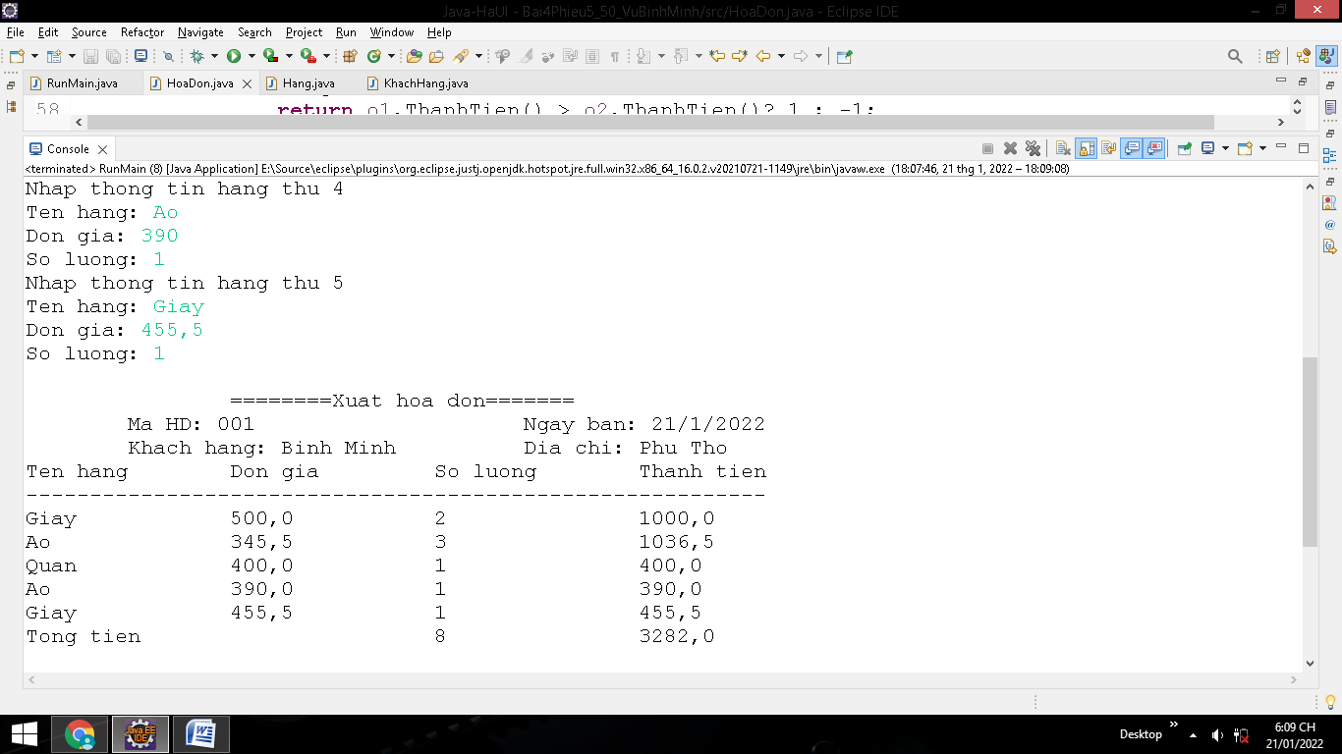

Kết quả xuất hd sau khi sx:

