**NAME : NAVALE VINOD**

**ROLL NO : 1231**

Q1. Using Jquery create a program a. Create a copy of Add button every time you click on the button. (Click event should be applicable to all added button also) b. Background of paragraph should change on mouse hover c. Add new paragraph above the first

tag when click Add para

INDEX.HTML CODE :

<!doctype html>

<html lang="en">

<style>

.para{

background-color: #ffffff;

}

para:hover{

background-color: orange;

}

</style>

<head>

<!-- Required meta tags -->

<meta charset="utf-8">

<meta name="viewport" content="width=device-width, initial-scale=1, shrink-to-fit=no">

<script src="https://ajax.googleapis.com/ajax/libs/jquery/3.5.1/jquery.min.js"></script>

<!-- Bootstrap CSS -->

<link rel="stylesheet" href="https://maxcdn.bootstrapcdn.com/bootstrap/4.0.0/css/bootstrap.min.css"

integrity="sha384-Gn5384xqQ1aoWXA+058RXPxPg6fy4IWvTNh0E263XmFcJlSAwiGgFAW/dAiS6JXm" crossorigin="anonymous">

<title>Hello, world!</title>

</head>

<body>

<div id="root">

</div>

<button class="btn btn-primary para" id="para">Add Para</button>

<button class="btn btn-primary button1" id="button1">Add Button</button>

<script>

$(document).ready(() => {

$(".button1").click(function () {

$("#root").append("<button class=' btn btn-primary button1' onClick='add()' > New Button </botton>")

});

$(".para").click(function () {

$("#root").append('<p class="para"> Para created </p>')

});

function add() {

$("#root").append("<button class='btn btn-primary button1' onClick=`add()`> New Button </botton>")

}

});

</script>

<!-- Optional JavaScript -->

<!-- jQuery first, then Popper.js, then Bootstrap JS -->

<script src="https://code.jquery.com/jquery-3.2.1.slim.min.js"

integrity="sha384-KJ3o2DKtIkvYIK3UENzmM7KCkRr/rE9/Qpg6aAZGJwFDMVNA/GpGFF93hXpG5KkN"

crossorigin="anonymous"></script>

<script src="https://cdnjs.cloudflare.com/ajax/libs/popper.js/1.12.9/umd/popper.min.js"

integrity="sha384-ApNbgh9B+Y1QKtv3Rn7W3mgPxhU9K/ScQsAP7hUibX39j7fakFPskvXusvfa0b4Q"

crossorigin="anonymous"></script>

<script src="https://maxcdn.bootstrapcdn.com/bootstrap/4.0.0/js/bootstrap.min.js"

integrity="sha384-JZR6Spejh4U02d8jOt6vLEHfe/JQGiRRSQQxSfFWpi1MquVdAyjUar5+76PVCmYl"

crossorigin="anonymous"></script>

</body>

</html>

OUTPUT :

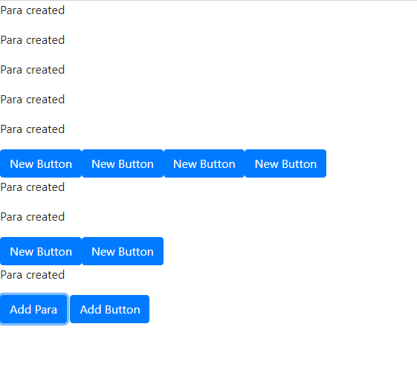  
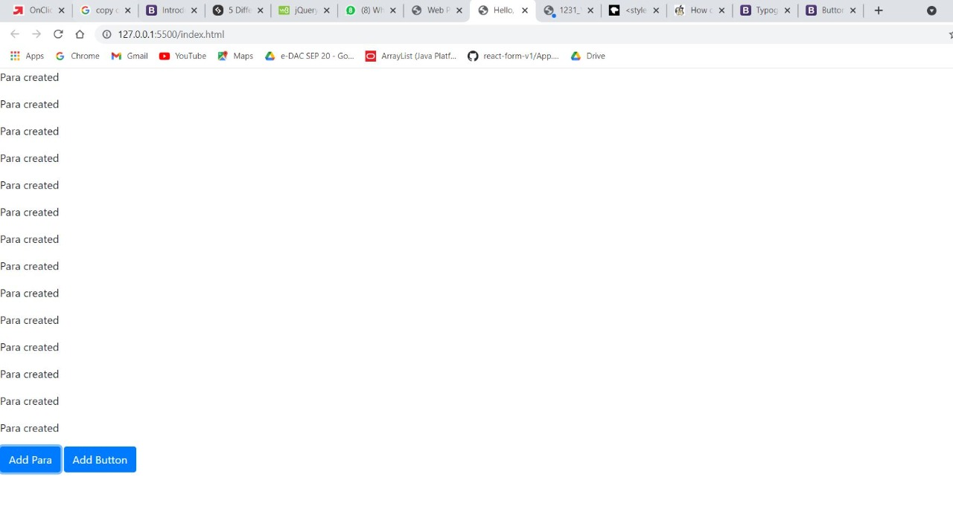

Q.2 Write a program using nodeJs and expressJs to accept two numbers in html form and check whether first number is prime or not if it is prime number display message “The number is prime” otherwise display number is not prime in browser window. (Note: use modules wherever possible)

INDEX.HTML FOR Q.2

<!doctype html>

<html lang="en">

<style>

.para{

background-color: #ffffff;

}

para:hover{

background-color: rgb(47, 0, 255);

}

</style>

<head>

<!-- Required meta tags -->

<meta charset="utf-8">

<meta name="viewport" content="width=device-width, initial-scale=1, shrink-to-fit=no">

<script src="https://ajax.googleapis.com/ajax/libs/jquery/3.5.1/jquery.min.js"></script>

<!-- Bootstrap CSS -->

<link rel="stylesheet" href="https://maxcdn.bootstrapcdn.com/bootstrap/4.0.0/css/bootstrap.min.css"

integrity="sha384-Gn5384xqQ1aoWXA+058RXPxPg6fy4IWvTNh0E263XmFcJlSAwiGgFAW/dAiS6JXm" crossorigin="anonymous">

<title>Hello, world!</title>

</head>

<body>

<div id="root">

</div>

<button class="btn btn-primary para" id="para">Add Para</button>

<button class="btn btn-primary button1" id="button1">Add Button</button>

<script>

$(document).ready(() => {

$(".button1").click(function () {

$("#root").append("<button class=' btn btn-primary button1' onClick='add()' > New Button </botton>")

});

$(".para").click(function () {

$("#root").append('<p class="para"> Para created </p>')

});

function add() {

$("#root").append("<button class='btn btn-primary button1' onClick=`add()`> New Button </botton>")

}

});

</script>

<!-- Optional JavaScript -->

<!-- jQuery first, then Popper.js, then Bootstrap JS -->

<script src="https://code.jquery.com/jquery-3.2.1.slim.min.js"

integrity="sha384-KJ3o2DKtIkvYIK3UENzmM7KCkRr/rE9/Qpg6aAZGJwFDMVNA/GpGFF93hXpG5KkN"

crossorigin="anonymous"></script>

<script src="https://cdnjs.cloudflare.com/ajax/libs/popper.js/1.12.9/umd/popper.min.js"

integrity="sha384-ApNbgh9B+Y1QKtv3Rn7W3mgPxhU9K/ScQsAP7hUibX39j7fakFPskvXusvfa0b4Q"

crossorigin="anonymous"></script>

<script src="https://maxcdn.bootstrapcdn.com/bootstrap/4.0.0/js/bootstrap.min.js"

integrity="sha384-JZR6Spejh4U02d8jOt6vLEHfe/JQGiRRSQQxSfFWpi1MquVdAyjUar5+76PVCmYl"

crossorigin="anonymous"></script>

</body>

</html>

SERVER.JS FILE

var express =require('express');

var path=require('path');

var app=express();

var staticMiddleware=express.static(path.join(__dirname, "public"));

app.use(staticMiddleware);

app.get("/",(request, response)=>{

response.sendFile(__dirname+"/index.html");

});

app.listen(9898);

;

OUTPUT :

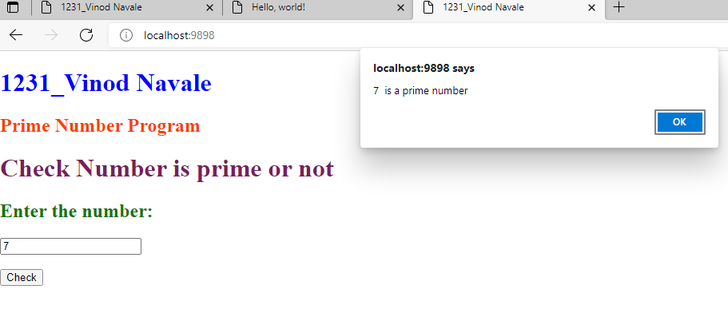

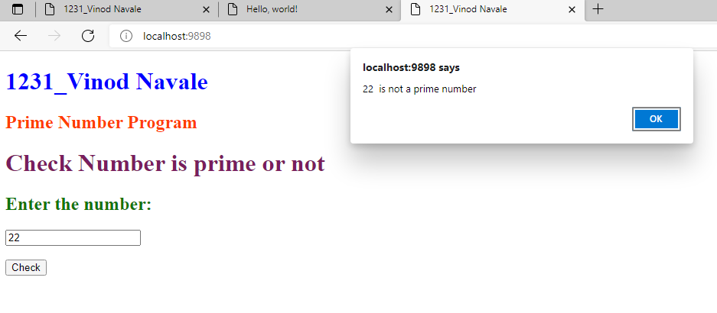

ALGORITHAM AND FLOWCHART

