How To Install MariaDB 10.5 on Ubuntu 20.04

MariaDB is a popular drop-in replacement of MySQL database server with more features, new storage engines, and better performance. You can check a complete list of MariaDB 10.5 features from the official website. The MariaDB database server is published as free and open source software under the General Public License version 2

nstall MariaDB 10.5 on Ubuntu 20.04 LTS
To install MariaDB 10.5 on Ubuntu 20.04, you need to add MariaDB repository on to the system. Then the installation of MariaDB 10.5 on Ubuntu 20.04 will be done from the APT repository added without any issues.

Step 1: Update System
Ensure your system is updated and install software-properties-common package.
sudo apt update && sudo apt upgrade
sudo apt -y install software-properties-common

Step 2: Import MariaDB gpg key:
Run the command below to add Repository Key to the system:
sudo apt-key adv --fetch-keys 'https://mariadb.org/mariadb_release_signing_key.asc'

Step 3: Add MariaDB APT repository
After importation of repository GPG key, add the APT repository by running the following command:
sudo add-apt-repository 'deb [arch=amd64] http://mariadb.mirror.globo.tech/repo/10.5/ubuntu focal main'
Command execution output:
Hit:1 http://security.ubuntu.com/ubuntu focal-security InRelease
Hit:2 http://nova.clouds.archive.ubuntu.com/ubuntu focal InRelease
Get:3 http://mariadb.mirror.globo.tech/repo/10.5/ubuntu focal InRelease [3202 B]
Hit:4 http://nova.clouds.archive.ubuntu.com/ubuntu focal-updates InRelease
Hit:5 http://nova.clouds.archive.ubuntu.com/ubuntu focal-backports InRelease
Get:6 http://mariadb.mirror.globo.tech/repo/10.5/ubuntu focal/main amd64 Packages [7924 B]
Fetched 11.1 kB in 1s (15.6 kB/s)
Reading package lists... Done

Step 4: Install MariaDB Server on 20.04 Linux
The last step is the installation of MariaDB Server:
sudo apt update
sudo apt install mariadb-server mariadb-client
Hit the y key to accept installation of MariaDB 10.5 on Ubuntu 20.04 Linux.
The following additional packages will be installed:
galera-4 libcgi-fast-perl libcgi-pm-perl libdbd-mariadb-perl libdbi-perl libencode-locale-perl libfcgi-perl libhtml-parser-perl libhtml-tagset-perl
libhtml-template-perl libhttp-date-perl libhttp-message-perl libio-html-perl liblwp-mediatypes-perl libmariadb3 libmysqlclient21
libterm-readkey-perl libtimedate-perl liburi-perl mariadb-client-10.5 mariadb-client-core-10.5 mariadb-common mariadb-server-10.5
mariadb-server-core-10.5 mysql-common socat
Suggested packages:
libclone-perl libmldbm-perl libnet-daemon-perl libsql-statement-perl libdata-dump-perl libipc-sharedcache-perl libwww-perl mailx mariadb-test
tinyca
The following NEW packages will be installed:
galera-4 libcgi-fast-perl libcgi-pm-perl libdbd-mariadb-perl libdbi-perl libencode-locale-perl libfcgi-perl libhtml-parser-perl libhtml-tagset-perl
libhtml-template-perl libhttp-date-perl libhttp-message-perl libio-html-perl liblwp-mediatypes-perl libmariadb3 libmysqlclient21
libterm-readkey-perl libtimedate-perl liburi-perl mariadb-client mariadb-client-10.5 mariadb-client-core-10.5 mariadb-common mariadb-server
mariadb-server-10.5 mariadb-server-core-10.5 mysql-common socat
0 upgraded, 28 newly installed, 0 to remove and 0 not upgraded.
Need to get 29.5 MB of archives.
After this operation, 229 MB of additional disk space will be used.
Do you want to continue? [Y/n] y

Step 5: Secure MariaDB Server on 20.04 Linux
You have to manually run the MySQL hardening script.
$ sudo mysql_secure_installation

NOTE: RUNNING ALL PARTS OF THIS SCRIPT IS RECOMMENDED FOR ALL MariaDB
SERVERS IN PRODUCTION USE! PLEASE READ EACH STEP CAREFULLY!

In order to log into MariaDB to secure it, we'll need the current
password for the root user. If you've just installed MariaDB, and
haven't set the root password yet, you should just press enter here.

Enter current password for root (enter for none):
OK, successfully used password, moving on...

Setting the root password or using the unix_socket ensures that nobody
can log into the MariaDB root user without the proper authorisation.

You already have your root account protected, so you can safely answer 'n'.

Switch to unix_socket authentication [Y/n] y
Enabled successfully!
Reloading privilege tables..
... Success!

You already have your root account protected, so you can safely answer 'n'.

Change the root password? [Y/n] y
New password:
Re-enter new password:
Password updated successfully!
Reloading privilege tables..
... Success!

By default, a MariaDB installation has an anonymous user, allowing anyone
to log into MariaDB without having to have a user account created for
them. This is intended only for testing, and to make the installation
go a bit smoother. You should remove them before moving into a
production environment.

Remove anonymous users? [Y/n] y
... Success!

Normally, root should only be allowed to connect from 'localhost'. This
ensures that someone cannot guess at the root password from the network.

Disallow root login remotely? [Y/n] y
... Success!

By default, MariaDB comes with a database named 'test' that anyone can
access. This is also intended only for testing, and should be removed
before moving into a production environment.

Remove test database and access to it? [Y/n] y
- Dropping test database...
... Success!
- Removing privileges on test database...
... Success!

Reloading the privilege tables will ensure that all changes made so far
will take effect immediately.

Reload privilege tables now? [Y/n] y
... Success!

Cleaning up...

All done! If you've completed all of the above steps, your MariaDB
installation should now be secure.

Thanks for using MariaDB!
The database service should be started automatically after installation.
$ systemctl status mysql
● mariadb.service - MariaDB 10.5.2 database server
Loaded: loaded (/lib/systemd/system/mariadb.service; enabled; vendor preset: enabled)
Drop-In: /etc/systemd/system/mariadb.service.d
└─migrated-from-my.cnf-settings.conf
Active: active (running) since Sat 2020-04-25 23:57:39 UTC; 2min 8s ago
Docs: man:mysqld(8)
https://mariadb.com/kb/en/library/systemd/
Main PID: 4309 (mysqld)
Status: "Taking your SQL requests now..."
Tasks: 11 (limit: 2344)
Memory: 82.5M
CGroup: /system.slice/mariadb.service
└─4309 /usr/sbin/mysqld

Apr 25 23:57:44 ubuntu20 /etc/mysql/debian-start[4332]: mysql
Apr 25 23:57:44 ubuntu20 /etc/mysql/debian-start[4332]: performance_schema
Apr 25 23:57:44 ubuntu20 /etc/mysql/debian-start[4332]: Phase 6/7: Checking and upgrading tables
Apr 25 23:57:44 ubuntu20 /etc/mysql/debian-start[4332]: Processing databases
Apr 25 23:57:44 ubuntu20 /etc/mysql/debian-start[4332]: information_schema
Apr 25 23:57:44 ubuntu20 /etc/mysql/debian-start[4332]: performance_schema
Apr 25 23:57:44 ubuntu20 /etc/mysql/debian-start[4332]: Phase 7/7: Running 'FLUSH PRIVILEGES'
Apr 25 23:57:44 ubuntu20 /etc/mysql/debian-start[4332]: OK
Apr 25 23:57:44 ubuntu20 /etc/mysql/debian-start[5138]: Checking for insecure root accounts.
Apr 25 23:57:44 ubuntu20 /etc/mysql/debian-start[5142]: Triggering myisam-recover for all MyISAM tables and aria-recover for all Aria tables
Test login to MariaDB shell using mysql command:
$ mysql -u root -p
Enter password:
Welcome to the MariaDB monitor. Commands end with ; or \g.
Your MariaDB connection id is 56
Server version: 10.5.2-MariaDB-1:10.5.2+maria~focal-log mariadb.org binary distribution

Copyright (c) 2000, 2018, Oracle, MariaDB Corporation Ab and others.

Type 'help;' or '\h' for help. Type '\c' to clear the current input statement.

MariaDB [(none)]>
Check version using the command:
MariaDB [(none)]> SELECT VERSION();
+-----------------------------------------+
| VERSION() |
+-----------------------------------------+
| 10.5.2-MariaDB-1:10.5.2+maria~focal-log |
+-----------------------------------------+
1 row in set (0.000 sec)
MariaDB [(none)]>

Step 5: Install Desktop Database Management Tool
If working with MySQL command line is not your thing, then consider installing a Database Tool to help you. Check out our guide below:

Other Actions

Step 3 – Create a New Database
To create a new database, first log in to MariaDB shell with the following command:
mysql -u root -p
Enter your root password when prompted, then create a database with the following command:
CREATE DATABASE db1;
After creating a new database, you can list all databases with the following command:
SHOW DATABASES;
You should see the following output:
+--------------------+
| Database |
+--------------------+
| db1 |
| information_schema |
| mysql |
| performance_schema |
+--------------------+
4 rows in set (0.002 sec)

Step 4 – Create a New User Account
You can create a new MariaDB user account by running the following command:
CREATE USER 'dbuser'@'localhost' IDENTIFIED BY 'yourpassword';
In this line, the variables are defined as follows:
dbuser: The name of the MariaDB user.
localhost: This option specifies that the user can connect to the MariaDB server only from the localhost.
yourpassword: The password of the MariaDB user.
If you want to change the MariaDB user account password, then run the following command:
ALTER USER 'dbuser'@'localhost' IDENTIFIED BY 'yournewpassword';
To list all MariaDB user accounts, run the following command:
SELECT user, host FROM mysql.user;
You should get the following output:
+------------------+-----------+
| user | host |
+------------------+-----------+
| root | 127.0.0.1 |
| root | ::1 |
| dbuser | localhost |
| debian-sys-maint | localhost |
| root | localhost |
+------------------+-----------+
5 rows in set (0.003 sec)

Step 5 – Grant Privileges to User Account
You can grant multiple types of privileges to the MariaDB user account.
To grant all privileges to a user (dbuser) over a specific database (db1), run the following command:
GRANT ALL PRIVILEGES ON db1.* TO 'dbuser'@'localhost';
To grant all privileges to a user (dbuser) over all databases, run the following command:
GRANT ALL PRIVILEGES ON *.* TO 'dbuser'@'localhost';
To grant only specific privileges to a user (dbuser) over a specific database (db1), run the following command:
GRANT SELECT, INSERT, DELETE ON db1.* TO dbuser@'localhost';
You can see all the privileges granted to a specific user account with the following command:
SHOW GRANTS FOR 'dbuser'@'localhost';
You should see the following output:
+------------------------------------------------------------------------------------------------------------------------+
| Grants for dbuser@localhost |
+------------------------------------------------------------------------------------------------------------------------+
| GRANT ALL PRIVILEGES ON *.* TO 'dbuser'@'localhost' IDENTIFIED BY PASSWORD '*7F99F4477B835ED95816BC01E9823771AE2A3F1C' |
| GRANT ALL PRIVILEGES ON `db1`.* TO 'dbuser'@'localhost' |
+------------------------------------------------------------------------------------------------------------------------+
2 rows in set (0.000 sec)

Step 6 – Deleting Databases and Users
You can delete a database with the following command:
DROP DATABASE db1;
To delete a user account, run the following command:
DROP USER 'dbuser'@'localhost';

Step 7 – Reset MariaDB Root Password
If you have forgotten your MariaDB root password, then you can recover it easily by following the below steps.
First, stop the running MariaDB service with the following command:
systemctl stop mariadb
Next, you will need to start MariaDB service with –skip-grant-tables option. This will allow you to connect to the database server without a password:
You can start MariaDB service without loading the grant tables by running the following command:
mysqld_safe --skip-grant-tables &
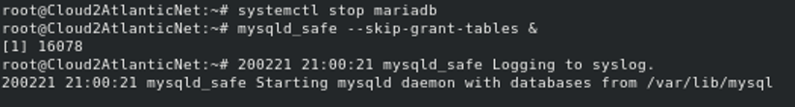
Now, you can connect to the MariaDB server as a root user without a password as shown below:
mysql -u root
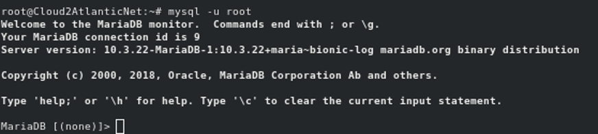
After successful login, run the following command to reset the root password:
ALTER USER 'root'@'localhost' IDENTIFIED BY 'your-new-password';
FLUSH PRIVILEGES;
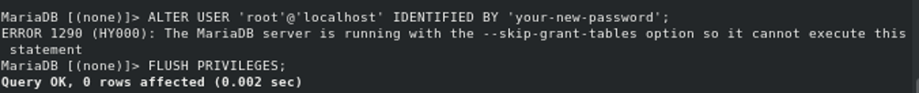
If the above command doesn’t work, run the following command:
UPDATE mysql.user SET authentication_string = PASSWORD('your-new-password')
WHERE User = 'root' AND Host = 'localhost';
FLUSH PRIVILEGES;
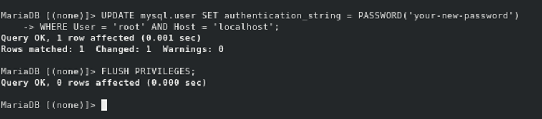
Next, stop the MariaDB service and start it normally with the following commands:
mysqladmin -u root -p shutdown
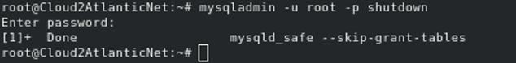
Provide your root password when prompted to stop the MariaDB service.
Next, start the MariaDB service normally with the following command:
systemctl start mariadb

Conclusion
In the above tutorial, we learned how to create and manage databases and user accounts in MariaDB. We also learned how to reset the MariaDB root password. For more information, visit the MariaDB official documentation at MariaDB Doc.

