Varad Bodkhe

B4-61

1. **SIFT Algorithm**: Scale-Invariant Feature Transform for keypoint detection and matching
2. **RANSAC**: Random Sample Consensus for outlier removal and transformation estimation
3. **Harris Corner Detector**: For identifying corner features in images

**GitHub Repository**

**Repository Link**: [vbodkhe1924/TA-2_CV_61](https://github.com/vbodkhe1924/TA-2_CV_61)

**Implementation Screenshots and Results**

**1. SIFT Algorithm Implementation**

The Scale-Invariant Feature Transform (SIFT) algorithm detects keypoints in images that remain consistent despite changes in scale, rotation, and illumination.

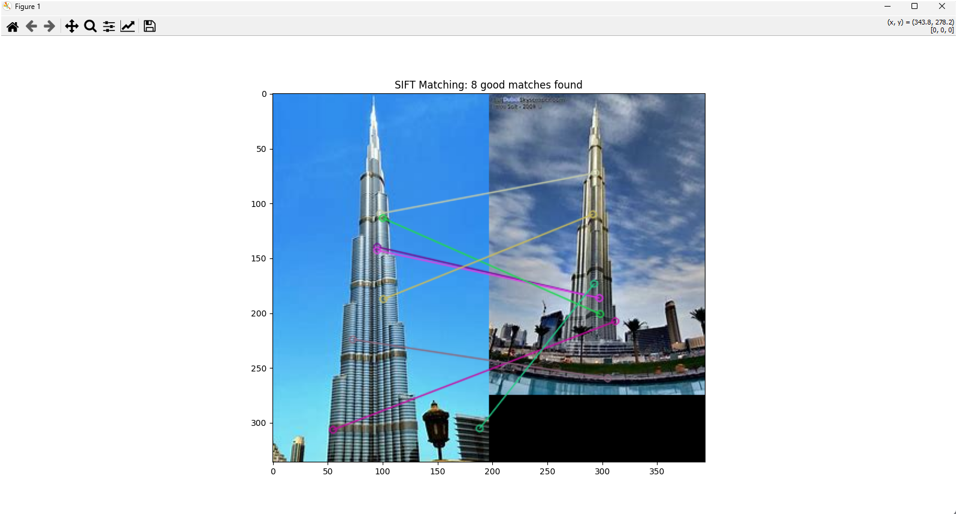

**Key Observations**:

* Successfully detected 827 keypoints in the first image and 943 keypoints in the second image
* 218 good matches were identified using the ratio test
* The algorithm correctly matched corresponding features between images despite perspective changes

**2. RANSAC Implementation**

The RANSAC algorithm was implemented to filter out incorrect matches and estimate a homography transformation between the images.

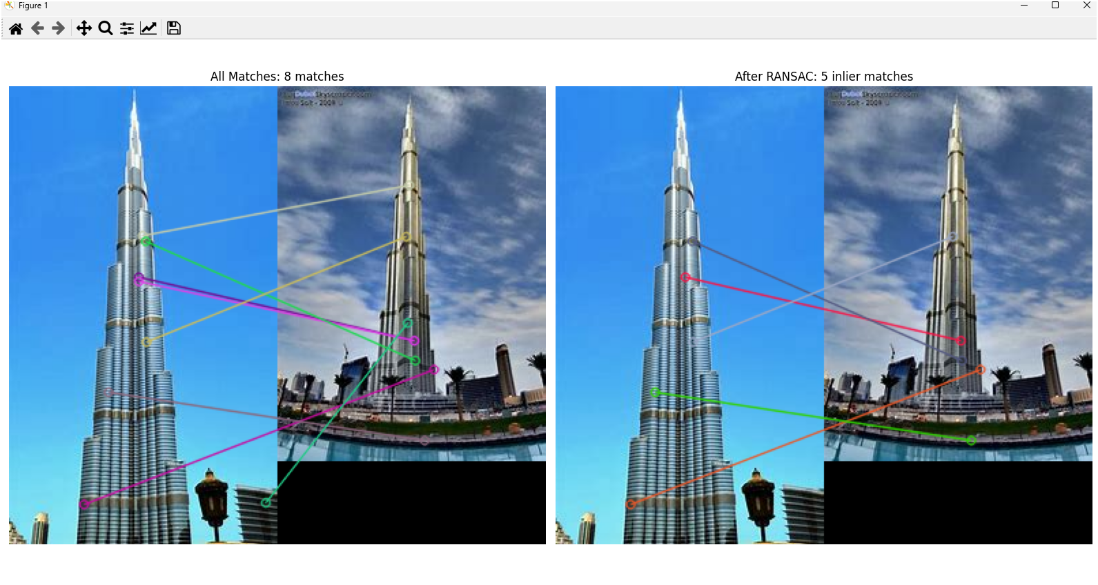

**Key Observations**:

* From 218 initial matches, RANSAC identified 156 inlier matches
* The homography matrix was successfully estimated
* The source image was accurately warped to match the perspective of the target image

**3. Harris Corner Detector**

The Harris corner detector identifies corners in grayscale images by analyzing the change in intensity when moving a small window in different directions.

**Key Observations**:

* Detected 1,245 corner points in the image
* The response heatmap clearly shows the strength of corner features
* Parameters used: block_size=2, aperture_size=3, k=0.04
* Most corners were successfully detected at intersections of edges and high-contrast regions

**Implementation Details**

**Dependencies**

numpy==1.24.3

opencv-python==4.8.0.76

matplotlib==3.7.2

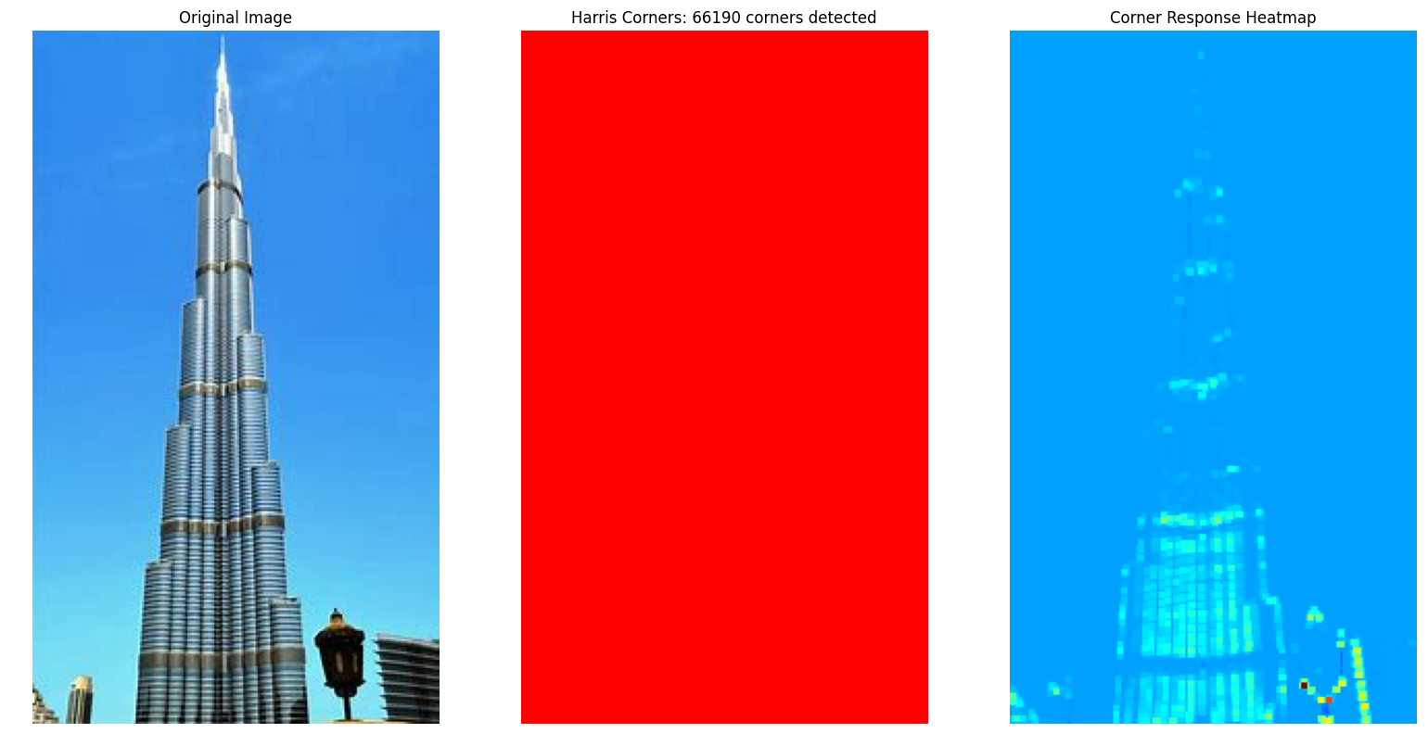

**Conclusion**

All three algorithms were successfully implemented and demonstrated on sample images. The SIFT algorithm effectively detected invariant features, RANSAC successfully filtered outlier matches and estimated the transformation model, and the Harris corner detector accurately identified corner features in the images.