Product Warehouse Management System
Project Main Requirements
1. User Sign On Sub-system
1.1 User Sign On Database model
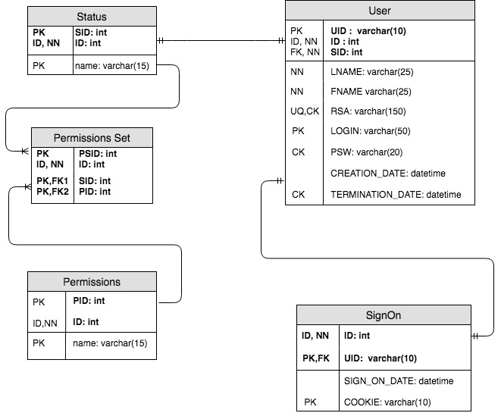

1.2 User Sign On GUI

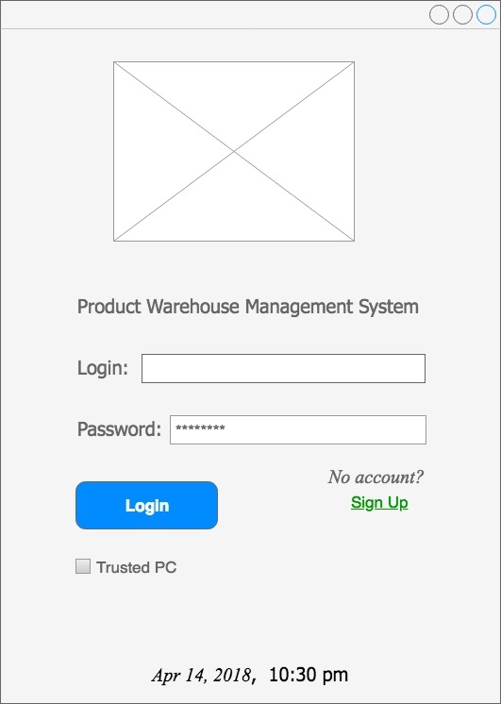

1.3 Sign Up GUI
