N741 Spring 2018 - Homework 6

Homework 6 - DUE FRIDAY April 6, 2018

Tori Bonisese

April 6, 2018

# Git Repo

<https://github.com/vbonise/HW6.git>

## Homework 6

### Background and Information on HELP Dataset

For homework 6, you will be working with the **HELP** (Health Evaluation and Linkage to Primary Care) Dataset.

The HELP Dataset:

* You can learn more about the HELP (Health Evaluation and Linkage to Primary Care) dataset at <https://nhorton.people.amherst.edu/sasr2/datasets.php>. This dataset is also used by Ken Kleinman and Nicholas J. Horton for their book “SAS and R: Data Management, Statistical Analysis, and Graphics” (which is another helpful textbook).
* You can download the datasets from their website <https://nhorton.people.amherst.edu/sasr2/datasets.php>
* The original publication is referenced at <https://www.ncbi.nlm.nih.gov/pubmed/12653820?ordinalpos=17&itool=EntrezSystem2.PEntrez.Pubmed.Pubmed_ResultsPanel.Pubmed_DefaultReportPanel.Pubmed_RVDocSum>
* The HELP documentation (including all forms/surveys/instruments used) are located at:
  + <https://nhorton.people.amherst.edu/help/>
  + specifically the details on all BASELINE assessments are located in this PDF <https://nhorton.people.amherst.edu/help/HELP-baseline.pdf>
  + with the follow up time points described in the PDF <https://nhorton.people.amherst.edu/help/HELP-followup.pdf>

### Summary of Entire HELP Dataset - Complete Codebook

See complete data descriptions and codebook at <https://melindahiggins2000.github.io/N736Fall2017_HELPdataset/>

### Variables for Homework 6

###load dataset:   
load("/Users/victoriabonisese/Downloads/help.Rdata")

For Homework 6, you will focus only on these variables from the HELP dataset:

Use these variables from HELP dataset for Homework 06

|  |  |
| --- | --- |
|  | Variable Label |
| age | Age at baseline (in years) |
| female | Gender of respondent |
| pss_fr | Perceived Social Support - friends |
| homeless | One or more nights on the street or shelter in past 6 months |
| pcs | SF36 Physical Composite Score - Baseline |
| mcs | SF36 Mental Composite Score - Baseline |
| cesd | CESD total score - Baseline |

## Homework 6 Assignment

**SETUP** Download and run the “loadHELP.R” R script (included in this Github repo <https://github.com/melindahiggins2000/N741Spring2018_Homework6>) to read in the HELP Dataset “helpmkh.sav”. This script also pulls out the variables you need and creates the dichotomous variable for depression cesd_gte16 which you will need for the logistic regression.

After running this R script, you will have a data frame called h1 you can use to do the rest of your analyses. You can also copy this code into your first R markdown code chunk to get you started on Homework 6.

###run script  
# use this script to setup the data subset from  
# HELP to use for N741 Spring 2018 Homework 6  
  
# load libraries and dataset  
  
library(tidyverse)  
library(haven)  
helpdata <- haven::read_spss("helpmkh.sav")  
  
# choose variables for Homework 6  
  
h1 <- helpdata %>%  
 select(age, female, pss_fr, homeless,   
 pcs, mcs, cesd)  
  
# add dichotomous variable  
# to indicate depression for  
# people with CESD scores >= 16  
  
h1 <- h1 %>%  
 mutate(cesd_gte16 = cesd >= 16)  
  
# change cesd_gte16 LOGIC variable type  
# to numeric coded 1=TRUE and 0=FALSE  
  
h1$cesd_gte16 <- as.numeric(h1$cesd_gte16)  
  
# check final data subset h1  
summary(h1)

## age female pss_fr homeless   
## Min. :19.00 Min. :0.0000 Min. : 0.000 Min. :0.0000   
## 1st Qu.:30.00 1st Qu.:0.0000 1st Qu.: 3.000 1st Qu.:0.0000   
## Median :35.00 Median :0.0000 Median : 7.000 Median :0.0000   
## Mean :35.65 Mean :0.2362 Mean : 6.706 Mean :0.4614   
## 3rd Qu.:40.00 3rd Qu.:0.0000 3rd Qu.:10.000 3rd Qu.:1.0000   
## Max. :60.00 Max. :1.0000 Max. :14.000 Max. :1.0000   
## pcs mcs cesd cesd_gte16   
## Min. :14.07 Min. : 6.763 Min. : 1.00 Min. :0.0000   
## 1st Qu.:40.38 1st Qu.:21.676 1st Qu.:25.00 1st Qu.:1.0000   
## Median :48.88 Median :28.602 Median :34.00 Median :1.0000   
## Mean :48.05 Mean :31.677 Mean :32.85 Mean :0.8985   
## 3rd Qu.:56.95 3rd Qu.:40.941 3rd Qu.:41.00 3rd Qu.:1.0000   
## Max. :74.81 Max. :62.175 Max. :60.00 Max. :1.0000

For Homework 6, you will be looking at depression in these subjects. First, you will be running a model to look at the continuous depression measure - the CESD [Center for Epidemiologic Studies Depression Scale](http://cesd-r.com/) which is a measure of depressive symptoms. Also see the APA details on the CESD at <http://www.apa.org/pi/about/publications/caregivers/practice-settings/assessment/tools/depression-scale.aspx>. The CESD can be used to predict actual clinical depression but it is not technically a diagnosis of depression. The CESD scores range from 0 (no depressive symptoms) to 60 (most severe depressive symptoms). You will use the (cesd) variable to run a linear regression.

The recommended threshold use to indicate potential clinical depression is for people with scores of 16 or greater. You will then use the variable created using this cutoff (cesd_gte16) to perform a similar modeling approach with the variables to predict the probability of clinical depression (using logistic regression).

## Homework 6 Tasks

1. [Model 1] Run a simple linear regression (lm()) for cesd using the mcs variable, which is the mental component quality of life score from the SF36.

model1 <- lm(cesd ~ mcs, data = h1)  
summary(model1)

##   
## Call:  
## lm(formula = cesd ~ mcs, data = h1)  
##   
## Residuals:  
## Min 1Q Median 3Q Max   
## -27.3593 -6.7277 -0.0024 6.2374 24.4239   
##   
## Coefficients:  
## Estimate Std. Error t value Pr(>|t|)   
## (Intercept) 53.90219 1.14723 46.98 <2e-16 ***  
## mcs -0.66467 0.03357 -19.80 <2e-16 ***  
## ---  
## Signif. codes: 0 '***' 0.001 '**' 0.01 '*' 0.05 '.' 0.1 ' ' 1  
##   
## Residual standard error: 9.164 on 451 degrees of freedom  
## Multiple R-squared: 0.465, Adjusted R-squared: 0.4638   
## F-statistic: 392 on 1 and 451 DF, p-value: < 2.2e-16

1. Write the equation of the final fitted model (i.e. what is the intercept and the slope)? Write a sentence describing the model results (interpret the intercept and slope). *NOTE: The mcs values range form 0 to 100 where the population norm for “normal mental health quality of life” is considered to be a 50. If you score higher than 50 on the mcs you have mental health better than the population and visa versa - if your mcs scores are less than 50 then your mental health is considered to be worse than the population norm.*

### Answer

*Model 1* y = 53.90 + -.66x For every one point increase on the MCS, the CESD score decreases by .66.

1. How much variability in the cesd does the mcs explain? (what is the R2?) Write a sentence describing how well the mcs does in predicting the cesd. **The R-squared is about .46 which means that 46% of the variation in CESD is explained by MCS**
2. [Model 2] Run a second linear regression model (lm()) for the cesd putting in all of the other variables:
   * age
   * female
   * pss_fr
   * homeless
   * pcs
   * mcs

model2 <- lm(cesd ~ mcs + age + female + pss_fr + homeless + pcs + mcs, data = h1)  
summary(model2) ##this prints out the results with the test & fit coefficients

##   
## Call:  
## lm(formula = cesd ~ mcs + age + female + pss_fr + homeless +   
## pcs + mcs, data = h1)  
##   
## Residuals:  
## Min 1Q Median 3Q Max   
## -25.1711 -5.9894 -0.2077 5.5706 27.3137   
##   
## Coefficients:  
## Estimate Std. Error t value Pr(>|t|)   
## (Intercept) 65.30046 3.18670 20.492 < 2e-16 ***  
## mcs -0.62093 0.03261 -19.042 < 2e-16 ***  
## age -0.01348 0.05501 -0.245 0.8065   
## female 2.35028 0.98810 2.379 0.0178 *   
## pss_fr -0.25569 0.10567 -2.420 0.0159 *   
## homeless 0.46545 0.84261 0.552 0.5810   
## pcs -0.23639 0.03987 -5.929 6.1e-09 ***  
## ---  
## Signif. codes: 0 '***' 0.001 '**' 0.01 '*' 0.05 '.' 0.1 ' ' 1  
##   
## Residual standard error: 8.683 on 446 degrees of freedom  
## Multiple R-squared: 0.5249, Adjusted R-squared: 0.5185   
## F-statistic: 82.14 on 6 and 446 DF, p-value: < 2.2e-16

+ Print out the model results with the coefficients and tests and model fit statistics.

1. Which variables are significant in the model? Write a sentence or two describing the impact of these variables for predicting depression scores (HINT: interpret the coefficient terms).

**MCS and PCS are significant at the 0.001 level and female and pss_fr are significant at the 0.1 level. This means that for every unit incease of MCS, CESD decreases by 0.63, for every unit increase of age, CESD decreases by 0.013, females are associated with a CESD 2.35 points higher than makes and for every unit increase of PSS_FR, CESD decreases by 0.26.**

1. Following the example we did in class for the Prestige dataset <https://cdn.rawgit.com/vhertzb/2018week9/2f2ea142/2018week9.html?raw=true>, generate the diagnostic plots for this model with these 6 predictors (e.g. get the residual plot by variables, the added-variable plots, the Q-Q plot, diagnostic plots). Also run the VIFs to check for multicollinearity issues.

library(car)

##   
## Attaching package: 'car'

## The following object is masked from 'package:dplyr':  
##   
## recode

## The following object is masked from 'package:purrr':  
##   
## some

#residual plots  
residualPlots(model2)

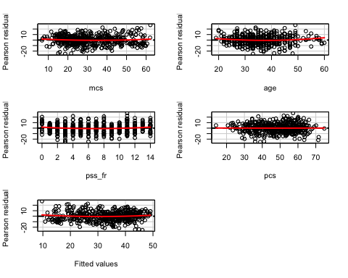

## Test stat Pr(>|t|)  
## mcs 1.260 0.208  
## age 1.941 0.053  
## pss_fr 1.964 0.050  
## pcs 0.081 0.936  
## Tukey test 1.434 0.152

##qqPlot  
qqPlot(model2)

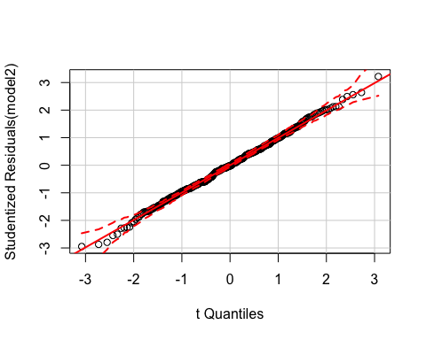

##added variable plots  
avPlots(model2, id.n=2, id.cex=.08)

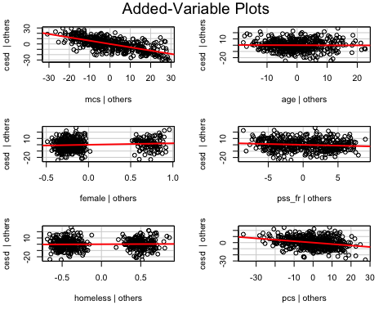

#Diagnotic Plots  
##identify highly influential points  
influencePlot(model2, id.n=2)

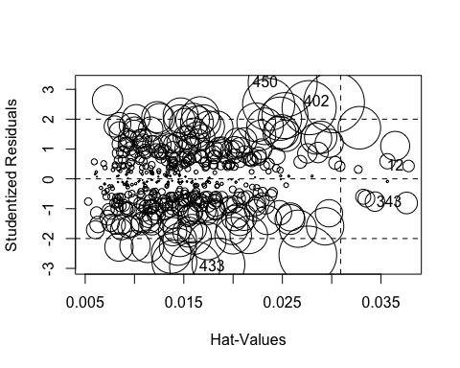

## StudRes Hat CookD  
## 12 0.4313265 0.03779399 0.001045833  
## 343 -0.8084322 0.03760068 0.003650624  
## 402 2.5591353 0.03023968 0.028815823  
## 433 -2.9474775 0.01612078 0.019990575  
## 450 3.2188680 0.02502996 0.037218269

influenceIndexPlot(model2, id.n=2)

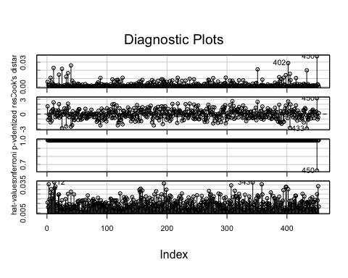

##heteroskedasticity  
ncvTest(model2)

## Non-constant Variance Score Test   
## Variance formula: ~ fitted.values   
## Chisquare = 4.857132 Df = 1 p = 0.02753206

##multicollinearity  
vif(model2)

## mcs age female pss_fr homeless pcs   
## 1.050768 1.078264 1.058232 1.068213 1.060007 1.108172

1. [Model 3] Repeat Model 1 above, except this time run a logistic regression (glm()) to predict CESD scores => 16 (using the cesd_gte16 as the outcome) as a function of mcs scores. Show a summary of the final fitted model and explain the coefficients. [**REMEMBER** to compute the Odds Ratios after you get the raw coefficient (betas)].

model3 <- glm(cesd_gte16 ~mcs, data = h1, family=binomial)  
summary(model3)

##   
## Call:  
## glm(formula = cesd_gte16 ~ mcs, family = binomial, data = h1)  
##   
## Deviance Residuals:   
## Min 1Q Median 3Q Max   
## -3.04167 0.06727 0.13027 0.29676 1.79914   
##   
## Coefficients:  
## Estimate Std. Error z value Pr(>|z|)   
## (Intercept) 9.2691 1.0621 8.727 < 2e-16 ***  
## mcs -0.1716 0.0219 -7.835 4.68e-15 ***  
## ---  
## Signif. codes: 0 '***' 0.001 '**' 0.01 '*' 0.05 '.' 0.1 ' ' 1  
##   
## (Dispersion parameter for binomial family taken to be 1)  
##   
## Null deviance: 297.59 on 452 degrees of freedom  
## Residual deviance: 174.73 on 451 degrees of freedom  
## AIC: 178.73  
##   
## Number of Fisher Scoring iterations: 7

exp(coef((model3)))

## (Intercept) mcs   
## 1.060544e+04 8.423518e-01

**For every one point increase in MCS, people are 16% less likely to be depressed.**

1. Use the predict() function like we did in class to predict CESD => 16 and compare it back to the original data. For now, use a cutoff probability of 0.5 - if the probability is > 0.5 consider this to be true and false otherwise. Like we did in class. **REMEMBER** See the R code for the class example at <https://github.com/melindahiggins2000/N741_lecture11_27March2018/blob/master/lesson11_logreg_Rcode.R>
   * How well did the model correctly predict CESD scores => 16 (indicating depression)? (make the “confusion matrix” and look at the true positives and true negatives versus the false positives and false negatives).

m3.predict <- predict(model3, newdata=h1, type = "response") ##why wont this work?  
summary(m3.predict)

## Min. 1st Qu. Median Mean 3rd Qu. Max.   
## 0.1982 0.9042 0.9874 0.8985 0.9961 0.9997

##confusion matrix  
table(h1$cesd_gte16, m3.predict >.5)

##   
## FALSE TRUE  
## 0 22 24  
## 1 12 395

**The model did a good job, only incorrectly predicted 36 people out of 453 total; 12 people were depressed but were not predicted to be depressed and 24 weren’t depressed but were predicted to be depressed.**

1. Make an ROC curve plot and compute the AUC and explain if this is a good model for predicting depression or not

library(ROCR)

## Loading required package: gplots

##   
## Attaching package: 'gplots'

## The following object is masked from 'package:stats':  
##   
## lowess

p <- predict(model3, newdata=h1, type="response")  
pr <- prediction(p, as.numeric(h1$cesd_gte16))  
prf <- performance(pr, measure = "tpr", x.measure = "fpr")  
plot(prf)  
abline(a=0, b=1, col = "red")

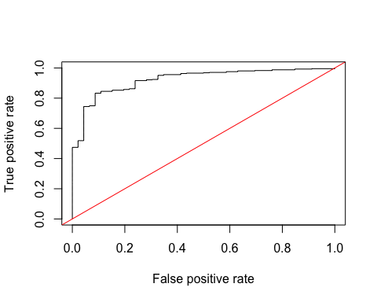

##area under the curve  
auc <- performance(pr, measure = "auc")  
auc <- auc@y.values[[1]]  
auc

## [1] 0.9221771

**This is a good model for prediciting because an auc of .5 is a 50/50 prediction (think coin toss) where as an auc of .9 is much stronger.**

1. Make a plot showing the probability curve - put the mcs values on the X-axis and the probability of depression on the Y-axis. Based on this plot, do you think the mcs is a good predictor of depression? [**FYI** This plot is also called an “effect plot” is you’re using Rcmdr to do these analyses.]

plot(h1$mcs, m3.predict)

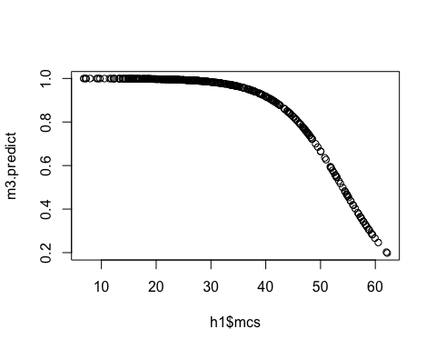

## MCS is a fairly good predictor of depression as higher scores on the MCS indicate lower liklihood of depression, and this is exhibited in the model/plot

**Use R markdown to complete your homework and show all of your code and output in your final report - Turn in a PDF of your report to Canvas. Include a link to your Github repo for Homework 6**