**WooCommerce <> VBOUT Integration Instructions**

Integrate your WooCommerce store with VBOUT and launch your ecommerce marketing automation in few clicks. You can create abandoned cart campaigns, post purchase follow-ups, product recommendations and more.

This WooCommerce-VBOUT plugin creates buyer profiles on your VBOUT account and syncs behavior from abandoned cart activity, product search, categories and products visits as well as completed purchase details. VBOUT will make available all these data at the micro level, so you can create abandoned cart follow-ups, lifetime value campaigns and even generate ecommerce reporting for your WooCommerce store.

Below are step by step instructions on using this plugin: 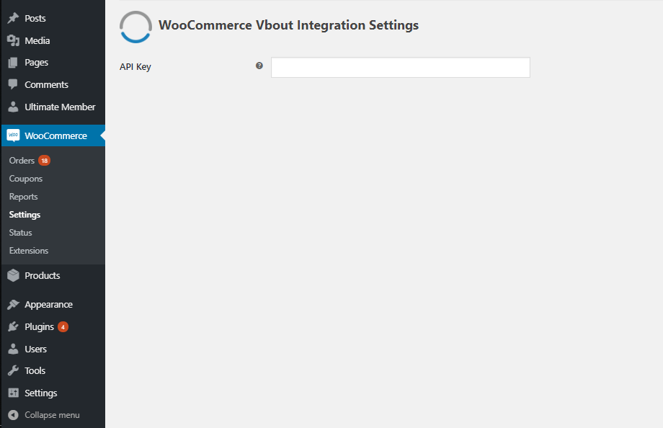

1. Download the Woo-commerce VBOUT plugin.
2. Install the plugin to your Wordpress admin panel. For instructions on installing plugin please visit this page: <https://codex.wordpress.org/Managing_Plugins>.
3. Once the plugin is active, visit your Woocommerce🡪Settings page.
4. Go to the integrations tab and fill out the plugin details. You can get access to your API key from the VBOUT API page: [https://app.VBOUT.com/settings/index](https://app.vbout.com/settings/index).
5. Any customers added will sync in you E-Commerce List in VBOUT.
6. If you wish to synchronize old records, prior to installing the plugin, choose the option “Existing Customers and Existing Products”.
7. Once you click SAVE, the screen will refresh and will prompt you to map your WooCommerce integration settings on VBOUT in the following page : [https://app.VBOUT.com/Settings/Integrations](https://app.vbout.com/Settings/Integrations)

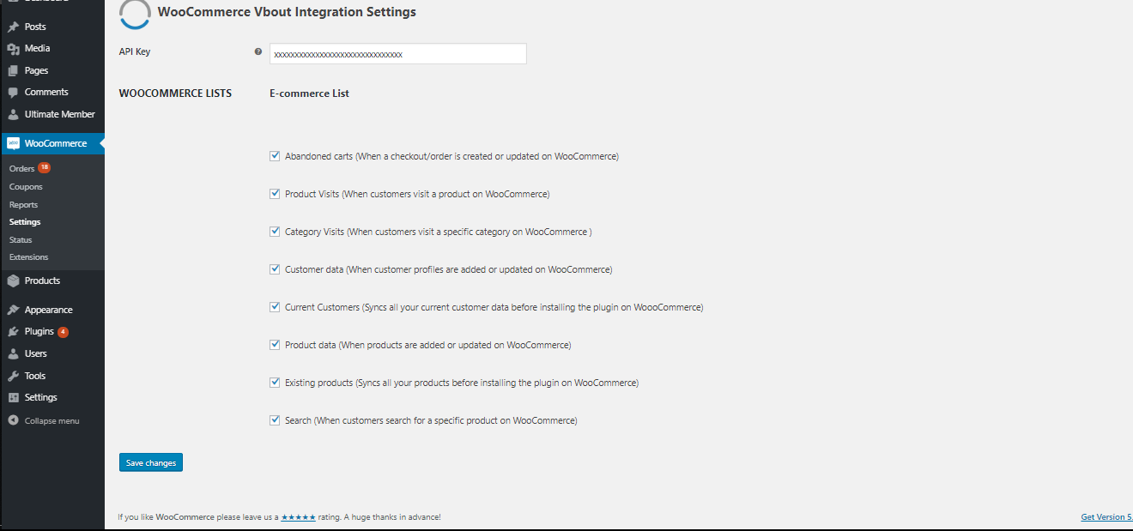

1. Click SAVE and enjoy!

Note that upon saving, synchronizing old records might take some time. If you have a large database on your WooCommerce account you might hit API connection limit. Contact [hello@VBOUT.com](mailto:hello@vbout.com) to assist with increasing this limit or try importing them manually into your VBOUT account by exporting from Wordpress into a designated VBOUT list.

**If you don’t have a VBOUT account yet,** [**signup now!**](https://www.vbout.com/pricing?ref=woocommerce-plugin)