Descriptives

Table of contents

# 1. Tables

## 1.1 Number of posts by university and category

| University | Number of Posts by Category | | | | | Total Number of Posts |
| --- | --- | --- | --- | --- | --- | --- |
| *Community Support* | *Updates and Instructions* | *Academic Adjustments* | *Supporting Our Troops and Hostages* | *Marketing of Academic Programs* |
| Ariel University | 17 | 10 | 2 | 54 | 30 | 113 |
| Bar-Ilan University | 24 | 6 | 2 | 42 | 54 | 128 |
| Ben-Gurion University | 32 | 4 | 2 | 28 | 18 | 84 |
| Reichman University | 40 | 2 | 0 | 43 | 41 | 126 |
| Technion | 33 | 6 | 3 | 38 | 31 | 111 |
| Tel Aviv University | 22 | 4 | 6 | 31 | 40 | 103 |
| The Hebrew University | 26 | 11 | 3 | 31 | 16 | 87 |
| The Open University | 22 | 10 | 4 | 23 | 15 | 74 |
| University of Haifa | 39 | 3 | 4 | 46 | 15 | 107 |
| Weizmann Institute of Science | 17 | 1 | 1 | 10 | 48 | 77 |

## 1.2 Number of posts by category and week

(To create this table, all dates except for Fridays were transformed into the date of the next Friday. Therefore, the displayed counts correspond to the number of posts published from the previous Saturday (inclusive) until the Friday that corresponds to the date in the “7 days ending on” column. This was chosen so that the first “week” corresponds to the 7 days immediately after Oct 7, inclusive. As the last day of data is Feb 7, 2024, there is not data for Feb 8 and 9, so the last “week” contains only 5 days of data.)

| 7 days ending on | Number of Posts per Category | | | | |
| --- | --- | --- | --- | --- | --- |
| *Community Support* | *Updates and Instructions* | *Academic Adjustments* | *Supporting Our Troops and Hostages* | *Marketing of Academic Programs* |
| 2023-10-13 | 17 | 9 | 1 | 30 | 0 |
| 2023-10-20 | 37 | 3 | 0 | 21 | 0 |
| 2023-10-27 | 23 | 5 | 2 | 20 | 2 |
| 2023-11-03 | 30 | 2 | 0 | 19 | 1 |
| 2023-11-10 | 26 | 7 | 0 | 23 | 4 |
| 2023-11-17 | 23 | 3 | 4 | 24 | 7 |
| 2023-11-24 | 17 | 2 | 0 | 19 | 16 |
| 2023-12-01 | 15 | 1 | 1 | 19 | 21 |
| 2023-12-08 | 23 | 5 | 0 | 18 | 13 |
| 2023-12-15 | 15 | 5 | 4 | 15 | 16 |
| 2023-12-22 | 9 | 3 | 5 | 13 | 21 |
| 2023-12-29 | 12 | 0 | 2 | 26 | 15 |
| 2024-01-05 | 8 | 0 | 5 | 20 | 34 |
| 2024-01-12 | 4 | 8 | 1 | 19 | 23 |
| 2024-01-19 | 5 | 3 | 0 | 25 | 30 |
| 2024-01-26 | 5 | 0 | 2 | 14 | 30 |
| 2024-02-02 | 2 | 0 | 0 | 12 | 38 |
| 2024-02-09 | 1 | 1 | 0 | 9 | 37 |

## 1.3 All posts, by university

| University | Interactions | | Pos Sentiment | | Neg Sentiment | | *N* | Max Number of Followers |
| --- | --- | --- | --- | --- | --- | --- | --- | --- |
| *Mean* | *SD* | *Mean* | *SD* | *Mean* | *SD* |
| Tel Aviv University | 248.92 | 868.73 | 132.78 | 198.74 | 60.75 | 355.04 | 103 | 109,585.00 |
| Ben-Gurion University | 335.55 | 769.72 | 242.86 | 517.27 | 28.54 | 176.79 | 84 | 62,709.00 |
| Ariel University | 169.87 | 230.75 | 88.00 | 130.22 | 68.70 | 123.20 | 113 | 43,928.00 |
| University of Haifa | 582.79 | 1,201.01 | 380.12 | 828.13 | 67.28 | 229.93 | 107 | 80,452.00 |
| Technion | 512.50 | 580.17 | 396.41 | 400.28 | 64.81 | 273.23 | 111 | 104,777.00 |
| Reichman University | 141.71 | 263.16 | 94.22 | 139.13 | 30.65 | 117.70 | 126 | 51,381.00 |
| Bar-Ilan University | 131.36 | 203.31 | 73.46 | 94.84 | 47.23 | 129.08 | 128 | 62,166.00 |
| The Hebrew University | 296.97 | 700.46 | 204.63 | 534.87 | 40.17 | 150.56 | 87 | 75,917.00 |
| The Open University | 135.11 | 314.07 | 94.07 | 232.83 | 16.28 | 94.52 | 74 | 85,324.00 |
| Weizmann Institute of Science | 182.08 | 506.57 | 144.09 | 422.64 | 11.13 | 57.99 | 77 | 35,555.00 |

## 1.4 All posts, by category

| Category | Interactions | | Pos Sentiment | | Neg Sentiment | | *N* |
| --- | --- | --- | --- | --- | --- | --- | --- |
| *Mean* | *SD* | *Mean* | *SD* | *Mean* | *SD* |
| Marketing of Academic Programs | 124.71 | 225.28 | 105.18 | 192.78 | 1.69 | 13.45 | 308 |
| Community Support | 263.35 | 599.46 | 204.82 | 487.87 | 8.39 | 61.06 | 272 |
| Supporting Our Troops and Hostages | 453.45 | 922.39 | 258.72 | 525.27 | 125.34 | 312.33 | 346 |
| Updates and Instructions | 116.12 | 196.86 | 96.33 | 171.70 | 1.35 | 7.07 | 57 |
| Academic Adjustments | 119.74 | 209.25 | 100.59 | 183.93 | 1.04 | 1.99 | 27 |

## 1.5 One table per category, by university

| *Descriptives for Community Support posts, by University* | | | | | | | | | |
| --- | --- | --- | --- | --- | --- | --- | --- | --- | --- |
| University | Interactions | | Page Followers | | Pos Sentiment | | Neg Sentiment | | *N* |
| *Mean* | *SD* | *Mean* | *SD* | *Mean* | *SD* | *Mean* | *SD* |
| Ben-Gurion University | 238.09 | 217.36 | 62,509.41 | 110.40 | 195.94 | 186.56 | 2.72 | 10.45 | 32 |
| The Hebrew University | 265.58 | 630.89 | 75,774.54 | 119.60 | 216.88 | 541.34 | 1.62 | 3.74 | 26 |
| Tel Aviv University | 106.32 | 119.83 | 109,262.50 | 120.47 | 87.73 | 92.23 | 0.95 | 1.89 | 22 |
| Ariel University | 117.06 | 254.44 | 43,853.00 | 45.30 | 102.12 | 223.18 | 0.00 | 0.00 | 17 |
| Reichman University | 73.85 | 120.08 | 51,171.85 | 139.60 | 62.22 | 101.44 | 0.67 | 2.72 | 40 |
| Bar-Ilan University | 46.75 | 54.17 | 61,876.46 | 113.00 | 37.88 | 47.70 | 0.29 | 0.91 | 24 |
| The Open University | 155.95 | 288.64 | 85,220.05 | 90.65 | 115.59 | 220.00 | 7.00 | 13.91 | 22 |
| University of Haifa | 699.62 | 1,156.98 | 80,173.38 | 261.37 | 476.59 | 943.81 | 46.87 | 156.34 | 39 |
| Technion | 341.97 | 257.18 | 104,732.76 | 16.26 | 301.79 | 224.99 | 0.52 | 1.72 | 33 |
| Weizmann Institute of Science | 394.24 | 1,049.02 | 35,491.71 | 23.57 | 332.24 | 886.34 | 5.88 | 17.42 | 17 |

| *Descriptives for Updates and Instructions posts, by University* | | | | | | | | | |
| --- | --- | --- | --- | --- | --- | --- | --- | --- | --- |
| University | Interactions | | Page Followers | | Pos Sentiment | | Neg Sentiment | | *N* |
| *Mean* | *SD* | *Mean* | *SD* | *Mean* | *SD* | *Mean* | *SD* |
| Technion | 448.83 | 382.45 | 104,743.50 | 25.00 | 369.33 | 344.45 | 8.83 | 21.15 | 6 |
| University of Haifa | 173.33 | 242.21 | 80,177.00 | 153.01 | 144.33 | 204.14 | 0.67 | 0.58 | 3 |
| Tel Aviv University | 108.25 | 99.72 | 109,438.00 | 73.06 | 96.75 | 95.79 | 0.25 | 0.50 | 4 |
| The Hebrew University | 141.55 | 157.71 | 75,799.91 | 93.45 | 118.64 | 152.28 | 1.36 | 3.88 | 11 |
| Ariel University | 23.20 | 23.55 | 43,866.60 | 39.09 | 18.40 | 17.63 | 0.50 | 1.58 | 10 |
| Bar-Ilan University | 20.83 | 20.45 | 61,930.50 | 69.83 | 17.00 | 16.99 | 0.00 | 0.00 | 6 |
| Ben-Gurion University | 126.75 | 200.79 | 62,473.25 | 81.94 | 105.00 | 169.83 | 0.00 | 0.00 | 4 |
| The Open University | 48.50 | 46.04 | 85,243.90 | 87.98 | 38.30 | 39.27 | 0.10 | 0.32 | 10 |
| Reichman University | 24.00 | 33.94 | 51,142.50 | 185.97 | 21.50 | 30.41 | 0.00 | 0.00 | 2 |
| Weizmann Institute of Science | 19.00 |  | 35,489.00 |  | 18.00 |  | 0.00 |  | 1 |

| *Descriptives for Academic Adjustments posts, by University* | | | | | | | | | |
| --- | --- | --- | --- | --- | --- | --- | --- | --- | --- |
| University | Interactions | | Page Followers | | Pos Sentiment | | Neg Sentiment | | *N* |
| *Mean* | *SD* | *Mean* | *SD* | *Mean* | *SD* | *Mean* | *SD* |
| The Open University | 75.50 | 49.21 | 85,248.25 | 55.54 | 64.25 | 41.64 | 2.25 | 4.50 | 4 |
| The Hebrew University | 138.00 | 122.23 | 75,718.00 | 119.82 | 106.00 | 95.39 | 1.67 | 1.15 | 3 |
| Ben-Gurion University | 141.00 | 114.55 | 62,516.50 | 23.33 | 114.00 | 117.38 | 1.50 | 2.12 | 2 |
| Bar-Ilan University | 19.50 | 13.44 | 61,991.50 | 54.45 | 19.00 | 12.73 | 0.00 | 0.00 | 2 |
| Ariel University | 6.50 | 6.36 | 43,856.50 | 9.19 | 5.50 | 4.95 | 0.00 | 0.00 | 2 |
| University of Haifa | 46.75 | 31.06 | 80,118.50 | 240.75 | 37.50 | 25.65 | 0.00 | 0.00 | 4 |
| Tel Aviv University | 107.33 | 91.27 | 109,299.83 | 64.06 | 91.67 | 87.13 | 1.00 | 1.55 | 6 |
| Technion | 434.33 | 576.11 | 104,710.33 | 9.24 | 374.67 | 509.78 | 1.00 | 1.73 | 3 |
| Weizmann Institute of Science | 49.00 |  | 35,485.00 |  | 40.00 |  | 2.00 |  | 1 |

| *Descriptives for Supporting Our Troops and Hostages posts, by University* | | | | | | | | | |
| --- | --- | --- | --- | --- | --- | --- | --- | --- | --- |
| University | Interactions | | Page Followers | | Pos Sentiment | | Neg Sentiment | | *N* |
| *Mean* | *SD* | *Mean* | *SD* | *Mean* | *SD* | *Mean* | *SD* |
| University of Haifa | 656.11 | 1,437.99 | 80,225.91 | 222.98 | 402.65 | 868.01 | 115.09 | 314.87 | 46 |
| Tel Aviv University | 550.48 | 1,550.54 | 109,372.68 | 154.19 | 206.00 | 329.15 | 200.10 | 632.36 | 31 |
| Ariel University | 288.78 | 241.29 | 43,862.65 | 48.39 | 129.98 | 116.35 | 139.76 | 146.30 | 54 |
| Bar-Ilan University | 268.43 | 277.05 | 61,995.14 | 89.54 | 110.83 | 84.52 | 142.48 | 194.33 | 42 |
| Reichman University | 293.35 | 392.61 | 51,234.05 | 94.81 | 174.12 | 191.57 | 87.02 | 190.03 | 43 |
| The Open University | 223.87 | 475.97 | 85,227.61 | 98.42 | 142.26 | 353.30 | 45.17 | 167.82 | 23 |
| Ben-Gurion University | 570.61 | 1,272.24 | 62,544.96 | 122.73 | 376.43 | 847.17 | 80.75 | 302.78 | 28 |
| Technion | 826.00 | 792.10 | 104,712.32 | 33.53 | 561.21 | 504.24 | 187.24 | 445.50 | 38 |
| The Hebrew University | 502.52 | 990.42 | 75,770.19 | 84.63 | 301.97 | 735.59 | 110.55 | 238.78 | 31 |
| Weizmann Institute of Science | 207.40 | 253.97 | 35,445.50 | 69.60 | 94.80 | 77.51 | 75.40 | 150.10 | 10 |

| *Descriptives for Marketing of Academic Programs posts, by University* | | | | | | | | | |
| --- | --- | --- | --- | --- | --- | --- | --- | --- | --- |
| University | Interactions | | Page Followers | | Pos Sentiment | | Neg Sentiment | | *N* |
| *Mean* | *SD* | *Mean* | *SD* | *Mean* | *SD* | *Mean* | *SD* |
| Tel Aviv University | 128.95 | 106.04 | 109,433.52 | 121.00 | 110.58 | 86.04 | 0.65 | 2.53 | 40 |
| Ariel University | 45.53 | 100.62 | 43,880.47 | 40.39 | 33.13 | 67.21 | 7.03 | 38.33 | 30 |
| Ben-Gurion University | 211.17 | 296.48 | 62,511.50 | 113.72 | 163.44 | 224.70 | 2.56 | 7.08 | 18 |
| Technion | 329.65 | 388.37 | 104,718.65 | 27.24 | 302.48 | 359.51 | 0.19 | 0.54 | 31 |
| Reichman University | 54.61 | 51.80 | 51,250.27 | 92.18 | 45.20 | 35.90 | 2.27 | 13.42 | 41 |
| Bar-Ilan University | 78.78 | 124.71 | 62,011.54 | 106.37 | 68.50 | 113.28 | 1.00 | 3.23 | 54 |
| University of Haifa | 279.07 | 600.14 | 80,257.07 | 220.36 | 198.73 | 488.41 | 5.00 | 13.86 | 15 |
| The Hebrew University | 86.38 | 100.77 | 75,797.25 | 92.27 | 73.75 | 86.45 | 0.38 | 0.81 | 16 |
| The Open University | 42.07 | 47.18 | 85,240.67 | 71.01 | 33.73 | 40.38 | 0.13 | 0.35 | 15 |
| Weizmann Institute of Science | 107.83 | 70.61 | 35,464.31 | 32.82 | 92.52 | 60.37 | 0.02 | 0.14 | 48 |

# 2. Plots

## 2.1 One plot per University, by category

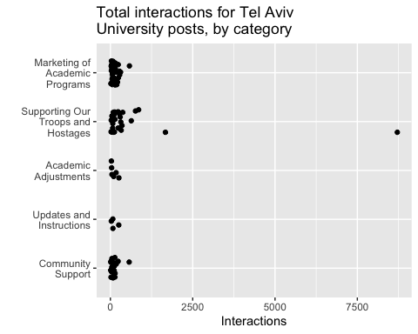

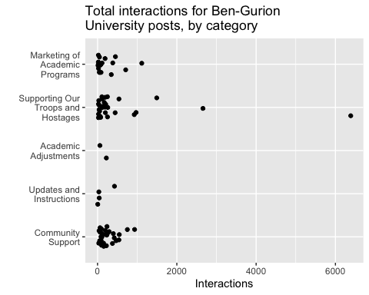

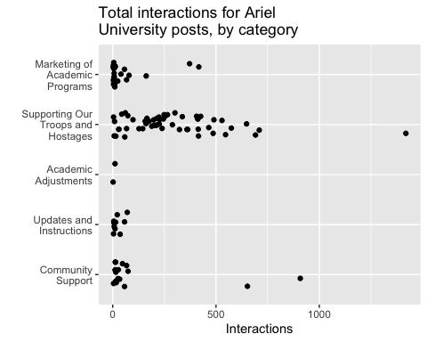

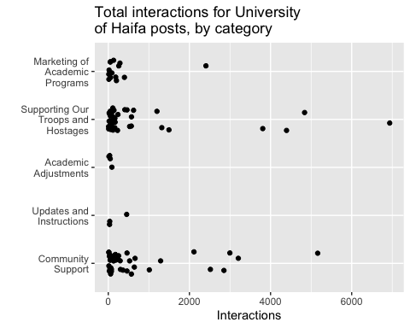

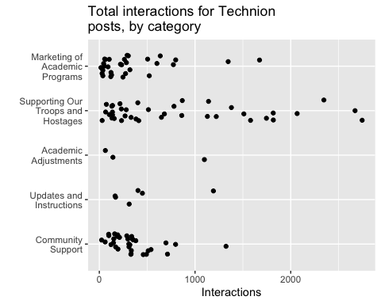

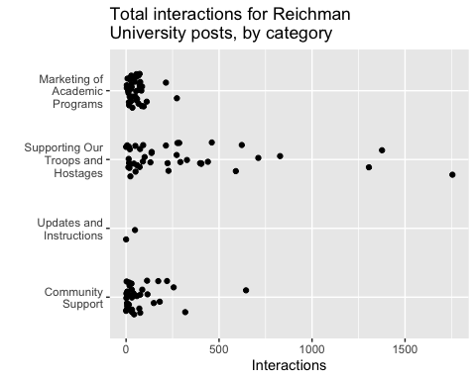

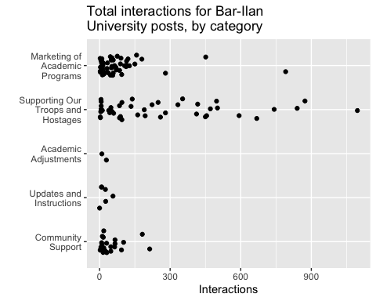

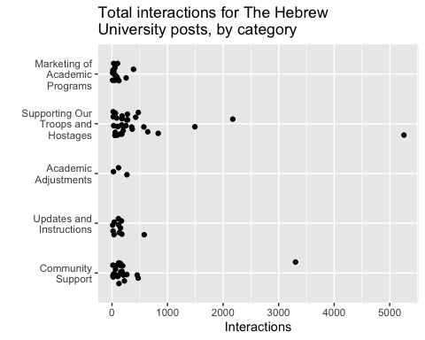

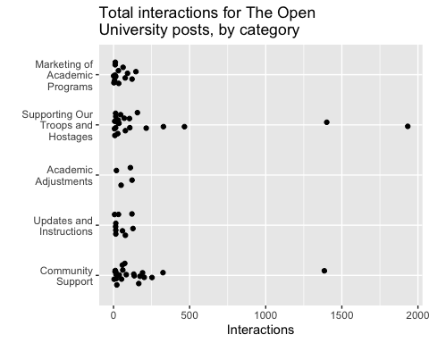

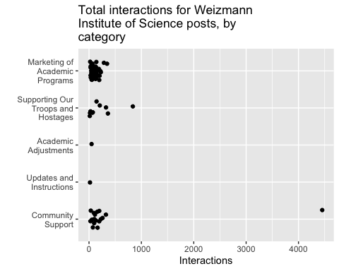

## 2.2 Alternative timeline plot

